**SOFTWARE TESTING USING SELENIUM**

**ASVANTH T E**

**727721EUIT016**

Day: 07 – Class Exercise Lab

**Task-01: Maven Configuration**

WebDriverManager.*chromedriver*().setup();

ChromeOptions co=**new** ChromeOptions();

co.addArguments("--remote-allow-origins=*");

WebDriver driver=**new** ChromeDriver(co);

driver.get("https://demo.wpeverest.com/user-registration/guest-registration-form/");

driver.manage().window().maximize();

String t="Guest Registration Form – User Registration";

String t1=driver.getTitle();

*assertEquals*(t, t1);

Output:

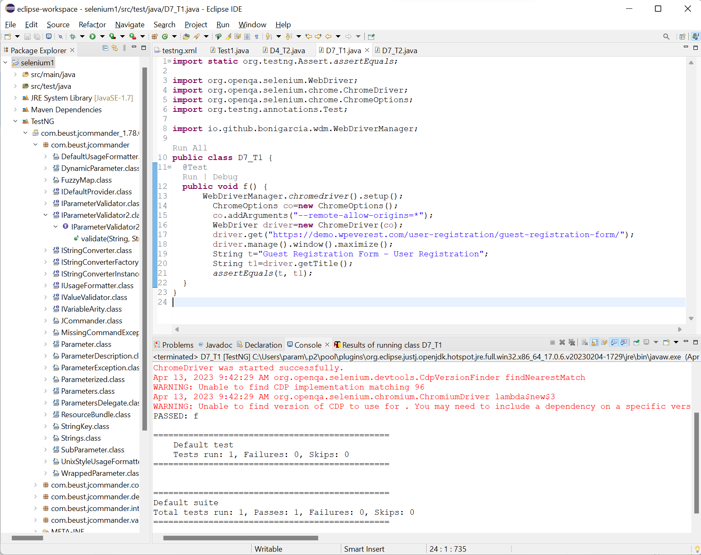

**Task-02: TestNG Annotations (Calculator)**

**int** a=10,b=2,c;

@Test(priority=2)

**public** **void** add() {

c=a+b;

*assertEquals*(12,c);

}

@Test(priority=4)

**public** **void** sub() {

c=a-b;

*assertEquals*(8,c);

}

@Test(priority=1)

**public** **void** mul() {

c=a*b;

*assertEquals*(20,c);

}

@Test(priority=3)

**public** **void** div() {

c=a/b;

*assertEquals*(5,c);

}

Output:

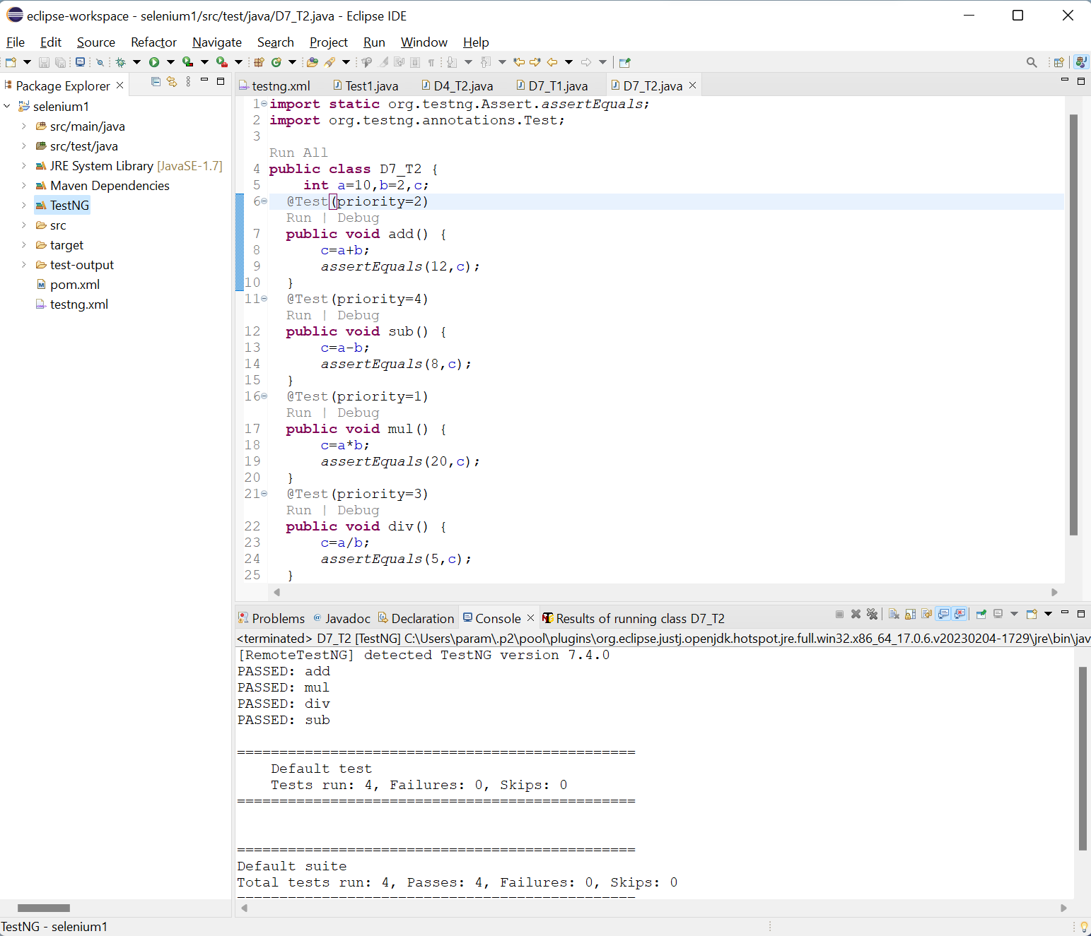

**Task-03: TestNG Annotations (Login)**

WebDriver driver;

@Test

**public** **void** OpenURL() **throws** InterruptedException{

Thread.*sleep*(3000);

WebElement uname=driver.findElement(By.*name*("username"));

WebElement pwd=driver.findElement(By.*name*("password"));

WebElement submit=driver.findElement(By.*xpath*("//*[@id=\"app\"]/div[1]/div/div[1]/div/div[2]/div[2]/form/div[3]/button"));

uname.sendKeys("Admin");

pwd.sendKeys("admin123");

submit.click();

String url1="https://opensource-demo.orangehrmlive.com/web/index.php/dashboard/index";

String ActualUrl=driver.getCurrentUrl();

AssertJUnit.*assertEquals*(url1,ActualUrl);

}

@BeforeMethod

**public** **void** beforemethod() {

WebDriverManager.*chromedriver*().setup();

ChromeOptions co=**new** ChromeOptions();

co.addArguments("--remote-allow-origins=*");

driver=**new** ChromeDriver(co);

driver.manage().window().maximize();

String url="https://opensource-demo.orangehrmlive.com/web/index.php/auth/login";

driver.get(url);

}

@AfterMethod

**public** **void** aftermethod() {

driver.close();

}

Output:

**Task-04: TestNG Annotations (Testcases)**

**public** **class** D7_T4 {

WebDriver driver;

@BeforeSuite

**void** init(){

WebDriverManager.*chromedriver*().setup();

ChromeOptions co = **new** ChromeOptions();

co.addArguments("--remote-allow-origins=*");

driver=**new** ChromeDriver(co);

}

@Test

**void** Test1() **throws** InterruptedException{

//open url and maximize

// assertEquals(1, 2);

String url="https://opensource-demo.orangehrmlive.com/web/index.php/auth/login";

driver.get(url);

Thread.*sleep*(3000);

driver.manage().window().maximize();

//Entering uname, pwd and click login button

WebElement uname=driver.findElement(By.*name*("username"));

WebElement pwd=driver.findElement(By.*name*("password"));

WebElement submit=driver.findElement(By.*xpath*("//*[@class='oxd-button oxd-button--medium oxd-button--main orangehrm-login-button']"));

uname.sendKeys("Admin");

pwd.sendKeys("admin123");

submit.click();

}

@Test(dependsOnMethods = "Test1")

**void** Test2() **throws** Exception{

//click profile option and click logout button

Thread.*sleep*(3000);

driver.findElement(By.*xpath*("//*[@id=\"app\"]/div[1]/div[1]/header/div[1]/div[2]/ul/li/span/p")).click();

Thread.*sleep*(3000);

driver.findElement(By.*xpath*("//*[@id=\"app\"]/div[1]/div[1]/header/div[1]/div[2]/ul/li/ul/li[4]/a")).click();

Thread.*sleep*(3000);

//verifying login page

String s1="OrangeHRM";

String s2=driver.getTitle();

*assertEquals*(s1, s2);

driver.close();

}

}

Output:

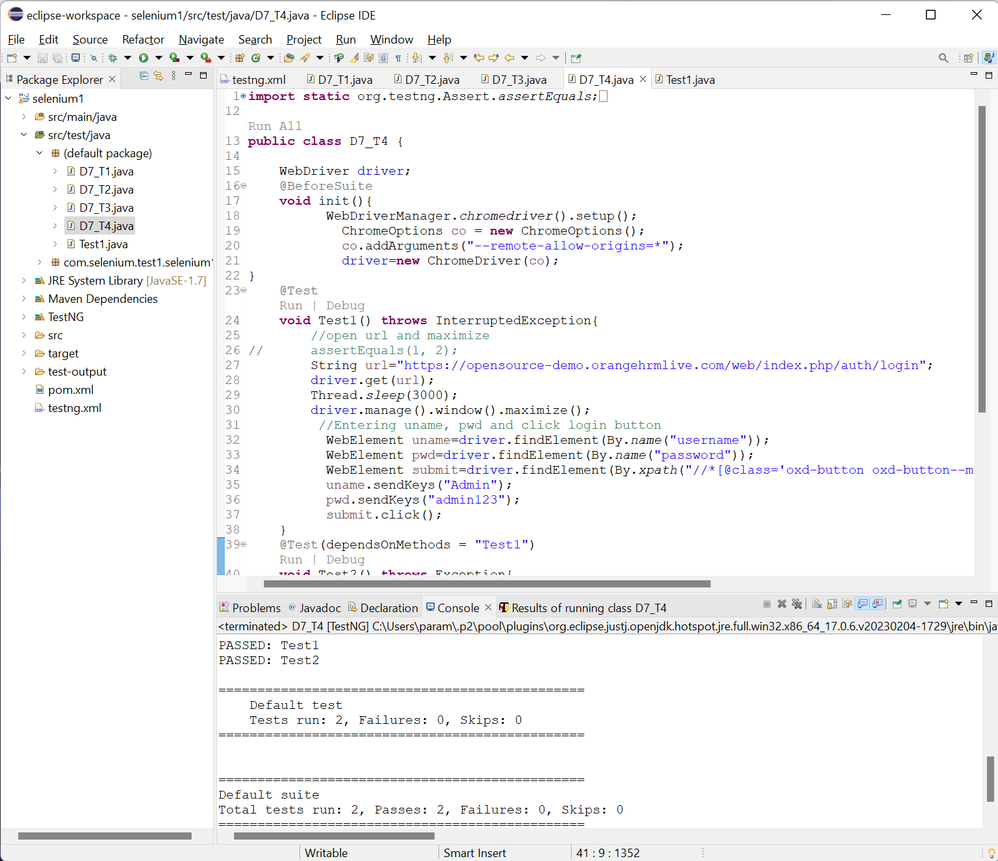

**Task-05: TestNG Annotations (Group By)**

D7_T5.java:

**public** **class** D7_T5 {

@Test(groups= {"SmokeTest"})

**public** **void** f() {

WebDriverManager.*chromedriver*().setup();

WebDriver driver;

ChromeOptions co = **new** ChromeOptions();

co.addArguments("--remote-allow-origins=*");

driver=**new** ChromeDriver(co);

driver.get("https://www.godaddy.com/en-in");

driver.manage().window().maximize();

String actualTitle="Domain Names, Websites, Hosting & Online Marketing Tools - GoDaddy IN";

String extractedTitle=driver.getTitle();

*assertEquals*(actualTitle, extractedTitle);

String actualURL="https://www.godaddy.com/en-in";

String extractedURL=driver.getCurrentUrl();

*assertEquals*(actualURL, extractedURL);

System.***out***.println("Smoke test");

driver.quit();

//driver.manage().timeouts().implicitlyWait(10, TimeUnit.SECONDS);

}

@Test(groups= {"RegressionTest"})

**public** **void** f1() {

WebDriverManager.*chromedriver*().setup();

WebDriver driver;

ChromeOptions co = **new** ChromeOptions();

co.addArguments("--remote-allow-origins=*");

driver=**new** ChromeDriver(co);

driver.get("https://www.godaddy.com/en-in");

driver.manage().window().maximize();

//driver.manage().timeouts().implicitlyWait(5, TimeUnit.SECONDS);

driver.manage().timeouts().~~implicitlyWait~~(10,TimeUnit.***SECONDS***);

driver.findElement(By.*xpath*("//*[@id=\"id-631b049a-e9c0-4d24-8710-c504745206dd\"]/div[2]/div[1]/ul/li[1]/button")).click();

driver.findElement(By.*linkText*("Domain Name Search")).click();

System.***out***.println("Regressiontest");

//driver.quit();

}

}

Testng.xml:

<?xml version="1.0" encoding="UTF-8"?>

<!DOCTYPE suite SYSTEM "https://testng.org/testng-1.0.dtd">

<suite name="Suite">

<test thread-count="5" name="Test">

<groups>

<run>

<exclude name="RegressionTest"/>

</run>

</groups>

<classes>

<class name=".D7_T5"/>

</classes>

</test> <!-- Test -->

</suite> <!-- Suite -->

Output:

