*Hand Hygiene Monitoring System for Hospital*

Shardul Kulkarni  
School of Computer Engineering  
MIT Academy of EngineeringAlandi, India  
skulkarni@mitaoe.ac.in

Mr. Pramod Ganjewar (Faculty)  
School of Computer Engineering  
MIT Academy of EngineeringAlandi, India  
pdganjewar@comp.maepune.ac.in

***Abstract*—Healthcare is one of the leading industry in the present era. Patients are supposed to get cured in the hospital, but in some cases, they get infected at the Hospital itself. Due to low immunity or recent injury or surgical wounds, patients are vulnerable to acquire infections. Even at the hospital, these pathogens are spread due to many reasons. Improper hand hygiene is one of the prominent cause behind the spread of infections at the hospital. Use of sanitizers at the hospital is highly recommended, but authority can’t keep the track of hand hygiene manually. Hand Hygiene Monitoring System uses image processing and cloud database technology to deal with the problem. Using Face detection and recognition of an individual profile of hand hygiene record of the working staff at the hospital is created and stored on the cloud database. Authorities will be able to access this data of individual staff which will help them to take necessary steps wherever possible.**

***Keywords—Hospital Management, Face Recognition, Hand Hygiene, Raspberry PI, Firbase.***

# Introduction

Hospital Acquired Infection or Healthcare Associated Infections (HAI) is a severe health condition acquired by the patients in the hospitals and health-care facilities. The patients are vulnerable to HAI while they are either in In-patient wards or in ICU. One of the reasons for spreading HAI is poor hand hygiene maintained by the Doctors, nursing staff or visitors. It is recommended by the health organizations for everyone to use sanitizers to clean their hands while entering as well as leaving the patient area. The Hand Hygiene Monitoring System for Hospital ensures that the working staff at the Hospital has cleaned his/her with sanitizer before entering the In-patient wards. This system uses face detection technology to keep a record of the staff who have used the sanitizer to clean the hand. In this way, a profile will be created of every staff and thus the authority will be able to take necessary steps to ensure the Hand Hygiene. Practicing hand hygiene is a simple yet effective way to prevent infections. Staffs tend to perform hand hygiene when they are aware, that they are being observed. To track compliance, it is required to design a simple, cost-effective hardware device easily reproducible on a mass scale which will in real time, record the entire process of hand-washing.

# Motivation

Hospital Acquired Infections is a major issue in front of Hospitals and Healthcare institutes. Of every 100 hospitalized patients at any given time, 7 in developed and 10 in developing countries will acquire at least one healthcare-associated infection [1]. As it is difficult to manually track everyone's hand hygiene practices. Use of technology to automatically monitor the hand hygiene practice will be very effective and help to decrease the chances of HAI making hospitals more secure.

# System Architecture

At the entrance of the In-patient wards or Intensive Care Unit (ICU), hand sanitizers are attached to the wall. The designed system is attached along with sanitizer to the wall near the entrance of the In-Patient area. The system basically consists of a webcam, Raspberry Pi 3 and a push button. The system is to be connected to the internet so as to access and store the record at the cloud database. Internet connectivity can be accessed using WiFi or LAN facility. The webcam is placed just above the sanitizer arranged in such a way that it captures the face of the person who is using sanitizer. The Webcam is connected to Raspberry Pi through USB port. A Push button is attached into the nozzle of the sanitizer and is connected to Raspberry pi 3 through GPIO ports. A 5V 2A constant DC supply is required for running of the Raspberry Pi 3 and webcam.



Fig. 1 Block Diagram of the System

## Hardware Requirements

* Raspberry PI is a popular System on Chip (SoC) device with the specification of Quad-Core 1.2GHz Broadcom BCM2837 64Bit CPU which is a low powered ARM-based CPU has an inbuilt VideoCore IV Graphics processing unit (GPU) and consists of four Cortex A53 cores of 14nm fabrication allowing for efficient power disposal and scaling when power is needed. Raspberry Pi a small-sized, low-cost CPU capable of doing high-level calculations for image processing and working with internet connectivity.
* 24 MP USB webcam with night vision capability. It is used to record and stream the video to Raspberry Pi for further processing.
* Push button acts as a switch to check if the nozzle is pressed.

## B. Software Requirements

* Raspbian: A Debian-based, Unix-like operating system which is highly optimized for the low-powered ARM CPU of the Raspberry Pi.
* Python 3.x is installed on the Raspbian OS of raspberry pi 3.
* OpenCV 2: A cross-platform open-source library of programming functions mainly aimed at real-time computer vision used for recognition and manipulation.
* NumPy 1.16: A library dedicated for the Python adding support for large arrays, matrices, and high-level mathematical functions.
* Firebase library is installed for python 3 to have the Google FIrebase connectivity. Firebase Database provides real-time NO-SQL database.
* Frontal Face Haar Cascade Classifier file is required which helps in face detection and recognition.

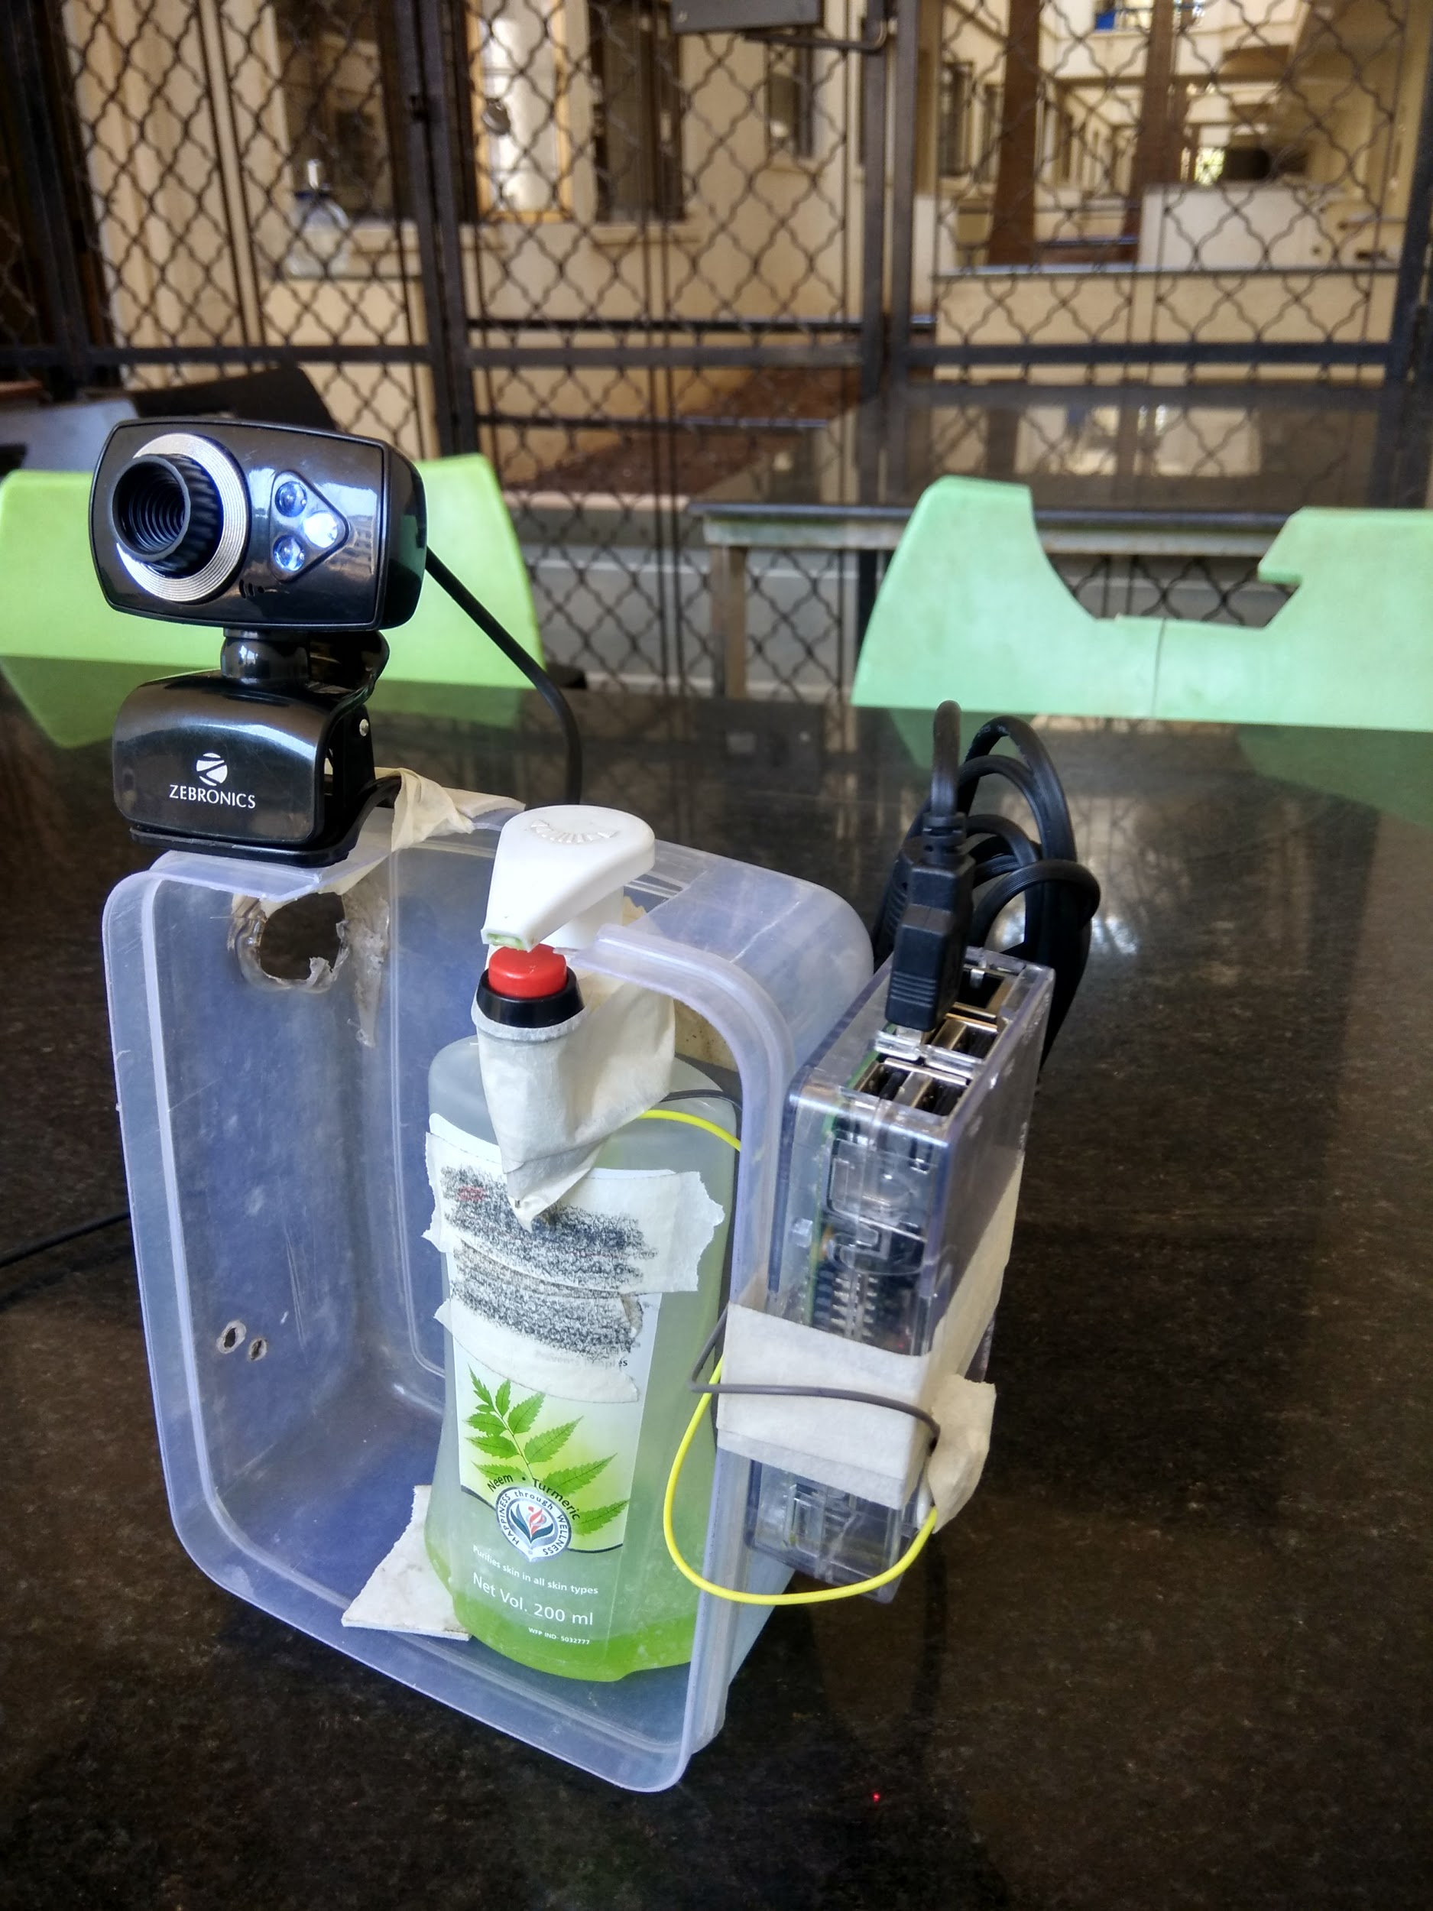

fig. 2 Working Prototype model of the Hand Hygiene Monitoring System

# Working

The designed system has multiple tasks to do, it has to recognize the staff, validate that he/she has used the sanitizer, generate the record of that instance and append it to the cloud database. In order to Recognize the faces of the staff, the module is to be trained first using the photos of individual staff. Frontal face haar cascade is the classifier used for the classification of the faces from the photos. This frontal face haar cascade detects only the frontal portion of the face. It is necessary that the photos used to train the module should not have any other person than the respective staff. Each detected face is labeled with the name of the staff. Once the module gets trained then their is no further need of the photos, the trained module will be used directly during the actual working of the system.

The trained module is added into the file system of the raspberry pi. The python program loads the trained module consisting of data for face recognition, initiates the webcam and sets respective GPIO pin of push button to input mode and gets connected with the real-time firebase database in the cloud via the internet.

When any person approaches the sanitizer, the webcam will detect the face and will search in the trained module to recognize the person name. As the module is trained with the face data of working staff, it will recognize the name of the staff or else if any unknown person approaches the sanitizer he/she will be tagged as ‘Anonymous’. Now to avoid error such as if the person just stands in front of the camera or simply passes by the camera without using the sanitizer, even though the system may recognize the person but the hand cleaning record will not be directly appended. In order to append the record, it is necessary that the nozzle of the sanitizer is to be pressed. Pressing the nozzle implicitly triggers the push button which sends the signal to Raspberry pi through GPIO ports, at this point the hand cleaning record of the recognized face will get validated and appended in the firebase database.

 fig 3. Detection and Recognition of face by the Hand Hygiene Monitoring System



fig 4. Detection of an unknown face who is using Sanitizer by the Hand Hygiene Monitoring System.

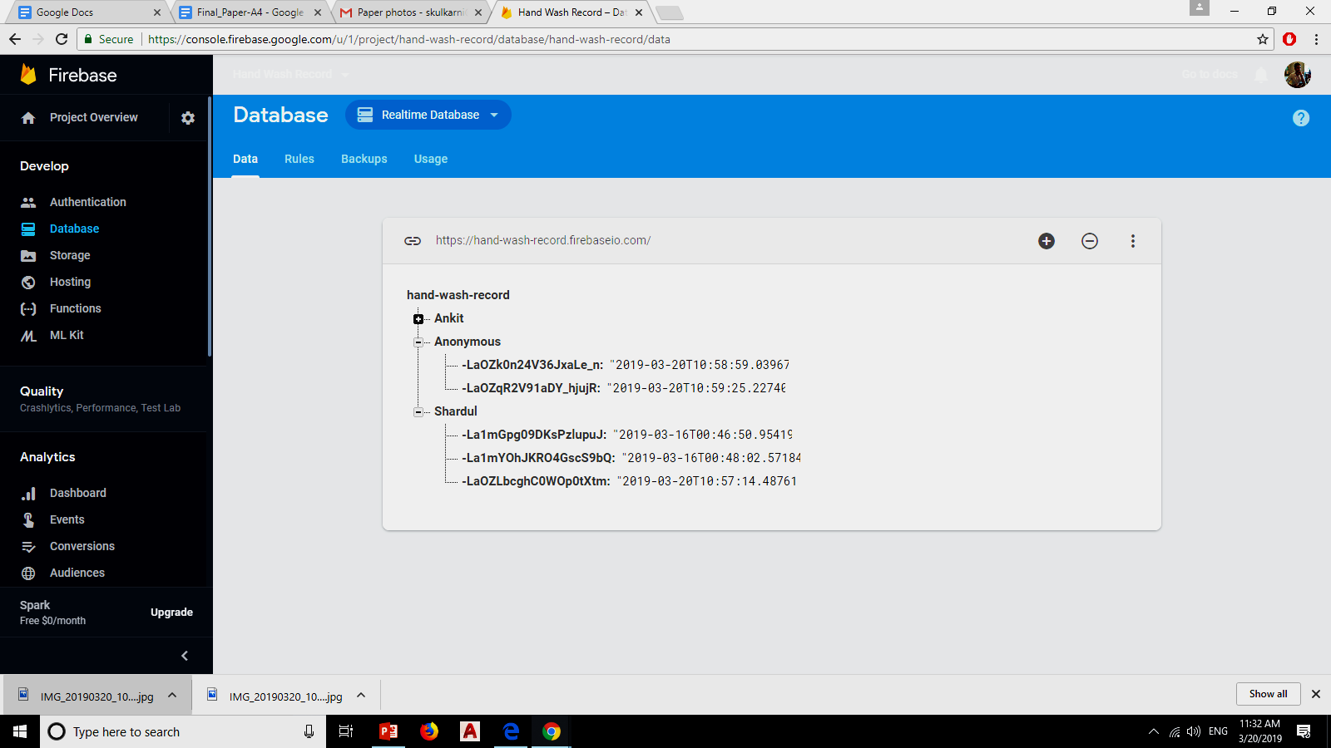

Fig 5. Log records of use of Sanitizer by individual staffs with Name, Data and time stored in Real-time database of Firebase cloud.

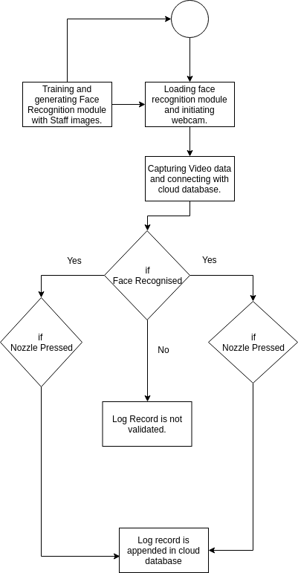

fig.6 Flow Diagram of the Hand Hygiene Monitoring System

# Testing and Evaluation

For Experimental testing, the Hand Hygiene Monitoring System was trained with images of a few people, each face data labeled with their names. During experimental testing following test cases were taken into consideration.

The first case is the recognition of person and real-time storage of the hand cleaning record. The system successfully detected and recognized the person standing in front of the webcam (shown in fig 3) and it appended the record of that instance after he pressed the nozzle. The stored record in the database had data i.e. Name of the person, date and time of the nozzle press (shown in fig 5).

The Second case is the recognition of person but no nozzle is pressed, it is the case where if staffs try to trick the system for fake records. The system was able to detect and recognize the person standing in front of the webcam but no record was appended into the firebase’s database.

The third case is of the unrecognized person, it is the case if a visitor comes to visit the patient (shown in fig. 4). The system only detects the face but due to unavailability of face data in the trained module the detected faced is tagged as ‘Anonymous’ and after pressing of the nozzle the record is stored at the cloud (shown in fig. 5).

# Conclusion

Hand Hygiene Monitoring System for Hospital is an effective solution to reduce the chances of HAI due to poor hand hygiene practices by automatically keeping track of the people who have used the hand Sanitizer at the Hospital, staffs are likely to follow the rule when they are under surveillance but it does not comply everyone to use sanitizer. The total cost of the Hand Hygiene Monitoring System for as single sanitizer is Rs.1,097.00.

# Future Scope

The system can be upgraded with person counter functionality which will keep track of the number of people going in or coming out of the patient area. This person counter data is to be compared with the hand cleaning record, the resulting conclusion can help the authority about the location where hand hygiene is maintained poorly.

Hand Hygiene Monitoring System can be integrated with the doors of the In-patient area. The door will be unlocked only when the visitor or staff first clean his/her hands using the sanitizer. An emergency door unlock button will also be provided so as to bypass the door unlocking procedure for some time period without validation of Hand Cleaning through the system.

##### Acknowledgment

We thank MIT Academy of Engineering for providing us the platform to work on this project. We would like to show our gratitude towards Ms. Vaishali Wangikar (MIT Academy of Engineering) for sharing their pearls of wisdom during the course of this project work. We would like to thank our classmate Muskan Pandey, Sumit Sakarkar and Vaibhav Chaudhari (MIT Academy of Engineering) for providing few components during the project work and helping during experimental testing. We would also like to thank Akashdeep Dhar for helping in a few technical things.

##### References

1. Health Care-Associated Infections Fact Sheet by WHO <https://www.who.int/gpsc/country_work/gpsc_ccisc_fact_sheet_en.pdf>
2. “Tutorial for Face Detection using Haar Cascade ”https://docs.opencv.org/3.4.3/d7/d8b/tutorial_py_face_detection.html
3. Varun Garg and Kritika Garg, “Face recognition using haar cascade classifier”, Journal of Emerging Technologies and Innovative Research, Volume 3 Issue 12, 2016, pp. 140-142.