***MACHINE LEARNING CLASSIFICATION***

***1.PROBLEM STATEMENT:***

*A Client requirement is to predict the chronic kidney disease based on several parameters.*

***SOLUTION:*** *CHRONIC KIDNEY DISEASE PREDICTION*

***2.BASIC INFO ABOUT THE DATASETS:***

*The dataset contains technical details from the patient’s report like age, BP, sugar level and more technical datas related to chronic kidney disease.*

***3. PREPROCESSING TECHNIQUES****:*

***1. One Hot Encoding -*** *To convert categorical input & output dataset into nominal input data.*

***2. Standardization -*** *To increase the accuracy level of the input dataset which is between (-n to n).*

1. ***MODEL CREATION:***
2. ***Domain Selection :***

*Input is numerical value so that it falls under* ***Machine Learning*** *domain.*

1. ***Learning Selection :***

* *Requirement is clear that it is* ***Chronic Kidney Disease Prediction****.*
* *Both Input & Output columns are present.*

*So, it fall under* ***Supervised Learning****.*

1. ***Regression or Classification Selection:***

*Output Column is categorical data so that it falls under* ***Classification.***

*Developed using various Machine Learning Regression algorithms,*

***“Support Vector Classifier (SVC)”***

1. ***Evaluation Metrics Performance:***

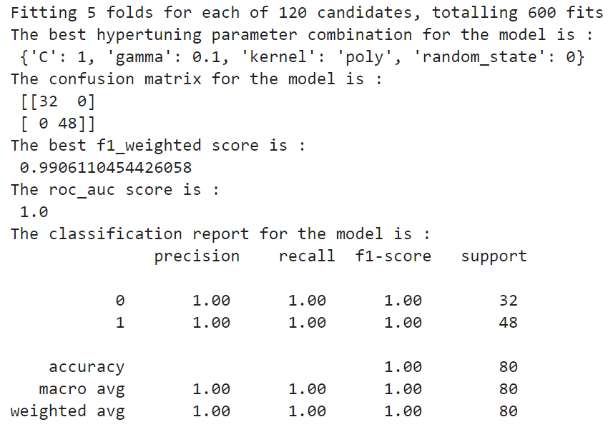

|  |  |  |
| --- | --- | --- |
| ***S.No*** | ***Evaluation metrics name*** | ***Score*** |
| *1.* | *F1-weighted* | *0.99* |
| *2.* | *Roc_auc* | *1.0* |
| *3.* | *Accuracy* | *1.0* |
| *4.* | *Precsion* | *1.0* |
| *5.* | *Recall* | *1.0* |
| *6.* | *F1 score* | *1.0* |
| *7.* | *Macro Average* | *1.0* |
| *8.* | *Weighted Average* | *1.0* |

***6. FINAL MODEL****:*

*Algorithm - Support Vector Classification*

*Because of the 100% accuracy of the model.*