The below 2 folders are not added in the GITHUB Repo.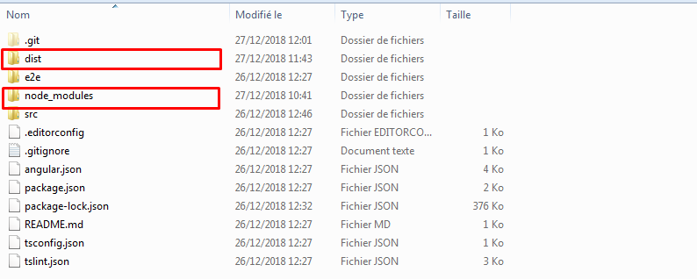

dist folder will be created when building the application in production mode, so it can be created after cloning 🡪 **ng build --prod**

node_modules are the set of libraries which are common to all projects (it will be created during the setup of project) 🡪 **ng new project-name**

copy node_modules from here to put it in your above cloned project at your desktop.

**Prerequisites:**

To work with angular & use above:

Step 1: Download & install node.js (verify node -v)

Step 2: Verify NPM version (node pack manager version: npm -v )

Step 3: Install the Angular CLI globally.

npm install -g @angular/cli

**Other Info**



**Reference:**

[**https://www.youtube.com/watch?v=5wtnKulcquA**](https://www.youtube.com/watch?v=5wtnKulcquA)

[**https://coursetro.com/posts/code/171/Angular-7-Tutorial---Learn-Angular-7-by-Example**](https://coursetro.com/posts/code/171/Angular-7-Tutorial---Learn-Angular-7-by-Example)

[**https://www.youtube.com/watch?v=k5E2AVpwsko**](https://www.youtube.com/watch?v=k5E2AVpwsko)

**Deployment:**

[**https://medium.com/@longboardcreator/deploying-angular-6-applications-to-firebase-hosting-b5dacde9c772**](https://medium.com/@longboardcreator/deploying-angular-6-applications-to-firebase-hosting-b5dacde9c772)