A web-based decision support system with a hybrid GA–SA–Q-learning metaheuristic for multi-compartment, multi-product, multi-trip fuel distribution: an Indonesian fuel-terminal case
Asepta Surya Wardhana^{1*}, Astrie Kusuma Dewi¹, Chalidia Nurin Hamdani¹, Nano Koes Ardhiyanto¹
¹Politeknik Energi dan Mineral Akamigas (PEM Akamigas), Cepu, Blora, Central Java, Indonesia
*Corresponding author: aseptasw@esdm.go.id
Abstract — Petrol-station replenishment combines compartmented tank trucks, several products and multiple trips per shift, so routes planned on aggregated volumes may not be loadable. This paper formulates a multi-compartment, multi-product, multi-trip vehicle routing problem (MC-MP-MT-VRP) with a heterogeneous fleet, time-dependent speeds, soft time windows and a load- and speed-dependent CO₂ model, and solves it with a hybrid genetic algorithm–simulated annealing method in which a tabular Q-learning agent selects the annealing move (GA-SA-RL). A heterogeneous-fleet Split decoder with an exact compartment-assignment check turns giant tours into feasible trips, and a scheduler chains trips into truck-days. The method is embedded in an open-source web decision support system with a Google Sheets database. On a 13-station case from an Indonesian fuel terminal, the algorithm matched the MILP-proven optimum (272.5 km) in all 30 runs of the capacitated setting, 2.5% shorter than the incumbent Savings plan. Allowing multiple trips, the full model serves the aggregated demand with 2 instead of 3 trucks, reducing daily cost by 16.5%. Under compartment and product constraints the Savings plan contained 1 unloadable trip, whereas GA-SA-RL returned a feasible plan with 2 trucks and 5 trips. On 10 CVRPLIB X instances the mean gap to the best-known solutions was 6.47% (Clarke–Wright 6.87%). In an ablation, the hybrid significantly outperformed the GA alone (Wilcoxon p = 0.002), while Q-learning move selection did not significantly outperform uniform random selection (p = 0.520). Scenario, Pareto, Monte Carlo and dynamic re-routing experiments illustrate the decision support value; product shares and compartment sizes are assumptions to be calibrated with operator data.
Keywords: petrol station replenishment; multi-compartment vehicle routing; multi-trip; hybrid metaheuristic; Q-learning; decision support system

1. Introduction
Fuel distribution from terminals to petrol stations is a daily, safety-critical logistics operation. Compared with general freight it has three distinctive features: tank trucks are divided into compartments that each hold a single product, several fuel grades must be delivered to each station, and trucks usually perform more than one trip per shift. These features define the petrol station replenishment problem (PSRP) [1], [2], a member of the multi-compartment vehicle routing problem (MCVRP) family [3], [4] with multiple trips [5], [6].
In Indonesia, published fuel-routing studies mostly use constructive heuristics such as Clarke–Wright savings and nearest neighbour [7]–[9], or a single metaheuristic such as tabu search [10], [11], and typically aggregate all products into one volume. A few studies model compartments, products and trips [12]–[14], but on small instances, without emissions and without a reusable decision tool. Internationally, learning-assisted metaheuristics, in which reinforcement learning selects among neighbourhood operators, have produced competitive results on several VRP variants [15]–[18], yet they have rarely been applied to compartmented fuel distribution or evaluated against exact optima on a real case.
This paper addresses that gap with four contributions. (i) An MC-MP-MT-VRP model with a heterogeneous fleet, exact compartment feasibility, product–truck compatibility, road-access restrictions, time-dependent speeds, soft time windows weighted by a fuzzy priority, and a load- and speed-dependent fuel/CO₂ model. (ii) A hybrid GA-SA-RL algorithm built on a heterogeneous-fleet Split decoder, with an ablation that isolates the contribution of the annealing phase and of Q-learning move selection. (iii) A layered validation: reproduction of the incumbent plan, comparison with a MILP-proven optimum, CVRPLIB benchmarks, and stochastic, scenario and dynamic experiments. (iv) An open-source web decision support system (DSS) backed by Google Sheets, released together with data and scripts so that every number in this paper can be regenerated.
Section 2 reviews related work, Section 3 states the model, Section 4 describes the algorithm and DSS, Section 5 reports the computational study, Section 6 discusses implications and limitations, and Section 7 concludes.

2. Related work
Cornillier et al. [1] introduced heuristics for the multi-period PSRP, and subsequent work added time windows, multiple depots and split deliveries [2], [6], [19], [20]. Recent studies consider truck-and-trailer configurations with hazard risk [21], deteriorating inventory [22], exact methods for real fuel distributors [23], and hybrid variable neighbourhood search for real PSRP instances [24]. Heterogeneous-fleet MCVRP case studies [25], [26] confirm that compartment constraints change the solution structure. Surveys of MCVRP [3] and multi-trip VRP [5] identify the combination of compartments, multiple trips and heterogeneous fleets as under-studied.
Giant-tour genetic algorithms with an optimal Split decoder [27] remain the backbone of leading CVRP methods [28]. Simulated annealing [29] is a common intensification step. Hyper-heuristics and adaptive operator selection [30] have increasingly used Q-learning [31], [32]: QMOEA for the time-dependent green VRPTW [15], Q-learning assisted evolutionary search for the CVRP [16], a Q-learning hyper-heuristic for the electric CVRP [17], RL-assisted NSGA-II for the multi-objective CVRPTW [18], and RL-designed metaheuristics [33]. Dynamic VRP surveys [34], [35] and Q-learning based rescheduling for waste collection [36] motivate the re-routing module. Emissions are modelled following the pollution-routing literature [37], [38] and IPCC Tier 2 factors [39].
Table 1. Positioning of this study
Study | Problem | Method | Multi-trip | CO₂/learning | Open DSS
Cornillier et al. [1] | Multi-period PSRP | Heuristic | – | – | –
Wang et al. [6] | Split-delivery MCVRP, multi-trip | Exact / heuristic | ✓ | – | –
Che et al. [20] | Multi-depot PSRP | Tabu-ALNS | – | – | –
Liu et al. [24] | Real PSRP, compartments | Hybrid VNS | – | – | –
Qi et al. [15] | Green TD-VRPTW | EA + Q-learning | – | ✓ | –
Nugroho et al. [12] | Fuel, Indonesia | Sequential insertion | ✓ | – | –
Ramadhani et al. [13] | Fuel, Indonesia | MILP | ✓ | – | –
This study | MC-MP-MT-VRP | GA-SA-RL + MILP check | ✓ | ✓ | ✓

3. Problem description and model
Let N = {1,…,n} be the stations and 0 the terminal; P the products; K the truck types, each with capacity Q_{k}, compartments {c_{k1},…,c_{km}}, U_{k} units, base consumption FC_{0,k} and daily fixed cost B_{k}. Station i requires q_{ip} of product p, and d_{ij} is the road distance. A trip is a sequence (0, i₁,…,i_{L}, 0) performed by one truck. Each station is served by exactly one trip (no split delivery). A trip is loadable by type k if every product is compatible with k, every station's access road is at least the minimum width of k, and there is an assignment of compartments to products (each compartment holds at most one product) such that Σ_{j∈C(p)} c_{kj} ≥ Σ_{i∈r} q_{ip} for all p. A truck performs at most three consecutive trips within a 12-h shift; loading takes 5 min/kL, unloading 15 min + 2.5 min/kL, and the speed is v(t) = 40·CF(t) km/h with an hourly congestion factor CF(t). Fuel use on arc (i,j) is
F_{ij} = FC_{0,k} (1 + β L_{ij}/Q_{k})(1 + α₁(v − v₀)²) d_{ij} (1)
with on-board load L_{ij}, β = 0.3, α₁ = 10⁻⁴ and v₀ = 65 km/h. The three objectives are cost Z₁ = h Σ F_{ij} + c_{km} Σ d_{ij} + Σ_{k} u_{k} B_{k} (fuel price h = IDR 12,000/L, maintenance c_{km} = IDR 1,500/km, u_{k} trucks of type k used), emissions Z₂ = EF Σ F_{ij} with EF = 2.68 kg CO₂/L, and time Z₃ = total trip duration plus priority-weighted lateness. The scalar objective is
F = w₁ Z₁/Z₁^{ref} + w₂ Z₂/Z₂^{ref} + w₃ Z₃/Z₃^{ref} + penalties (2)
where Z^{ref} are the objectives of direct delivery (one trip per station), (w₁,w₂,w₃) = (0.5, 0.3, 0.2), and penalties apply to lateness and overtime (0.02 per minute), trips without an available truck (5.0 each) and quota excess (1.0 per kL). Station priorities in [0,100] come from a Mamdani fuzzy system [40] with time-to-empty, distance and demand variability as inputs. For verification, the special case with one 16-kL truck type, one trip per truck and distance objective is solved exactly as a two-index MILP with load-based Miller–Tucker–Zemlin constraints [41] using HiGHS [42].

4. Solution approach and decision support system

4.1 Representation, Split and scheduling
A solution is a permutation of stations. The Split procedure of Prins [27] is extended to a heterogeneous fleet: for every sub-sequence it selects the cheapest truck type that is loadable (exact compartment assignment by memoised recursion), accessible and compatible, and finds the minimum weighted-cost partition by dynamic programming; each trip cost includes the truck's daily fixed cost amortised over the maximum number of trips per truck-day (w₁B_{k}/(3Z₁^{ref})), so that type selection does not ignore fixed costs. The resulting trips are assigned to truck units in decreasing fuzzy priority and then longest-duration order, preferring the same type and avoiding lateness and overtime, and are simulated with time-dependent speeds to obtain arrival times, fuel and CO₂.

4.2 GA, SA and Q-learning move selection
The GA uses a population of 100 (60% greedy nearest-neighbour with perturbation), tournament selection (k = 5), order crossover (p_{c} = 0.85), inversion/swap/relocation mutation (p_{m} = 0.10, tripled when diversity falls below 5%), elitism of two and 200 generations. SA starts from the GA best with T₀ = 1000, geometric cooling α = 0.995 and 5,000 iterations, using the normalised energy E = 10⁶ F/F_{GA}, so that a 0.1% deterioration is initially accepted with probability e⁻¹. In GA-SA-RL, a tabular Q-learning agent chooses the move at every SA iteration among 2-opt, relocate, swap, or-opt and segment swap. The state combines a stagnation level (< 50, 50–199, ≥ 200 non-improving iterations) with the previous move; the reward is the relative improvement plus 1 for a new best and −0.05 for a rejected move; α = 0.1, γ = 0.9 and ε decays linearly from 0.1 to 0.02. Two ablation variants use the same evaluation budget: GA alone (extra generations equivalent to the SA iterations) and GA-SA (uniform random move selection). The energy scale was calibrated beforehand on X-n101-k25 with seeds 100–102, which are disjoint from the evaluation seeds; with the initial scale 10⁵ the SA phase behaved as a random walk and almost never improved the GA solution.

4.3 Dynamic re-routing
At an event time (truck breakdown, or a sudden congestion with CF = 0.3 for 3 h), served stations are removed, the load of a broken truck is stranded, and the other trucks become available when their current trip ends. A naive policy keeps the remaining plan and adds one trip for stranded stations; the re-optimisation policy reruns GA-SA-RL (population 40, 60 generations, 1,500 SA iterations) warm-started with the naive plan.

4.4 Web DSS
SMARTROUTE-BBM is a Streamlit application with five modules: data and map; optimisation with KPIs relative to the incumbent plan, route map, convergence and operator statistics, multi-trip Gantt chart and compartment loading table; dynamic re-routing; research results; and reports with an optional Telegram notification. Master data (stations, distance matrix, fleet, product shares) are read from Google Sheets, with a CSV fallback, and every run is appended to an audit-log sheet. Code, data and experiment scripts are public at https://github.com/asw09zoom-netizen/smartroute-bbm.
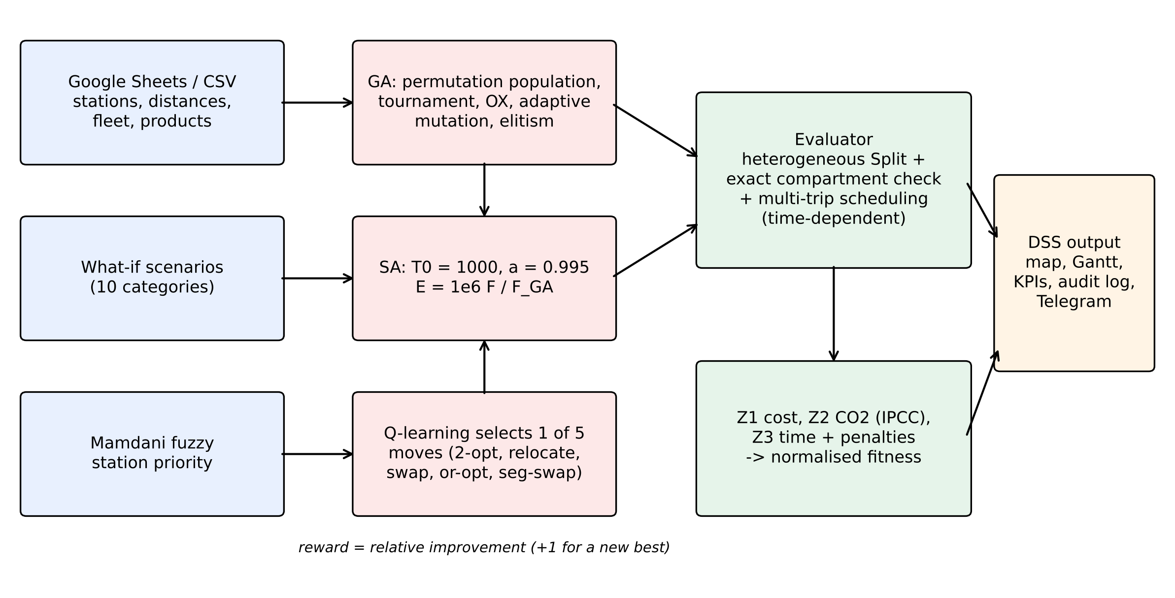
Fig. 1. Architecture of SMARTROUTE-BBM and the GA-SA-RL loop

5. Computational study

5.1 Data and set-up
The case is FT Gelumbang (South Sumatra, Indonesia), serving 13 stations with a total demand of 60.78 kL/day, taken from a 2026 capstone design project together with a 14×14 road-distance matrix. The road distances average 1.23 times the great-circle distances, contain 150 ordered triangle-inequality violations (actual, not shortest, roads) and place 6 stations beyond 30 km from the terminal. The existing fleet is four 16-kL trucks (compartments 6+4+3+3 kL) and one 8-kL truck (4+2+2 kL). Product shares (Pertalite 62%, Biosolar 26%, Pertamax 12%), compartment sizes, consumption and fixed costs are assumptions because the capstone data report only total volumes. Each algorithm variant was run 30 times (seeds 0–29) on the case and 10 times on benchmarks, on a 4-core Linux machine in Python.

5.2 Validation against the incumbent plan and the exact optimum
In the capacitated setting used by the capstone (16 kL, one trip per truck, distance objective), the incumbent Savings plan measures 279.4 km and direct delivery 728.2 km, both reproduced exactly from the matrix. Our Clarke–Wright implementation yields 279.3 km and nearest neighbour 335.8 km. The MILP was solved to proven optimality in 185 s with 272.5 km. All three variants reached this optimum in every run (hit rates GA 100%, GA-SA 100%, GA-SA-RL 100%; mean run time 1.2–5.4 s), i.e. 2.47% shorter than the incumbent (Fig. 2). The instance is too small to discriminate between variants; the ablation is therefore assessed on the full model and on benchmarks.
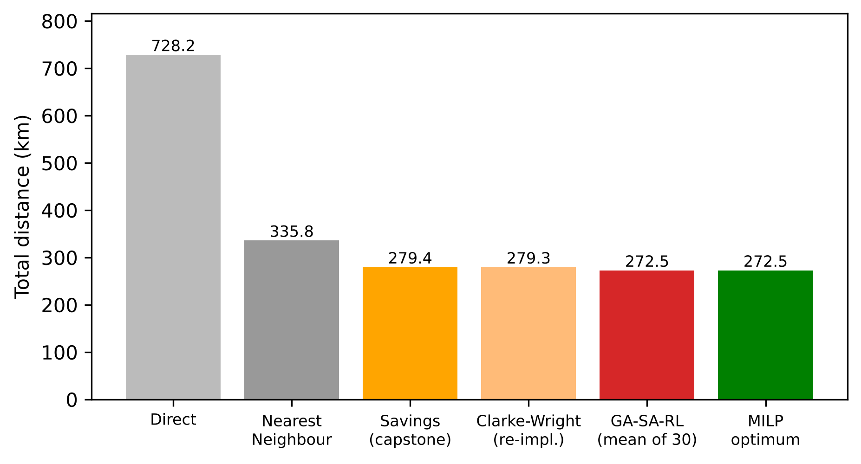
Fig. 2. Total distance of the methods in the capacitated setting

5.3 Full MC-MP-MT-VRP and ablation on the case
Table 2. Full-model results with the existing fleet (30 runs per variant)
Case | Plan | Fitness | Distance (km) | Cost/day | CO₂ (kg) | Trucks/trips | Unloadable trips
Aggregated | Savings plan | 0.4952 | 279.4 | IDR 4,102,739 | 264.3 | 3/5 | 0
Aggregated | GA (mean) | 0.4610 | 281.2 | IDR 3,426,507 | 269.1 | 2.0/4.0 | 0.00
Aggregated | GA-SA (mean) | 0.4609 | 281.1 | IDR 3,426,116 | 269.0 | 2.0/4.0 | 0.00
Aggregated | GA-SA-RL (mean) | 0.4609 | 281.1 | IDR 3,426,116 | 269.0 | 2.0/4.0 | 0.00
Multi-product | Savings plan | 5.4732 | 279.4 | IDR 3,494,345 | 284.8 | 2/5 | 1
Multi-product | GA (mean) | 0.4590 | 281.4 | IDR 3,415,671 | 266.6 | 2.0/5.0 | 0.00
Multi-product | GA-SA (mean) | 0.4590 | 281.4 | IDR 3,415,671 | 266.6 | 2.0/5.0 | 0.00
Multi-product | GA-SA-RL (mean) | 0.4590 | 281.4 | IDR 3,415,671 | 266.6 | 2.0/5.0 | 0.00

With products and compartments, the incumbent plan is infeasible: 1 of its trips cannot be loaded on any truck because, for example, route S8–S9–S10 needs 9.60 kL of Pertalite, 4.02 kL of Biosolar and 1.86 kL of Pertamax, which does not fit the 6+4+3+3 kL compartments. GA-SA-RL returns a feasible plan with 2 trucks and 5 trips, 281.4 km, IDR 3,415,671 and 266.6 kg CO₂ per day, without lateness or overtime (Fig. 3); between variants, all runs of all variants returned the same plan, so no between-variant test applies (Fig. 4).
In the aggregated case the best plan uses 2 instead of 3 trucks by chaining trips, which lowers the daily cost by 16.5% (IDR 4,102,739 → IDR 3,426,116) for a 1.7 km longer distance (281.1 vs 279.4 km); between variants, one-way ANOVA F = 1.00 (p = 0.372), Kruskal–Wallis H = 2.00 (p = 0.368), i.e. the variants do not differ significantly at α = 0.05. The size of this saving depends on the assumed truck fixed cost.
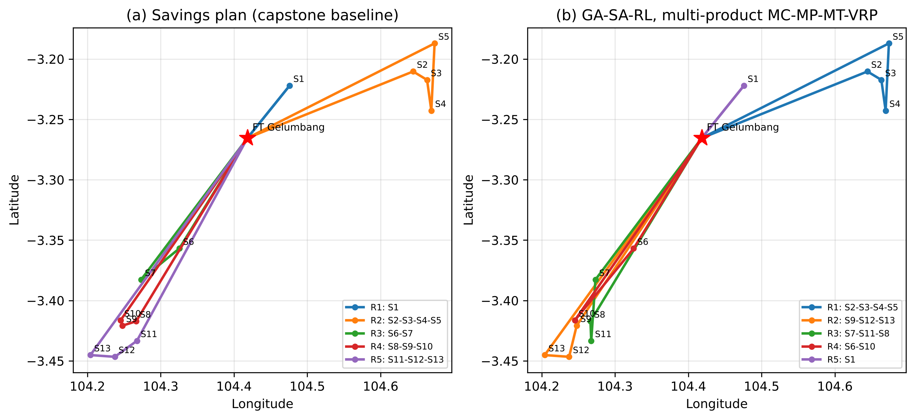
Fig. 3. Routes of (a) the incumbent Savings plan and (b) the GA-SA-RL multi-product plan
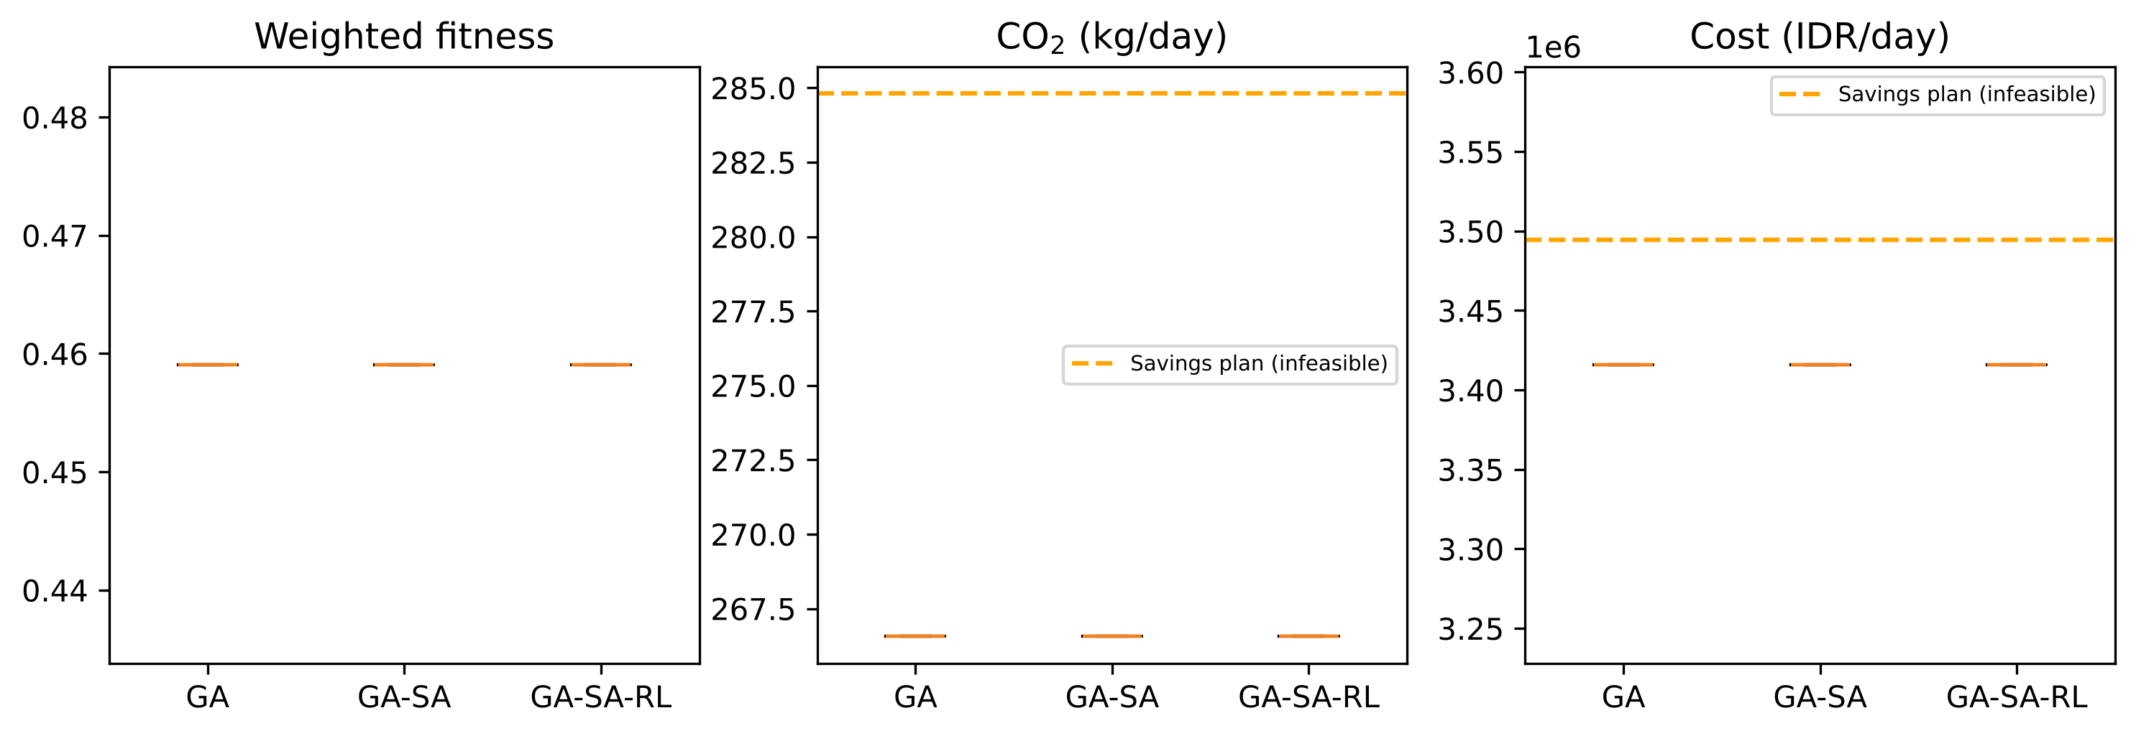
Fig. 4. Distribution of 30 runs per variant on the multi-product case

5.4 Benchmark validation and ablation on CVRPLIB
Table 3. Results on CVRPLIB set X [43] (10 runs, 1,000 generations)
Instance | Variant | BKS | CW gap % | Mean gap % | SD | Best gap % | Time (s)
X-n101-k25 | GA | 27591 | 5.06 | 4.32 | 0.89 | 3.37 | 17
X-n101-k25 | GA-SA | 27591 | 5.06 | 4.29 | 0.91 | 3.12 | 18
X-n101-k25 | GA-SA-RL | 27591 | 5.06 | 4.25 | 0.88 | 3.04 | 18
X-n106-k14 | GA | 26362 | 3.47 | 3.13 | 0.53 | 2.23 | 21
X-n106-k14 | GA-SA | 26362 | 3.47 | 3.02 | 0.52 | 2.23 | 23
X-n106-k14 | GA-SA-RL | 26362 | 3.47 | 3.09 | 0.50 | 2.25 | 23
X-n110-k13 | GA | 14971 | 7.78 | 5.72 | 0.82 | 4.52 | 22
X-n110-k13 | GA-SA | 14971 | 7.78 | 5.61 | 0.72 | 4.52 | 24
X-n110-k13 | GA-SA-RL | 14971 | 7.78 | 5.59 | 0.71 | 4.52 | 24
X-n115-k10 | GA | 12747 | 5.81 | 4.86 | 1.24 | 2.97 | 28
X-n115-k10 | GA-SA | 12747 | 5.81 | 4.83 | 1.20 | 3.00 | 31
X-n115-k10 | GA-SA-RL | 12747 | 5.81 | 4.75 | 1.23 | 2.40 | 31
X-n120-k6 | GA | 13332 | 9.07 | 7.66 | 1.49 | 5.68 | 34
X-n120-k6 | GA-SA | 13332 | 9.07 | 7.45 | 1.49 | 5.57 | 42
X-n120-k6 | GA-SA-RL | 13332 | 9.07 | 7.47 | 1.50 | 5.66 | 38
X-n125-k30 | GA-SA-RL | 55539 | 7.42 | 5.83 | 1.04 | 3.49 | 26
X-n129-k18 | GA-SA-RL | 28940 | 4.80 | 6.08 | 0.44 | 5.39 | 25
X-n134-k13 | GA-SA-RL | 10916 | 6.93 | 7.14 | 0.79 | 5.77 | 34
X-n139-k10 | GA-SA-RL | 13590 | 7.05 | 8.07 | 1.25 | 6.36 | 39
X-n143-k7 | GA-SA-RL | 15700 | 11.32 | 12.45 | 2.46 | 9.08 | 55

Across 10 X instances (n = 100–142), GA-SA-RL obtains a mean gap of 6.47% (range 3.09–12.45%), against 6.87% for Clarke–Wright (Fig. 5). The implementation is therefore correct but only modestly better than the savings heuristic on average (and worse on some instances), and far from state-of-the-art CVRP solvers such as HGS [28], which typically reach gaps below 0.5%; the method should be read as a flexible engine for the rich case model rather than as a competitive pure-CVRP solver. On the 5 instances used for the ablation, mean gaps are GA 5.14%, GA-SA 5.04%, GA-SA-RL 5.03%. A Friedman test over instance means gives χ² = 7.60 (p = 0.022). Paired one-sided Wilcoxon test GA-SA-RL < GA-SA: p = 0.520 over 50 instance–seed pairs (GA-SA-RL better in 42%, worse in 42%). Paired one-sided Wilcoxon test GA-SA-RL < GA: p = 0.002 over 50 instance–seed pairs (GA-SA-RL better in 52%, worse in 22%).
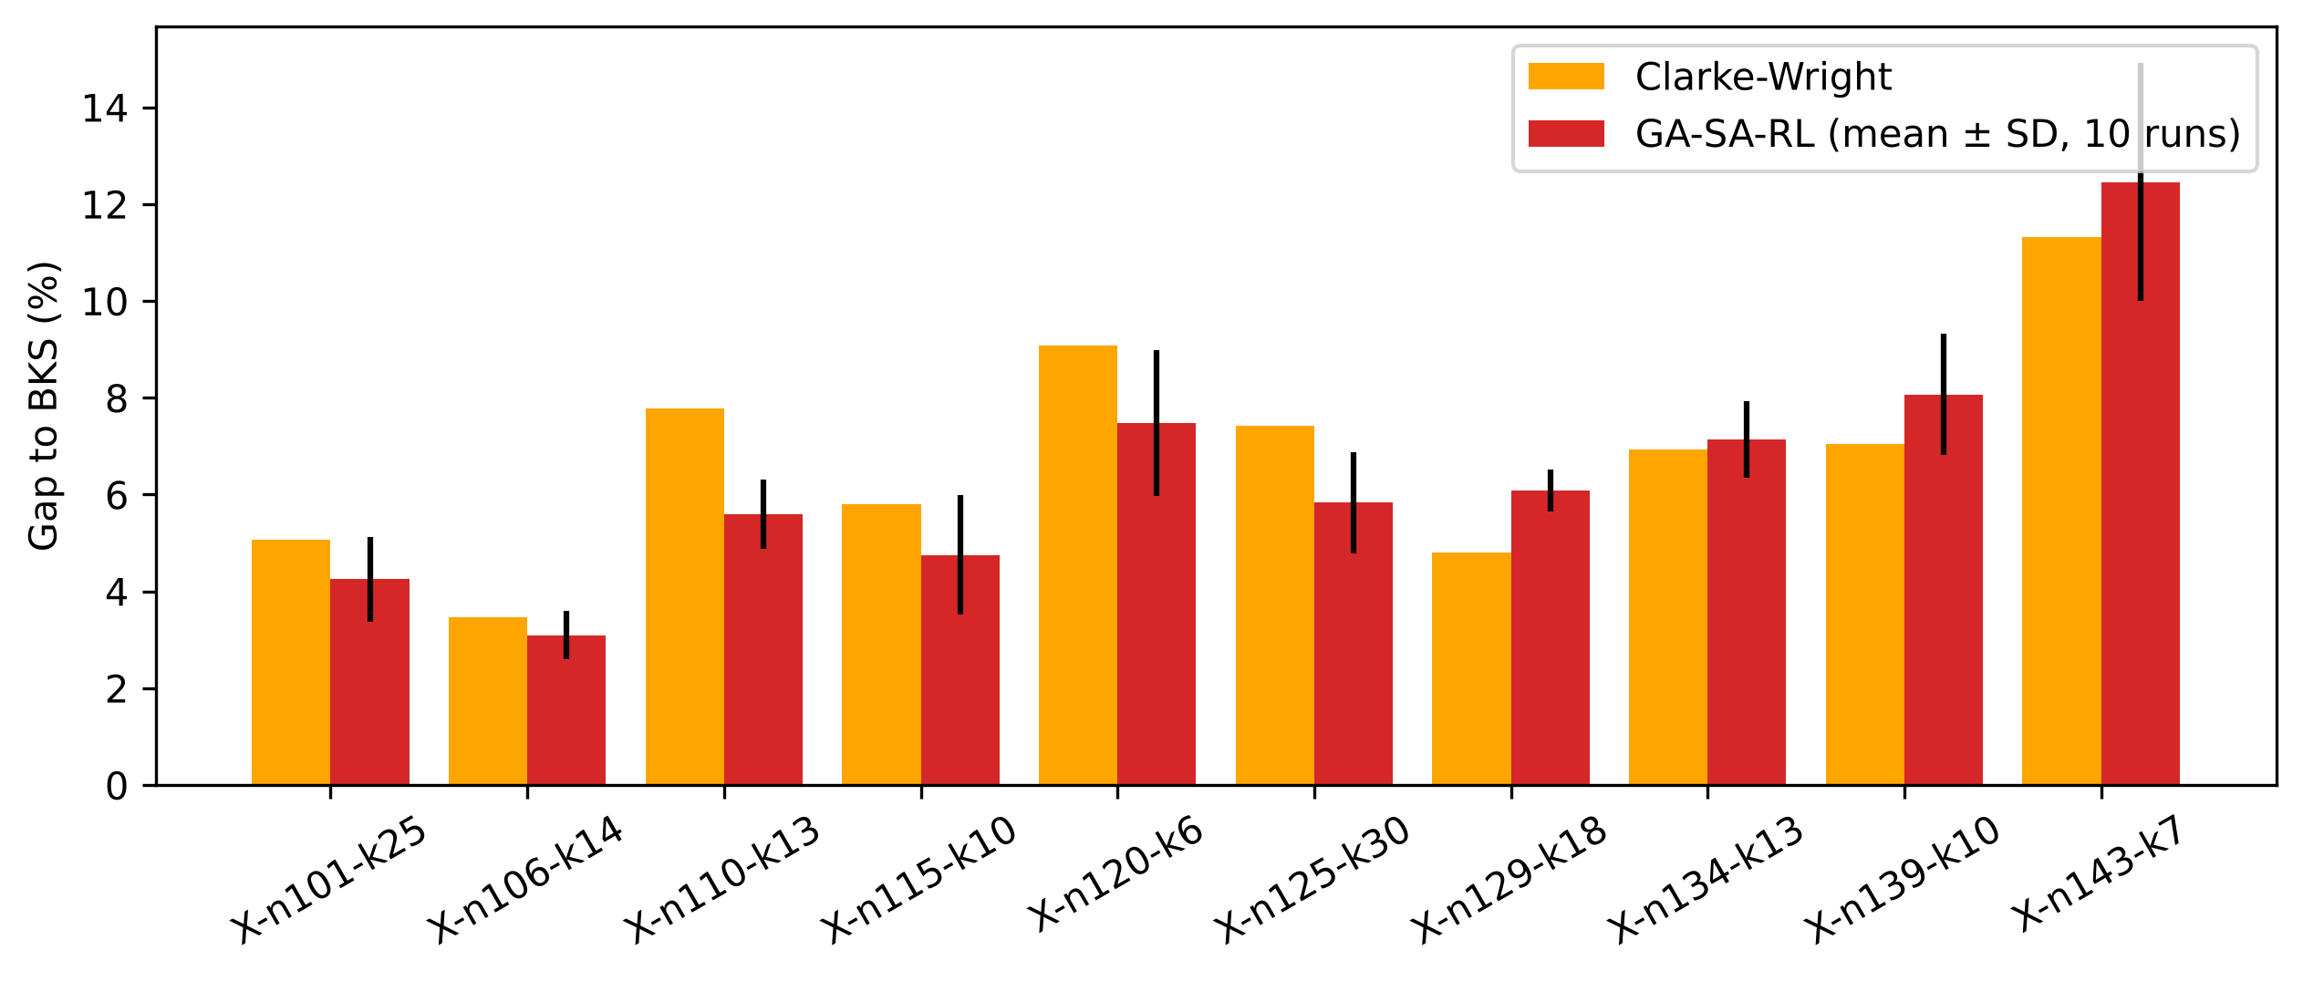
Fig. 5. Gap to best-known solutions on CVRPLIB set X

5.5 Cost–emission trade-off
A weight sweep with step 0.1 (two seeds per weight vector) produced 132 solutions (132 feasible) and 1 distinct non-dominated cost–CO₂ point(s) (IDR 3,415,671, 266.6 kg CO₂ per day; Fig. 6a). Scaling the truck fixed cost from 0 to 2 times its assumed value leaves the plan unchanged (2 trucks, 281.4 km; Fig. 6b), so the recommendation for the existing fleet is robust to this assumption. With the existing fleet, the cost-minimal plan is also emission-minimal, so no genuine trade-off exists. When the fleet options are extended (2×6 kL, 2×8 kL, 4×16 kL, 1×32 kL), the sweep yields 2 non-dominated points, from the cheapest plan (IDR 3,415,671, 266.6 kg CO₂, trip types CCCCC) to the lowest-emission plan (IDR 3,678,145, 235.3 kg, trip types CCCD); the implied abatement cost at the extremes is about IDR 8,402 per kg CO₂.
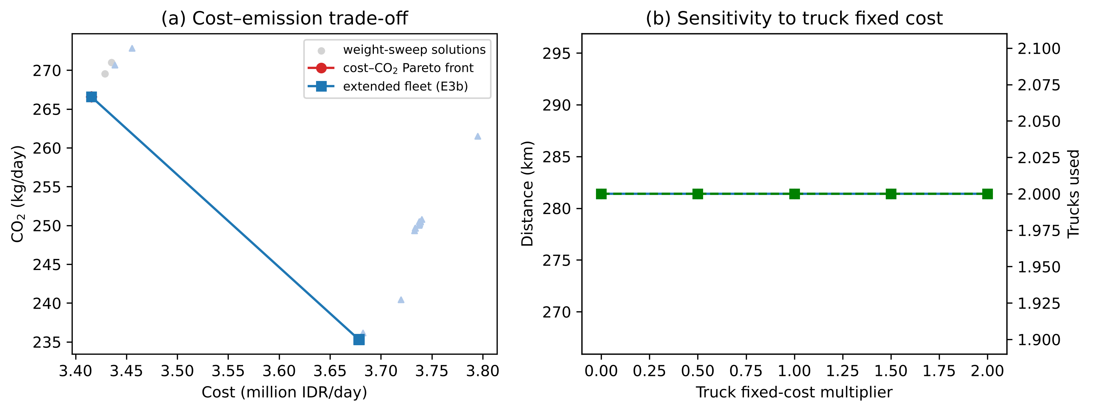
Fig. 6. (a) Cost–CO₂ Pareto front; (b) sensitivity to truck fixed cost

5.6 What-if scenarios and robustness
Table 4. GA-SA-RL plans under what-if scenarios (best of 5 seeds)
# | Scenario (assumption) | Cost/day | CO₂ (kg) | Trucks/trips | Unserved trips
0 | Normal operations | IDR 3,415,671 | 266.6 | 2/5 | 0
1 | Peak congestion (CF 0.5 at 07–09, 16–18; 0.85 otherwise) | IDR 3,485,942 | 282.3 | 2/5 | 0
2 | Road-width limit 5 m at S2–S5 (types C/D barred) | IDR 4,899,194 | 380.9 | 3/8 | 1
5 | Time window 06:00–11:00 at six stations | IDR 3,543,668 | 288.0 | 2/5 | 0
6 | Emission-dominant weights (0.1, 0.8, 0.1) | IDR 3,415,671 | 266.6 | 2/5 | 0
7 | Tank management, initial stock 15–60% | IDR 3,415,671 | 266.6 | 2/5 | 0
8 | Loading-rack queue M/M/4 | IDR 6,293,915 | 323.6 | 5/6 | 0
9 | Demand surge ×1.5 (all stations) | IDR 5,205,045 | 412.8 | 3/8 | 0
9b | Local surge ×3 at S1, S6, S10 | IDR 3,774,974 | 336.2 | 2/6 | 3
10 | Biosolar quota 95% of demand | IDR 3,414,148 | 266.2 | 2/5 | 0
2R | Scenario 2 + one extra 8-kL truck | IDR 5,599,194 | 380.9 | 4/8 | 0
9bR | Scenario 9b + one 32-kL truck | IDR 5,174,974 | 336.2 | 3/6 | 0
9R | Scenario 9 control (existing fleet) | IDR 5,205,045 | 412.8 | 3/8 | 0

Peak-hour congestion raises emissions by 5.9% without changing routes, whereas a congested loading rack (M/M/4 queue) raises daily cost by 84% because waiting time forces 5 trucks into service. Two scenarios are infeasible with the existing fleet: a road-width restriction that limits four stations to the single 8-kL truck, and a local threefold demand surge in which one station needs about 20 kL, more than the largest available truck, while split delivery is not modelled. Adding one 8-kL truck leaves 0 unserved trip(s) in the first case, and adding one 32-kL truck leaves 0 in the second, illustrating how the DSS supports fleet sizing.
Monte Carlo simulation (1,000 demand draws per cell, normal demand with coefficient of variation up to 0.20) gives, for the multi-product case at CV = 0.20, service levels of 97.45% for the incumbent plan, 98.82% for GA-SA-RL and 99.82% for a robust variant planned with 90% of truck capacity (at 377.6 km). The capacity buffer is thus a transparent lever for trading distance against shortage risk.

5.7 Dynamic re-routing
Over 30 breakdown events (truck × time × seed), re-optimisation lowered the residual fitness from 0.2903 to 0.2855 (one-sided Wilcoxon p = 0.012) in 0.45 s on average, but improved only 20% of events and by little (residual distance 161.0 → 159.1 km), because the existing fleet has ample slack. With tight stock-out deadlines the share of improved events was 23% (p = 0.008). For sudden congestion the two policies produced identical plans.

6. Discussion
Three findings matter for practice. First, a plan that is optimal on aggregated volumes may be unloadable once compartments and product mix are considered; modelling compartments is therefore a feasibility issue, not a refinement. Second, on a small terminal network the distance gain over a well-built Savings plan is modest (2.5% to the proven optimum), which is far below the 15–60% savings often reported against unoptimised existing routes [8]–[10]; the larger value of the model lies in fleet utilisation through multiple trips, feasibility checking, and scenario analysis. Third, the loading rack and the fixed cost of trucks can dominate routing decisions, so terminal capacity planning should be considered together with routing.
Regarding the learning component, the evidence must be read carefully. Q-learning move selection did not significantly improve on uniform random selection on the benchmark set, which echoes comparative studies where learned and simple selection policies show complementary strengths rather than uniform dominance; the annealing phase itself, not the learning rule, provides most of the intensification in our implementation. On the 13-station case all variants find the optimum, so the case alone cannot demonstrate a benefit of RL.
Limitations are as follows. Product shares, compartment sizes, consumption, fixed costs and congestion profiles are assumptions; distances come from the capstone matrix rather than a routing engine; split delivery is not modelled; the learning component is a tabular operator-selection policy, not a trained routing policy; and the DSS has not yet been evaluated with industrial users. Because code, data and scripts are released, these assumptions can be replaced and every experiment re-run.

7. Conclusion
This study formulated an MC-MP-MT-VRP for petrol-station replenishment, solved it with a hybrid GA-SA-RL built on a heterogeneous-fleet Split decoder with exact compartment checking, and embedded it in an open-source web DSS with a Google Sheets database. The method reproduces the incumbent plan, reaches the MILP-proven optimum on the capacitated case, exposes the infeasibility of volume-based plans under compartment constraints, and supports scenario, Pareto, stochastic and dynamic analyses within seconds. Future work will calibrate the assumptions with operator data, add split deliveries and hired trucks, integrate historical traffic data, evaluate the DSS with users, and compare learned operator selection with other adaptive schemes.
Data and code availability. Source code, data, experiment scripts and raw results: https://github.com/asw09zoom-netizen/smartroute-bbm. Master data are also mirrored in a Google Sheets database: https://docs.google.com/spreadsheets/d/1CohYmRvhwtAD3y34z9DmqEYkp-sfHlJ1g_Zs4YWPRq4.
Acknowledgement. This research was funded by DIPA 2026 PEM Akamigas (SP3 No. 046/SP3/Penelitian/DIPA2026/PEM Akamigas). The authors thank the 2026 Capstone Design students for the field data.
Author contributions (CRediT). A.S.W.: conceptualisation, methodology, software, writing – original draft. A.K.D.: validation, resources, writing – review. C.N.H.: data curation, investigation. N.K.A.: formal analysis, visualisation. [Authors to confirm.]

References
[1] F. Cornillier, F. F. Boctor, G. Laporte, and J. Renaud, "A heuristic for the multi-period petrol station replenishment problem," European Journal of Operational Research, vol. 191, no. 2, pp. 295–305, 2008.
[2] A. Benantar, R. Ouafi, and J. Boukachour, "A petrol station replenishment problem: new variant and formulation," Logistics Research, vol. 9, 2016.
[3] M. Ostermeier, T. Henke, A. Hübner, and G. Wäscher, "Multi-compartment vehicle routing problems: State-of-the-art, modeling framework and future directions," European Journal of Operational Research, vol. 292, no. 3, pp. 799–817, 2021.
[4] L. C. Coelho and G. Laporte, "Classification, models and exact algorithms for multi-compartment delivery problems," European Journal of Operational Research, vol. 242, no. 3, pp. 854–864, 2015.
[5] D. Cattaruzza, N. Absi, and D. Feillet, "Vehicle routing problems with multiple trips," 4OR, vol. 14, no. 3, pp. 223–259, 2016.
[6] L. Wang, J. Kinable, and T. van Woensel, "The fuel replenishment problem: A split-delivery multi-compartment vehicle routing problem with multiple trips," Computers & Operations Research, vol. 118, p. 104904, 2020.
[7] G. Clarke and J. W. Wright, "Scheduling of vehicles from a central depot to a number of delivery points," Operations Research, vol. 12, no. 4, pp. 568–581, 1964, doi: 10.1287/opre.12.4.568.
[8] T. Melani, S. Abusini, and M. Marjono, "Optimization of Pertamax fuel distribution using Clarke-Wright Savings, Nearest Neighbour, and Goal Programming (case study: Malang City)," CAUCHY: Jurnal Matematika Murni dan Aplikasi, vol. 10, no. 1, 2025, doi: 10.18860/cauchy.v10i1.31529.
[9] E. F. Aqidawati et al., "Application of vehicle routing problem to determine optimal route in fuel distribution: A case study," in Proc. Int. Conf. Industrial Engineering and Operations Management, 2021.
[10] A. Awaludin et al., "Fuel distribution route optimization model based on hybrid Cheapest Insertion–Tabu Search," Jurnal Riset Ilmu Teknik, 2025.
[11] U. I. Abdul et al., "Optimasi rute pendistribusian BBM menggunakan algoritma Tabu Search dan Cheapest Insertion Heuristic," Transformasi: Jurnal Pendidikan Matematika dan Matematika, 2023.
[12] S. Nugroho, L. Nafisah, M. S. A. Khannan, H. Mastrisiswadi, and M. Ramdhani, "Vehicle routing problem with heterogeneous fleet, split delivery, multiple product, multiple trip, and time windows: A case study in fuel distribution," IOP Conf. Ser.: Materials Science and Engineering, vol. 847, 2020.
[13] D. S. Ramadhani, N. A. Masruroh, and J. Waluyo, "Model of vehicle routing problem with split delivery, multi trips, multi products and compartments for determining fuel distribution routes," ASEAN Journal of Systems Engineering, vol. 5, no. 2, 2021, doi: 10.22146/ajse.v5i2.72461.
[14] I. Surjandari et al., "Oil fuel delivery optimization for multi product and multi depot: the case of petrol station replenishment problem (PSRP)," 2011.
[15] R. Qi, J. Li, J. Wang, H. Jin, and Y. Han, "QMOEA: A Q-learning-based multiobjective evolutionary algorithm for solving time-dependent green vehicle routing problems with time windows," Information Sciences, 2022.
[16] W. Zhao et al., "A Q-learning-assisted evolutionary optimization method for solving the capacitated vehicle routing problem," Applied Sciences, 2025.
[17] J. Lin et al., "A Q-learning-based hyper-heuristic for capacitated electric vehicle routing problem," IEEE Transactions on Intelligent Transportation Systems, 2025.
[18] A. Koç et al., "A novel reinforcement learning–assisted genetic algorithm for the multi-objective capacitated vehicle routing problem with time windows," International Journal of Industrial Engineering Computations, 2026.
[19] B.-H. Wang et al., "A metaheuristic method for the multireturn-to-depot petrol truck routing problem with time windows," Petroleum Science, 2019.
[20] A. Che et al., "Tabu-based adaptive large neighborhood search for multi-depot petrol station replenishment with open inter-depot routes," IEEE Transactions on Intelligent Transportation Systems, 2023.
[21] W.-T. Wu et al., "The multi-compartment truck and trailer petrol station replenishment problem with domino hazard risks," Transportation Research Part B: Methodological, 2024.
[22] S. Haseltalab et al., "Enhancing efficiency in delivering petroleum products: optimizing the deteriorating inventory-routing problem with heterogeneous multi-compartment vehicles," International Journal of Management Science and Engineering Management, 2024.
[23] G. Baptista et al., "An exact approach to the multi-compartment vehicle routing problem: The case of a fuel distribution company," Mathematics, 2024.
[24] Z.-S. Liu et al., "A hybrid variable neighborhood search for a real-world petrol station replenishment problem with multi-compartment vehicles," RAIRO – Operations Research, 2025.
[25] S. Efthymiadis et al., "Solving a heterogeneous fleet multi-compartment vehicle routing problem: a case study," International Journal of Systems Science: Operations & Logistics, 2023.
[26] H. Yahyaoui et al., "Two metaheuristic approaches for solving the multi-compartment vehicle routing problem," Operational Research, 2018.
[27] C. Prins, "A simple and effective evolutionary algorithm for the vehicle routing problem," Computers & Operations Research, vol. 31, no. 12, pp. 1985–2002, 2004.
[28] T. Vidal, "Hybrid genetic search for the CVRP: Open-source implementation and SWAP* neighborhood," Computers & Operations Research, vol. 140, p. 105643, 2022.
[29] S. Kirkpatrick, C. D. Gelatt, and M. P. Vecchi, "Optimization by simulated annealing," Science, vol. 220, no. 4598, pp. 671–680, 1983, doi: 10.1126/science.220.4598.671.
[30] E. K. Burke et al., "Hyper-heuristics: a survey of the state of the art," Journal of the Operational Research Society, vol. 64, no. 12, pp. 1695–1724, 2013.
[31] C. J. C. H. Watkins and P. Dayan, "Q-learning," Machine Learning, vol. 8, no. 3–4, pp. 279–292, 1992.
[32] R. S. Sutton and A. G. Barto, Reinforcement Learning: An Introduction, 2nd ed. Cambridge, MA, USA: MIT Press, 2018.
[33] W. Yi, R. Qu, L. Jiao, and B. Niu, "Automated design of metaheuristics using reinforcement learning within a novel general search framework," IEEE Transactions on Evolutionary Computation, 2023.
[34] B. H. O. Rios, E. C. Xavier, F. K. Miyazawa, P. Amorim, E. Curcio, and M. J. Santos, "Recent dynamic vehicle routing problems: A survey," Computers & Industrial Engineering, vol. 160, p. 107604, 2021, doi: 10.1016/j.cie.2021.107604.
[35] J. F. Sze, S. Salhi, and N. Wassan, "An adaptive variable neighbourhood search approach for the dynamic vehicle routing problem," Computers & Operations Research, vol. 164, p. 106531, 2024, doi: 10.1016/j.cor.2024.106531.
[36] Y. Zhao et al., "Energy-efficient dynamic vehicle routing for waste collection by Q-learning-based hyperheuristic particle swarm optimization," IEEE Access, 2024.
[37] T. Bektaş and G. Laporte, "The pollution-routing problem," Transportation Research Part B: Methodological, vol. 45, no. 8, pp. 1232–1250, 2011.
[38] R. Dekker, J. Bloemhof, and I. Mallidis, "Operations Research for green logistics – An overview of aspects, issues, contributions and challenges," European Journal of Operational Research, vol. 219, no. 3, pp. 671–679, 2012, doi: 10.1016/j.ejor.2011.11.010.
[39] IPCC, 2006 IPCC Guidelines for National Greenhouse Gas Inventories, vol. 2 (Energy), ch. 3 (Mobile Combustion). Hayama, Japan: IGES, 2006.
[40] E. H. Mamdani and S. Assilian, "An experiment in linguistic synthesis with a fuzzy logic controller," International Journal of Man-Machine Studies, vol. 7, no. 1, pp. 1–13, 1975.
[41] C. E. Miller, A. W. Tucker, and R. A. Zemlin, "Integer programming formulation of traveling salesman problems," Journal of the ACM, vol. 7, no. 4, pp. 326–329, 1960.
[42] Q. Huangfu and J. A. J. Hall, "Parallelizing the dual revised simplex method," Mathematical Programming Computation, vol. 10, no. 1, pp. 119–142, 2018.
[43] E. Uchoa, D. Pecin, A. Pessoa, M. Poggi, T. Vidal, and A. Subramanian, "New benchmark instances for the capacitated vehicle routing problem," European Journal of Operational Research, vol. 257, no. 3, pp. 845–858, 2017.

