ASSESSMENT OF MARGINAL WORKERS IN TAMILNADU

Distribution of marginal workers based on age, industrial category, and sex: In this stage, we extract or engineer new features from the dataset to gain deeper insights into marginal workers.This could involve generating new variables or aggregating existing ones to better represent the data Depending on the project's goals, we consider developing predictive models. These models can aid in predicting factors affecting marginal workers, such as employment status. We employ machine learning algorithms for modeling and assess model performance using relevant metrics to ensure accuracy.

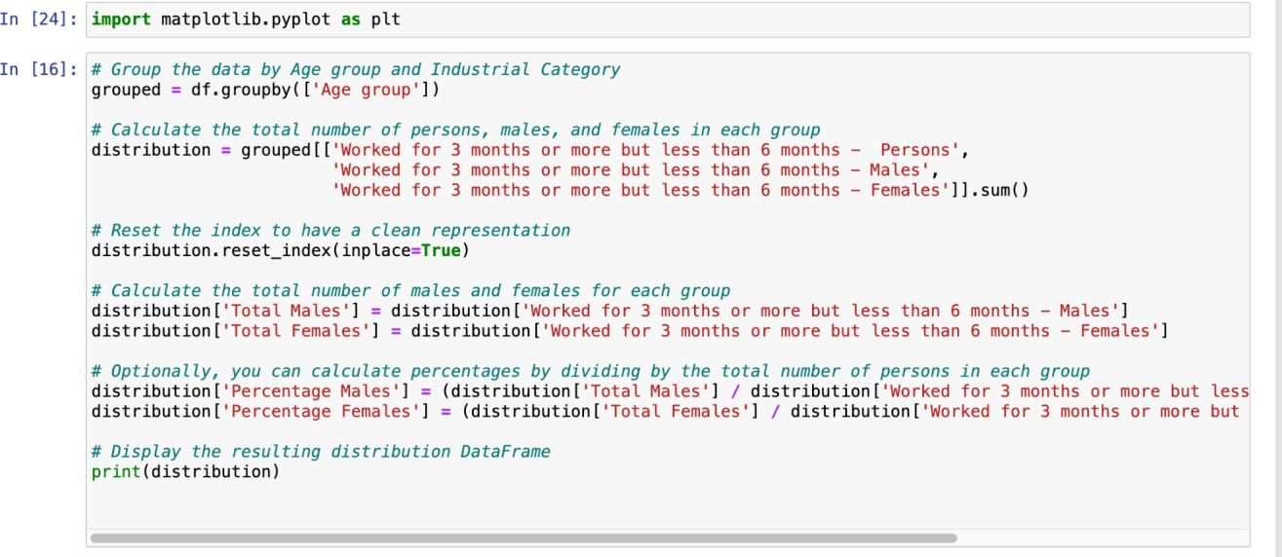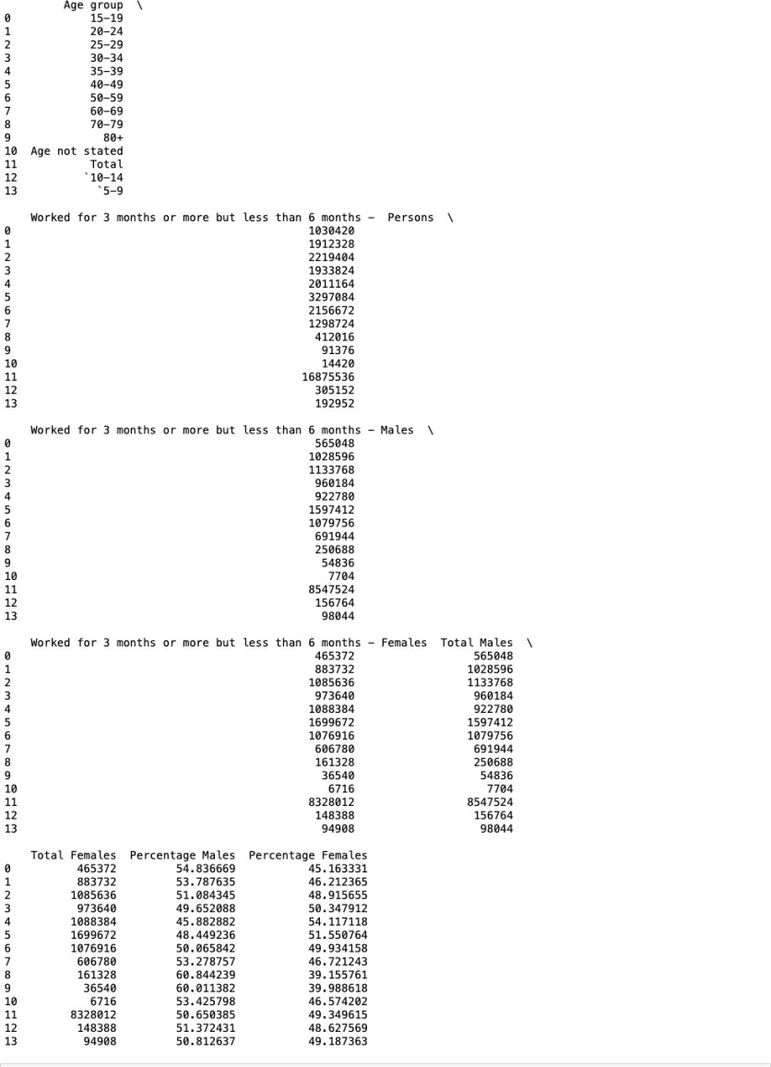

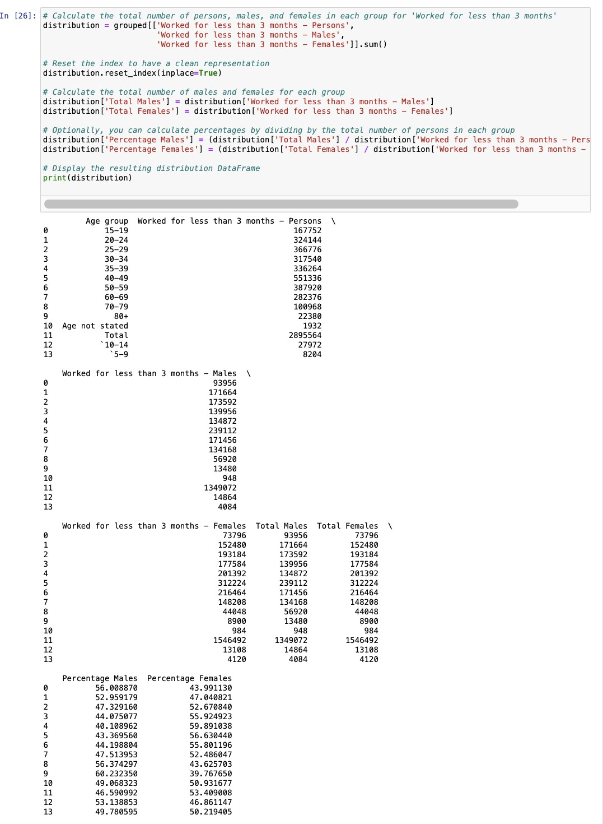

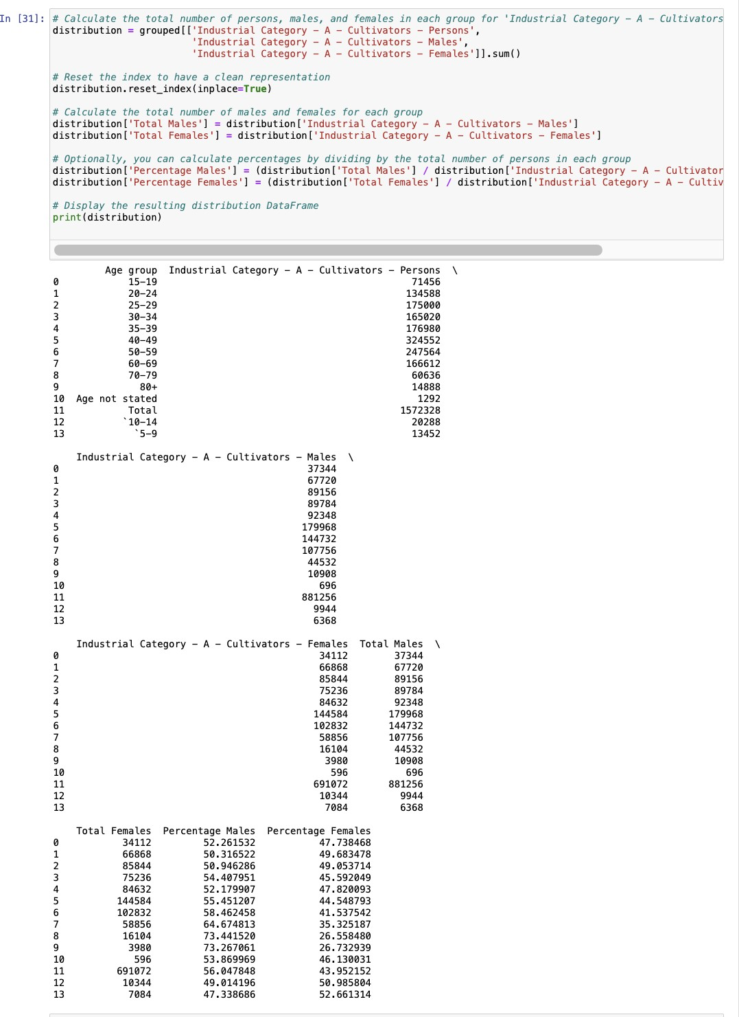

Visualisation:

