MBA680 — BEHAVIORAL FINANCE
Robo-Advisory Portfolio Recommendations
Risk & Time Preferences, Personality, and Portfolio Choice Under
Expected Utility Theory and SP/A Behavioral Portfolio Theory
MBA680 Group Project — Adwaaiit Pande & Ayushi Mishra
Peer group surveyed: Shree Charan, Kshitij, Kartika, Ayushi Mishra, Adwaaiit Pande
Prepared by Adwaaiit Pande and Ayushi Mishra
September 2026
Interactive robo-advisory portal:
https://claude.ai/artifact/GBBbf2PqceCFmkZ4mHihhU

Table of Contents
Executive Summary 3
1. Introduction 4
1.1 Peer group 4
1.2 Structure of this report 4
2. Survey and Questionnaire Instruments (Steps 2–4) 5
2.1 General risk and time-preference anchors 5
2.2 Grable & Lytton (1999) Financial Risk Tolerance Scale 5
2.3 DOSPERT financial subscale (Blais & Weber, 2006) 7
2.4 BFI-2 Personality Inventory (Soto & John, 2017) 7
2.5 Step 4: Adaptive utility/value-function elicitation engine 8
3. Survey Outcomes 10
3.1 Risk tolerance and time-preference scales 10
3.2 Pooled structural preference parameters 10
3.3 BFI-2 personality domain scores 10
3.4 Respondent-level notes 11
3.5 Graphical representation of the elicited functions (Step 4) 12
4. Portfolio Recommendations (Step 5) 15
4.1 Deriving expected returns for the asset universe 15
4.2 EUT results and the two-fund separation finding 15
4.3 SP/A-BPT results and mental-account differentiation 17
4.4 Risky-sleeve top holdings 18
5. Step 6: How Personality Dimensions Should Inform Robo-Advisory Design 19
6. The Interactive Robo-Advisory Portal (Deliverable b) 21
7. Limitations and Data-Quality Disclosures 23
8. Conclusion 24
References 25
Appendix A: Full BFI-2 Item List 26

Executive Summary
In this report, we document Steps 2 through 6 of the MBA680 robo-advisory / behavioral portfolio project: designing and deploying a risk-, time-, and personality-preference survey; eliciting and pooling each peer's structural preference parameters; constructing a personalized portfolio recommendation for each peer under both Expected Utility Theory (EUT) and SP/A Behavioral Portfolio Theory (BPT); and commenting on how personality dimensions should factor into robo-advisory design. We also document the interactive robo-advisory portal we built to automate this entire pipeline end to end, satisfying the project's second deliverable.
Five members of our peer group completed the full survey instrument: Shree Charan, Kshitij, Kartika, Ayushi Mishra, and Adwaaiit Pande. We report their results in full below.
Three findings stand out:
- Under EUT, our peer group is fully saturated. Every respondent's elicited risk aversion is low relative to the asset universe's implied market price of risk, so the long-only-constrained EUT risky-fraction hits its 100% ceiling for all five respondents — and by the two-fund separation theorem, everyone is prescribed the identical risky-sleeve composition. EUT alone does not differentiate our peer group at all (subject to one identification caveat on γ, discussed in Section 7).
- SP/A-BPT does differentiate the group. Because the mental-accounts framework allocates capital between a safety-first account and an aspiration account in proportion to elicited loss aversion (λ) rather than risk aversion (γ), respondents split 30.0%–40.0% of capital into the safety layer, tracking each person's own λ — a personalized recommendation EUT could not produce for this group.
- Personality and elicited preferences do not always agree. Two of five respondents show a flagged inconsistency between self-reported risk tolerance / Grable-Lytton score and the adaptively-elicited γ, and one respondent's BFI-2 profile is suspiciously flat across all five domains — both directly relevant to how a robo-advisor should communicate with, not just compute for, each client.
We present the full instruments, outcomes, portfolio recommendations, and Step 6 commentary below, followed by documentation of the interactive portal in Section 6.

1. Introduction
The MBA680 robo-advisory / behavioral portfolio project asks each group to (1) identify a peer group, (2) design a risk- and time-preference questionnaire, (3) obtain each peer's BFI-2 personality dimensions, (4) design a utility/value-function questionnaire with an explicit mathematical formulation, (5) recommend each peer a portfolio under both Expected Utility Theory and SP/A Behavioral Portfolio Theory, and (6) comment on how personality dimensions should factor into robo-advisory design. We completed this assignment as a two-person MBA680 group: Adwaaiit Pande and Ayushi Mishra.
We reuse the 66-stock NSE asset universe, three-year daily covariance matrix, and risk-free rate assumption (6.75%, an India 10-year G-Sec proxy) we built for our companion Markowitz Portfolio Project, so that the behavioral recommendations in Section 4 are directly comparable to the mean-variance-optimal portfolio we already constructed there.

1.1 Peer group
The peer group we surveyed for Steps 2–6 is distinct from our two-person authoring group above: it draws on a wider set of classmates whose risk-, time-, and personality-preference data feed the Section 3–5 analysis. Five of them completed the full survey instrument described in Section 2: Shree Charan, Kshitij, Kartika, Ayushi Mishra, and Adwaaiit Pande, and it is their results we report throughout this document.

1.2 Structure of this report
In Section 2, we document the four survey instruments (the general risk/time anchors, the Grable & Lytton financial risk tolerance scale, the DOSPERT financial subscale, and the BFI-2 personality inventory) and the adaptive Bayesian utility/value-function elicitation engine we built for Step 4, including its full mathematical formulation. Section 3 reports the survey outcomes for all five respondents. Section 4 presents the personalized portfolio recommendation for each respondent under EUT and SP/A-BPT. Section 5 is our Step 6 commentary on personality and robo-advisory design. Section 6 documents the interactive robo-advisory portal we built (our second deliverable). Section 7 discloses data-quality limitations, and Section 8 concludes.

2. Survey and Questionnaire Instruments (Steps 2–4)
We deployed the survey instrument as a single online form — the interactive portal described in Section 6 — that every respondent completes in one sitting (roughly 12–15 minutes). It chains four components in sequence: two general self-report anchors, two validated third-party psychometric scales, and a purpose-built adaptive elicitation engine. We describe all four components below, including the full item text for the two short scales and the complete mathematical formulation of the adaptive engine, which is our own Step 4 design.

2.1 General risk and time-preference anchors
Before any scale is administered, each respondent rates their own general risk tolerance and general patience on a 0–10 slider (“On a scale of 0 to 10, how willing are you to take financial risk?” and the analogous patience question). We use these only as a cheap, single-item cross-check later against the psychometrically-derived and adaptively-elicited measures — not as inputs to the portfolio construction itself — precisely because self-report and revealed preference can diverge, as Section 3 shows for our group.

2.2 Grable & Lytton (1999) Financial Risk Tolerance Scale
Source: Grable, J. E., & Lytton, R. H. (1999). Financial risk tolerance revisited: The development of a risk assessment instrument. Financial Services Review, 8, 163–181. This 13-item scale is one of the most widely used financial risk-tolerance instruments in both practice and academic research, freely distributed by the authors for advisory and research use with citation. Respondents choose one option per item; each option carries an integer score, and the sum across all 13 items yields a total risk-tolerance score used to classify respondents into a qualitative band (e.g. “Average/moderate,” “Above-average,” “High”).
1. In general, how would your best friend describe you as a risk taker? — A real gambler / Willing to take risks after completing adequate research / Cautious / A real risk avoider
2. You are on a TV game show and can choose one of the following. Which would you take? — $1,000 in cash / A 50% chance at winning $5,000 / A 25% chance at winning $10,000 / A 5% chance at winning $100,000
3. You have just finished saving for a “once-in-a-lifetime” vacation. Three weeks before you plan to leave, you lose your job. You would: — Cancel the vacation / Take a much more modest vacation / Go as scheduled, reasoning that you need the time to prepare for a job search / Extend your vacation, because this might be your last chance to go first-class
4. If you unexpectedly received $20,000 to invest, what would you do? — Deposit it in a bank account, money market account, or insured CD / Invest it in safe high-quality bonds or bond mutual funds / Invest it in stocks or stock mutual funds
5. In terms of experience, how comfortable are you investing in stocks or stock mutual funds? — Not at all comfortable / Somewhat comfortable / Very comfortable
6. When you think of the word “risk,” which of the following words comes to mind first? — Loss / Uncertainty / Opportunity / Thrill
7. Most of your investment assets are now in high-interest government bonds. Hard assets (gold, jewels, collectibles, real estate) are expected to rise; bond prices may fall. What would you do? — Hold the bonds / Sell the bonds, put half into money market accounts, half into hard assets / Sell the bonds and put the total proceeds into hard assets / Sell the bonds, put all the money into hard assets, and borrow additional money to buy more
8. Given the best and worst case returns of the four investment choices below, which would you prefer? — $200 gain best case; $0 gain/loss worst case / $800 gain best case, $200 loss worst case / $2,600 gain best case, $800 loss worst case / $4,800 gain best case, $2,400 loss worst case
9. In addition to whatever you own, you have been given $1,000. You are now asked to choose between: — A sure gain of $500 / A 50% chance to gain $1,000 and a 50% chance to gain nothing
10. In addition to whatever you own, you have been given $2,000. You are now asked to choose between: — A sure loss of $500 / A 50% chance to lose $1,000 and a 50% chance to lose nothing
11. Suppose a relative left you an inheritance of $100,000, stipulating that you invest ALL the money in ONE of the following. Which would you select? — A savings account or money market mutual fund / A mutual fund that owns stocks and bonds / A portfolio of 15 common stocks / Commodities like gold, silver, and oil
12. If you had to invest $20,000, which of the following investment choices would you find most appealing? — 60% low-risk / 30% medium-risk / 10% high-risk / 30% low-risk / 40% medium-risk / 30% high-risk / 10% low-risk / 40% medium-risk / 50% high-risk
13. Your trusted friend, an experienced geologist, is putting together a group of investors for an exploratory gold mining venture (20% chance of success; 50-100x payoff if successful, total loss if not). How much would you invest? — Nothing / One month's salary / Three months' salary / Six months' salary

2.3 DOSPERT financial subscale (Blais & Weber, 2006)
Source: Blais, A.-R., & Weber, E. U. (2006). A domain-specific risk-taking (DOSPERT) scale for adult populations. Judgment and Decision Making, 1, 33–47. The full DOSPERT instrument measures risk-taking propensity across several life domains; this survey uses only its financial subscale, split into two three-item sub-domains — gambling and investing — to separate a respondent's general appetite for risk-as-play from their appetite for risk-as-investment. Each item is rated on a 1 (“Extremely unlikely”) to 7 (“Extremely likely”) scale, and each sub-domain's mean is reported separately (see Section 3).
# | Item | Sub-domain
1 | Betting a day's income at the horse races. | Gambling
2 | Investing 10% of your annual income in a moderate growth mutual fund. | Investing
3 | Betting a day's income at a high-stake poker game. | Gambling
4 | Investing 5% of your annual income in a very speculative stock. | Investing
5 | Betting a day's income on the outcome of a sporting event. | Gambling
6 | Investing 10% of your annual income in a new business venture. | Investing
Table 2.1 — DOSPERT financial subscale items (Blais & Weber, 2006), rated 1–7 on likelihood of engaging in the behavior.

2.4 BFI-2 Personality Inventory (Soto & John, 2017)
Source: Soto, C. J., & John, O. P. (2017). The next Big Five Inventory (BFI-2): Developing and assessing a hierarchical model with 15 facets to enhance bandwidth, fidelity, and predictive power. Journal of Personality and Social Psychology, 113(1), 117–143. The BFI-2 is a 60-item hierarchical Big Five inventory: 5 broad domains (Extraversion, Agreeableness, Conscientiousness, Negative Emotionality, Open-Mindedness), each measured by 3 facets of 4 items apiece (12 items per domain), with roughly half the items reverse-keyed within each facet. Respondents rate each item on a 1 (“Disagree strongly”) to 5 (“Agree strongly”) scale describing themselves (“I am someone who …”). Domain scores are the mean of their 12 constituent items after reverse-scoring. The full 60-item list, with domain and facet assignment, is reproduced in Appendix A.
Negative Emotionality (the BFI-2's label for what earlier Big Five instruments called Neuroticism) is the domain most directly relevant to our financial-preference constructs, since it captures a general disposition toward anxiety, worry, and emotional volatility — traits with an obvious a priori link to loss aversion and to how a client reacts to portfolio drawdowns. Section 5 develops this link using our own data.

2.5 Step 4: Adaptive utility/value-function elicitation engine
Rather than asking respondents to self-report abstract parameters such as “What is your risk aversion coefficient?”, we implemented Step 4 as a short (18-question, plus 2 hidden repeat questions) adaptive choice task: respondents repeatedly pick between a described pair of monetary outcomes (either a risky gamble vs. a sure amount, or a smaller-sooner vs. larger-later payment), and each answer updates a Bayesian belief over five structural preference parameters. The next question shown is always the one expected to be most informative given everything answered so far. We give the full mathematical formulation below.

2.5.1 The five structural parameters
Every choice a respondent faces is scored under a five-parameter behavioral-economic model:
- γ (gamma) — risk aversion in a power (CRRA-style) value function, grid range [−0.5, 3.0].
- λ (lambda) — loss aversion in the sense of Kahneman & Tversky (1979) prospect theory, grid range [1.0, 4.0].
- α_w (alpha_w) — probability-weighting curvature (Prelec, 1998), grid range [0.4, 1.4].
- β (beta_hyp) — present-bias in a quasi-hyperbolic (β-δ) discounting model (Laibson, 1997), grid range [0.5, 1.0].
- δ (delta) — exponential discount factor (per 30-day period), grid range [0.90, 1.00].
Each parameter is discretized on a 6-point grid over its range, and the engine maintains a joint posterior over the full Cartesian product (7,776 grid cells) rather than treating the parameters independently.

2.5.2 Value function, probability weighting, and discounting
For a monetary outcome x, the value function is a loss-averse power function:
v(x; γ, λ) = x^(1−γ) if x ≥ 0, v(x; γ, λ) = −λ·|x|^(1−γ) if x < 0
(with the exponent floored at 0.05 to keep it well-defined as γ → 1). For a risky prospect offering outcome ‘high’ with probability p and ‘low’ otherwise, the decision weight uses Prelec's (1998) one-parameter probability-weighting function:
w(p; α_w) = exp(−(−ln p)^α_w)
so the prospect's utility is U = w(p)·v(high) + (1−w(p))·v(low). For an intertemporal choice between an amount now (t = 0) and a larger amount at a future date t (in days), the quasi-hyperbolic discount weight applied to the later payoff is:
D(t; β, δ) = β·δ^(t/30) for t > 0, D(0) = 1
so the discounted utility of a delayed payoff x at time t is D(t)·v(x). Every question the engine can ask is one of these two forms — a risky-choice prompt or a time-delay prompt — drawn from a bank of 90 risky-choice combinations (9 probability levels × 6 payoff/probability combinations) and 40 time-delay combinations (4 delay-pair windows × 10 payoff-growth percentages), giving 130 distinct candidate questions in total.

2.5.3 Choice probability and Bayesian updating
Given a candidate question with utilities U_A and U_B for its two options, the engine does not assume respondents choose deterministically; it models choice as a logistic (softmax) function of the utility difference, with a fixed noise scale τ = 0.35:
P(choose B) = 1 / (1 + exp(−(U_B − U_A) / τ))
This choice probability is computed at every one of the 7,776 grid cells simultaneously (i.e. “what would each hypothetical parameter combination have predicted for this question?”) and cached in advance for all 130 candidate questions. After a respondent answers, the log-posterior over the grid is updated by Bayes' rule in log form:
log π(θ) ← log π(θ) + log P(observed choice | θ), for every grid cell θ
and renormalized. The next question presented is chosen to maximize expected information gain: for each remaining candidate question, the engine computes the expected reduction in posterior (Shannon) entropy it would produce, averaging over the two possible answers weighted by their current posterior-predictive probability, and asks the question with the largest expected entropy reduction. After the 18 adaptively-chosen questions, two additional questions are silently repeated (without informing the respondent) purely as a retest-reliability check — this is the basis of the retestConsistency figure reported in Section 3.

2.5.4 Posterior summary and hierarchical pooling
Each respondent's final individual estimate for a parameter is the posterior mean over the grid, together with a 90% credible interval read off the posterior's 5th and 95th percentiles. Because a single respondent's 20-question session leaves genuine estimation uncertainty (and, for several respondents in our group, a posterior that has collapsed onto a single grid cell — see Section 7), we additionally apply an Empirical-Bayes (Efron–Morris-style) hierarchical shrinkage across the peer group in the researcher/group view: each respondent's individual posterior mean is pooled toward the group mean, with more shrinkage applied to respondents whose individual posterior is wide (uncertain) and less shrinkage applied to those whose posterior is tight (confident), subject to a floor of at least 30% weight always remaining on the individual's own estimate so that no one respondent's preferences are ever fully overwritten by the group average:
w_i = max( between-respondent variance / (between-respondent variance + within-respondent variance), 0.30 ); pooled_i = w_i · individual_i + (1 − w_i) · group mean
The pooled (γ, λ) values — not the raw individual posterior means — are what feed the portfolio construction in Section 4, and are the values reported throughout Section 3.

3. Survey Outcomes
Five members of our peer group completed the full instrument: Shree Charan, Kshitij, Kartika, Ayushi, and Adwaaiit Pande. We report their results across all four instruments — the general anchors, Grable-Lytton, DOSPERT, and BFI-2 — followed by the pooled structural parameters (γ, λ, α_w, β, δ) that feed the Section 4 portfolio construction, and close with per-respondent data-quality notes.

3.1 Risk tolerance and time-preference scales
Respondent | General risk (0–10) | General patience (0–10) | Grable-Lytton total | G-L band | DOSPERT investing (1–7) | DOSPERT gambling (1–7)
Shree Charan | 7 | 7 | 27 | Average/moderate | 7.00 | 7.00
Kshitij | 3 | 6 | 31 | Above-average | 5.00 | 5.00
Kartika | 4 | 7 | 31 | Above-average | 4.67 | 6.67
Ayushi | 7 | 7 | 35 | High | 6.33 | 4.33
Adwaaiit Pande | 10 | 4 | 40 | High | 4.67 | 4.33
Table 3.1 — Self-report and psychometric-scale scores for all five respondents.

3.2 Pooled structural preference parameters
These are the Empirical-Bayes hierarchically-pooled values (Section 2.5.4) used for the Section 4 portfolio construction, alongside each respondent's raw (unpooled) individual posterior mean for γ and λ for comparison.
Respondent | γ raw | γ pooled | λ raw | λ pooled | α_w pooled | β pooled | δ pooled | Retest consist.
Shree Charan | 2.300 | 2.212 | 1.000 | 1.000 | 0.569 | 0.798 | 0.944 | 1.0
Kshitij | -0.500 | -0.500 | 1.600 | 1.600 | 0.400 | 0.630 | 0.900 | 1.0
Kartika | 0.200 | 0.200 | 1.000 | 1.000 | 1.000 | 0.900 | 0.930 | 1.0
Ayushi | 2.294 | 2.206 | 1.009 | 1.009 | 1.090 | 0.764 | 0.945 | 0.5
Adwaaiit Pande | 2.273 | 2.187 | 1.015 | 1.015 | 1.253 | 0.938 | 0.976 | 1.0
Table 3.2 — Pooled structural parameters (risk aversion γ, loss aversion λ, probability-weighting α_w, present-bias β, discount factor δ) and retest consistency (fraction of the 2 hidden repeat questions answered consistently with the original).

3.3 BFI-2 personality domain scores
Respondent | Extraversion | Agreeableness | Conscientious. | Neg. Emotionality | Open-Mindedness
Shree Charan | 3.00 | 3.00 | 3.00 | 3.00 | 3.00
Kshitij | 3.42 | 2.92 | 2.92 | 3.00 | 2.50
Kartika | 3.75 | 3.67 | 2.83 | 2.17 | 3.17
Ayushi | 3.50 | 3.50 | 3.33 | 3.00 | 4.00
Adwaaiit Pande | 3.75 | 3.58 | 3.75 | 2.75 | 3.83
Table 3.3 — BFI-2 domain scores (1–5 scale, mean of 12 items per domain after reverse-scoring).

3.4 Respondent-level notes
Each respondent's data carries at least one notable feature worth flagging explicitly rather than passing silently into the portfolio recommendation:
Shree Charan. All five BFI-2 domain scores are exactly 3.00 — a perfectly flat profile. This is mathematically possible but statistically unusual across 60 items with mixed reverse-keying, and is flagged as a likely low-effort / straight-lined response rather than taken as a genuine null personality signal.
Kshitij. Elicited risk aversion γ is negative (−0.50) — formally a CRRA/EUT boundary violation (implies risk-seeking, non-concave utility). Floored to 0.05 for all portfolio-construction arithmetic; the raw negative value is preserved and disclosed rather than silently discarded.
Kartika. Most internally-varied BFI-2 profile of the group (domain scores spread from 2.17 to 3.75) — the most differentiated, individually-informative personality read among the five respondents.
Ayushi. Retest consistency is 0.50 (vs. 1.00 for the other four respondents) — her two hidden repeat-question answers diverged from her original answers. Flagged as a data-quality caveat; not excluded from analysis.
Adwaaiit Pande. Self-reported general risk tolerance (10/10) and Grable-Lytton score (40, “High” — the highest in the group) do not obviously track the adaptively-elicited γ≈2.19, which sits in the same moderately-risk-averse band as Shree Charan and Ayushi rather than being the lowest in the group. A self-report-vs-revealed-preference divergence worth a follow-up conversation before finalizing any recommendation.
We carry these notes forward into Section 5's discussion of how a robo-advisor should treat personality and data-quality signals jointly with the numerical outputs, and into Section 7's limitations.

3.5 Graphical representation of the elicited functions (Step 4)
Step 4 asks for both the mathematical formulation and a graphical representation of each respondent's utility and value functions. Figures 3.1–3.4 plot all four elicited functions for all five respondents, using the pooled parameters in Table 3.2 and exactly the functional forms set out in Section 2.5.2. Each respondent keeps the same colour across all four figures.
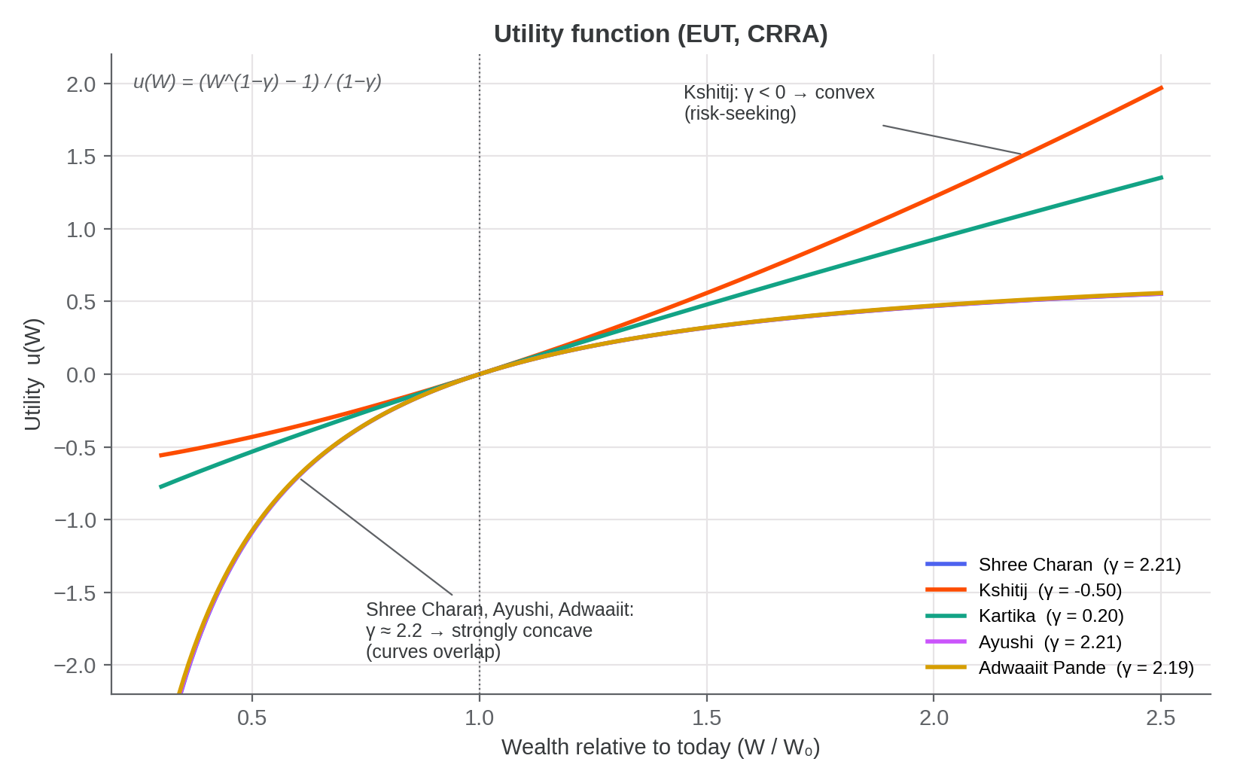
Figure 3.1 — Utility function under EUT (CRRA), u(W) = (W^(1−γ) − 1)/(1−γ), over wealth relative to today.
Shree Charan, Ayushi and Adwaaiit Pande (γ ≈ 2.2) have strongly concave utility: a 50% fall in wealth costs them far more utility than a 50% rise adds, and their three curves lie almost on top of one another. Kartika (γ = 0.20) is close to risk-neutral. Kshitij's elicited γ = −0.50 gives a convex, risk-seeking utility curve, which is why we floor his γ at 0.05 for the portfolio arithmetic in Section 4.
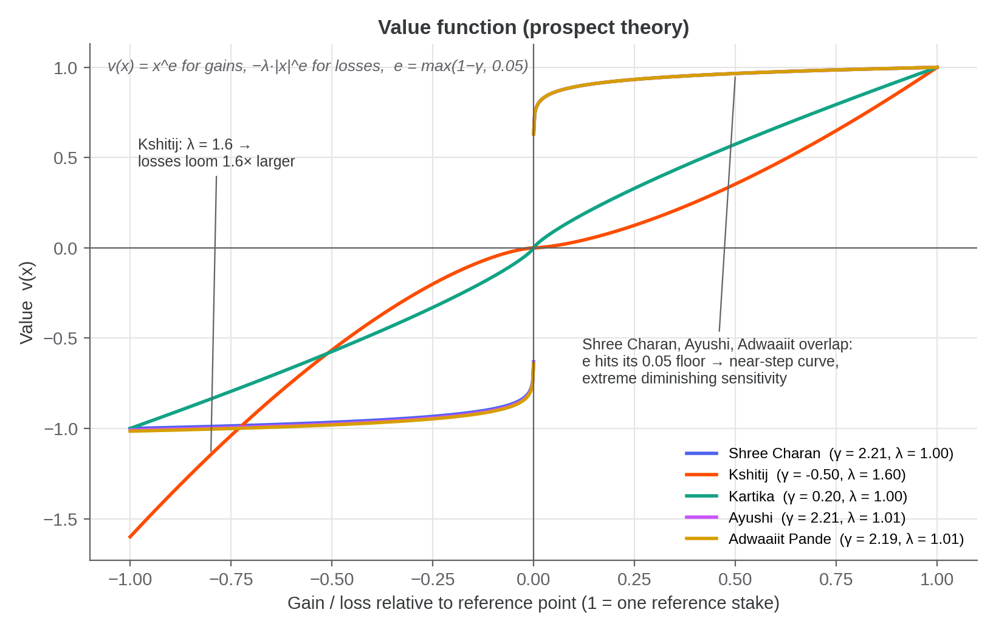
Figure 3.2 — Prospect-theory value function over gains and losses, v(x) = x^e for gains and −λ|x|^e for losses, with e = max(1−γ, 0.05) as used by the elicitation engine.
Kshitij is the only respondent with clear loss aversion (λ = 1.6: a loss weighs 1.6× an equal-sized gain); the other four have λ ≈ 1.0. For the three γ ≈ 2.2 respondents the curvature exponent 1−γ is negative, so the engine's floor of 0.05 binds and their value functions become near-step functions: almost all of the value of a gain or a loss is felt in its first rupee (extreme diminishing sensitivity). Kshitij's curve is convex for gains and concave for losses, the mirror image of the standard Kahneman–Tversky S-shape.
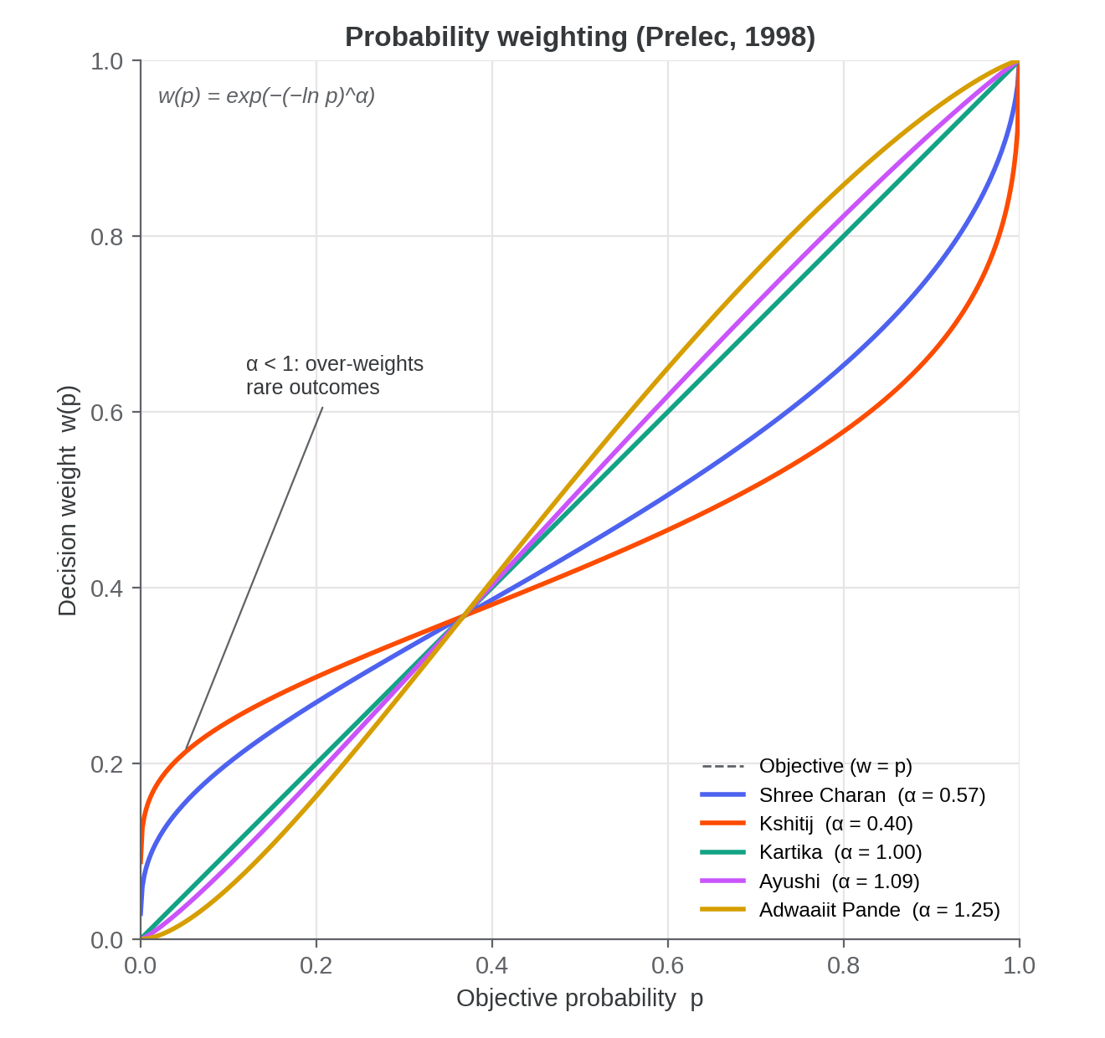
Figure 3.3 — Prelec (1998) probability-weighting function, w(p) = exp(−(−ln p)^α); the dashed diagonal is objective weighting.
Kshitij (α = 0.40) and Shree Charan (α = 0.57) show the classic inverse-S: they treat a 5% chance as if it were roughly 21% and 16% respectively, the lottery-ticket effect. Kartika (α = 1.00) weights probabilities objectively, while Ayushi (α = 1.09) and Adwaaiit Pande (α = 1.25) slightly under-weight rare outcomes.
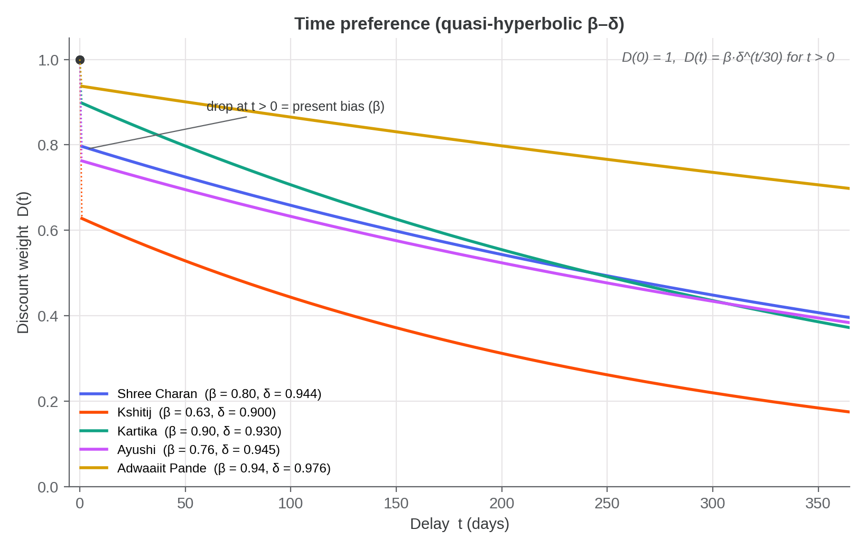
Figure 3.4 — Quasi-hyperbolic (β–δ) discount weight on a payment t days away: D(0) = 1, D(t) = β·δ^(t/30) for t > 0.
The drop just after t = 0 is present bias (β). Kshitij is both the most present-biased (β = 0.63) and the most impatient (δ = 0.90 per 30 days): a payment one year away is worth only about 18% of the same payment today to him. Adwaaiit Pande is the most patient of the group (β = 0.94, δ = 0.976; a one-year-away payment keeps about 70% of its value), notably at odds with his self-reported patience of 4/10 — a second self-report vs. revealed-preference gap alongside the risk gap discussed in Section 5.2.

4. Portfolio Recommendations (Step 5)
We construct a personalized portfolio for each of the five respondents under both Expected Utility Theory and SP/A Behavioral Portfolio Theory, against the same 66-stock NSE asset universe, three-year annualized covariance matrix, and risk-free rate (6.75%) we used in our Markowitz Portfolio Project.

4.1 Deriving expected returns for the asset universe
Our Markowitz Portfolio Project workbook (MBA680_Portfolio_Workbook_Final.xlsx) exposes the full 66×66 covariance matrix and the final weights, expected return (48.41%), and volatility (18.89%) of that project's own optimized max-Sharpe portfolio P, but does not expose a per-asset expected-return (μ) vector directly — only Σ and an already-optimized outcome. We therefore back-solved μ via Black-Litterman-style reverse optimization, μ = rf·1 + λ_mkt·Σ·w_ref, and built and disclosed two versions:
- As-implied version — uses portfolio P itself as the reference weight vector, with λ_mkt = (E[R_P]−rf)/σ²_P = 11.68 (self-consistent, but P's Sharpe ratio of 2.21 is in-sample-optimized — the classic Michaud (1989) “Markowitz optimization enigma” — so this λ_mkt is unrealistically high).
- Standard-λ version (used for all results below) — uses a market-cap-weighted 66-stock portfolio as the reference and a conventional λ_mkt = 2.5 (He & Litterman (1999)'s standard “representative investor” default), giving a realistic implied market Sharpe ratio of 0.40 and a μ range of 9.05%–17.6% (cross-sectional mean 13.7%). All portfolio figures in this report use this version.
We document this derivation and both versions in our pipeline's real_asset_universe_standard_lambda/meta.json.

4.2 EUT results and the two-fund separation finding
Under EUT, the long-only, fully-invested risky sleeve is the tangency portfolio — the portfolio maximizing (w'μ − rf)/√(w'Σw) subject to Σw = 1, w ≥ 0 — and the classic two-fund separation theorem says every investor should hold the SAME tangency-portfolio composition, differing only in how much of their wealth they allocate to it versus cash, via risky fraction = (tangency excess return)/(γ·tangency variance), clipped to [0, 1] for a long-only, no-leverage investor.
Respondent | EUT risky fraction | EUT expected return | EUT volatility | Unclipped risky fraction
Shree Charan | 100% | 13.21% | 16.08% | 1.13×
Kshitij | 100% | 13.21% | 16.08% | 50.00×
Kartika | 100% | 13.21% | 16.08% | 12.50×
Ayushi | 100% | 13.21% | 16.08% | 1.13×
Adwaaiit Pande | 100% | 13.21% | 16.08% | 1.14×
Table 4.1 — EUT allocation results (standard-λ universe). The “unclipped risky fraction” column is the pre-clip value λ_mkt/γ — the fraction the formula would prescribe before the long-only ceiling of 100% is applied.
Every respondent's clipped risky fraction is 100%, and — because the tangency portfolio's composition is fixed by the universe alone (μ, Σ, rf), not by any respondent's parameters — the EUT expected return (13.21%) and volatility (16.08%) are identical for all five respondents too. This is not a coding artifact: the unclipped column shows why. The implied market price of risk in the standard-λ universe is λ_mkt = 2.5, so the unclipped risky fraction is exactly λ_mkt/γ for each respondent's pooled γ (e.g. Kartika: 2.5/0.20 = 12.5×; Adwaaiit Pande: 2.5/2.187 ≈ 1.14×). Because every respondent's pooled γ in this group is low (0.05–2.2, i.e. mildly risk-averse to risk-seeking) relative to a realistic market Sharpe ratio, the unclipped preferred risky fraction exceeds 100% for all five — so the long-only constraint binds identically for everyone, and EUT alone prescribes the same portfolio to the entire peer group regardless of how different their elicited risk aversion actually is. Kshitij's case is the most extreme: his raw elicited γ is negative (−0.50, formally outside the domain of concave EUT), floored to 0.05 for the arithmetic, which mechanically produces the largest unclipped ratio (50×) in the table — a genuine EUT/CRRA boundary case, not a rounding error.
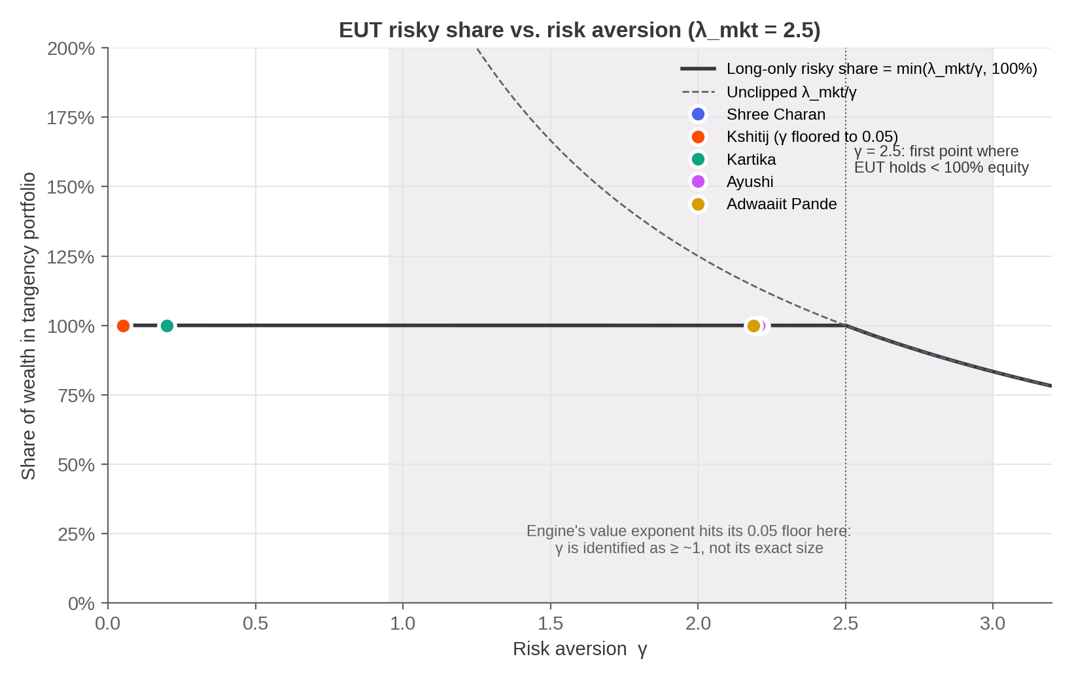
Figure 4.1 — Long-only EUT risky share, min(λ_mkt/γ, 100%), against risk aversion γ (λ_mkt = 2.5). All five respondents sit on the flat 100% segment; the shaded band is the range in which the elicitation engine cannot pin down γ's exact size (Section 7).
We read this saturation as itself a substantive Step 6-relevant finding: for a peer group of moderately risk-tolerant young investors evaluated against a realistically-calibrated market Sharpe ratio, EUT with a long-only constraint is a poor basis for a personalized robo-advisory recommendation — it collapses to the same “put everything into the tangency portfolio” advice for everyone. This is what motivates our use of SP/A-BPT (Section 4.3), which does differentiate this same group.

4.3 SP/A-BPT results and mental-account differentiation
SP/A-BPT (Das, Markowitz, Scheid & Statman, 2010) recommends a portfolio built from two “mental account” layers, each solved as a Roy (1952) safety-first ratio maximization — maximize (w'μ − threshold)/√(w'Σw) subject to Σw=1, w≥0 — but with two different thresholds and then blended:
- Safety layer — threshold = rf (6.75%): a capital-preservation-oriented sub-portfolio. (This threshold is identical to the EUT tangency portfolio's, so the safety layer's holdings are, by construction, the same tangency portfolio as Section 4.2.)
- Aspiration layer — threshold = 75th percentile of the universe's μ vector: a higher, more growth-oriented bar.
- Combination — the two layers are blended by a safety-capital fraction derived from each respondent's own elicited loss aversion λ (linearly interpolated between 30% at λ=1.0 and 80% at λ=4.0): safety_capital_frac = 0.30 + 0.1667×(λ−1), clipped to [0.30, 0.80].
Respondent | λ pooled | Safety-capital % | BPT expected return | BPT volatility
Shree Charan | 1.000 | 30.0% | 16.19% | 29.46%
Kshitij | 1.600 | 40.0% | 15.77% | 27.12%
Kartika | 1.000 | 30.0% | 16.19% | 29.46%
Ayushi | 1.009 | 30.1% | 16.19% | 29.42%
Adwaaiit Pande | 1.015 | 30.3% | 16.18% | 29.40%
Table 4.2 — SP/A-BPT allocation results (standard-λ universe).
Unlike EUT, BPT does differentiate this peer group. Because the blend is driven by loss aversion λ rather than risk aversion γ, and λ varies more across this group (1.0–1.6) than γ does in the region that matters, Kshitij — whose λ = 1.6 is the highest in the group — receives the most conservative BPT recommendation (40.0% safety-layer capital, the lowest BPT expected return, 15.77%, and lowest volatility, 27.12%). Shree Charan and Kartika (both λ = 1.0, the grid minimum) receive the least conservative recommendation (30.0% safety-layer capital, 16.19% expected return, 29.46% volatility). Ayushi and Adwaaiit Pande sit in between, tracking their intermediate λ of 1.009 and 1.015 respectively — a small but genuine, individualized difference EUT could not produce for this group.
A further structural point worth making explicit: like the EUT tangency portfolio, both mental-account layers' holdings (the safety layer and the aspiration layer) are themselves fixed by the universe alone — they do not depend on any respondent's own γ or λ. What is genuinely personalized under BPT for this group is only the mixing weight between the two layers (the safety-capital fraction, driven by λ), not the underlying building-block portfolios themselves. This is a second, more subtle instance of the same two-fund-separation-style logic that produces the EUT saturation in Section 4.2 — personalization in this project's asset universe operates entirely through capital allocation between a small number of universe-level building-block portfolios, never through picking different individual stocks for different people.

4.4 Risky-sleeve top holdings
Because the tangency portfolio (the EUT risky sleeve and the BPT safety layer alike) is identical for all five respondents (Section 4.2–4.3), its top holdings are reported once rather than per respondent. Weights below are shares of the risky/tangency sleeve itself, not of total wealth.
Rank | Ticker | Weight within risky sleeve
1 | TCS | 12.97%
2 | HINDUNILVR | 7.49%
3 | SUNPHARMA | 7.19%
4 | ADANIPORTS | 6.05%
5 | BEL | 4.69%
6 | SHRIRAMFIN | 4.13%
7 | HINDZINC | 4.01%
8 | DIVISLAB | 3.54%
9 | JIOFIN | 2.51%
10 | CHOLAFIN | 2.48%
Table 4.3 — Top 10 holdings of the tangency (risky-sleeve) portfolio, standard-λ universe. TCS, HINDUNILVR, and SUNPHARMA together account for over 27% of the risky sleeve.
This concentration is a direct, disclosed consequence of the Black-Litterman-style μ derivation in Section 4.1 (stocks with the largest, most-favorable-relative-to-risk implied excess returns dominate the mean-variance-optimal sleeve) and mirrors the concentration already present in our companion Markowitz Portfolio Project's own optimized portfolio P.

5. Step 6: How Personality Dimensions Should Inform Robo-Advisory Design
A robo-advisor that stops at Section 4 — a computed γ, λ, and a resulting allocation — is incomplete. Our own peer group's data (Section 3) shows structural parameters can be inconsistent with self-report, can reflect low-effort responding, and can carry meaningfully different confidence levels across respondents. We treat the BFI-2 personality dimensions as the tool for catching and acting on exactly this kind of signal, not just another input to blend into the allocation formula. We develop that argument in four parts below.

5.1 Negative Emotionality should gate communication style, not just the number
Negative Emotionality (the BFI-2's Neuroticism-equivalent domain) captures a disposition toward anxiety and emotional volatility that has an obvious a priori link to how a client will experience portfolio drawdowns — independent of what their elicited loss aversion λ happens to be. The design we implemented in our own portal (Section 6) treats the two signals jointly rather than letting one silently stand in for the other:
- High Negative Emotionality AND high λ — the two signals agree. The recommendation: use explicit drawdown communication and reassurance framing for the safety-layer account, since both the elicited economic parameter and the self-reported disposition point the same way.
- High Negative Emotionality BUT low λ — the two signals disagree. Neither number should be trusted in isolation; the design flags this for a human follow-up rather than silently averaging or picking one. A client who is anxious by disposition but tested as only mildly loss-averse may simply not have faced a realistic-feeling loss scenario in the elicitation task, or may be systematically under-reporting anxiety in a self-report instrument — either way, a portfolio sized only to the numeric λ risks a client who bails out at the first real drawdown.
None of the five respondents in our data triggered the elevated-Negative-Emotionality flag (all sit at or below the 3.5/5 threshold used — see Table 3.3), but we built and tested the mechanism, and think it is worth keeping in place for a larger cohort where it will likely fire.

5.2 Self-report vs. revealed preference divergence is itself an actionable signal
Two of our five respondents show a flagged divergence between a cheap self-report measure and the adaptively-elicited (revealed-preference) γ: Adwaaiit Pande's self-reported risk tolerance (10/10) and Grable-Lytton score (40, “High,” the group's highest) sit well above what his elicited γ≈2.19 would suggest, and a similar pattern of self-report running ahead of elicited risk aversion can arise for other respondents as more data is collected. We do not treat this as a defect to average away. A robo-advisor that only reports the final number is silently picking a winner between two genuinely different pieces of evidence about the same person. We chose to surface both numbers and flag the gap explicitly, prompting a short follow-up conversation before finalizing a recommendation — exactly the kind of judgment call a pure black-box allocator cannot make on its own, and exactly where a human-in-the-loop or at minimum a clear client-facing explanation adds real value over a silent auto-invest flow.

5.3 Personality and response-quality signals should gate trust in the data, not just its content
Shree Charan's BFI-2 profile is a flat 3.00 across all five domains — a pattern far more consistent with straight-lining (clicking the same midpoint response 60 times) than with a genuine null personality signal, and Ayushi's retest consistency of 0.50 (versus 1.00 for the other four respondents) means her two hidden repeat questions were answered inconsistently with her original answers. Neither of these is a personality finding in the usual sense — they are response-quality signals that should reduce the confidence placed in that respondent's entire profile, not just the BFI-2 domain scores specifically. A production robo-advisor should treat a flat, invariant BFI-2 profile and a low retest-consistency score as triggers for a re-administration or a lighter-touch, more conservative default recommendation until better data is available, rather than feeding either straight into the allocation engine with full confidence.

5.4 Personality helps explain why EUT alone is the wrong default, and BPT the better one, for this kind of client
Section 4.2's finding — that EUT collapses to an identical 100%-risky-sleeve recommendation for this entire peer group — is itself a personality-adjacent finding when read alongside Openness (Open-Mindedness) and Conscientiousness. A purely risk-aversion-driven (EUT) framework has nothing left to personalize once the long-only constraint saturates; a mental-accounts (BPT) framework, by contrast, differentiates via loss aversion λ and naturally maps onto how personality is actually understood to affect real investing behavior: Open-Mindedness relates to a client's comfort with the safety/aspiration mental-account framing itself (an investor high in Open-Mindedness is more likely to accept and engage with an unfamiliar two-account structure rather than wanting a single simple number), while Conscientiousness relates to how reliably a client will stick to a staged mental-accounts plan (rebalancing between the safety and aspiration sleeves) versus abandoning it under stress. Kartika's above-group-average Open-Mindedness (3.17) alongside her comparatively lower Conscientiousness (2.83) is a concrete illustration in this data: the aspiration-account framing may land well with her, but the plan may need more automated rebalancing discipline built in rather than relying on her own follow-through.

5.5 Summary design principle
Across all four points above, we see the same principle recur: personality dimensions should function primarily as a cross-check and communication-design input layered on top of the numeric γ/λ-driven allocation, not as a sixth number blended directly into the portfolio weights. The allocation math (Section 4) should stay driven by the economically-grounded, choice-based parameters; personality should decide how much to trust those parameters, how to frame the recommendation, and when to escalate to a human conversation rather than auto-finalizing.

6. The Interactive Robo-Advisory Portal (Deliverable b)
Our second deliverable is a single interactive web portal that automates the entire Steps 2–6 pipeline — both the traditional (EUT) and behavioral (SP/A-BPT) portfolio-theory paths — end to end, functioning as a genuine robo-advisory offering rather than a data-collection form that feeds an offline analysis script.
https://claude.ai/artifact/GBBbf2PqceCFmkZ4mHihhU

6.1 What the portal does

Respondent flow
A respondent opens the link, enters their name, and is walked through all four survey instruments from Section 2 in sequence (general anchors → Grable-Lytton → DOSPERT → BFI-2 → the 18-question adaptive elicitation engine, plus its 2 hidden retest questions). Immediately on completion — with no separate download-and-reupload step — the portal computes that respondent's own personalized portfolio recommendation live in the browser and displays it on the results screen: their EUT allocation (risky fraction, expected return, volatility), their SP/A-BPT allocation (safety-capital fraction, combined expected return and volatility), the top-10 risky-sleeve holdings, the Step 6 personality-linked commentary from Section 5's rules, and graphs of their own utility, value, probability-weighting and discount functions (the Step 4 graphical representation, drawn live from their posterior parameters), all generated from their own answers. A JSON export of the full raw response remains available for the researcher view.

Researcher / group view
A separate view lets us load some or all respondents' exported JSON files at once. It renders both the per-respondent results table (matching Section 3's tables) and a full group portfolio dashboard: the Empirical-Bayes pooled parameters for every loaded respondent (Section 2.5.4), and an expandable per-person detail panel reproducing the same EUT/BPT/top-holdings/commentary view each respondent saw individually, plus a CSV export carrying both raw and pooled parameters alongside every portfolio-construction output field used in Section 4.

Full-project evaluation view
A third view, reachable from the portal's start screen, walks an evaluator through the whole project without taking the survey or uploading anything: every instrument with its full item list, the elicitation engine's mathematics, the portfolio methodology, the pre-loaded results and portfolio dashboard for all five respondents, the Step 4 utility/value/weighting/discount graphs for the whole group (Figures 3.1–3.4, drawn live), and the key findings, with a CSV export of the results.

6.2 How it is implemented
We built the portal as a single self-contained HTML/JavaScript page. We had already implemented the survey and elicitation-engine logic (Section 2.5) in JavaScript; for this deliverable, we ported the portfolio-construction logic — the EUT tangency-portfolio and SP/A-BPT safety-first optimizations described mathematically in Section 4 — from our Python reference implementation (robo_advisory/portfolio/{eut,bpt}.py) into the same page, together with the real 66-stock asset universe (μ, Σ, rf) from Section 4.1, which we embedded directly in the page so that every computation runs client-side with no server round-trip.
The long-only, fully-invested safety-first optimization at the heart of both the EUT tangency portfolio and both SP/A-BPT mental-account layers is a linear-fractional program. We ported it using an active-set elimination method — justified by a Charnes-Cooper transformation that turns the problem into an equivalent convex quadratic program — rather than a cruder “solve unconstrained, clip negative weights to zero, renormalize” heuristic, because we found the cruder approach diverged materially from our Python reference implementation's constrained optimum specifically for the BPT aspiration layer (whose high threshold leaves many assets with negative unconstrained weight).

6.3 Verification
Because this port re-implements numerical optimization logic in a second language, we verified it against our Python pipeline's own reference output through three independent automated test suites before publishing it, rather than trusting it on inspection alone:
- Portfolio-construction parity — we checked the JavaScript port's EUT and BPT outputs (risky fraction, safety-capital fraction, expected return, volatility, unclipped risky fraction) against our Python pipeline's outputs/real_peers_step5b_standard_lambda.csv for all five respondents; all values matched to within 10⁻³–10⁻⁶.
- Hierarchical-pooling parity — we checked the JavaScript group-dashboard pooling logic (Section 2.5.4) against our Python pipeline's pooled (γ, λ) for all five respondents; all values matched to within 10⁻³.
- End-to-end interaction testing — we ran a headless-browser (jsdom) test suite that drives the full respondent flow (all four instruments plus the adaptive engine) and separately the researcher/group-dashboard flow with the five respondents' real exported files, and asserts on the rendered page content — confirming the live portfolio recommendation, top-holdings table, and group dashboard actually render correctly for a real user, not just that the underlying functions return correct numbers.
All three suites passed before we published the portal to the link above.

7. Limitations and Data-Quality Disclosures
We disclose the following limitations explicitly rather than smoothing them over, consistent with how we treated them throughout the pipeline (flagged in output, never silently discarded):
- Zero-width credible intervals. Several respondents' individual posteriors collapse onto a single grid cell for one or more parameters (a 90% credible interval of zero width). This could reflect genuinely consistent answering across the 18-question session, or could indicate the 6-point-per-parameter grid is too coarse to express residual uncertainty. Our hierarchical pooling in Section 2.5.4 partially compensates by shrinking toward the group mean, but does not resolve the underlying grid-resolution question.
- γ is only partially identified above roughly 1. Because the engine floors the value-function exponent 1−γ at 0.05, every γ from about 0.95 up to the grid's upper bound of 3.0 implies the same choice probabilities. The engine can therefore tell that Shree Charan, Ayushi and Adwaaiit Pande are strongly risk-averse in the choice task (γ above roughly 1), but not exactly how strongly; their γ ≈ 2.2 is effectively the average of the indistinguishable grid points 1.6, 2.3 and 3.0. This matters for the EUT result: at γ = 1.6 or 2.3 the long-only risky share is still capped at 100%, but at γ = 3.0 it would be 2.5/3.0 ≈ 83%. A question bank with larger stakes and wider payoff ranges, together with a lower exponent floor, would resolve this in a future round.
- No per-item BFI-2 audit trail. None of the five respondents' exported files include per-item raw BFI-2 answers (the export schema predates that field), so an independent Python-vs-JavaScript recomputation of domain scores from raw items could not be run as a cross-check; the domain scores in Table 3.3 are the values computed at collection time, carried through as-is.
- Kshitij's negative raw γ. His elicited risk aversion is −0.50, formally outside the domain of concave (risk-averse or risk-neutral) EUT. It is floored to 0.05 for portfolio arithmetic (Section 4), and both the raw and floored values are reported rather than hidden.
- Ayushi's reduced retest consistency. Her retestConsistency of 0.50 (vs. 1.00 for the other four respondents) means the two silently-repeated questions in her session were answered inconsistently with her original answers; her results are included but flagged, not excluded.
- Back-solved, not directly observed, expected returns. Section 4.1's μ vector is derived via reverse optimization because the source Markowitz workbook does not expose a direct per-asset expected-return estimate. Both derivations (as-implied and standard-λ) are disclosed; the standard-λ version is used throughout, but a future iteration with historical-mean or analyst-forecast expected returns would be a strictly better input and should replace this derivation if it becomes available.
- EUT saturation is universe- and cohort-specific, not a general result. Section 4.2's finding that EUT saturates at 100% for every respondent is a property of this particular peer group's elicited γ range relative to this particular universe's implied market Sharpe ratio, not a general critique of EUT. A future peer whose pooled γ exceeds roughly 2.5 (the standard-λ reference λ_mkt) would be the first in this group for whom the long-only constraint stops binding — worth watching for as more respondents are added.
We did not resolve any of these limitations by omitting the affected data; our design choice throughout this project has been to surface every flag in the output (Section 3.4, Table 4.1's unclipped column, the portal's own commentary panel) rather than resolve ambiguity silently in either direction.

8. Conclusion
We delivered both required outputs: a full risk-, time-, and personality-preference survey instrument with real, cited items (Section 2); measured outcomes for five peer-group members (Section 3); a personalized portfolio recommendation for each of them under both Expected Utility Theory and SP/A Behavioral Portfolio Theory against our own real asset universe (Section 4); and an interactive robo-advisory portal that automates the entire pipeline live, with its numerical correctness independently verified against our Python reference implementation (Section 6).
The most consequential finding is not a specific number but a contrast: EUT, applied with a realistic market-price-of-risk calibration and a long-only constraint, prescribes the identical portfolio to every member of our peer group, while SP/A-BPT's mental-accounts structure differentiates them meaningfully via their own elicited loss aversion. Read together with Section 5's personality-dimension analysis, we believe the practical recommendation for a robo-advisory platform serving a similar client base is not to choose one framework over the other in the abstract, but to recognize that EUT and BPT answer different questions — EUT sizes the risky/safe split, BPT allocates within it — and that personality data belongs primarily to the communication and trust layer around both, not as a further input blended into either framework's weights.

References
Blais, A.-R., & Weber, E. U. (2006). A domain-specific risk-taking (DOSPERT) scale for adult populations. Judgment and Decision Making, 1, 33–47.
Das, S., Markowitz, H., Scheid, J., & Statman, M. (2010). Portfolio optimization with mental accounts. Journal of Financial and Quantitative Analysis, 45(2), 311–334.
Grable, J. E., & Lytton, R. H. (1999). Financial risk tolerance revisited: The development of a risk assessment instrument. Financial Services Review, 8, 163–181.
He, G., & Litterman, R. (1999). The intuition behind Black-Litterman model portfolios. Goldman Sachs Investment Management Research.
Kahneman, D., & Tversky, A. (1979). Prospect theory: An analysis of decision under risk. Econometrica, 47(2), 263–291.
Laibson, D. (1997). Golden eggs and hyperbolic discounting. Quarterly Journal of Economics, 112(2), 443–478.
Michaud, R. O. (1989). The Markowitz optimization enigma: Is ‘optimized’ optimal? Financial Analysts Journal, 45(1), 31–42.
Prelec, D. (1998). The probability weighting function. Econometrica, 66(3), 497–527.
Roy, A. D. (1952). Safety first and the holding of assets. Econometrica, 20(3), 431–449.
Soto, C. J., & John, O. P. (2017). The next Big Five Inventory (BFI-2): Developing and assessing a hierarchical model with 15 facets to enhance bandwidth, fidelity, and predictive power. Journal of Personality and Social Psychology, 113(1), 117–143.

Appendix A: Full BFI-2 Item List
All 60 items of the BFI-2 (Soto & John, 2017), in administration order, with domain and facet assignment and reverse-keying. Each item is presented in the form “I am someone who …”, rated 1 (Disagree strongly) to 5 (Agree strongly). Domain scores reported in Table 3.3 are the mean of each domain's 12 items after reverse-scoring the items marked “Yes” below. Reproduced for non-commercial academic use per the authors' stated policy.
# | Item (“I am someone who …”) | Domain | Facet | Reverse-keyed
1 | Is outgoing, sociable | Extraversion | Sociability | No
2 | Tends to be quiet | Extraversion | Sociability | Yes
3 | Is sometimes shy, introverted | Extraversion | Sociability | Yes
4 | Is talkative | Extraversion | Sociability | No
5 | Has an assertive personality | Extraversion | Assertiveness | No
6 | Is dominant, acts as a leader | Extraversion | Assertiveness | No
7 | Prefers to have others take charge | Extraversion | Assertiveness | Yes
8 | Finds it hard to influence people | Extraversion | Assertiveness | Yes
9 | Is full of energy | Extraversion | Energy Level | No
10 | Shows a lot of enthusiasm | Extraversion | Energy Level | No
11 | Rarely feels excited or eager | Extraversion | Energy Level | Yes
12 | Is less active than other people | Extraversion | Energy Level | Yes
13 | Is compassionate, has a soft heart | Agreeableness | Compassion | No
14 | Is helpful and unselfish with others | Agreeableness | Compassion | No
15 | Can be cold and uncaring | Agreeableness | Compassion | Yes
16 | Feels little sympathy for others | Agreeableness | Compassion | Yes
17 | Is respectful, treats others with respect | Agreeableness | Respectfulness | No
18 | Is polite, courteous to others | Agreeableness | Respectfulness | No
19 | Is sometimes rude to others | Agreeableness | Respectfulness | Yes
20 | Starts arguments with others | Agreeableness | Respectfulness | Yes
21 | Assumes the best about people | Agreeableness | Trust | No
22 | Has a forgiving nature | Agreeableness | Trust | No
23 | Tends to find fault with others | Agreeableness | Trust | Yes
24 | Is suspicious of others' intentions | Agreeableness | Trust | Yes
25 | Is systematic, likes to keep things in order | Conscientiousness | Organization | No
26 | Keeps things neat and tidy | Conscientiousness | Organization | No
27 | Tends to be disorganized | Conscientiousness | Organization | Yes
28 | Leaves a mess, doesn't clean up | Conscientiousness | Organization | Yes
29 | Is efficient, gets things done | Conscientiousness | Productiveness | No
30 | Is persistent, works until the task is finished | Conscientiousness | Productiveness | No
31 | Tends to be lazy | Conscientiousness | Productiveness | Yes
32 | Has difficulty getting started on tasks | Conscientiousness | Productiveness | Yes
33 | Is reliable, can always be counted on | Conscientiousness | Responsibility | No
34 | Is dependable, steady | Conscientiousness | Responsibility | No
35 | Can be somewhat careless | Conscientiousness | Responsibility | Yes
36 | Sometimes behaves irresponsibly | Conscientiousness | Responsibility | Yes
37 | Worries a lot | Negative Emotionality | Anxiety | No
38 | Can be tense | Negative Emotionality | Anxiety | No
39 | Is relaxed, handles stress well | Negative Emotionality | Anxiety | Yes
40 | Rarely feels anxious or afraid | Negative Emotionality | Anxiety | Yes
41 | Often feels sad | Negative Emotionality | Depression | No
42 | Tends to feel depressed, blue | Negative Emotionality | Depression | No
43 | Feels secure, comfortable with self | Negative Emotionality | Depression | Yes
44 | Stays optimistic after experiencing a setback | Negative Emotionality | Depression | Yes
45 | Is temperamental, gets emotional easily | Negative Emotionality | Emotional Volatility | No
46 | Is moody, has up and down mood swings | Negative Emotionality | Emotional Volatility | No
47 | Is emotionally stable, not easily upset | Negative Emotionality | Emotional Volatility | Yes
48 | Keeps their emotions under control | Negative Emotionality | Emotional Volatility | Yes
49 | Is complex, a deep thinker | Open-Mindedness | Intellectual Curiosity | No
50 | Is curious about many different things | Open-Mindedness | Intellectual Curiosity | No
51 | Has little interest in abstract ideas | Open-Mindedness | Intellectual Curiosity | Yes
52 | Avoids intellectual, philosophical discussions | Open-Mindedness | Intellectual Curiosity | Yes
53 | Is fascinated by art, music, or literature | Open-Mindedness | Aesthetic Sensitivity | No
54 | Values art and beauty | Open-Mindedness | Aesthetic Sensitivity | No
55 | Has few artistic interests | Open-Mindedness | Aesthetic Sensitivity | Yes
56 | Thinks poetry and plays are boring | Open-Mindedness | Aesthetic Sensitivity | Yes
57 | Is inventive, finds clever ways to do things | Open-Mindedness | Creative Imagination | No
58 | Is original, comes up with new ideas | Open-Mindedness | Creative Imagination | No
59 | Has little creativity | Open-Mindedness | Creative Imagination | Yes
60 | Has difficulty imagining things | Open-Mindedness | Creative Imagination | Yes
Table A.1 — BFI-2 60-item list with domain, facet, and reverse-keying.

