|  |  |
| --- | --- |
| **Course code and Title : BCSE101E – Computer Programming: Python**  **Lab student exercise – 1 (Solutions)** | |
| **Student Name :A Aswanth Raj** | **Given Date : 31.07.2024** |
| **Register no: 24BAI0044** | **Submitted Date : 01-08-2024** |
| **Topics:**   1. Boolean Data Types Exercise 2. Basic List Operations 3. List Slicing and Iteration 4. List Methods and Functions 5. Basic String Operations 6. Advanced String Operations | |

**GitHub profile link:- https://github.com/aswanth-07**

**Exercise -1: Boolean Data Types**

**Objective:** Understand and use Boolean data types, Boolean expressions, and logical operators (and, or, not) in Python.

1. Boolean Variables:

Code:



1. Boolean Expressions:

Code:

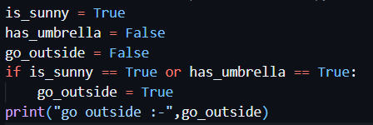

1. Logical operators:

Code:

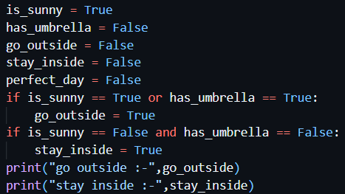

1. Combining conditions:

Code:

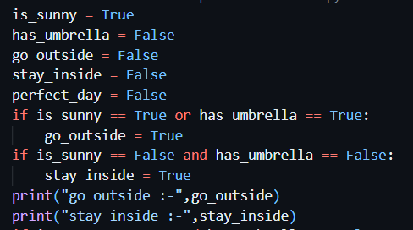

1. Interactive input:

Code: 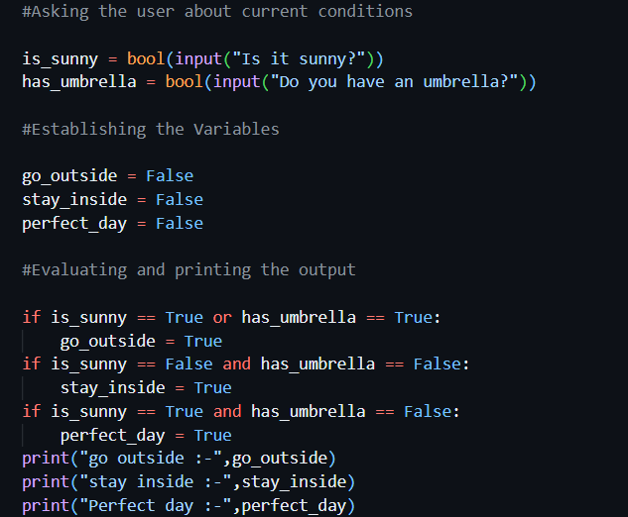

**Final Outputs:-**

**1**

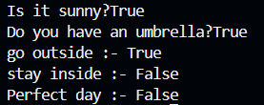

**2**

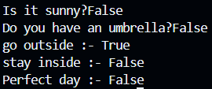

**3**

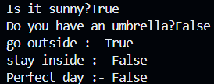

**Exercise-2: Basic list operations**

**Objective:** Understand basic list operations such as creating lists, accessing elements, and modifying lists.

1. Creating list:

Code:



1. Accessing elements:

Code:



Output:



1. Modifying a list:

Code:

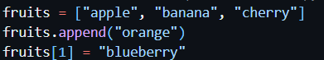

1. Removing elements:

Code:

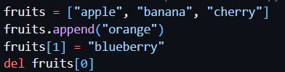

1. Print the final list:

Code:

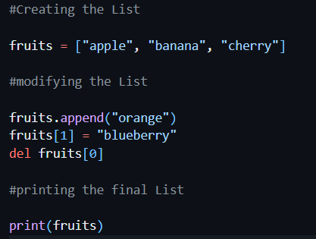

Output:



**Exercise-3**: **List Slicing and Indexing**

**Objective:** Practice list slicing and iterating through list elements.

1. Creating a List:

Code:



1. Slicing a List:

Code:



1. Iterating Through a List:

Code:

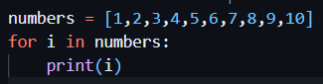

Output:

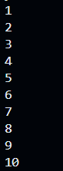

1. List Comprehension

Code:



1. Print the new List

Code:

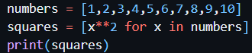

Output:



**Exercise-4: List Methods and Functions**

**Objective:** Understand and use various list methods and built-in functions.

1. Creating a List:

Code: 

1. Using List Methods:

Code:

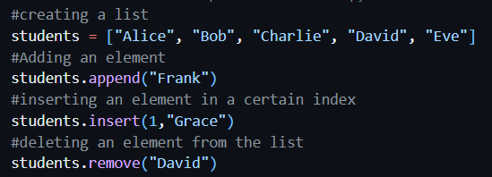

1. Using built in functions:

Code:

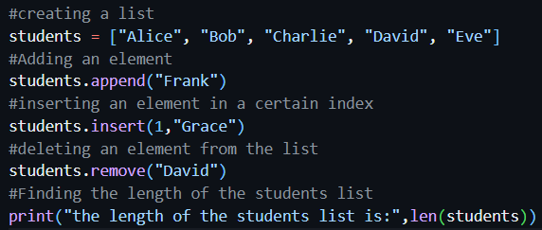

Output:



Code:

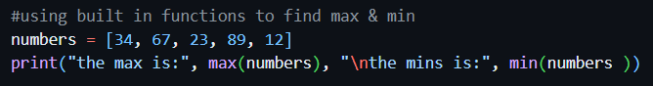

Output:



1. Print the Final List:

Code:

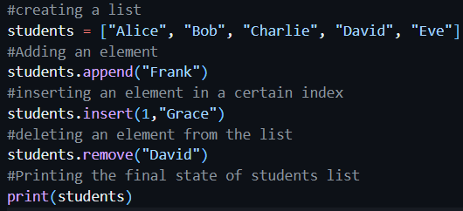

Output:



**Exercise-5: Basic string operations**

**Objective:** Understand basic string operations such as creating strings, accessing characters, and modifying strings.

1. Creating Strings:

Code:

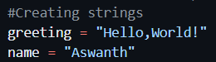

1. String concatenation:

Code:

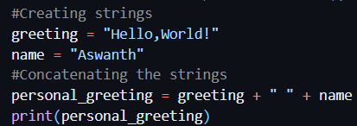

Output:



1. Accessing characters:

Code:

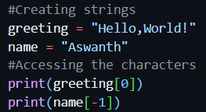

Output:



1. String slicing:

Code:

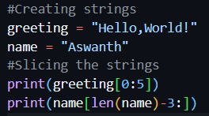

Output:



1. String methods:

Code:

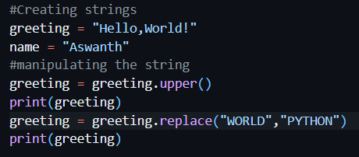

Output:



**Exercise-6: Advanced string operations**

**Objective:** Practice more advanced string operations such as formatting, finding substrings, and splitting/joining strings.

1. String Formatting:

Code:

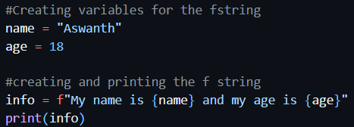

Output:



1. Finding substrings:

Code:

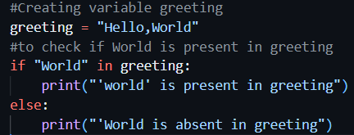

Output:



Code2:

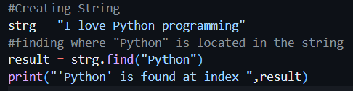

Output:



1. Splitting and joining strings

Code:

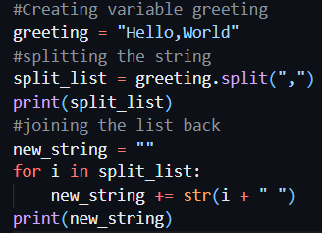

Output:



1. Interactive Input:

Code:

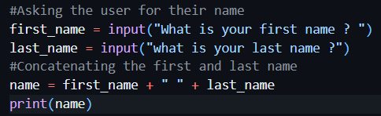

Output:

