PONDICHERRY UNIVERSITY

(A Central university)



**SCHOOL OF ENGINEERING AND TECHNOLOGY DEPARTMENT OF COMPUTER SCIENCE**

**M.Sc. Computer Science**

## NAME : ASWANTH E K

REG. NO. : 23370009

## SEMESTER : 3rd Semester

SUBJECT : CSSC 513 - WEB TECHNOLOGY AND COMPUTER NETWORKS LAB

**PONDICHERRY UNIVERSITY**

**(A Central university)**



**SCHOOL OF ENGINEERING AND TECHNOLOGY DEPARTMENT OF COMPUTER SCIENCE**

**M.Sc. Computer Science** PRACTICAL LAB RECORD **BONAFIDE CERTIFICATE**

## This is to certify that this is a Bonafide record of practical work done by **ASWANTH E K**, having Reg. No. **23370009** semester - III from the month July 2024 to December 2024.

### FACULTY IN-CHARGE

SUBMITTED FOR THE PRACTICAL EXAM HELD ON:

### INTERNAL EXAMINER EXTERNAL EXAMINER

**AIM:**

NETWORKTOPOLOGY

To configure a basic Network Topology using Cisco Packet Tracer.

### PROCEDURE:

1. **Place the devices:**
   * From the **Devices menu**, select **Routers** and choose the **1841 Router**. Place it in the center.
   * Go to **Switches**, select two **2960 switches**, and place them on the left and right of the router.
   * From **End Devices**, select **PC** and place three PCs connected to the left switch and three PCs connected to the right switch.

### Configure Connections:

* + **Router to Switches:**
    - Use the **Copper Straight-Through Cable** tool to connect:
      * **Router FastEthernet0/0** to **Switch0 FastEthernet0/1** (left switch).
      * **Router FastEthernet0/1** to **Switch1 FastEthernet0/1** (right switch).

### Switches to PCs:

* + - For **Switch0**, connect each of its **FastEthernet ports (e.g., FastEthernet0/2, FastEthernet0/3, and FastEthernet0/4)** to **PC0, PC1, and PC2**.

### For Switch1, connect its FastEthernet ports (e.g., FastEthernet0/2, FastEthernet0/3, and FastEthernet0/4) to PC3, PC4, and PC5.

1. **Configure IP Addresses:**

### Router Interfaces:

* + - Click on **Router0**, go to **Config** > **FastEthernet0/0**, and set:
      * **IP Address:** 192.168.10.1
      * **Subnet Mask:** 255.255.255.0
      * **Turn on** the interface by clicking on **Port Status**.
    - Go to **FastEthernet0/1** and set:
      * **IP Address:** 192.168.11.1
      * **Subnet Mask:** 255.255.255.0
      * **Turn on** the interface by clicking on **Port Status**.

### PCs:

* + - For **PC0, PC1, and PC2** (connected to the left switch):
      * Set IP addresses within the 192.168.10.0 network (e.g., 192.168.10.2, 192.168.10.3, 192.168.10.4) with a **Subnet Mask** of 255.255.255.0.
      * Set the **Default Gateway** to 192.168.10.1.
    - For **PC3, PC4, and PC5** (connected to the right switch):
      * Set IP addresses within the 192.168.11.0 network (e.g., 192.168.11.2, 192.168.11.3, 192.168.11.4) with a **Subnet Mask** of 255.255.255.0.
      * Set the **Default Gateway** to 192.168.11.1.

### Test Connectivity:

* + Use the **Ping Tool** from **PC0** to **PC3** (or any PC on a different subnet) to verify connectivity.

### PictureDIAGRAM :

**RESULT**:

Thus the configuration of the basic Network Topology is successfully pings indicate proper configuration and connectivity between the subnets.

**AIM**:

## **VLAN**

To configure VLANs on a switch and router in Cisco Packet Tracer to enable

communication between devices in different VLANs through inter-VLAN routing.

### PROCEDURE:

**Step 1: Set Up the Devices**

* Place the **Router**, **Switch**, and **PCs** in the workspace.
* Connect the **Router to the Switch** using a cross-over cable from **Router FastEthernet0/0** to **Switch FastEthernet0/20**.
* Connect each **PC to the Switch**:
  + PC1 and PC2 will be in VLAN 10 (connect to any ports like Fa0/1 and Fa0/2).
  + PC3 and PC4 will be in VLAN 20 (connect to any ports like Fa0/3 and Fa0/4).

### Step 2: Configure VLANs on the Switch

1. **Access the Switch CLI:**
   * Click on the switch, go to the **CLI** tab.

### Enter Configuration Mode:

config# enable

config# configure terminal

### Create VLANs:

* + **VLAN 10:**

config# vlan 10 config# name VLAN10 config# exit

### VLAN 20:

config# vlan 20 config# name VLAN20 config# exit

### Assign Ports to VLANs:

* + For **VLAN 10 (PC1 and PC2)**: config# interface FastEthernet0/1 config# switchport mode access config# switchport access vlan 10 config# exit

config# interface FastEthernet0/2 config# switchport mode access config# switchport access vlan 10 config# exit

### For VLAN 20 (PC3 and PC4):

config# interface FastEthernet0/3 config# switchport mode access config# switchport access vlan 20 config# exit

config# interface FastEthernet0/4 config# switchport mode access config# switchport access vlan 20 config# exit

### Configure the Trunk Port:

* + Set the port connected to the router as a trunk port (e.g., FastEthernet0/20).

config# interface FastEthernet0/20 config# switchport mode trunk config# exit

### Step 3: Configure the Router for Inter-VLAN Routing

1. **Access the Router CLI:**
   * Click on the router, go to the **CLI** tab.

### Enter Configuration Mode:

config# enable

config# configure terminal

### Configure Subinterfaces for Each VLAN:

* + **Subinterface for VLAN 10:**

config# interface FastEthernet0/0.10 config# encapsulation dot1Q 10

config# ip address 192.168.1.100 255.255.255.0 config# exit

### Subinterface for VLAN 20:

config# interface FastEthernet0/0.20 config# encapsulation dot1Q 20

config# ip address 192.168.2.100 255.255.255.0 config# exit

### Enable the Main Interface:

* + Make sure the main interface **FastEthernet0/0** is up. config# interface FastEthernet0/0

config# no shutdown config# exit

### Step 4: Configure IP Addresses on PCs

* For **PC1 (VLAN 10)**:

o IP Address: 192.168.1.1

o Subnet Mask: 255.255.255.0

* + Default Gateway: 192.168.1.100
* For **PC2 (VLAN 10)**:

o IP Address: 192.168.1.2

o Subnet Mask: 255.255.255.0

* + Default Gateway: 192.168.1.100
* For **PC3 (VLAN 20)**:

o IP Address: 192.168.2.1

o Subnet Mask: 255.255.255.0

* + Default Gateway: 192.168.2.100
* For **PC4 (VLAN 20)**:

o IP Address: 192.168.2.2

o Subnet Mask: 255.255.255.0

* + Default Gateway: 192.168.2.100

### Step 5: Test Connectivity

* **Ping** from PC1 to PC2 within VLAN 10 (should succeed).
* **Ping** from PC3 to PC4 within VLAN 20 (should succeed).
* **Ping** between PCs in different VLANs (e.g., PC1 to PC3) to verify inter-VLAN routing (should also succeed).

**DIAGRAM:**

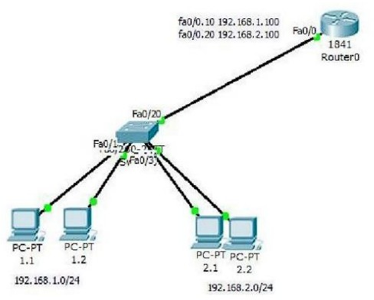

**RESULT:**

Thus the configuration of VLAN is successfully done and the ping from one PC to other PCs is verified.

**AIM:**

**FIREWALL**

To setup an network based firewall using Cisco Packet Tracer.

### PROCEDURE:

**Step 1: Replace Router_A with Firewall_1**

* **a.** Remove **Router_A** and replace it with **Firewall_1**.
* **b.** Connect the **FastEthernet 0/0** interface on **Firewall_1** to the **FastEthernet 0/1** interface on **Switch_A**.

Connect the **FastEthernet 0/1** interface on **Firewall_1** to the **Ethernet 6**

interface of the **ISP cloud**.

*(Use straight-through cables for both connections.)*

* **c.** Confirm that the host name of **Firewall_1** is **Firewall_1**.
* **d.** On **Firewall_1**, configure the WAN IP address and subnet mask for the

**FastEthernet 0/1** interface as **209.165.200.225** and **255.255.255.224**.

* **e.** Configure the LAN IP address and subnet mask for the **FastEthernet 0/0**

interface on **Firewall_1** as **192.168.1.1** and **255.255.255.0**.

### Step 2: Verify the Firewall_1 Configuration

* **a.** Use the **show run** command to verify your configuration. This is a partial example of the output:

Firewall_1#show run Building configuration... hostname Firewall_1

!

interface FastEthernet0/0

ip address 192.168.1.1 255.255.255.0

ip nat inside duplex auto speed auto

!

interface FastEthernet0/1

ip address 209.165.200.225 255.255.255.224

ip access-group 100 in ip nat outside

duplex auto speed auto

!

interface Vlan1 no ip address shutdown

!

ip nat inside source list 1 interface FastEthernet0/0 overload ip classless

ip route 192.168.2.0 255.255.255.0 192.168.1.2

ip route 192.168.3.0 255.255.255.0 192.168.1.3

!

access-list 1 permit 192.168.0.0 0.0.255.255 access-list 100 deny ip any host 209.165.200.225

<output omitted>

!

end

* **b.** From **PC_B**, ping **209.165.200.225** to verify that the internal computer can access the Internet.

PC>ping 209.165.200.225

Pinging 209.165.200.225 with 32 bytes of data:

Reply from 209.165.200.225: bytes=32 time=107ms TTL=120 Reply from 209.165.200.225: bytes=32 time=98ms TTL=120 Reply from 209.165.200.225: bytes=32 time=104ms TTL=120 Reply from 209.165.200.225: bytes=32 time=95ms TTL=120 Ping statistics for 209.165.200.225:

Packets: Sent = 4, Received = 4, Lost = 0 (0% loss), Approximate round trip times in milli-seconds: Minimum = 95ms, Maximum = 107ms, Average = 101ms

* **c.** From privileged EXEC mode on **Firewall_1**, save the running configuration

to the startup configuration using the **copy run start** command.

### DIAGRAM:

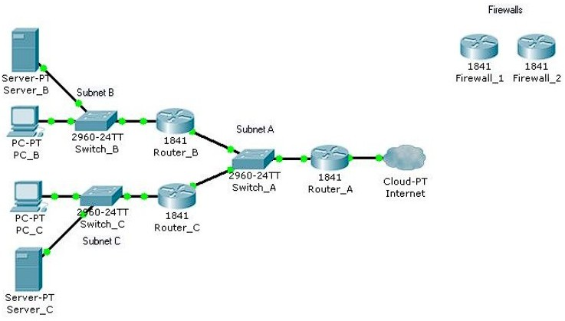

**RESULT:**

Hence, the firewall setup is configured within the network interface.

**AIM**:

**ROUTER CONFIGURATION**

Basic configuration of Router using Cisco Packet Tracer.

### PROCEDURE:

1. **Place the Router:**
   * From the **Devices menu**, go to **Routers** and select a router model (e.g., **1841 Router**). Place it on the workspace.

### Add Network Devices (Optional):

* + Add switches and PCs if you want to connect multiple devices to the router, creating different networks or subnets.

### Connect Devices:

* + Use **Copper Straight-Through Cable** to connect the router to other devices.
  + Connect **Router’s FastEthernet or GigabitEthernet ports** to the switches or directly to PCs, depending on the setup.

### Enter Router Configuration Mode:

* + Click on the router, then go to the **CLI (Command Line Interface)** tab.
  + When prompted, type no if it asks if you want to enter the initial configuration dialog.

### Access the Router’s Global Configuration Mode:

* + Type enable to enter **privileged EXEC mode**.
  + Type configure terminal to enter **global configuration mode**.

### Configure Router Interfaces:

* + Enter interface configuration mode for each interface you want to configure:
    - For **FastEthernet0/0**:

config# interface FastEthernet0/0

* + - Set the IP address and subnet mask:

config# ip address 192.168.10.1 255.255.255.0

* + - Turn on the interface:

config# no shutdown

* + - Exit the interface configuration: config# exit
  + Repeat the process for **FastEthernet0/1** (or any other interface): config# interface FastEthernet0/1

config# ip address 192.168.11.1 255.255.255.0 config# no shutdown

config# exit

### Configure Routing (Optional, if using multiple networks):

* + For **static routing**, type:

config# ip route 192.168.11.0 255.255.255.0 192.168.10.2

* + This step is optional if you only need basic routing between directly connected networks.

### Save the Configuration:

* + To save the configuration, exit global configuration mode by typing exit until you return to the privileged EXEC mode.
  + Type:

config# write memory

* + Alternatively, use copy running-config startup-config to save the configuration to non-volatile memory.

### Test Connectivity:

* + Connect PCs to the router via switches or directly.
  + Assign IP addresses and default gateways to each PC in their respective network.
  + Use the **Ping Tool** to test communication between devices in different networks.

### DIAGRAM:

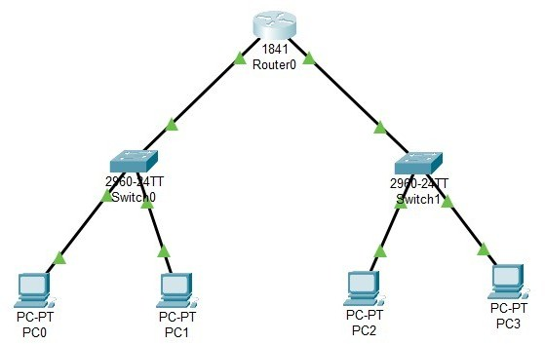

**RESULT**:

The basic router configuration is made using PCs, Switches and Router which connects all seamlessly.