**Introduction**

This conference paper discusses the development and implementation of a website to display teachers timetables in a user-friendly format. In many educational institutions, students are not aware of their teachers’ timetables. This makes it difficult for them to know when to meet specific teachers. We have developed a website where students can view the teachers’ timetables sorted by department.

As the second part of our problem statement, we aim to solve the problem of substitute teacher assignment digitally. Prior to this, substitute teacher assignment was a time-consuming, labour-intensive process. A timetable officer would have to go through the timetables of each teacher to find if that teacher is free at that given time. It would be ideal if a teacher who is most free in a day is given substitute teacher duty. But for this, the officer would have to manually calculate the working hours of each teacher in each day. We aim to automate this process as well.

The final product is a single well-designed website for timetable viewing and finding potential substitute teachers.

**Methodology**

We have used JAM (JavaScript, API, Markup) stack to design the website. Google charts API is used to draw the timetables. First the data is converted into a suitable format.

**Data**

Well formatted data is important for any program to function. The timetables in excel format are not machine-readable. We convert it into a suitable JSON file for well-functioning of the website and ease of access.

Our initial approach was to store the data in this format:

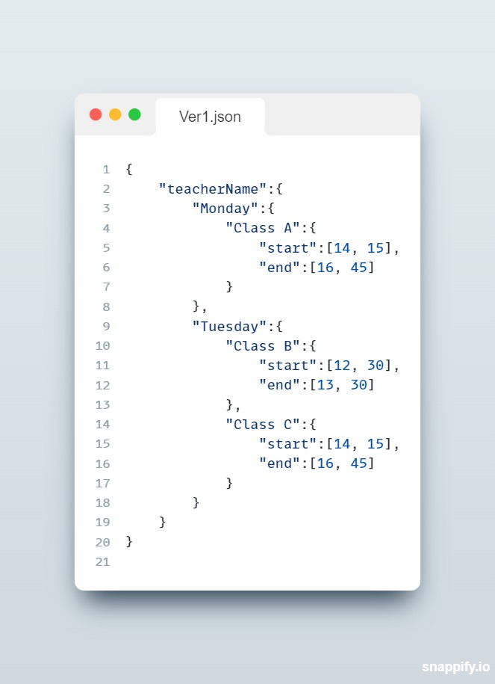

But this approach had a couple of drawbacks

1. The times are stored using two variables: hour and minute. This makes calculations difficult. Since time is unidimensional, it is more appropriate to use a single variable to store time.
2. JSON keys must be unique, but class names are not always unique. This results in a conflict in the JSON file. This leads to data loss and makes the whole website unviable.

To solve the former, we have come up with a standard time format. The time format we use is minutes since 9am. All the times are stored in their “minutes since 9am” equivalents. Instead of storing start and end times, we store the start time and duration of classes. This makes calculations and comparisons easy. For example, the total work-hours of a teacher is just the sum of all the durations.

To solve the latter, we store start time as the key for JSON. The class name and duration are saved as values in the JSON. Start times are unique since no two classes start at the same time for a given teacher. Thus we arrive at this format.

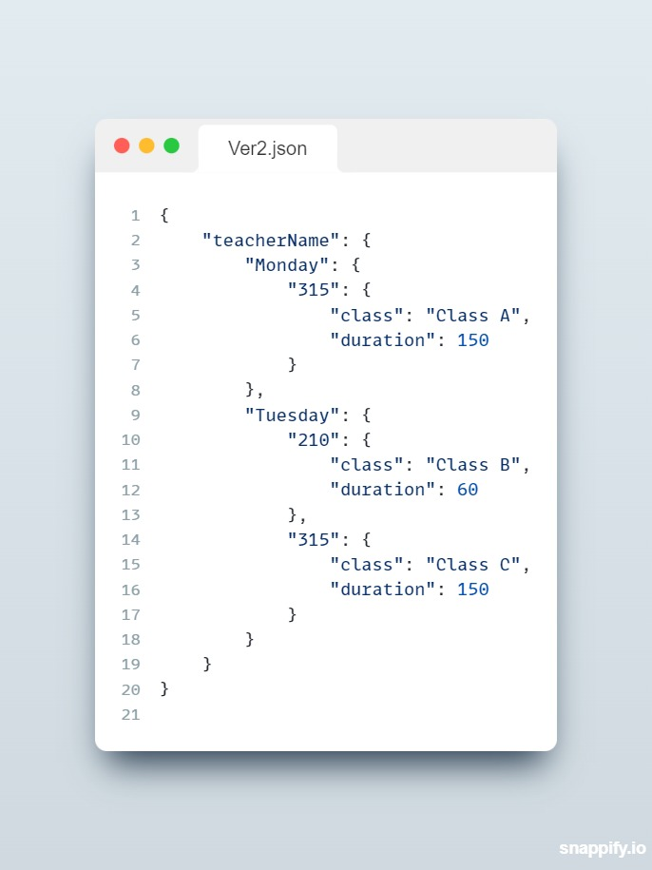

The website consists of two webpages, one for viewing the timetables and another for finding substitute teachers.

**Timetable page**

The timetable page takes department and teacher names as inputs and displays their timetables. It also shows the daily workload of the teachers. The timetable is a timeline chart drawn using Google Charts API. The details of a teacher like their name, qualifications etc can also be shown.

The timeline chart takes data in a specific format. It takes a 2D array, with the rows being different elements and columns being the attributes of each element. The first column determines which row in the chart the element falls in. The next one is the text displayed in the element. The next two are the start and the end times.

When hovered over the chart elements, vital information such as duration is displayed in a tool-tip. The daily workload of all the teachers is calculated as follows:



We iterate through all the classes a teacher takes in each day and sum up their durations to obtain the daily workloads. Daily workload is then displayed on the webpage.