6/7/16

**Title**

Allan Swartz

**Introduction.** The study was conducted on time series data of the monthly total of new one-family home sales in the US. The span of the series begins in 1973 extending until November of 1995. For this duration, at least 24 houses were sold from month to month reaching a maximum of 89 homes sold. On average, approximately 52 were sold, and the median was 53 homes sold. *Figure 1* shows a visual representation of the data, and it is immediately apparent that any rises in sales is immediately followed by a drop in sales, or that strong positive correlation is followed by negative correlation. It appears to be an ongoing pattern. The two main goals are to find any significant seasonal effects on sales and to determine a reasonable one-year forecast.

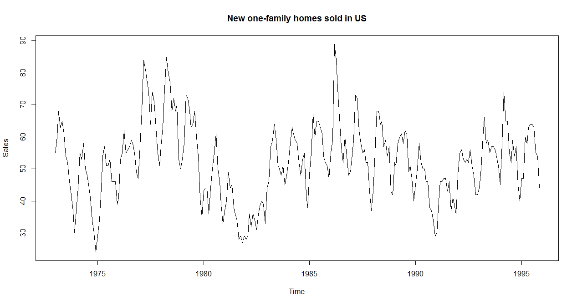

Figure