Game Design Document

Fill up the following document

1. Write the title of your project.

Bike Racer

1. What is the goal of the game?

To reach the finish line first .

1. Write a brief story of your game.

Two people are racing their bikes in an sports event . While 5they are facing some challenges like random obstacles . They can go fast for a few second by collecting nitro fuels.

1. Which are the playing characters of this game?

* Playing characters are the ones who respond to the user based on the input from the user.
* Cars, monkeys, dinos, wizards, etc., are the playing characters in the game.

|  |  |  |
| --- | --- | --- |
| Number | Character Name | What can this character do? |
| 1 | Blue Sports Bike | It can move forward, left and right. |
| 2 | Red sports bike | It can move forward, left and right |
| 3 |  |  |
| 4 |  |  |
| 5 |  |  |
| 6 |  |  |
| 7 |  |  |
| 8 |  |  |

1. Which are the Non-Playing Characters of this game?

* Non-Playing characters are the ones that don't have an action or behavior when the user interacts with the game.
* Hurdles, stones, bananas, coins, etc., are non-playing characters in the game.

|  |  |  |
| --- | --- | --- |
| Number | Character Name | What can this character do? |
| 1 | Coins | By collecting it ,the score will increase |
| 2 | Nitro | If the bike collects it the bike can go fast for 3 seconds |
| 3 | Tyres | If the bike collides with the tyres ,the game will be over |
| 4 | Cones | If the bike collides with the cones,the game will be over |
| 5 |  |  |
| 6 |  |  |
| 7 |  |  |
| 8 |  |  |

Draw your imagination of this game. What does this game look like?

* Draw the game either on your computer or on paper.
* Add images of the game scenes to show each of the playing and non-playing characters at least once.

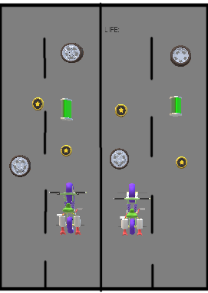

How do you plan to make your game engaging?

There will be lives .The lives will be reduced if collided with the obstacles .

And there will also be nitro to make the game more engaging.