Frontend Development With React .JS

**l.lntroduction**:

* **Project Title** : **Store Manager:Keep Track of Inventory**

** Team Members:**

|  |  |  |
| --- | --- | --- |
|  | ROLL.NO | **NAME** |
|  | per104C24UG104CSC006 | ASPATH FATHINIA S |
| per104C24UG104CSC007 | **CHRUSTIK** M |
| per104C24UG104CSC016 | **GAYATHRI** K |
| per104C24UG104CSC017 | **GAYATHRI** P |
| per104C24UG104CSC078 | **VINITHA** M |

Welcome to the future of retail management — *Store Manager: Keep Track of Inventory*, a modern inventory management application designed to help businesses efficiently monitor stock levels, sales, and suppliers.

This system eliminates manual errors and provides real-time insights into product availability, ensuring businesses never run out of essential items. With its user-friendly interface and powerful features, Store Manager makes inventory handling seamless for both small shops and large enterprises.

**Scenario-Based Intro:**

Imagine running a busy retail store. Customers walk in asking for products, and instead of rushing to the shelves or checking registers, you open the Store Manager app. In seconds, you can see product availability, stock count, supplier details, and even low-stock alerts.

When sales are made, the stock automatically updates, invoices are generated, and you can review detailed reports at the end of the day. This ensures a smooth flow of operations without stockouts or overstocking.

**Target Audience :**

* **Retail Stores & Supermarkets** – For daily stock and billing.
* **Small Businesses** – To manage limited yet fast-moving products.
* **Warehouses & Distributors** – For bulk stock tracking.
* **Pharmacies & Specialty Shops** – To ensure accuracy for critical items.

**Project Goals and Objectives :**

* **Efficient Stock Management** – Provide real-time tracking of inventory levels.
* **User-Friendly Interface** – Easy for store clerks and managers to navigate.
* **Reduce Manual Errors** – Automate calculations for stock-in and stock-out.
* **Sales & Order Tracking –** Keep records of customer orders and invoices.
* **Reports & Analytics** – Generate daily, weekly, and monthly stock reports.

**Key Features :**

* **Product Listings** – Add, edit, delete products with details (name, category, supplier, price, stock).
* **Inventory Tracking** – Automatic updates on stock-in and stock-out, with low-stock alerts.
* **Sales & Billing** – Generate invoices and auto-update stock on every sale.
* **Supplier Management** – Store supplier details for quick restocking.
* **Reports & Analytics** – Export daily/weekly/monthly stock reports.
* **User Roles** – Admin, Store Manager, Clerk with role-based access.

**PRE-REQUISITES**

Here are the key prerequisites for developing a frontend application using React.js:

**Node.js and npm:**

Node.js is a powerful JavaScript runtime environment that allows you to run JavaScript code on the local environment. It provides a scalable and efficient platform for building network applications.

Install Node.js and npm on your development machine, as they are required to

run JavaScript on the server-side.

Download: <https://nodejs.org/en/download/>

Installation instructions: <https://nodejs.org/en/download/package-manager/>

**React.js:**

React.js is a popular JavaScript library for building user interfaces. It enables developers to create interactive and reusable UI components, making it easier to build dynamic and responsive web applications.

Install React.js, a JavaScript library for building user interfaces.

**Create a new React app:**

Npx create-react-app my-react-app

Replace my-react-app with your preferred project name.

Navigate to the project directory:

Cd my-react-app

**Running the React App:**

With the React app created, you can now start the development server and see your React application in action.

**Start the development server:**

Npm start

This command launches the development server, and you can access your React app at <http://localhost:3000> in your web browser.

HTML, CSS, and JavaScript: Basic knowledge of HTML for creating the structure of your app, CSS for styling, and JavaScript for client-side interactivity is essential.

Version Control: Use Git for version control, enabling collaboration and tracking changes throughout the development process. Platforms like GitHub or Bitbucket can host your repository.

• Git: Download and installation instructions can be found at: <https://git-scm.com/downloads>

Development Environment: Choose a code editor or Integrated Development Environment (IDE) that suits your preferences, such as Visual Studio Code, Sublime Text, or WebStorm.

• Visual Studio Code: Download from <https://code.visualstudio.com/download>

• Sublime Text: Download from <https://www.sublimetext.com/download>

• WebStorm: Download from <https://www.jetbrains.com/webstorm/download>

To get the Application project from drive:

Follow below steps:

Install Dependencies:

• Navigate into the cloned repository directory and install libraries:

Cd store

Npm install

Start the Development Server:

• To start the development server, execute the following command:

Npm start

Access the App:

• Open your web browser and navigate to <http://localhost:3000>.

• You should see the application’s homepage, indicating that the installation and setup were successful.

You have successfully installed and set up the application on your local machine. You can now proceed with further customization, development, and testing as needed.

**Project structure**

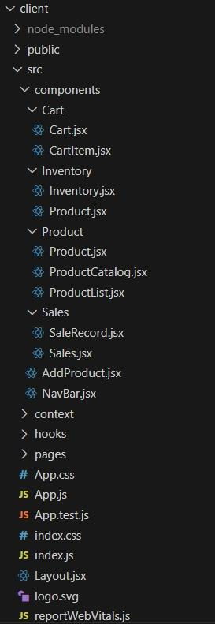The image is of the folder structure which shows all the files and folders that have been used in project development.

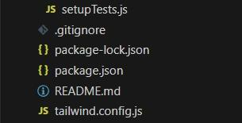

* **Frontend (React.js)** – Product listings, stock display, and dashboards.
* **Backend (Node.js/Express.js)** – APIs for managing stock, orders, and suppliers.
* **Database (MySQL/MongoDB/JSON)** – Stores product data, transactions, and reports.

**Project Flow :**

**Project setup and configuration Project Setup**

Step 1: Initialize a new React application.

Use create-react-app or Vite for project setup.

Step 2: Install dependencies.

Add tailwindcss, react, react-dom, and other necessary packages.

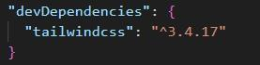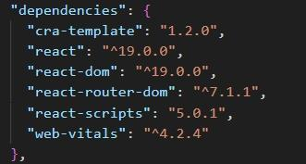

Step 3: Configure TailwindCSS.

Set up the tailwind.config.js file.

Add the required styles in index.css.

Step 4: Create a basic folder structure.

Example:

Css

Src/

??? components/

??? context/

??? hooks/

??? pages/

For further reference, use the following resources

<https://react.dev/learn/installation>

<https://react-bootstrap-v4.netlify.app/getting-started/introduction/>

<https://axios-http.com/docs/intro>

<https://reactrouter.com/en/main/start/tutorial>

***Project Development***

Setting Up Context and Reducers

Step 1: Create context files for Inventory, Cart, and Sales.

Use createContext() and define default states.

Step 2: Define reducers for state management.

Inventory Reducer: Handle stock addition, updates, and sales.

Cart Reducer: Manage adding/removing items and quantities.

Sales Reducer: Track sales records.

Step 3: Set up ContextProvider components.

Wrap the app in these providers in index.js or App.js.

Step 4: Persist data in localStorage.

Save and load context states to/from localStorage.

**Milestone 3 – Developing Core Components**

Step 1: Build the Inventory Component.

Display a list of products with stock details.

Implement search and alert value input.

Step 2: Build the Product Component.

Show product details, including an image, price, and stock.

Add functionality to update stock.

Step 3: Build the Cart Component.

Display items added to the cart with quantity and total value.

Add buttons for incrementing, decrementing, and removing items.

Include checkout functionality to update inventory and create sales records.

Step 4: Build the Sales Component.

Display a list of sales records with details like date, cart items, and total sale value.

Sort records from the latest to the oldest.

**Milestone 4 – Implementing Utilities**

Step 1: Create reusable helper functions.

Format currency.Sort or filter data.

Step 2: Add input validation.

Prevent invalid values for stock or cart quantities.

Step 3: Handle edge cases.

Avoid negative stock updates.

Restrict checkout when the cart is empty.

**Milestone 5 – Styling with TailwindCSS**

Step 1: Create responsive layouts.

Use flexbox (flex, flex-wrap) and grid utilities.

Step 2: Style individual components.

Inventory: Add hover effects and responsive search bar.

Cart: Highlight selected products and display alerts on low stock.

Sales: Use a clean table or card layout for sale records.

Step 3: Ensure consistency.

Apply a theme or consistent color palette.

**Milestone 6 – Testing and Debugging**

Step 1: Test individual components.

Ensure correct rendering and functionality.

Step 2: Test context and reducers.

Verify state updates and interactions with localStorage.

Step 3: Debug UI/UX issues.

Check for responsiveness and usability.

### **Project Implementation & Execution**

**Product Catalog:**

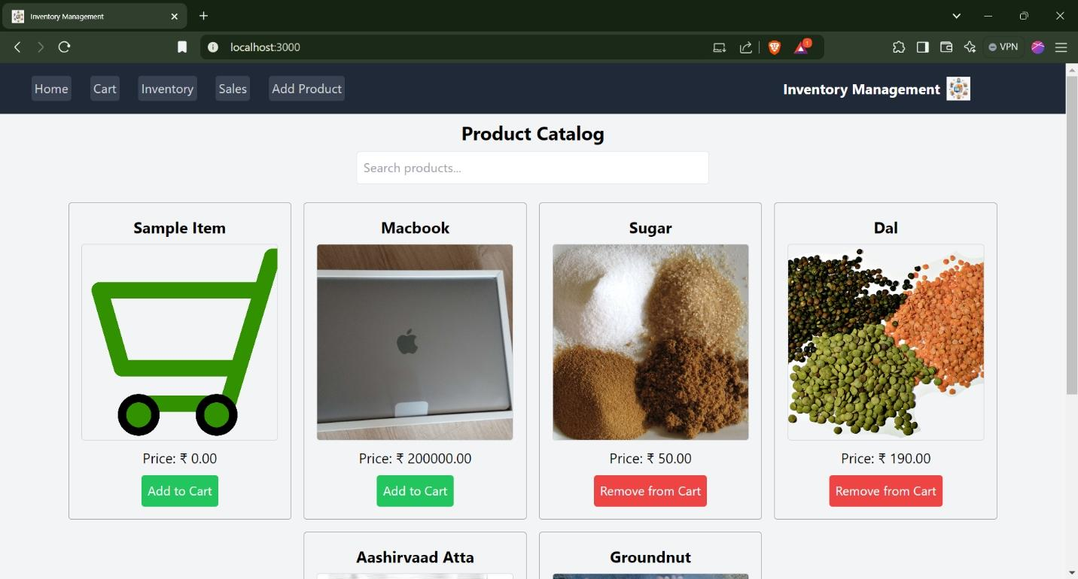**Cart:**

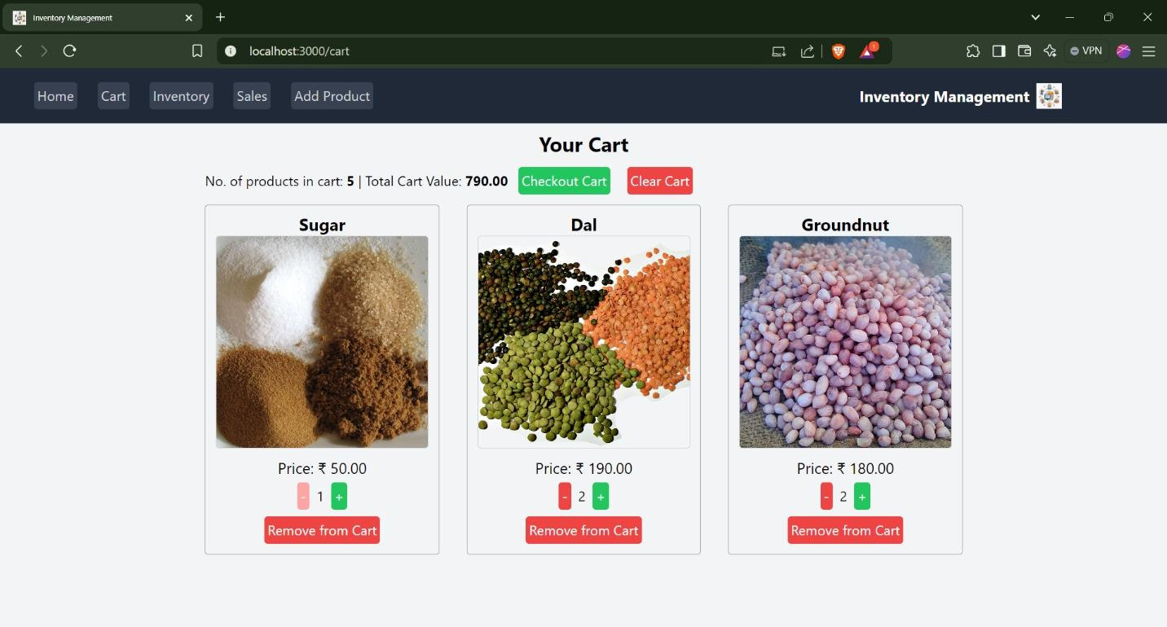

**Inventory :**



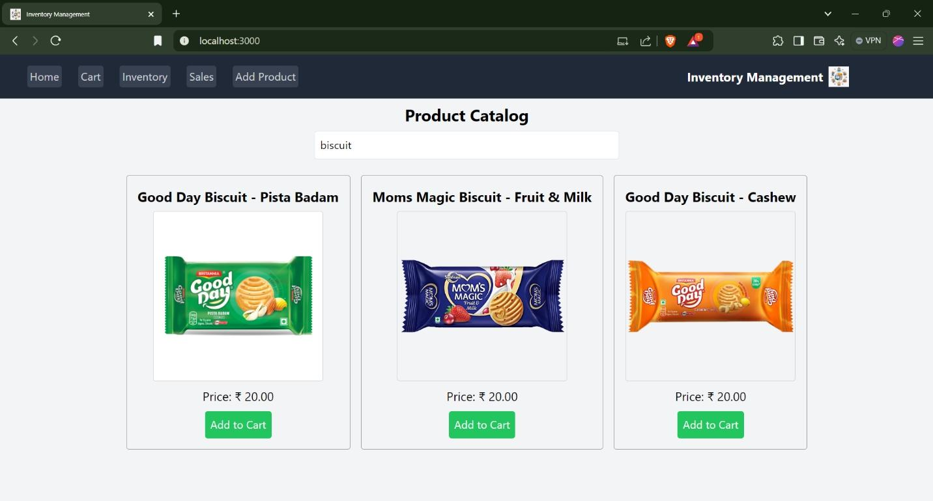**Search Functionality :**

**Sales:**

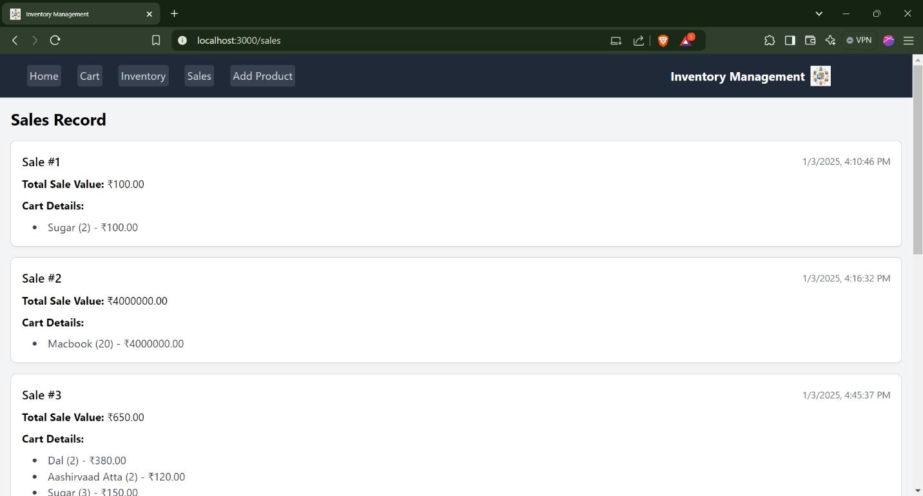

**Add Product :**

