ChainSentinel — Executive Overview
Document D1 of the ChainSentinel Manual
ChainSentinel Engineering
2026-05-12
Table of Contents

ChainSentinel in one paragraph
ChainSentinel is a blockchain forensics tool. A client says “we got exploited”, hands over an RPC endpoint, a handful of contract ABIs, and an approximate time window. ChainSentinel runs a full forensic pipeline against the chain, looking for the fingerprints of every attack class it has been taught to recognise — 60 detection signals, 38 attack patterns, fund-trace analysis up to five hops, and a Gemma-3 powered copilot that writes the report. No cloud dependency. Works offline. Switches between Anvil simulations, testnets, and mainnet with a single URL change.

1. The problem ChainSentinel solves
When a DeFi protocol is exploited, the first 48 hours determine whether funds are recovered, the attacker is identified, and the protocol survives. Today that window is consumed by manual forensic work:
- An analyst pulls transactions one at a time from a block explorer.
- They eyeball traces in Tenderly or Phalcon.
- They piece together the attack timeline in a Notion doc.
- They write the client report from scratch.
Each step is slow, error-prone, and depends entirely on the analyst’s experience. Two analysts looking at the same incident often arrive at different verdicts.
ChainSentinel changes the unit of work. Instead of “analyse one transaction at a time”, the unit becomes “answer the question was this an exploit, and if so, which kind?” for a whole window of on-chain activity. The analyst still applies judgement; they just no longer carry the entire forensic load by hand.

1.1 What an analyst’s day looks like before and after
Before | After
Manually open every tx in a block explorer | Click “Analyze” on the window
Eyeball traces in a separate tool | Trace renders inside the investigation view
Write detection logic mentally | 60 signals + 38 patterns run automatically
Write the report in Notion | Copilot drafts the 7 sections
2–5 days to first verdict | 5–15 minutes

1.2 What ChainSentinel does not do
- Stop attacks in progress. ChainSentinel is read-only; it analyses, it does not intervene.
- Recover funds. It tells you where they went; chain analysis providers and law enforcement handle recovery.
- Replace the analyst. It accelerates them. Every verdict is auditable back to the underlying transaction data.

2. Capabilities at a glance
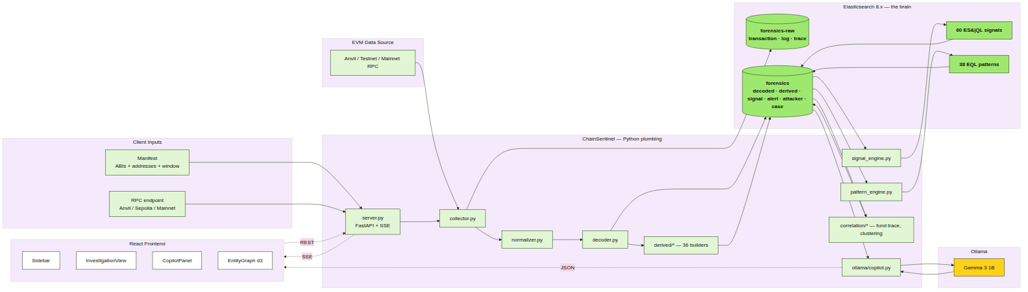
System architecture

2.1 Detection coverage
- 60 detection signals across 7 families (structural, behavioural, value, oracle, sequence, graph, additional).
- 38 attack patterns (AP-001..AP-038) covering reentrancy, flash-loan oracle manipulation, admin-key abuse, MEV sandwich, token rugs, governance manipulation, mixer/bridge use, and more.
- Detection logic is written in Elasticsearch query languages — any analyst who knows ES can read, modify, and contribute rules. No Python required.

2.2 Fund tracing
- 5-hop BFS in both directions from the victim and attacker.
- Haircut taint scoring: mixer × 0.7, bridge × 0.8, CEX × 0.9.
- Known-address corpus: Tornado Cash, Hop, Stargate, Multichain, Across, Binance, Coinbase, Kraken, OFAC SDN, notable past exploiters.

2.3 Copilot
- Local LLM (Ollama + Gemma 3 1B by default). No cloud. No data leaves the analyst’s machine.
- 7-section forensic report: Executive Summary, Timeline, Mechanism, Attribution, Fund Trail, Evidence, Remediation.
- Strict anti-hallucination: copilot prompts forbid invented addresses, hashes, amounts, or block numbers.

2.4 Coverage of demo scenarios
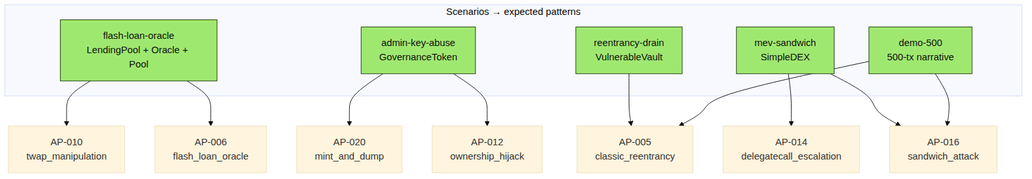
Simulation scenario matrix
Five Foundry simulations ship in the repo, each reproducing a real attack class end-to-end. ChainSentinel correctly identifies each one purely from the ABIs + transaction data — without ever seeing the attacker’s source code.
Scenario | Attack class | Patterns it triggers
reentrancy-drain | Classic recursive withdraw | AP-001, AP-030, AP-031
flash-loan-oracle | Flash-loan-funded oracle manipulation | AP-006, AP-009, AP-033
admin-key-abuse | Owner privilege abuse | AP-012, AP-020, AP-031
mev-sandwich | Three-tx bracket sandwich | AP-016, AP-017
demo-500 | Mixed reentrancy + sandwich in 500 txs | AP-001, AP-016, AP-030, AP-031

3. Demo storyline
End-to-end demo storyboard
A live demo runs as follows.
Stage 1 — One command starts everything. The analyst types ./run_demo.sh demo-500. In sequence: Elasticsearch boots, Ollama warms up, Anvil launches as a local EVM, FastAPI starts on :8000, the React frontend opens on :5173. About 60 seconds.
Stage 2 — The chain populates. Foundry deploys a vulnerable vault, a simple DEX, and assorted ERC-20 tokens. A scripted backdrop runs ~300 legitimate transactions: deposits, swaps, transfers, approvals. Then two exploits unfold inside the same window — a recursive withdraw reentrancy on the vault, and a sandwich attack on the DEX.
Stage 3 — Analysis starts. The analyst clicks Analyze. The workspace’s PipelineFeed lights up:
[collect] 500 txs fetched
[normalize] timestamps + addresses canonicalised
[decode] 1247 events decoded, 0 unknown
[derive] 36 builder types produced
[ingest] indexed in Elasticsearch
[signals] 8 signals fired (5 CRIT, 3 WARN)
[patterns] 3 patterns matched
[complete] investigation ready
Stage 4 — The verdict appears. The workspace flips to the report view. Two attack patterns: AP-001 classic_reentrancy and AP-016 sandwich_attack. Three additional contextual alerts. The entity graph shows the attacker EOA connected to a Tornado Cash contract via two intermediary wallets.
Stage 5 — The copilot writes the report. The analyst clicks Generate Executive Summary. Two paragraphs appear, in plain English, ready to send to a client. The analyst asks “summarise the fund trail”; a hop-by-hop narrative is produced.
Stage 6 — The analyst is done. Total elapsed time: under 15 minutes from ./run_demo.sh to a client-ready report.

4. Value to SISA
ChainSentinel changes three things about how SISA delivers blockchain forensics engagements.

4.1 Time to first verdict drops by an order of magnitude
The demos show 5–15 minutes from data to a client-ready report. For real engagements the bottleneck shifts from analyst hand-work to RPC throughput and clients’ ABI handover speed — both addressable.

4.2 Consistency improves because the rules are machine-readable
Two analysts running ChainSentinel against the same data get the same signals and patterns. Differences come from judgement on top of the analysis, not from the analysis itself.

4.3 Detection coverage scales with the SISA team’s knowledge
Because every detection rule is an .esql or .eql file — not Python code — adding a new detection is a Pull Request that any team member who knows Elasticsearch can write. As SISA accumulates engagement experience, the rule base grows.

4.4 No data leaves the engagement
- LLM runs locally on the analyst’s machine.
- Elasticsearch runs locally.
- The only thing that ever talks to the public internet is the RPC endpoint, which the client chooses (Alchemy, Infura, their own archive node).
This matters for sensitive engagements where the client cannot authorise sending data to OpenAI, Anthropic, Chainalysis, or any SaaS forensics tool.

4.5 Offline-demonstrable
The full demo runs on a laptop, on a plane, without internet. Foundry simulations on Anvil reproduce real engagement workflows so SISA can walk a prospective client through the tool without exposing past clients’ data.

4.6 Open architecture
Every architectural decision (see D3 §9 ADRs) optimises for modularity. New chains, new patterns, new derived events, new ABIs are additive — there are no schema migrations, no rule-engine rewrites, no compiled binaries to redistribute.

5. Roadmap and limits

5.1 What is shipped today
Capability | Status
Pipeline (collector → ingest → derive) | Complete
Detection engine (60 signals, 38 patterns) | Complete
Correlation (fund trace, clustering, mixer detection) | Complete
React frontend (3-column workspace) | Complete
Ollama copilot (7-section reports) | Complete
Foundry simulations (5 scenarios) | Complete
tx mode, range mode | Working
Docker Compose deployment | Working

5.2 What is planned (not yet wired)
Capability | Notes
wallet mode | Architectural support is in; runner not yet implemented.
watch mode | Continuous new-block polling for ongoing incidents.
POST /simulate endpoint | Currently a placeholder; would deploy scenarios via the API.
Auto-loading client manifest from frontend | Today done via static file drop.
Commercial intel feed integration | Plug-in point exists (correlation/label_db.py); not wired to Chainalysis / TRM.
Cross-chain support | Architecturally tied to a single chain_id per investigation.

5.3 Explicit limits
- EVM only. No Solana, no Cosmos, no Bitcoin. Architectural rather than software-engineering choice.
- Single-tenant. Multi-analyst-on-same-machine works, but the default ES setup has no auth — fine for a single analyst, not fine for a shared production cluster.
- No automated legal artefact production. ChainSentinel reproduces evidence deterministically but does not produce court-admissible chain-of-custody documents.
- Detection is what it knows. Novel attack classes will not match any of the 38 patterns. The remedy is to add a pattern; the cookbook is in D5 §6.

5.4 What the engineering team is watching
- ES|QL coverage gaps. Some detections are awkward in pure ES|QL and require derived-event support. The team adds builders as needed.
- Copilot quality. Gemma 3 1B is excellent for summaries but can fumble long sequences. The team evaluates new local models as they appear.
- Performance at high TX volume. The pipeline is async-first but RPC is the dominant cost. Adding a caching layer is on the roadmap.

6. Glossary
Term | Meaning
ABI | Application Binary Interface — the JSON description of a smart contract’s functions and events. The decoder uses ABIs to turn raw call data into human-readable records.
Anvil | Foundry’s local EVM node. Used for offline simulations.
ChainSentinel | This tool.
Copilot | The Ollama-backed assistant that turns analysis findings into prose.
Derived event | A higher-level fact synthesised by the pipeline (e.g. “value flowed from X to Y”) that signals run against.
EQL | Event Query Language — Elasticsearch’s sequence-query language. Used for attack patterns.
ES|QL | Elasticsearch Query Language — the SQL-like language used for signals.
Fund trace | The BFS walk over value-transfer edges that ChainSentinel performs to follow funds.
Haircut | The factor by which taint is reduced at each hop (mixer × 0.7, bridge × 0.8, CEX × 0.9).
Investigation | One unit of forensic work, identified by an investigation_id.
Manifest | The client-supplied JSON containing ABIs, addresses, and time window.
Mixer | A contract designed to obscure transaction lineage (e.g. Tornado Cash).
Ollama | The local LLM runtime used by the copilot.
Pattern (AP-NNN) | A multi-signal attack pattern; matched by EQL sequence queries.
Pipeline | The Python plumbing that fetches, normalises, decodes, and derives data.
Severity | One of INFO, WARN, CRIT — used to colour signals and alerts.
Signal | A single piece of detection evidence; matched by an ES|QL query.
SISA | The forensics organisation ChainSentinel was built for.
Taint | The propagation strength of “this money came from the exploit”. A scalar in [0,1].
Trace | The full execution call tree of a transaction (requires debug_traceTransaction from the RPC).
Wise design system | The UI palette and typography used by the frontend.

