ChainSentinel — Analyst Handbook
Document D2 of the ChainSentinel Manual
ChainSentinel Engineering
2026-05-12
Table of Contents

About this document
This handbook is for the analyst running an investigation. It assumes no Python or Elasticsearch background. It walks through the UI, the workflow, how to read what ChainSentinel reports, and five complete case studies — one per shipped simulation.
If you are extending the tool with new detection rules, see D5 Developer Guide. If you are responsible for deploying ChainSentinel, see D6 Operations Guide.

1. Getting started

1.1 What you need from the client
To run an investigation you need four things:
- RPC URL — the client’s node endpoint (Alchemy / Infura / their own archive node) or a local Anvil if testing simulations.
- Contract ABIs — JSON files for every contract involved in the suspected exploit. These tell ChainSentinel how to read the chain data. For ERC-20 tokens the registry already has standard ABIs; you only need the custom contracts.
- Deployed contract addresses — the on-chain addresses for those ABIs.
- Approximate window — a block range, transaction hash, or wallet address. “Last Tuesday around lunchtime” is enough if you know the victim contract.
Bundle these into a manifest.json (see D5 §8.4 for the schema or copy from any simulations/scenarios/*/client/manifest.json).

1.2 Starting the tool
If the operator has set things up, just open the URL they gave you — typically http://localhost:5173. If not, run:
./chainsentinel/start.sh
Wait until the terminal shows === ChainSentinel Ready ===, then open the frontend.

1.3 The three-column workspace
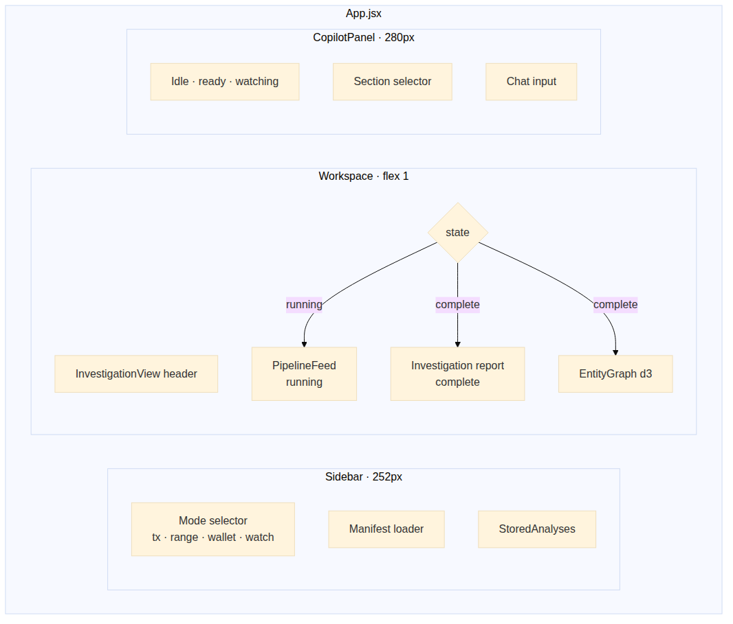
Three-column layout
Column | Purpose
Sidebar (left) | Pick a mode, load a manifest, see past investigations.
Workspace (centre) | Live pipeline log while running; investigation report when complete.
Copilot (right) | Ask follow-up questions; generate the 7 report sections.
You will spend most of your time in the centre column. The sidebar is for control, the copilot is for explanation.

2. Running an investigation

2.1 Four modes
Pick the right mode from the sidebar.
Mode | When to use | What to enter
tx | The client gave you a specific transaction hash. | The 66-character 0x… hash.
range | The client gave you a block window. | from_block and to_block.
wallet | The client gave you a wallet address. | The 42-character 0x… address.
watch | You want to watch new blocks as they arrive (e.g. an exploit unfolding live). | Nothing — leave it running.
The wallet and watch modes are planned in the architecture but not yet wired in the shipping code. If you select them, the SSE feed tells you so. Use tx or range for everything today.

2.2 Loading the manifest
- Click Load manifest in the sidebar.
- Pick the client’s manifest.json.
- The sidebar shows the investigation ID, chain ID, window, and the list of contracts.
- The frontend writes the manifest’s ABIs into the right place on disk automatically — no manual file-copying required.

2.3 Hitting “Analyze”
You will see:
- The status pill at the top of the workspace flips to Running.
- The PipelineFeed lights up with phase events:
  - collect (grey) — fetching from RPC
  - decode (grey) — applying ABIs
  - derive (grey) — synthesising events
  - ingest (grey) — writing to Elasticsearch
  - signals (yellow / red) — counts how many fired
  - patterns(yellow / red) — counts how many matched
  - complete (green)
- When complete arrives, the workspace auto-flips to the investigation report and renders the entity graph.

2.4 If something looks wrong
- No signals at all. Either the client’s manifest didn’t include the right ABIs (so the decoder couldn’t make sense of the logs), or the time window doesn’t cover the suspicious activity. The PipelineFeed shows decoded vs unknown counts at the decode phase — if “unknown” dominates, you are missing ABIs.
- Pipeline crashed. A red error event explains what failed. Common causes are wrong RPC URL, ES not reachable, or a malformed ABI in the manifest.
- Pipeline stuck at “collect” for ages. The RPC is slow or rate- limited. Free Alchemy / Infura tiers throttle aggressively on big ranges — switch to a paid key or shrink the window.

3. Reading what ChainSentinel found

3.1 Three things you’ll always see
When complete fires, the workspace shows:
- Verdict card at the top — a one-line summary (e.g. “Classic reentrancy exploit drained 1,237 ETH from 0xVault”).
- Signals & alerts in the middle — chips for each fired signal grouped by family, plus alert cards for each matched pattern.
- Entity graph at the bottom — d3 force-directed layout of the fund flow.
The right column’s CopilotPanel automatically flips to Ready so you can ask questions.

3.2 What a signal means
A signal is one piece of evidence. Example: drain_ratio_exceeded fires when a contract’s balance dropped by more than 30 % in a single transaction. That, alone, does not prove anything malicious — a treasury withdrawal can match. The point of signals is to gather all the relevant evidence before applying judgement.
Signals carry three pieces of information you care about:
- Name — what kind of evidence (e.g. flashloan_bracket_detected).
- Severity — INFO (grey), WARN (yellow), or CRIT (red).
- Score — a number [0,1] indicating how strong this individual piece of evidence is.
Read severity colour first, then dig into the signals that fired with high score.

3.3 What a pattern means
A pattern (a.k.a. alert, AP-NNN) is a combination of signals fired in the right order. Pattern matches are much more meaningful than individual signals because they encode the shape of an attack.
The shipping catalogue is 38 patterns — see D4 §10 for the full table. The common ones:
Pattern | One-line verdict
AP-001 classic_reentrancy | Recursive withdraw drained the contract.
AP-006 flash_loan_oracle | Flash loan used to manipulate an oracle.
AP-012 ownership_hijack | Admin key transferred, then funds moved.
AP-016 sandwich_attack | Three swaps in one block; the middle one is the victim.
AP-021 infinite_approval_drain | Token approval abused to drain wallet.
AP-033 mixer_bridge_detection | Funds passed through Tornado Cash or a bridge.

3.4 What the entity graph means
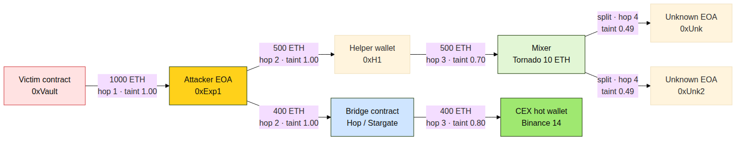
Fund-trace BFS walk
The graph shows who paid whom, hop by hop:
- Red nodes — the victim contract or the attacker EOA, derived from the manifest and the analysis.
- Yellow nodes — addresses the analyst should treat as suspect.
- Mint nodes — known mixers (Tornado Cash, …).
- Light-green nodes — known centralised-exchange deposit addresses.
- Pale-blue nodes — known bridge contracts.
- Plain nodes — unknown EOAs.
Edge thickness is value transferred; edge dashing reflects taint strength. A solid edge is fully tainted (=1.0); a dashed edge has passed through a mixer or bridge and the taint has been haircut.
The graph is interactive: click a node to highlight its hops, click an edge to see the transaction hash and value.

3.5 Severity colour key
This is the same colour key everywhere in the UI:
Colour | Severity | Meaning
Grey | INFO | Evidence noted; no action required.
Wise green | ok | Phase completed without issue.
Yellow | WARN | Suspicious but not conclusive.
Red | CRIT | Strong evidence of malicious activity.

4. Working with the copilot

4.1 What the copilot can do
The copilot summarises and explains. It does not invent. It cannot access the internet, query the blockchain directly, or write new detection rules. What it does is take the data ChainSentinel produced and turn it into prose.
Two modes:
- Section generation. Pick one of the 7 sections and the copilot writes a draft for it. Useful when you need to write a client report fast.
- Free-form Q&A. Ask it anything about the current investigation. “Why did AP-006 fire?” “Which addresses received funds after the exploit?” “Summarise the timeline in two paragraphs.”

4.2 The seven sections
Section | Typical content
Executive Summary | Two paragraphs you can paste at the top of a client report.
Attack Timeline | Block-by-block narrative.
Technical Mechanism | How the exploit worked.
Attacker Attribution | What the clustering and label DB say.
Fund Trail | Where the money went, hop by hop, with taint.
Signal Evidence | Bullet list of firing signals and what each means.
Remediation Actions | Suggestions for the victim contract.
Each section is regenerable — click Refresh to get a new draft.

4.3 Guardrails
The copilot is constrained by its prompt:
- Every address, hash, amount, and block number it mentions must appear in the analysis. If you see something invented, treat it as a bug and report it.
- If the analysis does not have an answer, the copilot must say so rather than guess.
- The copilot will refuse to write detection rules, blockchain transactions, or any code that would execute outside the report.
If you suspect the copilot has invented something, cross-check against the entity graph and the signal list. The analysis layer is the ground truth.

4.4 Picking a different model
If the operator configured a larger model (e.g. llama3:8b), reports will be slower but more polished. The copilot’s behaviour is otherwise identical.

5. Case study: reentrancy-drain
A first walkthrough using the reentrancy-drain simulation. Steps an analyst takes start-to-finish.

5.1 Setup
Run:
./run_demo.sh reentrancy-drain
The terminal logs deployment, then ~200 normal txs, then the attack. At the end it prints:
Investigation: SIM-REENTRANCY-001
Block range: 5..212
Open: http://localhost:5173?investigation=SIM-REENTRANCY-001

5.2 Open the investigation
- The sidebar shows the new investigation already loaded.
- The workspace shows the PipelineFeed is at complete (the demo script analyzes automatically).

5.3 What you see
- Verdict card: “Classic reentrancy exploit. Attacker recursively re-entered withdraw() on VulnerableVault and drained the contract before the balance update.”
- Alerts: AP-001 classic_reentrancy at 0.92, AP-030 attacker_deployment at 0.78, AP-031 fund_dispersion at 0.71.
- CRIT signals: cross_function_reentry, recursive_depth_pattern, value_drain_per_depth, drain_ratio_exceeded.
- WARN signals: same_block_deploy_and_attack, contract_deployed_before_attack, storage_update_delay, fund_dispersion_post_attack.
- Entity graph: the attacker EOA (yellow) is connected to the vault (red), to two helper EOAs, and eventually to a Tornado Cash contract (mint).

5.4 Confirming the verdict in the data
Open Kibana (or the Discover button in the workspace) and filter by investigation_id + layer:"derived" + derived_type:"reentrancy_patterns". You will see the recursive withdraw calls at increasing call depth, each with value_eth > 0. This is the underlying evidence the recursive_depth_pattern signal fired on.

5.5 Asking the copilot
Click into the CopilotPanel and try:
- “Generate the Executive Summary.” — two paragraphs you can paste into a client report.
- “Summarise the fund trail.” — narrative form of the entity graph.
- “How could the victim have prevented this?” — the copilot will produce a Remediation Actions section pointing at the checks-effects-interactions pattern and OpenZeppelin’s ReentrancyGuard.

5.6 Lessons
Three things to internalise:
- The strongest evidence here is cross_function_reentry (score 0.95) and recursive_depth_pattern (score 0.7). One of those alone would already be enough — together, the verdict is unambiguous.
- The pattern AP-001 required only the reentrancy + drain signals, not the flash-loan bracket — reentrancy doesn’t need flash loans.
- The entity graph would have shown the same fund flow even if the attacker had used a hand-funded EOA instead of self-deployment.

6. Case study: flash-loan-oracle

6.1 Setup
./run_demo.sh flash-loan-oracle
The terminal shows the lending pool deployment, the seeded liquidity, ~200 normal swap/lend txs, then the attack: a flash loan, a price swing, a profitable liquidation, and the loan repayment — all in one transaction.

6.2 What you see
- Verdict card: “Flash-loan-funded oracle manipulation. Attacker borrowed X ETH, manipulated the spot price on MockUniswapPool to trigger a profitable liquidation, then repaid the loan in the same tx.”
- Alerts: AP-006 flash_loan_oracle (0.94), AP-009 amm_spot_price (0.81), AP-033 mixer_bridge_detection (0.62).
- CRIT signals: flashloan_bracket_detected, spot_price_manipulation, drain_ratio_exceeded.
- WARN signals: multi_oracle_divergence, price_read_during_callback, bridge_interaction_detected.

6.3 Reading the trace
Open the workspace’s Trace tab. The call tree shows:
flashLoan(X)
├─ onFlashLoan() callback
│ ├─ Pool.swap(big amount) — moves spot price
│ ├─ LendingPool.liquidate(victimPosition) — uses inflated price
│ └─ Pool.swap(reverse) — recovers the asset
└─ Pool.repay(X + fee)
Two price reads, with a value swap in between — that’s why price_before_after_mismatch fired.

6.4 Copilot helpers
Try “Walk me through the attack step by step.” The copilot will produce a numbered list reflecting the trace, citing the tx hash and block number for each step.

6.5 Lessons
- The flash-loan bracket is the scaffold — the actual harm is the oracle manipulation. AP-006 requires both.
- The same evidence also matches AP-009 amm_spot_price at lower confidence. ChainSentinel surfaces both; the higher confidence is the verdict, the lower is a corroborating perspective.
- If the lending pool had used a TWAP instead of a spot price, AP-006 would not have fired — but AP-010 twap_manipulation would have, if the attacker sustained the manipulation across blocks.

7. Case study: admin-key-abuse

7.1 Setup
./run_demo.sh admin-key-abuse

7.2 What you see
- Verdict card: “Admin-key compromise. Ownership of GovernanceToken was transferred to attacker EOA at block N, who then minted 10× the existing supply and dumped it into the AMM.”
- Alerts: AP-012 ownership_hijack (0.93), AP-020 mint_and_dump (0.88), AP-031 fund_dispersion (0.7).
- CRIT signals: ownership_transfer_then_drain, mint_to_dump_ratio, rapid_token_dump.

7.3 Distinguishing legitimate ownership transfers
Not every OwnershipTransferred event is malicious — multisigs migrate admin keys all the time. AP-012 requires the drain to happen within a short window of the transfer. Open the Timeline view in InvestigationView and you’ll see:
block N OwnershipTransferred(prev, new=0xAttacker)
block N+1 GovernanceToken.mint(0xAttacker, 1e25)
block N+2 SimpleDEX.swap(token, weth) ×3 — dump
Three blocks. That is what makes this malicious.

7.4 What the copilot says
“Generate Remediation Actions.” You’ll get:
- Migrate admin to a multisig (2-of-3 minimum) before re-issuing.
- Time-lock all owner-only functions; the abused mint should have a 24-hour delay.
- Add a per-block mint cap (e.g. max 1 % of supply per day).
- Subscribe to ChainSentinel watch-mode on the victim contract going forward.

7.5 Lessons
- Ownership signals on their own are weak. The strength comes from pattern AP-012, which requires the transfer → drain sequence.
- The mint_to_dump_ratio signal would have fired even without the ownership transfer if a malicious owner had been in place from day one — useful for catching slow rugs.

8. Case study: mev-sandwich

8.1 Setup
./run_demo.sh mev-sandwich

8.2 What you see
- Verdict card: “MEV sandwich. Attacker bracketed a victim swap with a front-run buy and a back-run sell in the same block, profiting N USDC.”
- Alerts: AP-016 sandwich_attack (0.91), AP-017 frontrunning (0.74).
- CRIT signals: the sequence-based detections in sequence/.
- WARN signals: reserve_ratio_spike, value_concentration, high_gas_anomaly.

8.3 What makes this different
MEV sandwiches are unique among the shipped scenarios because the exploit is purely economic, not contractual. The victim contract has no bug; the victim user just paid a worse price.
That makes detection an ordering problem — three transactions in one block, in a specific pattern. The pattern engine’s EQL sequence queries are the natural fit.

8.4 Copilot quirks
The copilot is allowed to mention prices and gas amounts only when they appear in the derived events. Try “What was the slippage?” and it will quote a figure straight from the value_flow_intra_tx data.

8.5 Lessons
- Sandwich detection depends on block ordering, not call traces. AP-016 is fundamentally a sequence query.
- The attacker is generally a bot; clustering identifies them across thousands of past sandwiches if you re-run with a wider window.

9. Case study: demo-500 (live presentation)

9.1 What demo-500 is
A scripted scenario that packs 500 transactions — most of them benign — around two distinct exploits: a reentrancy drain and a sandwich attack. Designed for live demos to a non-technical audience.

9.2 Running it
The default docker-compose workflow runs demo-500 end-to-end:
docker compose up
When chainsentinel-pipeline exits, open the frontend and you’ll see the analysis already complete.

9.3 What to highlight
When demoing:
- Show the PipelineFeed while it’s running — the rapid-fire phase events make the system feel alive.
- Once complete fires, open the alerts panel. There will be two patterns: AP-001 (reentrancy) and AP-016 (sandwich). This is the magic moment — ChainSentinel found two unrelated exploits in the same 500-tx window without being told what to look for.
- Open the entity graph. The attacker and the sandwich bot are different addresses, both visible.
- Click the CopilotPanel and generate the Executive Summary. Two paragraphs that tell the story.

9.4 Caveats
- demo-500 is deterministic — the same private keys, same nonces, same outcomes. If you need novelty, modify the script or pull a real on-chain incident.
- The copilot output is not deterministic with default gemma3:1b; expect minor wording variation between runs.

10. Frequently asked questions

10.1 Can ChainSentinel find every exploit?
No. ChainSentinel has 60 signals and 38 patterns. It will catch every exploit class it has been taught to recognise — reentrancy, flash-loan oracle manipulation, admin-key abuse, sandwiches, vault inflation, many more. It will miss novel attack classes the same way an antivirus misses zero-days. The remedy is to add a signal or a pattern — see D5 §5–6.

10.2 Can it analyse contracts I don’t have the source for?
Yes — ABIs only. The decoder reads function selectors and event signatures from the ABI; no source is required. If the client cannot provide an ABI, the contract’s calls will appear as unknown decoded records, which is still useful but limits the detection coverage.

10.3 Can it look back further than a few hundred blocks?
Yes — tx_history_limit is configurable. Practical limits come from your RPC: free Alchemy / Infura tiers throttle aggressively. For very deep history (months / years) point at an archive node.

10.4 Does it support chains other than Ethereum?
It supports any EVM-compatible chain (set chain_id and rpc_url in config.json). It does not support non-EVM chains (Solana, Cosmos, Bitcoin).

10.5 Can the copilot post on my behalf to the client?
No. The copilot only generates text. It has no integration with email, chat, ticketing systems, etc. Copy and paste.

10.6 What if the copilot says something wrong?
Cross-check against the entity graph, the signal list, and the underlying Kibana data. The analysis layer is ground truth. Report hallucinations to the operator so they can tune prompts.

10.7 Can I rerun the same investigation?
Yes. The deterministic document IDs (see D3 §3.4) mean re-running an analysis upserts existing documents — you won’t get duplicates. Useful when:
- A new signal .esql was added and you want to apply it to old data.
- An ABI was updated and you want to re-decode.

10.8 Where do my investigations live?
Three places:
- The Elasticsearch index forensics (and the raw evidence in forensics-raw).
- The browser’s localStorage — for quick navigation and the “Stored Analyses” sidebar list.
- Optionally, exported PDFs / DOCX from the copilot output.
If you wipe the ES indices, the sidebar history becomes stale links — nothing in localStorage resolves anymore.

10.9 Is anything sent to the cloud?
By default, no. RPC fetches go wherever you point them. Ollama runs locally. Elasticsearch runs locally. The frontend is also served locally. If you point at a cloud RPC (Alchemy / Infura), that provider sees your queries — same as any blockchain explorer.

10.10 How do I get help?
Three layers of help:
- Tooltip help inline in the UI — hover any signal name.
- This manual — D4 Detection Reference has the full catalog.
- Your operator / the engineering team — see D5 §10 for the contribution workflow.

