ChainSentinel — System Architecture & Design
Document D3 of the ChainSentinel Manual
ChainSentinel Engineering
2026-05-12
Table of Contents

About this document
This is the architectural reference for ChainSentinel. It explains what the system is built from, how data flows through it, and why the key design choices were made. It assumes the reader is technical (engineer, senior operator, or security architect) but does not require prior familiarity with the code.
Companion documents:
- D4 Detection Reference — every signal, pattern, derived event, ABI, and ES field, in catalogue form.
- D5 Developer Guide — per-module API contracts and extension points.
- D6 Operations Guide — install, configure, deploy, troubleshoot.
- D1 Executive Overview — non-technical summary for stakeholders.
- D2 Analyst Handbook — workflow guide for SISA analysts.
- D7 Simulation Guide — the five Foundry attack scenarios.

1. Goals and non-goals

1.1 What ChainSentinel is for
ChainSentinel is a standalone EVM blockchain forensics tool. Given a transaction hash, wallet address, or block range — plus a client-supplied manifest of ABIs and deployed contract addresses — it runs a full forensic pipeline:
- Collects raw chain data from an RPC endpoint (Anvil, testnet, or mainnet).
- Decodes it using the client’s ABIs and a registry of standards.
- Synthesises higher-level derived events (value flows, reentrancy patterns, governance actions, …).
- Runs 60 ES|QL signals and 38 EQL attack patterns against the indexed data.
- Traces funds across up to five hops and clusters related wallets.
- Surfaces findings in a React investigation workspace with an Ollama-powered copilot that explains them in plain English.
The real-world workflow it targets: “a client comes to SISA and says they were exploited. They hand over their RPC endpoint, contract ABIs, deployed addresses, and an approximate time window. The analyst loads this into ChainSentinel and the tool tells them what happened — purely from on-chain data plus the client’s ABIs.”

1.2 Hard goals
# | Goal | Mechanism
G1 | Detection logic readable by anyone who knows Elasticsearch | All signals are .esql files, all patterns are .eql files — no Python logic.
G2 | Raw evidence never mixed with interpretations | Two strict ES indices: forensics-raw (untouched) and forensics (everything derived).
G3 | Modular growth | Add a signal = drop a .esql file. Add a pattern = drop a .eql file. Add a derived event = add a .py builder. Engines auto-discover.
G4 | Switch between Anvil, testnet, mainnet with one URL change | No node-specific conditional logic; only rpc_url and chain_id differ across deployments.
G5 | Idempotent re-ingestion | Every ES document has a deterministic _id; replaying the same data yields the same documents.
G6 | Graceful degradation | Tool works on basic RPC (receipts + logs) and degrades from there. Full traces are an enhancement, not a requirement.
G7 | Fully demonstrable offline | Foundry simulations on local Anvil reproduce real client engagements end-to-end.
G8 | One-command stack startup | chainsentinel/start.sh brings up ES, Ollama, Anvil, FastAPI, and the React frontend.
G9 | Copilot never invents data | Ollama is fed structured JSON context, never raw ES documents; prompts forbid invented addresses, amounts, hashes, or block numbers.

1.3 Explicit non-goals
- Not a SIEM. ChainSentinel ingests one investigation at a time; it is not designed for continuous, multi-tenant ingestion.
- Not a generic blockchain indexer. The forensic schema is opinionated. Use The Graph, Subsquid, or a custom indexer for product analytics.
- Not a paid intel feed. Address labels (OFAC, known exploiters, mixers, bridges, CEX wallets) ship as a small local DB; integration with commercial intel providers is out of scope.
- Not a chain-of-custody system. ChainSentinel reproduces evidence deterministically but does not produce court-admissible artefacts.
- No cross-VM support. Solana, Cosmos, Bitcoin are out of scope; this is EVM-only.

1.4 Trust boundaries
The system has four trust regions:
- Client handover — manifest + ABIs + RPC URL. Treated as untrusted input: invalid ABIs degrade decode rather than crash; out-of-range blocks produce an error event, not silent partial results.
- RPC endpoint — assumed honest about chain state but may be slow, rate-limited, or partial (no debug traces). The collector tolerates missing fields and records decode_status = unknown when needed.
- Local infrastructure — Elasticsearch, Ollama, the FastAPI server, and the frontend all run on the analyst’s machine (or a single locked- down VM). Network exposure is unnecessary; defaults bind to localhost.
- Operator inputs — the analyst chooses what to investigate, but the copilot never accepts free-form SQL or ES queries via the chat interface. Questions are routed through report_sections.py which builds structured prompts.

2. System architecture

2.1 The one-page picture
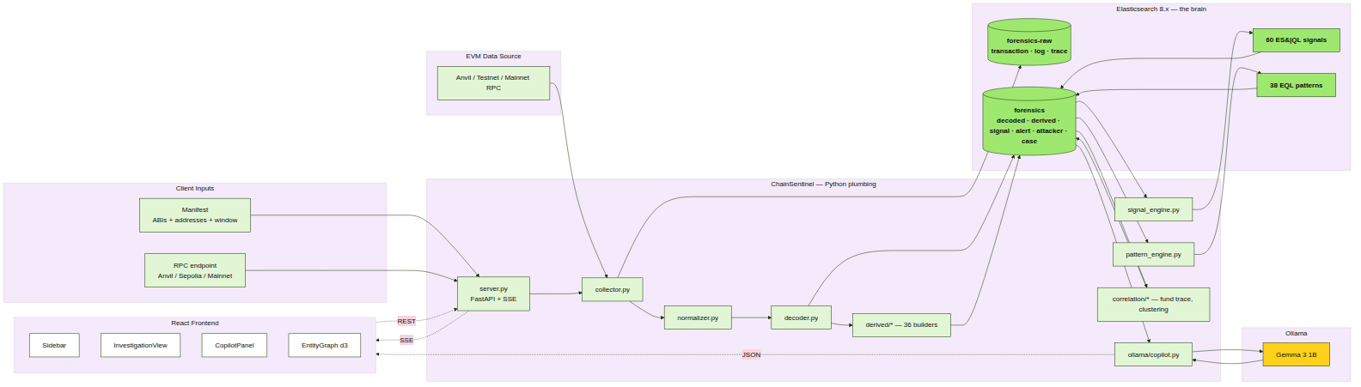
System architecture
Five logical regions:
- Client inputs — the manifest (ABIs + addresses + window) and an RPC URL.
- EVM data source — Anvil for simulations, Sepolia/mainnet via Alchemy or Infura in production.
- Python plumbing — FastAPI server, the pipeline (collector, normalizer, decoder, derived builders), and the two detection engines.
- Elasticsearch — two indices and the queries that operate on them (60 ES|QL signals, 38 EQL patterns).
- Ollama + React UI — the copilot and the three-column investigation workspace.
The single thing every region shares: an investigation_id. It is generated by pipeline.runner.generate_investigation_id() at the start of every run and threaded through every document, every signal, every alert, and every copilot context.

2.2 Module responsibilities
Module | Path | Responsibility | Detail in
FastAPI server | chainsentinel/server.py | REST + SSE entry point; 4 endpoints | D5 §3.1
Runner | pipeline/runner.py | Orchestrate pipeline phases, yield SSE events | D5 §3.6
Collector | pipeline/collector.py | Fetch tx + receipt + traces from RPC | D5 §3.2
Normalizer | pipeline/normalizer.py | hex → int, lowercase addresses, ISO timestamps | D5 §3.5
Decoder | pipeline/decoder.py | Decode events + fn calls via ABI registry | D5 §3.4
Derived | pipeline/derived/*.py | 36 builders that synthesise higher-level events | D5 §3.7
Ingest | pipeline/ingest.py | Bulk-index to ES with idempotent _ids | D5 §3.3
Signal engine | detection/signal_engine.py | Discover + run *.esql against ES | D5 §3.8
Pattern engine | detection/pattern_engine.py | Discover + run *.eql over signals | D5 §3.9
Fund trace | correlation/fund_trace.py | BFS 5-hop, haircut taint scoring | D5 §3.10
Clustering | correlation/clustering.py | Group wallets by signals (timing, funding, creator) | D5 §3.11
Mixer detect | correlation/mixer_detect.py | Classify mixers, bridges, CEX | D5 §3.12
Label DB | correlation/label_db.py | Known-address corpus | D5 §3.13
ES setup | es/setup.py | Create indices + apply strict mappings | D5 §3.14
Copilot | ollama/copilot.py | Build prompt + stream Ollama tokens | D5 §3.15
Report template | ollama/report_template.py | Build structured context from ES | D5 §3.16
Report sections | ollama/report_sections.py | 7-section forensic report generation | D5 §3.17
Frontend | chainsentinel/frontend/src/ | React 18 + Vite + d3 + Wise design system | D5 §4

2.3 Process topology
A single run touches five processes, all on localhost by default:
┌────────────┐ ┌──────────────┐ ┌───────────────┐
│ React UI │ ◄─ │ FastAPI :8000│ ◄─ │ Python pipeline│
│ Vite :5173 │ SSE│ + worker │ │ (in-process) │
└─────┬──────┘ └─────┬────────┘ └───────┬───────┘
│ HTTP │ HTTP │ RPC
│ ▼ ▼
│ ┌──────────────┐ ┌───────────────┐
└────────► │ Ollama :11434│ │ Anvil :8545 │
└─────┬────────┘ └───────────────┘
│
▼
┌──────────────┐
│ Elasticsearch│
│ :9200 │
└──────────────┘
docker-compose.yml runs Elasticsearch + Kibana in containers; start.sh orchestrates Ollama, Anvil, FastAPI, and Vite on the host. The two are deliberately decoupled — operators can swap ES for a remote cluster by changing config.json and never touching the start script.

3. Data flow

3.1 End-to-end pipeline
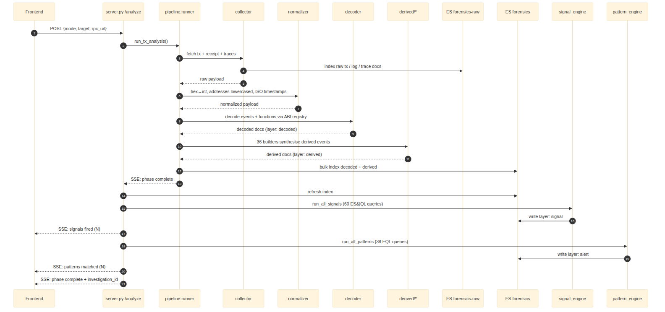
Pipeline data flow
A single tx-mode run produces, in order:
- Collection. collector.py fetches the transaction, its receipt, all logs, and (if the RPC supports it) the full call trace. Each artefact is written to forensics-raw with doc_type ∈ {transaction, log, trace}.
- Normalisation. normalizer.py rewrites hex strings to integers, lowercases every address, converts wei to ETH (storing both as value_wei: keyword and value_eth: double), and replaces every timestamp with ISO 8601 UTC. Any field the normaliser does not understand is preserved in raw_extra (a flattened field) so nothing is lost.
- Decoding. decoder.py walks logs and function inputs, looks up the event signature (topic0) and function selector (first 4 bytes) in the ABI registry, and produces decoded documents with layer: decoded. The registry resolution order is case ABIs → standards → protocols → selector cache. Anything that cannot be resolved gets decode_status: unknown; partial matches get partial; clean matches get decoded.
- Derivation. pipeline/derived/*.py runs 36 builders against the decoded stream and emits higher-level events with layer: derived and a derived_type keyword. Each derived event carries source_tx_hash, source_log_index, and source_layer so the provenance is always traceable back to the raw evidence.
- Ingest. ingest.py bulk-indexes everything in chunks of es_bulk_chunk_size (default 500), using deterministic _id strings so re-running the same investigation overwrites instead of duplicating.
- Signal engine. signal_engine.py discovers every .esql file under detection/signals/, substitutes {investigation_id} and {chain_id}, executes via POST /_query, and writes the results as layer: signal documents.
- Pattern engine. pattern_engine.py does the same for every .eql file under detection/patterns/, runs them as sequence queries via POST /_eql/search, and writes results as layer: alert documents.
- Correlation. When the pipeline finishes, correlation/*.py runs the BFS fund trace and wallet clustering, producing layer: attacker and fund_flow_edge documents.
- Case roll-up. A single layer: case document captures the verdict and is the target for GET /analysis/{investigation_id} and the copilot.
Every phase yields an SSE event on the way through; the frontend’s PipelineFeed renders them in real time.

3.2 SSE event contract
The runner emits JSON payloads on the pipeline event stream:
{
"phase": "collect" | "decode" | "derive" | "ingest" | "signals" | "patterns" | "complete" | "error",
"msg": "human-readable status line",
"severity": "ok" | "warn" | "crit" | "gray",
"esIndex": "forensics-raw" | "forensics",
"ts": "HH:MM:SS",
"stats": { ... only on phase=complete ... }
}
The frontend keys colour and badging off severity; the analyst sees crit events in red and ok events in Wise Green.

3.3 ES index model
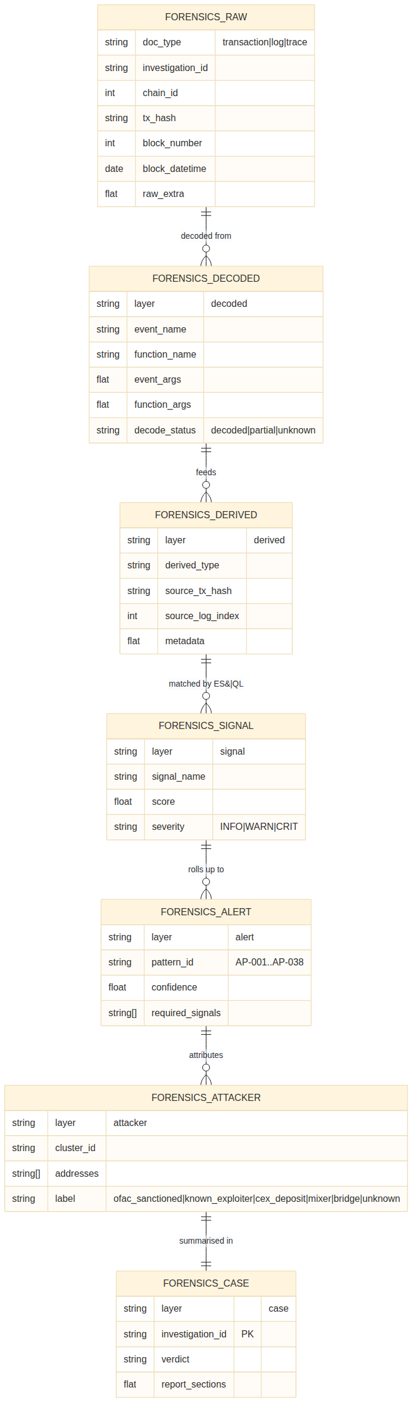
ES index model
Two strictly-mapped indices. Strict mapping (dynamic: strict) is a deliberate choice: any future field added by a builder must be declared in es/mappings/*.json. This prevents the mapping explosion that often plagues blockchain indexing projects, where every contract adds its own keyword fields.
Key mapping rules:
- Every address field is keyword, lowercased, and never analysed.
- event_args, function_args, metadata, and raw_extra are flattened to allow arbitrary content without inflating the mapping.
- value_eth is double; value_wei is keyword (because uint256 exceeds the range of long).
- score is float; severity and decode_status are keyword.
- Each document has the seven mandatory shared fields: investigation_id, chain_id, @timestamp, block_number, block_datetime, tx_hash, and layer (or doc_type for raw).
forensics-raw exists separately from forensics to honour goal G2 — evidence integrity. Nothing in the pipeline rewrites a raw document. If a decode rule changes, only the decoded documents in forensics need to be regenerated.

3.4 Deterministic document IDs
Document | _id formula
forensics-raw transaction | {chain_id}_{tx_hash}
forensics-raw log | {chain_id}_{tx_hash}_{log_index}
forensics-raw trace | {chain_id}_{tx_hash}_trace
forensics decoded | {investigation_id}_{tx_hash}_{log_index}_decoded
forensics derived | {investigation_id}_{derived_type}_{tx_hash}_{log_index}
forensics signal | {investigation_id}_{signal_name}_{tx_hash}
forensics alert | {investigation_id}_{pattern_id}
forensics attacker | {investigation_id}_{cluster_id}
forensics case | {investigation_id}
This is goal G5 (idempotency) made concrete. The collector can be re-run against the same tx without producing duplicates; the signal engine can be re-run after a rule change without manual cleanup.

4. Detection model

4.1 The layer cake
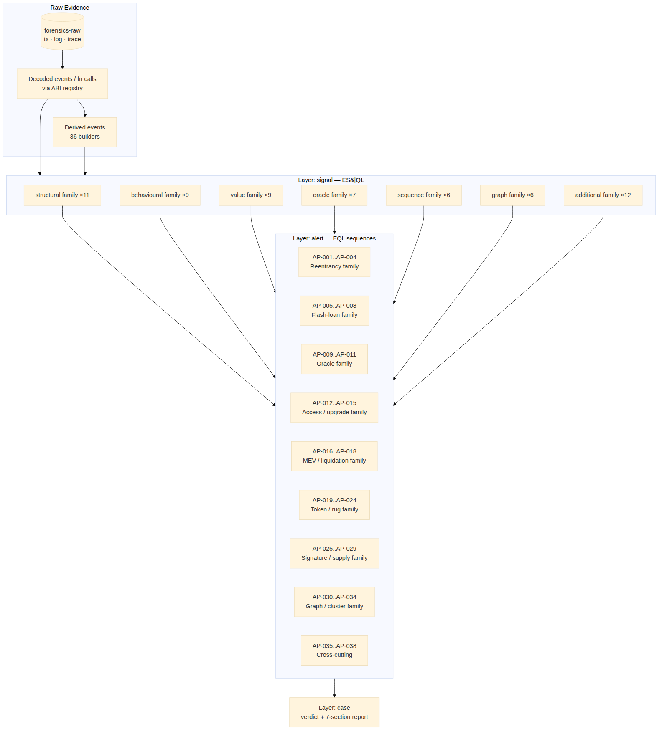
Signal → Pattern → Incident hierarchy
Four logical layers in the forensics index distinguish evidence from interpretation:
Layer | Source | Document content
decoded | pipeline.decoder | Decoded events + function calls
derived | pipeline.derived.* | Synthesised events (value flows, reentrancy depth, …)
signal | detection.signal_engine | A single suspicious finding from one .esql query
alert | detection.pattern_engine | A multi-signal sequence matched by an .eql query
attacker | correlation.clustering | Inferred attacker cluster
case | runner roll-up | Verdict + report sections, one per investigation
This separation supports goal G1: a SISA analyst with Kibana access can read every layer in isolation, follow the chain of inferences, and modify a signal without touching Python.

4.2 Signals — ES|QL queries
detection/signals/ contains 60 .esql files in 7 family folders. The signal engine:
for each .esql file:
text = read file
substituted = text.format(investigation_id=…, chain_id=…)
rows = es.esql_query(substituted)
for row in rows:
doc = { layer: signal, signal_name: <file stem>,
score, severity, … row data }
bulk_index(doc)
A signal scores in [0, 1] and carries a severity bucket. The bucket threshold is signal_score_threshold from config.json (default 0.5). Anything below threshold still ingests as INFO so analysts can see near-misses.
Families (with counts):
Family | Count | Theme
structural | 11 | Trace-level structure: reentrancy depth, flash-loan brackets, selfdestruct, proxy upgrade.
behavioural | 9 | Cross-tx behaviour: funding lineage, deployment timing, gas anomalies.
value | 9 | Token / ETH value movement: drain ratios, dispersion, share-price spikes.
oracle | 7 | Price-feed manipulation: TWAP drift, donation inflation, spot manipulation.
sequence | 6 | Event ordering: missing events, deposit→withdraw same tx, ownership→drain.
graph | 6 | Graph membership: mixer/bridge interactions, cluster identification, multi-hop trails.
additional | 12 | Cross-cutting: replay, integer overflow, fee-on-transfer, governance abuse.
Full catalog: D4 §2–9.

4.3 Patterns — EQL sequences
detection/patterns/ contains 38 .eql files (AP-001..AP-038). Each is a sequence query of the form:
sequence by investigation_id with maxspan=5m
[ signal where signal_name == "flashloan_bracket_detected" ]
[ signal where signal_name == "spot_price_manipulation" ]
[ signal where signal_name == "drain_ratio_exceeded" ]
A pattern fires only when all of its required signals fire in the specified order within the time window. Confidence is computed from contributing signal scores and stored as layer: alert with pattern_id set to the file’s AP-NNN prefix.
Pattern families (informal grouping):
- Reentrancy — AP-001..AP-004 (classic, cross-function, read-only, ERC777 hook)
- Flash loan — AP-005..AP-008 (classic, oracle, governance, multi-pool)
- Oracle — AP-009..AP-011 (AMM spot, TWAP, multi-oracle inconsistency)
- Access / upgrade — AP-012..AP-015 (ownership hijack, uninit proxy, delegatecall escalation, selfdestruct drain)
- MEV / liquidation — AP-016..AP-018
- Token / rug — AP-019..AP-024
- Signature / supply — AP-025..AP-029
- Graph / cluster — AP-030..AP-034
- Cross-cutting — AP-035..AP-038
Full catalog: D4 §10.

4.4 Scoring model
A signal score is a function of evidence strength, normalised to [0,1]. A pattern’s confidence is a weighted product of contributing signal scores plus a sequence-quality factor (do the signals appear in the expected order? do they share a tx hash where they should?).
Severity | Score range | UI badge | Trigger threshold
INFO | < 0.5 | grey | Always ingested for analyst review
WARN | 0.5..0.79 | yellow | Appears in Sidebar badge count
CRIT | ≥ 0.8 | red | Triggers toast notification
Threshold is configurable via signal_score_threshold in config.json. Per-signal weight tables live in D4 §1.

4.5 Adding detection — drop-a-file model
Per goal G3:
- A new signal → drop a .esql file under the correct family folder. The signal engine will discover and run it on next invocation. Naming rule: snake_case.esql; the stem becomes the signal_name.
- A new pattern → drop a .eql file under detection/patterns/. Naming rule: AP-NNN_short_slug.eql.
- A new derived event → add a .py file under pipeline/derived/ that subclasses the Builder contract in _base.py and registers itself.
- A new ABI → drop a JSON under pipeline/abi_registry/standards/ or, for client-specific contracts, under cases/{investigation_id}/.
The cookbook for each of these lives in D5 §5–8.

5. Correlation model

5.1 What correlation answers
Detection finds what happened. Correlation finds who and where the money went. Three questions:
- Which wallets are likely the same actor?
- Where did funds flow before and after the exploit?
- Have any of these addresses been seen before?
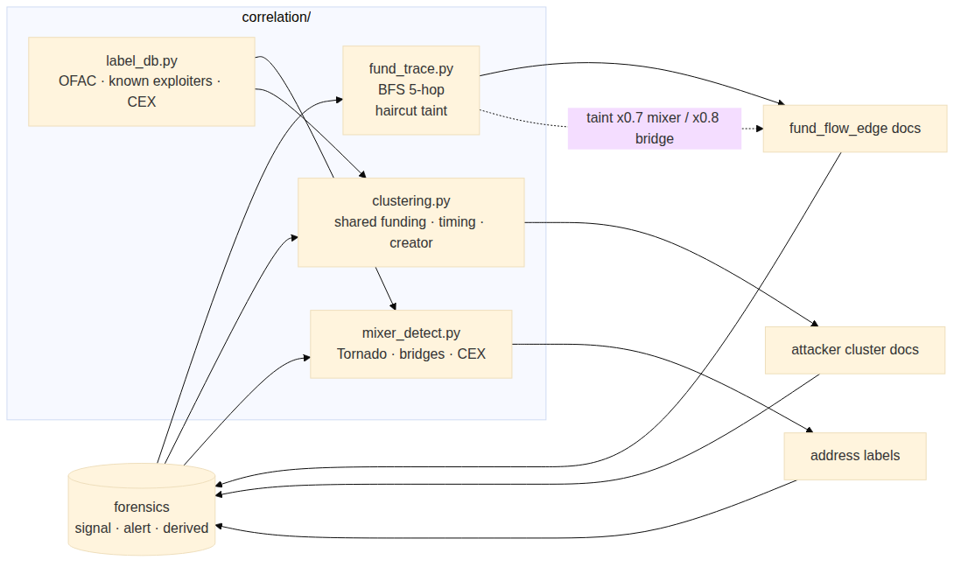
Correlation subsystem

5.2 Fund tracing — BFS with haircut taint
correlation/fund_trace.py walks the value-transfer graph starting from the victim and the attacker EOA. Each hop multiplies the taint scalar by a haircut factor depending on the destination’s classification:
Destination class | Haircut | Rationale
Mixer (Tornado Cash, …) | × 0.7 | Funds are likely commingled with legitimate user funds.
Bridge (Hop, Stargate, …) | × 0.8 | Funds may have crossed chains and become unrecoverable.
CEX hot wallet (Binance, Coinbase, …) | × 0.9 | Subpoena route exists; partial recoverability assumed.
Unknown EOA | × 1.0 | Taint preserved fully.
The walk respects max_trace_hops (default 5) in both directions: forward (from victim) and backward (to attacker funding source).
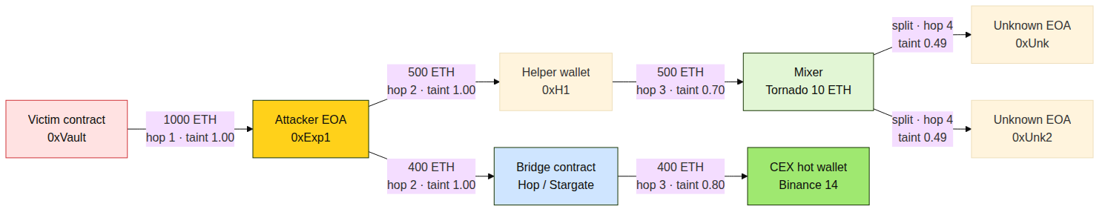
Fund-trace BFS walk
Output: a stream of fund_flow_edge documents with (src, dst, value, hop_index, taint, label_dst). The frontend’s EntityGraph renders these as a d3 force-directed layout.

5.3 Wallet clustering
correlation/clustering.py groups wallets that exhibit any of:
- Shared funding source — same EOA funded both wallets within a window.
- Timing correlation — both wallets active in the same block range with overlapping target contracts.
- Common contract creator — same deployer EOA (via the contract_creator_graph derived event).
- Trace co-occurrence — both wallets appear in the trace tree of the same transaction.
Each cluster gets a deterministic cluster_id (BLAKE2 hash of the sorted address tuple) and is written as a layer: attacker document with the labels assigned by mixer_detect + label_db.

5.4 Known-address corpus
correlation/label_db.py ships with a small static dataset of:
- 10 Tornado Cash variants (10 ETH, 100 ETH, USDC pools, …)
- Hop, Stargate, Multichain, Across bridges (mainnet contracts)
- Binance, Coinbase, Kraken known hot wallets
- OFAC SDN sanctioned addresses (initial seed)
- Notable past exploiter EOAs
Each address resolves to a label ∈ {ofac_sanctioned, known_exploiter, cex_deposit, mixer_contract, bridge_contract, protocol_treasury, unknown}. The corpus is stored in-memory as a dict; replace with a remote intel API later by reimplementing the single lookup() function.

6. Copilot architecture

6.1 Goals
The copilot exists to translate forensic findings into prose an analyst (or their client) can read. It must:
- Explain detected signals and patterns in plain English.
- Build a 7-section forensic report on demand.
- Never invent addresses, amounts, tx hashes, or block numbers (goal G9).

6.2 Three components
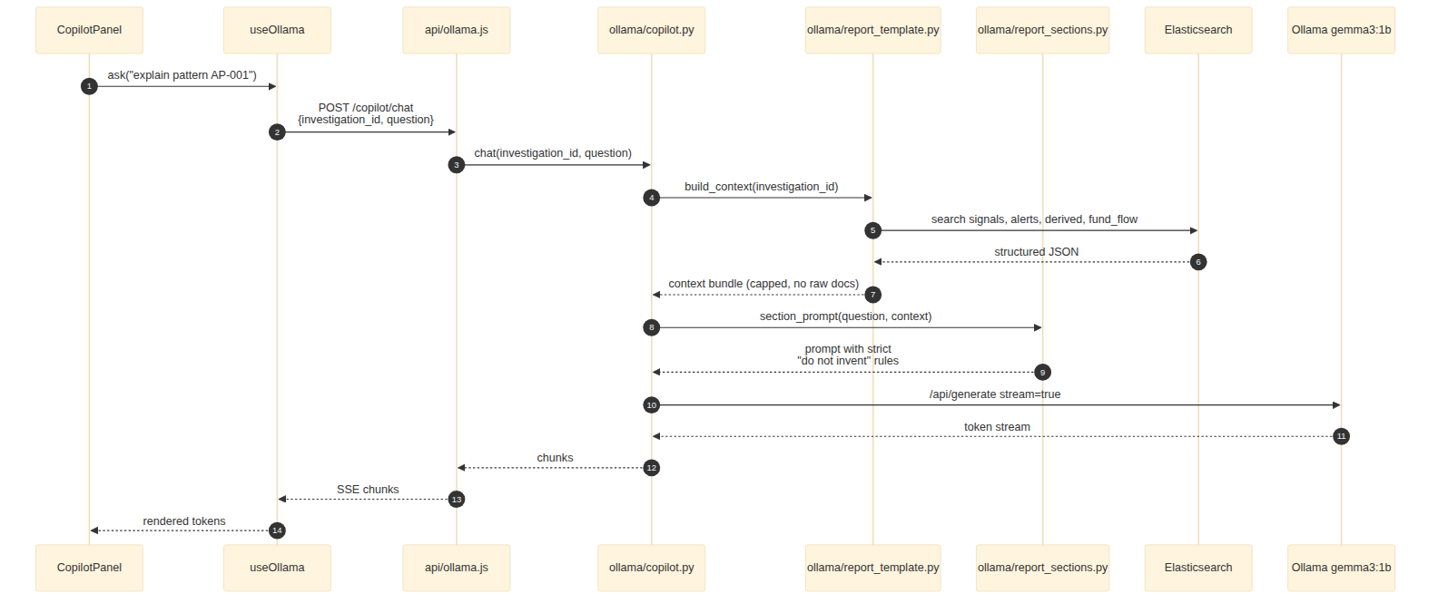
Ollama copilot flow
File | Role
ollama/report_template.py | Builds the context bundle from ES: signals, alerts, derived events, fund-trace edges, attacker cluster summary. Always structured JSON, never raw documents.
ollama/report_sections.py | Defines the 7 report sections (Executive Summary, Attack Timeline, Technical Mechanism, Attacker Attribution, Fund Trail, Signal Evidence, Remediation Actions) and the strict prompt for each.
ollama/copilot.py | Streams completions from Ollama with prompt caching where supported; exposes a chat interface and a one-shot section generator.

6.3 Prompt safety
Every system prompt includes:
You are summarising findings from a forensic analysis. You must NOT invent
any address, transaction hash, amount, block number, or contract name. If
the context does not include a fact, say so explicitly. If asked a question
the context cannot answer, refuse and ask for additional ES queries.
Per-section prompts further constrain the model: the Fund Trail section, for example, is told that any dst address it mentions must appear in the provided fund_flow_edges list, or it must use the phrase “address not in trace”.

6.4 Model choice — Gemma 3 1B
The default is gemma3:1b (≈1 GB on disk). Reasons:
- Cheap enough to ship on an analyst laptop, no cloud dependency.
- 1B parameters is sufficient because the model only summarises and paraphrases; it does not reason about smart-contract code from scratch.
- Temperature pinned at 0.2 (ollama_temperature in config.json) to minimise variance between runs.
Operators can swap in a larger model (e.g. llama3:8b) by editing config.json; the API contract with the copilot does not change.

7. Frontend architecture

7.1 Three-column workspace
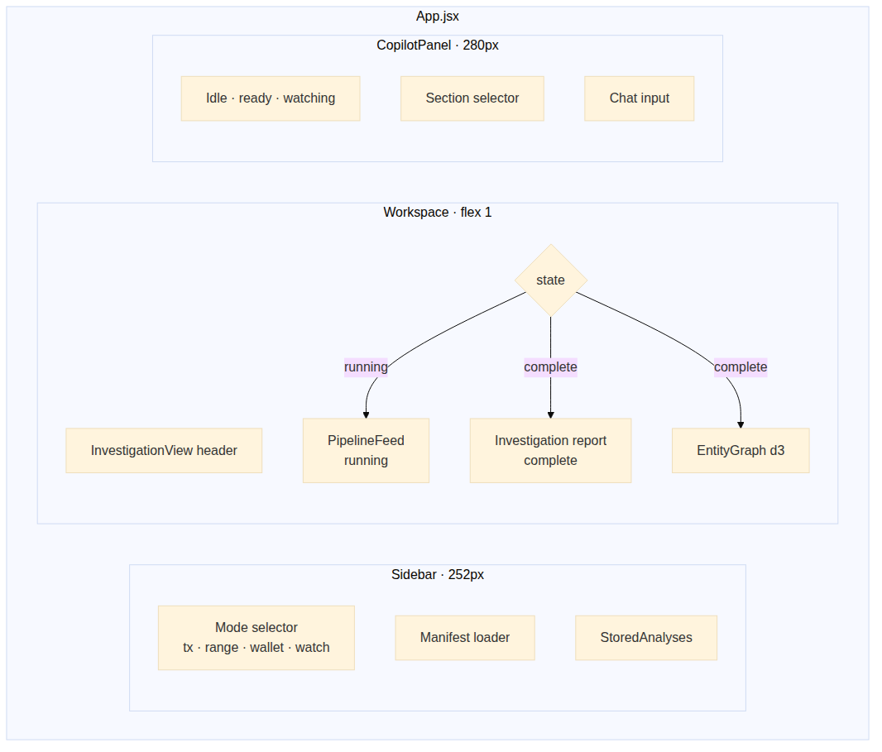
Frontend three-column layout
A single-page React 18 application built with Vite. Three columns:
- Sidebar (252 px) — mode selector, manifest loader, list of StoredAnalyses from localStorage.
- Workspace (flex 1) — InvestigationView. State machine: Running (renders PipelineFeed, the live SSE event log) → Complete (auto-flips to investigation report + EntityGraph).
- CopilotPanel (280 px) — chat interface, section selector, status badges (Idle / Watching / Ready).

7.2 Component × hook × API graph
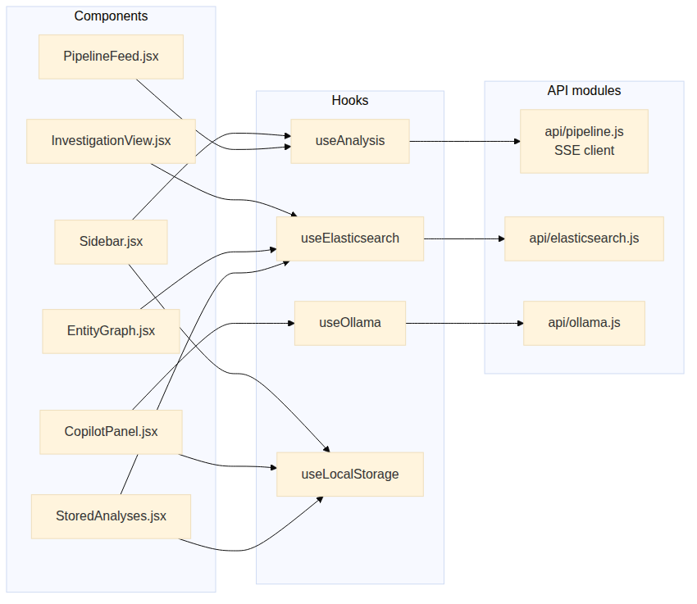
Frontend component graph
Component (src/components/) | Hooks | Purpose
Sidebar | useAnalysis, useLocalStorage | Run controls + history
PipelineFeed | useAnalysis | Live SSE stream renderer
InvestigationView | useElasticsearch | Report + state machine
EntityGraph | useElasticsearch | d3-force graph of fund flow
CopilotPanel | useOllama, useLocalStorage | LLM chat
StoredAnalyses | useLocalStorage, useElasticsearch | Past investigations

Hook | API module | Notes
useAnalysis | api/pipeline.js | Wraps the SSE EventSource for /analyze
useElasticsearch | api/elasticsearch.js | Direct ES queries (read-only)
useOllama | api/ollama.js | Streams completion tokens
useLocalStorage | — | Persistent UI state

7.3 Wise design system
The UI uses a Wise-inspired palette and typography:
Token | Value
--near-black | #0e0f0c
--wise-green | #9fe870
--dark-green | #163300
--light-mint | #e2f6d5
--danger-red | #d03238
--warning-yellow | #ffd11a
--gray | #868685
Typography: Inter weight 600 body, weight 900 headings, monospace for addresses, hashes, and amounts. Pill buttons use border-radius: 9999px; cards use border-radius: 30px.
Styles live in App.css and per-component *.css files alongside the .jsx. There is no separate tokens file — the variables are defined in the :root block of App.css.

8. Security and performance

8.1 Network surface
By default, every service binds to localhost:
Service | Port | Bind | Notes
FastAPI | 8000 | 0.0.0.0 (dev) | CORS allows http://localhost:5173 only
Vite | 5173 | 127.0.0.1 | Frontend dev server
Anvil | 8545 | 127.0.0.1 | Local sim only
Elasticsearch | 9200 | 127.0.0.1 | No auth in dev — see §8.3
Ollama | 11434 | 127.0.0.1 | Local LLM
For production deployment, bind ES + Ollama to a private VLAN, terminate TLS at the FastAPI server, and set CORS to the analyst origin only.

8.2 Input handling
- The AnalyzeRequest model uses Pydantic validation. mode is checked against the allowed set; mismatched payload shapes (e.g. tx mode given a dict target) produce SSE error events, not crashes.
- ABIs in the manifest are loaded but never executed. Malformed JSON is caught in the decoder and downgrades affected logs to decode_status: unknown.
- The copilot does not accept free-form SQL or ES queries from the chat input — only natural language. All ES access is mediated by report_template.py.

8.3 What is not secured
- Elasticsearch ships without authentication in the default docker-compose.yml (single-node, ES_SETTING xpack.security.enabled=false). This is acceptable for an analyst’s local machine; it is not acceptable for a shared cluster.
- The FastAPI server has no auth. Anyone with HTTP access to port 8000 can start an investigation. Run behind an authenticated reverse proxy if exposed beyond localhost.
- The kibana_setup.py script writes Kibana saved objects without auth — same caveat.

8.4 Performance characteristics
Observed on a 16-core, 32 GB-RAM developer machine:
Workload | Time | Bottleneck
start.sh cold start | 60–90 s | Ollama model pull (one-time)
ES boot | 15–25 s | Heap allocation, mapping creation
Single tx forensic run (small contract, ~30 logs) | 4–8 s | RPC trace fetch dominates
demo-500 scenario (500 txs) | 60–120 s | Bulk ingest + signal queries
60 ES|QL signals against ~5k derived docs | 1–3 s | ES per-query latency
38 EQL patterns over 200 signals | 0.5–1.5 s | ES sequence evaluation
Fund trace 5 hops, ~50-edge graph | < 1 s | Pure Python BFS
Copilot section generation (gemma3:1b) | 2–4 s per section | LLM token rate
Tuning knobs:
- es_bulk_chunk_size (default 500) — increase to 1000+ on a fat box; decrease on low-RAM hosts.
- max_trace_hops (default 5) — drop to 3 for very dispersed graphs.
- tx_history_limit (default 200) — caps backfill in range/wallet mode.
- Ollama model — swap to llama3:8b for higher-quality reports at ~5× the latency.

9. Architecture decision records
Short-form ADRs. Each captures the choice, the alternatives considered, and the consequence.

ADR-001 — Detection logic lives in ES queries, not Python
Context. ChainSentinel needs a detection layer that domain experts (SISA analysts) can modify without learning Python.
Decision. Every signal is a .esql file under detection/signals/. Every attack pattern is a .eql file under detection/patterns/. The Python engines do nothing but file discovery + parameter substitution + ES execution + result indexing.
Alternatives considered.
- Python rules with a DSL (Sigma-like). Rejected: requires teaching the DSL to analysts and re-implementing query primitives ES already has.
- A no-code rule builder. Rejected: heavy UI investment, hard to version- control, opaque to debugging.
Consequence. Anyone with Kibana access can read, edit, and contribute detection rules. The trade-off is that some detections are awkward in ES|QL (recursive joins, for instance); those move into derived-event builders instead.

ADR-002 — Two strict ES indices
Context. Forensic outputs must not pollute raw evidence.
Decision. Two indices: forensics-raw (transactions, logs, traces — never modified) and forensics (decoded, derived, signal, alert, attacker, case). Both are dynamic: strict; new fields require an explicit mapping update.
Alternatives considered.
- Single index with a layer field. Rejected: makes evidence-integrity guarantees less obvious and risks accidental rewrites.
- Index per layer. Rejected: too many indices for a single-tenant tool; pattern queries that cross layers would need cross-index searches.
Consequence. A field rename requires a mapping migration; this is deliberate. The strict mapping has caught at least one bug where a builder emitted a typo’d field name.

ADR-003 — Deterministic document IDs
Context. Pipelines that re-ingest the same data must not create duplicates.
Decision. Every document _id is derived from (chain_id, tx_hash, log_index, layer/derived_type). Re-runs produce the same IDs and ES performs upserts.
Alternatives considered. Random UUIDs + a “current run” filter. Rejected: requires a sweeper to delete previous run data, complicates goal G7 (offline demos).
Consequence. Investigations are safely replay-able. The ID scheme is documented in D3 §3.4 and D5 §3.3.

ADR-004 — Local Ollama, no cloud LLM
Context. The copilot must work offline (goal G7).
Decision. Run Ollama on the analyst’s machine with gemma3:1b by default. Prompts forbid invented data and are fed structured JSON context, never raw documents.
Alternatives considered.
- OpenAI / Anthropic API. Rejected: introduces a network dependency, data-handling concerns for client cases, and per-token cost.
- No copilot. Rejected: report writing dominates analyst time; even a small model produces credible drafts.
Consequence. Reports are slower than they would be with a frontier model but completely self-contained. Operators can swap in a larger model with one config change.

ADR-005 — Python is plumbing, never policy
Context. Tempting to embed detection logic in Python where it would be easier to write than in ES|QL.
Decision. Python in this project is restricted to: I/O, serialisation/deserialisation, ES bulk writes, glue around the runner, and the explicit derived event layer. Anything that decides “is this suspicious?” lives in .esql or .eql.
Consequence. Detection coverage scales with the number of analysts who can write ES queries, not with the number of Python engineers.

ADR-006 — Mermaid + Pandoc for documentation
Context. Documentation must be diff-friendly, version-controllable, and produce shareable Word documents for stakeholders.
Decision. Author in Markdown + Mermaid sources; render to DOCX via Pandoc with a reference.docx style template; render Mermaid to PNG + SVG via mmdc ahead of Pandoc.
Alternatives considered.
- Confluence / Notion. Rejected: not version-controllable with the code.
- LaTeX. Rejected: tooling overhead disproportionate to audience.
- Pure DOCX hand-authored. Rejected: terrible for diff review and reuse.
Consequence. Catalog tables are regenerated from source on every build (scripts/generate_catalog_tables.py) so the reference cannot drift from the code.

