**300 cols: 300**

ppcm width: 0.216 ppcm_height: 0.32

Perspective Transform Matrix: [1.858332295027073, 2.090141800567316, -131.3389817529832;

-0.1280601087924226, 6.710774188797322, -100.9611234687288;

-0.0005360423007830877, 0.01434007782185692, 1]

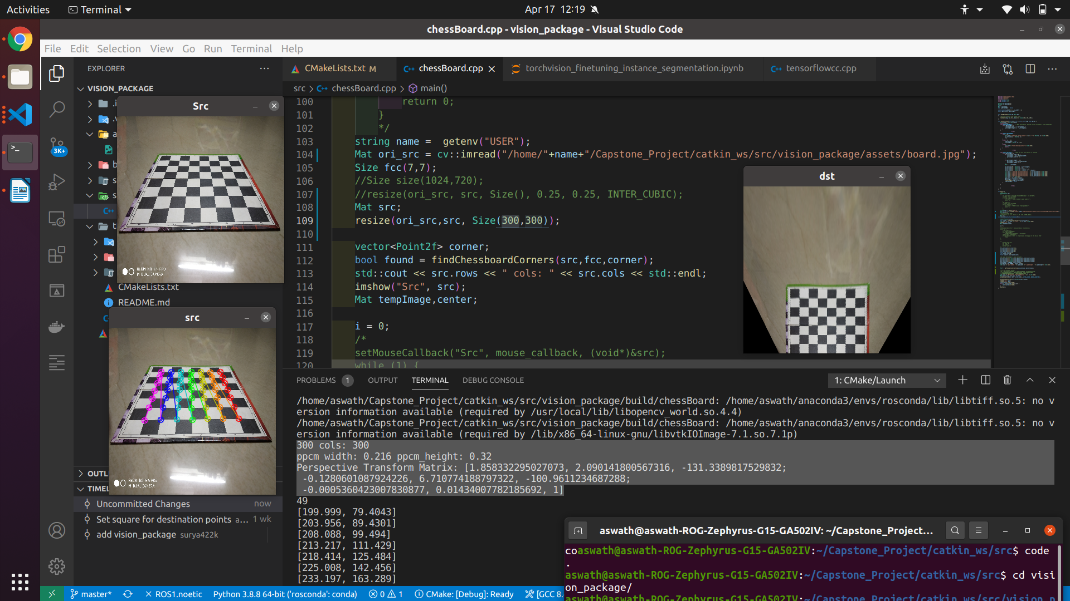

**600 cols: 600**

ppcm width: 0.216 ppcm_height: 0.32

Perspective Transform Matrix: [0.8401546945385282, 2.047259552524769, 25.33808016065188;

-0.1850430888873615, 5.329932776176629, 206.8949941885762;

-0.000338337541469997, 0.006918821057490105, 1]

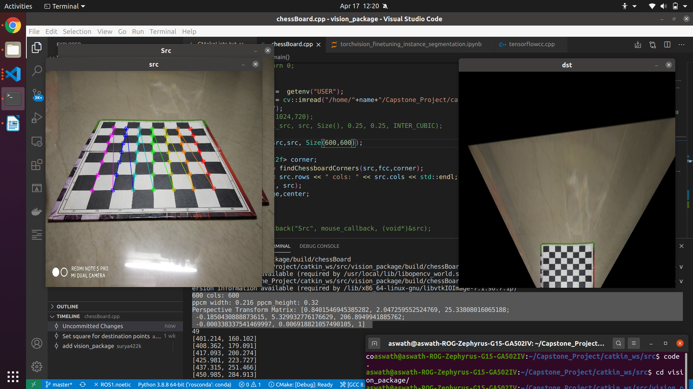

After scaling down the src image, **without** changing the findchessboard corners src_points

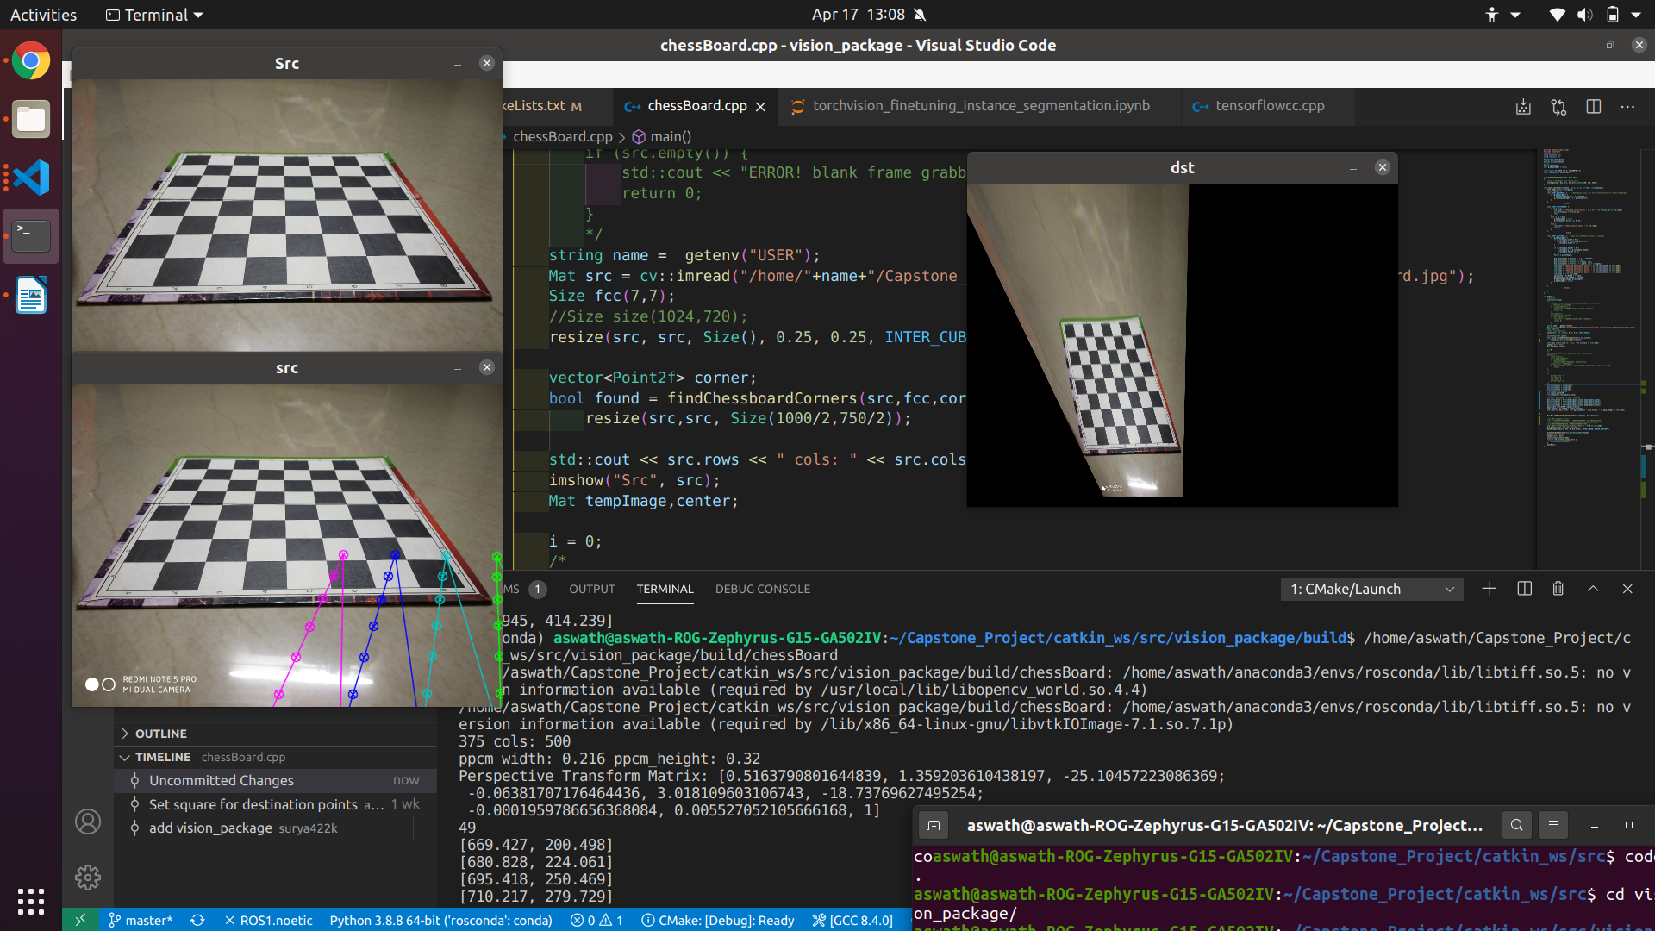

After scaling down the src image, **and** changing the findchessboard corners src_points

