**aswath@aswath-ROG-Zephyrus-G15-GA502IV:~$ sudo apt-get install -y kcachegrind**

[sudo] password for aswath:

Reading package lists... Done

Building dependency tree

Reading state information... Done

The following additional packages will be installed:

kio kwayland-data kwayland-integration libdbusmenu-qt5-2 libfam0

libhfstospell10 libkf5archive5 libkf5attica5 libkf5auth-data libkf5authcore5

libkf5codecs-data libkf5codecs5 libkf5completion-data libkf5completion5

libkf5config-bin libkf5config-data libkf5configcore5 libkf5configgui5

libkf5configwidgets-data libkf5configwidgets5 libkf5coreaddons-data

libkf5coreaddons5 libkf5crash5 libkf5dbusaddons-bin libkf5dbusaddons-data

libkf5dbusaddons5 libkf5doctools5 libkf5globalaccel-bin

libkf5globalaccel-data libkf5globalaccel5 libkf5globalaccelprivate5

libkf5guiaddons5 libkf5i18n-data libkf5i18n5 libkf5iconthemes-bin

libkf5iconthemes-data libkf5iconthemes5 libkf5idletime5 libkf5itemviews-data

libkf5itemviews5 libkf5jobwidgets-data libkf5jobwidgets5 libkf5kiocore5

libkf5kiontlm5 libkf5kiowidgets5 libkf5notifications-data

libkf5notifications5 libkf5service-bin libkf5service-data libkf5service5

libkf5solid5 libkf5solid5-data libkf5sonnet5-data libkf5sonnetcore5

libkf5sonnetui5 libkf5textwidgets-data libkf5textwidgets5 libkf5wallet-bin

libkf5wallet-data libkf5wallet5 libkf5waylandclient5

libkf5widgetsaddons-data libkf5widgetsaddons5 libkf5windowsystem-data

libkf5windowsystem5 libkf5xmlgui-bin libkf5xmlgui-data libkf5xmlgui5

libkwalletbackend5-5 libpolkit-qt5-1-1 libqt5texttospeech5

libqt5waylandclient5 libqt5waylandcompositor5 libvoikko1 qtwayland5

sonnet-plugins valgrind

Suggested packages:

kcachegrind-converters khelpcenter fam voikko-fi hspell valgrind-dbg

valgrind-mpi alleyoop valkyrie

The following NEW packages will be installed:

kcachegrind kio kwayland-data kwayland-integration libdbusmenu-qt5-2 libfam0

libhfstospell10 libkf5archive5 libkf5attica5 libkf5auth-data libkf5authcore5

libkf5codecs-data libkf5codecs5 libkf5completion-data libkf5completion5

libkf5config-bin libkf5config-data libkf5configcore5 libkf5configgui5

libkf5configwidgets-data libkf5configwidgets5 libkf5coreaddons-data

libkf5coreaddons5 libkf5crash5 libkf5dbusaddons-bin libkf5dbusaddons-data

libkf5dbusaddons5 libkf5doctools5 libkf5globalaccel-bin

libkf5globalaccel-data libkf5globalaccel5 libkf5globalaccelprivate5

libkf5guiaddons5 libkf5i18n-data libkf5i18n5 libkf5iconthemes-bin

libkf5iconthemes-data libkf5iconthemes5 libkf5idletime5 libkf5itemviews-data

libkf5itemviews5 libkf5jobwidgets-data libkf5jobwidgets5 libkf5kiocore5

libkf5kiontlm5 libkf5kiowidgets5 libkf5notifications-data

libkf5notifications5 libkf5service-bin libkf5service-data libkf5service5

libkf5solid5 libkf5solid5-data libkf5sonnet5-data libkf5sonnetcore5

libkf5sonnetui5 libkf5textwidgets-data libkf5textwidgets5 libkf5wallet-bin

libkf5wallet-data libkf5wallet5 libkf5waylandclient5

libkf5widgetsaddons-data libkf5widgetsaddons5 libkf5windowsystem-data

libkf5windowsystem5 libkf5xmlgui-bin libkf5xmlgui-data libkf5xmlgui5

libkwalletbackend5-5 libpolkit-qt5-1-1 libqt5texttospeech5

libqt5waylandclient5 libqt5waylandcompositor5 libvoikko1 qtwayland5

sonnet-plugins valgrind

0 upgraded, 78 newly installed, 0 to remove and 67 not upgraded.

Need to get 33.5 MB of archives.

**aswath@aswath-ROG-Zephyrus-G15-GA502IV:~$ cd ~/Capstone_Project/catkin_ws/src/vision_package/tfcc/build**

**aswath@aswath-ROG-Zephyrus-G15-GA502IV**:**~/Capstone_Project/catkin_ws/src/vision_package/tfcc/build**$ valgrind ./tfcc

==102971== Memcheck, a memory error detector

==102971== Copyright (C) 2002-2017, and GNU GPL&apos;d, by Julian Seward et al.

==102971== Using Valgrind-3.15.0 and LibVEX; rerun with -h for copyright info

==102971== Command: ./tfcc

==102971==

==102971== Warning: set address range perms: large range [0x484a000, 0x1a03c000) (defined)

2021-04-24 16:36:33.129628: I tensorflow/stream_executor/platform/default/dso_loader.cc:49] Successfully opened dynamic library libcudart.so.11.0

2021-04-24 16:36:40.233416: I tensorflow/core/platform/cpu_feature_guard.cc:142] This TensorFlow

‘

‘

‘

‘

‘

==102971== ERROR SUMMARY: 1 errors from 1 contexts (suppressed: 0 from 0)

Profiling timer expired

**aswath@aswath-ROG-Zephyrus-G15-GA502IV:~/Capstone_Project/catkin_ws/src/vision_package/tfcc/build$ /usr/bin/time valgrind --tool=callgrind ./tfcc**

==103304== Callgrind, a call-graph generating cache profiler

==103304== Copyright (C) 2002-2017, and GNU GPL&apos;d, by Josef Weidendorfer et al.

==103304== Using Valgrind-3.15.0 and LibVEX; rerun with -h for copyright info

==103304== Command: ./tfcc

==103304==

==103304== For interactive control, run &apos;callgrind_control -h&apos;.

2021-04-24 16:38:06.048211: I tensorflow/stream_executor/platform/default/dso_loader.cc:49] Successfully opened dynamic library libcudart.so.11.0

==103304== brk segment overflow in thread #1: can&apos;t grow to 0x4837000

==103304== (see section Limitations in user manual)

==103304== NOTE: further instances of this message will not be shown

2021-04-24 16:38:11.222085: I tensorflow/core/platform/cpu_feature_guard.cc:142] This TensorFlow binary is optimized with oneAPI Deep Neural Network Library (oneDNN) to use the following CPU instructions in performance-critical operations: SSE3 SSE4.1 SSE4.2 AVX AVX2 FMA

To enable them in other operations, rebuild TensorFlow with the appropriate compiler flags.

2021-04-24 16:38:11.339379: I tensorflow/stream_executor/platform/default/dso_loader.cc:49] Successfully opened dynamic library libcuda.so.1

==103304== Warning: noted but unhandled ioctl 0x30000001 with no size/direction hints.

==103304== This could cause spurious value errors to appear.

==103304== See README_MISSING_SYSCALL_OR_IOCTL for guidance on writing a proper wrapper.

==103304== Warning: noted but unhandled ioctl 0x27 with no size/direction hints.

==103304== This could cause spurious value errors to appear.

==103304== See README_MISSING_SYSCALL_OR_IOCTL for guidance on writing a proper wrapper.

==103304== Warning: noted but unhandled ioctl 0x30000002 with no size/direction hints.

==103304== This could cause spurious value errors to appear.

==103304== See README_MISSING_SYSCALL_OR_IOCTL for guidance on writing a proper wrapper.

2021-04-24 16:38:11.537039: E tensorflow/stream_executor/cuda/cuda_driver.cc:328] failed call to cuInit: CUDA_ERROR_COMPAT_NOT_SUPPORTED_ON_DEVICE: forward compatibility was attempted on non supported HW

2021-04-24 16:38:11.539062: I tensorflow/stream_executor/cuda/cuda_diagnostics.cc:169] retrieving CUDA diagnostic information for host: aswath-ROG-Zephyrus-G15-GA502IV

2021-04-24 16:38:11.539586: I tensorflow/stream_executor/cuda/cuda_diagnostics.cc:176] hostname: aswath-ROG-Zephyrus-G15-GA502IV

2021-04-24 16:38:11.549098: I tensorflow/stream_executor/cuda/cuda_diagnostics.cc:200] libcuda reported version is: 460.73.1

2021-04-24 16:38:11.552584: I tensorflow/stream_executor/cuda/cuda_diagnostics.cc:204] kernel reported version is: 460.67.0

2021-04-24 16:38:11.553802: E tensorflow/stream_executor/cuda/cuda_diagnostics.cc:313] kernel version 460.67.0 does not match DSO version 460.73.1 -- cannot find working devices in this configuration

2021-04-24 16:38:11.568738: I tensorflow/compiler/jit/xla_gpu_device.cc:99] Not creating XLA devices, tf_xla_enable_xla_devices not set

Done Loading graph

--103304-- WARNING: unhandled amd64-linux syscall: 315

--103304-- You may be able to write your own handler.

--103304-- Read the file README_MISSING_SYSCALL_OR_IOCTL.

--103304-- Nevertheless we consider this a bug. Please report

--103304-- it at http://valgrind.org/support/bug_reports.html.

2021-04-24 16:38:24.596022: I tensorflow/core/platform/profile_utils/cpu_utils.cc:112] CPU Frequency: 2994525000 Hz

Time take(us): 2661746

==103304==

==103304== Process terminating with default action of signal 27 (SIGPROF)

==103304== at 0x2616EAFF: poll (poll.c:29)

==103304== by 0x4B11736D: ??? (in /usr/lib/x86_64-linux-gnu/libglib-2.0.so.0.6400.6)

==103304== by 0x4B1176F2: g_main_loop_run (in /usr/lib/x86_64-linux-gnu/libglib-2.0.so.0.6400.6)

==103304== by 0x4F972F89: ??? (in /usr/lib/x86_64-linux-gnu/libgio-2.0.so.0.6400.6)

==103304== by 0x4B140AD0: ??? (in /usr/lib/x86_64-linux-gnu/libglib-2.0.so.0.6400.6)

==103304== by 0x263A5608: start_thread (pthread_create.c:477)

==103304== by 0x2617B292: clone (clone.S:95)

==103304==

==103304== Events : Ir

==103304== Collected : 3271713969

==103304==

==103304== I refs: 3,271,713,969

Command terminated by signal 27

30.02user 0.76system 0:32.10elapsed 95%CPU (0avgtext+0avgdata 1035176maxresident)k

2800inputs+27984outputs (26major+291749minor)pagefaults 0swaps

**aswath@aswath-ROG-Zephyrus-G15-GA502IV:~/Capstone_Project/catkin_ws/src/vision_package/tfcc/build$ ls**

**abseil-cpp** **clog-source** CPackSourceConfig.cmake **eigen** **FP16-source** Makefile **pthreadpool-download** **tfcc**

**buildtests.sh** CMakeCache.txt **cpuinfo** **farmhash** **FXdiv** **neon2sse** **pthreadpool-source** **tflite**

**callgrind.out.103304**  **CMakeFiles** **cpuinfo-download** **fft2d** **FXdiv-download** **psimd** **release.sh** **tmp**

**check.sh** cmake_install.cmake **cpuinfo-source** **flatbuffers** **FXdiv-source** **psimd-download** **ruy** **xnnpack**

**clog** compile_commands.json **debug.sh** **FP16** **gemmlowp** **psimd-source** **src**

**clog-download** CPackConfig.cmake **_deps** **FP16-download** gmon.out **pthreadpool** **tensorflow-lite**

**aswath@aswath-ROG-Zephyrus-G15-GA502IV:~/Capstone_Project/catkin_ws/src/vision_package/tfcc/build$ kcachegrind callgrind.out.103304**

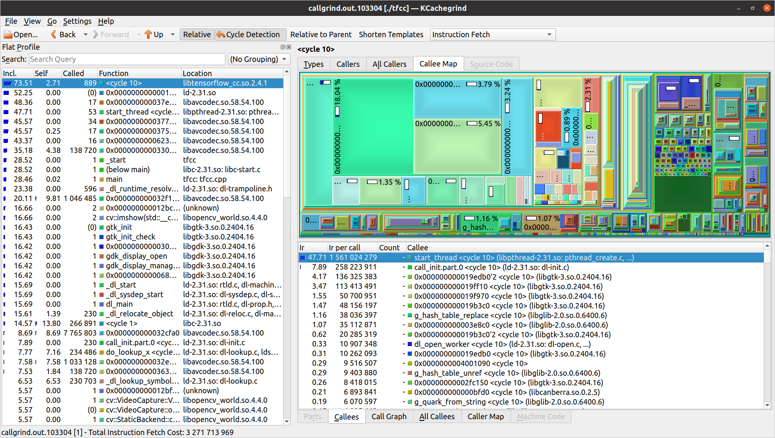

File-> Export_Graph:

