

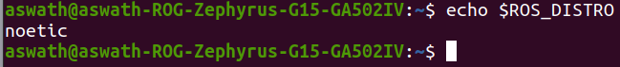

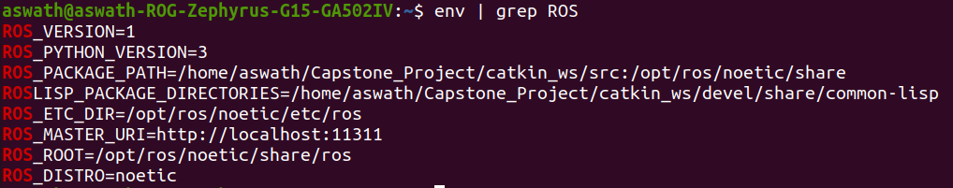

If you activate **rosconda**, ROS_ROOT will change along with the ROS_DISTRO:

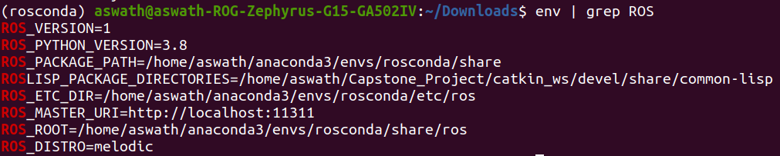

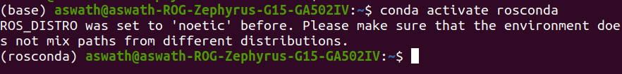

Solve this error by installing libbluetooth-dev

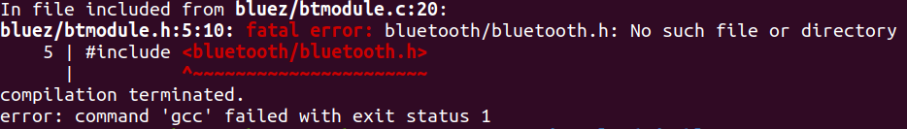

sudo apt-get install libbluetooth-dev

Now, install Pybluez: 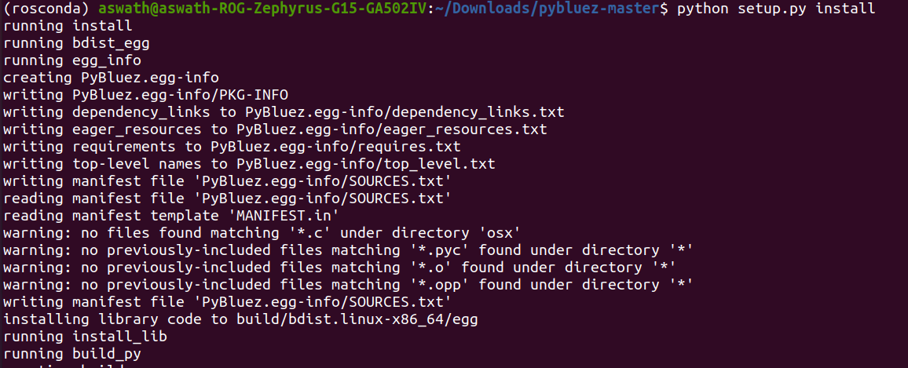

Pair your NXT device: 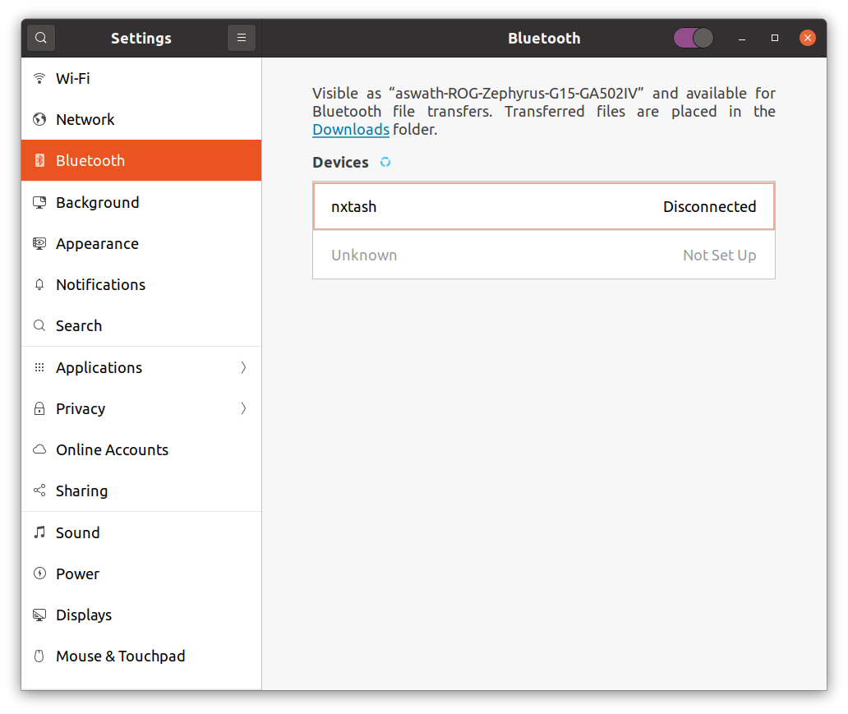

Now, run the test script, it will connect with the nxt:

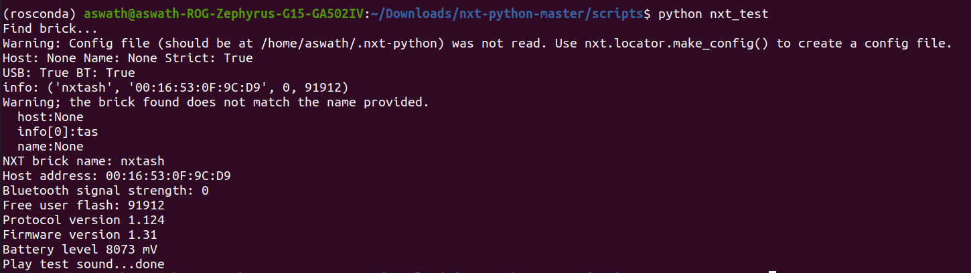

**aswath@aswath-ROG-Zephyrus-G15-GA502IV**:**~**$ echo $PYTHONPATH

/opt/ros/noetic/lib/python3/dist-packages

When switching between conda environments, PYTHON_EXECUTABLE will remain as same in CMAKE. So, delete the devel and build folders and start a fresh catkin_make.

**aswath@aswath-ROG-Zephyrus-G15-GA502IV**:**~/Capstone_Project/catkin_ws**$ catkin_make

Base path: /home/aswath/Capstone_Project/catkin_ws

Source space: /home/aswath/Capstone_Project/catkin_ws/src

Build space: /home/aswath/Capstone_Project/catkin_ws/build

Devel space: /home/aswath/Capstone_Project/catkin_ws/devel

Install space: /home/aswath/Capstone_Project/catkin_ws/install######## Running command: **"cmake /home/aswath/Capstone_Project/catkin_ws/src -DCATKIN_DEVEL_PREFIX=/home/aswath/Capstone_Project/catkin_ws/devel -DCMAKE_INSTALL_PREFIX=/home/aswath/Capstone_Project/catkin_ws/install -G Unix Makefiles"** in **"/home/aswath/Capstone_Project/catkin_ws/build"**####

-- Using CATKIN_DEVEL_PREFIX: /home/aswath/Capstone_Project/catkin_ws/devel

-- Using CMAKE_PREFIX_PATH: /opt/ros/noetic

-- This workspace overlays: /opt/ros/noetic

-- Using PYTHON_EXECUTABLE: /home/aswath/anaconda3/bin/python3

-- Using Debian Python package layout

-- Could NOT find PY_em (missing: PY_EM) **CMake Error** at /opt/ros/noetic/share/catkin/cmake/empy.cmake:30 (message):

Unable to find either executable 'empy' or Python module 'em'... try

installing the package 'python3-empy'Call Stack (most recent call first):

/opt/ros/noetic/share/catkin/cmake/all.cmake:164 (include)

/opt/ros/noetic/share/catkin/cmake/catkinConfig.cmake:20 (include)

CMakeLists.txt:58 (find_package)

-- Configuring incomplete, errors occurred!

See also "/home/aswath/Capstone_Project/catkin_ws/build/CMakeFiles/CMakeOutput.log".Invoking **"cmake"** failed

**How do I prevent Conda from activating the base environment by default?**

$ conda config --set auto_activate_base false

**NXT Python install:**

**aswath@aswath-ROG-Zephyrus-G15-GA502IV**:**~/Downloads/nxt-python-master**$ sudo python3 setup.py install

[sudo] password for aswath:

running install

running build

running build_py

running build_scripts

running install_lib

creating /usr/local/lib/python3.8/dist-packages/nxt

copying build/lib/nxt/lightblueglue.py -> /usr/local/lib/python3.8/dist-packages/nxt

copying build/lib/nxt/motcont.py -> /usr/local/lib/python3.8/dist-packages/nxt

copying build/lib/nxt/telegram.py -> /usr/local/lib/python3.8/dist-packages/nxt

copying build/lib/nxt/usbsock.py -> /usr/local/lib/python3.8/dist-packages/nxt

copying build/lib/nxt/bluesock.py -> /usr/local/lib/python3.8/dist-packages/nxt

copying build/lib/nxt/system.py -> /usr/local/lib/python3.8/dist-packages/nxt

copying build/lib/nxt/motor.py -> /usr/local/lib/python3.8/dist-packages/nxt

copying build/lib/nxt/devsock.py -> /usr/local/lib/python3.8/dist-packages/nxt

copying build/lib/nxt/utils.py -> /usr/local/lib/python3.8/dist-packages/nxt

copying build/lib/nxt/__init__.py -> /usr/local/lib/python3.8/dist-packages/nxt

copying build/lib/nxt/direct.py -> /usr/local/lib/python3.8/dist-packages/nxt

copying build/lib/nxt/error.py -> /usr/local/lib/python3.8/dist-packages/nxt

copying build/lib/nxt/locator.py -> /usr/local/lib/python3.8/dist-packages/nxt

creating /usr/local/lib/python3.8/dist-packages/nxt/sensor

copying build/lib/nxt/sensor/hitechnic.py -> /usr/local/lib/python3.8/dist-packages/nxt/sensor

copying build/lib/nxt/sensor/analog.py -> /usr/local/lib/python3.8/dist-packages/nxt/sensor

copying build/lib/nxt/sensor/mindsensors.py -> /usr/local/lib/python3.8/dist-packages/nxt/sensor

copying build/lib/nxt/sensor/__init__.py -> /usr/local/lib/python3.8/dist-packages/nxt/sensor

copying build/lib/nxt/sensor/generic.py -> /usr/local/lib/python3.8/dist-packages/nxt/sensor

copying build/lib/nxt/sensor/common.py -> /usr/local/lib/python3.8/dist-packages/nxt/sensor

copying build/lib/nxt/sensor/digital.py -> /usr/local/lib/python3.8/dist-packages/nxt/sensor

copying build/lib/nxt/brick.py -> /usr/local/lib/python3.8/dist-packages/nxt

copying build/lib/nxt/ipsock.py -> /usr/local/lib/python3.8/dist-packages/nxt

byte-compiling /usr/local/lib/python3.8/dist-packages/nxt/lightblueglue.py to lightblueglue.cpython-38.pyc

byte-compiling /usr/local/lib/python3.8/dist-packages/nxt/motcont.py to motcont.cpython-38.pyc

byte-compiling /usr/local/lib/python3.8/dist-packages/nxt/telegram.py to telegram.cpython-38.pyc

byte-compiling /usr/local/lib/python3.8/dist-packages/nxt/usbsock.py to usbsock.cpython-38.pyc

byte-compiling /usr/local/lib/python3.8/dist-packages/nxt/bluesock.py to bluesock.cpython-38.pyc

byte-compiling /usr/local/lib/python3.8/dist-packages/nxt/system.py to system.cpython-38.pyc

byte-compiling /usr/local/lib/python3.8/dist-packages/nxt/motor.py to motor.cpython-38.pyc

byte-compiling /usr/local/lib/python3.8/dist-packages/nxt/devsock.py to devsock.cpython-38.pyc

byte-compiling /usr/local/lib/python3.8/dist-packages/nxt/utils.py to utils.cpython-38.pyc

byte-compiling /usr/local/lib/python3.8/dist-packages/nxt/__init__.py to __init__.cpython-38.pyc

byte-compiling /usr/local/lib/python3.8/dist-packages/nxt/direct.py to direct.cpython-38.pyc

byte-compiling /usr/local/lib/python3.8/dist-packages/nxt/error.py to error.cpython-38.pyc

byte-compiling /usr/local/lib/python3.8/dist-packages/nxt/locator.py to locator.cpython-38.pyc

byte-compiling /usr/local/lib/python3.8/dist-packages/nxt/sensor/hitechnic.py to hitechnic.cpython-38.pyc

byte-compiling /usr/local/lib/python3.8/dist-packages/nxt/sensor/analog.py to analog.cpython-38.pyc

byte-compiling /usr/local/lib/python3.8/dist-packages/nxt/sensor/mindsensors.py to mindsensors.cpython-38.pyc

byte-compiling /usr/local/lib/python3.8/dist-packages/nxt/sensor/__init__.py to __init__.cpython-38.pyc

byte-compiling /usr/local/lib/python3.8/dist-packages/nxt/sensor/generic.py to generic.cpython-38.pyc

byte-compiling /usr/local/lib/python3.8/dist-packages/nxt/sensor/common.py to common.cpython-38.pyc

byte-compiling /usr/local/lib/python3.8/dist-packages/nxt/sensor/digital.py to digital.cpython-38.pyc

byte-compiling /usr/local/lib/python3.8/dist-packages/nxt/brick.py to brick.cpython-38.pyc

byte-compiling /usr/local/lib/python3.8/dist-packages/nxt/ipsock.py to ipsock.cpython-38.pyc

running install_scripts

copying build/scripts-3.8/nxt_test -> /usr/local/bin

copying build/scripts-3.8/nxt_push -> /usr/local/bin

copying build/scripts-3.8/nxt_filer -> /usr/local/bin

copying build/scripts-3.8/nxt_server -> /usr/local/bin

changing mode of /usr/local/bin/nxt_test to 775

changing mode of /usr/local/bin/nxt_push to 775

changing mode of /usr/local/bin/nxt_filer to 775

changing mode of /usr/local/bin/nxt_server to 775

running install_egg_info

Writing /usr/local/lib/python3.8/dist-packages/nxt_python-3.0.egg-info

**aswath@aswath-ROG-Zephyrus-G15-GA502IV**:**~/Downloads/nxt-python-master**$

**PYBLUEZ install:**

**aswath@aswath-ROG-Zephyrus-G15-GA502IV**:**~/Downloads/pybluez-master**$ sudo python3 setup.py install

running install

running bdist_egg

running egg_info

writing PyBluez.egg-info/PKG-INFO

writing dependency_links to PyBluez.egg-info/dependency_links.txt

writing eager_resources to PyBluez.egg-info/eager_resources.txt

writing requirements to PyBluez.egg-info/requires.txt

writing top-level names to PyBluez.egg-info/top_level.txt

reading manifest file &apos;PyBluez.egg-info/SOURCES.txt&apos;

reading manifest template &apos;MANIFEST.in&apos;

warning: no files found matching &apos;*.c&apos; under directory &apos;osx&apos;

warning: no previously-included files matching &apos;*.pyc&apos; found under directory &apos;*&apos;

warning: no previously-included files matching &apos;*.o&apos; found under directory &apos;*&apos;

warning: no previously-included files matching &apos;*.opp&apos; found under directory &apos;*&apos;

writing manifest file &apos;PyBluez.egg-info/SOURCES.txt&apos;

installing library code to build/bdist.linux-x86_64/egg

running install_lib

running build_py

running build_ext

creating build/bdist.linux-x86_64/egg

creating build/bdist.linux-x86_64/egg/bluetooth

copying build/lib.linux-x86_64-3.8/bluetooth/bluez.py -> build/bdist.linux-x86_64/egg/bluetooth

copying build/lib.linux-x86_64-3.8/bluetooth/msbt.py -> build/bdist.linux-x86_64/egg/bluetooth

copying build/lib.linux-x86_64-3.8/bluetooth/_bluetooth.cpython-38-x86_64-linux-gnu.so -> build/bdist.linux-x86_64/egg/bluetooth

copying build/lib.linux-x86_64-3.8/bluetooth/osx.py -> build/bdist.linux-x86_64/egg/bluetooth

copying build/lib.linux-x86_64-3.8/bluetooth/widcomm.py -> build/bdist.linux-x86_64/egg/bluetooth

copying build/lib.linux-x86_64-3.8/bluetooth/ble.py -> build/bdist.linux-x86_64/egg/bluetooth

copying build/lib.linux-x86_64-3.8/bluetooth/__init__.py -> build/bdist.linux-x86_64/egg/bluetooth

copying build/lib.linux-x86_64-3.8/bluetooth/btcommon.py -> build/bdist.linux-x86_64/egg/bluetooth

byte-compiling build/bdist.linux-x86_64/egg/bluetooth/bluez.py to bluez.cpython-38.pyc

byte-compiling build/bdist.linux-x86_64/egg/bluetooth/msbt.py to msbt.cpython-38.pyc

byte-compiling build/bdist.linux-x86_64/egg/bluetooth/osx.py to osx.cpython-38.pyc

byte-compiling build/bdist.linux-x86_64/egg/bluetooth/widcomm.py to widcomm.cpython-38.pyc

byte-compiling build/bdist.linux-x86_64/egg/bluetooth/ble.py to ble.cpython-38.pyc

byte-compiling build/bdist.linux-x86_64/egg/bluetooth/__init__.py to __init__.cpython-38.pyc

byte-compiling build/bdist.linux-x86_64/egg/bluetooth/btcommon.py to btcommon.cpython-38.pyc

creating stub loader for bluetooth/_bluetooth.cpython-38-x86_64-linux-gnu.so

byte-compiling build/bdist.linux-x86_64/egg/bluetooth/_bluetooth.py to _bluetooth.cpython-38.pyc

creating build/bdist.linux-x86_64/egg/EGG-INFO

copying PyBluez.egg-info/PKG-INFO -> build/bdist.linux-x86_64/egg/EGG-INFO

copying PyBluez.egg-info/SOURCES.txt -> build/bdist.linux-x86_64/egg/EGG-INFO

copying PyBluez.egg-info/dependency_links.txt -> build/bdist.linux-x86_64/egg/EGG-INFO

copying PyBluez.egg-info/eager_resources.txt -> build/bdist.linux-x86_64/egg/EGG-INFO

copying PyBluez.egg-info/requires.txt -> build/bdist.linux-x86_64/egg/EGG-INFO

copying PyBluez.egg-info/top_level.txt -> build/bdist.linux-x86_64/egg/EGG-INFO

copying PyBluez.egg-info/zip-safe -> build/bdist.linux-x86_64/egg/EGG-INFO

writing build/bdist.linux-x86_64/egg/EGG-INFO/native_libs.txt

creating &apos;dist/PyBluez-0.22-py3.8-linux-x86_64.egg&apos; and adding &apos;build/bdist.linux-x86_64/egg&apos; to it

removing &apos;build/bdist.linux-x86_64/egg&apos; (and everything under it)

Processing PyBluez-0.22-py3.8-linux-x86_64.egg

Copying PyBluez-0.22-py3.8-linux-x86_64.egg to /usr/local/lib/python3.8/dist-packages

Adding PyBluez 0.22 to easy-install.pth file

Installed /usr/local/lib/python3.8/dist-packages/PyBluez-0.22-py3.8-linux-x86_64.egg

Processing dependencies for PyBluez==0.22

Finished processing dependencies for PyBluez==0.22

**aswath@aswath-ROG-Zephyrus-G15-GA502IV**:**~/Downloads/pybluez-master**$

**INSTALL CMAKE GUI:**

**aswath@aswath-ROG-Zephyrus-G15-GA502IV**:**~**$ sudo apt install cmake-gui

[sudo] password for aswath:

Reading package lists... Done

Building dependency tree

Reading state information... Done

Note, selecting &apos;cmake-qt-gui&apos; instead of &apos;cmake-gui&apos;

The following NEW packages will be installed:

cmake-qt-gui

**START CMAKE GUI:**

**aswath@aswath-ROG-Zephyrus-G15-GA502IV**:**~**$ cmake-gui