***1. Define a class ‘product’ with data members pcode, pname and price. Create 3 objects of the class and find the product having the lowest price.***

import java.util.Scanner;

public class Product {

int pcode;

String pname;

double price;

public Product(int pcode, String pname, double price) {

this.pcode = pcode;

this.pname = pname;

this.price = price;

}

public static void main(String[] args) {

System.out.println("Name: ASWATHY CHANDRAN");

System.out.println("Reg. No: SJC22MCA-2016");

System.out.println("Date: 28/03/2023");

System.out.println("Course code: 20MCA132");

System.out.println();

Scanner input = new Scanner(System.in);

Product p1, p2, p3;

System.out.println("Enter the details of 3 products:");

System.out.print("Enter the product code of product 1: ");

int pcode1 = input.nextInt();

input.nextLine();

System.out.print("Enter the name of product 1: ");

String pname1 = input.nextLine();

System.out.print("Enter the price of product 1: ");

double price1 = input.nextDouble();

p1 = new Product(pcode1, pname1, price1);

System.out.print("Enter the product code of product 2: ");

int pcode2 = input.nextInt();

input.nextLine();

System.out.print("Enter the name of product 2: ");

String pname2 = input.nextLine();

System.out.print("Enter the price of product 2: ");

double price2 = input.nextDouble();

p2 = new Product(pcode2, pname2, price2);

System.out.print("Enter the product code of product 3: ");

int pcode3 = input.nextInt();

input.nextLine(); // Consume the leftover newline character

System.out.print("Enter the name of product 3: ");

String pname3 = input.nextLine();

System.out.print("Enter the price of product 3: ");

double price3 = input.nextDouble();

p3 = new Product(pcode3, pname3, price3);

System.out.println("\nProduct Details");

System.out.println("---------------");

System.out.println("Product 1: " + p1.pcode + ", " + p1.pname + ", " + p1.price);

System.out.println("Product 2: " + p2.pcode + ", " + p2.pname + ", " + p2.price);

System.out.println("Product 3: " + p3.pcode + ", " + p3.pname + ", " + p3.price);

Product lowestPriceProduct = p1;

if (p2.price < lowestPriceProduct.price) {

lowestPriceProduct = p2;

}

if (p3.price < lowestPriceProduct.price) {

lowestPriceProduct = p3;

}

System.out.println("\nThe product with the lowest price is: " + lowestPriceProduct.pname);

}

}

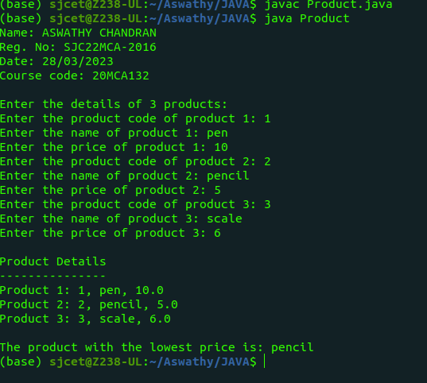

***2. Read 2 matrices from the console and perform matrix addition.***

import java.util.Scanner;

public class MatrixAdd {

public static void main(String[] args) {

System.out.println("Name: ASWATHY CHANDRAN");

System.out.println("Reg. No: SJC22MCA-2016");

System.out.println("Date: 28/03/2023");

System.out.println("Course code: 20MCA132");

System.out.println();

Scanner sc = new Scanner(System.in);

System.out.print("Enter the number of rows: ");

int rows = sc.nextInt();

System.out.print("Enter the number of columns: ");

int cols = sc.nextInt();

int[][] matrix1 = new int[rows][cols];

int[][] matrix2 = new int[rows][cols];

int[][] sum = new int[rows][cols];

System.out.println("Enter the elements of the first matrix:");

for (int i = 0; i < rows; i++) {

for (int j = 0; j < cols; j++) {

matrix1[i][j] = sc.nextInt();

}

}

System.out.println("Enter the elements of the second matrix:");

for (int i = 0; i < rows; i++) {

for (int j = 0; j < cols; j++) {

matrix2[i][j] = sc.nextInt();

}

}

for (int i = 0; i < rows; i++) {

for (int j = 0; j < cols; j++) {

sum[i][j] = matrix1[i][j] + matrix2[i][j];

}

}

System.out.println("The sum of the matrices is:");

for (int i = 0; i < rows; i++) {

for (int j = 0; j < cols; j++) {

System.out.print(sum[i][j] + " ");

}

System.out.println();

}

sc.close();

}

}

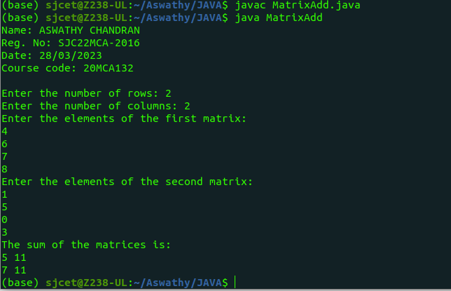

***3. Add complex numbers***

public class complex

{

int real;

int imaginary;

public complex(int real_get,int imag_get){

this.real = real_get;

this.imaginary = imag_get;

}

public static complex sum(complex c1,complex c2){

complex temp = new complex(0,0);

temp.real = c1.real + c2.real;

temp.imaginary = c1.imaginary + c2.imaginary;

return temp;

}

public static void main(String []args){

System.out.println("Name: ASWATHY CHANDRAN");

System.out.println("Reg. No: SJC22MCA-2016");

System.out.println("Date: 28/03/2023");

System.out.println("Course code: 20MCA132");

System.out.println();

complex first = new complex(1,2);

complex second = new complex(32,22);

complex temp = sum(first,second);

System.out.println("Sum is : " + temp.real + "+" +temp.imaginary + "i");

}

}

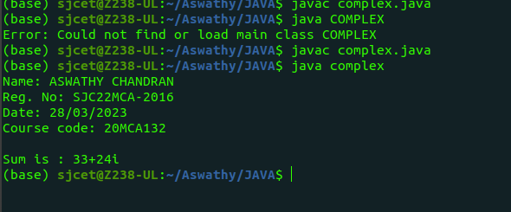

***4. Read a matrix from the console and check whether it is symmetric or not.***

import java.util.Scanner;

public class SymmetricMatrix {

public static void main(String[] args) {

System.out.println("Name: ASWATHY CHANDRAN");

System.out.println("Reg. No: SJC22MCA-2016");

System.out.println("Date: 28/03/2023");

System.out.println("Course code: 20MCA132");

System.out.println();

Scanner sc = new Scanner(System.in);

System.out.println("Enter the number of rows and columns of the matrix:");

int rows = sc.nextInt();

int cols = sc.nextInt();

int[][] matrix = new int[rows][cols];

System.out.println("Enter the elements of the matrix:");

for (int i = 0; i < rows; i++) {

for (int j = 0; j < cols; j++) {

matrix[i][j] = sc.nextInt();

}

}

boolean symmetric = true;

for (int i = 0; i < rows; i++) {

for (int j = 0; j < cols; j++) {

if (matrix[i][j] != matrix[j][i]) {

symmetric = false;

break;

}

}

if (!symmetric) {

break;

}

}

if (symmetric) {

System.out.println("The matrix is symmetric");

} else {

System.out.println("The matrix is not symmetric");

}

sc.close();

}

}

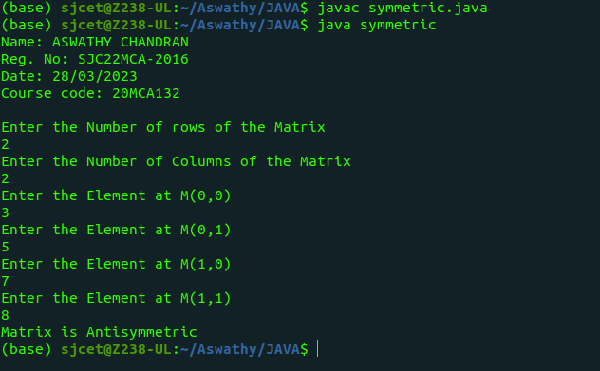

***5. Create CPU with attribute price. Create inner class Processor (no. of cores, manufacturer) and static nested class RAM (memory, manufacturer). Create an object of CPU and print information of Processor and RAM.***

public class CPU {

private double price;

public CPU(double price) {

this.price = price;

}

class Processor {

private int cores;

private String manufacturer;

public Processor(int cores, String manufacturer) {

this.cores = cores;

this.manufacturer = manufacturer;

}

public void displayInfo() {

System.out.println("Processor Cores: " + cores);

System.out.println("Processor Manufacturer: " + manufacturer);

}

}// Static nested class RAM

static class RAM {

private int memory;

private String manufacturer;

public RAM(int memory, String manufacturer) {

this.memory = memory;

this.manufacturer = manufacturer;

}

public void displayInfo() {

System.out.println("RAM Memory: " + memory);

System.out.println("RAM Manufacturer: " + manufacturer);

}

}

public static void main(String[] args) {

System.out.println("Name: ASWATHY CHANDRAN");

System.out.println("Reg. No: SJC22MCA-2016");

System.out.println("Date: 28/03/2023");

System.out.println("Course code: 20MCA132");

System.out.println();

CPU cpu = new CPU(500.0);

CPU.Processor processor = cpu.new Processor(4, "Intel");

CPU.RAM ram = new CPU.RAM(8, "Kingston");

System.out.println("CPU Price: " + cpu.price);

System.out.println("Processor Info:");

processor.displayInfo();

System.out.println("RAM Info:");

ram.displayInfo();

}

}

