1. **Firstly I created Helpers file.**

A "helper function" is **a function you write because you need that particular functionality in multiple places, and because it makes the code more readable**.

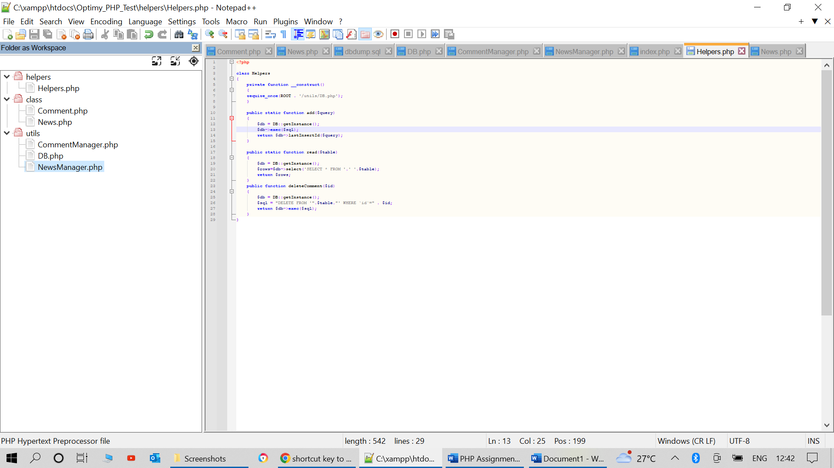

**I created a helper to filter the code and separate redundant functions in both *NewsManager.php* and *Commentmanager.php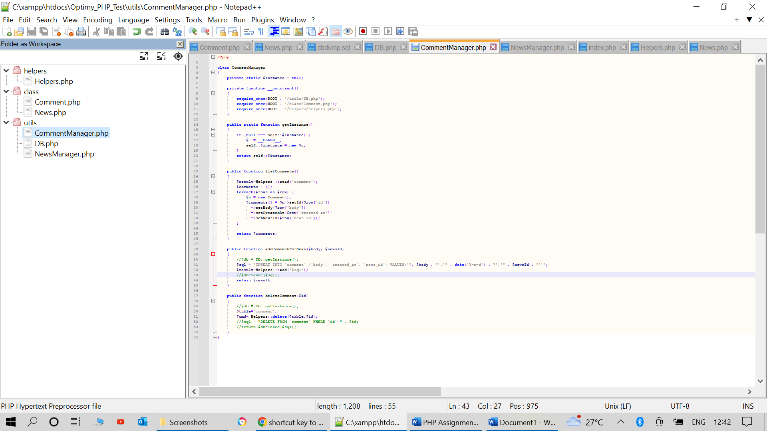tManager.php***

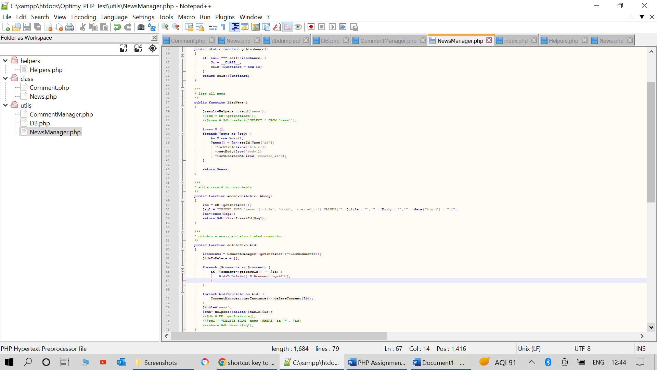

**Vulnerabilities**

