ASSIGNMENT -8
SDLC RAD Model & How to Design ER Diagrams

1) When to use (Rapid Application Development) RAD model. When not to use (Rapid Application Development) RAD model.

Ans:-

RAD( Rapid Application Development) is an adoption of waterfall model which aims at developing a software in a very short span of time.It concentartes more on development rather than delivery. The situations where RAD is used are as follows:-

- RAD should be used when there is a need to create a system that can be delivered in 2-3 months of time.
- It should be used if there’s a high availability of designers for modeling and the budget is high enough to afford their cost along with the cost of automated code generating tools.
- RAD SDLC model should be chosen only if resources with high business knowledge are available and there is a need to produce the system in a short span of time .
- When Quality is negotiable .

The situations where RAD is not used are as follows:-
- When client asks for a quality product,then RAD will be a failure. Because it concentrates only on development not on delivery.
- When budget allocated is very less.
- When project management will not accept informal project deliverables .

2) Define an ER diagram of a Software Organization with all the relationship
model that was discussed in the classroom.

Ans:-

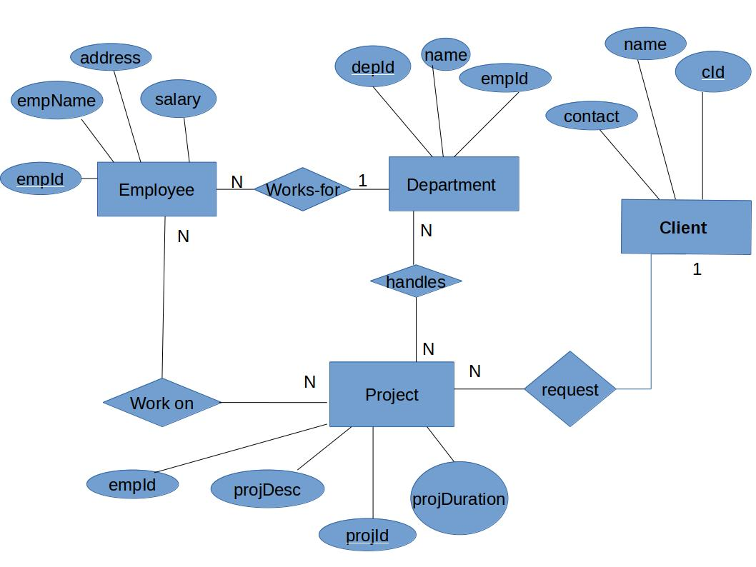

3. Describe the Entity Relationships for the following diagram :-

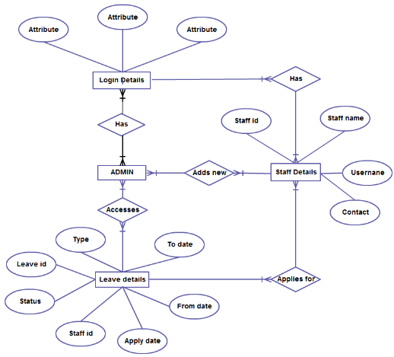

Ans:-
There are 4 entities in the given ER diagram.They are:-
- Admin
- Login Details
- Staff Details*
- Leave Details
An attribute characterize an entity. The attributes for the above entities include
- Login Details:- Id,Password and a Captcha
- Staff Details :- Id,name,username and contact
- Leave Details:- Type,todate,fromdate,ld,status,staffid,apply date

- Entity Admin has a many to many relationship with Login Details.
- Entity Admin has a many to many relationship with Leave details
- Entity Admin has an adds new relation with staff details.Its a many to many relationship.
- Entity staff details has applies new relationship with Leave Details.

