|  |
| --- |
|  |
| HCI - COMP 171 |
| Assignment 3 |
|  |
| **Aswathy Dinesh** |
| **2/15/2012** |

**Restaurant Locator**

1. **Semantic, Syntactic, and Lexical Design Specification**

**Semantic Level**

**Function 1:** Cuisine selection from the home page

**Parameters:** Which cuisine type?

**Description:** Click/touch on cuisine type listed on the home page of Restaurant Locator.

**Feedback:** The currently selected cuisine is highlighted and other cuisines remain de-highlighted.

**Errors:** Click position is misleading (can be engineered by constraining the click to include both cuisine image as well as name).

**Function 2:** Search restaurants in nearby location.

**Parameters:**

* Which location?
* What type of restaurant is the customer looking for?

**Description:** Click /touch on the where textbox, when the cursor blinks on the textbox, type the location (where the system needs to find restaurants) then press the search button to perform search.

**Feedback:** Previously selected Cuisine type from home page is auto filled in the cuisine type box besides the where location box.

**Errors:** The location is invalid (can be engineered by auto suggesting locations in the where textbox).

**Function3:** List restaurants by alphabet, distance or rating

**Parameters:** How to list the result (sort by alphabet, distance or rating)?

**Description:** System will display all the nearby restaurants based on the searched location. Customers click/touch a link to go the Restaurant details page.

**Feedback:** The search results are listed by alphabetical order, rating or by distance.

**Error:** The sort selection is not easily evident (can be engineered out by using dropdown for selecting the sort parameters which also displays the currently selected parameter (Ex: Name/Rating/Distance))

**Function 4:** View and write customer feedback

**Parameters:**

* Where to post the feedback?
* What type of feedback? (Good/bad/neutral)

**Description:** Feedback of the restaurant can be viewed/posted on the feedback form. Feedback button becomes highlighted and rest of the buttons are in the normal/de-selected state.

**Feedback:** Review form is the first tab on the restaurant details page and is selected by default.

**Errors:**

* Bad words displayed in reviews (can be engineered by using a Review Approval system where an admin needs to approve reviews before they are displayed to public)

**Function5:** View menu

**Parameters:**

* How to select menu?
* What are the items and price of items?

**Description:** Menu shows the items and price of different items.

**Feedback:** Menu section is shown on the display and menu button is highlighted because it is the currently selected button, all previously selected buttons are de-highlighted.

**Errors:** Menu items are cluttered (can be engineered out by separating items into Appetizers, Soups & Salads, Seafood, Entrees, Specialties etc)

**Function 6:** Reserve seats

**Parameters:**

* Basic information of customer (Ex: Name, Phone number, E-mail)
* How many seats?
* Date of reservation

**Description:** Reservation page opens and shows a reservation form for filling and saving basic information like name, email, phone number, date and number of seats. System shows a confirmation message and also triggers a message to restaurant’s mailbox.

**Feedback:** When customer saves the reservation form the system shows a confirmation message on screen.

**Errors:**

* Selected date is invalid (can be engineered by showing only current or future dates)
* Phone Number type is invalid (can be engineered out by constraining phone number to ten digits)
* No reservation confirmation message to user (can be engineered by triggering mail to user along with a mail to restaurant)

**Function 7:** Get directions

**Parameters:**

* Which Location?
* What medium for going to restaurant?
* How to get print?

**Description:** Get directions form is opened and customer adds their address and medium to go to the restaurant and then clicks on get directions button, the system then shows the directions.

**Feedback:** Directions are displayed on the directions page and customer can select the printer to print directions.

**Errors:** The location is invalid (can be engineered by auto suggesting locations in the Enter Address textbox).

**Syntactic Level**

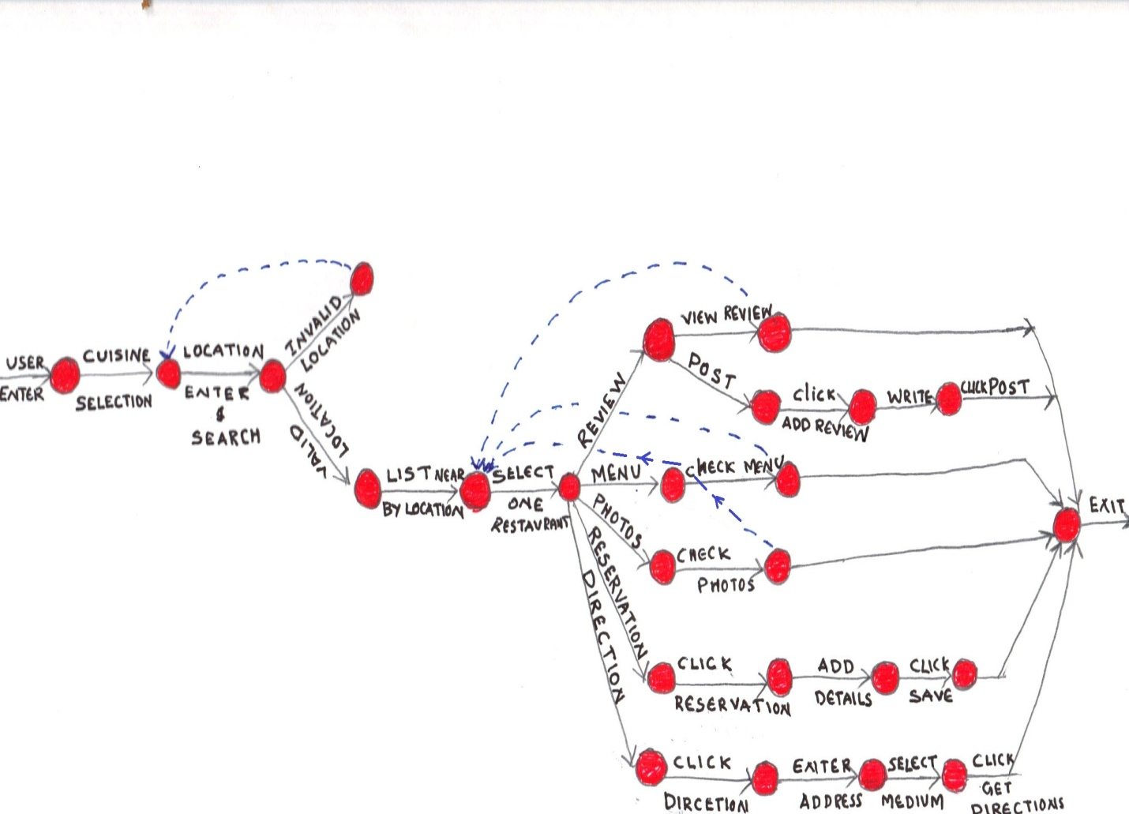

**Lexical Level**

Cuisine _Selection= Point mouse or finger on the cuisine tiles on homepage 🡪Click/touch on cuisine.

Location _Selection= Click/touch on where box🡪Type location🡪Click/touch **Search** button.

Select _Restaurant= Click/touch a restaurant link from search results list.

Check _Reviews= Click/touch **Review** button.

Post _Reviews= Click/touch **Write Review** button🡪Enter reviews in a text box🡪Click/touch post review button.

Check _Menu= Click/touch **Menu** button🡪Select other option/home button to exit from Menu screen.

Check _Photo= Click/touch **Photo** button🡪Click/touch photo🡪Click next button to see the next photos.

Make _Reservation=Click/touch **Reservation** button🡪Fill basic information🡪select number of seats🡪date🡪Clicks /touch **Save** button.

Get _Directions=Click/touch get **Directions** button🡪Type address in the Address box🡪Select medium for going to restaurant from dropdown🡪Click/touch **Get Directions** button.

1. **Storyboard**

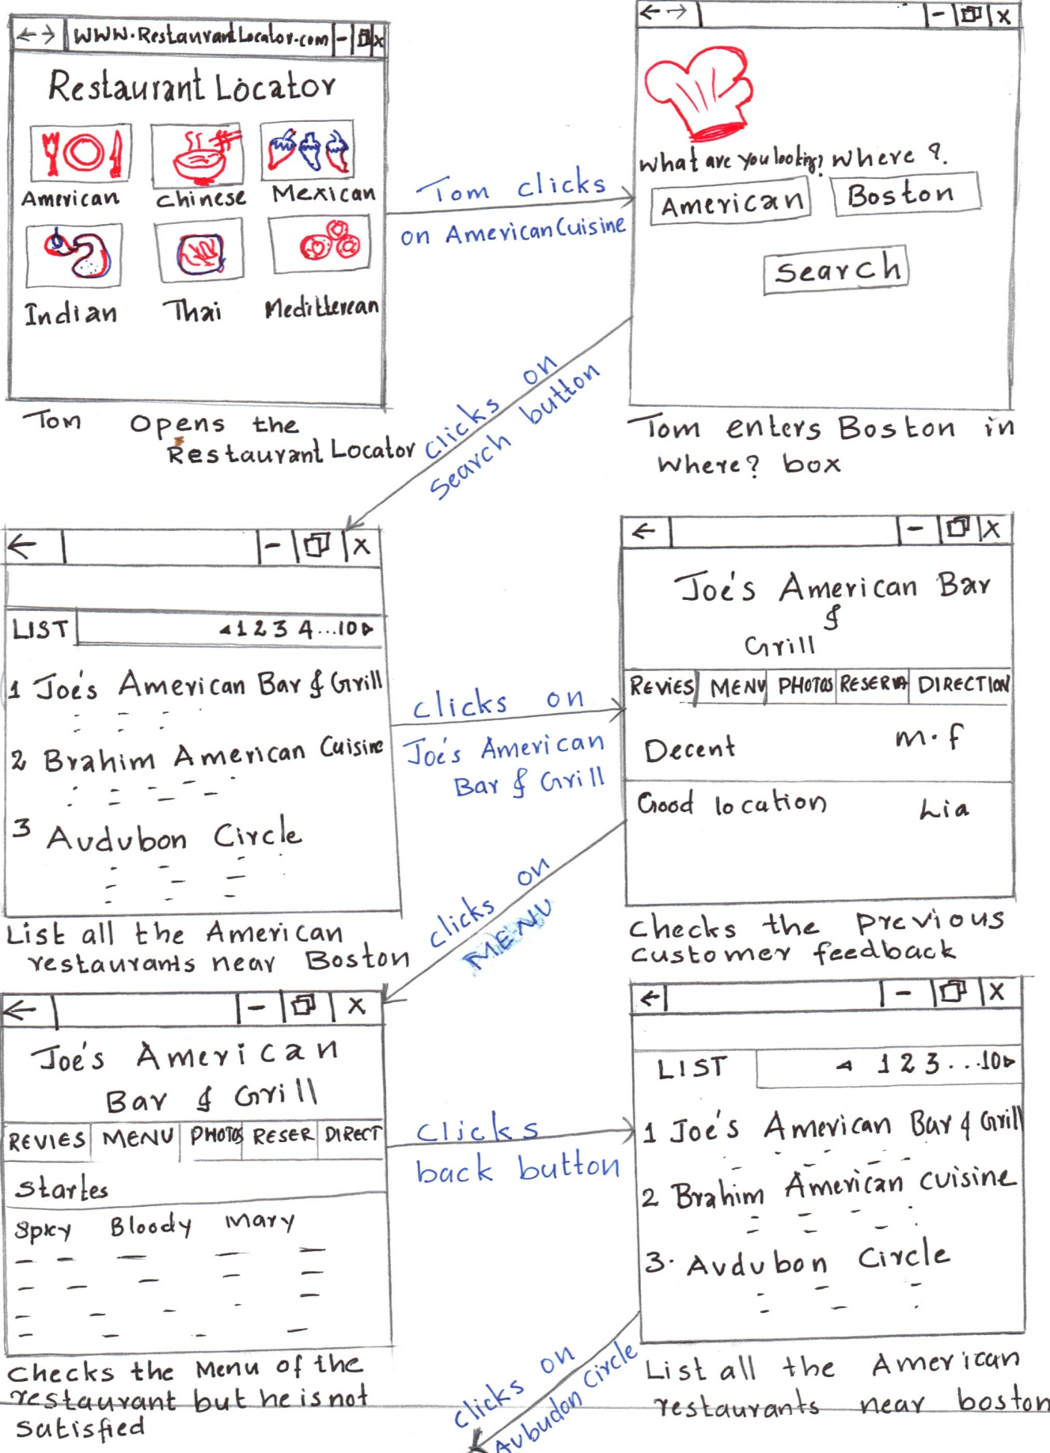

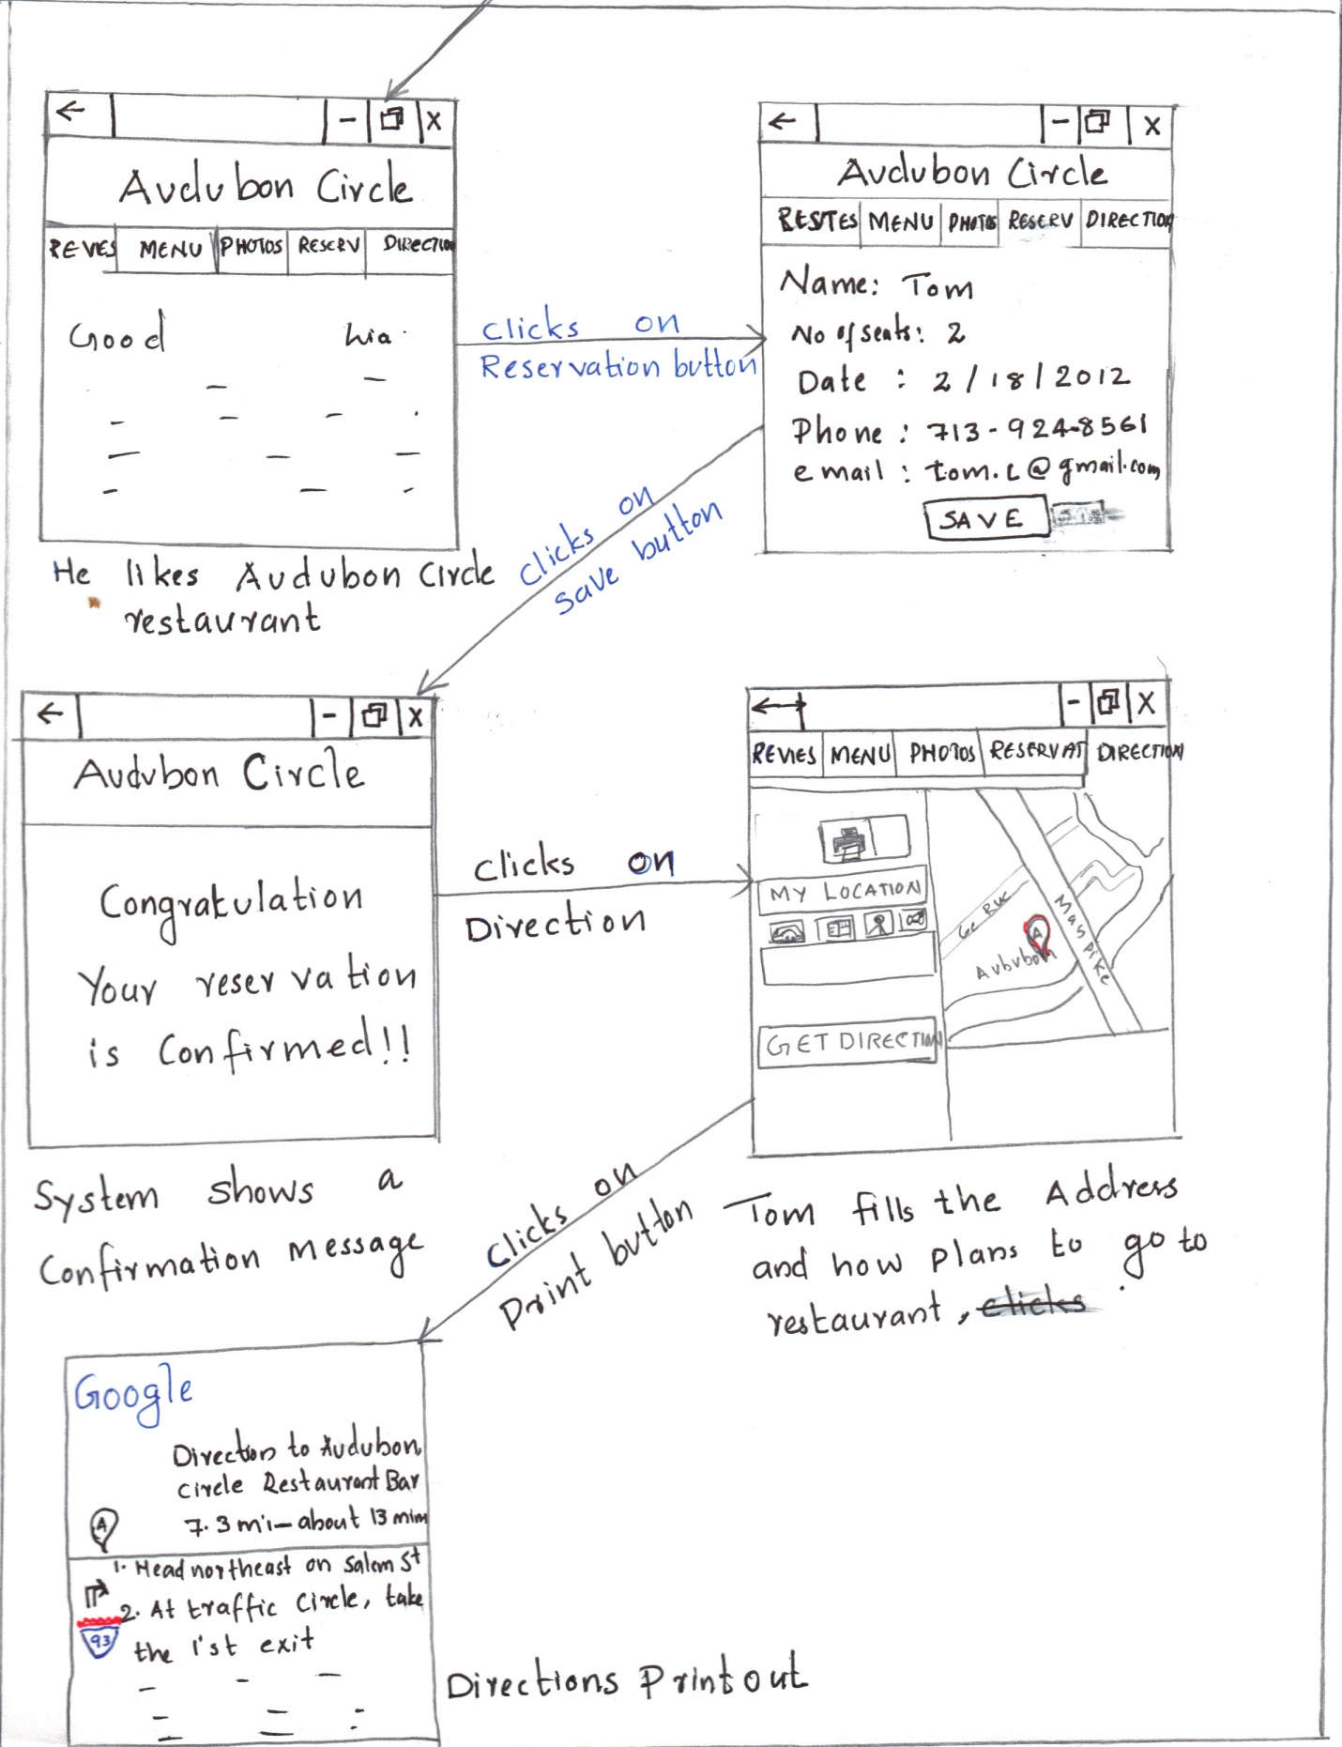

1. **Documentation**

Restaurant Locator web application helps you to easily find a restaurant in nearby locations. If you wish to go to a restaurant with the help of restaurant locator, firstly you need to type Restaurant Locator’s URL in browser. On restaurant locator home page you can select the cuisine type (Ex: American, Mexican, etc). Once you select the cuisine the system goes to the search page where you need to type the location (where you are looking for the restaurant) then click to perform search. Once you click on the search button the system will show all the matching restaurants nearby. Here you can select a link from the search results page and view the restaurant’s details (Ex: Address, Phone, E-mail, etc.) as well as feedback of previous customers and write your own reviews. If you want to see the photos of the restaurant, you just need to click on the photo button and the system will display restaurant’s pictures and will help you to make a decision about the restaurant without even going to the restaurant. If you are not satisfied with the selected restaurant you can go back and select another restaurant. In order to make a reservation you just need to click on the reserve button and system will show a reservation form to fill the basic information (Ex: Name, No of seats, Date to visit, Phone number, E-mail, etc.) and click on save button to submit the reservation. The system also provides directions to restaurant. When you click on the directions button the system will ask you to enter your starting address and how you plan to go to the restaurant (Ex: By Car/Bus/Bike, etc.) once you enter these details and click on Get Directions button the system will show you directions to restaurant.

1. **Task-command analysis**

**Find a restaurant of favorite cuisine**:

1. User enters Restaurant Locator’s URL on their browser
2. Opens a restaurant locator
3. Search restaurant
   1. Click/touch cuisine type displayed on the home page
   2. Enter the location on where box on the search screen
   3. Click/touch search button
4. Get a restaurant
   1. Click/touch a restaurant link from the search result screen
   2. Read the information and address about the restaurant from details screen
   3. Check photo and menu(optional)
5. Close the restaurant locator application

**Write Review**

1. User enters Restaurant Locator’s URL on their browser
2. Opens a restaurant locator
3. Search restaurant
   1. Click/touch cuisine type displayed on the home page
   2. Enter the location on where box on the search screen
   3. Click/touch search button
   4. Select the restaurant from displayed search list
4. Post Review
   1. Click/Touch Add Review button
   2. Write comments in textbox
   3. Click post button to post review
5. Close Restaurant Locator browser

**Find a restaurant and take direction:**

1. User browses Restaurant Locator application
2. Search restaurant
   1. Click /touch cuisine type from front page
   2. Enter location on where box display on screen
   3. Click/touch on search button
   4. Select one restaurant from displayed search list
3. Finalize restaurant
   1. Check review
   2. Check menu
   3. Check photos
4. Get direction
   1. Click/touch on direction button
   2. Enter customer address
   3. Select customer’s way to go to restaurant (Ex: car, bus, bike, etc.)
   4. Click/touch get direction button
   5. Click print page option from menu
5. Close Restaurant Locator browser

**Find a restaurant and reserve it:**

1. Open Restaurant Locator web application
2. Find a restaurant with favorite cuisine
   1. Click/touch a cuisine type from front page
   2. Enter location on where box in the search page
   3. Click/touch on search button
3. Finalize a restaurant
   1. Select one restaurant link from the search result
   2. Check review/photos/menu(optional)
   3. Customer not satisfied
      1. Go back to search list
      2. Click/touch on another restaurant link
         1. Check review/menu/photos(optional)
4. Reserve seat
   1. Click on reserve button
      1. Fill information
   2. Click on save button
5. Close Restaurant Locator

**Find a restaurant, reserve and take directions**

1. Open Restaurant Locator web application
2. Find a restaurant with favorite cuisine
   1. Click/touch a cuisine type from front page
   2. Enter location on where box in the search page
   3. Click/touch on search button
3. Finalize a restaurant
   1. Select one restaurant link from the search result
   2. Check review/photos/menu (optional)
   3. Customer not satisfied
      1. Go back to search list
      2. Click/touch on another restaurant link
         1. Check review/menu/photos(optional)
4. Reserve seat
   1. Click on reserve button
   2. Fill information
   3. Click on save button
5. Get directions
   1. Click/touch on direction button
   2. Enter customer address
   3. Select customer’s way to go to restaurant (Ex: car, bus, bike, etc.)
   4. Click/touch get direction button
   5. Take print page option from menu
6. Close Restaurant Locator browser