Face Tracking and Comparison
Aswathy Dinesh
Tufts University

- Abstract

In this project, I built a system that can track a human face as well as compare the tracked face with the grabbed image in the system. Face detection can be done effectively by identifying skin region using YCbCr color model. I developed this project using LabVIEW platform and with help of image processing toolkit.

Keyword: Face detection, Threshold, Skin region, Morphology.

- Introduction

Face recognition has already started to play major role in various areas such as video surveillance, human computer interface and image database management, etc. In education field, the proposed system can be used for attendance management. By utilizing face detection and recognition this system can track students attendance. Additionally the system would display a message if it cannot find a match.

The goal of this project is to track a face from live video, place a bounding box around the tracked face and then compare the face with grabbed image in the system. The system would display a message if the grabbed image matches with tracked image. Face detection is performed based on color thresh holding with an aim to reject as much of non-face region from the image.

There are a number of algorithms available for face detection like edge detection, template matching etc, for the purpose of this project I have used rejection scheme algorithm [1]. The first step in this approach is to reject regions in the image that are not faces based on color thresholding and skin segmentation. The next step is to use binary image processing to create clearer delineations in these regions [2]. Finally I used a blob detection function to find the largest pixel region from the image. The result is compared with the grabbed image a match or no match message is displayed.

- System Development

The following sections describe the various techniques used to detect face and compare it with grabbed image. System consists of three stages Skin segmentation, Binary Image Processing and Image comparison.

3.1 Skin segmentation:-
This is the first step in face detection; skin segmentation is used to reject as much of non-face of an image. I have used YCbCr color space to segment the skin region. The YCbCr space segments the image into luminosity component and color components, where Y is the luma component and Cb and Cr are blue-difference and red difference chroma component. In the RGB Image, each component of the picture has a different brightness, by using YCbCr color space we can separate the Y(luma), Cb (blue) and Cr(red) component separately. The following equations are used to convert the RGB image into Y, Cb and Cr components:

Y 0.257*R0.504*G0.098*B16
Cb  0.148* R − 0.291*G  0.439* B 128
Cr 0.439*R−0.368*G−0.071*B128
After the Y Cb Cr separation I used the Cb and Cr component to find the better skin region. I gave some threshold to Cb and Cr to find better skin region. Below are some threshold values based on [2] and the tests I performed.
140<Cr<165
105<Cb<135
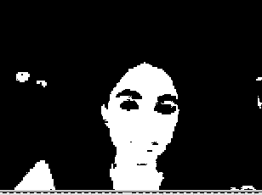
Figure 1: Original Image Figure 2: After thresholding

3.2 Binary image processing:-
After thresholding a black and white mask is obtained where the skin regions are filled with white and background region are compressed with black. This mask is then refined through some binary morphological operations such as erosion, closing, etc. to reduce the noise. Then I used “biggest blob” in image processing to track the largest blob such as face in the image. I then created a bounding box based on the centroid of the blob around the tracked face.

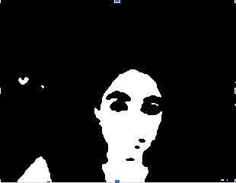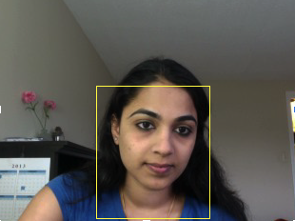
Figure 3: After Morphology Figure 4: Face Tracking

3.3 Image comparison:
After performing face tracking I grabbed an image from the tracked region then subtracted that image from the current image by using pixel by pixel image comparison method. If all the pixels match the resultant image will be a black image indicating that both the images match but while taking image from live video since it is not always a stationary image all pixels won’t match. In order to overcome this I took a count of black pixels and added a threshold, if the threshold is within the region it will display a message that “Images match” otherwise it will display “Images don’t match”.

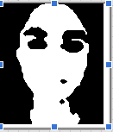
Figure 5: Tracked Face Figure 6: Grabbed Face

- Testing

I performed system testing based on some scenario’s, scenario and related results are listed below:

Scenario1: Both the images (tracked & grabbed) are of same person.

TestResult1:
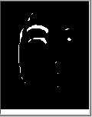
Figure 7: Tracked Face Figure 8: Grabbed Face Figure 9: Difference

Below is the message when the two images match.

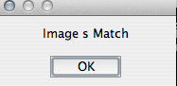
Figure 10: Message

Scenario 2 : Grabbed and Tracked image from different person.

Test Result2:
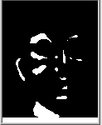
Figure 11: Tracked Face Figure 12: Grabbed Face Figure 13: Difference

Below is the message when the two images don’t match.



During overall testing 90% of the times faces were accurately tracked but whenever background matched with skin tone, system had difficulty in adjusting threshold values. In addition sometimes with variations in distance, movement and lighting conditions system displayed invalid results but still the overall performance was good.

- Future Work

In this project I implemented face recognition based only on the color model. But if the background is similar to skin tone it would be harder to distinguish face from the background. In order to overcome this if we use some kind of pattern recognition along with color model the system will provide more accurate results than the current approach. The current system compares the face with an image grabbed by the system but in order for the system to be scaled for a real application the images would need to stored in database and then compared with the tracked image. In addition to this changes need to be made to make the tracked face scale according to the grabbed image. Lastly more faces under diverse lighting conditions need to be analyzed to improve system accuracy.

- Conclusion

As a part of this project a face detection and comparison algorithm was implemented using LabVIEW. System uses color thresholding and skin segmentation to detect face in the live video feed and compare it with grabbed image and display match or no match message.
Although the system is able to detect faces, tracked face do not scale according to the grabbed image. Overall a larger set of faces needs to be used to thoroughly test the system.

- References

[1] M Elad. “Rejection Based face Detection,” EE368: Digital Image Processing Lecture, Stanford University, Stanford, CA. May 19, 2003.
[2] D Marius, S Pennathur, K Rose. “Face Detection Using Color Thresholding and Eigenimage Template Matching,” Penn State - Digital Image Processing project, 2003.
[3] M Hassan, I Aldasouqi. “Human Face Detection System Using HSV, ” Proceedings of the 9th WSEAS international conference on Circuits, systems, electronics, control & signal processing, CSECS 2010.

Aswathy Dinesh
I received my Masters in Computer Science from Mahatma Gandhi University, India. I am currently working towards a Graduate Certificate in Computer Science at Tufts University. My interests include interface design and development.

Project date: April 1, 2013.

