1) Download source code from Git.

2) Attach DB into your local.

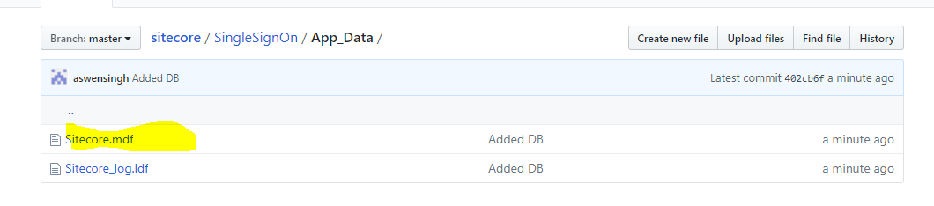

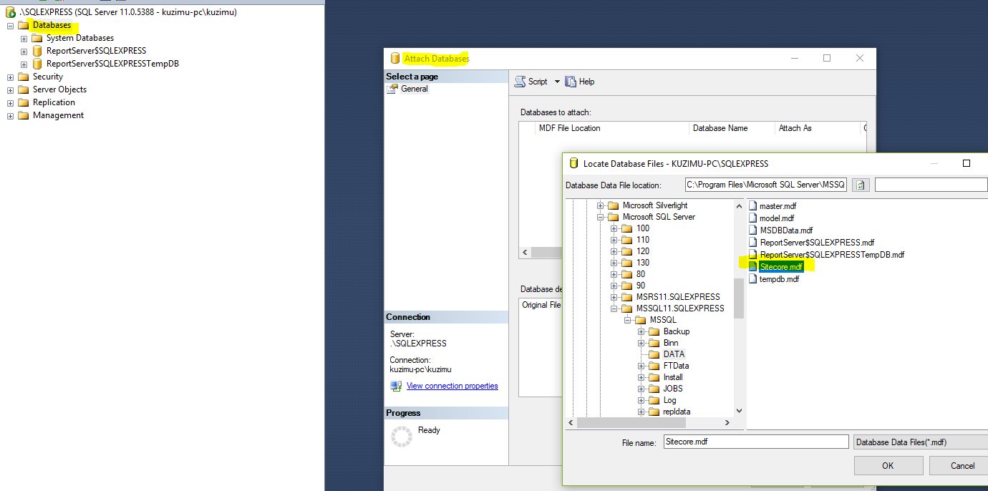

3) Modify web.config if needed to

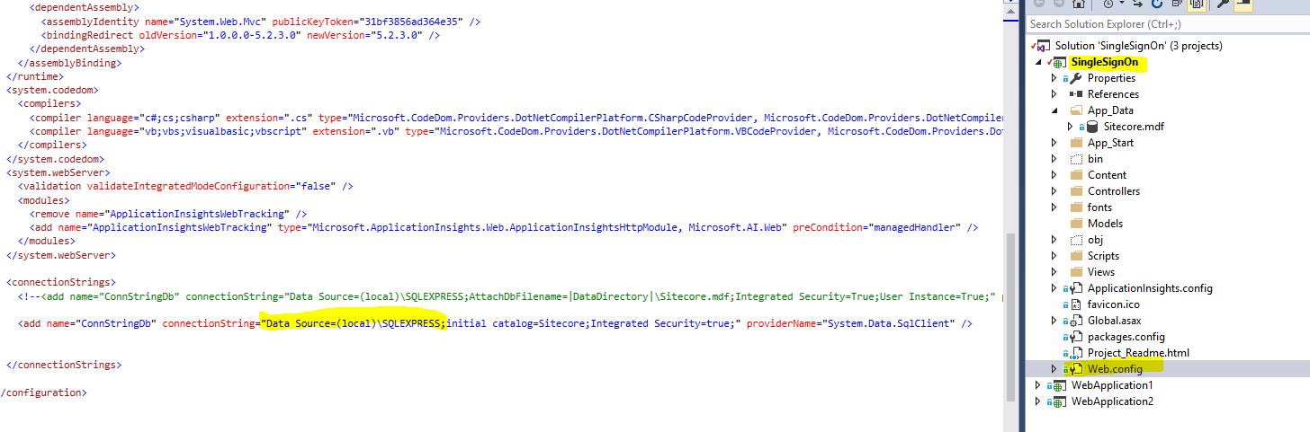

4) Run application instance of application 1 or 2:

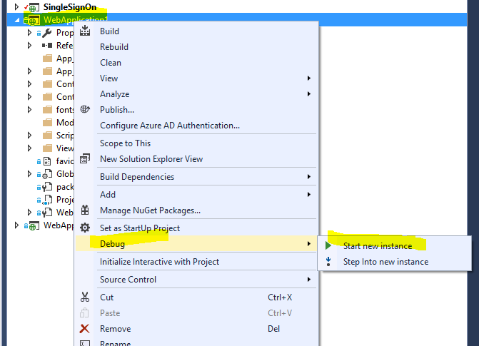

You will be redirected to SingleSignOn Application:

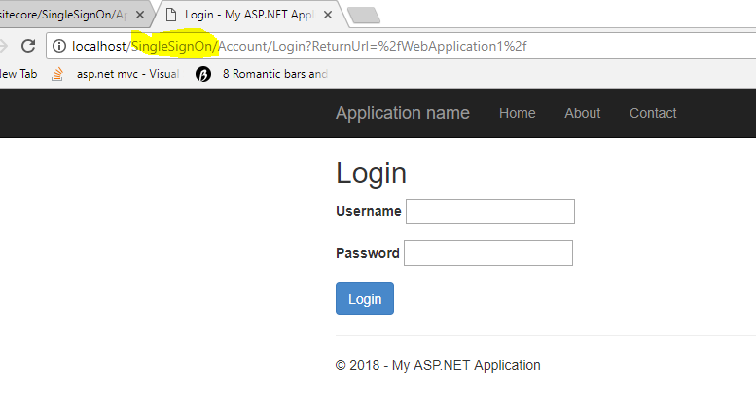

5) Login with any of the following user credentials

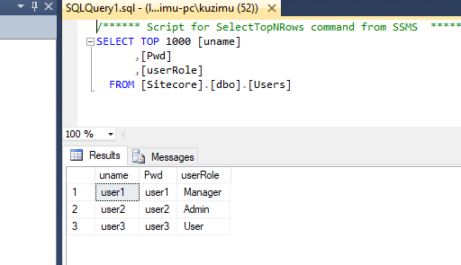

6) Once logged in, you may try to run the application again from web application 2. It will not ask for login details.

