Practical program-7
#include <stdio.h>
#include <stdlib.h>

int global = 100;
static int s = 50;

int main()
{
int stack = 10;
int *heap = (int*)malloc(sizeof(int));

printf("Code Segment : %p\n", main);
printf("Global Segment : %p\n", &global);
printf("Static Segment : %p\n", &s);
printf("Heap Segment : %p\n", (void*)heap);
printf("Stack Segment : %p\n", (void*)&stack);

free(heap);
return 0;
}
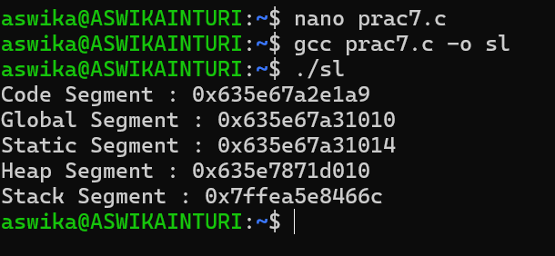
Practical Program-8
#include <stdio.h>
#include <stdlib.h>

int main()
{
int *a, *b;

a = (int*)malloc(5 * sizeof(int));

b = (int*)calloc(5, sizeof(int));

a = (int*)realloc(a, 10 * sizeof(int));

free(a);
free(b);

return 0;
}
