1. #include <stdio.h>
#include <sys/types.h>
#include <sys/stat.h>

int main()
{
if (mkfifo("myfifo", 0666) == -1)
{
perror("mkfifo");
return 1;
}

printf("FIFO created\n");
return 0;
}
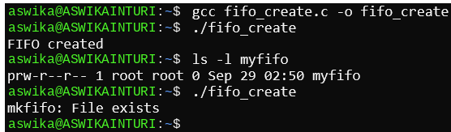
2. #include <stdio.h>
#include <fcntl.h>
#include <unistd.h>

int main()
{
int fd;
char buffer[100];

fd = open("myfifo", O_RDONLY);
read(fd, buffer, sizeof(buffer));
printf("Received: %s\n", buffer);
close(fd);
return 0;
}
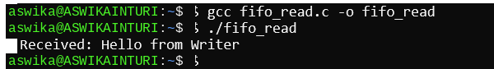
3. #include <stdio.h>
#include <fcntl.h>
#include <unistd.h>
#include <string.h>

int main()
{
int fd;
char message[] = "Hello from Writer";

fd = open("myfifo", O_WRONLY);
write(fd, message, strlen(message) + 1);
close(fd);
printf("Message sent\n");
return 0;
}
