|  |  |  |  |  |
| --- | --- | --- | --- | --- |
| 2014 | Employee | Smith,John | 2000 |  |
| 2015 | Salesman | Jones,Bill | 3000 | 100000 |
| 2014 | Executive | Bush,George | 5000 | 55 |
| 2014 | Salesman | Jones,Bill | 3000 | 100000 |

Expected Output:

|  |  |
| --- | --- |
| 2014 Average Salary: 152000 | 2015 Average Salary: 38000 |

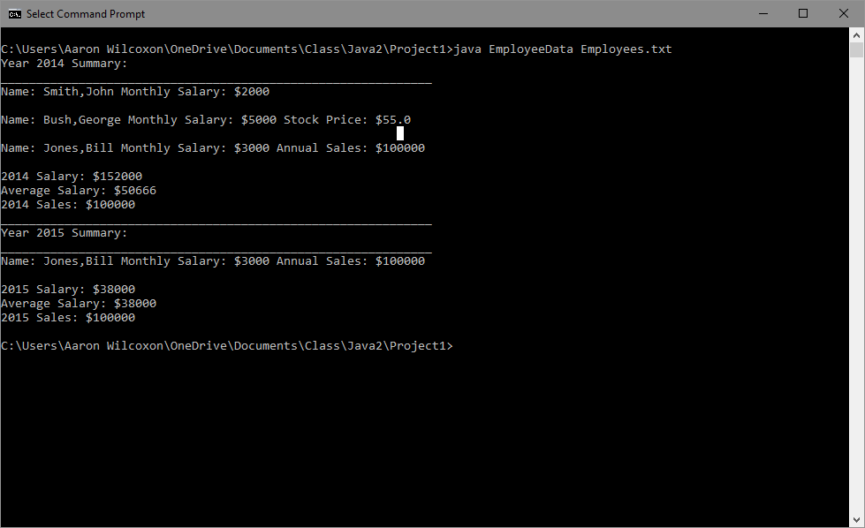

Included new employee with title of bodybuilder and monlthy salary of 10000. Show that incorrect years are excluded. Initial though that it would run and exclude line of bodybuilder. Instead of running with exclusion, it throws an error.

|  |  |  |  |  |
| --- | --- | --- | --- | --- |
| 2014 | Employee | Smith,John | 2000 |  |
| 2015 | Salesman | Jones,Bill | 3000 | 100000 |
| 2014 | Executive | Bush,George | 5000 | 55 |
| 2014 | Salesman | Jones,Bill | 3000 | 100000 |
| 2015 | Bodybuilder | Smith,Joan | 10000 |  |

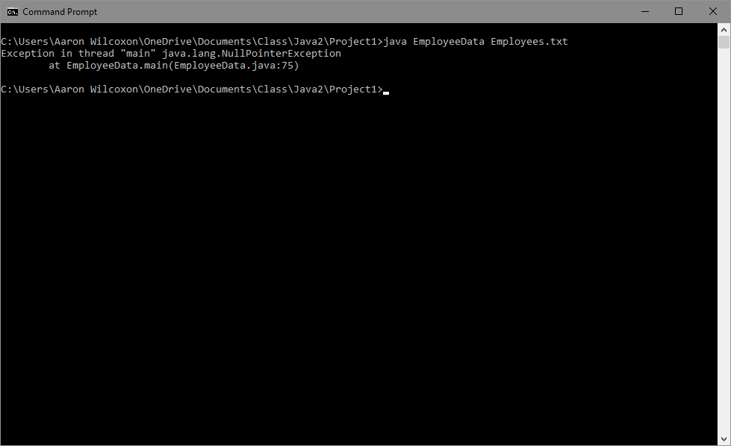

Included space in name to show error for data. Should include data validation.

|  |  |  |  |  |
| --- | --- | --- | --- | --- |
| 2014 | Employee | Smith,John | 2000 |  |
| 2015 | Salesman | Jones,Bill | 3000 | 100000 |
| 2014 | Executive | Bush,George | 5000 | 55 |
| 2014 | Salesman | Jones,Bill | 3000 | 100000 |
| 2015 | Executive | Appleseed, Johnny | 7000 | 22 |
| 2015 | Employee | Smith,Joan | 3000 |  |

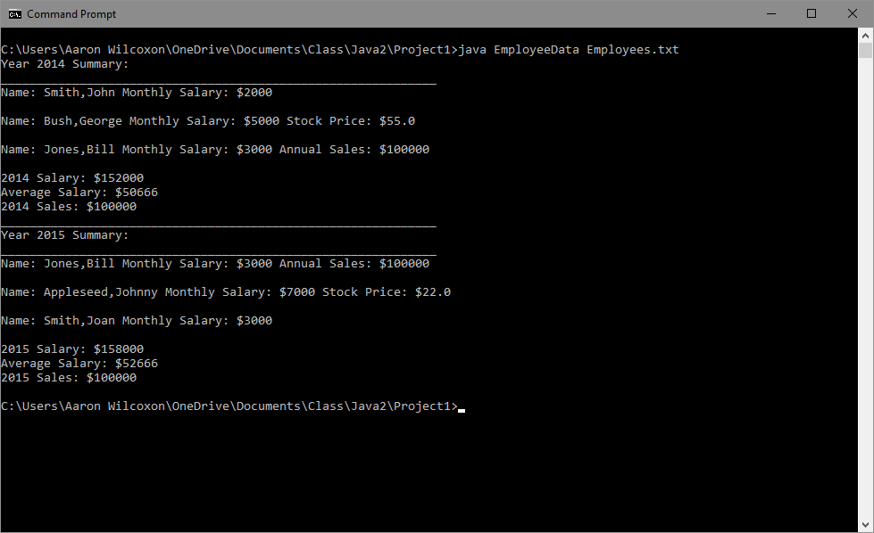

Corrected space in name.

|  |  |  |  |  |
| --- | --- | --- | --- | --- |
| 2014 | Employee | Smith,John | 2000 |  |
| 2015 | Salesman | Jones,Bill | 3000 | 100000 |
| 2014 | Executive | Bush,George | 5000 | 55 |
| 2014 | Salesman | Jones,Bill | 3000 | 100000 |
| 2015 | Executive | Appleseed,Johnny | 7000 | 22 |
| 2015 | Employee | Smith,Joan | 3000 |  |

Expected Output:

|  |  |
| --- | --- |
| 2014 Average Salary: 50666.00 | 2015 Average Salary: 52666.00 |

