Below are the test cases for my ATMMachine application. After running tests ensured that all balances are listed in $0.00 floating. Also included dollar sign in front of input.

Test cases

|  |  |  |  |
| --- | --- | --- | --- |
| # | Testing | Process | Results |
| 1 | Deposit to savings | Deposit $1000 to savings | Success |
| 2 | Deposit to checking | Deposit $800 to checking | Success |
| 3 | Throw $20 increment from checking | Withdraw $801 from checking | Success |
| 4 | Throw NSF when too much is withdrawn from checking | Withdraw $820 from checking | Success |
| 5 | Throw $20 increment from savings | Withdraw $1001 from savings | Success |
| 6 | Throw NSF when too much is withdrawn from savings | Withdraw $1020 from savings | Success |
| 7 | Throw NSF when too much is transferred from checking | Transfer $801 to savings | Success |
| 8 | Throw NSF when too much is transferred from savings | Transfer $1001 to checking | Success |
| 9 | Check savings Balance | Check savings balance | Success |
| 10 | Check checking Balance | Check checking Balance | Success |
| 11 | Transfer to savings | Transfer $500 to savings | Success |
| 12 | Transfer to checking | Transfer $500 to checking | Success |
| 13 | Withdraw from checking | Withdraw $20 from checking | Success |
| 14 | Withdraw from savings | Withdraw $20 from savings | Success |

Screen Shots

1. 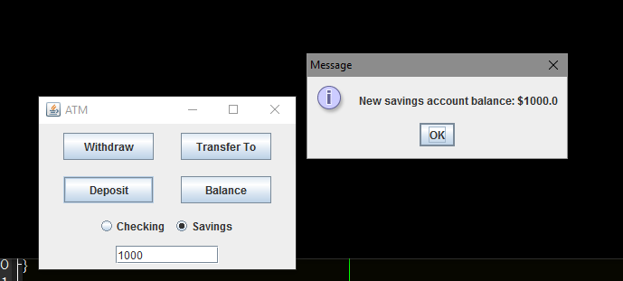
2. 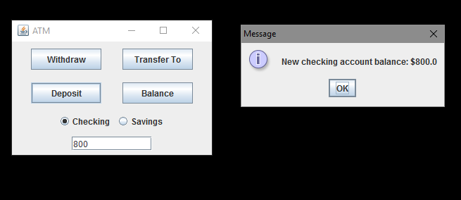
3. 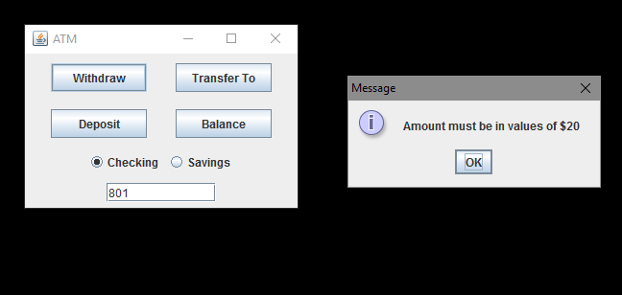
4. 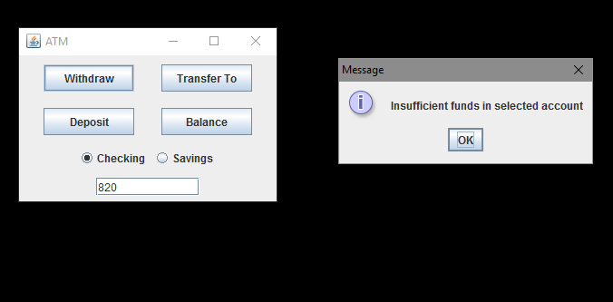
5. 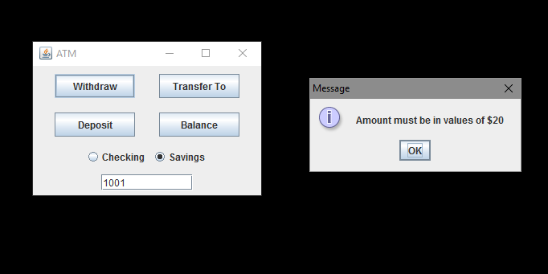
6. 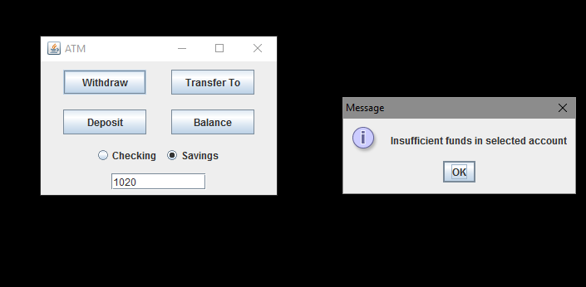
7. 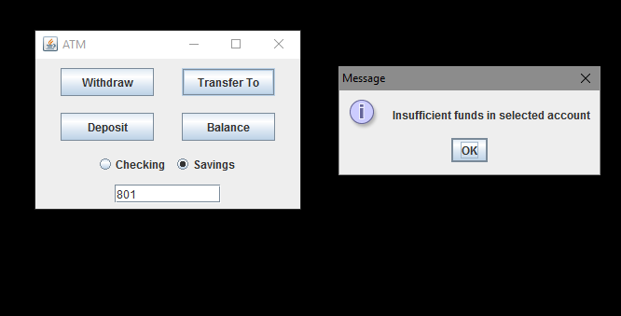
8. 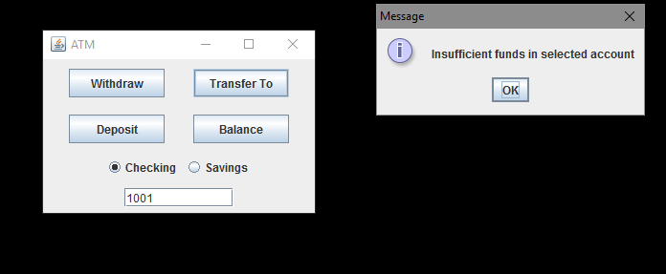
9. 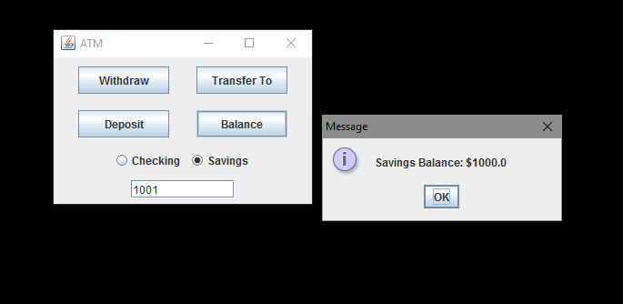
10. 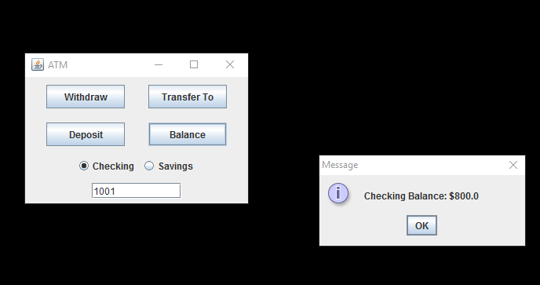
11. 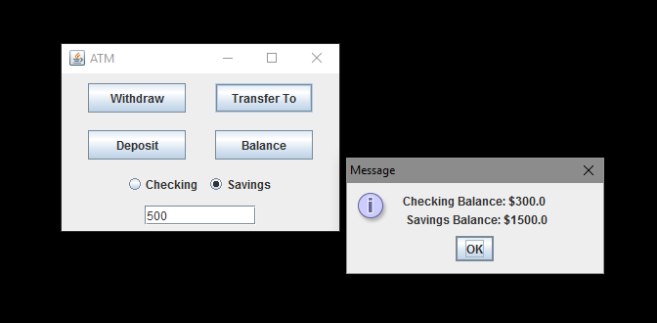
12. 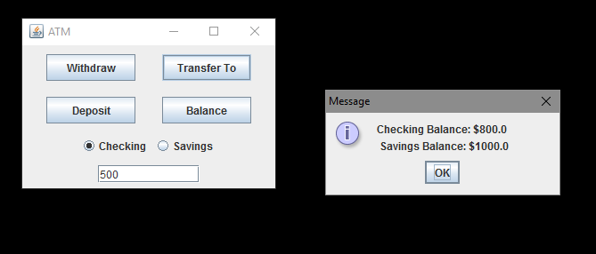
13. 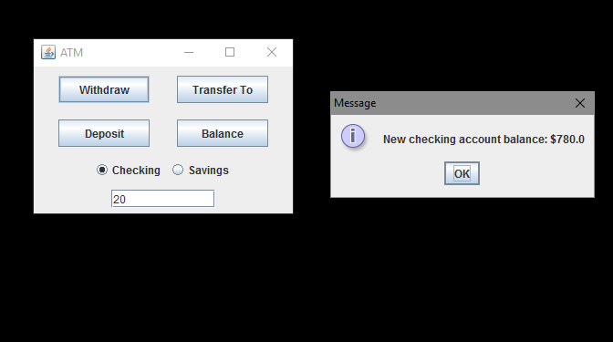
14. 