PROJECT REPORT

1.INTROUCTION

1.1 OVERVIEW

The project aim is to provide real-time knowledge for all the students who have basic knowledge of Salesforce and Looking for a real-time project. This project will also help to those professionals who are in cross-technology and wanted to switch to Salesforce with the help of this project they will gain knowledge and can include into their resume as well.

Employees travel on business trips to attend conference, perform research, scout potential locations, meet suppliers, visit clients, and for numerous other essential reasons. Whatever the reason, such trips enable them to seek lucrative opportunities, build relationships, solve problems, enhance productivity, and drive growth.

Unfortunately, a persistent problem facing many with such aspirations is that they often find themselves in situations where the trips become a tiresome burden with exponentially higher costs than expected.

1.2 PURPOSE

    The Purpose of travel policy is to ensure that the travel expense of the company is controlled by establishing certain standards. Employees must control business travel expense by making the sound judgement with respect to use of company funds.

                                                  Travel is an important aspect for carrying out the business, it is expected from employees that they will follow the **“travel guidelines for employees”** while travelling and would provide documentation in support of the same. It is also meant to reimburse the amount spent by an employee when on international or domestic travel.

2. PROBLEM DEFINITION & DESIGN THINKING

2.1 EMPATHY MAP

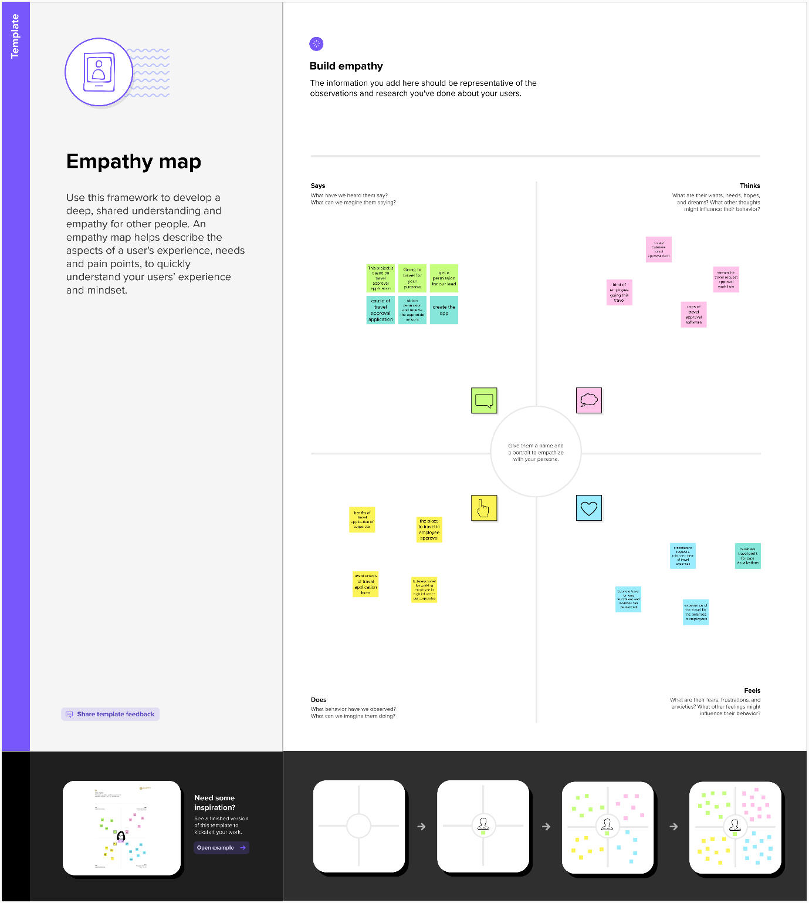

2.2 IDEATION & BRAINSTORMING MAP

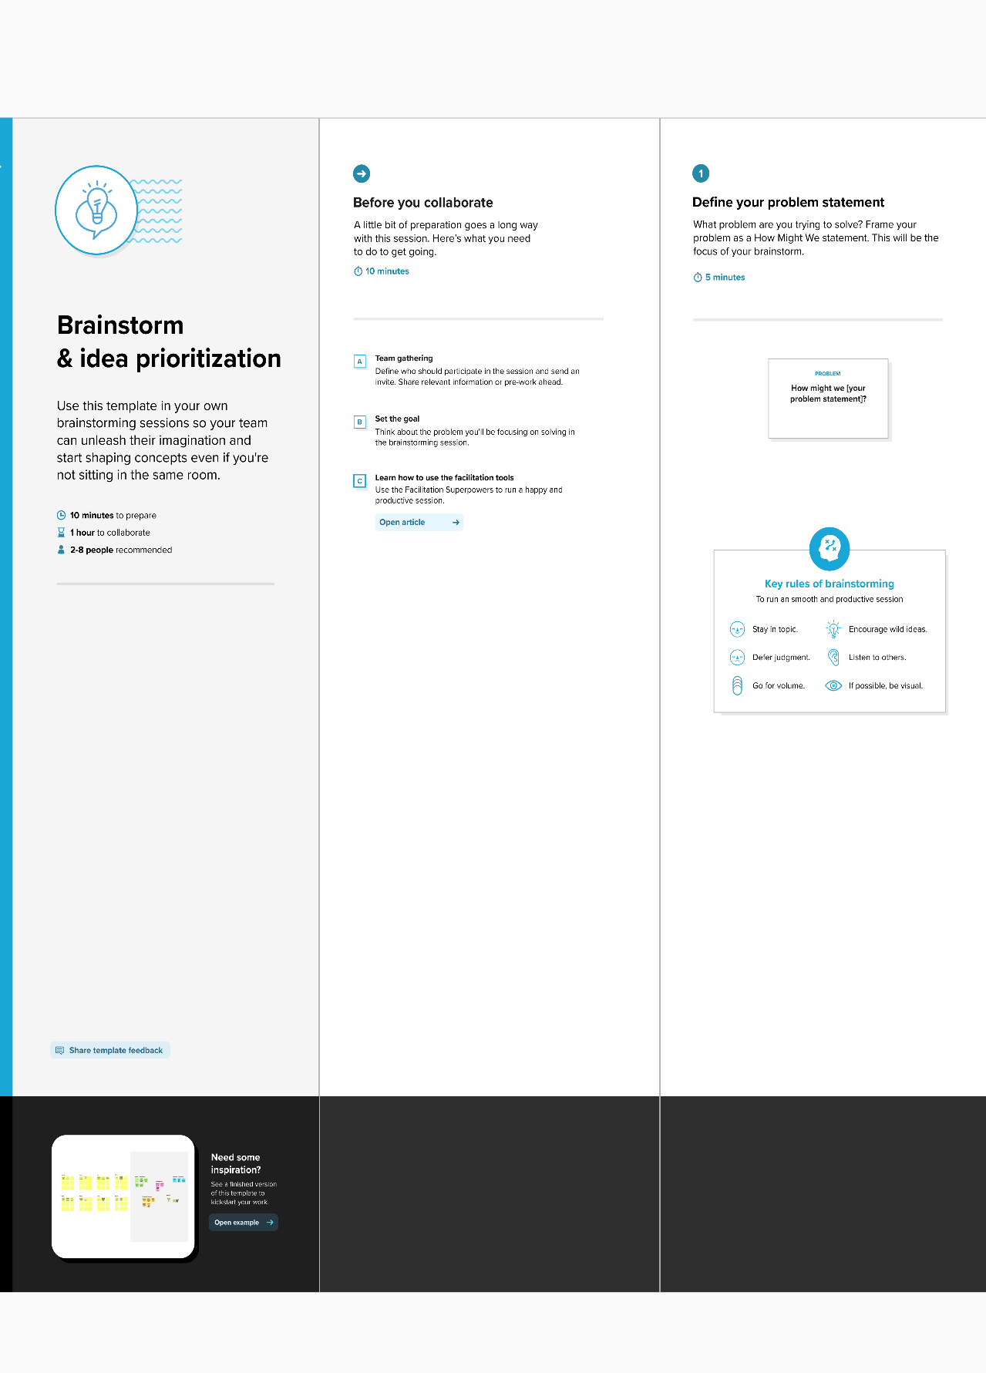

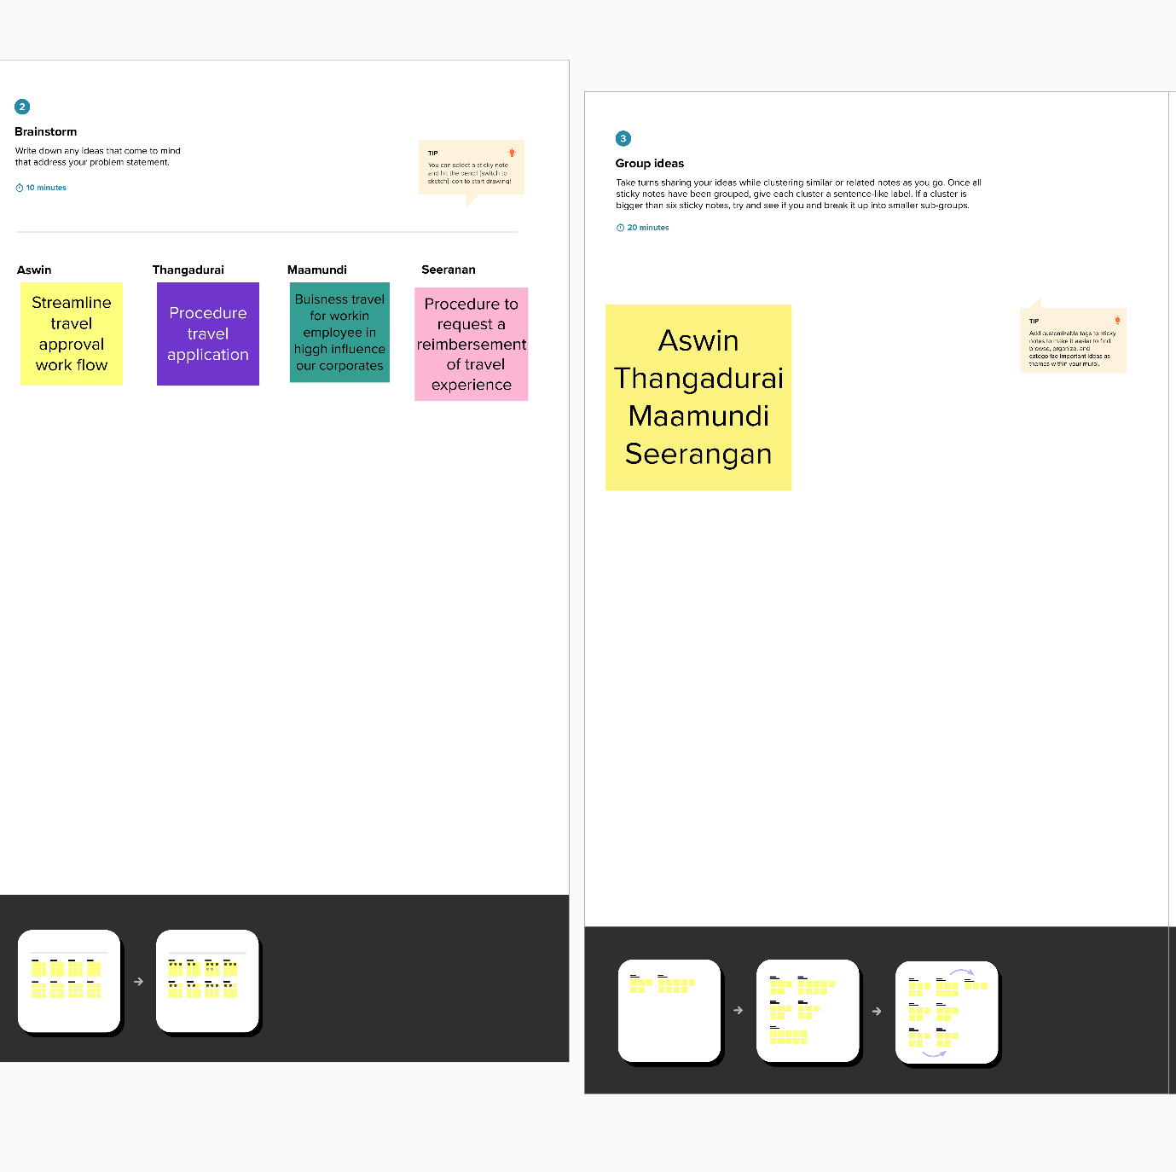

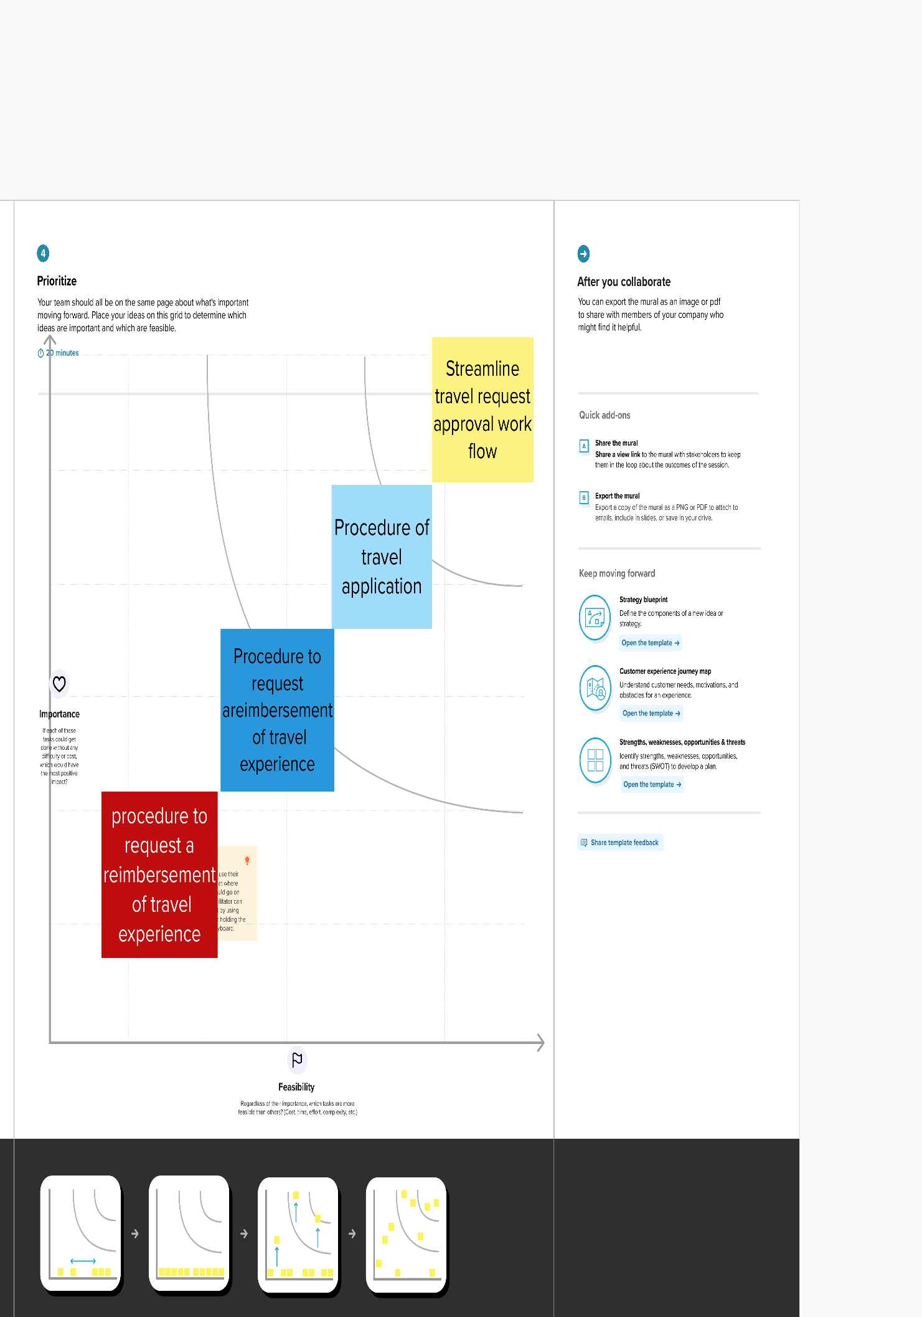

3.RESULT

3.1. DATA MODEL

|  |  |
| --- | --- |
| OBJECT NAME | Fields in the Object |
| **Job posting sites** | |  |  | | --- | --- | | **Field Label** | **Data type** | | Job Posting site | TEXT | | Site name | AUTO NUMBER | |
| **Reviews** | |  |  | | --- | --- | | **Field Label** | **Data type** | | Reviews | TEXT | | Review number | AUTO NUMBER | |

3.2 ACTIVITY AND SCREENSHOT

MILESTONE : 1-5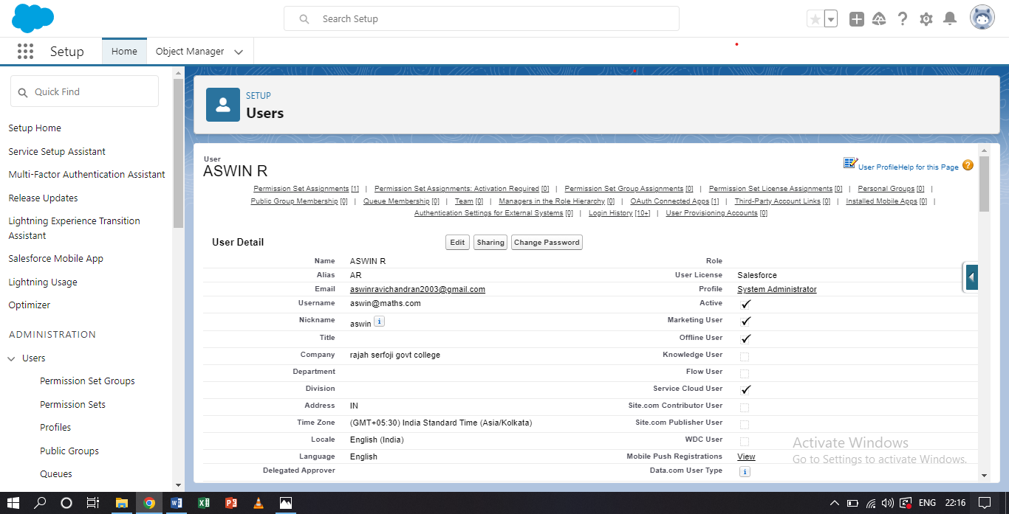

MILESTONE : 6-9

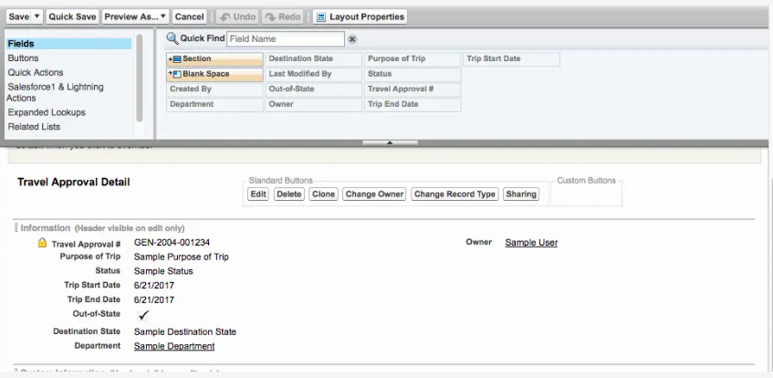

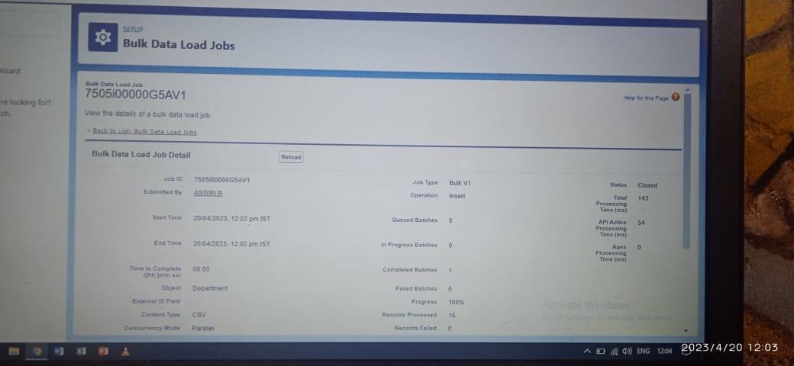

MILESTONE : 10,11

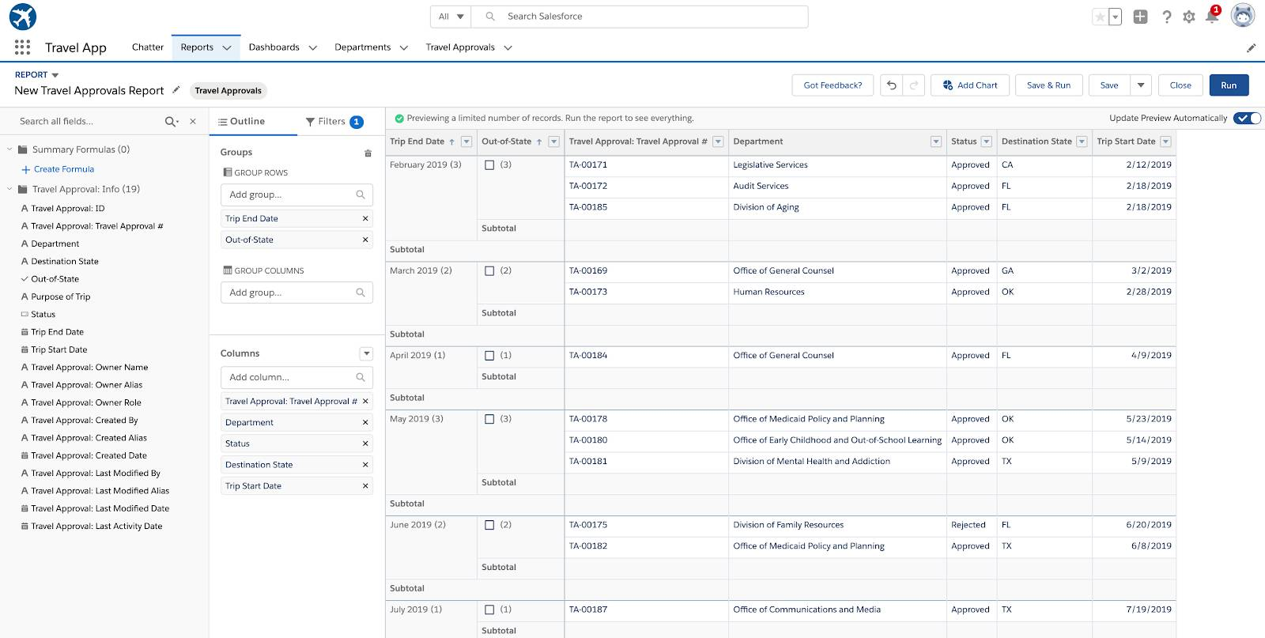

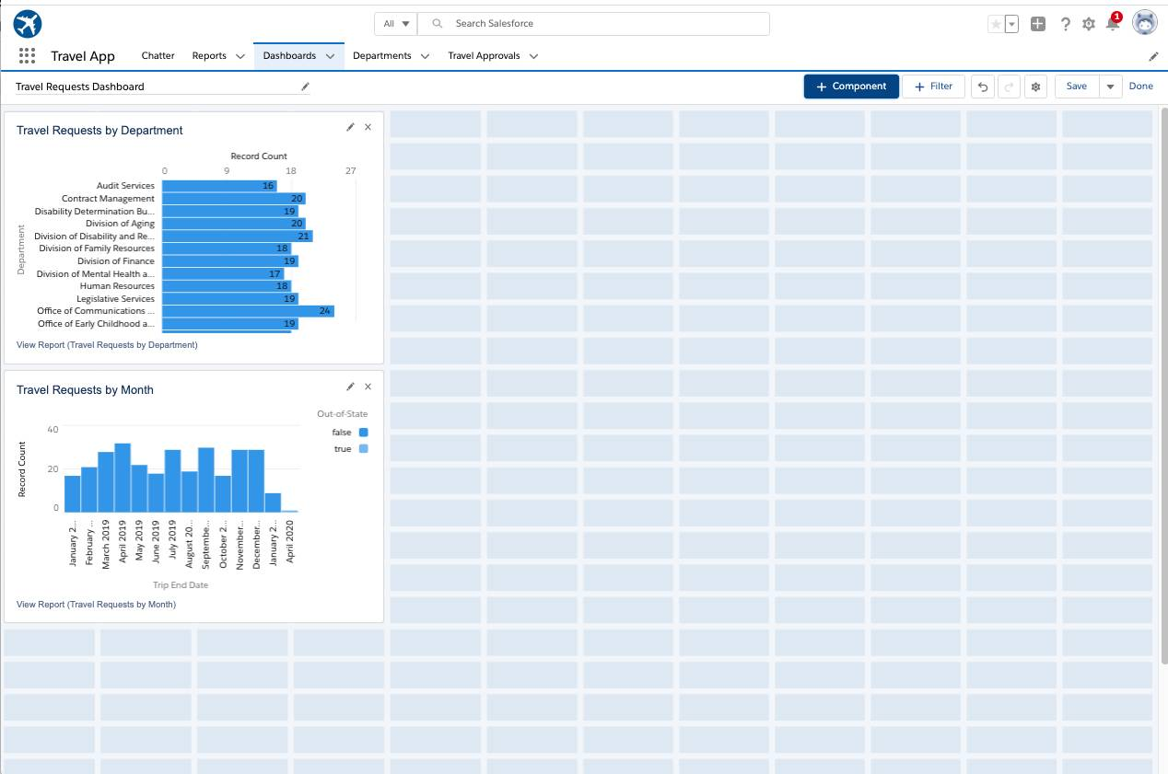

4.TRAILHEAD PROFILE PUBLIC URL

TEAM LEADER : https:// trailblazer.me/id/aswir8

TEAM MEMBER 1 : <https://trailblazer.me/id/thant26>

TEAM MEMBER 2 : .<https://trailblazer.me/id/mamundi>

TEAM MEMBER 3 : <https://trailblazer.me/id/labishek>

5. ADVANTAGES AND DISADVANTAGES

ADVANTAGES :

  ➢Approvals on time. The entire process of planning and managing a trip is a long and stressful process.

                       ➢Customize approval workflows. The approval process can differ from company to company

                        ➢Increase compliance and reduce costs.

                    ➢Faster process.

DISADVANTAGES :

➢It's another process for everyone to think about. An extra layer of bureaucracy costs time and efficiency.

                          ➢The old carrot and stick argument. Think about your company culture and how people want to be treated by their employers.

                         ➢Getting that green light.

6. APPLICATIONS

• About the sample application

• Prerequisites

• Installing the sample application

• Defining the Use of an External Web Browser

• Starting the sample application

• Logging is an Employee for Requesting of Business Trip

• Entering the Travel Request with Flight and Hotel Information

                  • Adding Additional Expenses to your Travel Request

                  • Logging in as a Manager for Approving Travel Request

 • Approving a Travel Request.

7. CONCLUSION

   Travellers continue to seek authentic experiences. The tools they use to research and book these experiences are constantly changing due to innovations in technology. Destinations are also challenged by limited financial resources and strong competition for tourist dollars from other iconic and even lesser known locations. The personalisation of travel suggests that independent travel will have a stronger presence than group travel, however, we must always consider the type of traveller. The travel services sector is being forced to innovate at a startling rate.

                   In the past, face to face consultations with a travel agent was paramount for booking both leisure and business travel. Technology and global circumstances, such as pandemics, financial collapses, and terrorism, have put pressure on tourism and travel services. With the development of OTAs and emerging and disruptive technologies, the travel services landscape is constantly changing.

8. FUTURE SCOPE

   As per various studies, the industry is expected to create over **45 million jobs in India by 2025**. Students have endless career opportunities in this fast-growing industry of travel and tourism.

**84% of Hilton** survey respondents plan to travel the same amount or more as they did in 2022, all the while seeking out travel innovations that make their stays easier through both technology and personalized service.