# A Project Report on

**Exam Scheduling System**

Submitted in partial fulfillment of requirement for the award of

# MASTER OF SCIENCE IN COMPUTER SCIENCE

**Of**

**KANNUR UNIVERSITY**

**By**

**ASWIN M P**

**B9DPSCS1003**



SCHOOL OF INFORMATION SCIENCEAND TECHNOLOGY

Kannur University Campus, Mangattuparamba Kannur-670567

2019-2021

**KANNUR UNIVERSITY**

**SCHOOL OF INFORMATION SCIENCE AND**

**TECHNOLOGY**

**KANNUR UNIVERSITY CAMPUS MANGATTUPARAMBA KANNUR-670567**





*This is to certify that the project entitled “Exam Scheduling System” submitted in partial fulfillment of the requirement for the award of* **Master of Science in Computer science** *Degree, is a result of bonafied work carried out by* **Mr. ASWIN M P, B9DPSCS1003** *during the year 2019-2021.*

Place: Mangattuparamba Dr. MOHAMMED ISMAIL B Date: Head Of the Department

Internal guide External Examiner

Mr. Sumesh K

**DECLARATION**

I ASWIN M P, fourth semester MSc Computer science student, hereby declare that the project report entitled ‘**Exam Scheduling System’** submitted in partial fulfillment of the requirement for the award of the MSc, is a report of the original work done by me during the period of study at School of Information Science and Technology, Mangattuparamba under the supervision of **Mr. Sumesh K, Assistant Professor, Department of IT, School of Information Science and Technology, Mangattuparamba.**

Place: Mangattuparamba ASWIN M P

Date:

# ACKNOWLEDGEMENT

The satisfaction and joy that accompany the successful completion of any task would be incomplete without the mention of those who made it possible. I would like to thank the support and guidance that came from various quarters during the course of my project work.

First of all, I thank to **Dr. Mohammed Ismail B,** Head of the Department of IT, for her valuable suggestion and guidance and for providing the necessary facilities.

I am extremely grateful to **Mr. Sumesh K, Assistant Professor,** my internal guide for his inspiring guidance and constant encouragement during the project period that enabled me to complete my work successfully.

My acknowledgement would not be complete without acknowledging my gratitude to my beloved parents who have been the pillars of support and constant encouragement throughout the course of this project.

ASWIN M P

# ABSTRACT

Exam Scheduling System is a web based application designed to handle the exam management process of University. That is it manages to schedule exams for various Programmes of University.It is developed as a web based application. It allows easy scheduling of exams in various semester of various Programmes in University.It allows admin and efficient way to schedule the exam by providing start date, interval between the exam , semester, department, center of examination.

This web based application designed to reduce the complexity of scheduling exam of various programmes under University.It makes sure that every exam is schedule excluding public holidays that is already available from the academic calender from the University. An administrator will schedule all the exam by providing program name , semester, start date, interval between exams and the session of the examination.There is a user who can view and download all the question papers generated by the administrator in pdf format. Dashboard allows the admin to view registered users at a glance.

# INDEX

|  |  |  |  |
| --- | --- | --- | --- |
| **TABLE OF CONTENTS** | | | |
| 1 | INTRODUCTION | | 1 |
|  | 1.1 | INTRODUCTION | 2 |
|  | 1.2 | MOTIVATION | 3 |
|  | 1.3 | PROBLEM DEFINITION | 3 |
|  | 1.4 | MODULE DESCRIPTION | 4 |
| 2 | REQUIREMENT ENGINEERING | | 5 |
|  | 2.1 | FEASIBILITY STUDY | 6 |
|  | 2.2 | REQUIREMENT ELICITATION AND ANALYSIS | 8 |
|  | 2.3 | SOFTWARE REQUIREMENT SPECIFICATION | 9 |
|  | 2.4 | SYSTEM SPECIFICATION | 17 |
|  | 2.5 | TECHNICAL SPECIFICATION | 18 |
| 3 | DESIGN | | 19 |
|  | 3.1 | INPUT DESIGN | 20 |
|  | 3.2 | OUTPUT DESIGN | 21 |
|  | 3.3 | DATABASE DESIGN | 22 |
|  | 3.4 | DATAFLOW DIAGRAM | 31 |
|  | 3.5 | UML DIAGRAMS | 36 |
| 4 | CODING AND TESTING | | 48 |
|  | 4.1 | SYSTEM DEVELOPMENT | 49 |
|  | 4.2 | SYSTEM TESTING | 51 |
| 5 | CONCLUSION AND FUTURE ENHANCEMENTS | | 55 |
|  | 5.1 | CONCLUSION | 56 |
|  | 5.2 | FUTURE ENHANCEMENT | 56 |
| 6 | SCREENSHOTS | | 57 |

|  |  |  |
| --- | --- | --- |
| 7 | BIBLIOGRAPHY | 65 |

# INTRODUCTION

#### INTRODUCTION

* 1. MOTIVATION
  2. PROBLEMDEFINITION
  3. MODULEDESCRIPTION
  4. **INTRODUCTION**

Exams are important part of University. In each University, there are a lot of programmes are courses conducted. Due to the semester system, the number of exams are also increased, So we need to conduct many exams in a particular time. For conducting exams, we need to schedule the examinations. The existing system schedule examinations manually. And need lot of paper work and human resources too. Due to manual scheduling, there is chance to occur human errors. And need time to schedule exams. So if we need to overcome these problems, We need to schedule examinations without implementation of human. So the new examination scheduling system is developed.

This project is based on creating a Web application for scheduling exams under University. And it will save examination scheduling time and reduce human errors on scheduling. And also we can scheduling exam in a simplified and secure way. This application have the options of add new department, add new examination centers and preview scheduled time table in PDF format. Also the time table scheduling by excluding public holidays according to university academic calendar. And it can add or delete time table. And also have facility to set interval between exams . As a result, the examination time table is available in standard format and available for each department under university. The Web application provides with better user interface. This application is expected to be effective with a convenient and comparatively simple user interface.

* 1. **MOTIVATION**

The traditional exam scheduling system will take lot of time and effort. By scheduling we need to check for public holidays to exclude them from examination conducting date. To overcome all these difficulties exam scheduling system was developed. Exam scheduling system is a Web based application that is efficiently manages exam scheduling in a university.The main motive behind developing this web based application is to overcome traditional exam scheduling difficulties in a university.

Scheduling exam of every programmes under university requires lot of efforts .By exam scheduling system , we can schedule exam at ease.

* 1. **PROBLEM DEFINITION**

To design a Web based application that will manage to schedule exams in a university there by reducing the complexity of scheduling exams.This web based application should enable the administrator to schedule the exam quicker.The existing scheduling system needs efforts like skipping public holidays according to academic calender of university.But in the proposing system , admin should be able to schedule exams according to the public holidays according to the academic calender of university

* 1. **MODULE DESCRIPTION**

Exam scheduling system is divided into 5 modules. They are usermanagement, create exam time table,view exam time table,add department , add center.

* + - Admin

Administrator of the system have access to the admin dashboard. He is the one who controls the overall system. Administrator has the provision to schedule the exam by mentioning the start date of an exam, semester , department, interval between examinations , morning/evening session of the day of examination.After scheduling , the scheduled time table will be available at PDF format. Where exam starts from start date provided by the admin . The administrator has the provision to view the all the generated exams by recent. Admin can also add members who can view the generated time tables. Admin can add the department if we need to implement new departments.Admin can also add the new examination centers if existing centers are not available.

* + - User

User can login with the valid login credentials . User can view the all generated question paper by admin in recent sorted form..User can edit his profile, change password and logout.User can download generated question paper if he wish to store locally.

# REQUIREM ENTENGINEERING

#### FEASIBILITY STUDY

* 1. REQUIREMENT ANALYSIS
  2. SOFTWARE REQUIREMENT SPECIFICATION
  3. SYSTEM SPECIFICATION
  4. TECHNICAL SPECIFICATION

**2.1 FEASIBILITY STUDY**

This is the primary step followed to the project. It determines the viability of a project and documents it. These studies are useful to take decision such as if we continue with the project or not. This is carried out to determine if the proposed system can build and deployed within the limit and without any trouble.

Development of “EXAM SCHEDULING SYSTEM”, the study of feasibility is followed to determine whether the proposed system can be implemented with available resources.

The key steps in the feasibility study are:

* Economic Feasibility
* Technical Feasibility
* Operational Feasibility
* Behavioral Feasibility

**2.1.1 ECONOMIC FEASIBILITY**

This is commonly used way of finding effectiveness of candidate system. It is usually known as benefit analysis or cost analysis. Its steps are to evaluate the benefits of candidate system and compare them. A technically developed system will use if installed is better for investment of organization. Hence exam scheduling system is economically feasible compared with cost. Its benefits out the decision are planned to develop and deploy the system. Otherwise more option will have to need. Here our web application requires small memory to operate and there is no extra hardware is required.

**2.1.2 TECHNICALFEASIBILITY**

To test this, configuration of system is given prior importance. This feasibility is the resources availability study. It may cause the availability to achieve an acceptable system. The management of proposed system does not require changing of existing system configuration. The software that is required for the system development is Visual studio code, PHP language for front end, MySQL package, which is essentially available online for download. During the technical analysis, it is checked whether this software is worth to carry out. Since the implementation of the required system does not need any additional software or hardware.

**2.1.3 OPERATIONAL FEASIBILITY**

Our implementing system is effective, user friendly, and functionally reliable. There is no difficulty in implementing the system. Users of our implementing system are completely unaware of it. They face lots of trouble because the users don’t know the internal working of the system. Our proposed system is safe for use to human. It will not cause any problem.

**2.1.4 BEHAVIORALFEASIBILITY**

If we are developing our project in an external organization, then we should work at there with full cooperation. There should not arise any ego between employees. When new ideas are introduced then all should encourage with that ideas. Behavioral feasibility mainly depends upon behavior of a person individually. It analyzes behavior of all persons directly involved with our project.

**2.2 REQUIREMENTANALYSIS**

Requirements are the features of a system behavior. It gives details regarding system properties and attributes. We can say it as an applications expectation. i.e., this describes what are the input and outputs of the system. It should also describe system working operational parameters. When new working systems are introduced instead of old working system, it should need enhanced functionality. Otherwise the problems may be arises.

Requirements for the project were collected from the staffs of the university through discussions. It should satisfy the following requirements.

* + - There is a login form for all users of the exam scheduling system.. Only the authorized users are allowed to enter the system.
    - These permitted users can easily use granted portion of the system.
    - Admin will have the overall control of the centralized system.

**2.3 SOFTWARE REQUIREMENT SPECIFICATION**

**2.3.1 PURPOSE**

The purpose of this exam scheduling system is to automate the existing scheduling system by the university.By using the system , we can automate the exams easily .Thus reducing complexity and effort of the existing exam scheduling.The system reduces the time required for schedule the exam. The system reduces interpretation. Thus system will minimizing possible human error.

**2.3.2 SCOPE**

The document covers the requirements specifications for exam scheduling system. The ire external interfaces and dependencies are also defined in this document. The scope of this system is limited to a particular organization. This system will help to reduce possibility of human errors and can ensure that the tasks of scheduling exams are completed easily.

**2.3.3 ACRONYMS AND ABBREVIATIONS**

* + - * Windows 10 : An Operating System which is developed by Microsoft.
      * SQL : Structured Query Language
      * Visual studio code : Code editor of the environment.
      * XAMPP : Cross-platform, Apache, MariaDB(MySQL), PHP, PERL

**2.3.4 OVERVIEW OF PROPOSED SYSTEM**

Exam scheduling system is the web based application designed to reduce the complexity of scheduling the exam for various programmes in a university.It make sure that exam will schedule by providing various condition like examination starting date , interval between two exam , and also excluding public holidays according to academic calender of the university.It also allows the to choose various programmes , semester and also allows to select the subjects in various semesters.It also has the facilitate to choose the center of the examination, name of the examination and session of examination. Admin can manage the user and admin can manage existing time table.

#### **Features**

* Dashboard : A page dedicated to displaying the details of the registered users
* Privacy and security : Exam scheduling system ensures the intact privacy and security of the generated question paper.
* Reduces Complexity : exam scheduling reduces the complexity of scheduling various exams under different programmes in university .

**2.3.5 GENERAL DESCRIPTION**

**2.3.5.1 PRODUCT PERSPECTIVE**

“EXAM SCHEDULING SYSTEM” is a Web based application designed for the management of exam scheduling in an university. This application will help the university to schedule the exams in a automated way. The admin can schedule the exam by providing required conditions and after generation , the time table will be available in PDF format.

**2.3.5.2 PRODUCT FUNCTIONS**

* The module represented in “EXAM SCHEDULING SYSTEM” will perform the following functions.

#### Admin can perform the following activities.

* **Add Department**

Admin can add departments of the various university.

#### Add Centers

Admin can add centers if existing centers are not available

#### View Users

Admin can view users who currently registered..

#### Create exam time table

Admin can generate the exam time table.

#### View time table

Admin can view the exam time table.

#### User can perform the following tasks.

* **View Time table**

User can view the existing time table generated by admin.

#### **Edit profile**

User can edit their own profile

**2.3.6 USER CHARECTERISTICS**

The system will be used in universities. The administrator and staffs of the universities are the main users of this application. The system is user friendly. The operator will be provided login id and password. Users with basic knowledge and skills can use this web application. Administrator of the system should have a basic skill in Webapplication.

.

**2.3.7 OPERATING ENVIRONMENT**

The system will operate on the following platforms:

* + - * Windows OS
      * Linux OS

### TECHNOLOGIES USED

* + - * + Language : PHP
        + Design Tool : dream weaver
        + Database : MySQL
        + Editor : visual studio code
        + Platform Used : Windows 10

### SYSTEM REQUIREMENTS

* + - * + Minimum RAM : 2GB
        + Hard Disk : 1 GB
        + Processor : Intel
        + Operating System : Windows, Linux

## **2.3.8 GENERAL CONSTRAINTS**

* + - * System is to be developed as web application.
      * Data must be stored in a relational database for quick queries and storage.

## **2.3.9 ASSUMPTIONS AND DEPENDENCIES**

The product need the following third party products:

* + - * Code igniter – To develop product
      * MySQL – To store database
      * Visual studio code – To perform coding

**2.3.10 EXTERNAL INTERFACE REQUIREMENTS**

**2.3.10.1 SYSTEM INTERFACE**

Database connection to the MySQL database containing centers,department details, exam details, holidays ,subject details, tbladmin, tbluser.

**2.3.10.2 USER INTERFACE**

The users of this application are university staffs. All user interactions occur through some forms and dialogues. This application requires the users to authenticate themselves hence the users are provided with a username and password.

### 2.3.10.3. HARDWARE INTERFACE :

The user can access the application using any device like desktop PC, laptop, tab, or phone. The application will run smoothly on any hardware platform. All it requires is a minimum hardware needed to operate the software.

### 2.3.10.4SOFTWARE INTERFACE :

The software interface for the application is a web browser. The user can use any desktop based or mobile based web browser to access the application. There are no specific requirements to which browser the user must use. It works with MySQL database. Exam scheduling system uses MySQL to store and retrieve all of its data including post content, user profiles, and custom post types.

* + - * + Editor : Visual studio code

**2.3.11 SYSTEM FEATURES**

This section contains all the functional and quality requirements of the module of the system. It gives a detailed description of the system and all its features.

**2.3.11.1 FUNCTIONAL REQUIREMENTS**

This section specifies all the fundamental action of the software system.

**USER CLASS 1 :- ADMIN**

* **Add Department**

Admin can add departments of the various university.

#### **Add Centers**

Admin can add centers if existing centers are not available

#### **View Users**

Admin can view users who currently registered..

#### **Create exam time table**

Admin can generate the exam time table.

#### **View time table**

Admin can view the exam time table.

### USER CLASS 2 :- USER

#### **Login:**

User will login to the system using the username and password.

* **View Time table**

User can view the existing time table generated by admin.

#### **Edit profile**

User can edit their own profile..

**2.3.12 OTHER NON-FUNCTIONAL RQUIREMENTS**

* + - 1. **PERFORMANCE REQUIREMENTS**

The software should have the least response time so that the users can save time. It should able to handle heavy workload as a large no. of users are likely to access and use the software simultaneously. The application should be platform independent and the user must be able to access the application from anywhere via internet connection.

### SAFETY REQUIREMENTS

To ensure database safety the developers should utilize all the safety features of the database. Access to database should be given only to authorized users. No users must be authorized to delete any data from the database. The data should only be set to inactive if necessary.

### SECURITY REQUIREMENTS

To ensure security each user is provided with username and password to login to the application. The password must be generated following all the password criteria and requirements. The data should be encrypted in every transfer. Each user must be able to access only the data they are privileged to. The privilege rights should be assigned to each user by the admin.

### SOFTWARE QUALITY ATTRIBUTES

The software must provide the users with both simple and advanced features The application must be designed well such that both experts and typical users can use it with ease. The application must easily respond to the user demands. The user must be able to access the application using any devices and any web browser. It must run on any platform independent of the OS or hardware.

**2.4 SYSTEM SPECIFICATION**

**2.4.1 SOFTWARE SPECIFICATION**

* + - * Front End : PHP, HTML
      * Back End : MySQL
      * Design Tool : Dream weaver
      * Editor : Visual studio code
      * Operating System : Windows 10

**2.4.2 HARDWARE SPECIFICATION**

1. Processor : Intel i3 Processor
2. Memory : 4GB RAM
3. HardDisk : 200GB
4. Keyboard : 104 Keys
5. Monitor : 15’’ digital color/LCD/LED monitor

**2.5 TECHNICAL SPECIFICATION**

Software selection is an important work in a project development cycle. Software must be selected in accordance with the application and the latest technology available. To do a project, PHP, HTML language should be selected as the frontend and MySQL should be selected as the backend.

### PHP

PHP stands for PHP:Hypertext Preprocessor. It is an open source scripting language. It is a widely used language. It is used especially for web development. It is a language that can be embedded into HTML. A web server processes the PHP code using a PHP interpreter. PHP files usually have an extension of .php. A PHP file can generate dynamic page content. Codeigniter is the framework used for development.

### HTML

HTML stands for Hyper Text Markup Language. It just describes the structure of a web page. HTML language consists of a series of elements. It will tell the browser how to display the web content. All the HTML elements are represented by tags. It is the standard markup language that is designed for documents to be displayed in a web browser.

#### MySQL

SQL stands for Structured Query Language. It is a free and open source relational database management system. It is a database system which runs on a server. It uses standard SQL. The data in the MySQL database are stored in tables. MySQL is used by exam scheduling system as its database management system. It is a software that is used to create databases, store and get data when requested.

# DESIGN

#### INPUT DESIGN

* 1. OUTPUT DESIGN
  2. DATABASE DESIGN
  3. DATAFLOW DIAGRAM
  4. UML DIGRAMS

**3.1 INPUT DESIGN**

The input design is the link between the information system and the user. It comprises the developing specification and procedures for data preparation and those steps are necessary to put transactions data in to a usable form for processing can be achieved by inspecting computer to read data from written or printed documents or it can be occur by having people keying the data directly into the system. The design of input focuses on controlling the amount of input required, controlling the errors, avoiding delay, avoiding extra steps and keeping the process simple. The input is designed in such a way so that it provides security and ease of use. With retrieving the privacy, input design considered the following steps.

* + - What data should be given as input
    - How the data is arranged/coded
    - The dialogue to guide operating personal in providing input
    - Method of preparing input validations and steps to follow when error occurs

Input design is the process of converting a user oriented description of the input into a computer based system. This design is important to avoid the data input process and shows the correct direction to the management for getting correct information from the computerized system. It is achieved by creating a user friendly screen for data entry to handle large volume of data. The goal of designing input is to make data entry easier and to be free from errors. The data entry screen is designed in such a way that all the data manipulates.

##### **MAJOR INPUT SCREEN:**

The following are the major input screens used.

The following are the major input screens :

* + - * Login
      * Add Department
      * Add exam center
      * Add exam time table

**3.2 OUTPUT DESIGN**

Computer output is the most important & direct source of information to the user. The system is accepted by the user only by the quality of its output. If the output is not of good quality, the user is likely to reject the system. Therefore, an effective output design is the major criteria for deciding the overall quality of the system.

##### **MAJOR OUTPUT SCREENS**

The following are the major output screens used.

* + - * View generated time table
      * View user list

**3.3 DATAFLOW DESIGN**

The database for “EXAM SCHEDULING SYSTEM” has

been designed to achieve integrity of the system. A database contain collection of information that are stored in tables in the form of rows and columns

In the DFD, there are four symbols

## DATA TYPES AND ITS DESCRIPTION

Fields in database table have a data type. Some of the data types used in database table are explained below.

* + - * INT − A normal-sized integer that can be signed or unsigned. If signed, the allowable range is from -2147483648 to 2147483647. If unsigned, the allowable range is from 0 to 4294967295. You can specify a width of up to 11 digits.
      * FLOAT(M,D) − A floating-point number that cannot be unsigned. You can define the display length (M) and the number of decimals (D). This is not required and will default to 10,2, where 2 is the number of decimals and 10 is the total number of digits (including decimals). Decimal precision can go to 24 places for a FLOAT.
      * DATE − A date in YYYY-MM-DD format, between 1000-01-01 and 9999-12-31. For example, December 30th, 1973 would be stored as 1973-12-30.

VARCHAR(M) − A variable-length string between 1 and 255 characters in length

#### Table Name: centers

Description: Details about examination center

|  |  |  |  |
| --- | --- | --- | --- |
| **Column name** | **Data Type** | **Constraint** | **Description** |
| id | Integer | Primary Key | Unique Id of a center |
| name | Varchar(100) | Not Null | Name of the center |

#### Table name : department

Description : Details about department

|  |  |  |  |
| --- | --- | --- | --- |
| **Column name** | **Data Type** | **Constraint** | **Description** |
| id | Integer | Primary Key | Unique Id of a department |
| name | Varchar(100) | Not Null | Name of the department |

#### Table name : tbladmin

Description : Details about roles of admin

|  |  |  |  |
| --- | --- | --- | --- |
| **Column name** | **Data Type** | **Constraint** | **Description** |
| id | Integer | Primary Key | Unique Id of the Roles |
| username | Varchar(120)) | Not Null | Username of admin |
| password | Varchar(120)) | Not Null | Password of admin |

#### Table name :tbluser

Description : Details about users

|  |  |  |  |
| --- | --- | --- | --- |
| **Column name** | **Data Type** | **Constraint** | **Description** |
| id | Integer | Primary Key | Unique Id of an employee |
| Firstname | Varchar(200) | Not Null | Name of the employee |
| lastname | Varchar(200) | Not Null | Date of Join of the employee |
| emailid | Varchar(200) | Not Null | Email id of user |
| mobilenumber | Char(12) | Not Null | Mobile number of user |
| userpassword | Varchar(255) | Not Null | Password of user |
| regdate | timestamp | Not Null | Registration date of user |
| isactive | Int(1) | Not Null | Whether user is active or not |
| lastUpdationDate | timestamp | Not Null | Last login date of user |

#### Table name :exam

Description : Details about exam time table

|  |  |  |  |
| --- | --- | --- | --- |
| **Column name** | **Data Type** | **Constraint** | **Description** |
| id | Integer | Primary Key | Unique Id of time table |
| name | Varchar(100) | Not Null | Name of exam |
| department | Varchar(100) | Not Null | Name of department |
| semester | Integer | Not Null | Semester number |
| subject | Varchar(100) | Not Null | Subject of examination |
| date | date | Not Null | Date which exam schedule |
| code | bight | Not Null | Unique code of exam |
| section | Integer | Not Null | Session of examination |
| remarks | Varchar(1000) | Not Null | Exam center list |
| postdate | timestamp | Not Null | Exam scheduling date |

#### Table name : holidays

Description : holiday list in which the exam exclude

|  |  |  |  |
| --- | --- | --- | --- |
| **Column name** | **Data Type** | **Constraint** | **Description** |
| id | Integer | Primary Key | Unique Id of the holiday |
| day | Varchar(100) | Not Null | Date of holiday |
| detail | Varchar(100) | Not Null | Description of holiday |
| year | Integer | Not Null | Year of holiday |

#### Table name : subject

Description : details about course and subject

|  |  |  |  |
| --- | --- | --- | --- |
| **Column name** | **Data Type** | **Constraint** | **Description** |
| id | Integer | Primary Key | Unique Id of the subject |
| department | Varchar(100) | Not Null | Name of department |
| semester | Integer | Not Null | Semester number |
| subject | Varchar(100) | Not Null | Subject name |

* + **3.4 DATA FLOW DIAGRAM (DFD)**

This Diagram shows the flow of data that passed through the system. A Data Flow Diagram contains inputs, outputs, data’s, processes, and data flows. The Data Flow Diagram consists of different levels. Initial level of a DFD is known as Context Diagram. In context diagram we get the idea about entire system data flow. When further development of the system occurs then DFD levels also increases. The symbols that represent DFD are:

“

#### Process

A process shows a transformation or manipulation of data flows within the system. A process transforms incoming data flow into outgoing data flow.

#### External Entity

External entities are outside the system, but they either supply input data into the system or use system output. External entities are represented by a rectangle.

#### Data Flows

A data flow shows flow of information from source to destination. A data flow is represented by a line, with arrowhead showing the direction of flow.”

#### Data Source

A data store indicates to which database a particular data is

**LEVEL 0 DFD**

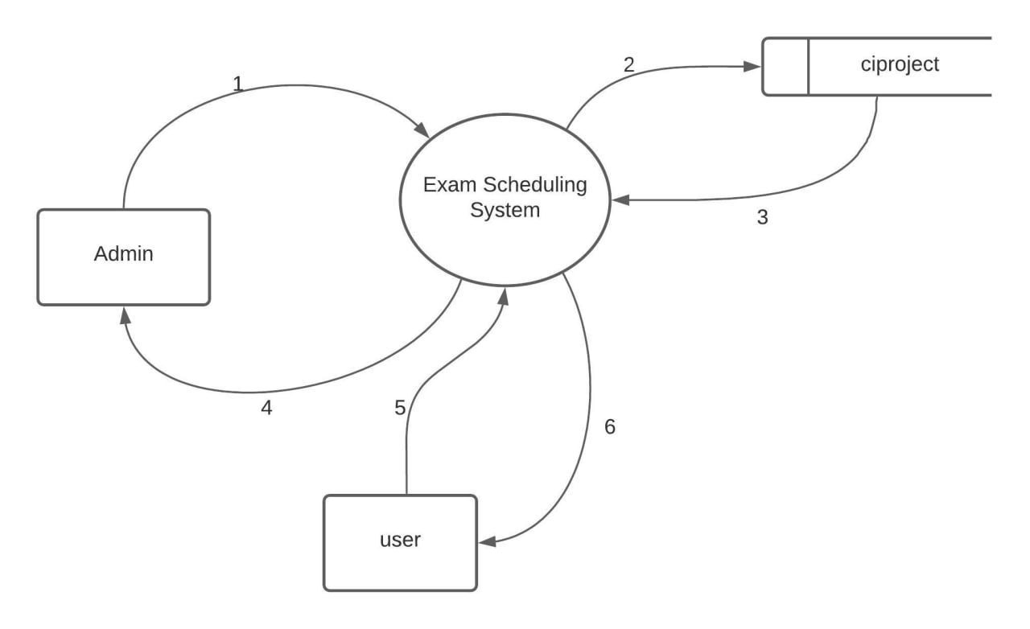

1. 1.user and password
2. 2.approve registration and login
3. 3.response
4. 4.response
5. 5.email id and password
6. 6.response

**LEVEL 1.1 DFD (For Admin)**

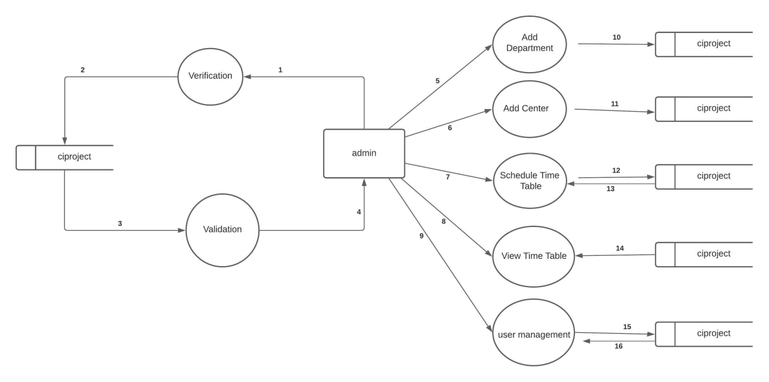

1.login and password

2.data pass to ciproject

3.verify

4.authentication status

5.add department

6.add center

7. schedule time table

8.time table

9.authenticating user

10.update database

11.update database

12. update database

13.data retrival

14. data retrival

15. data retrival

16.update database

**LEVEL 1.2 DFD (For User)**

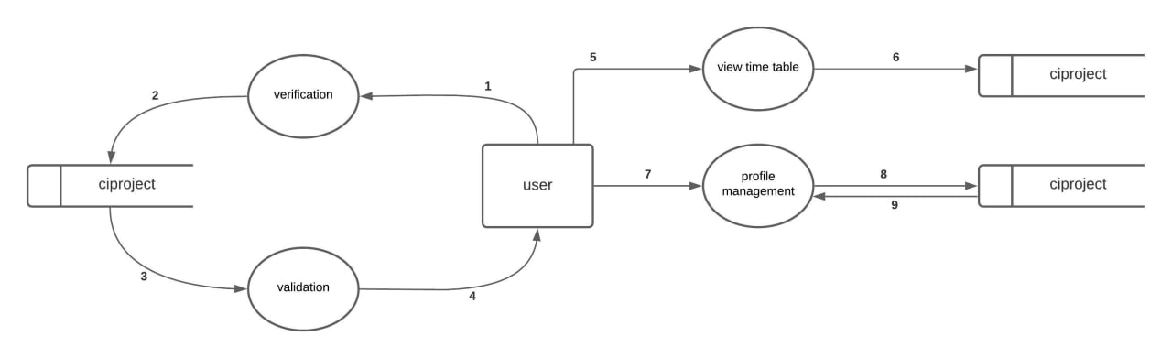

1.login and password

2.data pass to ciproject

3.verify

4.authentication status

5.time table view

6.data retrival from database

7.profile edit

8.update database

9.retrive database

* + **UML DIAGRAMS**

## USECASE DIAGRAM

Use case diagrams model the functionality of a system using actors and use cases. Use cases are services or functions provided by the system to its users. A use case diagram depicts actors, use cases, and the relationships among them. Use case is a software engineering term that is equivalent to a social scientist's notion of task.

Basic Use Case Diagram Symbols and Notations

#### Use Case

Draw use cases using ovals. Label the ovals with verbs that represent the system's functions.

C:\Users\user\Desktop\bbbbbb.JPG

#### Actors

Actors are the users of a system. When one system is the actor of another system, label the actor system with the actor stereotype

C:\Users\user\Desktop\bnbnb.JPG

.

#### System

Draw your system's boundaries using a rectangle that contains use cases. Place actors outside the system's boundaries.



#### Relationships

Demonstrate relationships between an actor and a use case with a simple line. For relationships among use cases, use arrows labeled either "uses" or "extends." A "uses" relationship indicates that one use case is needed by another in order to perform a task. An "extends" relationship indicates alternative options under a certain use case.

<<include>>

<<exclude>>

**USECASE DIAGRAM**

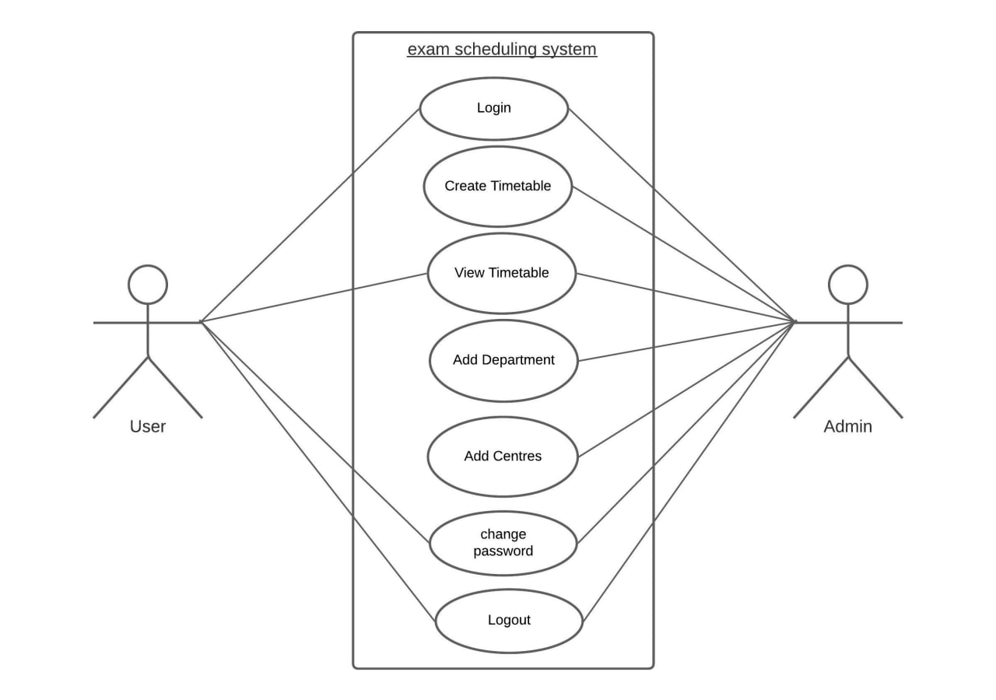

* + - **ACTIVITY DIAGRAM**

Activity diagrams, which are related to program flow plans (flowcharts), are used to illustrate activities. In the external view, we use activity diagrams for the description of those business processes that describe the functionality of the business system.

#### Action

The action can possess input and output information The output of one action can be the input of a subsequent action within an activity. Specific actions are calling other actions, receiving an event, and sending signals.

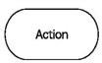

#### Edge (Control Flow)

Edges, represented by arrows, connect the individual components of activity diagrams and illustrate the control flow of the activity.Within the control flow an incoming arrow starts a single step of an activity; after the step is completed the flow continues along the outgoing arrow. A name can be attached to an edge (close to the arrow).



#### Merge Node

Its purpose is the merging of flows. The inputs are not synchronized; if a flow reaches such a node it precedes at the output without waiting for the arrival of other flows.

#### Fork

For the branching of flows in two or more parallel flows we use a synchronization bar, which is depicted as a thick horizontal or vertical line

#### Initial Node

The initial node is the starting point of an activity. An activity can have more than one initial node; in this case several flows start at the beginning of an activity

#### Activity Final Node

The activity final node indicates that an activity is completed. An activity diagram can have more than one exit in the form of activity final nodes.

## ACTIVITY DIAGRAM

* **ADMIN**

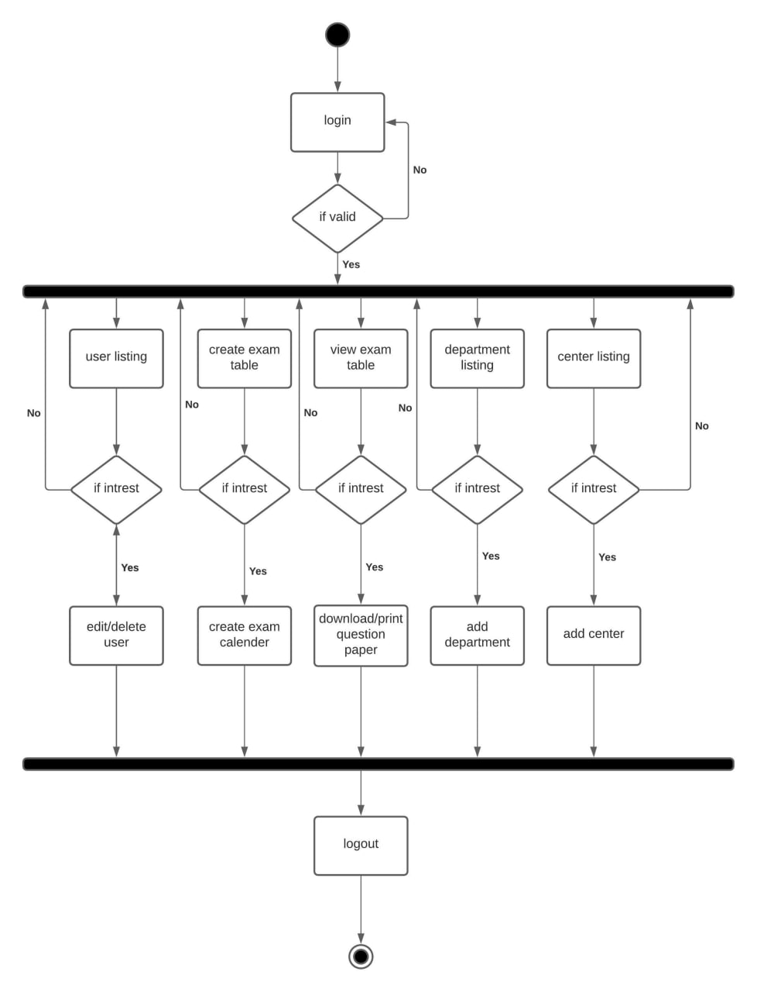

* **USER**

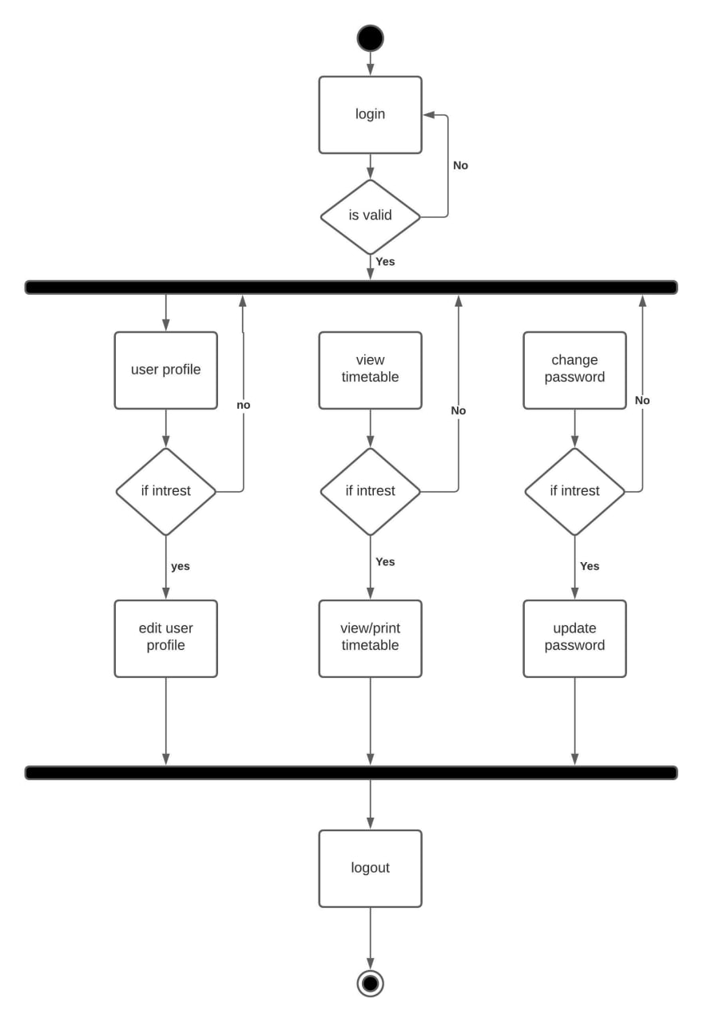

* + - **ENTITY RELATIONSHIP DIAGRAM (ER-DIAGRAM)**

There are three basic elements in an ER Diagram: entity, attribute, relationship. There are more elements which are based on the main elements. They are weak entity, multi valued attribute, derived attribute, weak relationship, and recursive relationship. Cardinality and ordinality are two other notations used in ER diagrams to further define relationships.

#### Entity

An entity can be a person, place, event, or object that is relevant to a given system.

#### Weak Entity

A weak entity is depends on the existence of another entity , or it can be defined as an entity that cannot be identified by its own attributes. It uses a foreign key combined with its attributed to form the primary key

#### Attribute0

An attribute is a property or characteristic of an entity, relationship, or another attribute



#### Multivalued Attribute

If an attribute have more than one value it is called a multi-valued attribute. It is important to note that this is different from an attribute having its own attributes.



#### Relationship

A relationship defines how entities interact.



#### Cardinality and Ordinality

These two further defines relationships between entities by placing the relationship in the context of number.

**ER-DIAGRAM**

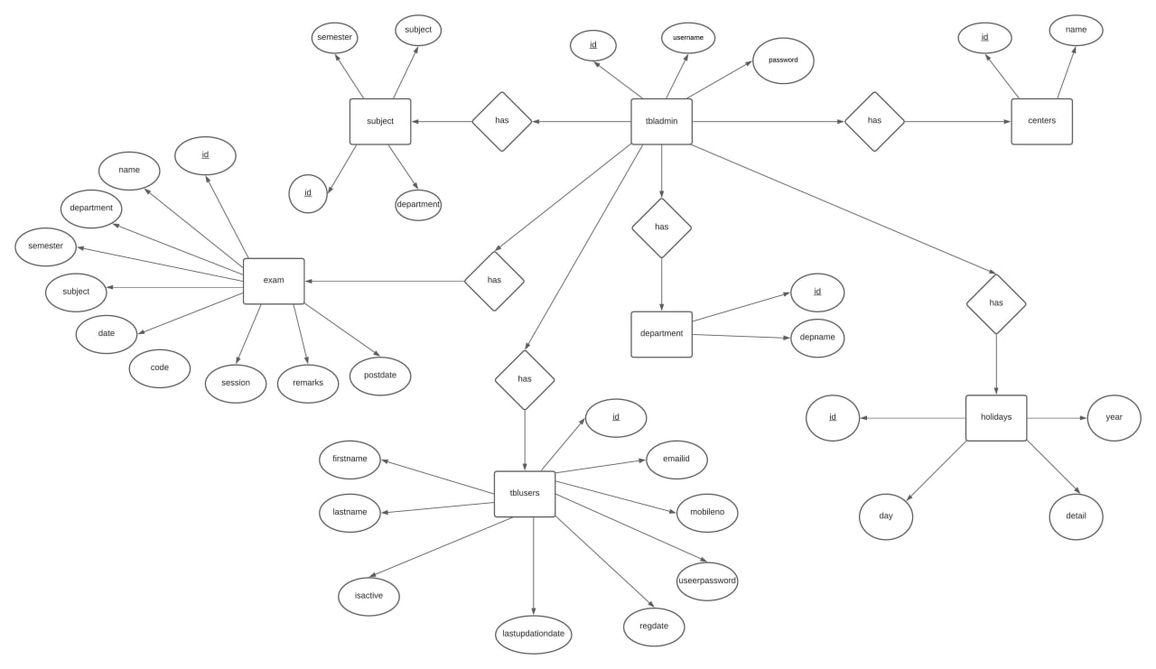

# CODING & TESTING

* + **SYSTEM DEVELOPMENT**
  + **CODING**
  + **SYSTEM TESTING**
  1. **SYSTEM DEVELOPMENT**

During the development phase, system is constructed from the specification prepared in design phase. Major activities in development phase are writing codes, testing and implementation.

The document coding provides the details on different modules of source codes which are developed by the programmer and the details about the standard library functions used for the development of indented software.

* 1. **CODING**

System development is a sequence of operation performed to deploy data to produce output from a computer system. This is greatly dependent on the programming language used. The principle activities performed during the development phase can be divided in to two major related sequences.

They are:

* + 1. External system development
    2. Internal system development

#### The major external system development activities are:

* Planning
* Equipment acquisition
* Installation
* Implementation

#### The major internal development activities are:

* Coding structure
* Computer program development
* Performance testing

Coding translates detailed representation of software into programming language realization. Code design has been implemented giving priority to understandability, simplicity and clarity. Coding has been chosen in such a way that it provide execution speed and minimum memory requirement.

## Security measures

Various measures of security are laid down by the system. This provides facility for validating the identification code and password to make the system as reliable and interactive as possible, necessary validation have been provided.

## SYSTEM TESTING

System testing is actually a series of different tests whose primary purpose is to fully exercise the computer-based system. Although each test has a different purpose, all work to verify that all system elements have been properly integrated and perform allocated functions.

Testing is the final verification and validation activity within the organization itself. Testing is done to achieve the following goals: to test the quality of the product, to find and eliminate any residual errors from previous stages, to validate the software as a solution to the original problem, to demonstrate the presence of all specified functionality in the product, to estimate the operational reliability of the system. During testing the major activities are concentrated on the examination and modification of the source code.

The following testing has been done for this project:

* Unit testing
* Integration testing
* Validation testing
* Output testing

## UNIT TESTING

It is the first level of testing. Each module is tested individually and focus is given for finding errors limited to each individual module and correcting them. The different modules of the system are tested individually and corrected all errors. “In computer programming, unit testing is a software testing method by which individual units of source code, sets of one or more computer program modules together with associated control data, usage procedures, and operating procedures, are tested to determine whether they are fit for use.

Consider our WordPress for Project Management System, it contains project manager and employees, it is checked whether the information is properly flowing in to the program unit and happen out of it or not, and also tested to inquiry if the data within the module is stored properly or not.

### INTEGRATION TESTING

Integration testing (sometimes called integration and testing, abbreviated I&T) is the phase in software testing in which individual software modules are combined and tested as a group. It occurs after unit testing and before validation testing. Integration testing takes as its input modules that have been unit tested, groups them in larger aggregates, applies tests defined in an integration test plan to those aggregates, and delivers as its output the integrated system ready for system testing.

### VALIDATION TESTING

For input forms validation testing is done to ensure that only allowed values will be entered. Entering incorrect values does the validation testing and it is checked whether the errors are being considered. Incorrect values are to be discarded. The errors are rectified.Validation is determining if the system complies with the requirements and performs functions for which it is intended and meets the organization’s goals and user needs.Validation is done during testing like feature testing, integration testing, system testing, load testing, compatibility testing, stress testing, etc.

For example, consider project manager in our system, project manager can sign up in our system. If the username and password is entered and if it is not correct, in this case validation will perform. This is the one type of validation.

### OUTPUT TESTING

After performing the validation testing, the next step is output testing of the proposed system, since no system could be useful if it does not produce the required output in the specific format. The output generated by the system under considerations is tested by asking the users about the format required by them.

### TEST CASE

A specific set of steps and data along with expected results for a particular test objective. A test case should only test one limited subset of a feature or functionality. Test case documents for each functionality/testing area will be written, reviewed and maintained separately in Excel Sheets.

In system testing, test data should cover the possible values of each parameter based on the requirements. Since testing every value is impractical, a few values should be chosen from each equivalence class. An equivalence class is a set of values that should all be treated the same. Ideally, test cases that check error conditions are written separately from the functional test cases and should have steps to verify the error messages and logs.

**TESTCASE 1**

|  |  |
| --- | --- |
| Test Case Name | Login |
| Test Case Description | Test whether login is possible |
| Item(s) to be tested | |
| All Fields | |
| Specifications | |
| Input | Expected Output / Result |
| 1. Any one of the mandatory field is empty 2. Invalid username 3. Invalid password | Displays message ‘Field is required’ Displays message ‘Invalid username’ Displays message ‘Password Incorrect’ |

**TESTCASE 2**

|  |  |  |  |
| --- | --- | --- | --- |
| Test Case Name | | Add Projects | |
| Test Case Description | | Test whether schedule exam is  possible without giving proper details | |
| Item(s) to be tested | | | |
| All Fields | | | |
| Specifications | | | |
| Input | | Expected Output / Result | |
| 1. Any one of the mandatory field is empty 2. Invalid start date 3. Invalid year 4. Invalid center id 5. Invalid semester 6. Invalid day difference 7. Invalid exam name | | Displays message ‘Field is required’  Displays message ‘starting date is required  Displays message ‘Year field is required’  Displays message ’center id is required’  Displays message ‘semester field is required’  Displays message ‘the conter field is required’  Displays message ‘exam name field is required’ | |

**TESTCASE 3**

|  |  |
| --- | --- |
| Test Case Name | Add Tasks |
| Test Case Description | Test whether adding task details is possible without giving proper details |
| Item(s) to be tested | |
| All Fields | |
| Specifications | |
| Input | Expected Output / Result |
| 1. Any one of the mandatory field is empty 2. Invalid department name | Displays message ‘Field is required’ Displays message ‘Invalid deadline’ |

# 5. CONCLUSION &

**FUTURE ENHANCEMENT**

* + **CONCLUSION**
  + **FUTURE ENHANCEMENT**
  1. **CONCLUSION**

The most important functions that the Exam scheduling system will schedule the exam under various programmes in university with the help of a web based application.. Exam scheduling system has been developed by keeping in mind the various drawbacks of the existing system. All the features of the proposed system described so far are integrated into the plugin without any negligence. Future enhancement is also possible according to the requirement of the users. As we do not need any new resources to run the system, it is economically feasible. Maintenance is easy and requires no further cost. Hence the system is developed successfully and is in proper function according to our goals and criteria.

* 1. **FUTURE ENHANCEMENT**

It is not possible to develop a system that meets all the requirements of the user. Users requirements keep changing as the system is being used. Some of the future enhancement that can be done to this system are:

There can be a student management module, where students are allowed to access a dashboard within this plugin. This helps clients to know the status of the examinations. Also students can be interact with the admin if any clarification needed.

# 6. SCREENSHOTS

**Home**

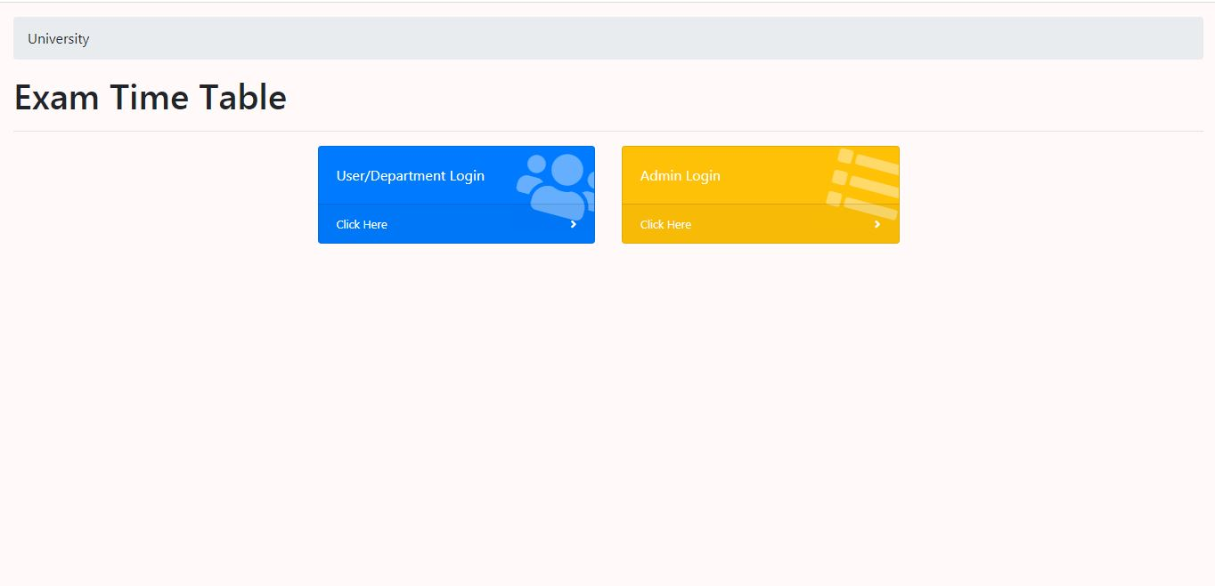

**Admin : Login**

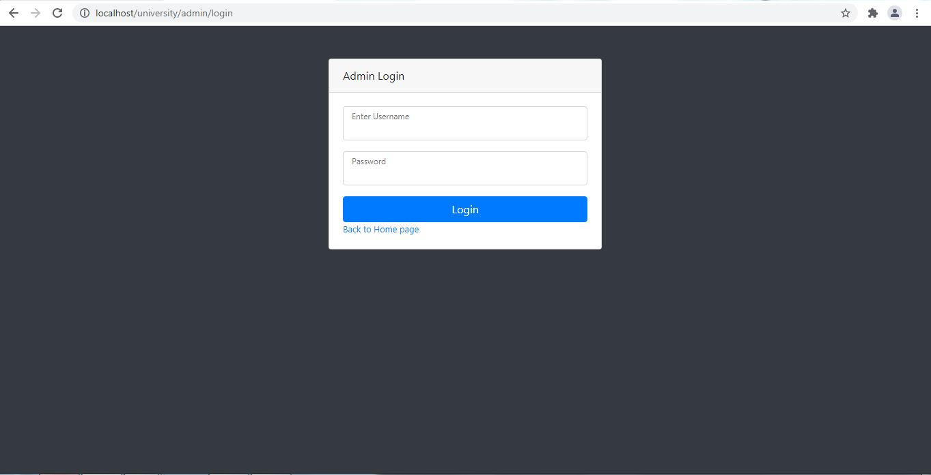

**Admin : Dashboard**

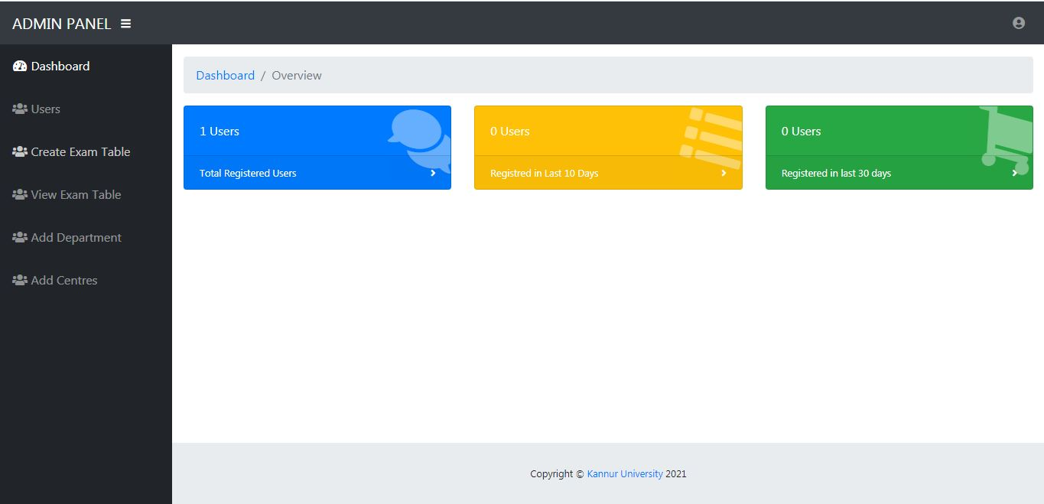

**Admin : Manage user**

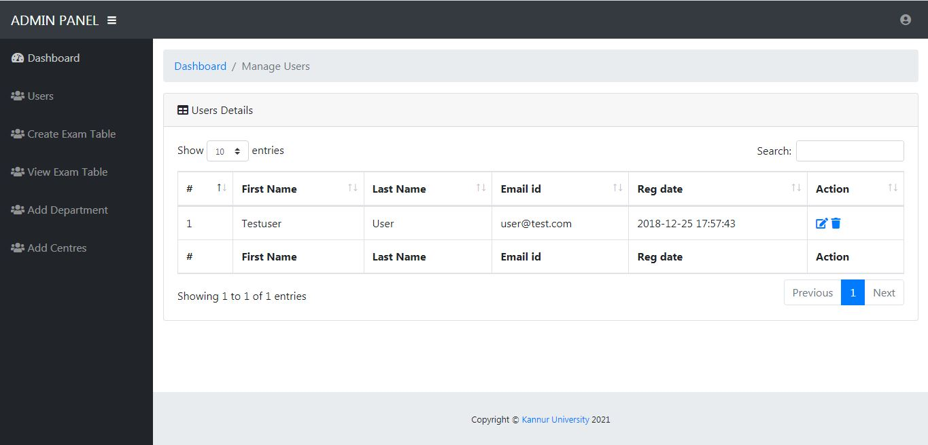

**Admin : Create time table**

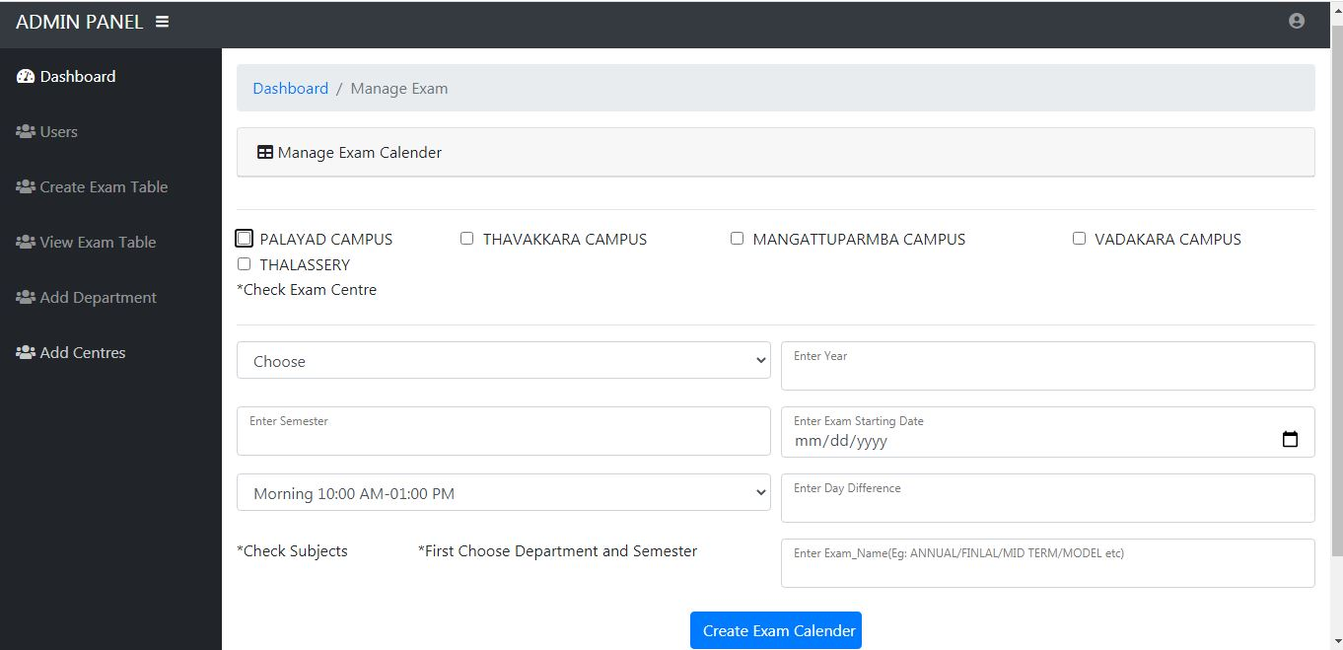

**Admin : Exam list**

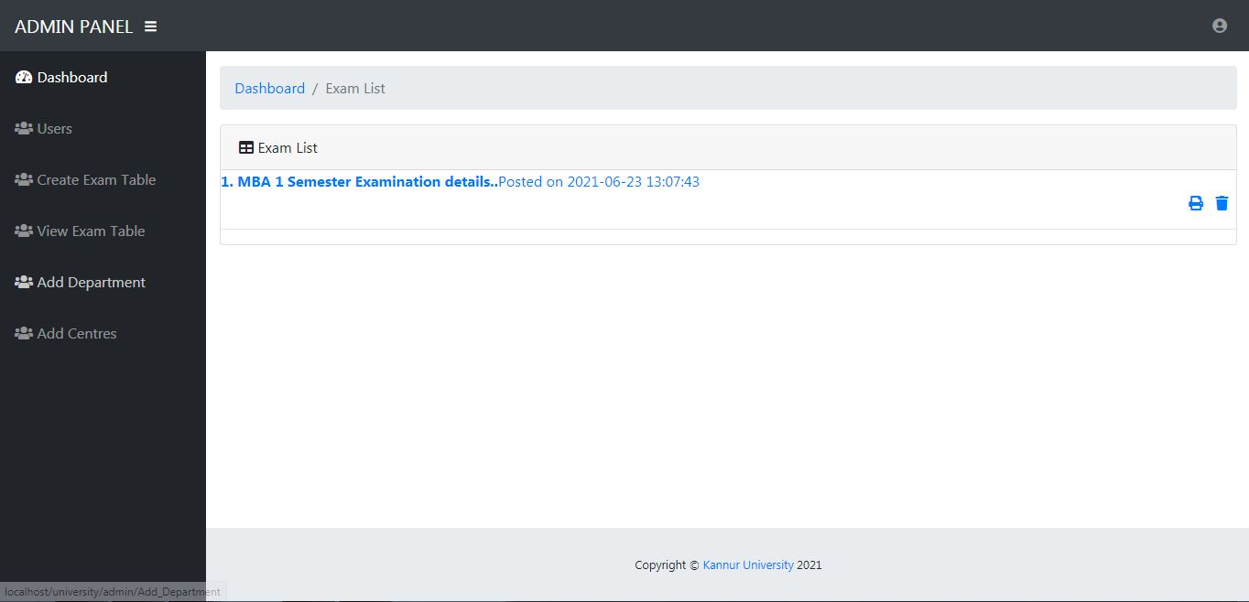

**Admin : Add department**

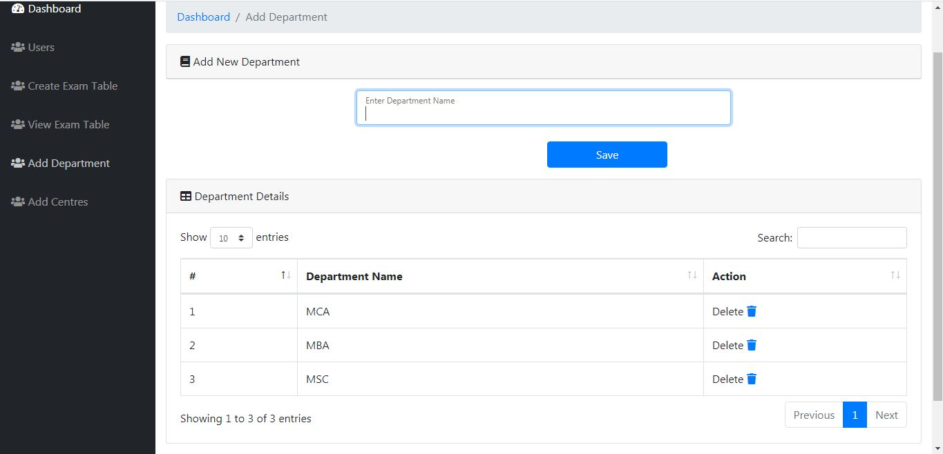

**Admin : Add center**

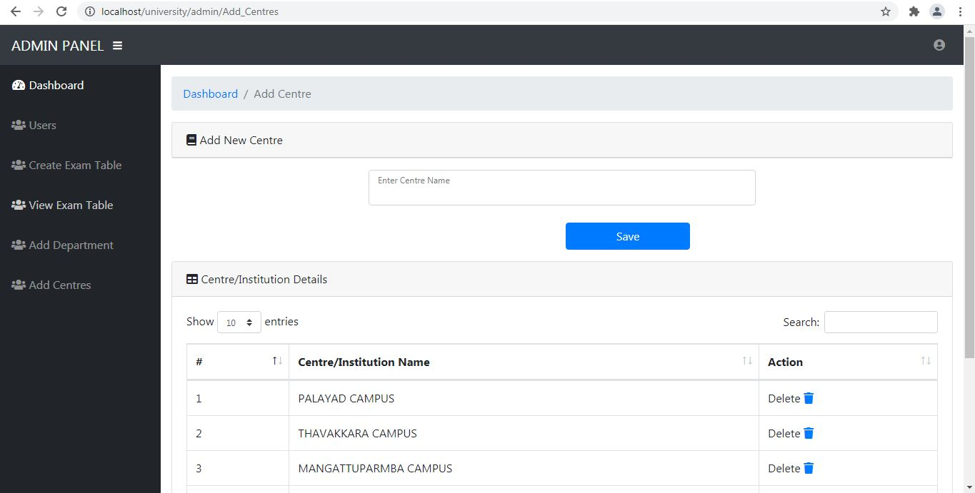

**User: login**

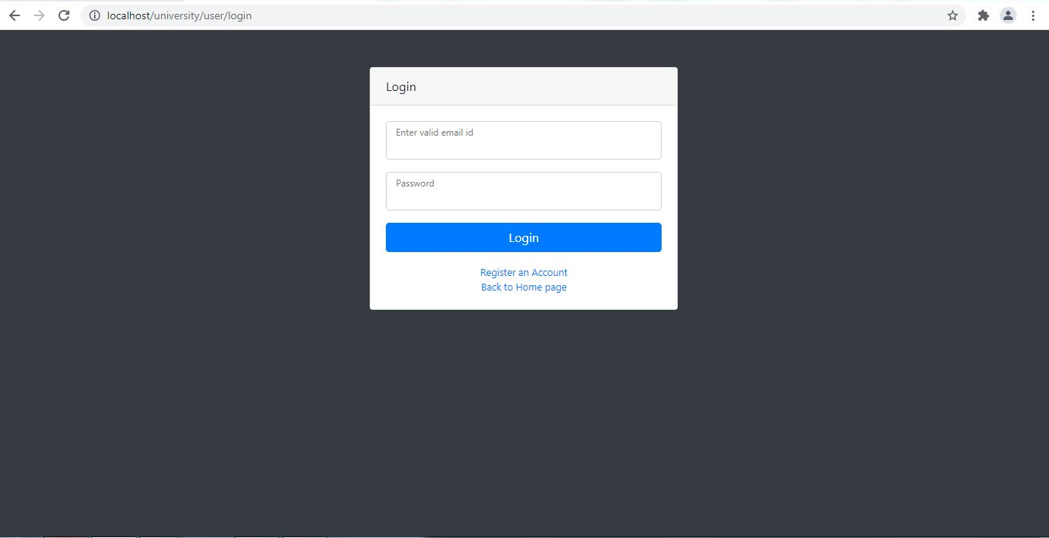

**User : dashboard**

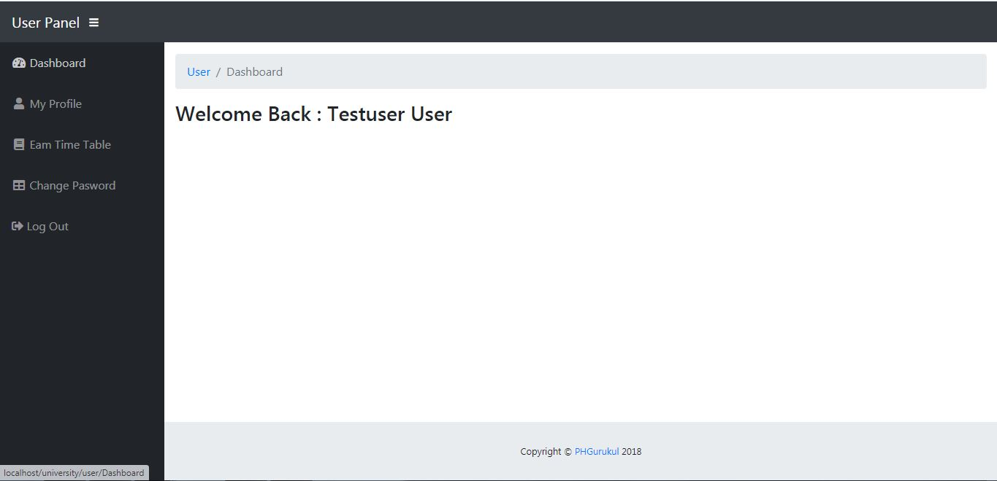

**User :profile**

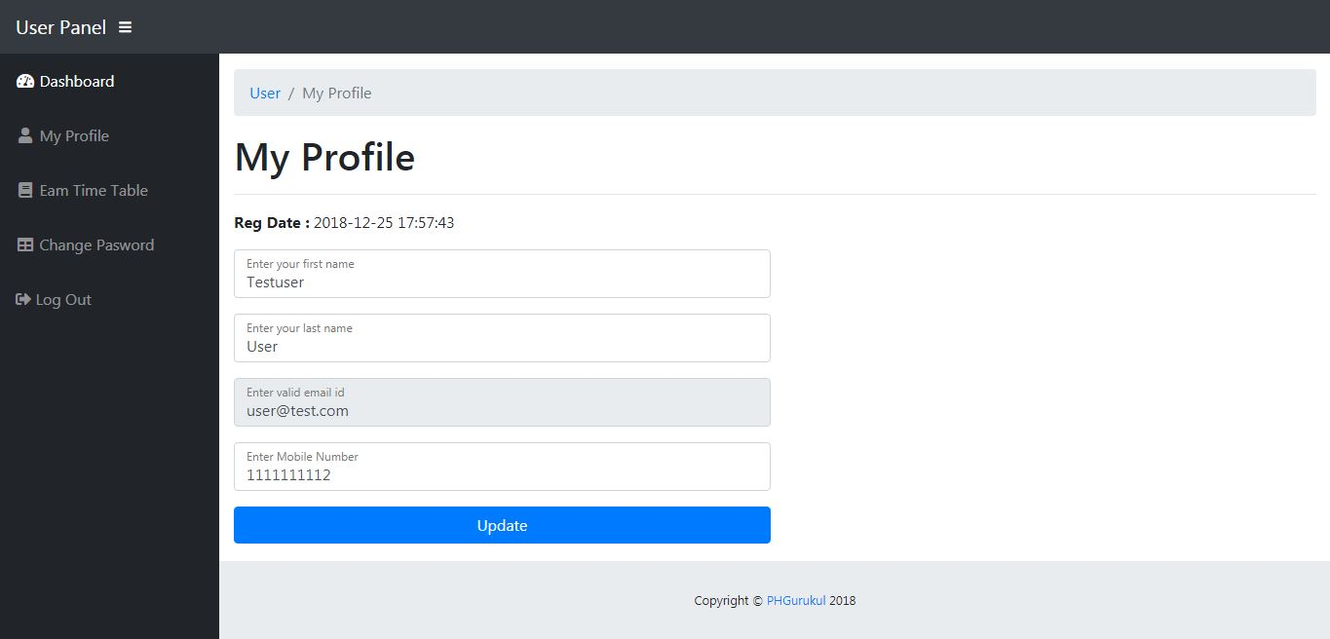

**User :view time table**

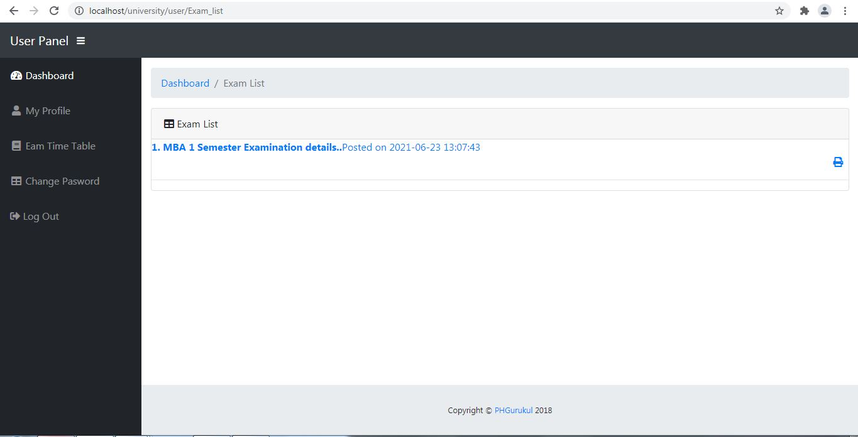

**User :change password**

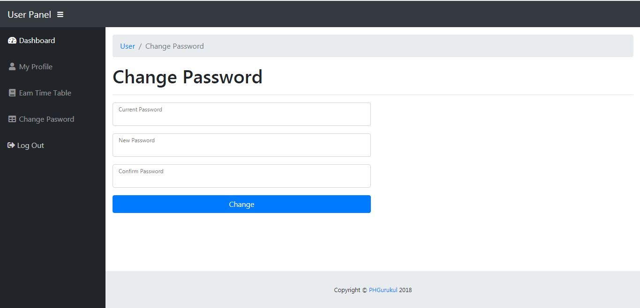

**7. BIBLIOGRAPHY**

## BOOKS

1. R. Pressman, Software engineering. Boston: McGraw-Hill Education, 2015
2. A. Silberschatz, H. Korth and S. Sudarshan, Database system concepts.
3. Mike Taylor, Step-by-step WordPress for beginners: How to build a beautiful website on your own domain from scratch

## WEBSITES

* + En.wikipedia.org. 2020. *Wordpress*. [online] Available at:

<https://en.wikipedia.org/wiki/WordPress> [Accessed 18 May 2020].

* + W3schools.com. 2020. *PHP OOP Classes And Objects*. [online] Available at:

<https:/[/www.w3schools.com/php/php_oop_classes_obj](http://www.w3schools.com/php/php_oop_classes_objects.asp)e[cts.asp>](http://www.w3schools.com/php/php_oop_classes_objects.asp) [Accessed 19

April 2020].

* + Wpbeginner.com. 2020. [online] Available at: <https://[www.wpbeginner.com/](http://www.wpbeginner.com/)> [Accessed 10 April 2020].
  + Tutorialspoint.com. 2020. *Mysql - Data Typetutorialspoints - Tutorialspoint*. [online] Available at: <https://[www.tutorialspoint.com/mysql/mysql-data-](http://www.tutorialspoint.com/mysql/mysql-data-) types.htm> [Accessed 12 April 2020].