1. **Introduction**

In the ever-evolving landscape of traffic management, the Vehicle Fine System project emerges as a pioneering initiative designed to revolutionize the administration of fines and penalties associated with vehicular offenses. This project is a testament to the commitment to modernize and optimize the intricate processes surrounding traffic law enforcement.

* 1. **Goals & Objectives**

The primary objectives of the Vehicle Fine System are twofold: to enhance the efficiency of fine management systems and to provide a seamless experience for both law enforcement agencies and the general public. By leveraging technological advancements, the project aspires to bring about a paradigm shift in the way fines are issued, tracked, and processed.

* **Run Things Smoother**:

Streamline the entire fine management process, minimizing complexities and ensuring a seamless workflow for both law enforcement and users.

* **Make Giving Fines Easier:**

Simplify the process for law enforcement agencies to issue fines, employing user-friendly interfaces and efficient tools for quicker and more accurate fine allocation.

* **Keep an Eye on Things Right Away:**

Enable real-time monitoring of the entire fine management system, allowing immediate intervention and responses to evolving situations or issues.

* **Easy for Everyone:**

Design the system with a user-centric approach, ensuring accessibility and simplicity for both law enforcement officers and the general public.

* **See Fines Clearly:**

Enhance visibility into fine-related data, providing clear and concise information to facilitate better decision-making and understanding.

* **Pay Fines Online:**

Introduce an online payment system, offering users a convenient and secure platform to settle fines, contributing to a more efficient and user-friendly experience.

* **Fit in Well Everywhere:**

Ensure the adaptability and compatibility of the system across various environments, accommodating different needs and scenarios seamlessly.

* **Connect Databases:**

Establish robust connections with relevant databases, fostering a comprehensive and interconnected system that can access and update data seamlessly.

* **Grow and Change When Needed:**

Design the system with scalability and flexibility, allowing for future expansion and modifications as requirements evolve or new functionalities are needed.

* **Be Clear and Responsible:**

Promote transparency and accountability in the fine management process, ensuring clarity in communication and responsibility in actions taken.

* **Keep Records Automatically:**

Implement an automated record-keeping system to capture and store fine-related data accurately, reducing manual efforts and minimizing errors.

* **Show What's Happening Clearly:**

Develop intuitive reporting features that present a clear overview of the fine system's activities, aiding both law enforcement agencies and users in understanding the system's status and performance.

* 1. **Scope**

The scope of this project is comprehensive, covering all aspects related to fines and penalties within the domain of traffic regulation. From the issuance of fines to real-time tracking, and from integration with existing databases to user-friendly interfaces for online fine payment, the system aims to encapsulate the entire lifecycle of traffic fines.

This project's significance lies in its potential to streamline operations, reduce complexities, and foster a more transparent and accessible environment for both authorities and citizens. It envisions a future where fines are managed with utmost efficiency, contributing to a safer and more organized transportation ecosystem.

* **Fine Issuance and Tracking:**

Implement a robust system for issuing fines and tracking their status throughout the entire process, ensuring accuracy and efficiency.

* **Integration with Existing Databases:**

Establish seamless integration with relevant databases, enabling the system to access and update information efficiently for a comprehensive view of offenses.

* **User-Friendly Interfaces:**

Design intuitive and user-friendly interfaces for both law enforcement officers issuing fines and users interacting with the system, promoting ease of use and understanding.

* **Real-Time Fine Payment:**

Enable a real-time fine payment system, allowing users to settle fines promptly through secure online platforms for convenience and efficiency.

* **Comprehensive Reporting:**

Develop a reporting feature that provides detailed insights into fine-related data, facilitating analysis, decision-making, and compliance monitoring for administrators and users.

# **System Requirements Study**

# **User Characteristics**

* **Administator:**

At the nucleus of the Vehicle Fine System is the Admin, the authoritative figure responsible for orchestrating the system's intricacies. Their purview includes defining the taxonomy of offenses, intricately categorizing their severity, and specifying nuanced details pertinent to each violation. The Admin is the gatekeeper, managing access permissions, and crafting a secure environment wherein both officers and vehicle owners can seamlessly navigate their respective responsibilities.

* **Officer:**

Positioned on the frontline of law enforcement, the Officer is a key actor in the system, tasked with enforcing traffic regulations and meticulously reporting violations. Their interaction with the system involves scrutinizing visual evidence, making determinations on offenses, and contributing to a meticulous record-keeping process. Officers play a pivotal role in the system's efficacy, ensuring the accuracy of captured violations and contributing to the maintenance of traffic order.

* **Vehicle Owner:**

At the intersection of regulations and responsibilities is the Vehicle Owner. They engage with the system to manage offenses associated with their registered vehicles. The onus is on them to provide accurate vehicle details during registration, enabling seamless tracking within the system. Acknowledging violations, making secure online payments, and obtaining digital receipts for records completes the cycle. The Vehicle Owner is empowered to navigate the nuances of the fine system, fostering responsible and compliant vehicular conduct.

## Hardware and Software Requirements

## Hardware Specification

The initial deployment is expected to support minimum configuration as illustrated below

* Processor: Two core Intel or AMD Processor
* Memory: 2GB RAM
* Disk Space: 250GB or more
  + 1. **Software Requirements**

Software development platform is PHP and HTML 5.

* Operating System Microsoft Windows 7 or later
* Database MYSQL
* Web Server WAMP/XAMPP Server
* PHP Version 7.0 or later
* HTML Version 5.0
  + 1. **Front-End Development**

The front-end of an application is distinctly human. It’s what the user sees, touches and experiences. In this respect, empathy is a required characteristic of a good front-end developer. The front-end of an application is less about code and more about how a user will interpret the interface into an experience.

The technologies used in front-end development commonly include:

* HTML – All code in a web application is eventually translated to HTML. It’s the language that web browsers understand and use to display information to users. A web developer’s understanding of HTML is analogous to a carpenter’s understanding of a screwdriver. It’s so important and necessary that it’s often assumed for employment.
* **CSS** – By itself, HTML is quite plain. HTML does provide some basic style options, but to build a good front-end, developers must have experience with CSS. CSS provides the paint, templates, glitter, buttons, tassel, lights, and many other things that can be used to improve the presentation of a web page. CSS is so commonly used that languages have been built to make writing CSS easier. These languages – like Sass and LESS – are also known as CSS pre-compilers, but they are simply used to write more efficient and manageable CSS code.
* **JavaScript** – If you could only learn one language in your lifetime, you’d be well-advised to choose JavaScript. Though it’s not exclusively a front-end language, that’s where it’s most commonly used. JavaScript is a language that is run on a client machine, i.e. a user’s computer. This means that JavaScript can be used to program fast, intuitive and fun user experiences, without forcing

a user to refresh their web page. Drag-and-drop, infinite-scroll and videos that come to life on a web page can all be programmed with JavaScript. JavaScript is so popular that entire frameworks have been built just to make building application front-ends easier. Frameworks like Angular, Ember, React and Backbone are all very widely used for JavaScript-heavy front-en ds.

* + 1. **Back-end development**

The back-end of a web application is an enabler for a front-end experience. An application’s front-end may be the most beautifully crafted web page, but if the application itself doesn’t work, the application will be a failure. The back-end of an application is responsible for things like calculations, business logic, database interactions, and performance. Most of the code that is required to make an application work will be done on the back-end. Back-end code is run on the server, as opposed to the client. This means that back-end developers not only need to understand programming languages and databases, but they must have an understanding of server architecture as well. If an application is slow, crashes often, or constantly throws errors at users, it’s likely because of back-end problems.

* **MYSQL -** MySQL is the most popular Open-Source Relational SQL Database Management System. MySQL is one of the best RDBMS being used for developing various web based software applications. MySQL is developed, marketed and supported by MySQL AB, which is a Swedish company. This tutorial will give you a quick start to MySQL and make you comfortable with MySQL programming.
* **WampServer** - WampServer is a Windows-centric web development solution, bundling Apache, MySQL, and PHP for a hassle-free experience. It empowers developers to create and test dynamic web applications on their local machines before going live. With a user-friendly interface, WampServer streamlines the process, making it an ideal choice for PHP and MySQL development on Windows
* **PHP** - PHP is an acronym for "PHP: Hypertext Pre-processor". PHP is a widely-used, open source scripting language. PHP scripts are executed on the server. PHP is free to download and use. PHP is an amazing and popular language. It is powerful enough to be at the core of the biggest blogging system on the web. It is deep enough to run the largest social network. It is also easy enough to be a beginner’s first server side language files can contain text, HTML, CSS, JavaScript, and PHP code. PHP code are executed on the server, and the result is returned to the browser as plain HTML. PHP files have extension ".php". PHP can generate dynamic page content. PHP can create, open, read, write, delete, and close files on the server. PHP can collect form data. PHP can send and receive cookies. PHP can add, delete, and modify data in your database. PHP can be used to control user-access. PHP can encrypt data. With PHP you are not limited to output HTML. You can output images, PDF files, and even flash movies. You can also output any text, such as XHTML and XML

1. **System Analysis**
   1. **Current System**

In the current vehicle fine payment system, the process revolves around a rather conventional framework. When a vehicle owner incurs a fine due to a traffic violation, the standard procedure mandates a visit to the Regional Transport Office (RTO). Here, the violator interacts with the manual administrative processes to settle the imposed fine.

**Disadvantages of Current System**

* Manual Inefficiencies: The reliance on manual methods introduces inefficiencies. Each transaction, from recording the violation to fine settlement, involves manual paperwork, which can be time-consuming and prone to errors.
* Inconvenience in Person: Vehicle owners are obligated to physically appear at the RTO office. This necessity often translates to lost time, potential work disruptions, and added inconveniences.
* Limited Payment Options: The exclusive use of cash as the primary mode of payment limits the choices available to vehicle owners. In an era where digital payment methods are prevalent, this restriction can be inconvenient.
* Tracking Challenges: Manual record-keeping poses challenges in maintaining an accurate and up-to-date database of fines. This can lead to difficulties in tracking the status of fines and may result in discrepancies.
  1. **Proposed system**

The proposed system represents a transformative shift from the current manual fines management process. It introduces an online payment system, replacing the traditional cash transactions at the RTO office. This user-friendly web interface enhances accessibility for officers and vehicle owners, focusing on automation to reduce manual efforts and improve accuracy in offense records. The centralized database ensures efficient management of records with real-time updates, empowering the admin with enhanced reporting capabilities for data-driven decisions. Robust security measures, a notification system, and mobile responsiveness further contribute to a streamlined, transparent, and user-centric fines management experience. The overarching goal is to optimize processes and elevate the system's efficiency for all stakeholders involved.

* Efficient Offense Recording:

The proposed system offers an advanced method for recording and managing traffic offenses. This involves a streamlined process for law enforcement officers to input details about the offense, including date, location, and related information.

* Centralized Database:

The heart of the system is a centralized database that stores comprehensive information about registered vehicles, offenses, and associated penalties. This allows for quick retrieval and analysis of data for various purposes.

* User-Friendly Interface:

The user interface is designed to be intuitive and user-friendly. Vehicle owners can easily register, view fines associated with their vehicles, and make payments through a secure online platform.

* Automated Fine Calculation:

The system automates the calculation of fines based on predefined criteria, ensuring consistency and fairness. It considers factors such as the type and severity of the offense, providing a transparent basis for penalty assessment.

* Real-time Updates:

Users, including law enforcement officers and vehicle owners, receive real-time updates on fines, penalties, and the status of payments. This enhances transparency and keeps all stakeholders informed.

* Multi-Level Authentication:

To ensure data security and prevent unauthorized access, the proposed system implements multi-level authentication. This includes secure login procedures for both administrators and users.

* Comprehensive Reporting:

The system generates detailed reports for administrators, officers, and users. This includes offense reports,

* 1. **Feasibility Study**

The feasibility study is pivotal in determining the viability of the project, ensuring it aligns with the organizational goals and justifying the investment of resources. It serves as a foresight tool, projecting the impact and utility of the completed project.

* + 1. **Technical Feasibility:**

This dimension assesses the system's compatibility with existing technical infrastructure. It evaluates the capability of the proposed system to integrate with current technologies, including hardware and software. Additionally, technical feasibility explores the potential need for system upgrades or adaptations to ensure smooth implementation and operation.

* + 1. **Economic Feasibility:**

The economic feasibility study delves into the financial considerations of the proposed system. It involves a thorough analysis of costs associated with development, implementation, and ongoing maintenance. This assessment aims to ensure that the investment in the new system is justifiable within budgetary constraints and brings about economic benefits in the long run.

* + 1. **Behavioral Feasibility:**

Behavioral feasibility focuses on the human element, evaluating how well the proposed system aligns with the behaviors, skills, and preferences of the end-users. It considers the adaptability of users to the new system, potential resistance to change, and the need for training programs. Ensuring that the system harmonizes with the behavioral aspects of its users is crucial for successful implementation and sustained usage.

* 1. **Functional & Behavioral Modeling**
     1. **Functional & Behavioral Modeling**
        1. **UML Diagrams**

**Use Case Vehicle Fine Management :**

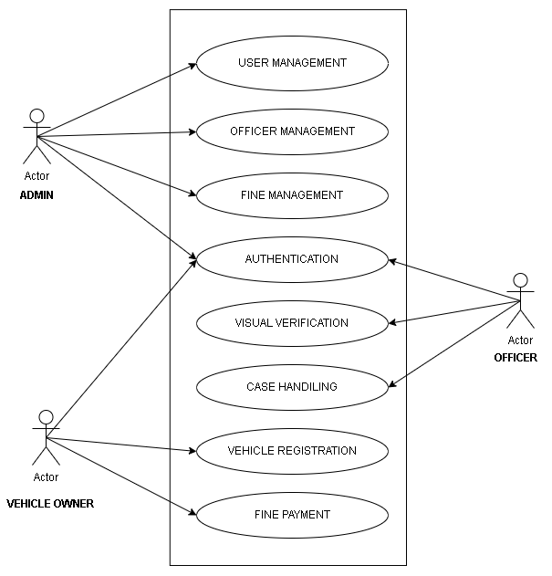

#### **Class Diagram**

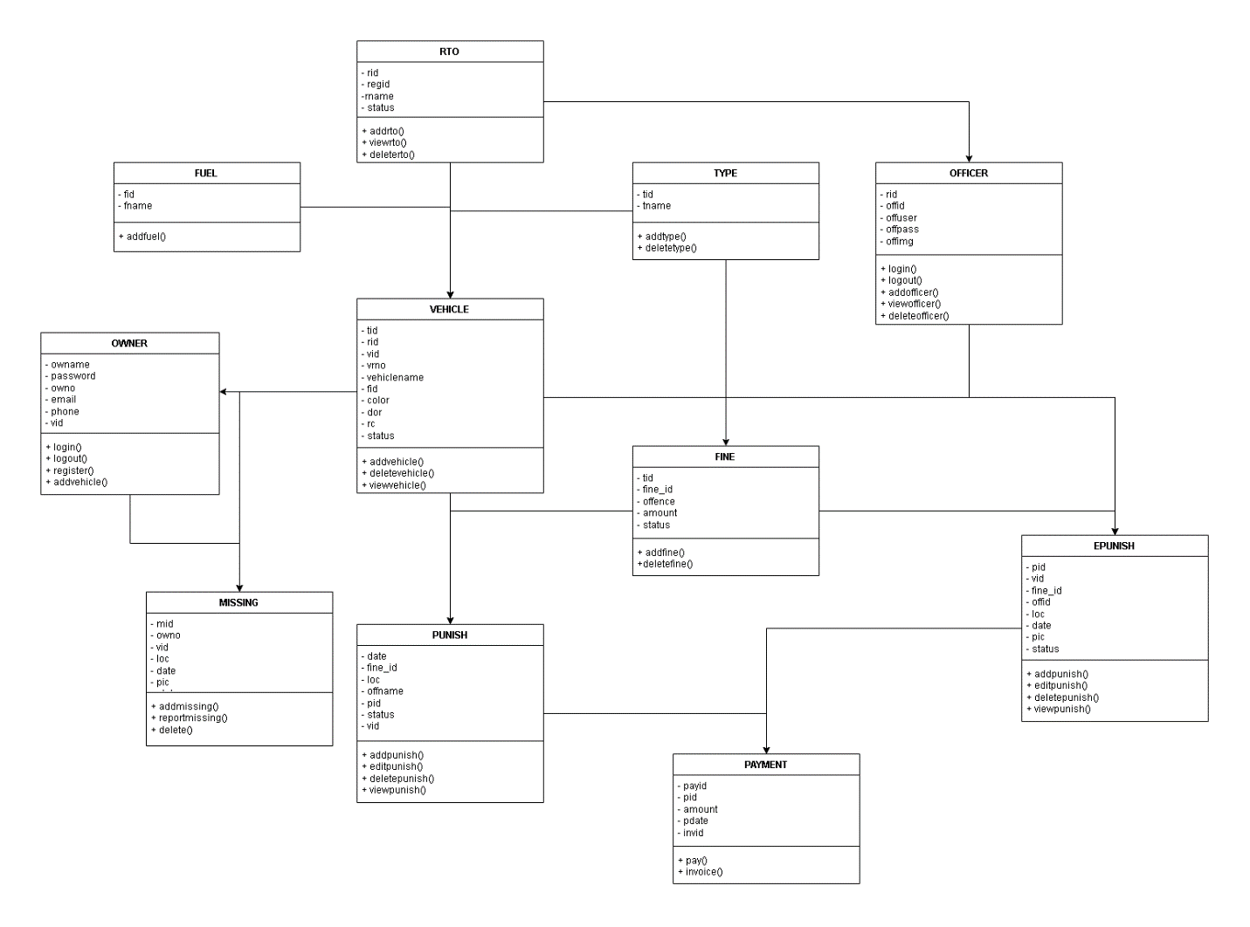

**Sequence diagram**

**ADD TYPE**

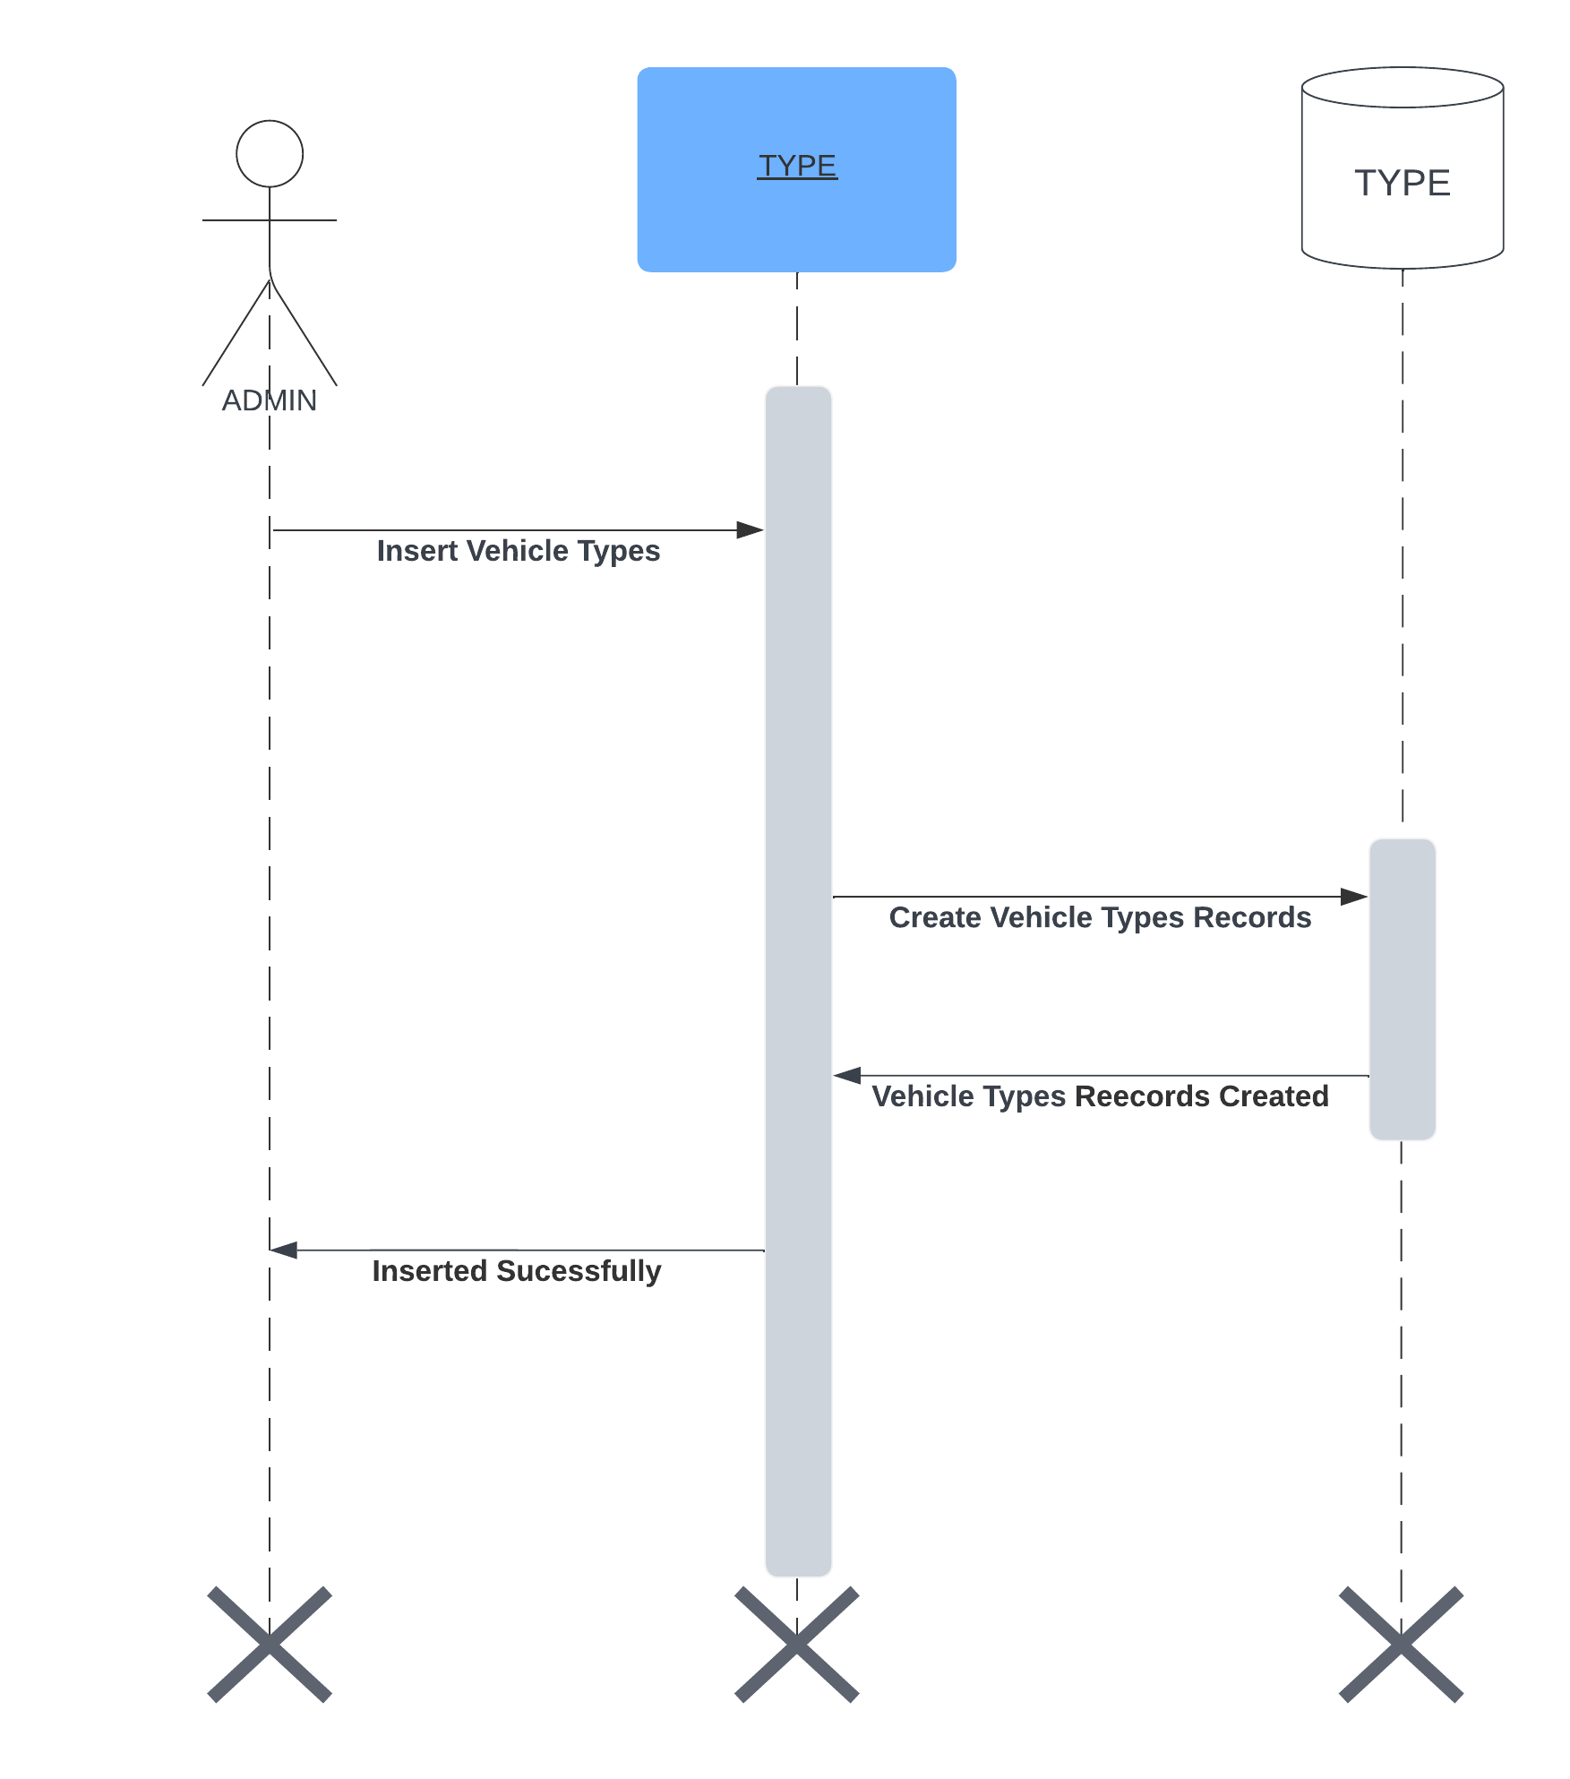

**ADD RTO**

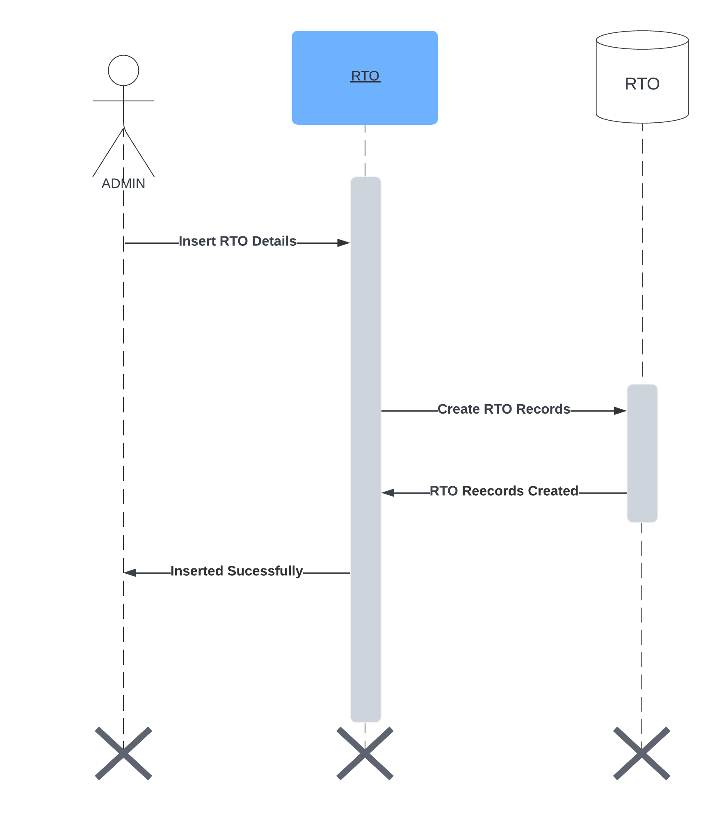

**ADD OFFENCE**

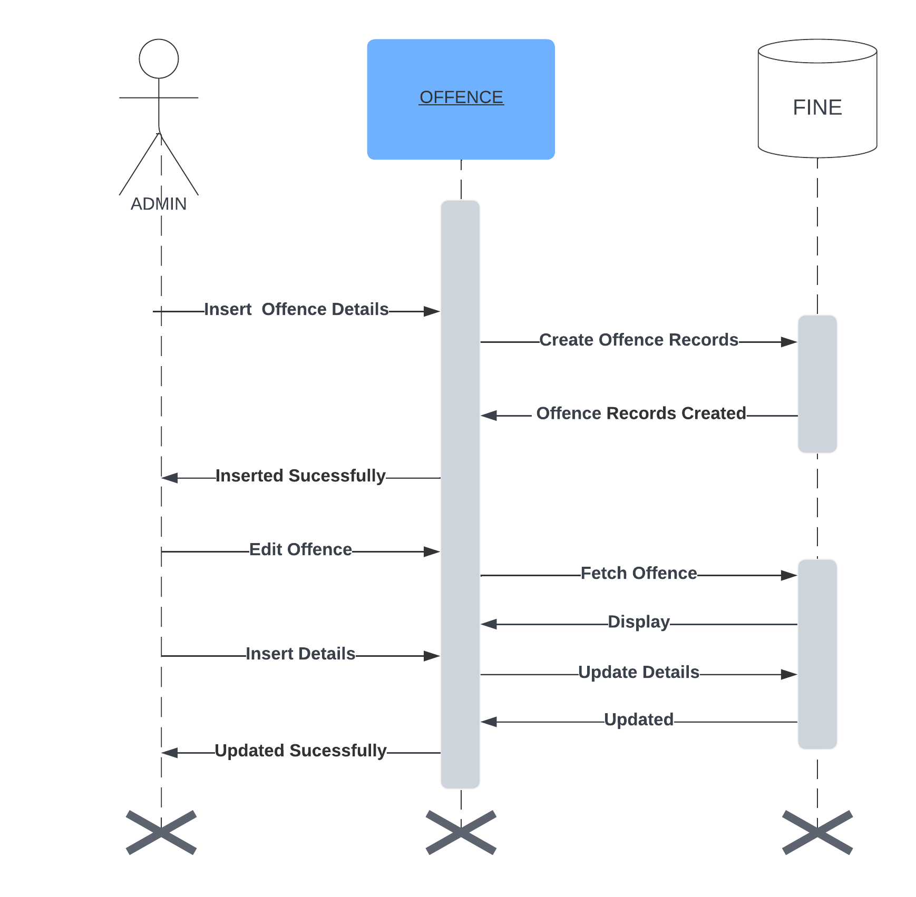

**ADD OFFICER**

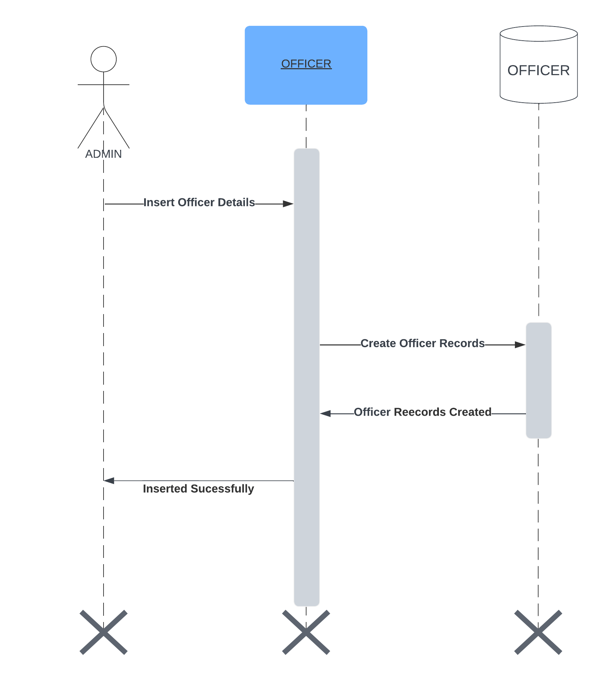

**ADD CHALLAN**

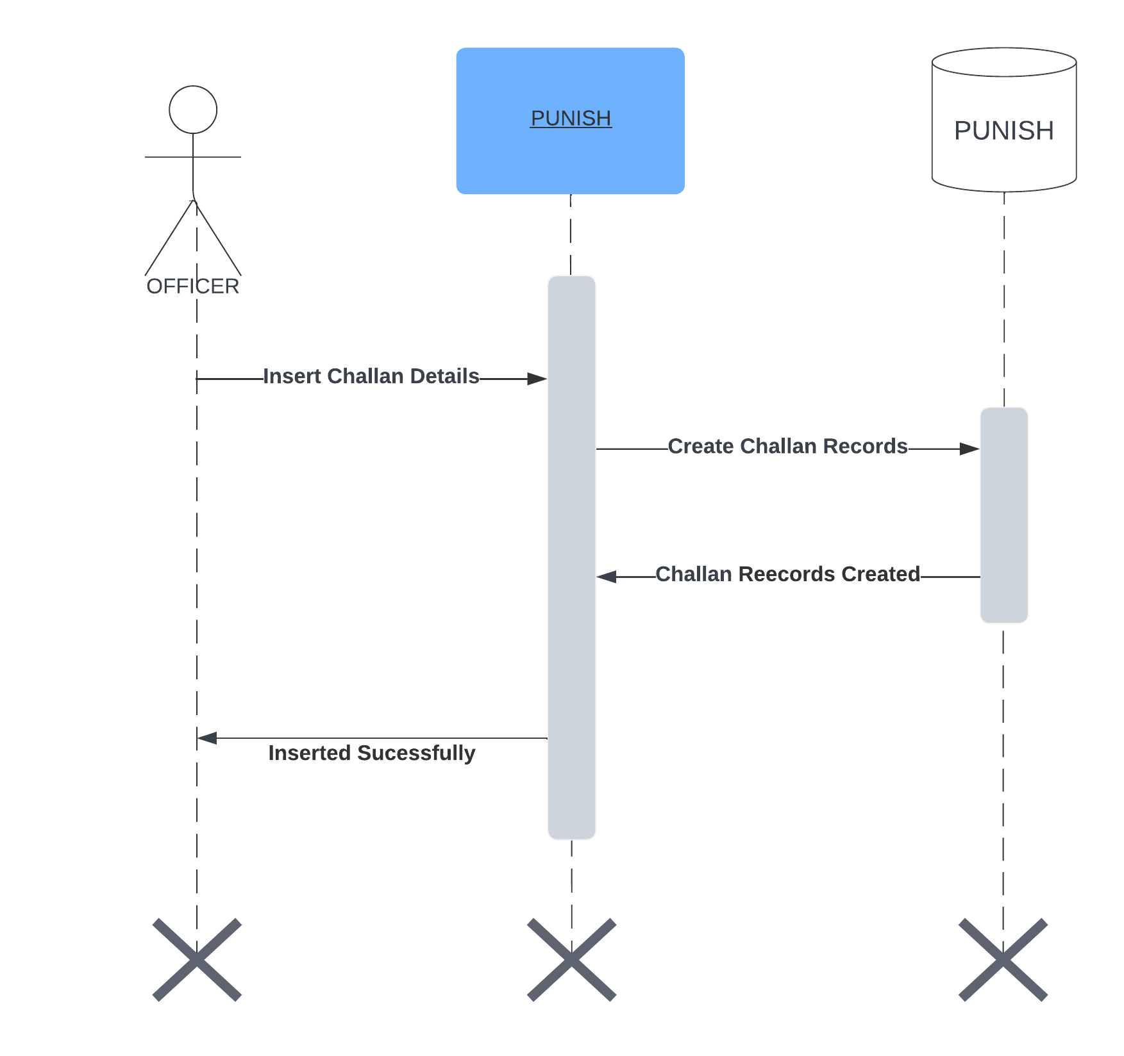

**ADD MISSING**

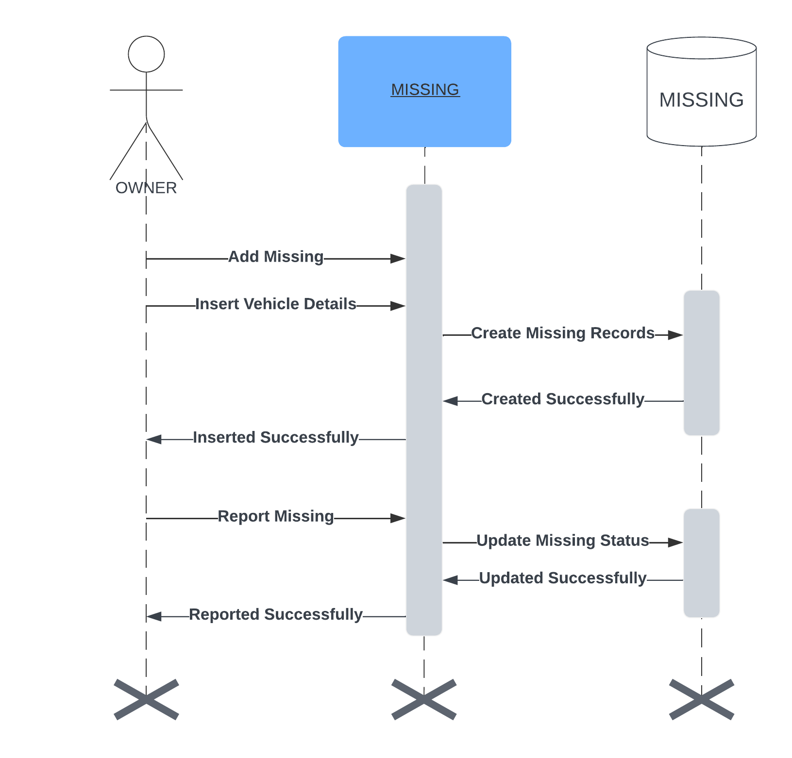

**VERIFY MISSING**

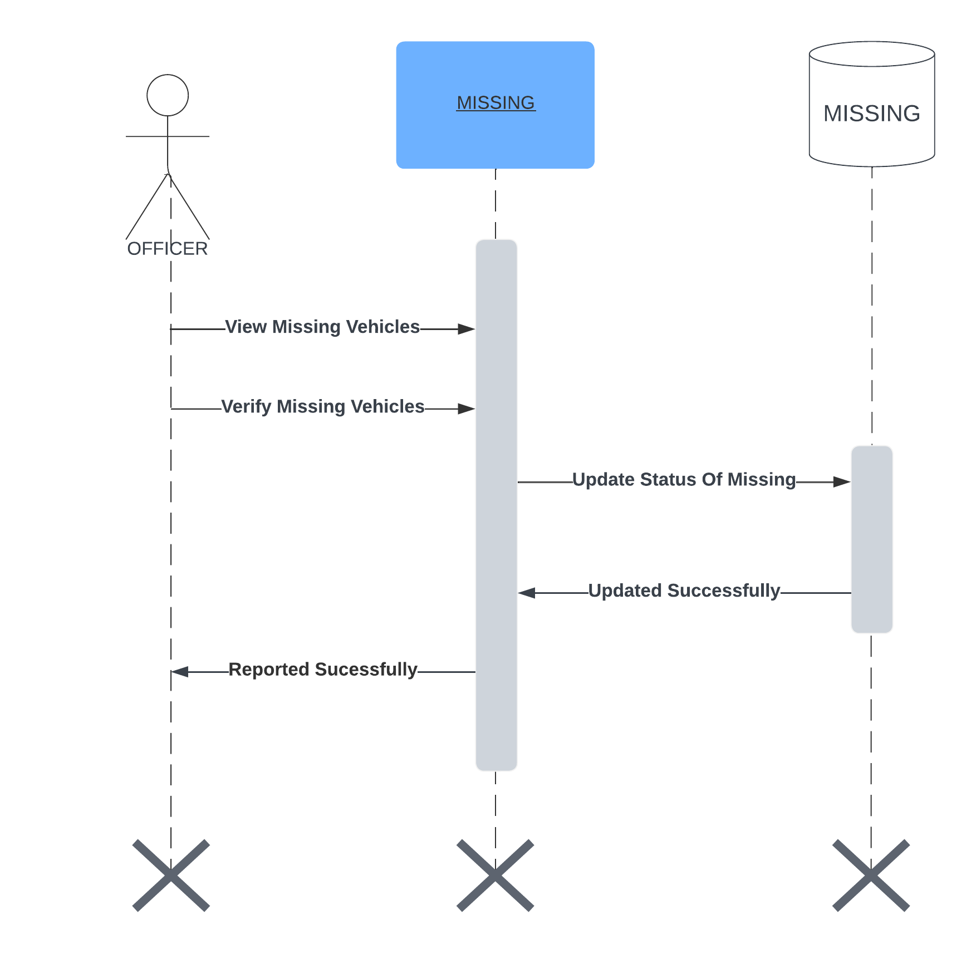

**CHALLAN**

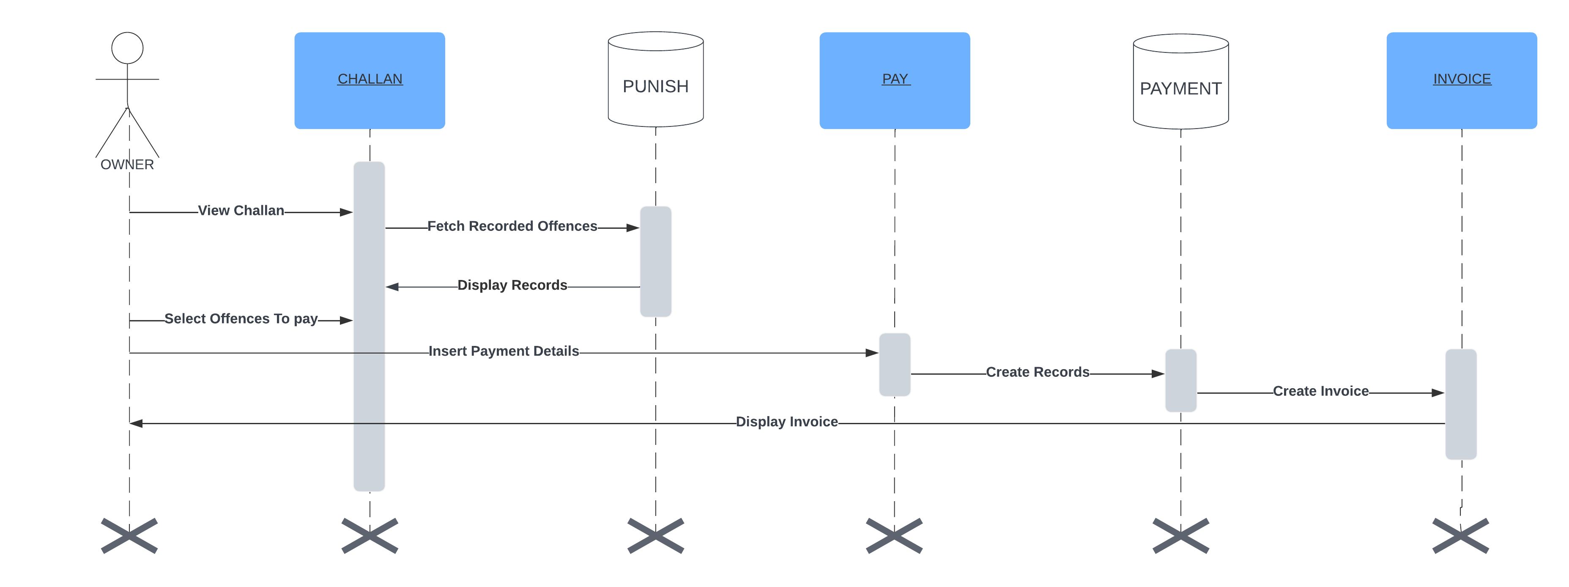

**HISTORY**

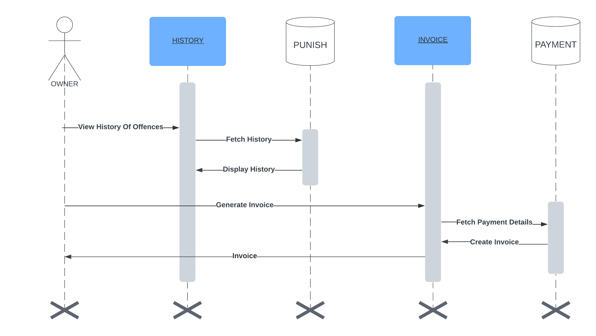

* + 1. **Tables**

**Type**

|  |  |  |  |
| --- | --- | --- | --- |
| **Field Nmae** | **Type** | **Constraints** | **Description** |
| tid | int | Primary key | ID assigned to each type |
| tname | varchar(30) | Not null | Name of each type |

**Rto**

|  |  |  |  |
| --- | --- | --- | --- |
| **Field Name** | **Type** | **Constraints** | **Description** |
| rid | INT | Primary key | ID assigned to each rto |
| regid | varchar(5) | Not null | Registration number of each rto |
| rname | varchar(30) | Not null | Name of each rto |
| status | int | Not null | Defines the status of each rto |

**Fine**

|  |  |  |  |
| --- | --- | --- | --- |
| **Field Name** | **Type** | **Constraints** | **Description** |
| tid | int | Not null | ID assigned to each type |
| fine_id | int | Primary key | ID assigned to each fine |
| offence | varchar(35) | Not null | Name of the offence |
| amount | varchar(20) | Not null | Amount of each offence |
| status | int | Not null | Defines the status of each fine |

**Vehicle**

|  |  |  |  |
| --- | --- | --- | --- |
| **Field Name** | **Type** | **Constraints** | **Description** |
| tid | int | Not null | ID assigned to each type |
| rid | int | Not null | ID assigned to each rto |
| vid | int | Primary key | ID assigned to each vehicle |
| vrno | varchar(15) | Not null | Vehicle registration number |
| vehiclename | varchar(25) | Not null | Name of each vehicle |
| fid | int | Not null | ID assigned to each fuel |
| color | varchar(30) | Not null | Color of the vehicle |
| dor | date | Not null | Date of registration of vehicle |
| rc | varchar(100) | Not null | Rc book of vehicle |
| status | int | Not null | Defines the status of each vehicle |

**Fuel**

|  |  |  |  |
| --- | --- | --- | --- |
| **Field Name** | **Type** | **Constraints** | **Description** |
| fid | int | Primary key | ID assigned to each fuel |
| fname | varchar(15) | Not null | Name of each fuel |

**Punish**

|  |  |  |  |
| --- | --- | --- | --- |
| **Field Name** | **Type** | **Constraints** | **Description** |
| date | date | Not null | Date of punishment |
| fine_id | int | Not null | ID assigned to each fine |
| loc | varchar(30) | Not null | Location of punishment |
| offname | varchar(25) | Not null | Officer Name of who charged punishment |
| pid | int | Primary key | ID assigned to each punishment |
| status | int | Not null | Defines the status of each punishment |
| vid | int | Not null | ID assigned to each vehicle |

**Payment**

|  |  |  |  |
| --- | --- | --- | --- |
| **Field Name** | **Type** | **Constraints** | **Description** |
| payid | int | Primary key | ID assigned to each payment |
| pid | int | Not null | ID assigned to each punishment |
| invid | varchar(25) | Not null | Invoice id |
| amount | int | Not null | Amount paid |
| pdate | date | Not null | Date of payment |

**Epunish**

|  |  |  |  |
| --- | --- | --- | --- |
| **Field Name** | **Type** | **Constraints** | **Description** |
| pid | int | Primary key | ID assigned to each punishment |
| vid | int | Not null | ID assigned to each vehicle |
| fine_id | int | Not null | ID assigned to each fine |
| offid | int | Not null | ID assigned to each officer |
| loc | varchar(25) | Not null | Location of punishment |
| date | date | Not null | Date of punishment |
| pic | varchar(1000) | Not null | Image of offence |
| status | int | Not null | Defines the status of each punishment |

**Missing**

|  |  |  |  |
| --- | --- | --- | --- |
| **Field Name** | **Type** | **Constraints** | **Description** |
| mid | int | Primary key | ID assigned to each missing vehicle |
| owno | int | Not null | ID assigned to each owner |
| vid | int | Not null | ID assigned to each vehicle |
| loc | varchar(25) | Not null | Location from which vehicle is missed |
| date | date | Not null | Date when vehicle missed |
| pic | varchar(1000) | Not null | Image of each vehicle |
| status | int | Not null | Defines the status of each missing vehicle |

**Officer**

|  |  |  |  |
| --- | --- | --- | --- |
| **Field Name** | **Type** | **Constraints** | **Description** |
| rid | int | Not null | ID assigned to each rto |
| offid | int | Primary key | ID assigned to each officer |
| offuser | varchar(30) | Not null | Name of each officer |
| offpass | varchar(14) | Not null | Password for each officer |
| offimg | varchar(1000) | Not null | Image of each officer |
| status | int | Not null | Defines the status of each officer |

**Owner**

|  |  |  |  |
| --- | --- | --- | --- |
| **Field Name** | **Type** | **Constraints** | **Description** |
| owname | varchar(20) | Not null | Name of each owner |
| password | varchar(10) | Not null | Password of each owner |
| owno | int | Primary key | ID assigned to each owner |
| email | varchar(30) | Not null | Email of each owner |
| phone | char(10) | Not null | Phone number of each owner |
| vid | int | Not null | ID assigned to each vehicle |

* 1. **Main Modules of New System**
     1. **Modularization**

The Vehicle Fine System adopts a structured design with modularization, breaking down the program into small, independent modules. Following a top-down hierarchy, this approach minimizes complexity and ensures manageability. Key advantages include testing critical interfaces first, the utility of early versions resembling the real system, and improved control and morale. Modules handling single tasks are preferred for their perceived lower error rates.

* **Structured Design Approach:**

Explanation: The Vehicle Fine System adopts a structured design approach, which is a methodical way of organizing a program. It emphasizes breaking down the system into manageable modules or components.

* **Top-Down Hierarchy:**

Explanation: The structured design in this system follows a top-down hierarchy. This means that the overall system is broken down into smaller modules, and each module is further divided into sub-modules, creating a structured and organized design.

* **Minimizing Complexity:**

Explanation: One of the key goals of modularization and structured design is to minimize complexity. Breaking the system into smaller modules makes it easier to comprehend and manage.

* **Preference for Single-Task Modules:**

Explanation: Modules that perform only one task are preferred. This design choice is based on the idea that such modules are less error-prone, enhancing the reliability and robustness of the system.

* + 1. **Module Description**
* **Offense Detection:**

This critical module empowers law enforcement officers by allowing them to meticulously examine visual evidence captured by traffic cameras. Through this, officers ensure the precise identification and classification of various traffic offenses. The module enables officers to select specific vehicles linked to violations and categorize offenses from a predefined and comprehensive list.

* **Fine Management:**

Admins play a pivotal role in overseeing the Fine Management module. They define and manage a spectrum of traffic offenses, setting corresponding fines. The module's purview extends to meticulous record-keeping, encompassing the management of officer registrations and cross-verification of payment statuses. Admins, as custodians, are responsible for maintaining secure access permissions within the system.

* **User Interaction:**

This module is designed to facilitate seamless interaction for vehicle owners. From registering with the system, where they provide essential personal information, to logging in to access their accounts, users can efficiently manage offenses linked to their vehicles. This user-friendly interface enhances the overall experience for vehicle owners.

* **Officer Authentication:**

Security is paramount, and the Officer Authentication module ensures that only authorized personnel gain access to the system. Officers log in using secure credentials to access the Officer module, where they can efficiently report and manage traffic violations. This step safeguards the integrity of the reported data.

* **User Registration and Login:**

The initial interaction of vehicle owners involves registering with the system. During registration, users provide personal information and create login credentials. Subsequent logins enable them to access their accounts, review offense details related to their vehicles, and make fine payments securely.

* **Search and Select:**

Enhancing user convenience, this module simplifies the process of associating offenses and vehicle details. By providing users with predefined lists, the system streamlines the search and selection process, contributing to an intuitive and user-friendly experience.

* **Payment Gateway Integration:**

The integration of a secure online payment gateway is a cornerstone of user convenience. Vehicle owners can choose from various payment options, and the system facilitates seamless transactions for fine payments. This integration enhances the overall efficiency and accessibility of the payment process.

* **Reporting and Records:**

Admins and users alike benefit from detailed reports generated by this module. From offense booking reports to comprehensive records, this feature contributes to maintaining accurate and accessible data. It serves as a valuable reference point for administrators and users alike.

* **System Security:**

The robustness of the system's security measures is paramount. This module ensures the integrity of the system and safeguards user data. Implemented security protocols prevent unauthorized access, guaranteeing the confidentiality of sensitive information and instilling user trust in the system's reliability.

1. **System Design**

System design deals with planning and designing of the system. It is a solution that is

the transaction of requirements into ways of meeting them. The most creative and

challenging phase of the system development is system design, is a solution to how to

approach the proposed system. The design will determine the success of the system. It

mainly deals with form design, screen design and database design. It is the transition

of a user-oriented document to document oriented programmers or database

personnel. The goal of the design process is producing a model or a representation of

a system, which can be used later to build that system. The produced system is called

the design of the system.

The term design describes a final system and the process by which it is developed. It

refers to the technical specification that will be applied in implementing the system. It

is the most creative and challenging phase of the system development life cycle.

Design process begins by identifying reports and other outputs the system will

produce. The system design also describes the data to be given as input, calculated or

stored. Individual data items and calculation procedures are written in detail.

The CHILDVACCINATIONMANAGEMENTSYSTEMisdesignedinsucha

way that the input and output designers are very user friendly. The system design

includes:

● Input Design

● Output Design

● Table Design

* 1. **Input Design**

Inaccurate input data are the most common cause of the errors in data processing. Error entered by data entry operations can be controlled by input design. Errors generated by the user can be controlled by the input design and control checking. Input design is the process of converting user originated input to a computer-based format. The global designing of input data is to make entry as easy, logical and free from errors as possible. A good system should be user friendly, interactive and well suited for user needs. Input is one of the most expensive phases of project and may cause major problems if not designed with a most care. Input design features can ensure the reliability of the system and also determine how efficiently the user can interact with the system.

The goal of designing input data is to make data entry easy, logical and free from errors as possible. In the design of input the following steps must be considered.

* The allocated space for each field.
* Field sequence, which must match that in the source document.
* The format in which data fields are entered

We have to keep in mind the following things to design the system

* What data to input
* What medium to use
* The dialogue to guide users in providing input
* Methods for performing input validation and steps to follow when errors occur.

Input design is a part of overall system design which requires very careful attention. Often the collection of input data is the most expensive part of the system, in terms of the equipment used; it is the point of most contact for the users with the computer system; and it is prone to error. If data going into the system is incorrect, then the processing and output will magnify these errors. Thus, the designer has to have a number of clear objectives in input design.

* + 1. **Input form**
* **Admin RTO Input Form:**

This form empowers administrators to input and manage Regional Transport Offices (RTOs) details. The inclusion of fields like RTO Code and RTO Name ensures comprehensive data representation.

* **Admin Vehicle Type Input Form:**

Facilitating administrators in defining and updating vehicle types, this form includes a dedicated field for Vehicle Type. This enhances the system's ability to categorize and manage various vehicle types effectively.

* **Admin Officer Input Form:**

Enabling administrators to manage officer details, this form includes essential fields such as Name, Password, Image, and Assigned RTO. This ensures secure control over officer-related information.

* **Admin Fuel Type Input Form:**

Administrators can input and manage various fuel types using this form. The Fuel Type Name field ensures accurate categorization and representation of fuel-related information.

* **Officer Punishment Input Form:**

This module comprises two distinct forms for handling punishments. The Officer Offline Punishment Form (4.1.5.1) enables officers to log offline violations, including fields for Date, Offense Details, Location, Officer Name, Punishment Details, and Vehicle Information. The Officer Online Punishment Form (4.1.5.2) extends this capability to online violations, introducing an Image field for enhanced documentation.

* **Officer Vehicle Input Form:**

Designed for officers to input details of vehicles encountered during duty, this form includes fields like Vehicle Type, RTO, Vehicle Registration Number, Vehicle Name, Fuel Details, Color, Date of Registration, and RC Book Image, ensuring a comprehensive vehicle database.

* **User Registration Input Form:**

Providing a platform for users to register, this form includes essential fields such as Name, Email, Password, Phone Number, and Vehicle Details, ensuring a secure and user-friendly registration process.

* **User Missing Vehicle Input Form:**

For users reporting missing vehicles, this form collects comprehensive details including Owner Details, Vehicle Details, Date Last Seen, Location Last Seen, and Image, contributing to a robust missing vehicle reporting system.

**4.2** **Output Design**

Computer-generated output is crucial for communicating system results to users and for decision-making. Effective output design enhances the user-system relationship and facilitates decision-making processes.

* **For Admins:**

Admins have access to several crucial output forms to effectively manage the Vehicle Fine System. The Offenses Details Form is instrumental in providing a comprehensive breakdown of each offense, including offense types, locations, and dates. The Vehicle Details Form offers a detailed overview of all vehicles in the system, encompassing types, registrations, and ownership details. The Punishment Status Form serves as a central hub for admins to track the status of punishments, distinguishing between paid and unpaid fines. The Missing Vehicles Status Form provides valuable insights into the status of missing vehicles, categorizing them as found or unfound. Additionally, admins utilize the Payment History Form to maintain a historical record of all payments made within the system.

* **For Officers:**

Officers interact with specialized output forms tailored to their responsibilities. The Assigned Vehicles Form allows officers to efficiently manage vehicles assigned to them, providing details like vehicle type, registration, and status. The Punishments by Officer Form offers a detailed overview of punishments logged by a specific officer, including offense types, locations, and dates. In the context of missing vehicles, the Missing Vehicles Form displays a list of missing vehicles that remain unfound, aiding officers in their duties.

* **For Users:**

Users, primarily vehicle owners, engage with specific output forms to interact with the system. The Invoice Form serves as a financial record, generating an invoice summarizing fines and their payment status for the user. The Punishments Form provides users with a detailed list of punishments associated with their vehicles, offering insights into offense types, locations, and dates. Users can track their financial interactions through the Payment History Form, ensuring transparency and record-keeping. Additionally, the Missing Vehicles Form enables users to view details of missing vehicles reported by others, fostering a collaborative approach to vehicle recovery.

* 1. **Table Design**

The database is a collection of data which helps to keep the data structure storage and access of data from tables efficiently and accurately and take necessary steps to concurrent access of data to avoid redundancy of data in tables by normalization criteria. The table design deals with number of grouping of data into a number of tables so as to:

● Reduce the duplication of data

● Simplify the function like adding, modifying and deleting

● Retrieve the data efficiently

Normalization is the process of breaking down the complex structures into simple table structures by using certain rules thus redundancy and inconsistency and disk space usage and thus increases the performance of the system or application which is directly linked to the database design and also solves the problems of anomalies. There are different forms of normalization, some are:

**First Normal Form (1 NF)**

A relation is said to be in first normal form if the value in the domain of each attribute of the relation are atomic that is only one value is associated with each attribute and the value is not a set of values or a list of values.

**Second Normal Form (2 NF)**

A relation schema R is in second normal form (2NF) if every non-prime attribute A is fully functionally dependent on the primary key.

**Third Normal Form (3 NF)**

A relation schema R is in third normal form (3NF) if it is in 2NF and no non-prime attribute A in R is transitively dependent on the primary key.

1. **Implementation** 
   1. **Implementation Planning**

Implementation is the stage in the project where theoretical design is turned into a working system and is giving confidence on the new system for the users, which will work efficiently. It involves careful planning, investigation of the current system and its constraints on implementation, design of methods to achieve the chance over an evaluation of change over methods. Apart from planning major complex systems being more involved be the system analysis and the design effort required for implementation.

An implementation coordination committee based on policies of individual organizations has been appointed. The implementation policies begin with preparing the implementation plan for the implementation system. According to this plan, the activities are to be carried out, discussions made regarding the equipment and resources and additional equipment has to be acquired to implement the new system.

Implementation is the final and important phase. It is the most critical stage in achieving a successful new system and in giving the users confidence that the new system will work and be effective. The system can be implemented only after testing is done and if it is found to be working according to the specification. This method also offers the greatest security since the old system can take over if errors are found or inability to handle certain types of transactions while using the new system.

The outline shows the structure of the Implementation Plan. The implementation plan involves the following tasks:

● Investigation of system and constraints.

● Design of methods to achieve the changeover.

● Training of the staff changeover phase.

● Evolution of changeover.

● Careful planning.

We implemented this new system in a parallel run plan without making any disruptions to the on-going system of the organization, but only computerizing the whole system to make the work, evaluation and retrieval of data easier and faster and reliable. Implementation plan System implementation is the process of making the newly designed system fully operational and consistent in performance.

After the initial design, the system is made published on the internet and the end user can do demonstration. The logical miss working of the system can be identified if any. Various combinations of test ware feed. Each processor accuracy/reliability checking was made after the approval; the system was implemented in the user department. The preparation of implementation of the documentation process is often viewed as the total sum of the software documentation process.

In a well-defined software developed environment, however, the presentation of implementation documents is essentially an interactive process that synthesizes and recognizes document items that were during the analysis and design phases for the preparation to the user. The following are three types of implementation documents:

● Conversion guide.

● User guide.

● Operation guide.

**Conversion Guide**

The conversion guide takes on the implementation, process the tasks that are required to place the system into an operation mode. They amplify the conversion lane that was defined during the internal design phase and defines file conversion, file creation and data entity requirements.

**User Guide**

The system application and operation functions describe the overall performance capabilities of the system and define procedures the user must follow to operate the system. In the realm of the information system, the content of a user guide must be developed to coincide with a criterion that defines the characteristics of one of the following methods of data processing.

● Direct processing.

● Off-line processing.

**Operation Guide**

The functions of an operation are to define the control requirements of a system and provide instructions for analyzing, running and terminating the system. The items contained in an operation guide may be grouped as follows:

● General Information

● System Overviews

* 1. **Sample Coding**

<?php

require('../config/autoload.php');

include("sidebar.php");

$file = new FileUpload();

$elements = array(

"vrno" => "", "tid" => "", "rid" => "", "vehiclename" => "", "fid" => "", "color" => "", "dor" => "", "rc" => ""

);

$form = new FormAssist($elements, $_POST);

$dao = new DataAccess();

$labels = array('vrno' => "vrno", 'tid' => "tname", 'rid' => "rname", 'vehiclename' => "vehiclename", 'fid' => "fname", 'color' => "color", 'dor' => "dor", 'rc' => "rc book");

$rules = array(

"tid" => array("required" => true),

"vrno" => array("required" => true),

"rid" => array("required" => true),

"fid" => array("required" => true),

"vehiclename" => array("required" => true),

"color" => array("required" => true, "alphaonly" => true),

"dor" => array("required" => true),

"rc" => array("filerequired" => true)

);

$validator = new FormValidator($rules, $labels);

if (isset($_POST["reset"])) {

if ($validator->validate($_POST)) {

if ($fileName = $file->doUploadRandom($_FILES['rc'], array('.jpg', '.png', '.jpeg'), 100000, 1, '../uploads')) {

$rto = $_POST['rid'];

$parts = explode(".", $rto);

$data = array(

'tid' => $_POST['tid'],

'vrno' => $_POST['vrno'],

'rid' => $parts[0],

'fid' => $_POST['fid'],

'vehiclename' => $_POST['vehiclename'],

'color' => $_POST['color'],

'dor' => $_POST['dor'],

'rc' => $fileName

);

if ($dao->insert($data, "vehicle")) {

echo "<script> alert('New record created successfully');</script> ";

} else {

$msg = "Registration failed";

}

}

}

} else {

echo $file->errors();

}

?>

<html>

<head>

</head>

<?php

$drop= $dao->getDataJoin(array('rid','regid','rname'),'rto');

$dropss=array();

foreach( $drop as $key=>$value)

{

$drops= array("rid" =>$value['rid'],"regid" =>$value['regid'], "rname" => $value['rname']);

array_push($dropss,$drops);

}

$optionsArray = [];

foreach ($dropss as $key=>$item) {

$optionsArray[] = [

"option" => $item['rid'].'.'.$item['regid'].' ' . $item['rname'],

"value" => $item['rid'].'.'.$item['regid'].' ' . $item['rname']

];

}

// Convert the PHP array to a JSON string for JavaScript

$optionsArrayJson = json_encode($optionsArray);

?>

<body>

<div class="col-md-6 grid-margin stretch-card">

<div class="card">

<div class="card-body">

<h4 class="card-title"></h4>

<p class="card-description"></p>

<form class="forms-sample" method="POST" enctype="multipart/form-data" action="addvehicle.php">

<div class="form-group row">

<label for="tid" class="col-sm-3 col-form-label">Type</label>

<div class="col-sm-9">

<?php

$options = $dao->createOptions('tname', 'tid', "type");

echo $form->dropDownList('tid', array('class' => 'form-control'), $options);

echo $validator->error('tid');

?>

</div>

</div>

<div class="form-group row">

<label for="vrno" class="col-sm-3 col-form-label">Vehicle RC Number</label>

<div class="col-sm-9">

<?= $form->textBox('vrno', array('class' => 'form-control')); ?>

<?= $validator->error('vrno'); ?>

</div>

</div>

<div class="form-group row">

<label for="rid" class="col-sm-3 col-form-label">RTO</label>

<div class="col-sm-9">

<div class="custom-dropdown">

<label class="col-form-label"></label><br>

<div class="input-container">

<input type="text" name="rid" id="customInput" placeholder="RTO" class="form-control d-inline">

<span class="clear-button d-inline mdi mdi-close"></span>

</div>

<ul id="customDropdown"></ul>

</div>

</div>

</div>

<div class="form-group row">

<label for="vehiclename" class="col-sm-3 col-form-label">Vehicle Name</label>

<div class="col-sm-9">

<?= $form->textBox('vehiclename', array('class' => 'form-control')); ?>

<?= $validator->error('vehiclename'); ?>

</div>

</div>

<div class="form-group row">

<label for="fid" class="col-sm-3 col-form-label">Fuel</label>

<div class="col-sm-9">

<?php

$options = $dao->createOptions('fname', 'fid', "fuel");

echo $form->dropDownList('fid', array('class' => 'form-control'), $options);

echo $validator->error('fid');

?>

</div>

</div>

<div class="form-group row">

<label for="color" class="col-sm-3 col-form-label">Color</label>

<div class="col-sm-9">

<?= $form->textBox('color', array('class' => 'form-control')); ?>

<?= $validator->error('color'); ?>

</div>

</div>

<div class="form-group row">

<label for="dor" class="col-sm-3 col-form-label">Date</label>

<div class="col-sm-9">

<input type="date" name="dor">

</div>

</div>

<div class="form-group row">

<label for="rc" class="col-sm-3 col-form-label">RC Book</label>

<div class="col-sm-9">

<?= $form->fileField('rc', array('class' => 'form-control')); ?>

<span style="color:red;"><?= $validator->error('rc'); ?></span>

</div>

</div>

<button type="submit" class="btn btn-primary mr-2" name="reset">Submit</button>

<button class="btn btn-light">Cancel</button>

</form>

</div>

</div>

</div>

<script>

const customInput = document.getElementById('customInput');

const customDropdown = document.getElementById('customDropdown');

// Define your array of objects with options and values

const optionsArrayyy = <?php echo $optionsArrayJson;?>;

const newData = [];

// Loop through the original data and transform it

optionsArrayyy.forEach(item => {

newData.push({

"option": item.option,

"value": item.value

});

});

optionsArray=newData;

// Function to populate the custom dropdown with options from the array

function populateDropdown() {

customDropdown.innerHTML = '';

optionsArrayyy.forEach(function (item) {

const listItem = document.createElement('li');

listItem.textContent = item.option;

listItem.setAttribute('data-value', item.value);

customDropdown.appendChild(listItem);

listItem.addEventListener('click', function () {

customInput.value = item.option;

customDropdown.style.display = 'none';

});

});

}

customInput.addEventListener('focus', function () {

customDropdown.style.display = 'block';

populateDropdown();

});

customInput.addEventListener('input', function () {

customDropdown.style.display = 'block';

const inputText = customInput.value.trim().toLowerCase();

populateDropdown(); // Populate the dropdown with all options

const filteredItems = customDropdown.querySelectorAll('li');

filteredItems.forEach(function (item) {

if (!item.textContent.toLowerCase().includes(inputText)) {

item.style.display = 'none';

} else {

item.style.display = 'block';

}

});

});

</script>

</body>

</html>

1. **Testing**

Software testing is an investigation conducted to provide stakeholders with

information about the quality of the product or service under test. Software testing can

also provide an objective, independent view of the software to allow the business to

appreciate and understand the risks of software implementation. Test techniques

include the process of executing a program or application with the intent of finding

software bugs (errors or other defects). Software testing involves the execution of a

software component or system component to evaluate one or more properties of

interest. In general, these properties indicate the extent to which the component or

system under test:

● Meetsthe requirements that guided its design and development.

● Responds correctly to all kinds of inputs.

● Performs its functions within an acceptable time.

● Itis sufficiently usable.

● Itcan be installed and run in its intended environments.

● Achieves the general result of its stakeholder’s desire.

* 1. **Defects and Failures**

Not all software defects are caused by coding errors. One common source of

expensive defects is requirement gaps, e.g., unrecognized requirements which result

in errors of omission by the program designer.

* 1. **Testing levels**

There are generally four recognized levels of tests: unit testing, integration tests,

component interface testing, and system testing. Tests are frequently grouped by

where they are added in the software development process, or by the level of

specificity of the test.

* **Unit Testing**

Unit testing focuses verification efforts on the smallest unit of Software design, the

module. This is also known as “module testing”. The modules are tested separately;

this testing is carried out during the programming stage itself. In this testing step

each module is found to be working satisfactorily as regard to the expected output

from the module, minimal unit tests include the constructors and destructors.

* **Integration Testing**

Integration testing is any type of software testing that seeks to verify the interfaces

between components against a software design. Integration testing is a systematic

technique for constructing tests to uncover errors associated with interfaces. In this

project, all the modules are combined and then the entire program is tested as a

whole, thus in the integration step, all the errors are uncovered for the next testing

steps.

* **System Testing**

System testing or end-to-end testing, tests a completely integrated system to verify

that the system meets its requirements. For example, a system test might involve

testing a login interface, then creating and editing an entry, plus sending or printing

results, followed by summary processing or deletion (or archiving) of entries, then

log off.

* **Software Performance Testing**

Performance testing is generally executed to determine how a system or sub-system

performs in terms of responsiveness and stability under a workload. It can also serve

to investigate, measure, validate or verify other quality attributes of the system, such

as scalability, reliability and resource usage.

* **Security Testing**

Security testing is essential for software that processes confidential data to prevent

system intrusion by hackers.

* **Validation Testing**

Validation testing when the software function in which the user expects. Validation

refers to the process of using the live environment in order to find valid errors.

During the course of validating the system failure may occur and sometimes the

coding has to be changed according to the requirement.

* **Output Testing**

The system should produce the required output on screen and in printed format. The

output format is to be designed in the system design phase according to the user

needs. For the hard copy also, the output comes out as the specified requirements by

the user.

* **User Acceptance Testing**

User acceptance of the system is the key factor for the success of any system. The

system under consideration is tested for user acceptance by constantly keeping in

touch with the prospective system users at the time of development. The testing of

software begins with coding. Since design was fully object oriented, first the

interfaces were developed and tested. Then unit testing was done for modules in

software for various inputs, such that each line of code is once executed.

1. **SCREENSHOTS**

**Owner Sign in/ Sign up Page**

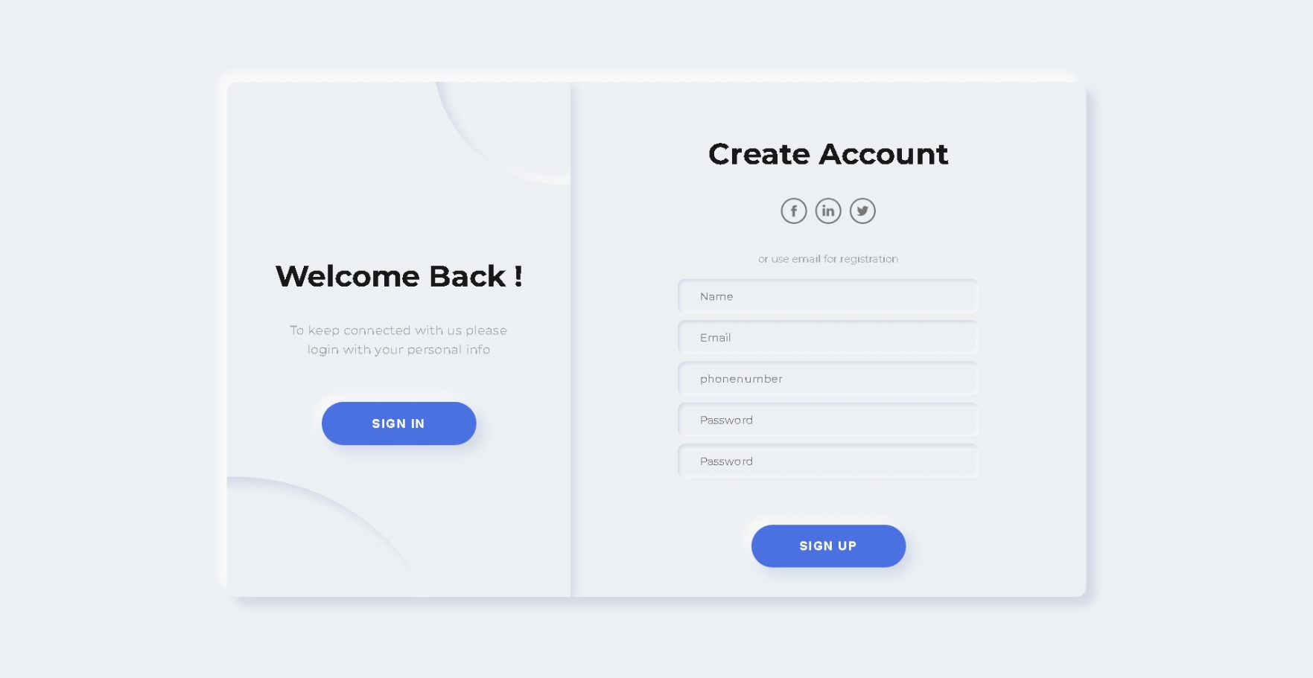

**Home page**

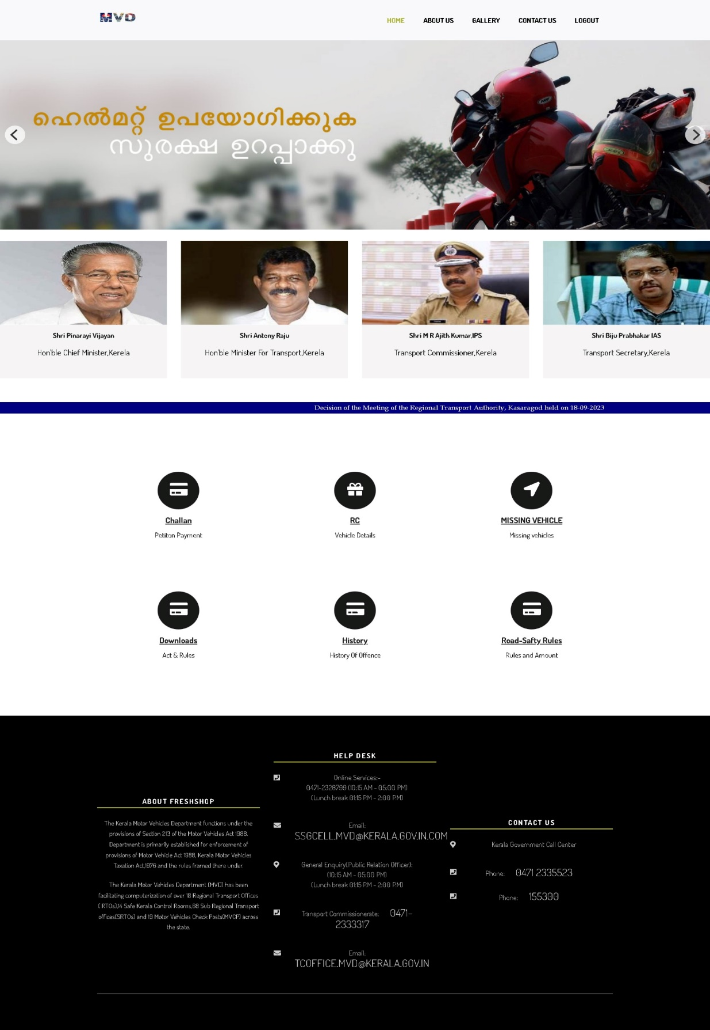

**View Challan**

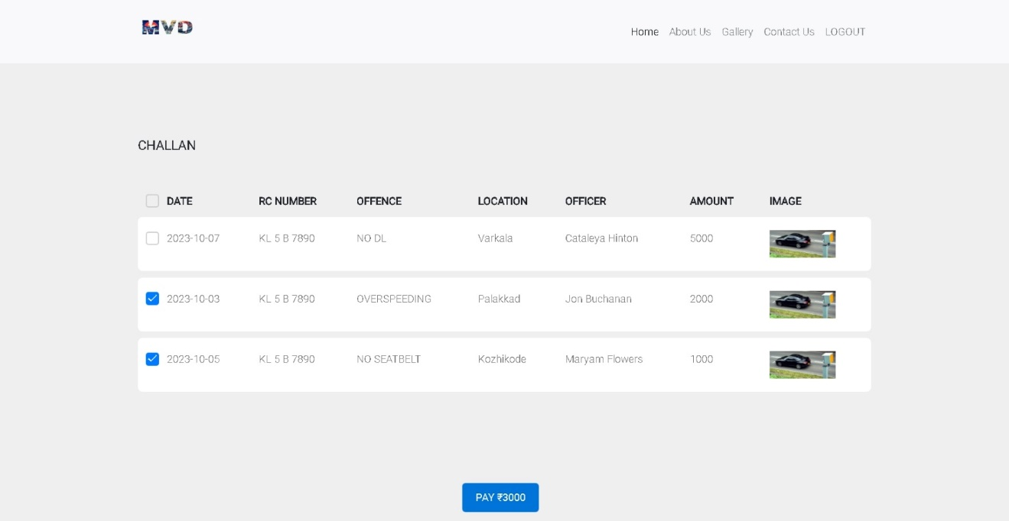

**Payment Page**

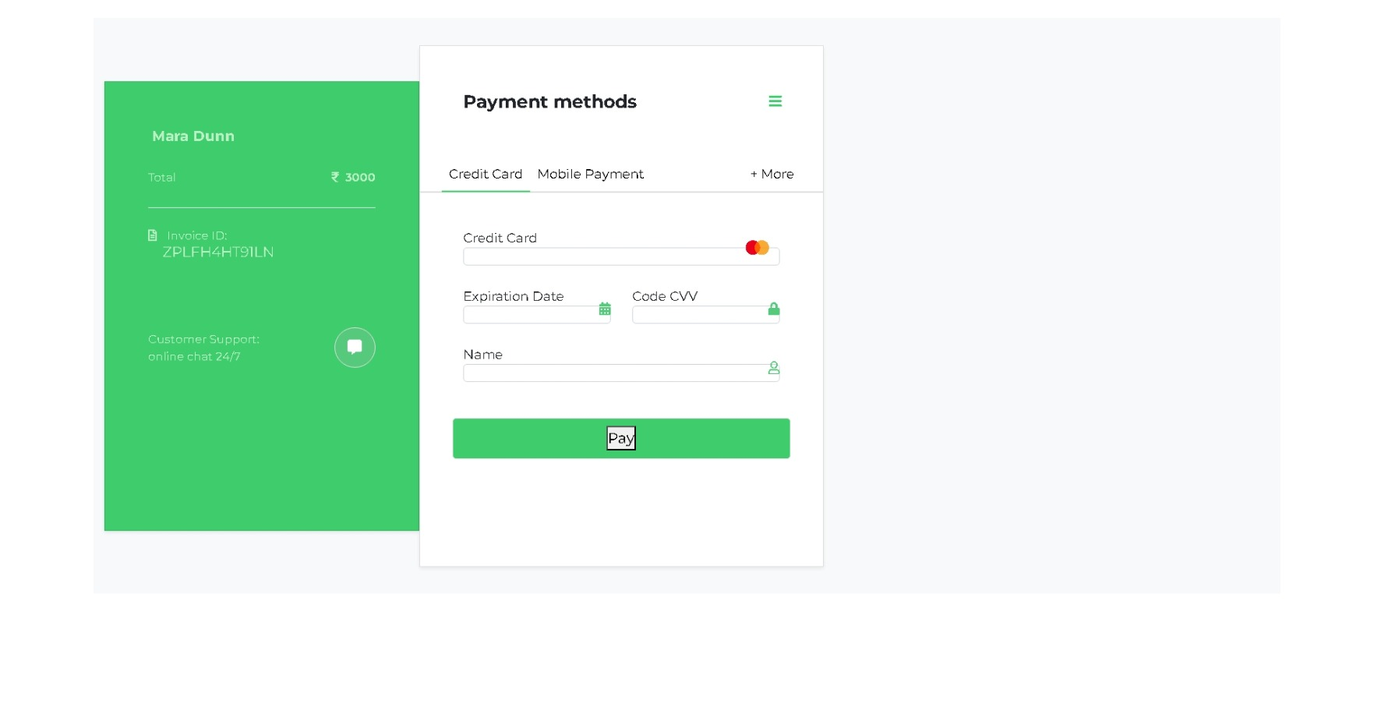

**Invoice**

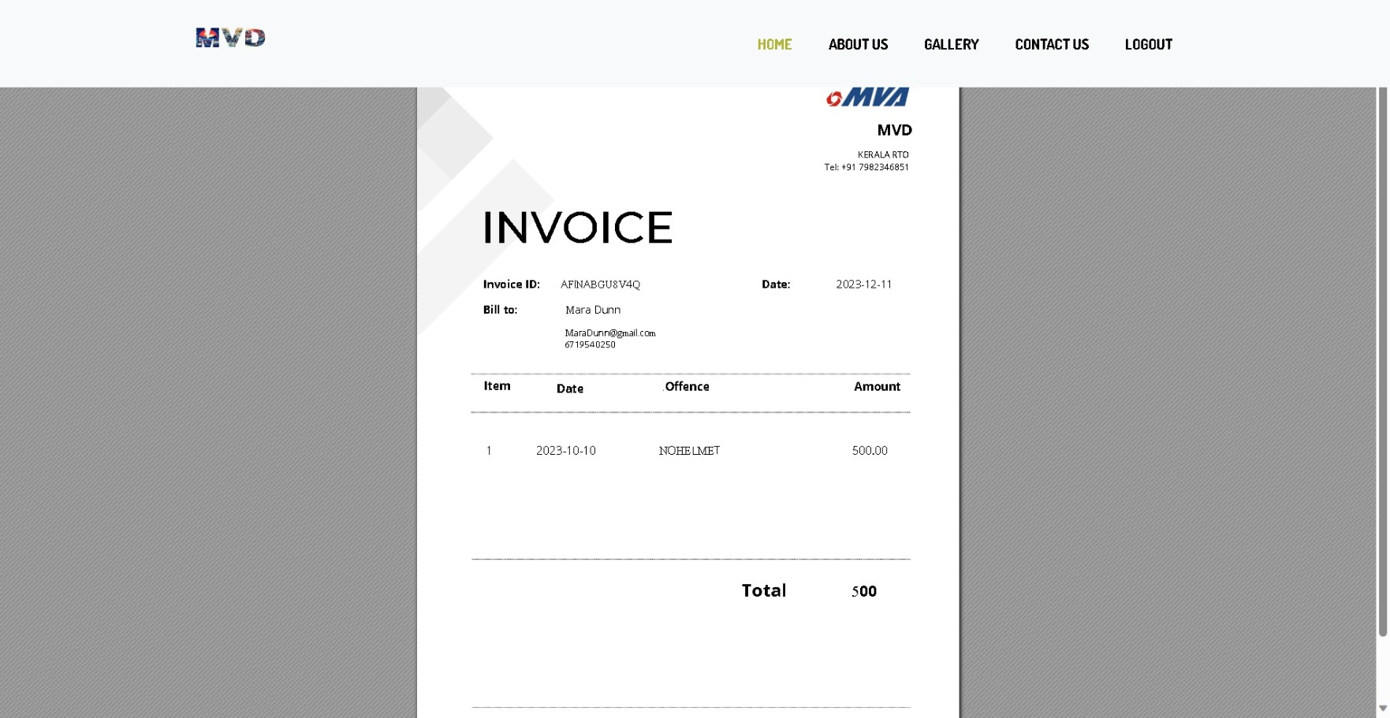

1. **Reports**

The reporting system within the Vehicle Fine System is a dynamic and integral component that provides valuable insights into various facets of the platform. These reports serve as powerful tools for administrators, officers, and users alike, offering detailed information on offenses, punishments, vehicle details, and financial transactions. Each report is designed with precision to meet specific informational needs, contributing to informed decision-making, streamlined management, and enhanced system transparency. This section delves into the diverse range of reports available, outlining their purposes, functionalities, and the wealth of data they offer for comprehensive system evaluation and control.

* **Punishment Status Report:**

The Punishment Status Report provides a comprehensive summary of the status of punishments within the system. It categorizes punishments based on whether they are paid or unpaid, allowing for efficient tracking and management. This report is instrumental for administrators in ensuring that the consequences for offenses are clearly documented and appropriately handled. Additionally, it provides a quick overview of the financial aspect of the system, aiding in financial reporting and decision-making.

* **Missing Vehicles Status Report:**

The Missing Vehicles Status Report offers valuable insights into the current status of vehicles reported as missing. It distinguishes between vehicles that have been found and those that are still unfound. This report serves as a crucial tool for law enforcement, helping them prioritize and focus their efforts on locating vehicles that are still missing. By providing detailed information on the status of missing vehicles, including owner details and last seen information, this report aids in ongoing investigations and contributes to the overall efficiency of law enforcement operations.

1. **Limitations and Future Advancements**

**Limitations:**

* **Risk of Fraudulent Activity:**

The system is susceptible to potential instances of fraud, presenting a challenge in ensuring the integrity and security of transactions.

* **Limited Product Quality Assessment:**

The system currently lacks the capability to provide users with a firsthand, tangible assessment of the actual quality of the products.

**Future Enhancements:**

* **Advanced Security Protocols:**

Future iterations will incorporate state-of-the-art security measures to fortify the system against fraudulent activities, ensuring a secure environment for users.

* **Integration of Virtual Reality:**

To enhance the online shopping experience, the incorporation of virtual reality technology is envisaged. This addition will allow users to engage with products in a more immersive and realistic manner, revolutionizing the virtual shopping landscape.

1. **Conclusion**

The continuous evolution of technology has markedly transformed the landscape of online shopping, offering consumers an increasingly refined and convenient experience. Projections suggest that online shopping may surpass traditional in-store purchases, although there remains a notable demand for physical stores, especially in contexts where consumers seek a tactile connection with their purchases. This dual existence caters to diverse consumer preferences.

The surge in online shopping has endowed consumers with unprecedented access to an extensive array of products and brands. This accessibility has cultivated a discerning and informed consumer base, capable of exploring various options effortlessly. Simultaneously, it has provided a lifeline for numerous small retailers who can now thrive without the substantial costs associated with maintaining a physical storefront.

In essence, the symbiotic relationship between consumers and sellers has reshaped the retail landscape, creating a mutually beneficial scenario. As technology continues to advance, the trajectory of online shopping appears poised for further innovation, promising an even more dynamic and enriched shopping experience for all stakeholders.

**References**

**Websites:**

● **W3Schools:**

○ https://www.w3schools.com

● **CodePen:**

○ https://www.codepen.io

● **PHP Lab:**

○ https://www.phplab.info

● **GitHub:**

○ https://www.github.com