A Dope Document
Mostly about cats…

This document is just to test that the text to speech alternative format is working properly. This following paragraph will be divided into columns; however, it should be read column by column without jumping around from one column to the other. With that said, if this message was read out loud in a coherent manner, then the text to speech is working as required.

This text is also divided into columns, however, now there is a line between the columns in order to see what the text to speech does. Again, if this section of the document was read out loud in a coherent manner, then the text to speech alternative format is working as required.



This paragraph is also divided into 3 columns, with the caveat that this text has images inserted in it. The image however should not prevent the text from being read out loud in a coherent manner. If that is the case, then the text to speech feature is working as required.

This paragraph is divided into 2 columns, with the majority of the text found on the right-side column; as such, the text should be read column by column without jumping around from one column to the next. With that said, if this message was read out loud in a coherent manner, then the text to speech is working as required.


This following paragraph is also divided into 2 columns, with the majority of the text found on the left-sided column; as such, the text should be read column by column without jumping around from one column to the next. The caveat here is that the left sided column has a picture of a cat with a hat inserted within it. With that said, if this message was read out loud in a coherent manner, then the text to speech is working as required.

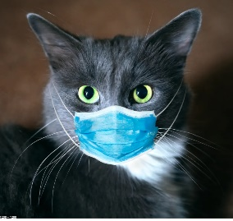

This is text with an image inserted within it to see how the text to speech alternative formats will respond. To describe the image, it is a black cat, with white fur around its neck area, and it is wearing a blue face mask because it doesn’t want to get sick, or perhaps it doesn’t want to get other cats sick. By the way, the picture has alternative text.

This is a 4 by 4 table
Column 1 row 1  This has added text to see if it’s read properly | Column 2 row 1 | Column 3 row 1 | Column 4 row 1
Column 1 row 2 | Column 2 row 2  This has added text to see if it’s read properly | Column 3 row 2 | Column 4 row 2
Column 1 row 3 | Column 2 row 3 | Column 3 row 3  This has added text to see if it’s read properly | Column 4 row 3
Column 1 row 4 | Column 2 row 4 | Column 3 row 4 | Column 4 row 4  This has added text to see if it’s read properly

