Task 12 Output Screenshots

Q1. Program to create two classes in two different packages and import one in another

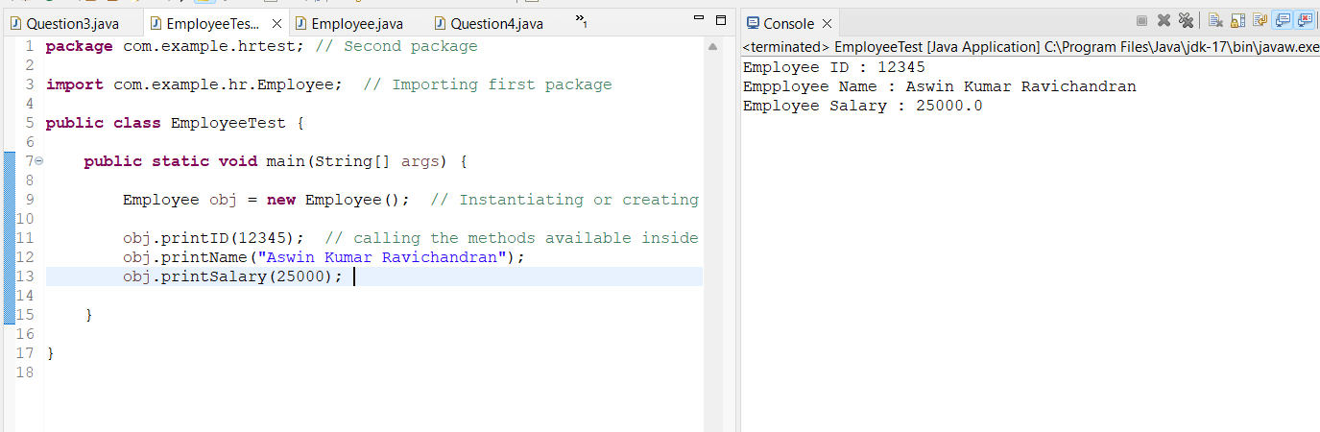

Q1 Output

Q2. Program to create ArrayList and removing it’s elements

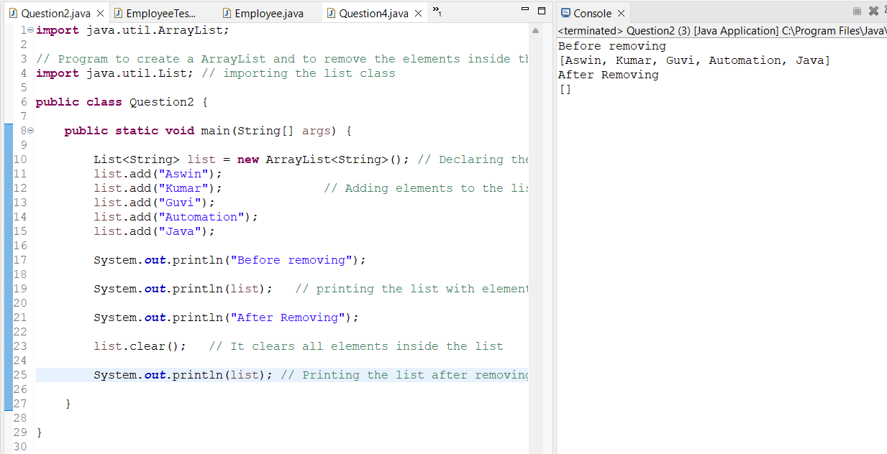

Q2 Output

Q3. Program to print TreeMap of Employees and print their names in Ascending order

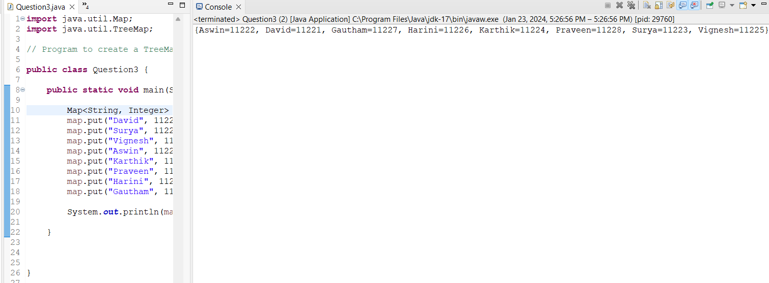

Q3 Output

Q4. Program to convert List to Array

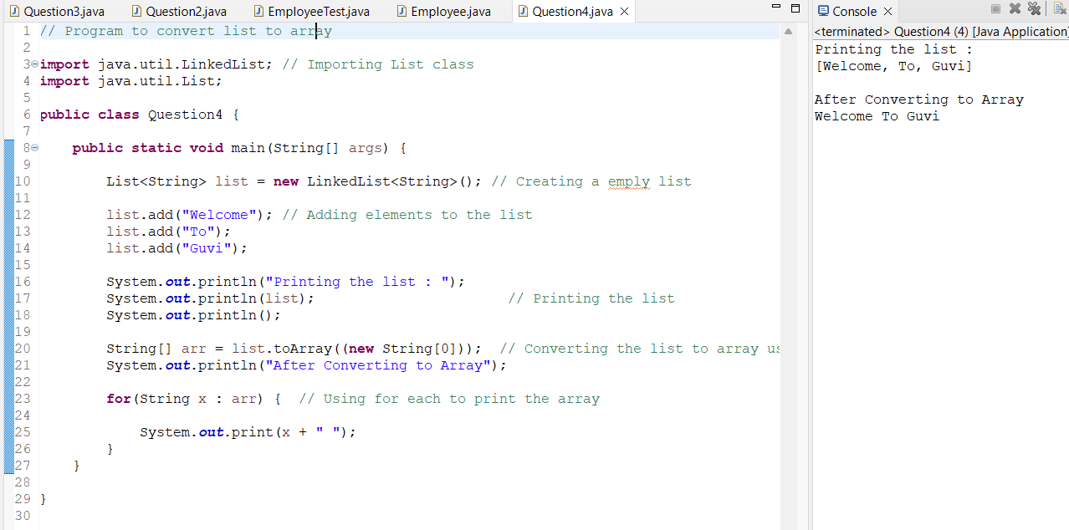

Q4 Output