An Introduction to HAProxy and Load Balancing Concepts

HAProxy is a very fast and reliable solution for high availability, load balancing, It supports TCP and HTTP-based applications.

Now a days most of websites need 99.999% uptime for there site, which are not possible with single server setup.

Then we need some high availability environment which can easily manage with single server failure.

Access Control List (ACL)

In relation to load balancing, ACLs are used to test some condition and perform an action (e.g. select a server, or block a request) based on the test result. Use of ACLs allows flexible network traffic forwarding based on a variety of factors like pattern-matching and the number of connections to a backend

Example of an ACL:

acl url_blog path_beg /blog

This ACL is matched if the path of a user's request begins with /blog. This would match a request of http://yourdomain.com/blog/blog-entry-1, for example.

Backend

A backend is a set of servers that receives forwarded requests. Backends are defined in the backend section of the HAProxy configuration. In its most basic form, a backend can be defined by:

* which load balance algorithm to use
* a list of servers and ports

Here is an example of a two backend configuration, web-backend and blog-backend with two web servers in each, listening on port 80:

backend web-backend
balance roundrobin
server web1 web1.yourdomain.com:80 check
server web2 web2.yourdomain.com:80 check

backend blog-backend
balance roundrobin
mode http
server blog1 blog1.yourdomain.com:80 check
server blog1 blog1.yourdomain.com:80 check

Frontend

A frontend defines how requests should be forwarded to backends. Frontends are defined in the frontend section of the HAProxy configuration. Their definitions are composed of the following components:

* a set of IP addresses and a port (e.g. 10.1.1.7:80, *:443, etc.)

* ACLs

* use_backend rules, which define which backends to use depending on which ACL conditions are matched, and/or a default_backend rule that handles every other case
No Load Balancing

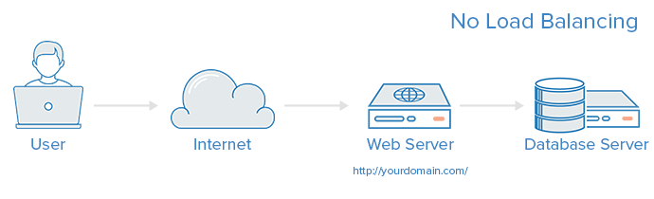

Layer 4 Load Balancing

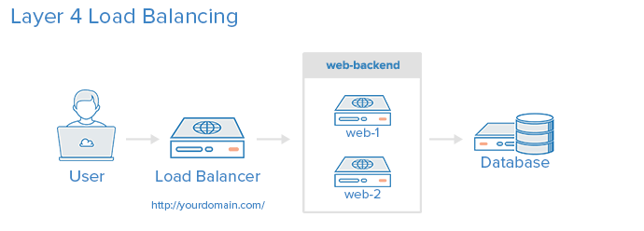
The simplest way to load balance network traffic to multiple servers is to use layer 4 (transport layer) load balancing.

(i.e. if a request comes in for http://yourdomain.com/anything, the traffic will be forwarded to the backend that handles all the requests for yourdomain.com on port 80).

Layer 7 Load Balancing

Another, more complex way to load balance network traffic is to use layer 7 (application layer) load balancing. Using layer 7 allows the load balancer to forward requests to different backend servers based on the content of the user's request

In this example, if a user requests yourdomain.com/blog, they are forwarded to the blog backend, which is a set of servers that run a blog application. Other requests are forwarded to web-backend, which might be running another application.

frontend http
bind *:80
mode http

acl url_blog path_beg /blog
use_backend blog-backend if url_blog

default_backend web-backend
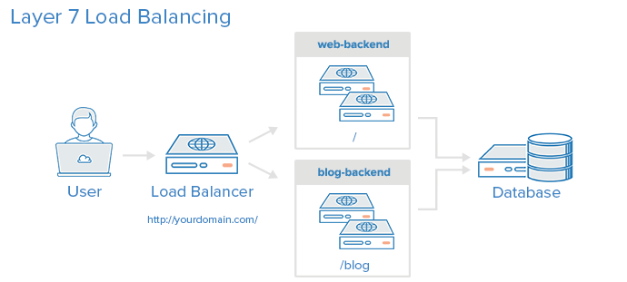

This configures a frontend named http, which handles all incoming traffic on port 80.

* acl url_blog path_beg /blog matches a request if the path of the user's request begins with /blog.

* use_backend blog-backend if url_blog uses the ACL to proxy the traffic to blog-backend.

* default_backend web-backend specifies that all other traffic will be forwarded to web-backend.

Load Balancing Algorithms

roundrobin

leastconn

source

Sticky Sessions:
Some applications require that a user continues to connect to the same backend server.

Installing HAProxy

wget http://dl.fedoraproject.org/pub/epel/6/x86_64/epel-release-6-8.noarch.rpm

rpm -ivh epel-release-6.8.noarch.rpm

yum install haproxy

Configuring HAProxy: Location : vi /etc/haproxy/haproxy.cfg

global
log 127.0.0.1 local0
log 127.0.0.1 local1 debug
maxconn 45000 # Total Max Connections. This is dependent on ulimit
daemon
nbproc 1 # Number of processing cores. Dual Dual-core Opteron is 4 cores for example.
defaults
timeout server 86400000
timeout connect 86400000
timeout client 86400000
timeout queue 1000s

# [HTTP Site Configuration]
listen http_web 192.168.10.10:80
mode http
balance roundrobin # Load Balancing algorithm
option httpchk
option forwardfor
server server1 192.168.10.100:80 weight 1 maxconn 512 check
server server2 192.168.10.101:80 weight 1 maxconn 512 check

# [HTTPS Site Configuration]
listen https_web 192.168.10.10:443
mode tcp
balance source# Load Balancing algorithm
reqadd X-Forwarded-Proto:\ http
server server1 192.168.10.100:443 weight 1 maxconn 512 check
server server2 192.168.10.101:443 weight 1 maxconn 512 check

