# House Price Prediction using Machine Learning

## 1. Project Overview

This project focuses on predicting house prices using machine learning techniques to provide accurate and reliable price estimations based on housing features. Accurate house price predictions are crucial for buyers, sellers, real estate agents, and developers, as they help in informed decision-making, budgeting, and investment planning. By leveraging machine learning, this project aims to address price prediction challenges with a structured and robust methodology.  
  
Objectives:

* Develop a Reliable Model: Build a machine learning model that can predict house prices with high accuracy.
* Feature Analysis: Understand the impact of various housing features on price predictions.
* Improve Decision-Making: Provide insights that assist stakeholders in making data-driven decisions.
* Scalable Solution: Ensure the model is scalable and can handle new data efficiently.

Expected Outcomes:  
By the end of this project, we achieved the following:

* A robust machine learning model that can predict house prices with high accuracy.
* Insights into the most important housing features affecting prices.
* Residual analysis highlights areas of model improvement.
* A structured, repeatable pipeline that can be applied to similar price prediction problems in other domains.

## 2. Introduction

The real estate market is highly dynamic and influenced by numerous factors, including property characteristics, location, and demand. Accurate price predictions can provide stakeholders with a competitive edge, ensuring they make informed decisions. Machine learning algorithms, particularly Random Forest, offer a powerful approach to modeling complex relationships between features and house prices.  
  
Importance of House Price Prediction:

* For Buyers: Helps identify fair pricing and plan budgets effectively.
* For Sellers: Assists in setting competitive prices to maximize profits.
* For Real Estate Businesses: Enables efficient market analysis and investment decisions.

## 3. Data Overview

The dataset consists of house features and their corresponding prices. These features provide valuable information about the size, condition, and amenities of houses, which are critical for predicting prices.

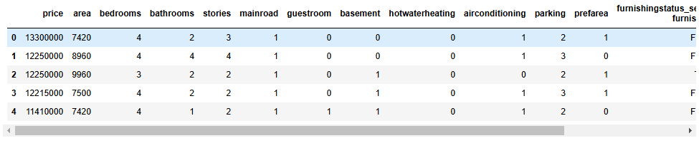  
  
Key Features:

* Area: Size of the house in square feet.
* Bedrooms: Number of bedrooms.
* Bathrooms: Number of bathrooms.
* Stories: Number of floors in the house.
* Main road, guestroom, basement, hot water heating, air conditioning: Binary variables indicating presence of amenities.
* Parking: Number of parking spaces.
* Furnishing status: Categorical feature indicating furnishing type (furnished, semi-furnished, unfurnished).

The target variable is “price”, representing the house price.

## 4. Data Preprocessing and Feature Engineering

Data preprocessing is critical to ensure the dataset is ready for machine learning algorithms. The following steps were executed:

4.1 Handling Categorical Variables

* Binary features were converted into numeric values (1/0).
* Dummy variables were created for multi-class features like `furnishingstatus`.

4.2 Scaling Numerical Features

* Standardization was applied to numerical features like `area`, `bathrooms`, and `parking` to ensure consistent scale.

4.3 Splitting the Dataset

* The dataset was split into **80% training** and **20% testing** subsets for training and validation.

## 5. Model Development

The Random Forest algorithm was chosen for its robustness and ability to handle complex data. The model was trained using the training dataset and validated on the testing set to ensure accurate predictions.

## 6. Feature Importance

The feature importance analysis highlights the contribution of each feature to the predictions. Area emerged as the most significant feature, followed by bathrooms and amenities.  
  
## 7. Conclusion and Insights

Key Insights:

* Area: Larger houses command higher prices.
* Bathrooms and Stories: Additional rooms significantly increase value.
* Amenities: Features like air conditioning positively influence prices.

Recommendations:

* For Buyers: Focus on key features like area and amenities.
* For Sellers: Highlight features like guestroom and mainroad proximity.
* For Agencies: Leverage the model to provide pricing guidance.

## 8. Summary

This project demonstrates how machine learning can provide reliable house price predictions through a systematic pipeline. The Random Forest model identified key drivers like area, bathrooms, and amenities while achieving high accuracy. Future enhancements, such as incorporating location data and optimizing hyperparameters, can further improve the model's performance, making it an invaluable tool for the real estate industry.