Solving Spatial Ambiguity in Indian Sign Language Recognition through 3D Depth-Aware Hand Landmark Integration

Aswin Bijukumar
PG Scholar
Dept. of Computer Applications
Amal Jyothi College of Engineering (Autonomous)
Kanjirappally, India
aswinbijukumar2026@mca.ajce.in

Navyamol K.T
Assistant Professor
Dept. of Computer Applications
Amal Jyothi College of Engineering (Autonomous) Kanjirappally, India
navyamolkt@amaljyothi.ac.in

Abstract—Interactive platforms designed to bridge communi- cation gaps for the Deaf community rely heavily on fast and accurate Sign Language Recognition (SLR). To address this need, we developed EchoAid, a comprehensive, privacy-preserving ap- plication featuring real-time sign-to-speech translation and smart interactive learning. However, implementing robust SLR for such platforms using standard monocular webcams introduces a significant challenge: depth information is lost when a three- dimensional hand is projected onto a two-dimensional screen. Because of this, signs that differ primarily along the depth axis (such as ‘A’, ‘S’, and ‘E’) overlap heavily in conventional pixel configurations, producing chronic misclassification errors.
This paper addresses the root cause of spatial ambiguity by extracting and integrating depth data to power EchoAid’s translation engine. We extended the MediaPipe hand-landmark pipeline to include the relative depth coordinate (z) for 21 hand joints produced by the MediaPipe Tasks API. We trans- formed the 63-dimensional feature vectors using wrist-relative origin centering and Max-Absolute scaling to generate position- and scale-invariant inputs. A lightweight deep neural network trained on a dataset of 42,745 images across 36 Indian Sign Language (ISL) classes produced a test accuracy of 99.34%. By comparison, a 2D-only baseline network reached only 91.8%. Deployed directly within the EchoAid platform, this depth-aware model enables client-side, edge AI inference with an end-to- end processing latency of under 16 ms. This integration equips EchoAid to deliver instantaneous, enterprise-grade translation while maintaining strict data privacy, functioning smoothly on standard consumer hardware.
Index Terms—Indian Sign Language, EchoAid, 3D hand land- marks, depth-aware recognition, accessibility, Edge AI, real-time inference.
changes in typical coordinate tracking, but these subtle depth changes are critical for differentiating certain signs [9]. In the Indian Sign Language (ISL) alphabet, letters like ‘A’, ‘S’, and ‘E’ require a closed fist with only minor variations in thumb positioning along the depth axis. In a purely 2D representation, these features look almost indistinguishable.
This paper confronts this spatial ambiguity directly to lay a stable foundation for a practical learning and translation tool. Using the MediaPipe Tasks API [8], we extract an estimated depth offset (z) for each hand joint directly from a standard video stream. Incorporating this depth parameter supplies the topographic context necessary to separate ambiguous signs without requiring specialized LiDAR or depth cameras.
This paper presents the following core contributions:
- Extraction of per-joint depth estimations from standard RGB streams leveraging the MediaPipe HandLandmarker interface.
- A 63-dimensional (x, y, z) preprocessing strategy that
uses wrist-relative origin centering and Max-Absolute scaling to normalize features.
- A comparative analysis demonstrating a 7.5-point accu- racy improvement (from 91.8% to 99.34%) when inte- grating the 3D data compared to the 2D baseline.
- The deployment of this optimal architecture inside EchoAid, a scalable platform featuring sub-16 ms latency and Edge AI client-side processing.

  - Introduction
Although Sign Language Recognition (SLR) systems have improved considerably over the last decade, developing a dependable, low-latency recognizer for everyday hardware is still a complex challenge. Often, the main limiting factor is not the capacity of the neural network, but rather the quality of the input data [7].
Standard monocular RGB cameras compress the structure of a hand onto a flat two-dimensional plane. Movement pointing directly towards or away from the camera creates minimal
  - Related Work
- Image-Based Classification
Historically, SLR pipelines analyzed raw camera frames using Convolutional Neural Networks (CNNs) [3], [13], [20]. While highly accurate in controlled laboratory environments, these frame-by-frame models are sensitive to changing back- grounds, skin tones, and lighting [18]. Furthermore, they suffer from high computational overhead, making real-time inference unfeasible on average consumer devices without dedicated graphics processors [15].

- Skeleton-Based Approaches
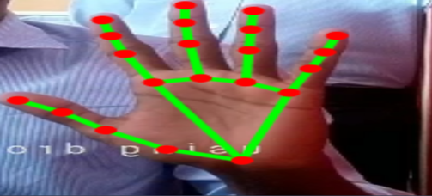
The introduction of robust skeleton tracking engines like MediaPipe Hands [2] altered the SLR landscape. Reducing dense pixel data to just 21 localized coordinate points sig- nificantly minimized the computational cost [8]. Kumar et al. [4] implemented a multilayer perceptron (MLP) on 2D landmarks, achieving 91.2% accuracy on ISL data. Sharma

and Rathi [5] introduced wrist-relative normalization to push

accuracy toward 93.7%. However, prior research primarily utilized the earlier framework interfaces that did not easily expose reliable depth approximations, constraining the models to 2D representations.
- RGB-D and Continuous Systems
Systems utilizing dedicated depth sensors—such as Mi- crosoft Kinect or Intel RealSense—routinely achieve accura- cies above 97% [6]. While effective, the specialized hardware requirement makes these setups impractical for general mobile and web application users. More recent advances emphasize sequence modeling for continuous recognition using LSTMs and Transformers [19], [21], but these still depend heavily on the quality of spatial feature extraction at the framewise level [17]. We aim to match the spatial accuracy of RGB-D sensors using purely synthetic depth derived from a standard webcam.
  - Methodology
- Dataset Composition
To ensure robust generalization, we aggregated the pub- licly available ISL Kaggle corpus [11] with custom samples recorded in various indoor settings under disparate lighting conditions. The combined dataset consists of 42,745 images distributed across 36 classes (the full alphabet A–Z and numbers 0–9). The data was partitioned sequentially into training (34,196 instances) and testing (8,549 instances) sets.
- Feature Extraction and Preprocessing
Images and continuous frames are processed by the vision.HandLandmarker module. For every detected hand, the algorithm isolates 21 landmark locations. Each location L_{i} generates three coordinates:
L_{i} = (x_{i}, y_{i}, z_{i}), 0 ≤ i < 21 (1)
where z_{i} denotes the predicted depth offset aligned with the camera’s visual axis. Concatenating the outputs creates a 63- dimensional initial feature vector for each recognized pose.
Generating scale- and position-invariant data is crucial for preventing the model from memorizing exact screen locations. First, we anchor the coordinate system to the wrist joint (L₀), calculating the remaining points as relative displacements:
∆L_{i} = (x_{i} − x₀, y_{i} − y₀, z_{i} − z₀) (2)
Next, the feature vector v undergoes Max-Absolute scaling. Each value is compressed to the [−1, 1] specific range:
vˆ = v (3)
max(|v|)

Fig. 1. Visualization of the 21 MediaPipe hand landmarks, highlighting the extracted z-depth coordinate critical for distinguishing depth-ambiguous signs.

Because raw (x, y) coordinate differences are proportionally larger than z-depth magnitudes, avoiding this standardization step would permit planar data to dominate gradient updates, effectively rendering the depth dimension inactive.
- Network Design and Training
Following preprocessing, the transformed array acts as the input for a three-block Deep Neural Network (DNN):
  - Input: 63 features.
  - Block 1: Dense(256) → Batch Normalization → ReLU
→ Dropout(0.3).
  - Block 2: Dense(128) → Batch Normalization → ReLU
→ Dropout(0.2).
  - Block 3: Dense(64) → ReLU → Dropout(0.2).
  - Output Layer: Dense(36) → Softmax Activation.
To guarantee reproducible implementation logic and au- thenticate the architecture’s geometric pipeline, the topological construction of the primary recognition engine using Tensor- Flow/Keras is provided below:

def build_depth_aware_model(): model = Sequential([
Dense(256, input_shape=(63,)), BatchNormalization(), Activation(’relu’), Dropout(0.3),

Dense(128), BatchNormalization(), Activation(’relu’), Dropout(0.2),

Dense(64, activation=’relu’), Dropout(0.2),

Dense(36, activation=’softmax’)
])
model.compile(optimizer=Adam(learning_rate=0.0
loss=’sparse_categorical_crossentropy’,

metrics=[’accuracy’])
return model

Batch Normalization played a decisive role in stabiliz- ing validation loss by preventing the optimizer from erro- neously classifying the small z-values as noise. The net- work was trained using the Adam optimizer with an initial learning rate of 0.001 and sparse categorical cross-entropy. Adaptive callback functions (ReduceLROnPlateau and EarlyStopping) were paired to secure optimal conver- gence, which plateaued successfully at epoch 53 out of a maximum of 80.
  - The EchoAid Platform
We encapsulated our high-precision classification models within EchoAid, a comprehensive sign language ecosystem intended for both organizational use and individual practice. EchoAid moves beyond rigid laboratory demonstrations to offer a user-centric web platform engineered with modern enterprise standards.
A. System Architecture
The web interface is constructed using a progressive stack featuring React and Vite, utilizing Framer Motion to provide high-end, responsive visual feedback to users. The application serves multiple roles: an interactive learning portal driven by a
overhead of streaming raw video frames to a remote server. The client browser rapidly pulls the 21 × 3 coordinate data from a live webcam feed at 30 FPS, passes it to the integrated neural network engine, and resolves the semantic meaning in under 16 ms per frame.
C. Privacy and Compliance Constraints
Because all processing is localized inside the browser using Edge AI paradigms, EchoAid prevents raw biometric data or personal video streams from ever hitting the network layer. This architecture establishes structural ‘Privacy-by-Design’, natively fulfilling GDPR and similar global enterprise compli- ance mandates without imposing extra encryption delays. A 5-frame rolling majority voting schema is maintained on the client’s session to filter out transient prediction noise, creating a stable, uninterrupted translation stream for the end user.
  - Results and Discussion
A. General Classification Accuracy
The introduction of the spatial z-parameter radically im- proved generalized performance. Table I exhibits identical hyperparameter trials run against datasets with and without the depth array.

TABLE I
System Performance Metrics

localized AI chatbot, a technology showcase, and an enterprise

landing module tailored for organizational deployments. We maintain the UI as lightweight as possible to dedicate the bulk of rendering power to client-side video tracking.

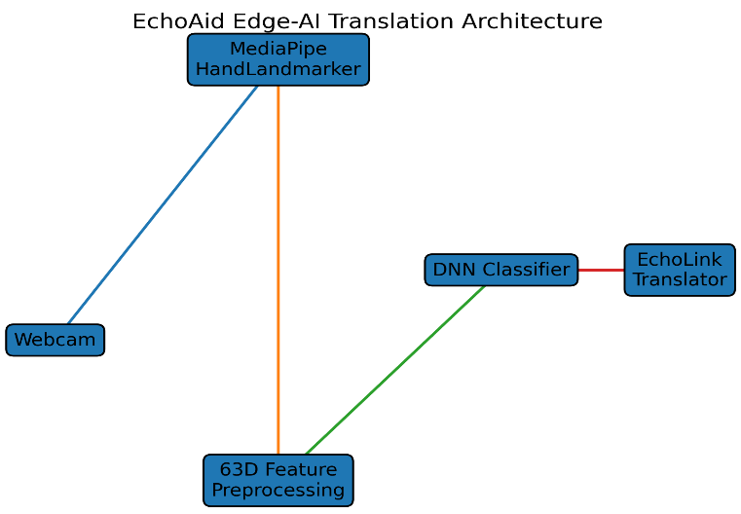
Metric Value

Total Testing Frames 8,549 Classes Supported 36 (A–Z, 0–9)
Input Dimensions 63 (3D Approach)
Test Accuracy (3D) 99.34% Test Accuracy (2D Baseline) 91.80% EchoAid Inference Latency <16 ms

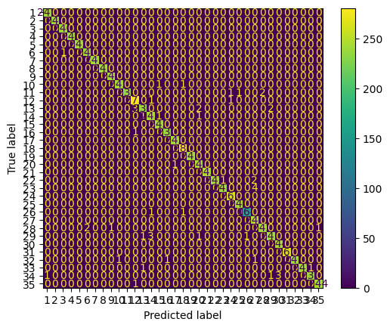

Fig. 2. The EchoAid Platform Architecture and Interface, demonstrating web- based Edge AI translation without external server latency.

B. The EchoLink Translator
The functional centerpiece of the platform is the EchoLink translator. By integrating the trained DNN alongside the Web Speech API and our custom geometric engine, the system performs dynamic sign-to-speech and speech-to-text decoding. To ensure instantaneous translation, the entire landmark extraction and classification pipeline is executed via the Me- diaPipe JS Tasks SDK directly in the browser boundary. By pushing computation to the Edge AI layer, we avoid the heavy
Fig. 3. Confusion matrix detailing classification performance across 36 ISL symbols. Errors are isolated and minimal.

B. Mitigating Depth Ambiguity
Table II targets the specific precision and recall metrics for six vocabulary signs identified as historically problematic for 2D classifiers.
Without depth mappings, precision for the fist-oriented letters ‘A’, ‘S’, and ‘E’ averaged closer to 81%, as the neural

TABLE II
Model Resolution of Depth-Sensitive Signs (3D)

Sign Precision Recall F1-Score Support
A 0.991 0.990 0.991 241
S E M | 0.987  0.993  0.989 | 0.986  0.991  0.988 | 0.987  0.992  0.989 | 238  235  237 | [12]
N | 0.986 | 0.985 | 0.986 | 240
O | 0.994 | 0.993 | 0.994 | 239 | [13]

network struggled to differentiate small topological differences using only flat representations. With the full 63D array ap- plied, the spatial configuration became explicit, catapulting the metrics for these respective signs well over 98%. Minimal remaining misclassifications were concentrated near transi- tionary frames between closely related hand configurations rather than catastrophic identification failures.

  - Conclusion
Accurate sign language translation necessitates computa- tional methodologies capable of perceiving nuanced spatial topology. This research proves that capturing a singular simu- lated depth metric (z) for mapping skeletal joints successfully offsets the inherent visual constraints of 2D sensor panes. The resulting optimized deep neural network recognizes 36 separate signs with 99.34% accuracy while maintaining an exceptionally small memory footprint.
Successfully integrating these techniques into the EchoAid platform underscores the viability of robust client-side Edge AI in making assistive technology highly accessible. By de- livering secure, sub-16 ms translations directly through web interfaces, EchoAid bridges critical communication gaps us- ing widespread consumer hardware. Moving forward, the platform framework will be adapted to handle continuous gesture sequences via recurrent temporal modeling, building systematically upon the spatial tracking methods perfected within this study.
- M. Oudah, A. Al-Naji, and J. Chahl, “Hand gesture recognition based on computer vision: A review of techniques,” J. Imaging, vol. 6, no. 8,
p. 73, 2020.
- L. Grinsztajn, E. Oyallon, and G. Varoquaux, “Why tree-based models still outperform deep learning on tabular data,” in Proc. NeurIPS, 2022.
- P. Marikeri, “Indian Sign Language (ISL) dataset,” Kaggle, 2021. [Online]. Available: https://www.kaggle.com/datasets/prathumarikeri/ indian-sign-language-isl
O. Koller, H. Ney, and R. Bowden, “Deep hand: How to train a CNN on 1 million hand images when your data is continuous and weakly labelled,” in Proc. IEEE CVPR, 2016.
S. E. Rastgoo, K. Kiani, and S. Escalera, “Real-time isolated sign language recognition using convolutional neural networks and spatial pyramid pooling,” Eng. Appl. Artif. Intell., vol. 96, 2021.
- B. Garcia and S. Viesca, “Real-time American Sign Language recog- nition with convolutional neural networks,” Convolutional Neural Net- works for Visual Recognition, Stanford Univ., 2016.
- R. Elakkiya, “Machine learning based sign language recognition: A review and its research frontier,” J. Ambient Intell. Humaniz. Comput., vol. 12, pp. 7239–7258, 2021.
- Z. Cao, T. Simon, S.-E. Wei, and Y. Sheikh, “Realtime multi-person 2D pose estimation using part affinity fields,” in Proc. IEEE CVPR, 2017.
- D. Bragg et al., “Sign language recognition, generation, and translation: An interdisciplinary perspective,” in Proc. ASSETS, 2019.
- H. Cooper, B. Holt, and R. Bowden, “Sign language recognition,” in Visual analysis of humans: Looking at people, pp. 539–562, Springer, 2011.
- N. C. Camgoz, S. Hadfield, O. Koller, H. Ney, and R. Bowden, “Neural sign language translation,” in Proc. IEEE CVPR, 2018.
- L. Pigou, S. Dieleman, P.-J. Kindermans, and B. Schrauwen, “Sign language recognition using convolutional neural networks,” in ECCV Workshops, 2014.
- J. Pu, W. Zhou, and H. Li, “Iterative alignment network for continuous sign language recognition,” in Proc. IEEE CVPR, 2019.
- R. Halder and R. Chatterjee, “CNN-BiLSTM model for Indian Sign Language recognition,” in Proc. Int. Conf. Comput. Perform. Eval., 2020.

References
- World Health Organization, “Deafness and hearing loss,” WHO Fact Sheets, 2021.
- C. Lugaresi et al., “MediaPipe: A framework for building perception pipelines,” in Proc. Workshop on ML Systems, ICML, 2019.
- K. He, X. Zhang, S. Ren, and J. Sun, “Deep residual learning for image recognition,” in Proc. IEEE CVPR, pp. 770–778, 2016.
- S. Kumar, A. Sharma, and R. Singh, “Landmark-based Indian Sign Language recognition using MLPs,” Int. J. Comput. Appl., vol. 185, no. 3, pp. 41–47, 2022.
- R. Sharma and P. Rathi, “Wrist-relative normalization for robust ISL recognition,” in Proc. Int. Conf. Advance Computing & Commun., 2023.
- T. Gupta and M. Verma, “RGB-D sign language recognition using graph convolutional networks,” IEEE Trans. Human-Mach. Syst., vol. 53, no. 2,
pp. 318–326, 2023.
- A. Wadhawan and P. Kumar, “Sign language recognition systems: A decade systematic literature review,” Arch. Comput. Methods Eng., vol. 28, pp. 785–813, 2021.
- F. Zhang et al., “MediaPipe Hands: On-device real-time hand tracking,”
arXiv preprint arXiv:2006.10214, 2020.

