PROJECT REPORT
ON
From BI to Big Data: Explain, Design & Defend

Subject Name: Big Data Analytics
Subject Code: BAD601
Submitted By: P Aswin Krishna Submitted To:
USN: 1AY23CD041 Ms. Surbhi

Table of Contents
Sl. No. | Title | Page Number
1. | TASK 1: Big Data in Daily Life – Visual Storytelling | 01
2. | TASK 2: BI vs Big Data – Role Play | 02 - 03
3. | TASK 3: Architecture Design Challenge | 04 - 05
4. | TASK 4: Analytics & Tool Match | 06
5. | Bonus Challenge | 07

TASK 1: Big Data in Daily Life – Visual Storytelling

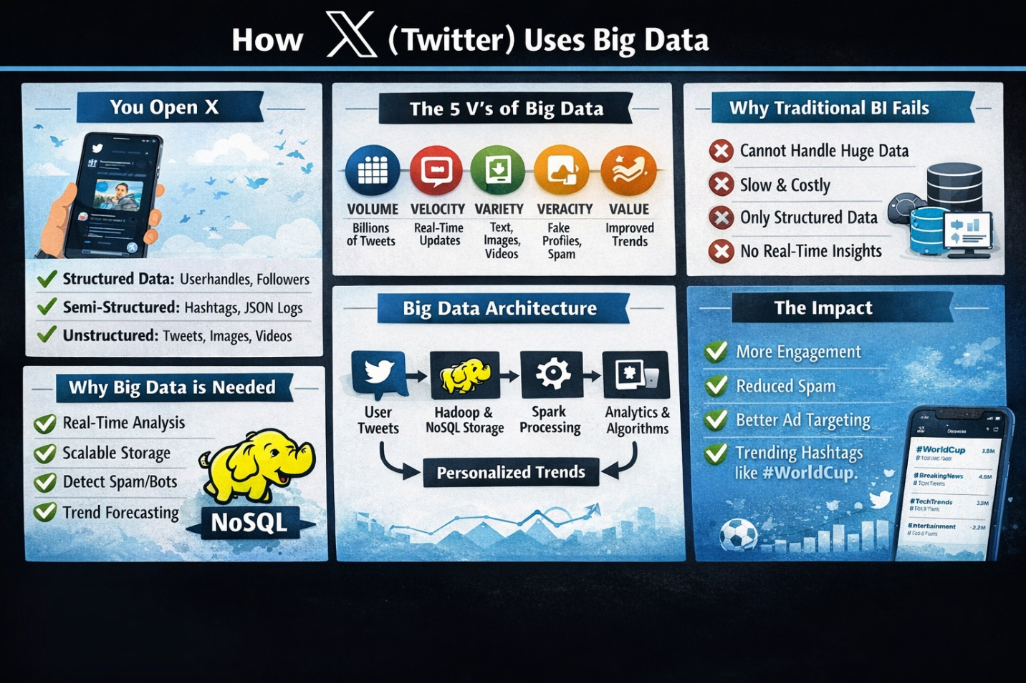

Fig 1: Infographic on X(Twitter)

TASK 2: BI vs Big Data – Role Play

Characters:
Ishaan - Business Manager
Aswin - Data Consultant

Ishaan: Hey Aswin. Tell me why we need Big Data? Excel and SQL are enough, no?
Aswin: Hahaha. Yes, they are enough ,but for small data. Not for the millions of data that are recorded and stored every second.
Ishaan: But we can store that millions of data in a database, right?
Aswin: Store maybe yes. But process ? Analysing them in real time? That’s a No and That’s the problem.
Ishaan: SQL can handle big tables also according to my knowledge.
Aswin: Big tables, yes. But what about videos, tweets, images, click logs, JSON files and the various types of data? Your SQL loves structured data only.
Ishaan: Hmm okay. But our reports are working fine. There is not an issue with that right?
Aswin: Reports show what happened last month, it is all previous data. Big Data shows what’s happening right now. That’s the difference between BI and Big Data.
Ishaan: So, you are saying BI is slow and useless??
Aswin: Not slow or useless. But just not built for massive volume, velocity, and variety of data. Data today is exploding through the roof Ishaan and we need to handle that
Ishaan: When did this become such a big issue, all this massive amount and variety of data ?
Aswin: Simple. When companies moved online. Apps, social media, IoT devices and many more as such started - data started coming every second. That’s how Big Data era started.
Ishaan: Okay fine. So why Hadoop? Why not something else?
Aswin: Well, listen carefully, Hadoop stores data in distributed way. Instead of one big server, it

splits data across many machines. And guess what, its cheap and scalable unlike many others.
Ishaan: And this NoSQL thing? I do not get it that well.
Aswin: NoSQL handles flexible and various forms of data. Suppose tomorrow data format changes, it won’t cry like your SQL schema which is focused only to one type of data.
Ishaan: But is this just tech hype or is there any real benefits for the people out there???
Aswin: Hahahhaha. There is of course real benefit. Better Recommendations, Fraud detection, Targeted Ads for companies, Predicting customer churn and turnover , all these are some benefits. I can tell you more but I think you should do some work and research on it.
Ishaan: I would of course research on this. Now does this actually increase revenue?
Aswin: Of course, man. Personalized suggestions are more engagement which leads to more money for the company. Understood?
Ishaan: Yes Yes. So BI is for reporting and Big Data is for strategy in a way, right?
Aswin: Exactly. BI tells you what happened. On the other hand, Big Data tells you what will happen and what to do for that.
Ishaan: Okay okay I get it now. Thank you for enlightening me on this.
Aswin: Finally . Now you’re thinking like a data-driven manager. Hahaha.

TASK 3: Architecture Design Challenge

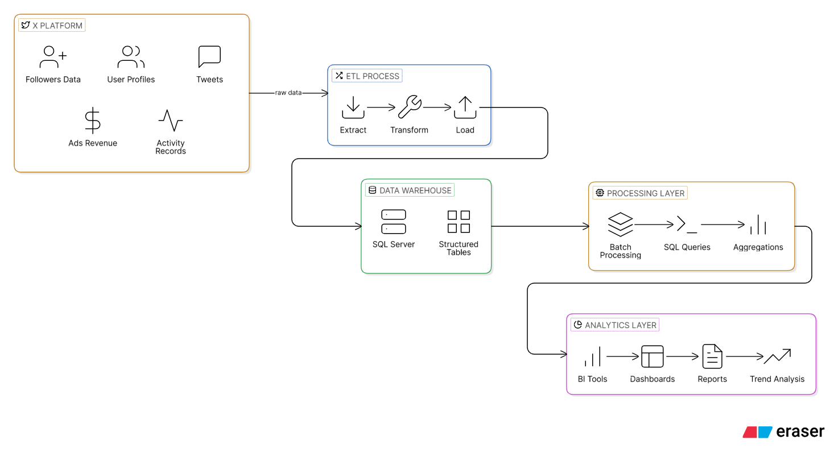
Fig 2: Traditional Warehouse Data Architecture of X(Twitter)

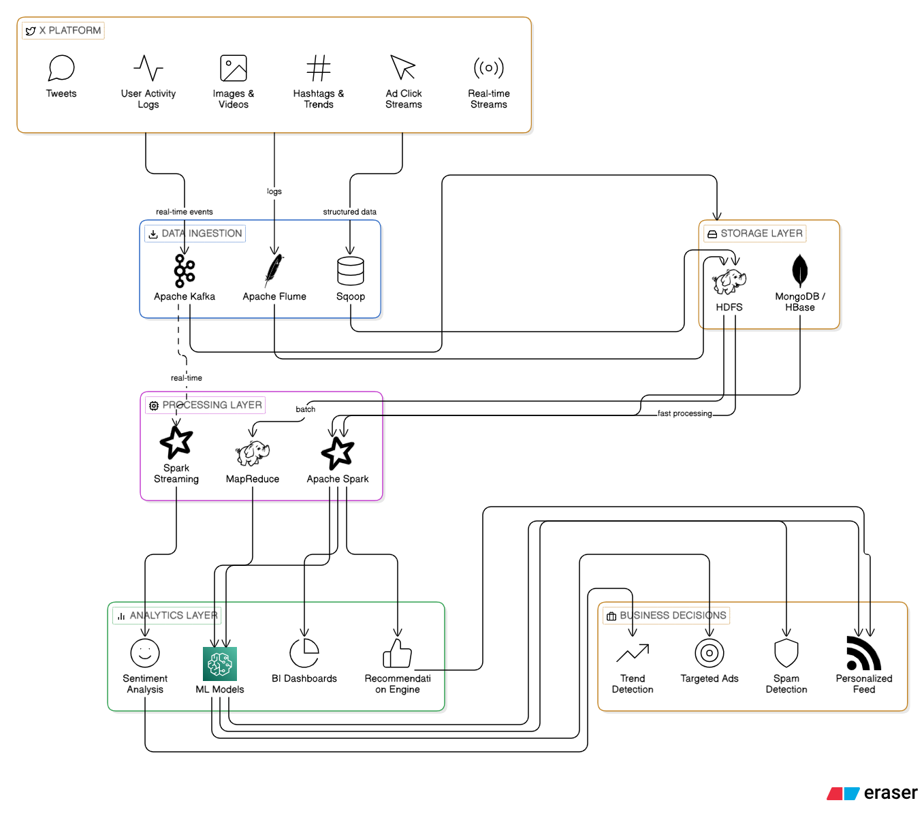

Fig 3: Hadoop Based Big Data Architecture For X(Twitter)

TASK 4: Analytics & Tool Match

Business Question | Analytics Type | Tool
What happened? | Descriptive Analytics | BI Tools (Power BI, Tableau)
Why did it happen? | Diagnostic Analytics | SQL + Spark
What will happen next? | Predictive Analytics | Spark
What action should be taken? | Prescriptive Analytics | Hadoop + NoSQL + ML Models

Table 1: Analytics and Tool Match Table

Bonus Challenge
“Explain Big Data to a 10-year-old”

Once upon a time, there was a huge online game called “Mega World Adventure.” Millions of kids played it every day. Some loved racing cars, some liked building houses, and some enjoyed fighting dragons.
Every time a player clicked something, chose a character, won a level, or bought a new outfit, the game remembered it. But there was a problem. So many players generated billions of clicks every day. The normal computer inside the game started feeling overwhelmed. It said, “I can’t remember all this! It’s too much!”
So, the game creators built something special, a super brain called Big Data.
Big Data was not just one small computer. It was like a huge team of supercomputers working together. It could store vast amounts of information, understand what players liked, and work very quickly. If Riya always picked racing cars, Big Data noticed. If Arjun always chose dragon missions, Big Data noticed that too.
Soon, something amazing started happening. When Riya opened the game, she saw new racing challenges waiting for her. When Arjun logged in, he saw exciting dragon battles. The game felt like it was reading their minds, but really, it was Big Data learning from their choices.
Big Data never sleeps. It keeps watching patterns, learning from actions, and helping the game make smart choices. It can even predict what a player might like next. If many players suddenly start choosing water-themed levels, Big Data quickly understands, “Oh! Water adventures are trending!” and suggests them to more players.
So, Big Data is like a giant magical brain behind the scenes. It helps games, as well as real apps like YouTube or Instagram, understand people better and make everything more fun and personal.

GitHub username: aswincodesathome

