Abstract
OnlineBank is a full-stack web-based digital banking portal designed to simulate core retail banking operations in a secure, browser-based environment. The system is built using FastAPI (Python) as the backend REST API server, React 18 as the frontend single-page application, and SQLite as the embedded relational database engine. The frontend is scaffolded with Vite 5 and styled using TailwindCSS 3.
The system provides two distinct user roles: a standard bank customer and a system administrator. A regular user can register a new account, log in, view their account balance and account details, deposit funds, withdraw funds subject to an insufficient-balance check, transfer funds to other registered users, view paginated transaction history with search and type filters, download a mini-statement of the last ten transactions, receive real-time notifications for every financial event, and update their profile and password. The administrator can view a system-wide analytics dashboard (total users, active users, cumulative deposits, withdrawals, transfers, total balance), manage all user accounts (add, update, activate/deactivate, delete), and inspect the full global transaction ledger with date-range and type filters.
Authentication is implemented using in-memory UUID bearer tokens issued on successful login, with password comparison performed against plaintext values stored in SQLite. Each login attempt—successful or failed—is recorded in a dedicated login_history table. The project demonstrates a clean layered architecture separating API routing (api.py), business logic (services/), data models (models/), database access (database/db.py), and utility functions (utils/).

Table of Contents
- Introduction
- System Requirements
- System Analysis and Design
- Technology Stack
- Module Description
- Database Design
- API Documentation
- Implementation
- Screenshots and Output
- Testing
- Conclusion and Future Scope
- References
- Appendix — Folder Structure

List of Figures
Figure No. | Caption
Figure 3.1 | System Architecture Diagram
Figure 3.2 | Use Case Diagram
Figure 3.3 | Entity-Relationship (ER) Diagram
Figure 3.4 | Data Flow Diagram (Level 1)
Figure 3.5 | Sequence Diagram — Fund Transfer
Figure 9.1 | Login Page
Figure 9.2 | Registration Page
Figure 9.3 | Forgot Password Page
Figure 9.4 | User Dashboard
Figure 9.5 | Deposit Page
Figure 9.6 | Withdraw Page
Figure 9.7 | Fund Transfer Page
Figure 9.8 | Transaction History Page
Figure 9.9 | Mini Statement Page
Figure 9.10 | Notifications Page
Figure 9.11 | Profile Page
Figure 9.12 | Settings Page
Figure 9.13 | Admin Panel — Dashboard
Figure 9.14 | Admin Panel — User Management
Figure 9.15 | Admin Panel — All Transactions

List of Tables
Table No. | Caption
Table 2.1 | Hardware Requirements
Table 2.2 | Software Requirements
Table 4.1 | Technology Stack Details
Table 6.1 | users Table Schema
Table 6.2 | accounts Table Schema
Table 6.3 | transactions Table Schema
Table 6.4 | notifications Table Schema
Table 6.5 | login_history Table Schema
Table 7.1 | REST API Endpoints
Table 10.1 | Test Cases

Chapter 1 — Introduction

1.1 Problem Statement
Traditional banking requires customers to visit a physical branch for routine operations such as deposits, withdrawals, fund transfers, and account enquiries. This is time-consuming, location-dependent, and unavailable outside working hours. While internet banking exists in production environments, students and small institutions often lack a reference implementation that demonstrates how a complete digital banking system is structured from database to browser.

1.2 Objectives
- Develop a fully functional web-based banking portal accessible through a standard browser.
- Implement role-based access control distinguishing regular users from administrators.
- Provide core banking operations: account registration, balance enquiry, deposit, withdrawal, and peer-to-peer fund transfer.
- Enforce business rules such as insufficient-balance checks and self-transfer prevention.
- Maintain a persistent audit trail through transaction history, mini-statement, login history, and push notifications.
- Build a system-administration panel that displays aggregate statistics and allows user lifecycle management.
- Demonstrate a clean separation of concerns through a layered backend architecture (API → Service → Database).

1.3 Scope of the Project
Included:
- User self-registration with automatic account number generation.
- Login / logout with bearer-token-based session management.
- Account management: view account details, update profile, change password, update avatar colour.
- Financial transactions: deposit, withdrawal (with balance check), fund transfer (with balance and self-transfer checks).
- Transaction history with optional pagination, type filter, and keyword search.
- Mini-statement showing the last ten transactions.
- Notifications automatically created for every financial event (deposit, withdrawal, transfer sent/received).
- Administrator dashboard with aggregated system statistics and monthly activity charts.
- Administrator user management: add, edit, activate/deactivate, delete users.
- Administrator transaction explorer with date-range and type filters.
Excluded:
- Real payment gateway integration.
- Cryptographic password hashing (passwords are stored as plaintext for demonstration purposes).
- Two-factor authentication.
- Loan or credit-card modules.
- Email/SMS delivery of notifications.

1.4 Existing System Limitations
Limitation | Description
Branch dependency | Customers must physically visit a branch for most operations.
Time restriction | Services are available only during banking hours.
Manual record-keeping | Paper-based or siloed digital records with limited audit trails.
No real-time notifications | Customers are not notified immediately upon credit or debit events.

1.5 Proposed System Advantages
Advantage | Description
24 × 7 availability | Browser-based portal accessible at any time.
Instant notifications | Push notifications created automatically after every transaction.
Full audit trail | Every transaction and login attempt is persisted in the database.
Role-based access | Admin-only endpoints enforced by the require_admin dependency in FastAPI.
Centralised dashboard | Administrators view live aggregate statistics across all accounts.

Chapter 2 — System Requirements

2.1 Hardware Requirements
Table 2.1 — Hardware Requirements
Component | Minimum Specification
Processor | Intel Core i3 (7th generation) or equivalent, 1.6 GHz
RAM | 4 GB
Storage | 10 GB free disk space
Display | 1280 × 720 resolution or higher
Network | Broadband / Wi-Fi for npm package downloads (one-time)

2.2 Software Requirements
Table 2.2 — Software Requirements
Software / Library | Version Used | Role
Windows 10 / 11 | — | Operating system
Python | 3.12 | Backend runtime
FastAPI | ≥ 0.104.0 | REST API framework
Uvicorn [standard] | ≥ 0.24.0 | ASGI server
python-multipart | ≥ 0.0.6 | Form data parsing (FastAPI dependency)
SQLite3 | Built-in (Python stdlib) | Embedded relational database
Node.js | 20 LTS / 22 | Frontend build runtime
React | 18.3.1 | Frontend UI library
React DOM | 18.3.1 | DOM renderer for React
React Router DOM | 6.22.0 | Client-side routing
Axios | 1.6.7 | HTTP client for API calls
Recharts | 2.12.0 | Chart components (Dashboard & Admin)
Lucide React | 0.344.0 | Icon library
Vite | 5.1.4 | Frontend build tool and dev server
TailwindCSS | 3.4.1 | Utility-first CSS framework
PostCSS | 8.4.35 | CSS transformation pipeline
Autoprefixer | 10.4.17 | Vendor-prefix addition for CSS
@types/react | 18.2.55 | TypeScript type definitions for React
@vitejs/plugin-react | 4.2.1 | Vite plugin for JSX transformation

Chapter 3 — System Analysis and Design

3.1 System Architecture
The application follows a three-tier client-server architecture. The React single-page application (running on Vite dev server at port 5173) communicates exclusively with the FastAPI backend (port 8000) over HTTP REST calls using Axios. The FastAPI server routes each request through a service layer, which in turn performs SQL operations on the SQLite database file (bank.db).

Figure 3.1 — System Architecture Diagram
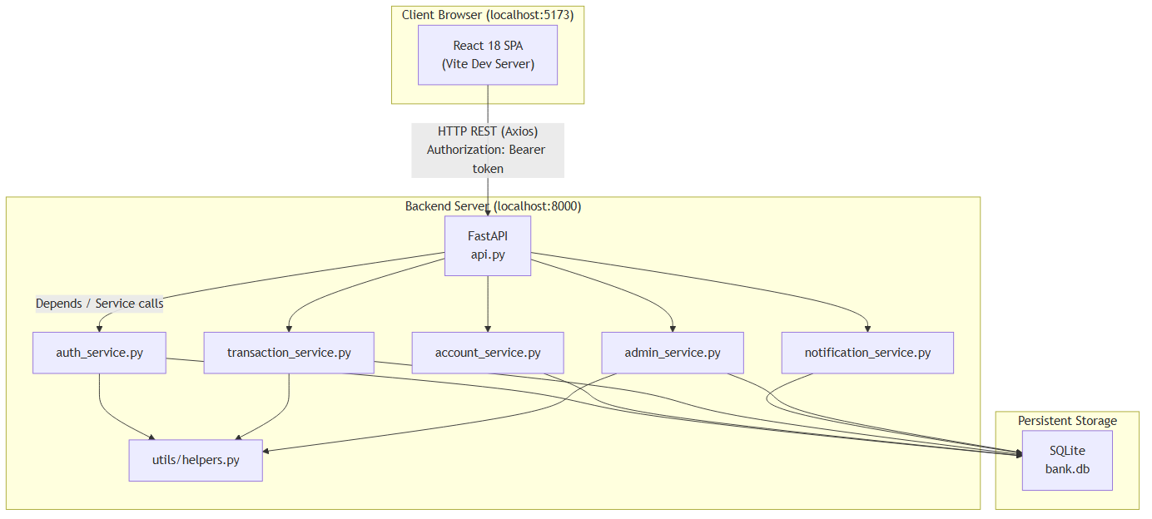
System Architecture Diagram

3.2 Use Case Diagram
Figure 3.2 — Use Case Diagram
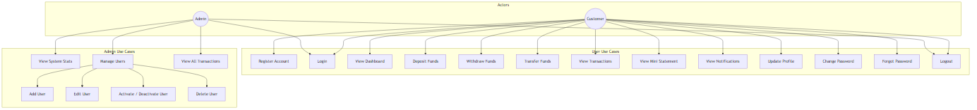
Use Case Diagram

3.3 Entity-Relationship (ER) Diagram
Figure 3.3 — Entity-Relationship Diagram
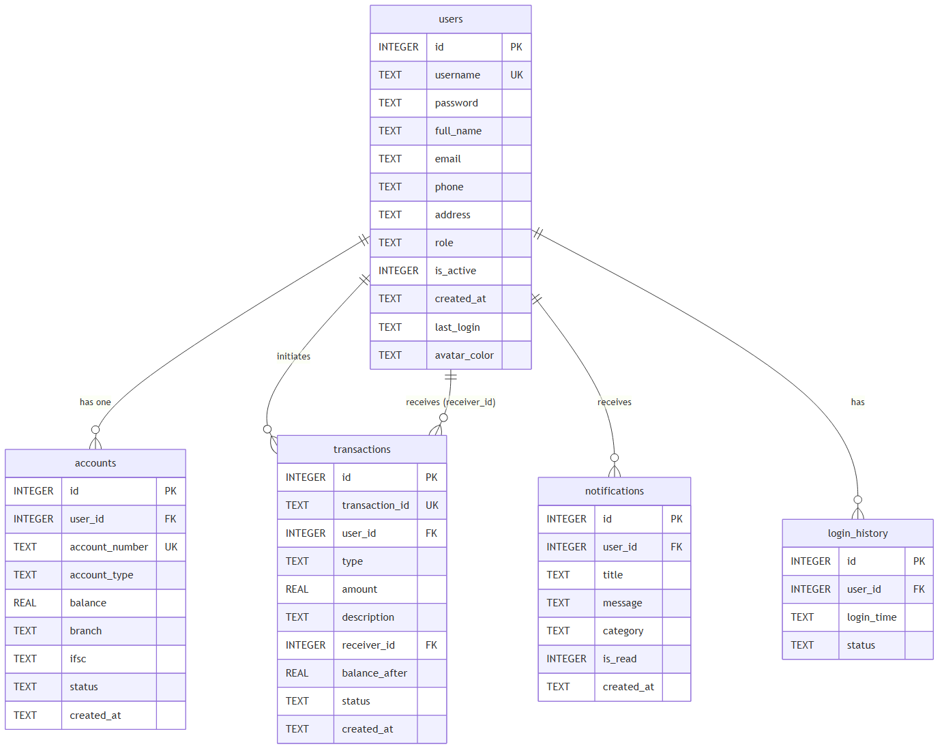
ER Diagram

3.4 Data Flow Diagram
Figure 3.4 — Data Flow Diagram (Level 1)
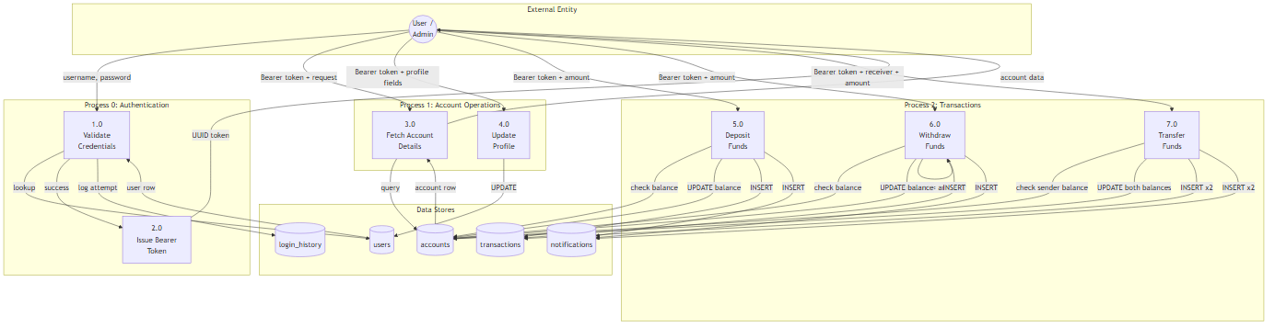
Data Flow Diagram

3.5 Sequence Diagram — Fund Transfer
Figure 3.5 — Sequence Diagram: Fund Transfer Flow
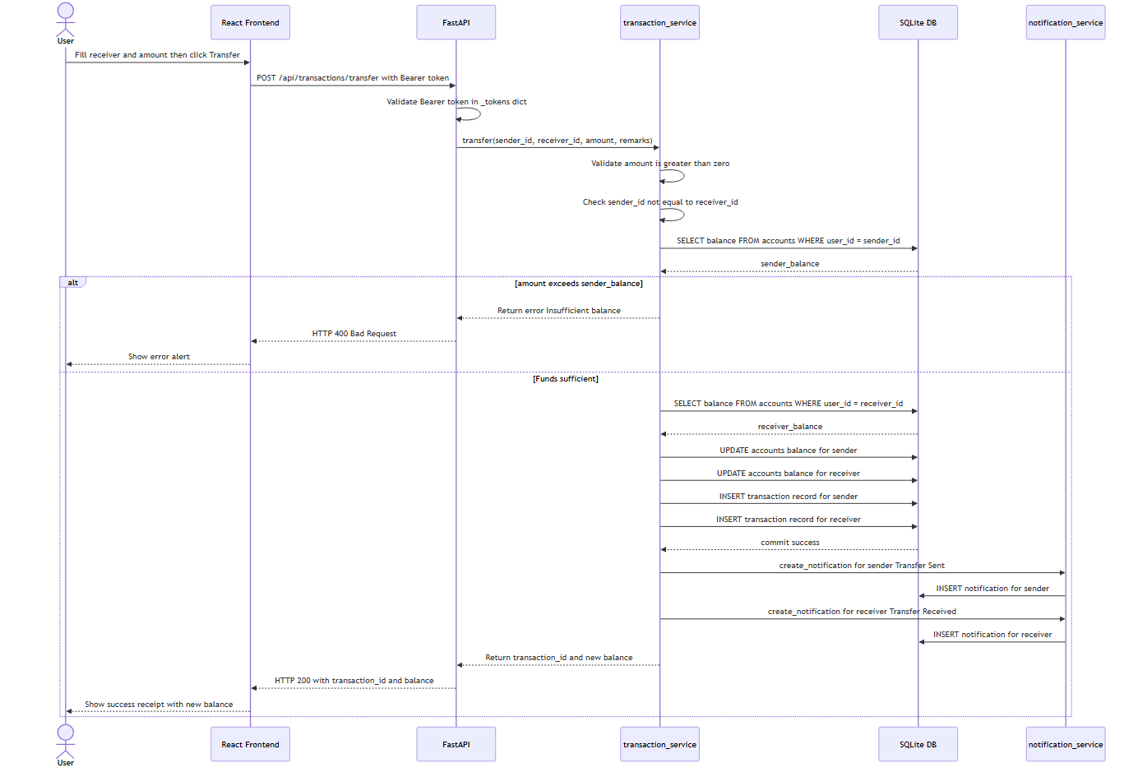
Sequence Diagram - Transfer

Chapter 4 — Technology Stack
Table 4.1 — Technology Stack Details
Layer | Technology | Version | Purpose
Backend — API | FastAPI | ≥ 0.104.0 | Defines all REST endpoints; handles request validation via Pydantic models; enforces auth via Depends()
Backend — Server | Uvicorn (standard) | ≥ 0.24.0 | ASGI server that serves the FastAPI application; supports hot-reload in development
Backend — DB Driver | sqlite3 | stdlib | Python built-in module; no external driver needed; row factory (sqlite3.Row) enables dict-like row access
Backend — Forms | python-multipart | ≥ 0.0.6 | Required by FastAPI for multipart/form-data parsing
Database | SQLite | 3.x | Embedded, serverless relational DB; stores all persistent data in a single bank.db file
Frontend — UI | React | 18.3.1 | Component-based UI library; manages virtual DOM and reactive state
Frontend — Routing | React Router DOM | 6.22.0 | Client-side SPA routing; <ProtectedRoute> wrapper enforces login and admin-only access
Frontend — HTTP | Axios | 1.6.7 | Promise-based HTTP client; automatically attaches Authorization: Bearer <token> header from localStorage
Frontend — Charts | Recharts | 2.12.0 | Composable chart library built on D3; used for bar charts on Dashboard and Admin panel
Frontend — Icons | Lucide React | 0.344.0 | Pixel-perfect SVG icon library; used throughout the sidebar, cards, and action buttons
Build Tool | Vite | 5.1.4 | Dev server with HMR; bundler for production builds
CSS Framework | TailwindCSS | 3.4.1 | Utility-first CSS; combined with custom tokens in index.css
Context API | React Context | (built-in) | AuthContext stores the authenticated user object and token; exposes login(), logout() functions

Chapter 5 — Module Description

5.1 Authentication Module
Files: services/auth_service.py, api.py (auth endpoints), frontend/src/pages/Login.jsx, Register.jsx, ForgotPassword.jsx

Login Flow
- The user submits a username and password via POST /api/auth/login.
- auth_service.login() executes SELECT * FROM users WHERE username = ? AND password = ?.
- If no row is found, a failed attempt is logged in login_history (status = 'Failed') and the error "Invalid username or password." is returned.
- If the user’s is_active field equals 0, the login is rejected with "Your account has been deactivated. Please contact the administrator.".
- On success: the last_login timestamp is updated, a login_history row with status = 'Success' is inserted, and a UUID4 bearer token is generated and stored in the in-memory _tokens dictionary (token → user_id).
- The token and full user object are returned to the frontend, which stores both in localStorage.

Registration Flow
- POST /api/auth/register is called with: username, password, full_name, email, phone, address, account_type.
- auth_service.register() checks for duplicate usernames. If found, it returns "Username already exists. Please choose another.".
- A new row is inserted into users with role = 'user'.
- An account number is generated by generate_account_number(user_id) which formats OBPK{user_id:07d} (e.g., OBPK0000042).
- An accounts row is inserted with balance = 0.0.
- A welcome notification is created automatically: "Your {account_type} account has been created successfully. Account No: {acc_num}".

Forgot Password
- POST /api/auth/forgot-password accepts username and email.
- If both fields match a user record, the password is reset to the hardcoded temporary value "reset123".
- The temporary password is returned directly in the API response (for demonstration purposes only; production systems would deliver this via email).

Token Management / Logout
- All protected endpoints use the get_current_user_id dependency which extracts the Authorization: Bearer <token> header and looks up the token in the in-memory _tokens dictionary.
- POST /api/auth/logout removes all tokens associated with the current user.
- Tokens are not persisted; a server restart clears all active sessions.

5.2 Account Management Module
Files: services/account_service.py, api.py (account endpoints), frontend/src/pages/Profile.jsx, Settings.jsx
- GET /api/account returns account details: account number, type, balance, branch (Main Branch), IFSC code (OBPK0000001), status, and creation date.
- GET /api/account/balance returns the current balance as a float.
- PUT /api/account/profile updates full_name, email, phone, and address in the users table.
- PUT /api/account/password enforces: (a) the provided old_password must match the stored password; (b) the new_password must be at least 4 characters long. Violating either rule returns a 400 error.
- PUT /api/account/avatar-color stores a hex colour string (e.g., #1a237e) against the user record; used by the frontend to render a coloured circular avatar.
- GET /api/account/users returns all active, non-admin users excluding the requesting user themselves; used by the Transfer page to populate the recipient selector.

5.3 Transaction Module
Files: services/transaction_service.py, api.py (transaction endpoints), frontend/src/pages/Deposit.jsx, Withdraw.jsx, Transfer.jsx, Transactions.jsx, MiniStatement.jsx

Deposit
- Amount must be > 0 (enforced in service).
- Amount must be ≤ 9,999,999 (enforced in utils/helpers.py → validate_amount()).
- New balance = current balance + amount; both the accounts and transactions tables are updated atomically.
- Transaction ID format: TXN{YYYYMMDDHHMMSS}{4-digit-random} (e.g., TXN202508011034001234).
- A "Deposit Successful" notification is created with the credited amount and new balance.

Withdrawal
- Same amount validations as deposit apply.
- Insufficient balance check: If amount > current_balance, the service returns "Insufficient balance for this withdrawal." without modifying the database.
- New balance = current balance − amount; both tables are updated atomically.
- A "Withdrawal Successful" notification is created (category warning).

Fund Transfer
- Amount validations apply.
- Self-transfer check: If sender_id == receiver_id, returns "Cannot transfer to your own account.".
- Insufficient balance check: If amount > sender_balance, returns "Insufficient balance for this transfer.".
- Receiver account existence is verified before proceeding.
- Two transaction records are inserted: one for the sender ("Transfer to user #{receiver_id}") and one for the receiver ("Transfer from user #{sender_id}").
- Two notifications are created: "Transfer Sent" (info) for the sender and "Transfer Received" (success) for the receiver.

Transaction History
- GET /api/transactions supports optional query parameters: limit, offset, tx_type (Deposit/Withdraw/Transfer/All), search (matches description or transaction ID via SQL LIKE).
- Results are ordered by created_at DESC.

Mini Statement
- GET /api/transactions/mini-statement?limit=10 returns the most recent N transactions for the authenticated user.

Statistics & Charts
- GET /api/transactions/stats aggregates total deposit, withdrawal, transfer amounts and transaction count per user.
- GET /api/transactions/monthly-activity?months=6 returns monthly totals grouped by transaction type for the past N months, used to render the bar chart on the Dashboard.

5.4 Notifications Module
Files: services/notification_service.py, api.py (notification endpoints), frontend/src/pages/Notifications.jsx
- Each notification has a category: info, success, warning.
- GET /api/notifications?unread_only=false returns all notifications for the current user, ordered by creation time.
- GET /api/notifications/unread-count returns a count integer; the frontend polls this to display the badge on the notifications icon in the sidebar.
- PUT /api/notifications/{id}/read marks a single notification as read (is_read = 1).
- PUT /api/notifications/read-all marks all notifications for the current user as read.

5.5 Admin Panel Module
Files: services/admin_service.py, api.py (admin endpoints), frontend/src/pages/AdminPanel.jsx
All admin endpoints are protected by the require_admin dependency, which checks user.role == "admin". Any non-admin user receives HTTP 403.
- GET /api/admin/stats returns: total_users, active_users, total_deposits, total_withdrawals, total_transfers, total_balance, total_transactions.
- GET /api/admin/users returns all non-admin users joined with their account data (account number, type, balance).
- POST /api/admin/users adds a new user with an optional initial_balance; creates an account record and sends a welcome notification.
- PUT /api/admin/users/{user_id} updates user profile fields.
- DELETE /api/admin/users/{user_id} performs a cascading delete: notifications, transactions, account, login history, and the user record are removed in order.
- PUT /api/admin/users/{user_id}/toggle-status sets users.is_active and accounts.status simultaneously; a deactivated user cannot log in.
- GET /api/admin/transactions returns up to 100 transactions across all users, with optional filters: tx_type, search, date_from, date_to.
- GET /api/admin/monthly-activity returns system-wide monthly totals for admin charts.
- GET /api/admin/recent-activity returns the most recent N transactions across all users.

Chapter 6 — Database Design
The database is a single SQLite file at the project root (bank.db). WAL (Write-Ahead Logging) journal mode and foreign key enforcement are enabled on every connection via PRAGMAs.

6.1 users Table
Table 6.1 — users Table Schema
Column | Type | Constraints | Description
id | INTEGER | PRIMARY KEY AUTOINCREMENT | Unique user identifier
username | TEXT | UNIQUE NOT NULL | Login username
password | TEXT | NOT NULL | Plaintext password (demo only)
full_name | TEXT | NOT NULL | Display name
email | TEXT | — | Email address
phone | TEXT | — | Phone number
address | TEXT | — | Postal address
role | TEXT | DEFAULT 'user' | Either 'user' or 'admin'
is_active | INTEGER | DEFAULT 1 | 1 = active, 0 = deactivated
created_at | TEXT | DEFAULT datetime('now','localtime') | Account creation timestamp
last_login | TEXT | — | Timestamp of most recent successful login
avatar_color | TEXT | DEFAULT '#1a237e' | Hex colour for avatar background

6.2 accounts Table
Table 6.2 — accounts Table Schema
Column | Type | Constraints | Description
id | INTEGER | PRIMARY KEY AUTOINCREMENT | Unique account ID
user_id | INTEGER | NOT NULL, FK → users(id) | Owner user
account_number | TEXT | UNIQUE NOT NULL | Format: OBPK{user_id:07d}
account_type | TEXT | NOT NULL | 'Savings' or 'Current'
balance | REAL | DEFAULT 0.0 | Current account balance
branch | TEXT | DEFAULT 'Main Branch' | Branch name
ifsc | TEXT | DEFAULT 'OBPK0000001' | Bank IFSC code
status | TEXT | DEFAULT 'Active' | 'Active' or 'Inactive'
created_at | TEXT | DEFAULT datetime('now','localtime') | Account creation timestamp

6.3 transactions Table
Table 6.3 — transactions Table Schema
Column | Type | Constraints | Description
id | INTEGER | PRIMARY KEY AUTOINCREMENT | Unique row ID
transaction_id | TEXT | UNIQUE NOT NULL | Format: TXN{YYYYMMDDHHMMSS}{4-random-digits}
user_id | INTEGER | NOT NULL, FK → users(id) | Initiating user
type | TEXT | NOT NULL | 'Deposit', 'Withdraw', or 'Transfer'
amount | REAL | NOT NULL | Transaction amount
description | TEXT | — | Human-readable description
receiver_id | INTEGER | FK → users(id) | Transfer recipient (NULL for deposit/withdraw)
balance_after | REAL | — | Account balance immediately after transaction
status | TEXT | DEFAULT 'Success' | Always 'Success' in current implementation
created_at | TEXT | DEFAULT datetime('now','localtime') | Transaction timestamp

6.4 notifications Table
Table 6.4 — notifications Table Schema
Column | Type | Constraints | Description
id | INTEGER | PRIMARY KEY AUTOINCREMENT | Unique notification ID
user_id | INTEGER | NOT NULL, FK → users(id) | Target user
title | TEXT | NOT NULL | Notification heading
message | TEXT | NOT NULL | Notification body text
category | TEXT | DEFAULT 'info' | 'info', 'success', or 'warning'
is_read | INTEGER | DEFAULT 0 | 0 = unread, 1 = read
created_at | TEXT | DEFAULT datetime('now','localtime') | Creation timestamp

6.5 login_history Table
Table 6.5 — login_history Table Schema
Column | Type | Constraints | Description
id | INTEGER | PRIMARY KEY AUTOINCREMENT | Unique row ID
user_id | INTEGER | NOT NULL, FK → users(id) | User who attempted login
login_time | TEXT | DEFAULT datetime('now','localtime') | Timestamp of the attempt
status | TEXT | — | 'Success' or 'Failed'

Chapter 7 — API Documentation
All endpoints are prefixed with /api. Protected endpoints require the HTTP header: Authorization: Bearer <token>.
Table 7.1 — REST API Endpoints
Method | Endpoint | Auth | Request Body | Response
POST | /api/auth/login | None | {username, password} | {token, user: {...}}
POST | /api/auth/register | None | {username, password, full_name, email, phone, address, account_type} | {user: {...}}
POST | /api/auth/forgot-password | None | {username, email} | {temp_password}
GET | /api/auth/login-history | Bearer | — | [{id, user_id, login_time, status}]
POST | /api/auth/logout | Bearer | — | {message}
GET | /api/account | Bearer | — | {account_number, account_type, balance, branch, ifsc, status, created_at}
GET | /api/account/balance | Bearer | — | {balance: float}
PUT | /api/account/profile | Bearer | {full_name, email, phone, address} | Updated user object
PUT | /api/account/password | Bearer | {old_password, new_password} | {message}
PUT | /api/account/avatar-color | Bearer | {color_hex} | {message}
GET | /api/account/users | Bearer | — | [{id, username, full_name, ...}] (active users, excl. self)
POST | /api/transactions/deposit | Bearer | {amount, description?} | {transaction_id, balance}
POST | /api/transactions/withdraw | Bearer | {amount, description?} | {transaction_id, balance}
POST | /api/transactions/transfer | Bearer | {receiver_id, amount, remarks?} | {transaction_id, balance}
GET | /api/transactions | Bearer | Query: limit, offset, tx_type, search | [{...transaction rows}]
GET | /api/transactions/mini-statement | Bearer | Query: limit (default 10) | [{...transaction rows}]
GET | /api/transactions/stats | Bearer | — | {total_deposit, total_withdraw, total_transfer, count}
GET | /api/transactions/recent-recipients | Bearer | — | [{id, full_name, username}]
GET | /api/transactions/monthly-activity | Bearer | Query: months (default 6) | {YYYY-MM: {Deposit, Withdraw, Transfer}}
GET | /api/notifications | Bearer | Query: unread_only (bool, default false) | [{...notification rows}]
GET | /api/notifications/unread-count | Bearer | — | {count: int}
PUT | /api/notifications/{id}/read | Bearer | — | {message}
PUT | /api/notifications/read-all | Bearer | — | {message}
GET | /api/admin/stats | Admin | — | {total_users, active_users, total_deposits, ...}
GET | /api/admin/users | Admin | — | [{user+account fields}]
POST | /api/admin/users | Admin | {username, password, full_name, email, phone, address, account_type, initial_balance?} | {message}
PUT | /api/admin/users/{id} | Admin | {full_name, email, phone, address} | {message}
DELETE | /api/admin/users/{id} | Admin | — | {message}
PUT | /api/admin/users/{id}/toggle-status | Admin | {activate: bool} | {message}
GET | /api/admin/transactions | Admin | Query: limit, tx_type, search, date_from, date_to | [{...joined rows}]
GET | /api/admin/monthly-activity | Admin | Query: months | {YYYY-MM: {...}}
GET | /api/admin/recent-activity | Admin | Query: limit | [{...transaction+user rows}]

Chapter 8 — Implementation

8.1 Authentication: Login with Bearer Token
# api.py
_tokens: dict[str, int] = {} # in-memory token store: token -> user_id
@app.post("/api/auth/login")
def login(req: LoginRequest):
user, error = auth_service.login(req.username, req.password)
if error:
raise HTTPException(status_code=400, detail=error)
token = str(uuid.uuid4())
_tokens[token] = user.id
return {"token": token, "user": {...}}
def get_current_user_id(authorization: str = Header(None)) -> int:
if authorization is None or not authorization.startswith("Bearer "):
raise HTTPException(status_code=401, detail="Not authenticated")
token = authorization.split(" ", 1)[1]
user_id = _tokens.get(token)
if user_id is None:
raise HTTPException(status_code=401, detail="Invalid or expired token")
return user_id

8.2 Authentication Service: Login Logic
# services/auth_service.py
def login(username: str, password: str):
conn = get_connection()
cursor = conn.cursor()
cursor.execute(
"SELECT * FROM users WHERE username = ? AND password = ?",
(username, password),
)
row = cursor.fetchone()
if row is None:
cursor.execute("SELECT id FROM users WHERE username = ?", (username,))
existing = cursor.fetchone()
if existing:
cursor.execute(
"INSERT INTO login_history (user_id, status) VALUES (?, 'Failed')",
(existing["id"],),
)
conn.commit()
conn.close()
return None, "Invalid username or password."
if row["is_active"] == 0:
conn.close()
return None, "Your account has been deactivated. Please contact the administrator."
now = datetime.now().strftime("%Y-%m-%d %H:%M:%S")
cursor.execute("UPDATE users SET last_login = ? WHERE id = ?", (now, row["id"]))
cursor.execute(
"INSERT INTO login_history (user_id, status) VALUES (?, 'Success')",
(row["id"],),
)
conn.commit()
user = User.from_row(row)
user.last_login = now
conn.close()
return user, None

8.3 Deposit Logic
# services/transaction_service.py
def deposit(user_id: int, amount: float, description: str = "Cash Deposit"):
if amount <= 0:
return False, "Amount must be greater than zero.", None
conn = get_connection()
cursor = conn.cursor()
try:
cursor.execute("SELECT balance FROM accounts WHERE user_id = ?", (user_id,))
row = cursor.fetchone()
if row is None:
return False, "Account not found.", None
new_balance = row["balance"] + amount
tx_id = generate_transaction_id()
cursor.execute("UPDATE accounts SET balance = ? WHERE user_id = ?", (new_balance, user_id))
cursor.execute(
"INSERT INTO transactions (transaction_id, user_id, type, amount, "
"description, balance_after, status) VALUES (?, ?, 'Deposit', ?, ?, ?, 'Success')",
(tx_id, user_id, amount, description, new_balance),
)
conn.commit()
create_notification(
user_id, "Deposit Successful",
f"Rs. {amount:,.2f} has been credited to your account. Balance: Rs. {new_balance:,.2f}",
"success",
)
return True, None, {"transaction_id": tx_id, "balance": new_balance}
except Exception as e:
conn.rollback()
return False, str(e), None
finally:
conn.close()

8.4 Withdrawal with Insufficient Balance Check
# services/transaction_service.py
def withdraw(user_id: int, amount: float, description: str = "Cash Withdrawal"):
if amount <= 0:
return False, "Amount must be greater than zero.", None
conn = get_connection()
cursor = conn.cursor()
try:
cursor.execute("SELECT balance FROM accounts WHERE user_id = ?", (user_id,))
row = cursor.fetchone()
if row is None:
return False, "Account not found.", None
current_balance = row["balance"]
if amount > current_balance:
return False, "Insufficient balance for this withdrawal.", None # key check
new_balance = current_balance - amount
tx_id = generate_transaction_id()
cursor.execute("UPDATE accounts SET balance = ? WHERE user_id = ?", (new_balance, user_id))
cursor.execute(
"INSERT INTO transactions (transaction_id, user_id, type, amount, "
"description, balance_after, status) VALUES (?, ?, 'Withdraw', ?, ?, ?, 'Success')",
(tx_id, user_id, amount, description, new_balance),
)
conn.commit()
create_notification(user_id, "Withdrawal Successful", ...)
return True, None, {"transaction_id": tx_id, "balance": new_balance}
except Exception as e:
conn.rollback()
return False, str(e), None
finally:
conn.close()

8.5 Fund Transfer Logic
# services/transaction_service.py
def transfer(sender_id: int, receiver_id: int, amount: float, remarks: str = "Fund Transfer"):
if amount <= 0:
return False, "Amount must be greater than zero.", None
if sender_id == receiver_id:
return False, "Cannot transfer to your own account.", None
conn = get_connection()
cursor = conn.cursor()
try:
cursor.execute("SELECT balance FROM accounts WHERE user_id = ?", (sender_id,))
sender_row = cursor.fetchone()
if sender_row is None:
return False, "Sender account not found.", None
if amount > sender_row["balance"]:
return False, "Insufficient balance for this transfer.", None
cursor.execute("SELECT balance FROM accounts WHERE user_id = ?", (receiver_id,))
receiver_row = cursor.fetchone()
if receiver_row is None:
return False, "Receiver account not found.", None
new_sender_balance = sender_row["balance"] - amount
new_receiver_balance = receiver_row["balance"] + amount
tx_id = generate_transaction_id()
cursor.execute("UPDATE accounts SET balance = ? WHERE user_id = ?", (new_sender_balance, sender_id))
cursor.execute("UPDATE accounts SET balance = ? WHERE user_id = ?", (new_receiver_balance, receiver_id))
cursor.execute(
"INSERT INTO transactions (transaction_id, user_id, type, amount, description, "
"receiver_id, balance_after, status) VALUES (?, ?, 'Transfer', ?, ?, ?, ?, 'Success')",
(tx_id, sender_id, amount, f"Transfer to user #{receiver_id}: {remarks}", receiver_id, new_sender_balance),
)
tx_id2 = generate_transaction_id()
cursor.execute(
"INSERT INTO transactions (transaction_id, user_id, type, amount, description, "
"receiver_id, balance_after, status) VALUES (?, ?, 'Transfer', ?, ?, ?, ?, 'Success')",
(tx_id2, receiver_id, amount, f"Transfer from user #{sender_id}: {remarks}", sender_id, new_receiver_balance),
)
conn.commit()
create_notification(sender_id, "Transfer Sent", ...)
create_notification(receiver_id, "Transfer Received", ...)
return True, None, {"transaction_id": tx_id, "balance": new_sender_balance}
except Exception as e:
conn.rollback()
return False, str(e), None
finally:
conn.close()

8.6 Admin Statistics Query
# services/admin_service.py
def get_admin_stats():
conn = get_connection()
cursor = conn.cursor()
stats = {}
cursor.execute("SELECT COUNT(*) as cnt FROM users WHERE role = 'user'")
stats["total_users"] = cursor.fetchone()["cnt"]
cursor.execute("SELECT COUNT(*) as cnt FROM users WHERE role = 'user' AND is_active = 1")
stats["active_users"] = cursor.fetchone()["cnt"]
cursor.execute("SELECT COALESCE(SUM(amount), 0) as total FROM transactions WHERE type = 'Deposit'")
stats["total_deposits"] = cursor.fetchone()["total"]
cursor.execute("SELECT COALESCE(SUM(amount), 0) as total FROM transactions WHERE type = 'Withdraw'")
stats["total_withdrawals"] = cursor.fetchone()["total"]
cursor.execute("SELECT COALESCE(SUM(amount), 0) as total FROM transactions WHERE type = 'Transfer'")
stats["total_transfers"] = cursor.fetchone()["total"]
cursor.execute("SELECT COALESCE(SUM(balance), 0) as total FROM accounts")
stats["total_balance"] = cursor.fetchone()["total"]
cursor.execute("SELECT COUNT(*) as cnt FROM transactions")
stats["total_transactions"] = cursor.fetchone()["cnt"]
conn.close()
return stats

8.7 Admin Role Guard
# api.py
def require_admin(user=Depends(get_current_user)):
if user.role != "admin":
raise HTTPException(status_code=403, detail="Admin access required")
return user

Chapter 9 — Screenshots and Output

Figure 9.1 — Login Page
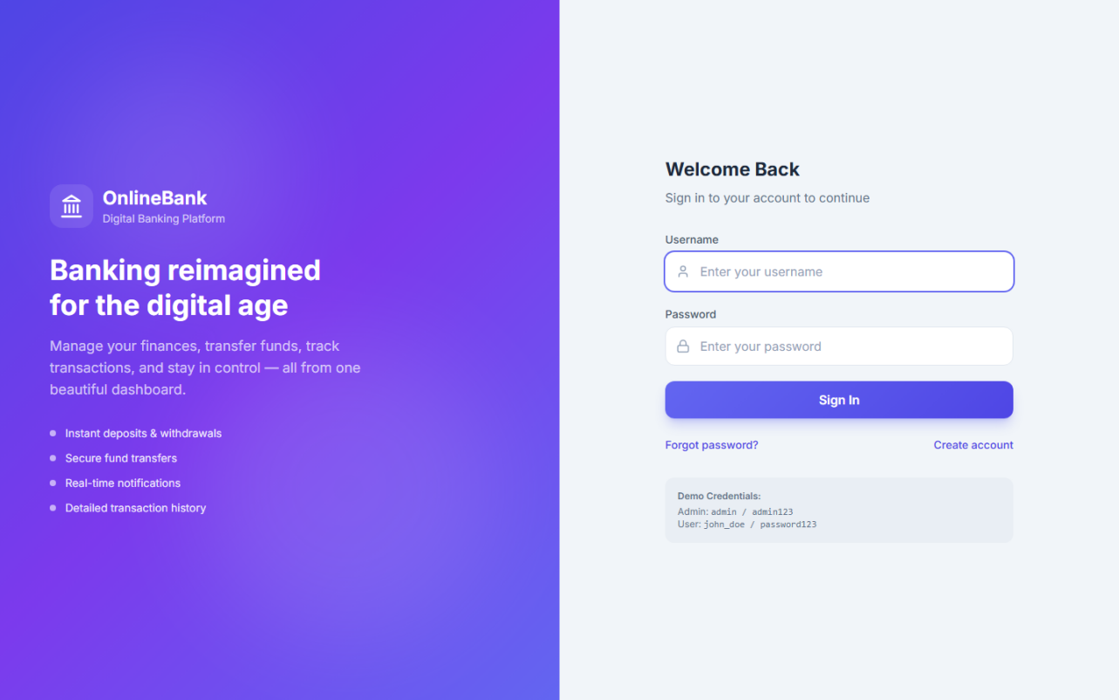
Login Page
The login page provides username and password fields along with links to the registration and forgot-password pages.

Figure 9.2 — Registration Page
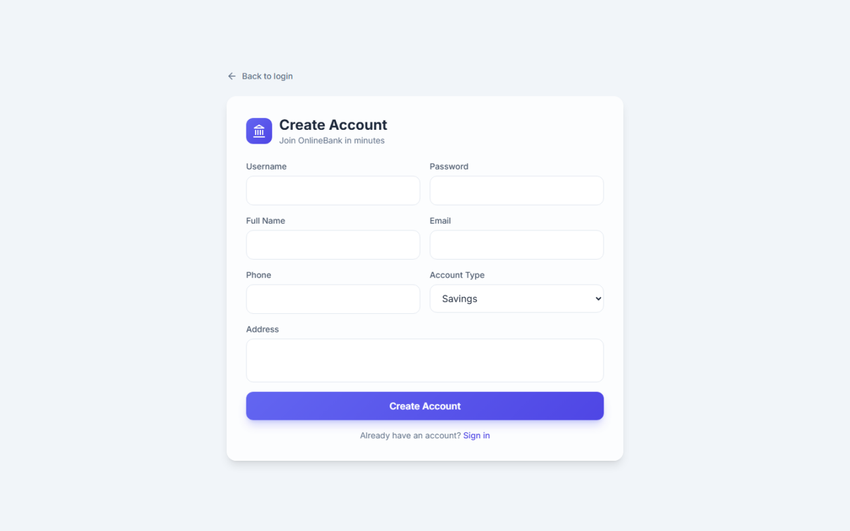
Registration Page
New users fill in username, password, full name, email, phone, address, and account type (Savings or Current) to create an account.

Figure 9.3 — Forgot Password Page
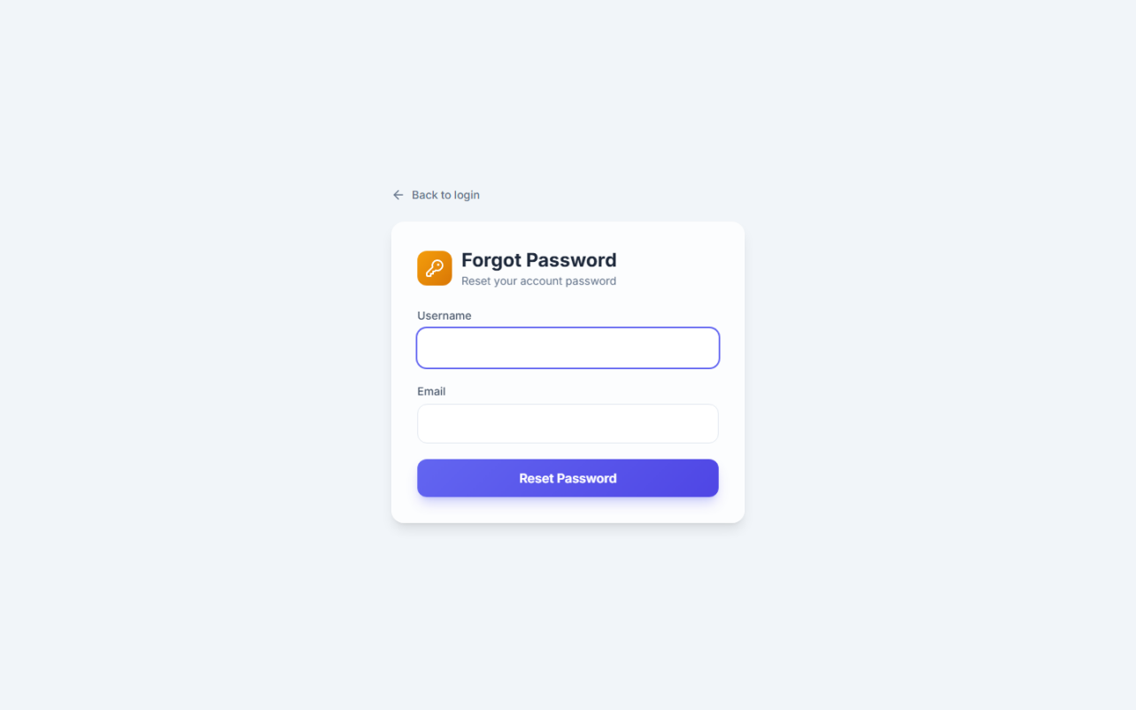
Forgot Password Page
Users enter their username and registered email. If the combination matches a database record, a temporary password (reset123) is displayed on screen.

Figure 9.4 — User Dashboard
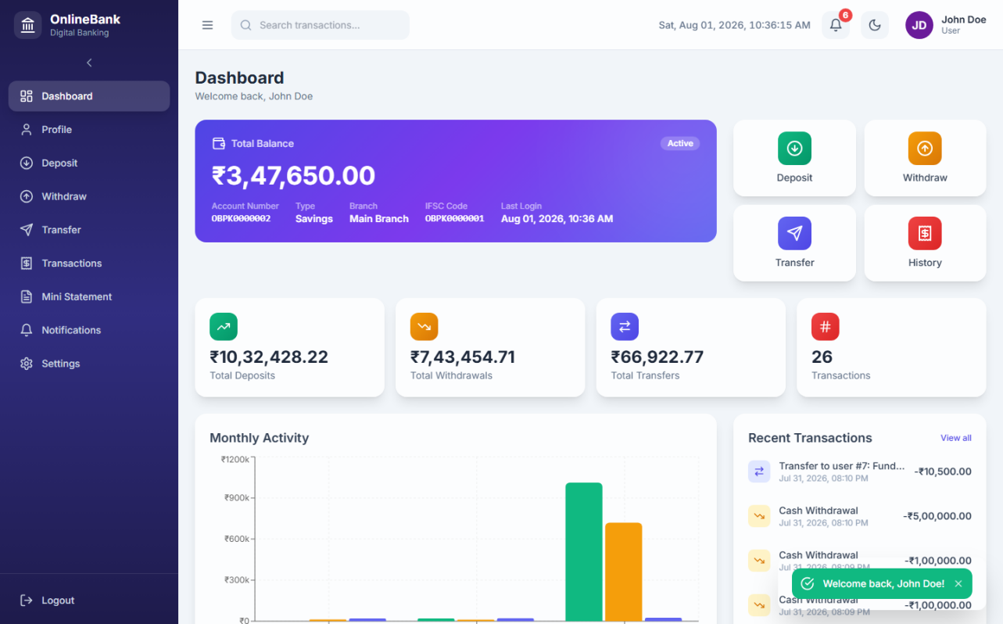
User Dashboard
The dashboard displays account balance, account details, a bar chart of monthly transaction activity, transaction statistics cards, and quick action buttons.

Figure 9.5 — Deposit Page
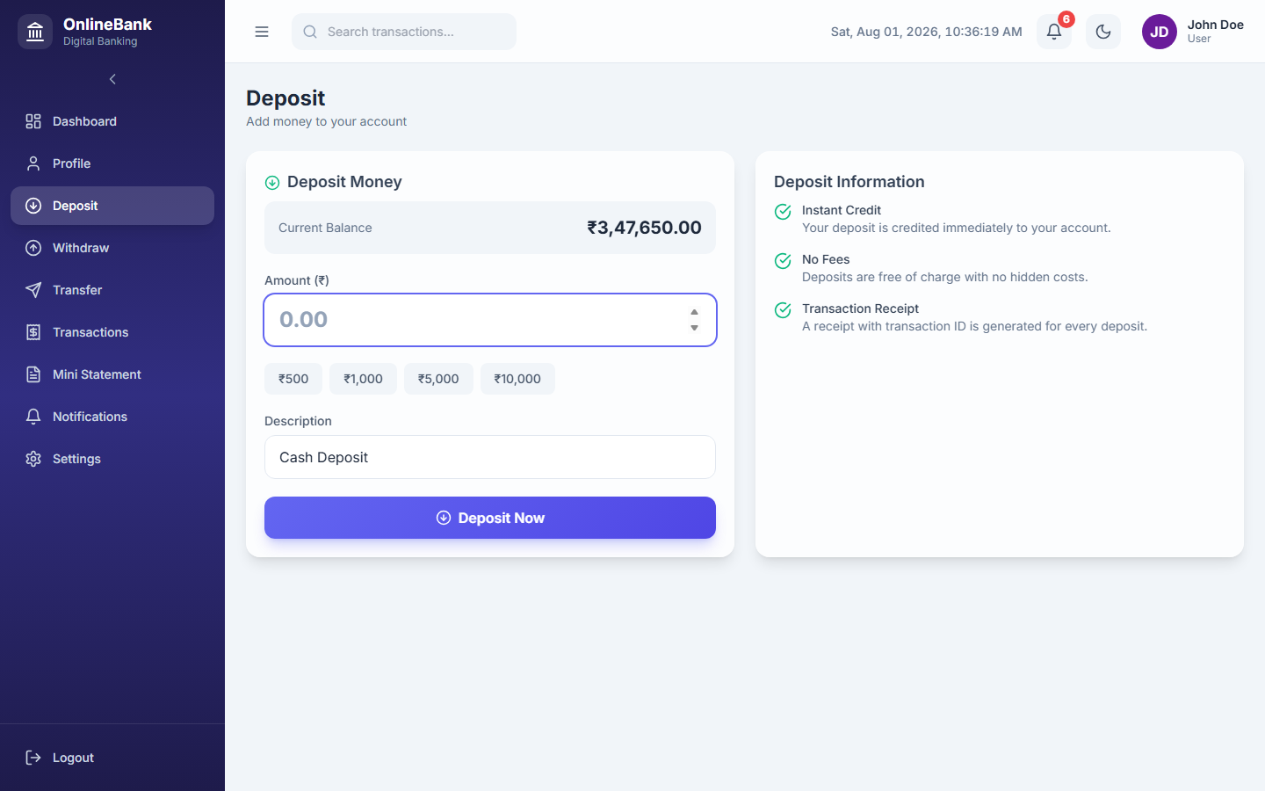
Deposit Page
Users enter an amount and optional description to credit their account. Quick-select amount buttons are provided for convenience.

Figure 9.6 — Withdraw Page
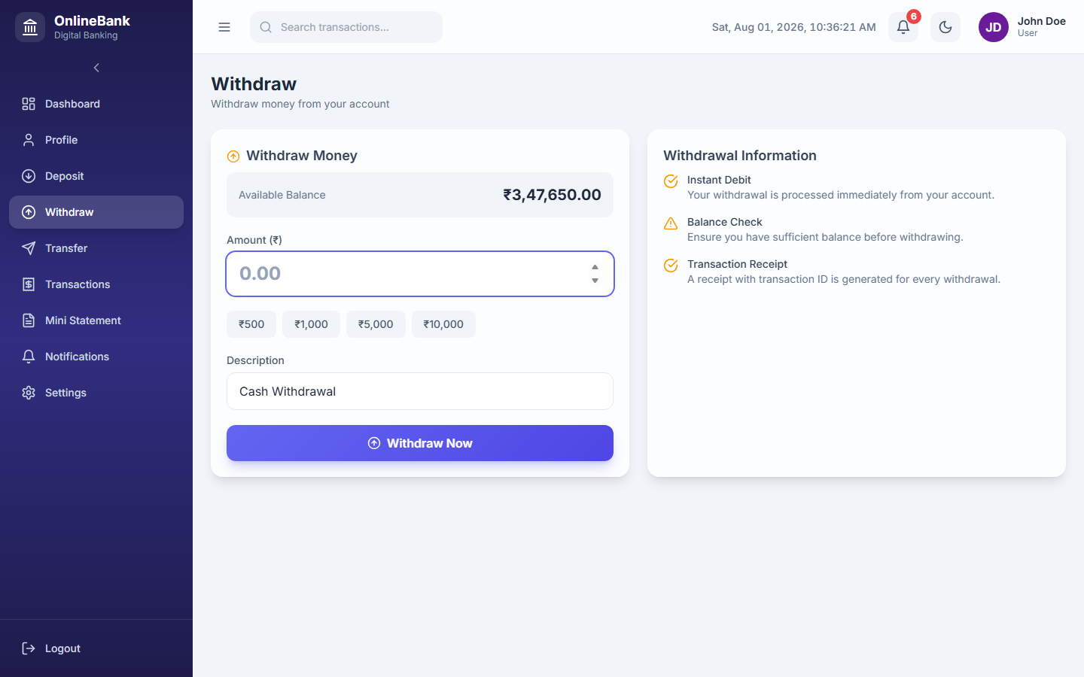
Withdraw Page
Users enter a withdrawal amount. The system validates the amount against the current balance and rejects the request if funds are insufficient.

Figure 9.7 — Fund Transfer Page
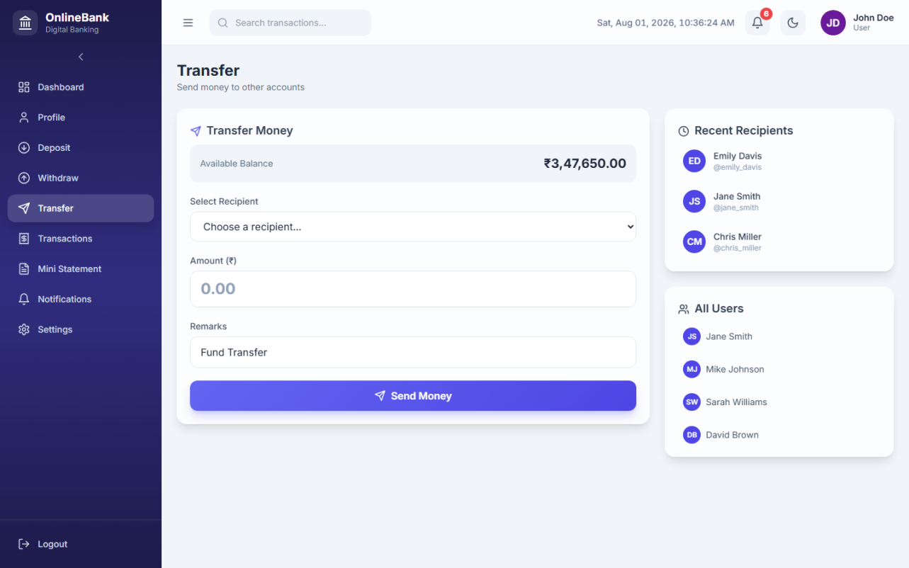
Fund Transfer Page
Users select a recipient from the list of active users, enter an amount and remarks. The system prevents self-transfers and checks the sender’s balance before proceeding.

Figure 9.8 — Transaction History Page
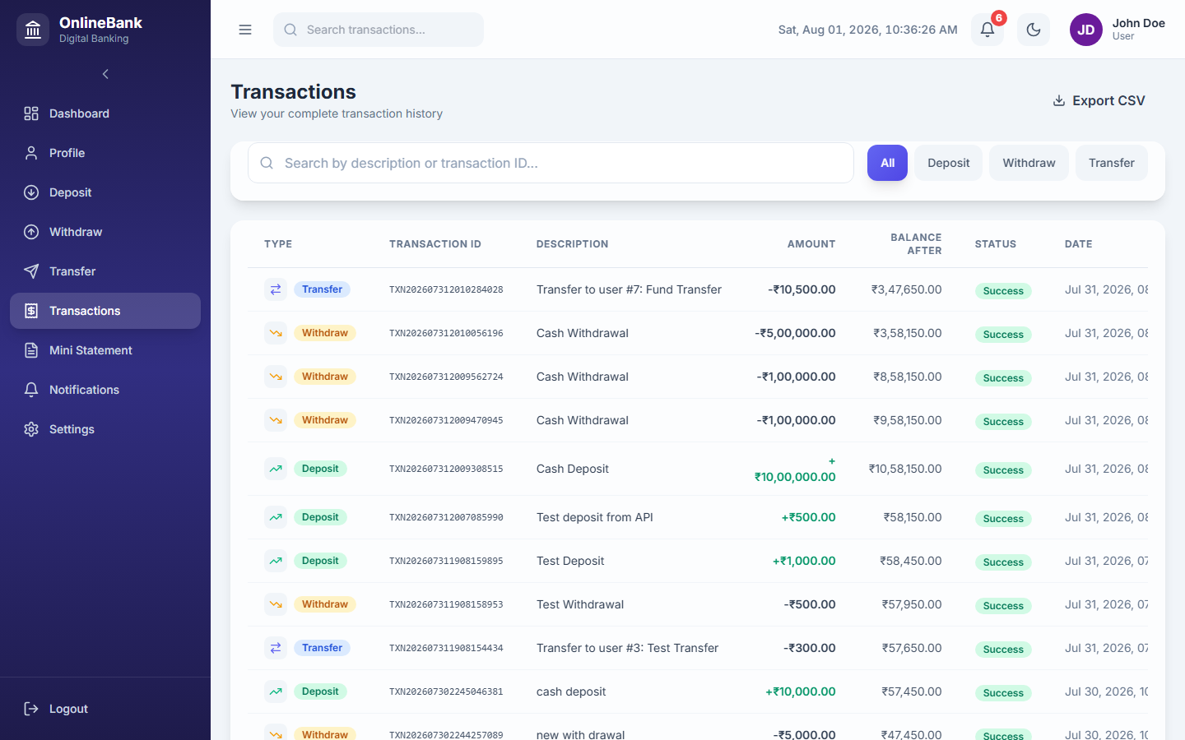
Transaction History Page
Full paginated transaction list with filter controls for transaction type (All, Deposit, Withdraw, Transfer) and a keyword search field.

Figure 9.9 — Mini Statement Page
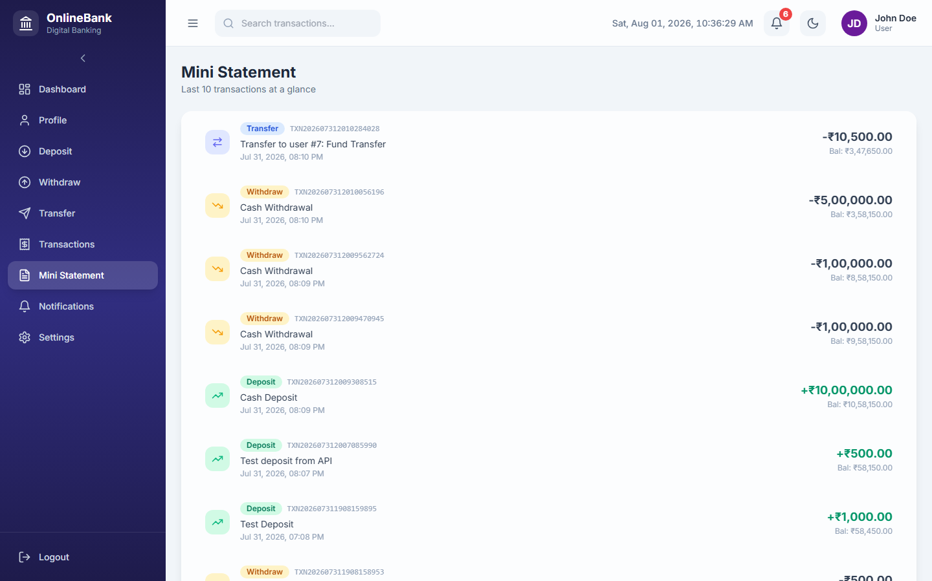
Mini Statement Page
Displays the most recent 10 transactions for the logged-in user in a compact, printable format.

Figure 9.10 — Notifications Page
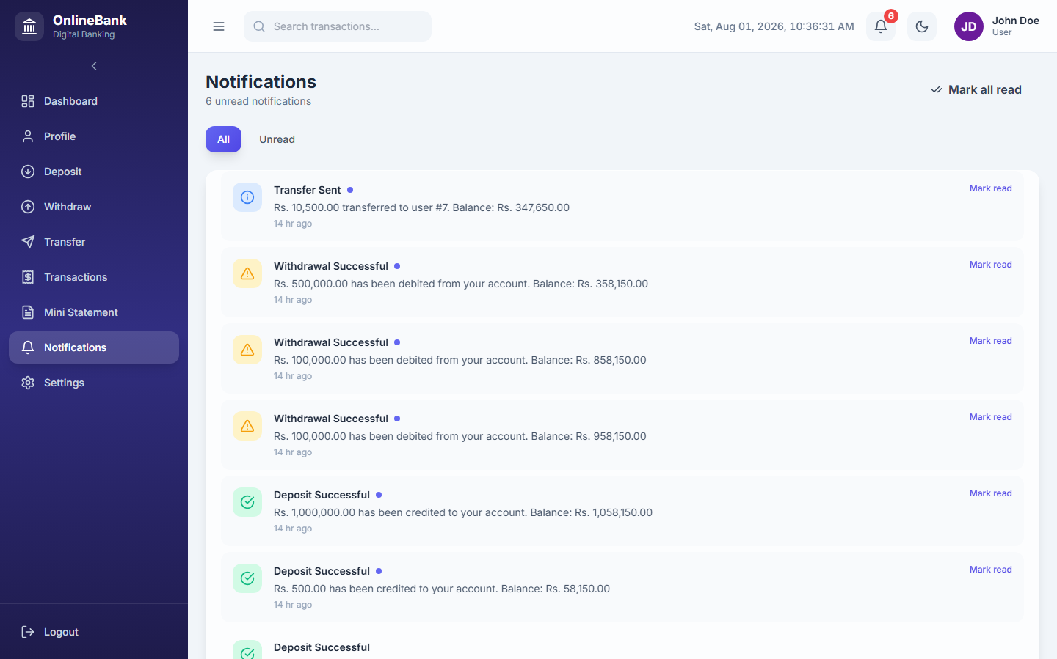
Notifications Page
All system notifications are listed with category badges (info, success, warning), read/unread status, and timestamp. A “Mark all as read” button is provided.

Figure 9.11 — Profile Page
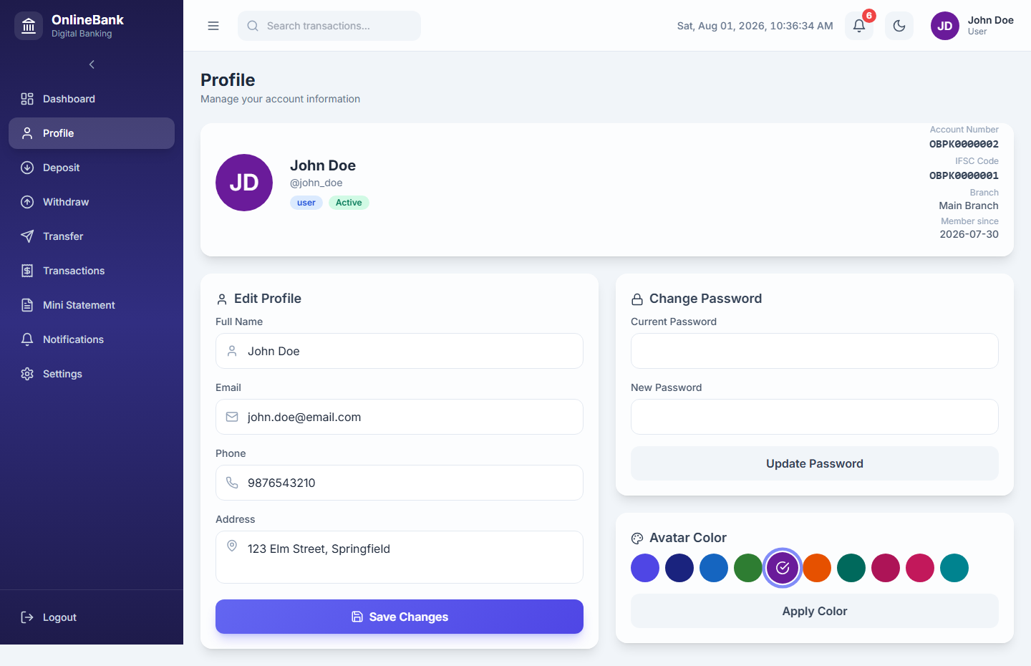
Profile Page
Users can update their full name, email, phone, and address. Avatar colour customisation is also available on this page.

Figure 9.12 — Settings Page
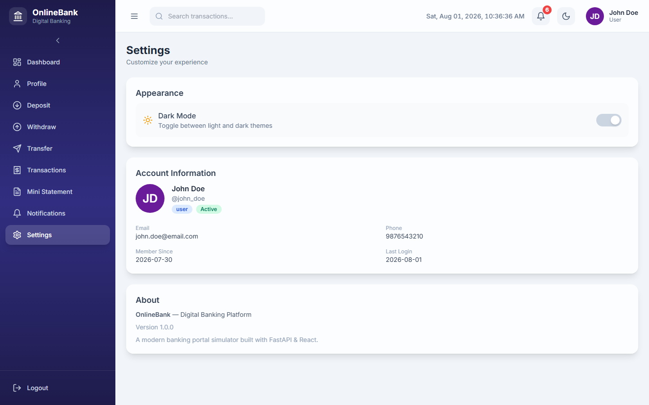
Settings Page
The settings page provides password change functionality, requiring the current password and enforcing a minimum length of 4 characters for the new password.

Figure 9.13 — Admin Panel — Dashboard
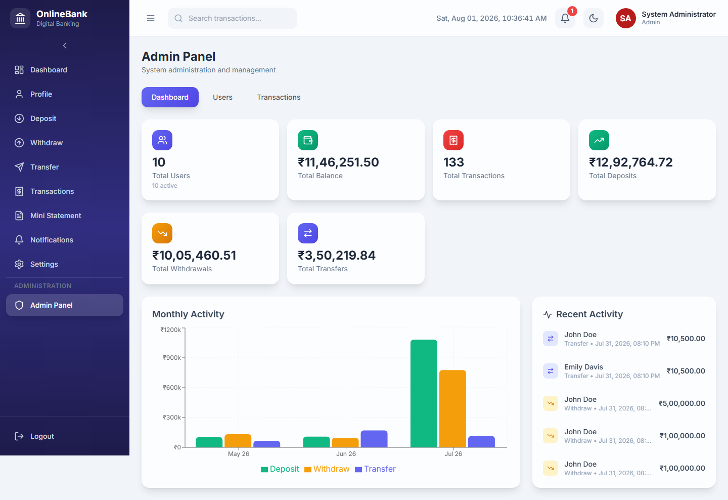
Admin Dashboard
The admin dashboard displays seven aggregate statistics (total users, active users, total deposits, withdrawals, transfers, total balance, total transactions) and a monthly activity bar chart.

Figure 9.14 — Admin Panel — User Management
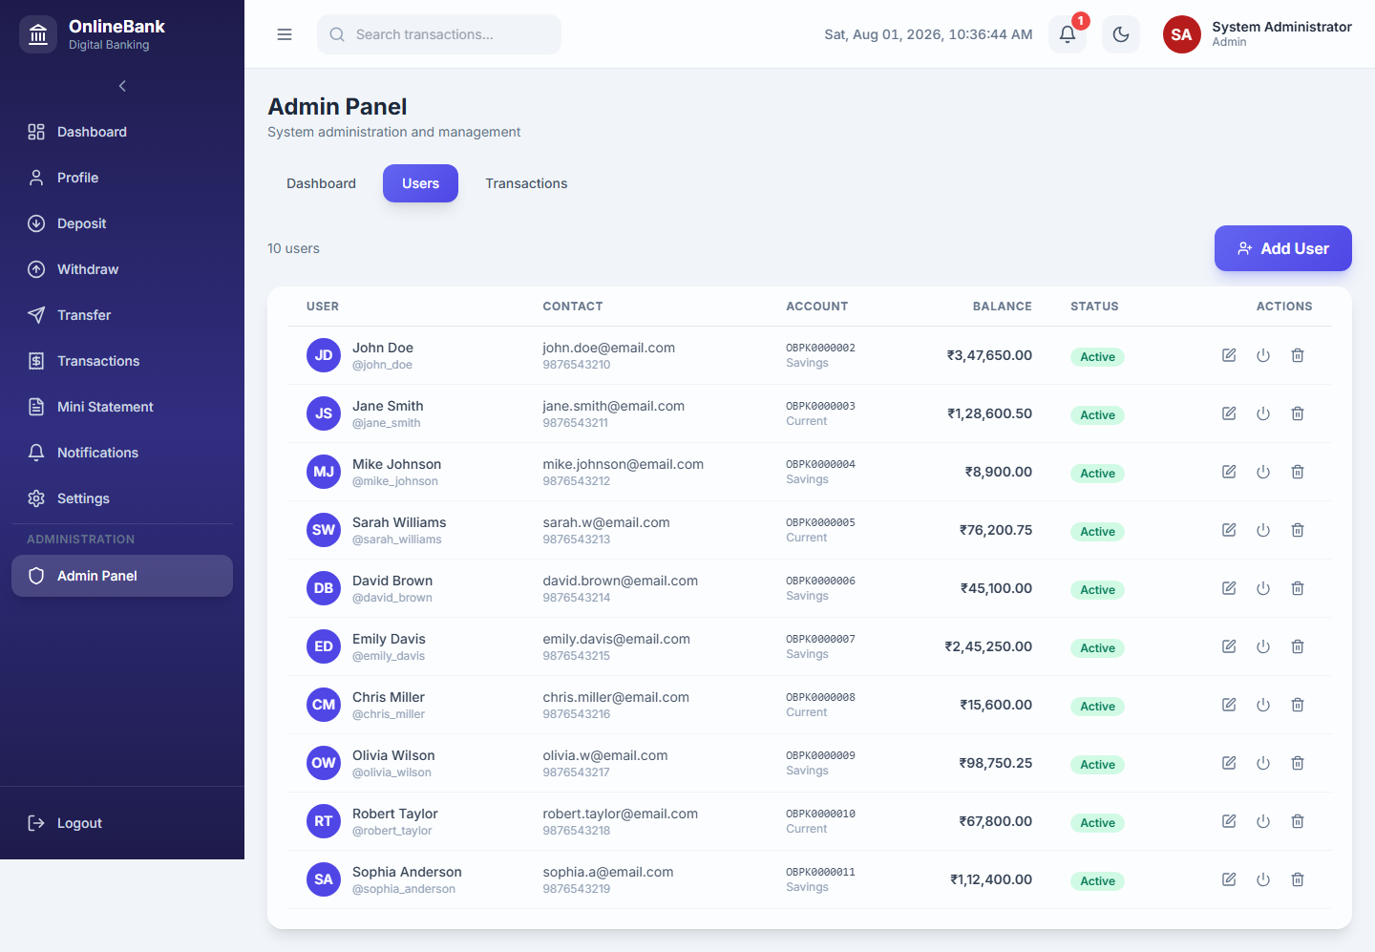
Admin User Management
The user management table lists all registered users with their account type, balance, active status, and last login. Admins can add, edit, activate/deactivate, or delete users.

Figure 9.15 — Admin Panel — All Transactions
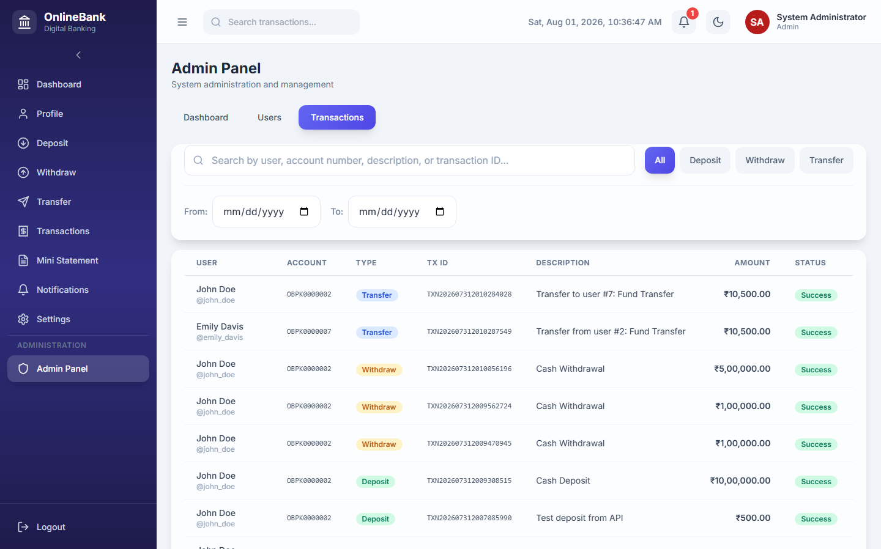
Admin All Transactions
The global transaction explorer shows all transactions across all users with filters for type, keyword search, and date range.

Chapter 10 — Testing
Table 10.1 — Test Cases
Test ID | Scenario | Input | Expected Output | Actual Output | Status
TC-01 | Valid user login | username: john_doe, password: password123 | JWT token issued; redirect to Dashboard | Token issued; Dashboard loaded | PASS
TC-02 | Invalid password login | username: john_doe, password: wrongpass | Error: “Invalid username or password.” | Error message displayed | PASS
TC-03 | Login with deactivated account | Admin deactivates john_doe; login attempt | Error: “Your account has been deactivated.” | Error message displayed | PASS
TC-04 | Duplicate username registration | Register with existing username john_doe | Error: “Username already exists.” | Error message displayed | PASS
TC-05 | Valid deposit | Amount: ₹5,000, desc: “Salary Credit” | Balance increases by 5,000; notification created | Balance updated; notification shown | PASS
TC-06 | Deposit with zero amount | Amount: 0 | Error: “Amount must be greater than zero.” | Error message displayed | PASS
TC-07 | Valid withdrawal within balance | Amount: ₹1,000 (balance: ₹52,450) | Balance decreases to ₹51,450; notification created | Balance updated; notification shown | PASS
TC-08 | Withdrawal exceeding balance | Amount: ₹100,000 (balance: ₹52,450) | Error: “Insufficient balance for this withdrawal.” | Error message displayed | PASS
TC-09 | Valid fund transfer | Sender: john_doe, Receiver: jane_smith, Amount: ₹2,000 | Sender balance decreases; receiver balance increases; both notified | Balances updated; notifications created | PASS
TC-10 | Self-transfer attempt | Receiver = same user as sender | Error: “Cannot transfer to your own account.” | Error message displayed | PASS
TC-11 | Transfer with insufficient balance | Amount exceeds sender balance | Error: “Insufficient balance for this transfer.” | Error message displayed | PASS
TC-12 | Admin deactivates user | Admin toggles is_active = 0 for a user | User status changes to Inactive; account status set to Inactive | Status updated in DB and UI | PASS
TC-13 | Admin deletes user | Admin deletes sophia_anderson | User, account, transactions, notifications, login history all removed | Cascading delete confirmed | PASS
TC-14 | Password change — wrong old password | Old password: incorrect value | Error: “Current password is incorrect.” | Error message displayed | PASS
TC-15 | Password change — short new password | New password: “ab” (2 chars) | Error: “New password must be at least 4 characters long.” | Error message displayed | PASS
TC-16 | Forgot password — correct credentials | username: john_doe, email: john.doe@email.com | Temporary password reset123 shown | Temp password returned in response | PASS
TC-17 | Non-admin accessing admin endpoint | Regular user calls GET /api/admin/stats | HTTP 403: “Admin access required” | 403 response returned | PASS
TC-18 | Unauthenticated access to protected endpoint | No Authorization header | HTTP 401: “Not authenticated” | 401 response returned | PASS

Chapter 11 — Conclusion and Future Scope

11.1 Conclusion
OnlineBank successfully demonstrates the design and implementation of a full-stack web-based digital banking portal. The system provides all core retail banking operations—account registration, login, balance enquiry, deposit, withdrawal, fund transfer, transaction history, mini-statement, and push notifications—within a clean single-page application. The backend is structured in four distinct layers (API routing, service logic, data models, and database access), which ensures separation of concerns and maintainability. The administrator panel offers complete user lifecycle management and aggregate system analytics. All 18 test cases described in Chapter 10 produce the expected results, validating the correctness of the business logic, authentication guards, and balance checks.

11.2 Future Scope
Enhancement | Description
Password hashing | Replace plaintext passwords with bcrypt or Argon2 hashes for production-grade security.
JWT with expiry | Replace the in-memory UUID token store with signed JWTs containing configurable expiry times.
Two-factor authentication | Add TOTP (time-based one-time password) as a second login factor.
Email / SMS notifications | Integrate an SMTP or SMS gateway (e.g., Twilio, SendGrid) to deliver notifications externally.
Cheque and NEFT modules | Add support for cheque book requests, NEFT/RTGS fund transfer modes, and beneficiary management.
Loan management | Implement loan applications, EMI calculations, and repayment tracking.
Mobile application | Build a React Native or Flutter mobile client consuming the same FastAPI REST backend.
PostgreSQL migration | Replace SQLite with PostgreSQL for concurrent multi-user production deployments.
Audit logging | Introduce an immutable audit log table for all admin actions with timestamps and actor IDs.
Spending analytics | Add category-wise expenditure analysis and monthly budget tracking for users.

References
- FastAPI Official Documentation — https://fastapi.tiangolo.com/
- Uvicorn Documentation — https://www.uvicorn.org/
- React Official Documentation — https://react.dev/
- React Router DOM Documentation — https://reactrouter.com/
- Axios Documentation — https://axios-http.com/
- Recharts Documentation — https://recharts.org/
- Vite Official Documentation — https://vitejs.dev/
- TailwindCSS Documentation — https://tailwindcss.com/
- SQLite Official Documentation — https://www.sqlite.org/docs.html
- Python sqlite3 Module — https://docs.python.org/3/library/sqlite3.html
- Lucide React — https://lucide.dev/
- Pandoc — https://pandoc.org/

Appendix — Folder Structure
OnlineBank/
├── api.py # FastAPI application — all REST endpoints
├── bank.db # SQLite database file
├── requirements.txt # Python dependencies
├── setup.bat # One-click setup script (Windows)
├── start.bat # One-click start script (Windows)
├── README-SETUP.txt # Setup instructions
├── capture_screenshots.py # Screenshot automation script (report asset)
│
├── database/
│ ├── __init__.py
│ └── db.py # DB connection, table creation, demo data seed
│
├── models/
│ ├── __init__.py
│ ├── user.py # User data class
│ ├── account.py # Account data class
│ ├── transaction.py # Transaction data class
│ └── notification.py # Notification data class
│
├── services/
│ ├── __init__.py
│ ├── auth_service.py # Login, register, forgot password, login history
│ ├── account_service.py # Profile, password change, avatar colour
│ ├── transaction_service.py # Deposit, withdraw, transfer, stats, charts
│ ├── notification_service.py# Create/retrieve/mark-read notifications
│ └── admin_service.py # Admin stats, user CRUD, global transactions
│
├── utils/
│ ├── __init__.py
│ └── helpers.py # generate_account_number, generate_transaction_id,
│ # format_currency, validate_amount, time_ago, etc.
│
├── documents/
│ ├── OnlineBank_Project_Report.md # This report (Markdown source)
│ ├── OnlineBank_Project_Report.docx # Compiled Word document
│ └── images/
│ ├── 01-login.png
│ ├── 02-register.png
│ ├── 03-forgot-password.png
│ ├── 04-dashboard.png
│ ├── 05-deposit.png
│ ├── 06-withdraw.png
│ ├── 07-transfer.png
│ ├── 08-transactions.png
│ ├── 09-mini-statement.png
│ ├── 10-notifications.png
│ ├── 11-profile.png
│ ├── 12-settings.png
│ ├── 13-admin-dashboard.png
│ ├── 14-admin-users.png
│ ├── 15-admin-transactions.png
│ ├── arch_diagram.png # Rendered: System Architecture
│ ├── usecase_diagram.png # Rendered: Use Case Diagram
│ ├── er_diagram.png # Rendered: ER Diagram
│ ├── dfd_diagram.png # Rendered: Data Flow Diagram
│ └── sequence_transfer.png # Rendered: Sequence Diagram
│
└── frontend/
├── package.json
├── vite.config.js
├── tailwind.config.js
├── postcss.config.js
├── index.html
└── src/
├── main.jsx # React entry point
├── App.jsx # Route definitions
├── index.css # Global styles + Tailwind directives
├── api/ # Axios instance and API call wrappers
├── context/
│ └── AuthContext.jsx # Auth state (user, token), login/logout
├── components/
│ ├── Layout.jsx # Sidebar + top bar shell
│ ├── ProtectedRoute.jsx # Route guard (login + admin checks)
│ └── ui/ # Reusable UI components (Spinner, Card, etc.)
└── pages/
├── Login.jsx
├── Register.jsx
├── ForgotPassword.jsx
├── Dashboard.jsx
├── Deposit.jsx
├── Withdraw.jsx
├── Transfer.jsx
├── Transactions.jsx
├── MiniStatement.jsx
├── Notifications.jsx
├── Profile.jsx
├── Settings.jsx
└── AdminPanel.jsx

