BHARAT ELECTRONICS LIMITED (BEL)
Probationary Engineer (Electronics) — Question Paper
Exam Date: 20 December 2025 • Total Questions: 125 • General Aptitude (12) | Reasoning (13) | Electronics Engineering (100)

SECTION I: GENERAL APTITUDE (Questions Q.1 – Q.12)

Q.1 If 30 workers earn ₹4,000 in 3 days, how much (in ₹) will 54 workers earn in 6 days?
(A) ₹14,150 (B) ₹13,900
(C) ₹14,600 (D) ₹14,400

Q.2 During a sale, 44% of the goods are sold at a profit of 28%, 25% of the remaining goods are sold at a profit of 48%, and the rest are sold at a loss of 13%. All items have the same cost price. If there is an overall profit of x%, then what is the value of x?
(A) 19.29 (B) 15.38
(C) 20.29 (D) 13.58

Q.3 A scooter travelling at two-third of its actual speed covers 66 km in 1 hr 6 mins. Find the actual speed of the scooter.
(A) 80 km/hr (B) 75 km/hr
(C) 90 km/hr (D) 96 km/hr

Q.4 X varies inversely as Y and Y varies inversely as Z. In a particular case, X = 1/5 and Z = 1/10. What will be the value of X, when Z = 8?
(A) 15 (B) 16
(C) 19 (D) 17

Q.5 The sum of two numbers is 49, and their LCM is 70. The two numbers are:
(A) 19, 30 (B) 14, 35
(C) 12, 37 (D) 7, 42

Q.6 The LCM of the numbers 18, 78 and 49 is:
(A) 11466 (B) 11526
(C) 11486 (D) 11506

Q.7 A class of 75 students took a Physics test. 22 students had an average score of 90. The other students had an average score of 70. What is the average score (rounded off to one decimal place) of the whole class?
(A) 73.6 (B) 75.9
(C) 83.1 (D) 72.3

Q.8 The ratio of the heights of a right circular cone and a right circular cylinder is 8 : 3, and the ratio of the radii of their bases is 9 : 2. If the volume of the cylinder is 792 cm³, then the volume (in cm³) of the cone is:
(A) 14246 (B) 14256
(C) 14249 (D) 14257

Q.9 The cost of a washing machine is 40% less than the cost of a TV. If the cost of the washing machine increases by 73% and that of the TV decreases by 67%, then what is the percentage change in the total cost of 5 washing machines and 2 TVs?
(A) Decrease by 18% (B) Decrease by 24%
(C) Increase by 17% (D) Increase by 19%

Q.10 During a Big Billion Day sale, a flagship mobile phone was available at a 20% discount on an e-commerce platform. Customers purchasing for the first time on the platform received an additional 10% cashback on the billing amount. Suraj, being a first-time user, purchased the mobile phone for ₹36,000. Find the original marked price (in ₹) of the mobile phone.
(A) 49,500 (B) 45,000
(C) 50,000 (D) 48,500

Q.11 Mohan has two grandsons, Pramod and Ashish. 14-year-old Pramod gets some money from Mohan’s wealth, and 15-year-old Ashish gets the rest of the money. But Pramod and Ashish will get the money only when they turn 23 years old. Till then, the money is in a bank getting interest at the rate of 8% per annum, compounded annually. When both turn 23, they receive the same amount. How much (in ₹) had Mohan given Ashish initially, if the total money with Mohan was ₹24,700?
(A) 11,625 (B) 12,825
(C) 13,175 (D) 11,875

Q.12 Sujit is three times as old as his son, and his daughter is 3 years younger than the son. If the sum of the ages of these three people 3 years ago was 63 years, then Sujit's present age (in years) is:
(A) 85 (B) 45
(C) 36 (D) 54

SECTION II: REASONING (Questions Q.1 – Q.13)

Q.1 Each of the digits in the number 5976248 is arranged in descending order from left to right. The positions of how many digits will remain unchanged as compared to those in the original number?
(A) Three (B) One
(C) None (D) Two

Q.2 What should come in place of ? in the given series based on the English alphabetical order?
DZD HWI LTN PQS ?
(A) HGT (B) DFR
(C) TNX (D) BGF

Q.3 In a certain code language, ‘SONG’ is coded as ‘6423’ and ‘ONES’ is coded as ‘2648’. How is ‘E’ coded in that language?
(A) 2 (B) 6
(C) 4 (D) 8

Q.4 Seven boxes, Q, R, S, T, G, H and I, are kept one over the other, but not necessarily in the same order. Only H is kept above I. Only T is kept between S and Q. Only G is kept below S.
How many boxes are kept between R and G?
(A) One (B) Two
(C) None (D) Three

Q.5 Refer to the following letter and symbol series and answer the question that follows. Counting to be done from left to right only.
(Left) N Z \ D J J G % W C U B F E Q \ G V # C S (Right)
How many such symbols are there each of which is immediately preceded by a letter and also immediately followed by a symbol?
(A) Three (B) None
(C) Two (D) One

Q.6 Based on the English alphabetical order, three of the following four letter- cluster pairs are alike in a certain way and thus form a group. Which letter- cluster pair DOES NOT belong to that group?
(Note: The odd one out is not based on the number of consonants/vowels or their position in the letter-cluster.)
(A) TU-WX (B) CE-GI
(C) EG-IK (D) JL-NP

Q.7 Refer to the given letter series and answer the question that follows. Counting to be done from left to right only.
(Left) Q C Y B H I N M K O P G D A W E D C T U I T (Right)
How many such consonants are there, each of which is immediately preceded by a vowel and also immediately followed by a vowel?
(A) Two (B) More Than Two
(C) None (D) One

Q.8 LQ 22 is related to HN 5 in a certain way. In the same way, KR 19 is related to GO 2. To which of the following is GH 16 related, following the same logic?
(A) CE -1 (B) CD -5
(C) BE -5 (D) BD -1

Q.9 Based on the English alphabetical order, three of the following four letter- clusters are alike in a certain way and thus form a group. Which letter-cluster DOES NOT belong to that group?
(Note: The odd one out is not based on the number of consonants/vowels or their position in the letter-cluster.)
(A) RXT (B) NTP
(C) LRM (D) PVR

Q.10 Select the pair which follows the same pattern as that followed by the two sets of pairs given below. Both pairs follow the same pattern.
QPI : PMJ
DTN : CQO
(A) RPI : QMI (B) PMS : OJT
(C) MQE : LNE (D) IMH : HII

Q.11 Seven people F, G, H, I, V, W, and X are sitting in a straight line facing north. Only two people sit between G and W. Only X sits to the right of H. Only one person sits between W and H. I sits at some place to the right of F and at some place to the left of V. How many people sit between V and F?
(A) Two (B) One
(C) Four (D) Three

Q.12 Each vowel in the word MINDFUL is changed to the letter immediately following it in the English alphabetical order and each consonant is changed to the letter immediately preceding it in the English alphabetical order.
How many vowels are there in the group of letters thus formed?
(A) None (B) Three
(C) One (D) Two

Q.13 What will come in place of the question mark (?) in the following equation, if ‘+’ and ‘−’ are interchanged and ‘×’ and ‘÷’ are interchanged?
4 ÷ 2 + 6 × 3 − 4 = ? + 16
(A) 22 (B) 24
(C) 28 (D) 26

SECTION III: ELECTRONICS ENGINEERING (Questions Q.1 – Q.100)

Q.1 The system has an impulse response defined by h(t) = sin(5t). Which of the following statements correctly describes the system?
(A) System cannot be classified without the input signal.
(B) System is causal because h(t) is defined for all t.
(C) The system is non-causal because h(t) is non-zero for t < 0
(D) System is causal because h(t) is always bounded between -1 and 1.

Q.2 Which of the following statements is correct in the context of the superheterodyne (SHD) receiver?
S1: The intermediate frequency for FM radio in a SHD receiver is 455 kHz.
S2: The first section in a SHD receiver is frequency converter.
S3: The purpose of the RF section in a SHD receiver is to pick up the desired station.
(A) S1 and S3 only (B) S1, S2 and S3
(C) S1 and S2 only (D) S3 only

Q.3 The charge neutrality condition in a semiconductor states that:
(A) The net density of negative charges is less than the net density of positive charges.
(B) The net density of negative charges is equal to the net density of positive charges.
(C) The net density of negative charges is greater than the net density of positive charges.
(D) The net density of negative charges is always equal to zero.

Q.4 A unity-feedback system has open-loop transfer function:
G(s)H(s) = K(s + 1) / (s² + 4s + 13)
What is the angle of arrival (in degrees) of the root locus at the zero z = −1?
(A) 270° (B) 90°
(C) 0° (D) 180°

Q.5 Consider the two-port network shown. Port 1 is excited by V₁ = 2∠30° V and Port 2 is short-circuited (V₂ = 0). Determine the input current I₁ and the output current I₂.
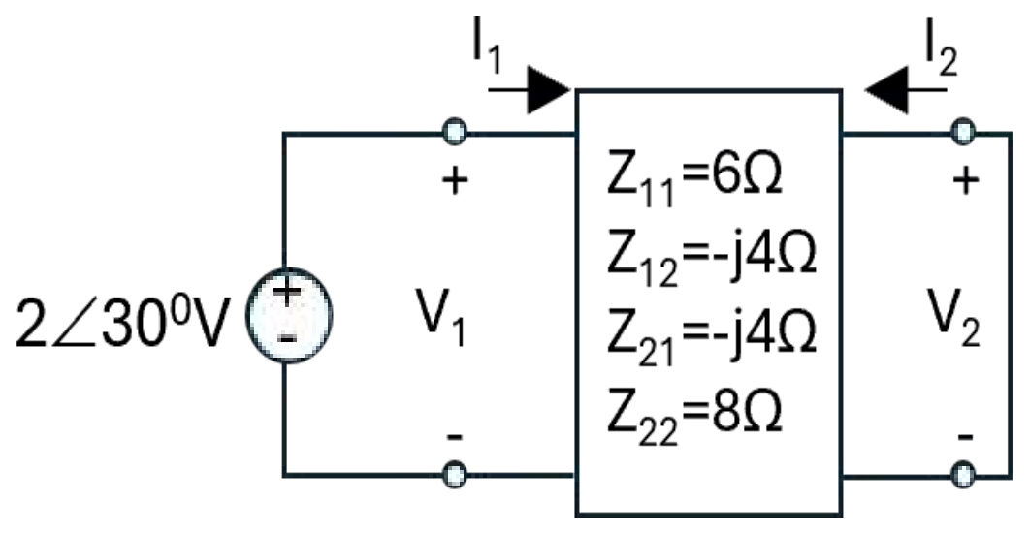
(A) I₁ = 0.25∠(−30°) A, I₂ = 0.125∠60° A
(B) I₁ = 0.25∠30° A, I₂ = 0.125∠120° A
(C) I₁ = 0.333∠30° A, I₂ = 0
(D) I₁ = 0.25∠30° A, I₂ = 0.125∠(−60°) A

Q.6 A series R–L–C circuit is excited by a sinusoidal source with frequency ω below its resonant frequency ω₀. What is the nature of the circuit and the phase relationship between the supply voltage and the current?
(A) Inductive circuit; current lags the voltage
(B) Capacitive circuit; current leads the voltage
(C) Purely resistive circuit; current is in phase with the voltage
(D) Inductive circuit; current leads the voltage

Q.7 A silicon photodiode has a responsivity of 0.6 A/W at a certain wavelength. If the incident optical power is 2 milliwatts, then what is the photocurrent generated?
(A) 0.6 µA (B) 1.2 mA
(C) 3.2 mA (D) 1.2 µA

Q.8 If a first-order low-pass active filter has a cut-off frequency of 2 KHz and a passband gain of 20, the gain (approximately) at frequency 2 KHz is ______.
(A) 28 (B) 20
(C) 14 (D) 2

Q.9 Match the following columns with reference to various regions of operation of the MOS capacitor with p-substrate.
Regions of operation Condition or validity
I- Accumulation A- Gate voltage much greater than threshold voltage
II- Depletion B- Gate voltage less than zero
III- Inversion C- Gate voltage greater than zero but less than threshold voltage
(A) I-A II- B III- C (B) I-A II- C III- B
(C) I-C II- B III- A (D) I-B II- C III- A

Q.10 A PAL can implement functions in sum-of-products form. For the Boolean function: F(A, B, C, D) = Σm(0, 1, 2, 4, 5, 6, 8, 9, 10, 12, 13, 14)
What is the minimum number of product terms required to implement F using a PAL, after Karnaugh map minimization?
(A) 4 (B) 1
(C) 2 (D) 3

Q.11 Which of the given statements is/are correct in the context of a direct coupling in a multistage amplifier?
S1: Direct coupling is suited for amplifying AC signals with frequencies as a fraction of hertz.
S2: It can amplify direct current as a DC amplifier.
S3: Q point of the BJT in a direct coupling multistage amplifier is not affected by the temperature variation.
(A) S1, S2 and S3 (B) S1 and S3 only
(C) S1 and S2 only (D) S2 and S3 only

Q.12 Which of the following statements is correct in the context of the AM envelope detector circuit?
S1: It is suitable only if the modulation index is > 1.
S2: It works only if the carrier is present.
S3: It is a type of synchronous detector.
(A) Only S2 and S3 (B) Only S1 and S3
(C) Only S2 (D) S1 and S2 only

Q.13 What is the typical current profile of a TTL output driver when switching from low to high?
(A) Current spikes up as the output switches and then gradually decreases.
(B) No current is drawn during the transition.
(C) Current remains constant throughout the transition.
(D) The current first decreases, then increases.

Q.14 For a certain sequence detector, the designer uses a Mealy FSM instead of a Moore FSM. What is the most likely reason for this choice?
(A) The detector requires faster output response upon input pattern recognition.
(B) The detector needs to minimise power.
(C) Moore FSMs cannot detect input sequences.
(D) The machine produce output only after the entire sequence is detected.

Q.15 Which of the following options is correct for a modulated signal s(t) = e^{−at} cos[(w_{c} + Δw)t] u(t), where a, w_{c} and Δw are non-negative constant? Assume w_{c} >> Δ.
(A) Complex envelope of S(t) is e^{at} u(t) e^{−jΔwt}
(B) Complex envelope of S(t) is e^{−at} u(t) e^{jΔwt}
(C) Complex envelope of S(t) is e^{−at} u(t) e^{−jΔwt}
(D) Complex envelope of S(t) is e^{at} u(t) e^{jΔwt}

Q.16 At absolute zero temperature (0 K), an intrinsic semiconductor behaves as a/an _____________ and has ideally _______________.
(A) Insulator, infinite resistivity (B) Conductor, infinite resistivity
(C) Conductor, zero resistivity (D) Insulator, zero resistivity

Q.17 A digital filter is required to satisfy the following specifications:
a) Exactly linear phase
b) Sharp transition band
c) Stable response even if coefficient quantization occurs
Which of the given filter architecture is the most appropriate?
(A) Direct-form IIR Chebyshev Type-I filter
(B) Long-length optimal equiripple FIR filter
(C) Long-length FIR filter using rectangular window
(D) Cascade-form IIR elliptic filter

Q.18 If a continuous-time signal x(t) has non-zero continuous spectrum only for f ≤ 3 kHz, what happens if it is sampled at f_{s} = 5 kHz?
(A) Oversampling
(B) Perfect reconstruction of the signal
(C) Undersampling and aliasing
(D) Time scaling

Q.19 Which of the following is the key characteristic of a Field-Programmable Gate Array (FPGA) that distinguishes it from a Complex Programmable Logic Device (CPLD) in terms of architecture?
(A) FPGAs are primarily used for implementing simple, fast logic, while CPLDs are used for complex, multi-core designs.
(B) FPGAs typically have a coarse-grained, logic-block based architecture, while CPLDs have a fine-grained, array-based architecture.
(C) FPGAs use a hierarchy of configurable logic blocks and programmable routing, whereas CPLDs use a single, large programmable AND-OR plane.
(D) FPGAs use an array of interconnected macrocells, while CPLDs use Look-Up Tables (LUTs).

Q.20 A solid sphere of radius R has a volume charge density given by:
ρ_{v}(r) = ρ₀(1 − r/R), 0 ≤ r ≤ R,
where r is the distance from the center. What is the total charge Q of the sphere?
(A) (π / 6) ρ₀ R³ (B) (π / 2) ρ₀ R³
(C) (π / 12) ρ₀ R³ (D) (π / 3) ρ₀ R³

Q.21 Two perfect dielectric media are separated by a charge-free planar boundary.
Their relative permittivities are: ε_{r1} = 6, ε_{r2} = 2.
In medium 1, the electric field at a point P has magnitude E₁ = 100 V/m and makes an angle α₁ = 60° with the normal to the boundary. Under electrostatic conditions, the angle α₂ in medium 2 and the magnitude E₂ are __________.
(A) α₂ = 45°, |E₂| = 100√3 V/m (B) α₂ = 45°, |E₂| = 100/3 V/m
(C) α₂ = 30°, |E₂| = 100√3 V/m (D) α₂ = 30°, |E₂| = 100/3 V/m

Q.22 If x₁[n] ↔ X₁(z) and x₂[n] ↔ X₂(z), then for y[n] = 3x₁[n] − 2x₂[n], the Z-transform is:
(A) Y(z) = X₁(z) ⋅ X₂(z) (B) Y(z) = 3X₁(z) − 2X₂(z)
(C) Y(z) = X₁(z) + X₂(z) (D) Y(z) = 3X₁(z) ⋅ X₂(z)

Q.23 A single-stage common-emitter amplifier is modelled with h-parameters, h_{ie} = 1000 Ω, h_{fe} = 50, and h_{re} is negligible. The collector resistor is R_{c} = 4.7 KΩ and the amplifier drives a load R_{L} = 10 KΩ connected at the collector (i.e., collector sees in parallel with R_{L}). Neglect h_{oe} effects. The approximate midband voltage gain A_{v} = V_{o} / V_{i} is:
(A) −160 (B) −200
(C) −80 (D) −120

Q.24 In weakly stationary process, ____________________________.
(A) mean value is dependent of the shift of time origin
(B) autocorrelation function dependent on the shift of time origin
(C) wide-sense stationary process and weakly stationary process are not same
(D) mean value is constant

Q.25 The junction (transition) capacitance of the PN junction exists in _____ bias and it is _____ proportional to the width of the barrier.
(A) forward, inversely (B) reverse, inversely
(C) forward, directly (D) reverse, directly

Q.26 A 12-bit ADC with a full-scale range of 0 to 4.095 V receives an analog input of 2.5V. What is the corresponding digital output code in decimal form?
(A) 1250 (B) 3000
(C) 2500 (D) 2000

Q.27 Determine the wavelength of the light emitted by a LED if the frequency of operation for the LED is 400 THz.
(A) 500 nm (B) 600 nm
(C) 1000 nm (D) 750 nm

Q.28 The electric potential in a region is given by:
V(x, y, z) = 2x + 3y² − 4z volts.
At the point P(1, −1, 2), find the electric field vector E(P) in unit vector form (a_{x}, a_{y}, a_{z}).
(A) −2 a_{x} − 6 a_{y} + 4 a_{z} V/m (B) −2 a_{x} + 6 a_{y} + 4 a_{z} V/m
(C) −2 a_{x} + 6 a_{y} − 4 a_{z} V/m (D) +2 a_{x} − 6 a_{y} − 4 a_{z} V/m

Q.29 What is the result of a 4-bit ring counter which performs left shifting the 4-bit number 0100 three times to the left?
(A) 0010 (B) 0100
(C) 1000 (D) 0001

Q.30 An anti-causal discrete time system has the system function as
H(z) = 2 / [(1 − 0.4z⁻¹)(1 − 1.1z⁻¹)]
The system is _______________.
(A) unstable because ROC does not include the unit circle
(B) stable because ROC is inside the smallest magnitude pole
(C) always stable because ROC: |z| > 0.4
(D) always unstable because ROC: |z| > 1.1

Q.31 In unsigned multiplication of two 6-bit numbers, what is the maximum bit- length of the output?
(A) 7 (B) 11
(C) 6 (D) 12

Q.32 In a region of space, the magnetic field intensity is given by:
H(x, y, z) = y a_{x} − x a_{y}
Find the total current I flowing through the square surface in the xy-plane bounded by x = 0, x = 1, y = 0, and y = 1.
Assume the standard orientation: surface normal a_{n} = a_{z} (counter-clockwise boundary when viewed from +z).
(A) −1 A (B) −2 A
(C) +2 A (D) 0 A

Q.33 A medium has ε_{r} = 60, μ_{r} = 1, σ = 3 S/m.
Let f_{c} be the frequency at which the conduction current density equals the displacement current density, i.e. J_{c} = J_{d}. Using the rule of ten, where the higher frequency is 10 times f_{c} and the lower frequency is f_{c} / 10, estimate the frequency ranges in which the medium behaves as a good conductor and as a good dielectric.
(A) Good conductor: f ≲ 1 MHz; Good dielectric: f ≳ 100 MHz
(B) Good conductor: f ≲ 9 MHz; Good dielectric: f ≳ 900 MHz
(C) Good conductor: f ≲ 900 MHz; Good dielectric: f ≳ 90 GHz
(D) Good conductor: f ≲ 90 MHz; Good dielectric: f ≳ 9 GHz

Q.34 A transistor in common-emitter configuration is described by the small-signal h-parameters h_{ie} = 1 kΩ, h_{fe} = 100, h_{re} ≈ 0, and h_{oe} ≈ 0. A sinusoidal signal source of amplitude v_{s} = 0.20 V with source resistance R_{s} = 1 kΩ is connected between the base and emitter. Using the hybrid small-signal model based on these h-parameters, determine the amplitude of the small-signal collector current i_{c}. Select the correct option.
(A) 20 mA (B) 10 mA
(C) 50 mA (D) 5 mA

Q.35 A slab of perfect dielectric (ε_{r} = 2) is adjacent to air. Inside the slab, the normal electric field is sinusoidal:
E_{d}(t) = E₀ cos(ωt) a_{n}, with E₀ = 300 V/m.
Assume μ_{r} = 1, no free surface charge at the interface, and the field is normal to the surface. Which option correctly gives the amplitudes of the displacement current density J_{d} in the dielectric and in air, respectively?
(A) Both are zero
(B) Air value is twice the dielectric value
(C) Equal and non-zero (same value in both media)
(D) Dielectric value is twice the air value

Q.36 An AWGN channel operating at a large signal to noise ratio (SNR >> 1) and bandwidth F has capacity C. If the signal to noise is quadrupled keeping F constant, then the resulting capacity of the channel C₁ is ______________.
(A) C₁ = 4C (B) C₁ = C + 2F
(C) C₁ = C + F (D) C₁ = 2C

Q.37 The corresponding minterm Boolean expression for 4-variable inputs A, B, C, and D, using the minterms m₃, m₄, and m₇, is ___________________.
(A) Y = A̅ B̅ C̅ D + A̅ B̅ C D̅ + A̅ B C D
(B) Y = A̅ B̅ C D + A̅ B C̅ D̅ + A̅ B C D
(C) Y = A B C D + A̅ B C̅ D̅ + A̅ B C D
(D) Y = A̅ B̅ C D̅ + A̅ B C D̅ + A̅ B̅ C D̅

Q.38 In a synchronous binary counter, what is the primary characteristic that distinguishes it from an asynchronous counter?
(A) The ability to count in decimal.
(B) All flip-flops are clocked simultaneously.
(C) The use of fewer flip-flops.
(D) Lower power consumption.

Q.39 The system is described by the equation, y(t) = x(t) + 3 x(t - 1). The system is __________.
(A) Causal and stable (B) Causal but unstable
(C) Non-causal but stable (D) Unsable and non-causal

Q.40 Which of the following statements is/are correct in the context of the encoding in a PCM system?
S1: A signal sampled at 8kHz in to 256 quantisation levels is encoded with 8 bits/sample.
S2: The basic function of an encoder in PCM is to convert quantised signal into a binary code sequence.
S3: The number of quantisation levels does not affect the encoding in a PCM system.
(A) S3 and S2 only (B) S1 and S3 only
(C) S1, S2 and S3 (D) S1 and S2 only

Q.41 Choose the correct statement for the encoding in a Pulse Code Modulation system?
S1: A signal sampled at 4kHz in to 32 quantization levels is encoded with 5 bits/sample.
S2: The basic function of an encoder is to convert quantized signal into a binary code sequence.
S3: The number of quantization levels does affect the encoding in Pulse Code Modulation system.
(A) S2 and S3 only (B) S1 and S3 only
(C) S1, S2 and S3 (D) S1 and S2 only

Q.42 A semi-infinite transmission line supports only a forward-traveling wave.
V(z) = V⁺ e^{−γz}, I(z) = (V⁺ / Z₀) e^{−γz}.
The line has Z₀ = 25 Ω and propagation constant
γ = α + jβ = (ln 2)/5 + j(π/15) per meter.
If the input voltage at z = 0 is V(0) = 50∠0° V, find the current at z = 5 m.
(A) 2∠0° A (B) 1∠+60° A
(C) 2∠−60° A (D) 1∠−60° A

Q.43 The small signal equivalent of a Zener diode in reverse breakdown region is represented by _____.
(A) series combination of a DC current source and dynamic capacitance
(B) shunt combination of a DC current source and dynamic inductance
(C) shunt combination of a DC voltage source and dynamic inductance
(D) series combination of a DC voltage source and small dynamic resistance

Q.44 A metal oxide semiconductor field effect transistor (MOSFET) is used in a self-biasing circuit with a drain resistor (R_{D}) and a source resistor (R_{S}). If the value R_{S} is increased, which of the following options is an immediate effect on the quiescent drain current (I_{DQ}) and the quiescent gate-source voltage (V_{GSQ})?
(A) I_{DQ} decreases, and V_{GSQ} becomes more negative.
(B) I_{DQ} increases, and V_{GSQ} increases.
(C) I_{DQ} decreases, and V_{GSQ} becomes more positive.
(D) I_{DQ} increases, and V_{GSQ} decreases.

Q.45 For a fixed (analog) spectrum continuous time signal x(t), increasing the DFT frequency samples corresponds to __________________ in the time domain.
(A) zero-padding (B) circular time shift
(C) time-scaling (D) signal compression

Q.46 An AC circuit has a voltage v(t) = 30 sin(ωt + 80°) V and a current i(t) = 10 sin(ωt + 50°) A. What are the apparent power (S) and reactive power (Q) of the circuit, respectively?
(A) S = 150 VA, Q = 75 VAR (B) S = 100 VA, Q = 50 VAR
(C) S = 150√2 VA, Q = 150 VAR (D) S = 150 VA, Q = 75√3 VAR

Q.47 Choose the correct statement.
S1: The intermediate frequency for AM radio in superheterodyne (SHD) receiver is 455 kHz.
S2: The first section in a superheterodyne (SHD) receiver is frequency converter.
S3: The purpose of RF section in a superheterodyne (SHD) receiver is to picks up the desired station.
(A) S1 and S2 only. (B) S1, S2 and S3.
(C) S2 and S3 only. (D) S1 and S3 only.

Q.48 A load resistor R_{L} is to be connected across a–b in the given circuit. For maximum power transfer to R_{L}, find the value of R_{L} and the maximum power delivered to it.
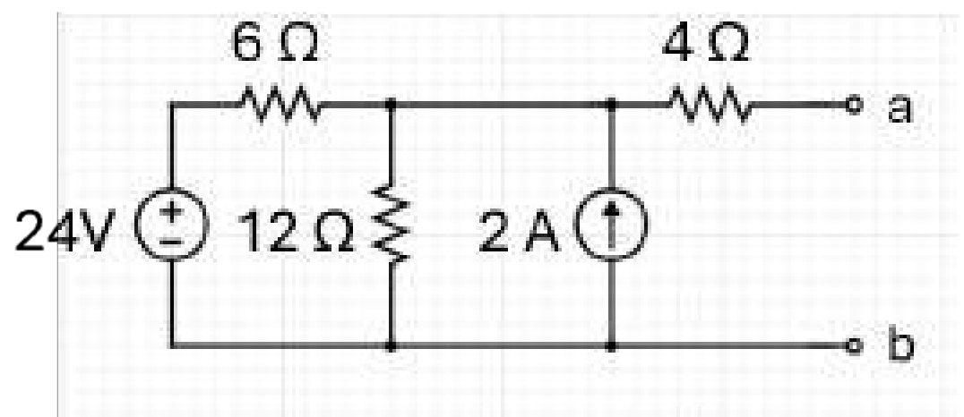
(A) R_{L} = 8 Ω, P_{max} = 12 W (B) R_{L} = 8 Ω, P_{max} = 18 W
(C) R_{L} = 6 Ω, P_{max} = 24 W (D) R_{L} = 4 Ω, P_{max} = 36 W

Q.49 Which of the given statements is/are correct in the context of a voltage- controlled oscillator?
S1: It is an oscillator whose frequency can be changed by a variable DC voltage.
S2: Voltage-controlled oscillator can produce a non-sinusoidal output only.
S3: Voltage-controlled sawtooth oscillator cannot be designed using UJT.
(A) S1, S2 and S3 (B) Only S1 and S3
(C) Only S2 and S3 (D) Only S1

Q.50 A unity negative-feedback system has an open-loop transfer function:
G(s) = K(s + z) / [s²(s + a)], where K > 0.
It is given that the system is unstable for every K > 0. A pure derivative controller with transfer function G_{c}(s) = s is introduced in the forward path. Determine for which values of K the compensated system is stable. Assuming a, z > 0.
(A) K > 1/5
(B) 0 < K < 2
(C) K > 0
(D) The system cannot be stabilized by a D-only controller

Q.51 Let x(t) be a causal signal with Laplace transform X(s). What is the Laplace transform of integral of x(t)?
(A) (X(s) − x(0))/s² (B) X(s)/s²
(C) X(s)/s (D) (sX(s) − x(0))/s

Q.52 The transfer function of a network is given by H(s) = (s + 2) / [(s + 4)(s + 6)]. The poles and zeros for the network are at:
(A) Z = 2, P₁ = 4, P₂ = 6 (B) Z = −2, P₁ = −4, P₂ = −6
(C) Z = −6, P₁ = −4, P₂ = −2 (D) Z = −4, P₁ = −2, P₂ = −6

Q.53 Identify the correct statement related to a photodiode.
(A) The application of light to the junction will result in increased number of minority carriers and a decreased level of reverse current.
(B) The application of light to the junction will result in increased number of majority carriers and an increased level of reverse current.
(C) The application of light to the junction will result in increased number of minority carriers and an increased level of reverse current.
(D) The application of light to the junction will result in increased number of majority carriers and a decreased level of reverse current.

Q.54 Choose the INCORRECT statement for the practical diode model.
S1: Equivalent circuit of the practical diode in the forward bias state consist of static resistance only.
S2: Reverse current for the practical diode is zero.
(A) S1 only (B) S2 only
(C) S1 and S2 (D) Neither S1 nor S2

Q.55 Determine the Norton equivalent seen between terminals a and b. Select the correct pair of R_{N}, and i_{N}.
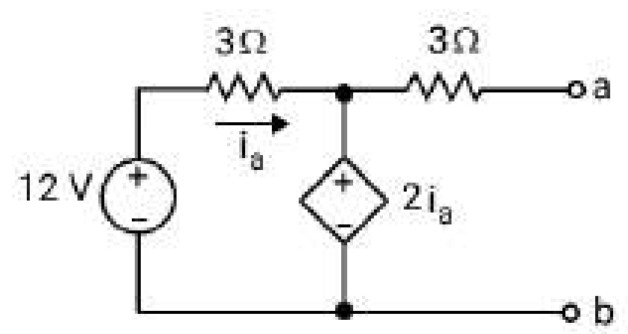
(A) R_{N} = 3 Ω, i_{N} = 1.6 A (B) R_{N} = 4 Ω, i_{N} = +3 A
(C) R_{N} = 4 Ω, i_{N} = −3 A (D) R_{N} = 6 Ω, i_{N} = −3 A

Q.56 Choose the correct statement.
S1: The entropy for a fair binary variable with probabilities P (0) =P (1) =0.5 is 1 bit.
S2: If the entropy is computed with natural log (ln), the unit of entropy is bits.
(A) S1 and S2 (B) Only S1
(C) Neither S1 nor S2 (D) Only S2

Q.57 The figure shows the frequency response of a series R–L–C circuit. Curves are labeled 1 to 5. Which option correctly matches each label to the corresponding quantity?
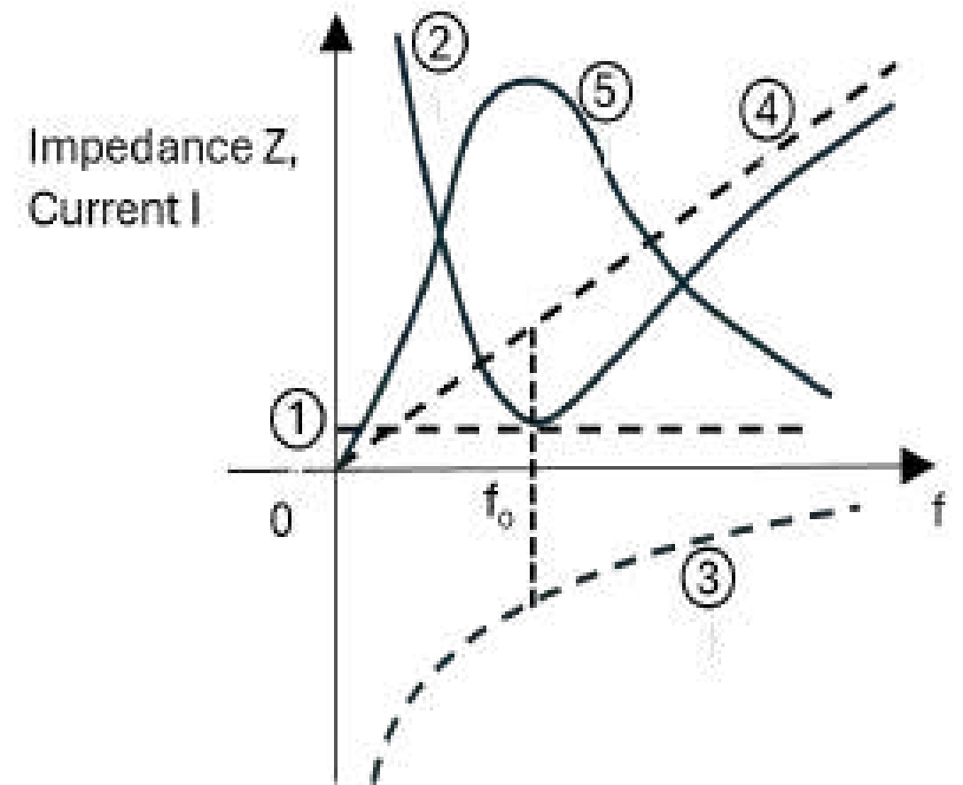
(A) 1 → R, 2 → |I|, 3 → X_{L}, 4 → X_{C}, 5 → |Z|
(B) 1 → X_{L}, 2 → |I|, 3 → X_{C}, 4 → |Z|, 5 → R
(C) 1 → R, 2 → |Z|, 3 → X_{C}, 4 → X_{L}, 5 → |I|
(D) 1 → |Z|, 2 → R, 3 → X_{C}, 4 → X_{L}, 5 → |I|

Q.58 Determine the DC current gain of the Common collector configuration in NPN BJT, if collector current is 0.98 mA and the base current is 0.02 mA.
(A) 49 (B) 50
(C) 100 (D) 98

Q.59 Which of the following statements is correct in the context of a semiconductor?
(A) Concentration of holes in the valence band is independent of the doping concentration in a p-type semiconductor.
(B) As the temperature increases, thermal energy excites more electrons from the valence band to the conduction band, leaving a higher concentration of holes behind.
(C) If a pure semiconductor is doped with donor impurities, then the material has a higher hole concentration.
(D) In a pure semiconductor, the concentration of holes is much greater than the concentration of electrons at thermal equilibrium.

Q.60 Which of the following facts is true for energy band diagram of n-type semiconductor?
(A) The doped fermi level overlaps the intrinsic fermi level for rise in doping concentration.
(B) The doped fermi level moves closer to the conduction band for rise in doping concentration.
(C) The doped fermi level moves closer to the valence band for rise in doping concentration.
(D) The fermi level transition is independent of the doping concentration.

Q.61 Which of the following statements related to the C-V (Capacitance-Voltage) characteristics of a MOS capacitor is correct?
(A) In accumulation, the capacitance is high and stable, but very much less than the oxide capacitance.
(B) In accumulation, the capacitance is low and unstable and it much higher than the oxide capacitance.
(C) In accumulation region, the capacitance is very low but stable and it is equal to the oxide capacitance.
(D) In accumulation, the capacitance is high and stable, equal to the oxide capacitance.

Q.62 Which of the following parameters affects the delay time the most in a second-order underdamped system?
(A) Both natural frequency (ω_{n}) and damping ratio (ζ)
(B) Damping ratio ζ only
(C) Input Amplitude
(D) Natural frequency ω_{n} only

Q.63 Select the correct statement(s) for the antilog amplifier.
S1: The antilog amplifier uses the nonlinear behaviour of either diodes or transistors.
S2: The antilog amplifier output is temperature independent.
S3: The antilog amplifier is used in computation like multiplication and division.
(A) S1, S2 and S3 (B) Only S1 and S2
(C) Only S2 and S3 (D) Only S1 and S3

Q.64 For the system shown, determine the transfer function Y(s)/D(s). (Take R(s) = 0.)
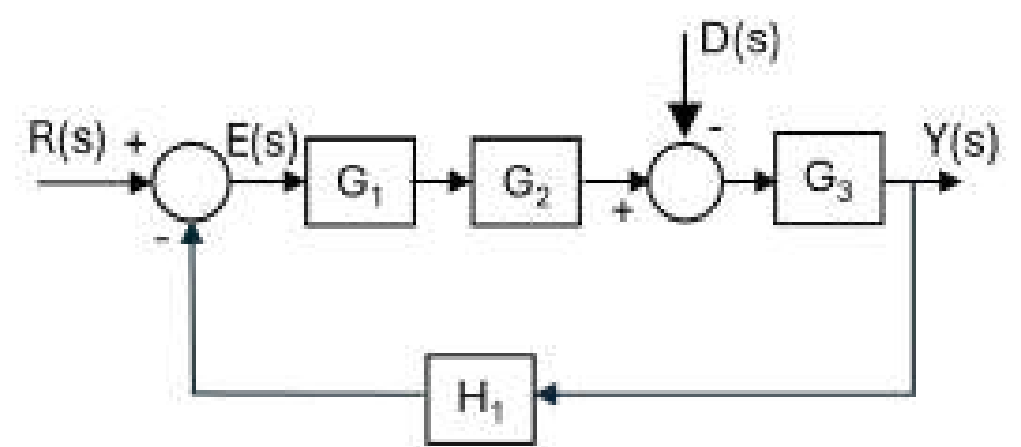
(A) G₃(s) / [1 + G₁(s)G₂(s)G₃(s)H₁(s)]
(B) −G₃(s) / [1 − G₁(s)G₂(s)G₃(s)H₁(s)]
(C) −G₃(s) / [1 + G₁(s)G₂(s)G₃(s)H₁(s)]
(D) G₃(s) / [1 − G₁(s)G₂(s)G₃(s)H₁(s)]

Q.65 A series RC circuit consists of a resistor R and a capacitor C connected in series. A unit-impulse voltage v_{in}(t) = δ(t) is applied across the circuit. The output is the capacitor voltage v_{c}(t). The expression correctly representing v_{c}(t) is _________.
(A) v_{c}(t) = e^{−t/RC} u(t)
(B) v_{c}(t) = (1/R) e^{−t/RC} u(t)
(C) v_{c}(t) = δ(t) − (1/RC) e^{−t/RC} u(t)
(D) v_{c}(t) = (1/RC) e^{−t/RC} u(t)

Q.66 Which of the following options is correct in the context of the practical diode model?
(A) It has fixed voltage drop when conducting.
(B) It has infinite resistance when forward biased.
(C) Equivalent circuit of the practical diode in the forward bias state consists of an open circuit only.
(D) Reverse current for the practical diode is zero.

Q.67 In a CMOS inverter (NOT gate), what happens to the output when the input voltage is close to the threshold voltage of the NMOS transistor?
(A) Both NMOS and PMOS transistors may conduct, causing high current dissipation
(B) Output is guaranteed logic low
(C) Output becomes undetermined logic level with no current drawn
(D) Output is guaranteed logic high

Q.68 Which antenna radiates through an open aperture formed by a flared waveguide?
(A) Small loop antenna (B) Parabolic reflector
(C) Patch antenna (D) Horn antenna

Q.69 Which of the given statements is correct in the context of the single side band amplitude modulation method or SSB modulation?
S1: Coherent detection demodulation technique is used.
S2: If there is a local oscillator that is 10° out of phase from the required phase, then the output is not distorted.
(A) S2 only (B) S1 and S2
(C) S1 only (D) Neither S1 nor S2

Q.70 What is the Z-transform X(z) of the signal x(n) = 3x₁(n) − 2x₂(n), where:
x₁(n) ⟷^{z} X₁(z)
x₂(n) ⟷^{z} X₂(z)
(A) X(z) = 3X₁(z) − 2X₂(z) (B) X(z) = X₁(z) − X₂(z)
(C) X(z) = x₁(n) + x₂(n) (D) X(z) = 3x₁(z) × x₂(z)

Q.71 For a good conductor at f = 10 MHz, the attenuation constant is measured as: α = 5 × 10² Np/m.
The permeability of the conductor is approximately that of free space (μ = μ₀). Estimate the skin depth (δ) and the phase velocity (v) of the wave in the conductor.
(A) δ = 0.2 mm, v = π × 10⁴ m/s. (B) δ = 2 mm, v = 4π × 10⁶ m/s.
(C) δ = 2 mm, v = 4π × 10⁴ m/s. (D) δ = 2 mm, v = 2π × 10⁴ m/s.

Q.72 The characteristic equation of a system is given as a₀s³ + a₁s² + a₂s + a₃ = 0, where coefficients a₀, a₁, a₂, and a₃ are real and positive numbers. By using the Routh-Hurwitz test, which of the following expressions is a necessary condition for the system to be stable?
(A) a₁a₃ > a₀a₂ (B) a₁a₂ > a₀a₃
(C) a₀a₃ > a₁a₂ (D) a₀a₁ > a₂a₃

Q.73 Which of the following options is correct in the context of a two-way parallel clipper circuit?
(A) The two diodes are connected in parallel but facing the same direction.
(B) The two diodes are connected in parallel but in the opposite direction.
(C) The two diodes are connected in series but in the opposite direction.
(D) The two diodes are connected in series with the load.

Q.74 Which of the following statements correctly describes the s-domain shifting property?
(A) Multiplying the signal x(t) by a units in the time domain ↔ multiplying the signal X(s) by e^{−as}.
(B) Multiplying the signal by e^{at} in the time domain ↔ shifting in the s-domain X(s) to X(s − a)
(C) Multiplying the signal by e^{−at} in the time domain ↔ shifting in the s-domain X(s) to X(s + 2a).
(D) Multiplying the signal by t⋅e^{at} in the time domain ↔ shifting in the s-domain X(s) to X(s − at)

Q.75 A pair of magnetically coupled coils is wound on a nonmagnetic core. The self-inductance of coil 1 is L₁ = 200 mH. The mutual inductance is M = 80 mH, and the coefficient of coupling is k = 4/5. The partial self-permeances are equal, so L ∝ N² with the same proportionality for both coils. Find the self-inductance L₂ of coil 2 and the turns ratio N₁/N₂.
(A) L₂ = 200 mH, N₁/N₂ = 2 (B) L₂ = 12.5 mH, N₁/N₂ = 2
(C) L₂ = 50 mH, N₁/N₂ = 1/2 (D) L₂ = 50 mH, N₁/N₂ = 2

Q.76 A third-order LTI system has three distinct real poles at p₁ = −0.8, p₂ = −4 and p₃ = −15. A new system G′(s) is formed by adding a zero at s = −3 to the original transfer function (the pole locations remain unchanged). Which statement about the unit-step response of G′(s) (compared to the original system G(s)) is FALSE?
(A) G′(s) will generally have a faster rise time than G(s).
(B) The zero at s = −3 will introduce an initial undershoot (inverse response) in the step output of G′(s).
(C) The dominant pole for both systems remains at s = −0.8.
(D) For a unit-step input, if both systems are adjusted to have unity DC gain, the final value of the response will be the same.

Q.77 In the CMOS implementation of a NOT gate, which of the following statements is true?
(A) Both NMOS and PMOS transistors are ON in the steady state.
(B) When the input is HIGH, NMOS transistor is ON, and PMOS transistor is OFF.
(C) When the input is HIGH, PMOS transistor is ON, and NMOS transistor is OFF.
(D) When the input is LOW, NMOS transistor is ON, PMOS transistor is OFF.

Q.78 A unity negative feedback system has a closed-loop transfer function obtained from the block diagram as: T(s) = C/R = 5/6. A student converts the system into a signal-flow graph (SFG) but forgets to include the feedback branch. Using the incomplete SFG, the student computes C/R. From this information, determine the ratio of the incorrect SFG result to the correct block-diagram result.
(A) 6 (B) 1/6
(C) 11/6 (D) 5/6

Q.79 When designing a traffic light controller using a Mealy finite state machine, which has three states: S0 (Green), S1 (Yellow), and S2 (Red), the controller utilises a vehicle sensor input X (where 1 indicates a vehicle is present and 0 means no vehicle). Then the output Y = 1 occurs only when __________________________.
(A) the machine is in state S1 or S2, and the sensor input X = 1
(B) the machine is in state S1 and S2, and the sensor input X = 0
(C) the machine is in state S1 or S2 and the sensor input X = 0
(D) the machine is in state S1 and the sensor input X = 1

Q.80 When a control system is represented as a Block Diagram (BD) or a Signal Flow Graph (SFG), both can show feedback and signal paths. Which statement is always true about the relation between these two forms?
(A) If two Block Diagrams give the same transfer function, their Signal Flow Graphs will also have identical sets of loops and non-touching loop pairs.
(B) If a Block Diagram has no feedback loops, then its Signal Flow Graph will also have no loops, and Δ = 1 in Mason’s formula.
(C) Moving a signal pickoff point across a block never changes the loop structure, so the SFG is always the same.
(D) If a Block Diagram contains an instantaneous feedback (called an algebraic loop), then the equivalent Signal Flow Graph must have at least one closed loop, and the system will give a valid transfer function only when Δ = 0.

Q.81 A common-emitter amplifier using the approximate h-model, has h_{fe} = 200 and h_{ie} = 2 kΩ. If the input AC voltage is 20 mV, then the base current, collector current and the input resistance are _______________________, respectively.
(A) 10 µ A, 2m A and 100 KΩ (B) 100 µ A, 20 m A and 2KΩ
(C) 10 µ A, 2m A and 2KΩ (D) 10 m A, 20µ A and 1KΩ

Q.82 A circularly polarized plane wave is incident from air (ε_{r1} = 1) onto a lossless dielectric medium (ε_{r2} = 3). The media are nonmagnetic. The wave is incident at the Brewster angle θ_{p}. The Brewster angle and the resulting polarization of the reflected wave are ___________.
(A) θ_{p} = 30°, reflected wave remains circularly polarized
(B) θ_{p} = 45°, reflected wave becomes elliptically polarized
(C) θ_{p} = 60°, reflected wave becomes linearly polarized with E perpendicular to the plane of incidence
(D) θ_{p} = 60°, reflected wave becomes linearly polarized with E parallel to the plane of incidence

Q.83 The transfer function of a system is given below.
(5s² + 3s + 1) / (s³ + 6s² + 11s + 6)
Which of the following is the order of this system?
(A) Second order (B) Fourth order
(C) First order (D) Third order

Q.84 A hollow conducting sphere has inner radius a and outer radius b. A point charge +q is fixed at the center of the cavity. The conductor is initially neutral and in electrostatic equilibrium. Consider a concentric closed surface S of radius r with a < r < b (i.e., entirely within the conducting material). The value of ∮_{s} E ⋅ dS is __________ .
(A) (2q / ε₀) (B) (−q / ε₀)
(C) (q / ε₀) (D) 0

Q.85 A CMOS inverter fabricated in a 0.18 µm process for which V_{DD} = 1.8 V, magnitude of threshold voltage = 0.5 V, µ_{n} = 4 µ_{p}, µ_{n}C_{ox} = 300 µA/V² and Q_{N} and Q_{p} have L_{p} = 18 µm, (W/L)_{n} = 1.5, then the value of width W_{p} is ___________.
(A) 4.32 µm (B) 0.27 µm
(C) 108 µm (D) 0.54 µm

Q.86 Determine the small-signal AC voltage gain of a BJT common-emitter (CE) amplifier with a fully bypassed emitter resistor if the transconductance is 100 mS and the collector resistor and the load resistor are 2 KΩ each. What is the output voltage if the input voltage is V_{in} = 10 sin(100πt) mV.
(A) Voltage gain = −100, V_{o} = −10 sin(100πt).
(B) Voltage gain = +10, V_{o} = sin(100πt).
(C) Voltage gain = +10, V_{o} = 10 sin(100πt).
(D) Voltage gain = −100, V_{o} = −sin(100πt).

Q.87 If analog filter is stable, then which of the following methods guarantees stability of an IIR filter?
(A) Impulse invariance method (B) Fourier series truncation
(C) Bilinear transform method (D) Frequency sampling method

Q.88 Choose the correct statement for a negative clamper circuit.
S1: A clamper circuit is used to add an AC voltage to its input signal.
S2: A negative DC can be added to the input signal in case of a negative clamper circuit.
S3: This circuit uses only diode and resister.
(A) S1 and S3 only (B) S1 and S2 only
(C) S2 and S3 only (D) S1, S2 and S2

Q.89 A rectangular waveguide of internal width a = 3 cm carries the dominant TE₁₀ mode of a signal at unknown frequency. The characteristic wave impedance in the guide is Z = 240π Ω. Take free-space impedance Z₀ = 120π Ω and c = 3 × 10⁸ m/s. Find the operating frequency f.
(A) (5/√3) GHz (B) (10/√3) GHz
(C) (5√3/2) GHz (D) (10/3) GHz

Q.90 A series R–C circuit consists of a resistor R and a capacitor C connected in series. The input is a delayed unit impulse voltage
v_{in}(t) = δ(t − T), T > 0.
The output is the capacitor voltage v_{C}(t). Which expression correctly represents v_{C}(t)?
(A) v_{C}(t) = e^{−t/RC} u(t)
(B) v_{C}(t) = δ(t − T) − (1/RC) e^{−(t−T)/RC} u(t − T)
(C) v_{C}(t) = (1/RC) e^{−(t−T)/RC} u(t)
(D) v_{C}(t) = (1/RC) e^{−(t−T)/RC} u(t − T)

Q.91 If frequency modulated signal has message bandwidth of 05 KHz and maximum frequency deviation of 75KHz, the value of modulation index β and bandwidth of the tone FM signal are _____________, respectively
(A) 15 and 160 KHz (B) 7.75 and 160 KHz
(C) 7.75 and 80 KHz (D) 15 and 80 MHz

Q.92 An EM wave of frequency f propagates in a non-magnetic medium (μ_{r} = 1). The medium parameters are chosen such that σ = ωε (that is, σ/(ωε) = 1), where ω = 2πf and ε = ε₀ ε_{r}. What is the phase difference between the electric field E and the magnetic field H? (Assume the usual phasor convention.)
(A) 22.5° (B) 45°
(C) 90° (D) 0°

Q.93 Study the given circuit carefully and answer the question that follows.
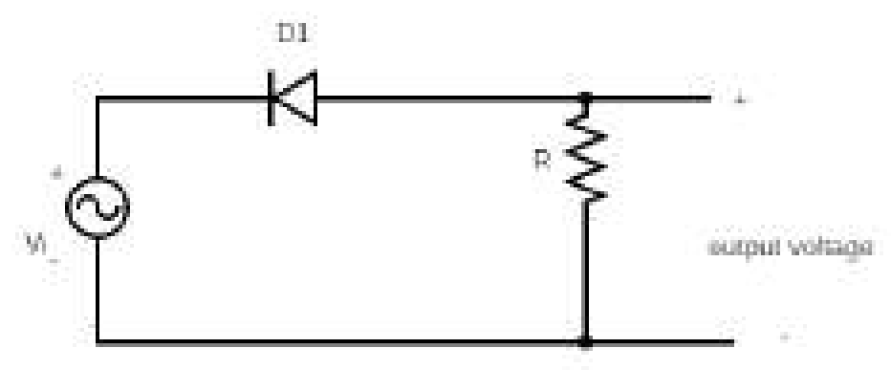
Which of the given statements are correct for the above circuit?
S1: It is a series positive clipper circuit.
S2: For the positive input voltage, output is clipped off.
S3: Output will be negative when the diode is forward biased.
(A) S2 and S3 only (B) S1 and S3 only
(C) S1, S2 and S3 (D) S1 and S2 only

Q.94 The transfer function of the discrete-time system H(z) has poles at z = 0.5 and z = 1.5. Which ROC corresponds to the stable and non-causal system?
(A) |z| = 1 (B) |z| > 1.5
(C) 0.5 < |z| < 1.5 (D) |z| < 0.5

Q.95 Five equal resistors, each of resistance R, are connected to form a square, with one diagonal placed between opposite corners. Find the equivalent resistance between two adjacent nodes of the square.
(A) R/2 (B) 4R/5
(C) 3R/4 (D) 5R/8

Q.96 The minimum number of check bits in a single error correcting hamming code if the number of message bits in a block is 27 is __________.
(A) 6 (B) 5
(C) 8 (D) 4

Q.97 A rectangular pulse x(t) of width T has Fourier transform X(f) = T sinc(f.T). The main-lobe bandwidth (null-to-null) is:
(A) 2 / T (B) T
(C) 1 / T (D) 1 / (2T)

Q.98 A pair of magnetically coupled coils is wound on a nonmagnetic form. The self-inductance of coil 1 is L₁ = 162 mH, the mutual inductance is M = 81 mH, and the coefficient of coupling is k = 0.75. The physical arrangement is such that the partial self-permeances are equal. Find L₂ and the turns ratio N₁/N₂.
(A) L₂ = 288 mH, N₁/N₂ = 1/2 (B) L₂ = 18 mH, N₁/N₂ = 3/2
(C) L₂ = 72 mH, N₁/N₂ = 3/2 (D) L₂ = 72 mH, N₁/N₂ = 2/3

Q.99 Design a pure parallel RLC resonant circuit having the following parameters:
• k = 2000 Ω (equivalent parallel resistance)
• Q = 10 (quality factor)
• ω₀ = 5000 rad/s (resonant angular frequency)
Determine the values of the inductance L and capacitance C of the circuit.
(A) L = 20 mH, C = 1 μF (B) L = 80 mH, C = 0.5 μF
(C) L = 40 mH, C = 1 μF (D) L = 10 mH, C = 4 μF

Q.100 Which of the following 8085 instructions uses indirect addressing mode?
(A) LXI H, 2310H (B) MVI A, 32H
(C) ADD B (D) MOV A, M

