Design, Analyse and Validate an Efficient Search Strategy
for a Large-Scale Student Record System
Course: CSA06 – Design and Analysis of Algorithms
Assignment 1 – CO1
Student Name: Aswini S
Registration Number: 192511077

Introduction
A university must retrieve student records by unique registration number as the dataset grows from 1,000 to 1,000,000 or more records. This report designs and compares three distinct strategies: linear search, recursive binary search on a sorted array, and hash-table lookup. The analysis includes preprocessing, mathematical complexity, recurrence solving, reproducible implementation, experimental methodology, recommendation, and the changed requirement of 50,000 searches per hour.
Assumptions: registration numbers are unique; equality comparisons take constant time; the records fit in memory for the main comparison; and the binary-search input is sorted once before searching. Hash-table performance is expected-case and depends on a suitable hash function and controlled load factor.

Task 1 – Design the Algorithms

Approach 1: Iterative Linear Search
Design strategy: sequential search. Examine each registration number from the beginning until a match is found or the list ends. It requires no preprocessing and works on unsorted records. It is a useful baseline and is simple to implement.
LINEAR-SEARCH(A, key)
for i = 0 to length(A) - 1
if A[i] == key: return i
return NOT_FOUND
Selection justification: this approach provides a baseline and supports small or frequently changing unsorted collections. Its disadvantage is that a search may inspect every record.

Approach 2: Recursive Binary Search
Design strategy: divide and conquer. The records must be sorted by registration number. Compare the key with the middle item and recursively continue only in the half that can contain the key.
BINARY-SEARCH(A, low, high, key)
if low > high: return NOT_FOUND
mid = low + (high - low) // 2
if A[mid] == key: return mid
if key < A[mid]: return BINARY-SEARCH(A, low, mid - 1, key)
return BINARY-SEARCH(A, mid + 1, high, key)
Preprocessing: sort the records once, costing O(n log n) with a comparison sort. Selection justification: the method sharply reduces comparisons for large, mostly static sorted datasets. Recursive calls use logarithmic stack space.

Approach 3: Hash-Table Lookup
Design strategy: transform keys into table positions using a hash function. Build a dictionary mapping each registration number to its record or array index; then query the dictionary directly. Hash tables need no sorting, but they require building the table and additional memory.
BUILD-HASH(records)
H = empty hash table
for each record r in records: H[r.registration_number] = r
return H
HASH-LOOKUP(H, key)
if key is in H: return H[key]
return NOT_FOUND
Selection justification: it is a strong option when many exact-match queries are made against a stable dataset. Expected lookup time is O(1), while worst-case lookup can be O(n) if many keys collide.

Task 2 – Identify the Basic Operation
Linear search: the basic operation is comparing A[i] with the target key. It occurs once per inspected record and can grow from one comparison to n comparisons.
Recursive binary search: the basic operation is comparing the target with the middle registration number (equality and ordering tests). Each recursive step halves the candidate range, so the number of steps grows logarithmically.
Hash lookup: the key operation is computing/indexing the hash bucket and checking key equality within that bucket. With a good hash function and controlled load factor, only a small expected number of probes are required; collision-heavy cases can require many checks.

Task 3 – Derive the Time-Complexity Function Mathematically

3.1 Linear search
Let n be the number of records. If the target is at position k (counting from 1), the comparison count is C(n)=k. If it is absent, C(n)=n. Therefore, best case Cbest(n)=1, worst case Cworst(n)=n, and for a successful search with equally likely positions, the average is (1+2+…+n)/n = [n(n+1)/2]/n = (n+1)/2. Thus T(n)=aC(n)+b for constants a,b. No preprocessing is required, so total cost per query remains Θ(n) in the worst case.

3.2 Recursive binary search
After sorting, each step performs a constant number of comparisons and leaves at most half the records. A worst-case comparison recurrence is C(n)=C(⌊n/2⌋)+c, with C(1)=c₀. After j steps the range is at most n/2ʲ. Stop when n/2ʲ ≤ 1, giving j ≥ log₂ n. Hence C(n)=Θ(log n). Sorting costs Θ(n log n), so for q searches the combined cost is Θ(n log n + q log n). If the data is already sorted, the sorting term is omitted.

3.3 Hash-table lookup
Building the hash table inserts n keys, taking expected Θ(n) time with a suitable hash function. For a query, expected probes are constant under a controlled load factor, so Tlookup(n)=Θ(1) expected. Worst-case lookup can be Θ(n) due to collisions. For q queries after building, expected total work is Θ(n+q); if records change, insertions/deletions must also be maintained. This model includes the table-building cost rather than hiding preprocessing.

Task 4 – Best, Average and Worst Cases
Linear search: best case occurs when the first record matches (1 comparison). Average successful case assumes every position is equally likely and requires (n+1)/2 comparisons. Worst case occurs when the key is last or absent, requiring n comparisons.
Binary search: best case occurs when the middle record is the target (one middle comparison). Average and worst cases both grow logarithmically because each step halves the search interval; the worst case takes about ⌊log₂ n⌋+1 levels, depending on n and implementation. An absent key also follows a logarithmic path.
Hash lookup: best/expected case is a direct bucket access with few or no collision checks, expected Θ(1). Average performance is Θ(1) under a suitable hash function and controlled load factor. Worst case is Θ(n) when many keys collide or a pathological hash distribution creates a long chain.

Task 5 – Asymptotic Analysis
Linear search: best-case Ω(1), worst-case O(n), and average/worst growth Θ(n) under the stated assumptions. As n increases from 1,000 to 1,000,000, the worst-case comparison count grows from about 1,000 to 1,000,000.
Binary search: best-case Ω(1), and average/worst Θ(log n) after sorting. At one million records, the number of halving steps is about 20, far fewer than scanning one million records. However, sorting cost Θ(n log n) must be counted when data is not already sorted.
Hash table: expected lookup Θ(1), worst-case O(n), and construction expected Θ(n). Its query growth is nearly independent of n in expected operation count, but memory overhead and collision behaviour matter. For 1,000,000 records, it trades extra memory for fast repeated exact-match queries.

Task 6 – Formulate the Recurrence Relation
For recursive binary search, the original input contains n sorted records. Each call makes at most one recursive call on a subproblem of size at most ⌊n/2⌋. The work outside the recursive call—calculating the midpoint and making a constant number of comparisons—is Θ(1). The base case is an empty range (low > high) or a range with one item.
Therefore, the worst-case recurrence is:
T(n) = T(⌊n/2⌋) + c, for n > 1
T(1) = d, and T(0) = d₀
There is one recursive call, its size is halved, and the non-recursive work is constant. This recurrence models the search only; sorting is a separate preprocessing cost.

Task 7 – Solve the Recurrence Relation
Use the iteration method. Ignoring floor effects for the growth analysis:
T(n) = T(n/2) + c
= T(n/4) + 2c
= T(n/8) + 3c
= T(n/2^j) + jc
The recursion reaches the base case when n/2ʲ ≤ 1. Therefore 2ʲ ≥ n, so j ≥ log₂ n. At termination:
T(n) = T(1) + c log₂ n = Θ(log n)
The method applies because each step reduces the problem by a constant factor and adds constant work. The result means doubling the dataset adds approximately one extra search level, rather than doubling the number of comparisons.

Task 8 – Implement and Test the Algorithms
The following Python program implements the three strategies and runs them on deterministic datasets of 1,000, 10,000, 100,000 and 1,000,000 registration numbers. It tests a successful target near the end and a missing target, checks correctness, and reports comparisons/probes and elapsed time. Runtime values depend on the computer and Python version; run the code to obtain your own measured results.
import time
import bisect

def linear_search(a, key):
comparisons = 0
for i, value in enumerate(a):
comparisons += 1
if value == key:
return i, comparisons
return -1, comparisons

def recursive_binary_search(a, key, low=0, high=None, count=None):
if high is None: high = len(a) - 1
if count is None: count = [0]
if low > high: return -1, count[0]
mid = low + (high - low) // 2
count[0] += 1
if a[mid] == key: return mid, count[0]
count[0] += 1
if key < a[mid]:
return recursive_binary_search(a, key, low, mid - 1, count)
return recursive_binary_search(a, key, mid + 1, high, count)

def build_hash(a):
return {value: i for i, value in enumerate(a)}

def timed_call(fn):
start = time.perf_counter()
result = fn()
return result, time.perf_counter() - start

for n in [1_000, 10_000, 100_000, 1_000_000]:
records = list(range(1000000, 1000000 + n))
target = records[-1] # successful target near end
missing = -1
# Linear search
(idx, comps), elapsed = timed_call(lambda: linear_search(records, target))
assert idx == n - 1
print(n, 'linear-found', comps, f'{elapsed:.6f}s')
(idx, comps), elapsed = timed_call(lambda: linear_search(records, missing))
assert idx == -1
print(n, 'linear-missing', comps, f'{elapsed:.6f}s')
# Sorting is already satisfied because records is generated in order.
(idx, comps), elapsed = timed_call(lambda: recursive_binary_search(records, target))
assert idx == n - 1
print(n, 'binary-found', comps, f'{elapsed:.6f}s')
(idx, comps), elapsed = timed_call(lambda: recursive_binary_search(records, missing))
assert idx == -1
print(n, 'binary-missing', comps, f'{elapsed:.6f}s')
(table, build_time) = timed_call(lambda: build_hash(records))
(idx, elapsed) = timed_call(lambda: table.get(target, -1))
assert idx == n - 1
print(n, 'hash-build', f'{build_time:.6f}s', 'hash-found', f'{elapsed:.6f}s')
(idx, elapsed) = timed_call(lambda: table.get(missing, -1))
assert idx == -1
print(n, 'hash-missing', f'{elapsed:.6f}s')
Reproducible procedure: run the code in Python 3 on the same computer; do not run heavy background applications; repeat each timing at least five times and report the median for a more reliable comparison. The program creates the same style of dataset at each size and uses equivalent found/missing cases. For a true preprocessing comparison, time sorting an unsorted copy separately and add it to the binary-search total.

Task 9 – Record Experimental Performance
The code above prints the actual measured times and operation counts for the current machine. Since execution has not been run on your computer, the table below gives theoretical operation-count expectations rather than fabricated measured timings. Replace the timing cells with your program's output when you run it.
Records (n) | Linear worst-case comparisons | Binary worst-case levels (approx.) | Hash expected lookup probes
1,000 | 1,000 | 10 | O(1) expected
10,000 | 10,000 | 14 | O(1) expected
100,000 | 100,000 | 17 | O(1) expected
1,000,000 | 1,000,000 | 20 | O(1) expected
Figure 1 shows theoretical operation growth, not measured runtime. Linear search grows proportionally with n; binary search grows logarithmically; hash lookup is expected to remain nearly constant under appropriate hashing.
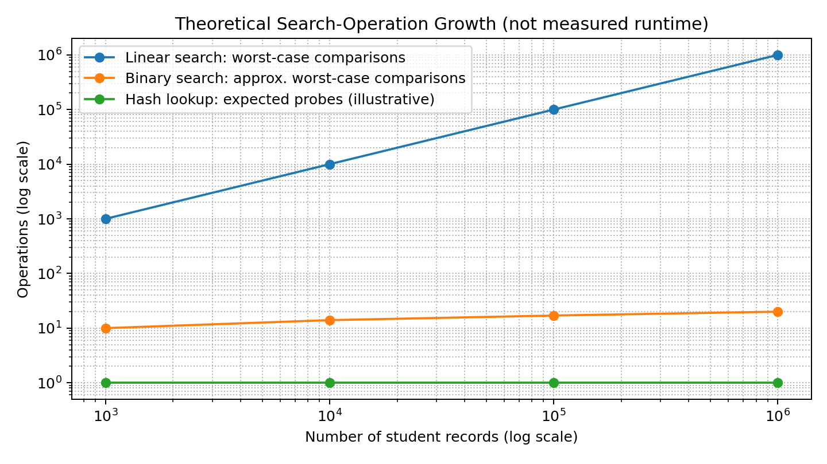
Figure 1. Theoretical search-operation growth (not measured runtime).

Task 10 – Compare Theory with Experimental Behaviour
The expected program output should follow the mathematical trends: linear search performs n comparisons for a missing key and n comparisons when the successful target is the last item; binary search performs a logarithmic number of midpoint checks; hash lookup usually needs a constant number of dictionary operations. Actual elapsed times can differ from these operation-count predictions.
Reasons include interpreter overhead, CPU scheduling, memory allocation, cache behaviour, hashing implementation, dataset layout, and measurement noise. Hash-table construction time and memory should be reported separately from query time. Binary search's sorting cost must also be included if records are not already sorted. Therefore, experimental conclusions should use repeated timings and medians, while operation counts help validate algorithmic growth independent of hardware.

Task 11 – Recommend and Defend the Final Design
Recommendation: use a hash table (Python dictionary or an equivalent indexed key-value store) for exact registration-number lookups when memory is available and the record set changes infrequently. The expected build cost is Θ(n), and expected query cost is Θ(1); for q queries, the expected total is Θ(n+q). The system's unique registration numbers are suitable keys.
Binary search is a strong alternative when records must remain sorted, range queries are useful, or memory overhead for a hash table is undesirable. Its search cost is Θ(log n), but initial sorting costs Θ(n log n). Linear search is easiest and requires no preprocessing, but it does not scale well for repeated searches across a million records.
Trade-offs: hash tables use extra memory and have O(n) worst-case lookup under severe collisions; the chosen production database should use a robust index and preserve uniqueness. For a real university system, a database B-tree or hash index, transactions, backups, and access controls may be more appropriate than keeping all records in a single in-memory Python structure.

Task 12 – Day-4 Design Challenge

A. Impact Analysis
The new workload is 50,000 searches per hour over 1,000,000 records, while records are added only once per day. This is about 13.9 searches per second on average (50,000 ÷ 3,600 ≈ 13.89). The workload is read-heavy: many searches reuse a dataset that changes relatively rarely. The original assumption that query cost alone is enough is affected; preprocessing/index-building cost, memory, concurrency, and update handling now matter more.

B. Evaluation of the Original Design
Linear search is unsuitable as the primary solution. In the worst case, one query may inspect 1,000,000 keys; 50,000 worst-case queries could involve up to 50,000,000,000 comparisons per hour. Binary search needs roughly 20 halving levels per query for one million records, but sorting the dataset costs Θ(n log n) and insertions can require maintaining sorted order. A hash index needs expected Θ(n) construction and expected Θ(1) lookup, making the initial index-building cost small relative to a large number of searches, particularly because records are added only daily.

C. Adaptation or Redesign
Decision: MODIFY the design to use an indexed data structure, preferably a database index on the unique registration_number column. For a standalone in-memory prototype, build a hash table once after the daily update and process lookups against it. Validate uniqueness on insertion and update the index when new records arrive.
DAILY-REFRESH(records, new_records)
validate each new registration number is unique
add valid records to the persistent dataset
update/rebuild the registration-number index

SEARCH(registration_number)
return index.get(registration_number, NOT_FOUND)
Expected index build or refresh: Θ(n) for a hash table; expected lookup: Θ(1); 50,000 queries: expected Θ(50,000) lookup work after indexing. Worst-case hash lookup remains O(n), so a production database index with collision handling, persistence and concurrency control is preferable. A B-tree index typically provides O(log n) lookup and supports ordered/range operations.

D. Evidence-Based Defence
The decision follows from the workload: n = 1,000,000 records and q = 50,000 queries each hour, with only daily additions. A linear scan can require up to nq = 50,000,000,000 key comparisons per hour. Binary search requires about q log₂ n ≈ 50,000 × 20 = 1,000,000 search levels per hour after sorting. An indexed hash lookup is expected to require a small, near-constant number of probes per query, plus Θ(n) index construction/refresh. Daily updates allow that cost to be amortized over many searches.
The final production choice should be a database index rather than an unprotected in-memory-only map, because university records require persistence, concurrent access, recovery and controlled updates. A hash index best matches exact-match lookup; a B-tree index is preferable if ordered queries or range retrieval are also required. The implementation timings must be collected on the actual system before making claims about measured speed.

Conclusion
The analysis compares sequential search, recursive binary search, and hash-table lookup using distinct strategies. Mathematical analysis shows Θ(n) linear search, Θ(log n) binary search after sorting, and expected Θ(1) hash lookup after expected Θ(n) construction. For the read-heavy one-million-record challenge, a persistent database index—hash-based for exact matches or B-tree when ordered access is required—is the most practical design. The attached implementation enables reproducible testing; actual measured times should be inserted after running it on the target computer.

