MAC Addresses, IP Addresses, and Complete Data Delivery

1. Introduction
Every time data travels from one device to another — whether across the room or across the globe — it relies on two complementary addressing systems working at two different layers of the network. The Data Link Layer uses the MAC (Media Access Control) address to move data within a local network, while the Network Layer uses the IP (Internet Protocol) address to move data across multiple interconnected networks. Together, these two mechanisms guarantee that data is delivered completely and correctly from its original source to its final destination, no matter how many networks lie in between.

2. Concept Map
The relationships below summarize the two addressing paths that jointly enable complete, end-to-end data delivery:
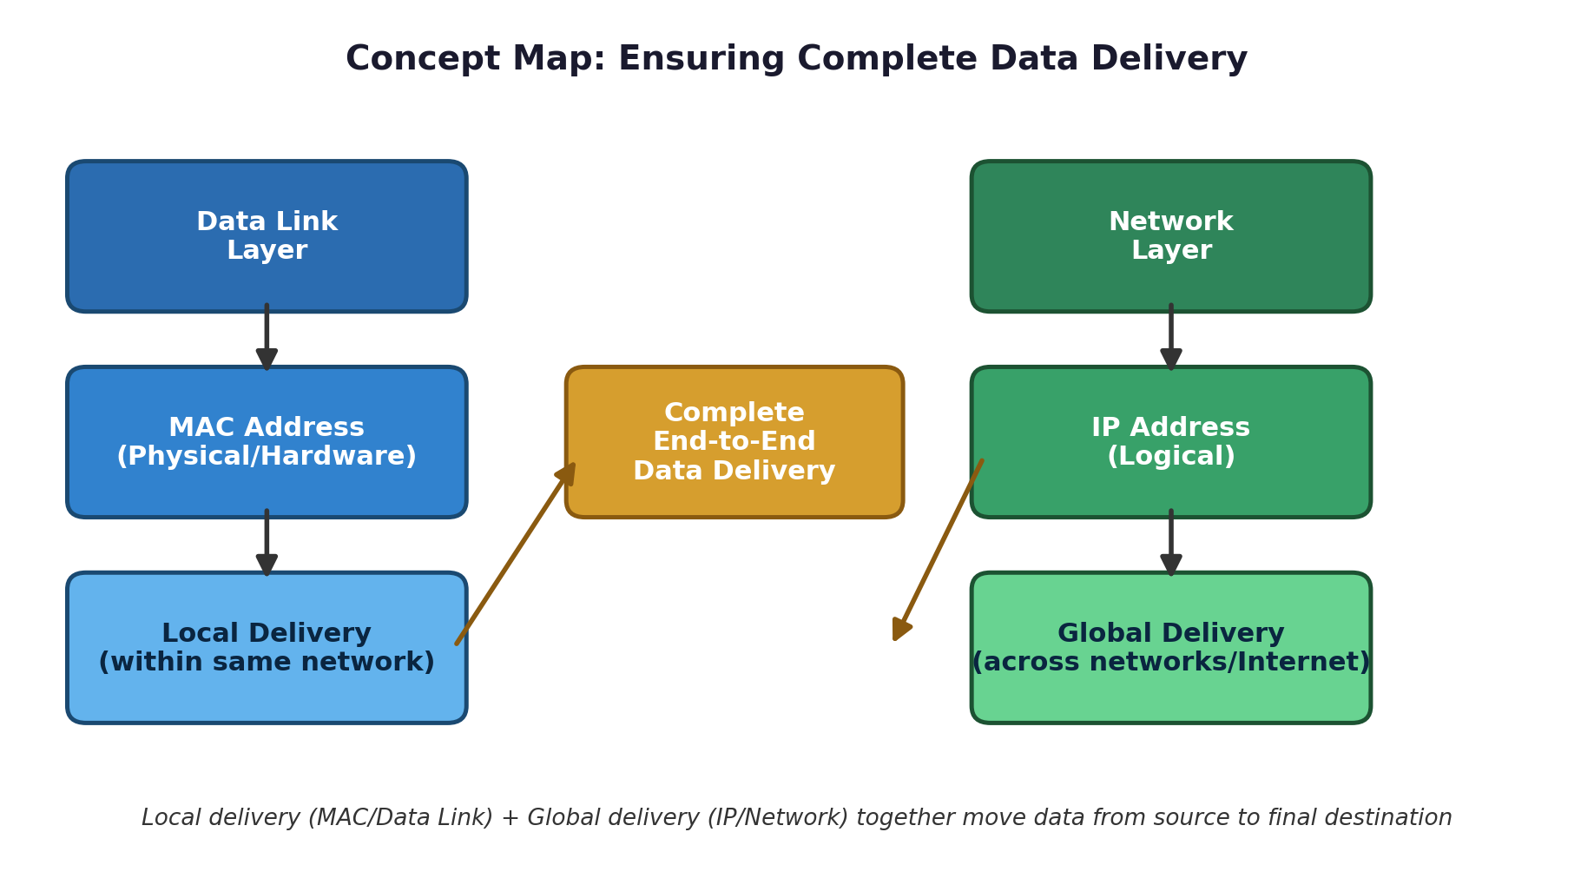
Figure 1: Concept map linking layers, address types, and delivery scope.

3. Data Link Layer → MAC Address → Local Delivery
The Data Link Layer (Layer 2 of the OSI model) is responsible for reliable node-to-node delivery of data within the same physical network segment, such as an Ethernet LAN or Wi-Fi network. It packages data received from the Network Layer into frames and adds a MAC address header that identifies the source and destination network interface cards (NICs).
- Physical addressing: MAC addresses are 48-bit physical addresses, permanently assigned to a network interface by its manufacturer, written as six pairs of hexadecimal digits (e.g., 00:1A:2B:3C:4D:5E).
- Local scope: A MAC address only has meaning within the local network; it is never used to route data across the wider Internet.
- Address Resolution Protocol (ARP): Because IP packets carry only an IP address, a device must translate the destination IP address into a MAC address before it can place data on the local wire. This is done using ARP (Address Resolution Protocol).
- Error detection & framing: The Data Link Layer also performs error detection using a Frame Check Sequence (FCS), and manages access to the shared medium so multiple devices can transmit without constant collisions.
In short, the Data Link Layer guarantees that once a packet has arrived at the correct local network, it is handed off precisely to the intended device (or to the router acting as the gateway to the next network) using its MAC address — this is local delivery.

4. Network Layer → IP Address → Global Delivery
The Network Layer (Layer 3 of the OSI model) is responsible for logical addressing and routing — moving data across multiple, potentially very different, networks until it reaches its final destination anywhere in the world.
- Logical addressing: An IP address is a logical, hierarchical address (e.g., 192.168.1.10 for IPv4) that identifies both the network a device belongs to and the device itself within that network.
- End-to-end persistence: Unlike a MAC address, the source and destination IP addresses in a packet remain unchanged for the entire journey, no matter how many networks or routers the packet passes through.
- Routing: Routers examine the destination IP address and consult routing tables to forward the packet toward the next network, hop by hop, until it reaches the destination network.
- Re-encapsulation at each hop: At each hop, the router strips off the old MAC header, determines the next hop's MAC address (again via ARP, or an equivalent mechanism), and re-encapsulates the packet in a new frame for the next local network.
In short, the Network Layer guarantees that data can traverse many different local networks and still arrive at the correct destination network anywhere on the Internet — this is global delivery.

5. How MAC and IP Addresses Work Together
Complete data delivery requires both layers acting in partnership. The Network Layer determines *where* the data ultimately needs to go (the destination IP address), while the Data Link Layer determines *how* to physically get the data to the very next device on the path (the destination MAC address). This partnership is visible in the way data is encapsulated as it moves down the protocol stack before transmission.
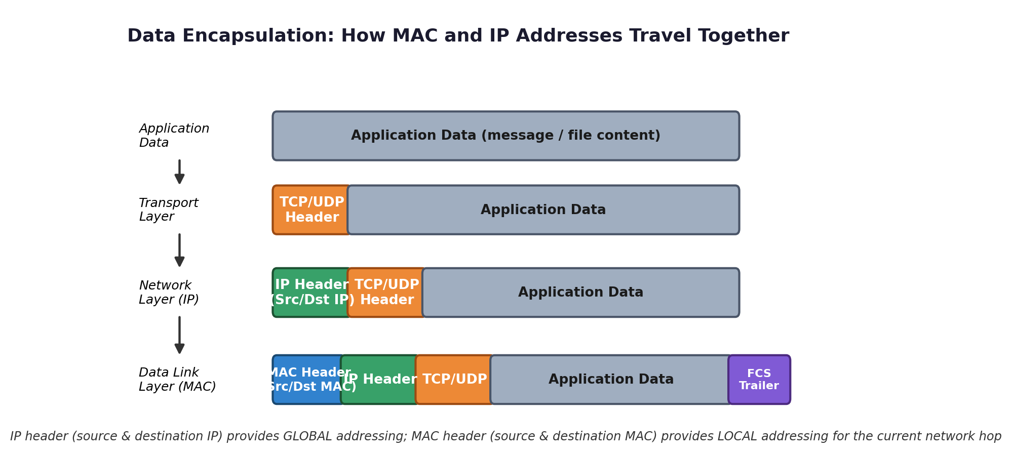
Figure 2: Encapsulation — the IP header (global address) and MAC header (local address) are added at different layers and travel together.
As the diagram shows, application data is wrapped first with a transport header, then an IP header carrying the unchanging source and destination IP addresses, and finally a MAC header carrying the source and destination MAC addresses for the current network hop. Every time the packet crosses into a new local network (through a router), the MAC header is discarded and rebuilt for that segment, while the IP header — and therefore the ultimate destination — remains untouched.
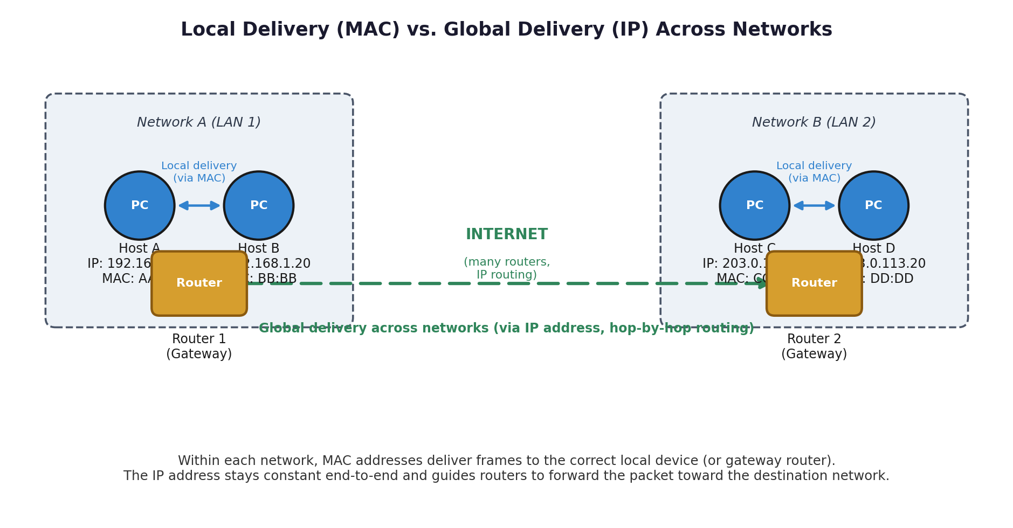
Figure 3: Local delivery within each network (MAC) versus global delivery across networks (IP).
In Figure 3, Host A can reach Host B directly using local MAC-based delivery because both are on the same network. To reach Host C on a different network, Host A's packet is addressed (at Layer 3) to Host C's IP address from the start, but is first delivered locally (at Layer 2) to Router 1, the local gateway. Router 1 forwards the packet across the Internet toward Router 2, which performs local MAC delivery to Host C. The IP address never changes; the MAC address changes at every hop.

6. Side-by-Side Comparison
Aspect | Data Link Layer (MAC Address) | Network Layer (IP Address)
Address type | Physical / hardware address, burned into the NIC | Logical address, assigned by network/administrator
Format | 48-bit, e.g. AA:BB:CC:11:22:33 | 32-bit (IPv4), e.g. 192.168.1.10
Scope of delivery | Local — within a single physical network/segment | Global — across interconnected networks (the Internet)
Changes during transit? | Yes — rewritten at every hop by each router | No — source/destination IP stay the same end-to-end
Key protocol | ARP (Address Resolution Protocol) resolves IP to MAC | IP routing / routing tables direct packets hop by hop
Analogy | House number on a street (local, only meaningful in the neighborhood) | Full postal address including city/country (globally meaningful)

7. Conclusion
Complete data delivery across networks depends on the coordinated use of two addressing systems operating at two different layers. The Data Link Layer and its MAC addresses ensure accurate local delivery within each individual network segment, while the Network Layer and its IP addresses ensure consistent global delivery across the many interconnected networks that make up the Internet. Neither mechanism alone is sufficient: IP addressing without MAC addressing could identify a destination but could not physically place a frame on any wire; MAC addressing without IP addressing could deliver frames locally but could never find a path beyond the local network. It is the layered combination of local (MAC) and global (IP) delivery — repeated at every hop along the path — that guarantees data reaches its destination completely and correctly.

