Salesforce CRM Project Documentation

HandsMen Threads:
Elevating the Art of Sophistication in Men's Fashion

Document Control
Module | Details
Project | HandsMen Threads – Salesforce CRM
Platform | Salesforce
Business Domain | Premium men's fashion / bespoke tailoring
Evidence | Salesforce implementation screenshots to be added

1. Project Overview
HandsMen Threads is a premium men's fashion and bespoke tailoring business use case implemented on Salesforce. The project centralizes customer, product, order, inventory and marketing information in one CRM environment. The implementation combines Salesforce configuration with Flow automation, email communication, Apex, triggers, batch processing and scheduled processing.
The solution includes data-quality controls and security configuration. A dedicated Lightning application provides users with access to the configured business objects and Salesforce features.

2. Business Problem
A premium fashion business needs to coordinate customer information, products, orders and inventory while maintaining customer relationships. HandsMen Threads uses Salesforce to organize this information, reduce invalid data, automate repetitive communication and provide a consistent operational environment.

3. Business Requirements / User Stories
- Build a Salesforce data model for customer, product, order, inventory and marketing information.
- Maintain data integrity through Salesforce validation and configuration rules.
- Send an automated customer email after an order is confirmed.
- Update customer loyalty status based on purchase history.
- Notify the inventory team when stock falls below five units.
- Process inventory records through scheduled batch processing.
- Control access through profiles, roles, users and permission sets.

4. Project Objectives
- Centralize customer, product, order, inventory and marketing data.
- Provide a structured Salesforce object model.
- Reduce invalid data through validation controls.
- Provide a dedicated HandsMen Threads Lightning application.
- Automate customer communication and inventory notifications.
- Use Apex for programmatic business logic.
- Use Batch Apex and Scheduled Apex for asynchronous processing.
- Provide verification evidence for implemented modules.

5. Solution Architecture
The implementation combines declarative Salesforce configuration and programmatic development. Custom objects form the data layer; tabs and the Lightning app form the user-facing layer; validation rules protect data quality; profiles, roles, users and permission sets control access; email templates and alerts provide communication; Flows automate business processes; and Apex with batch scheduling supports programmatic and bulk processing.
Module | Implementation
Data Layer | HandsMen Customer, HandsMen Product, HandsMen Order, Inventory, Marketing Campaign
UI | Custom tabs and HandsMen Threads Lightning App
Data Quality | Validation Rules and Formula Fields
Security | Profile, Roles, Users, Permission Set
Communication | Email Templates and Email Alerts
Automation | Record-Triggered Flows and Scheduled Flow
Programmatic Logic | OrderTriggerHandler and OrderTrigger
Asynchronous Processing | InventoryBatchJob and Daily Inventory Sync

6. Salesforce Setup
The Salesforce org is used as the development and demonstration environment for the HandsMen Threads implementation.
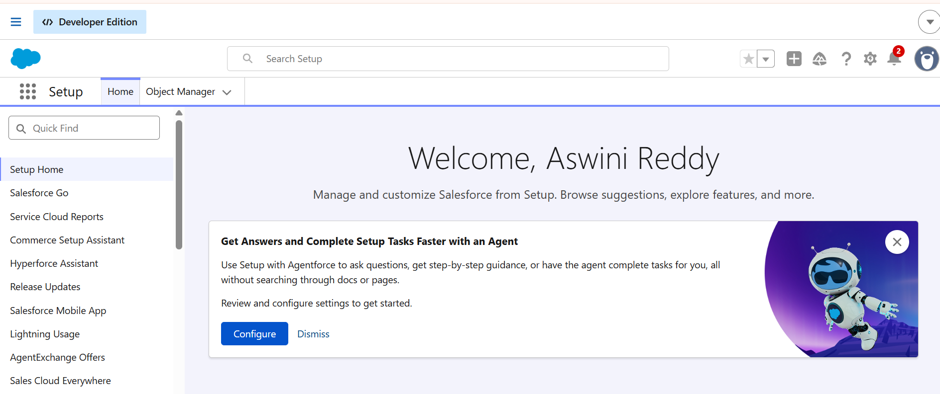
Figure – Salesforce Setup / implementation environment.

7. Data Management – Objects
Object | Purpose
HandsMen Customer | Stores customer information and loyalty-related data.
HandsMen Product | Stores product details such as SKU, price and stock quantity.
HandsMen Order | Stores customer order information including status, quantity and total amount.
Inventory | Stores warehouse and inventory information.
Marketing Campaign | Stores campaign information and its customer relationship.
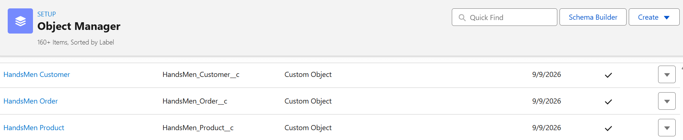
Figure – Custom object configuration evidence.

8. Data Management – Tabs
Custom object tabs make the configured business objects accessible through the Salesforce user interface.
- HandsMen Customer
- HandsMen Order
- HandsMen Product
- Inventory
- Marketing Campaign

9. Data Management – Lightning App
A dedicated Lightning application named HandsMen Threads was configured to bring the project objects together in one user-facing environment.
Navigation items: HandsMen Customer, HandsMen Order, Inventory, HandsMen Product, Reports, Dashboard, Account, Contact and Marketing Campaign.
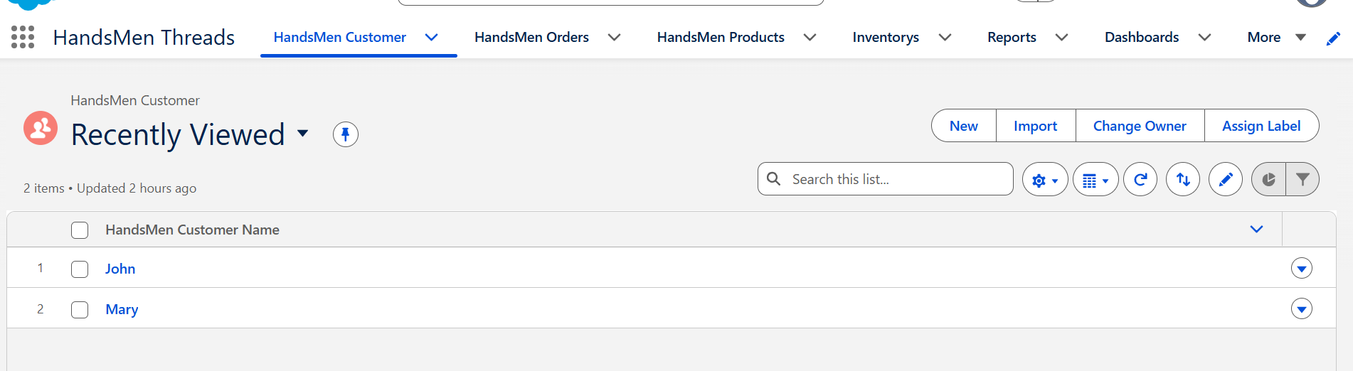
Figure – HandsMen Threads App Manager and application evidence.

10. Data Management – Fields

10.1 HandsMen Customer
Field | Type / Purpose
Email | Email
Phone | Phone
Loyalty Status | Picklist – Gold, Silver, Bronze
Total Purchases | Number
FirstName | Text
LastName | Text
Full Name | Formula (Text)

10.2 HandsMen Product
Field | Type / Purpose
SKU | Text
Price | Currency
Stock Quantity | Number

10.3 HandsMen Order
Field | Type / Purpose
Order Number | Record Name
Status | Picklist – Pending, Confirmed, Rejection
Quantity | Number
Total Amount | Number

10.4 Inventory
Field | Type / Purpose
Record Name | Auto Number
Warehouse | Text
Stock Quantity | Number
Stock Status | Formula (Text)

10.5 Marketing Campaign
Field | Type / Purpose
Campaign Name | Record Name
Start Date | Date
End Date | Date

11. Object Relationships
Relationship | Type | Purpose
Marketing Campaign → HandsMen Customer | Lookup | Associates campaigns with customers.
HandsMen Product → HandsMen Order | Lookup | Associates products with orders.
HandsMen Order → HandsMen Customer | Lookup | Associates orders with customers.
Inventory → HandsMen Product | Master-Detail | Associates inventory with its product.

12. Formula Fields

12.1 Full Name
Formula: FirstName__c + " " + LastName__c

12.2 Stock Status
Formula: IF(Stock_Quantity__c > 10, "Available", "Low Stock")

13. Validation Rules / Data Configuration
Object | Rule | Condition | Error Message
HandsMen Order | Total Amount | Total_Amount__c <= 0 | Please Enter Correct Amount
Inventory | Stock Quantity | Stock_Quantity__c <= 0 | the inventory count is never less than zero.
HandsMen Customer | Email | NOT CONTAINS(Email, "@gmail.com") | Please fill Correct Gmail
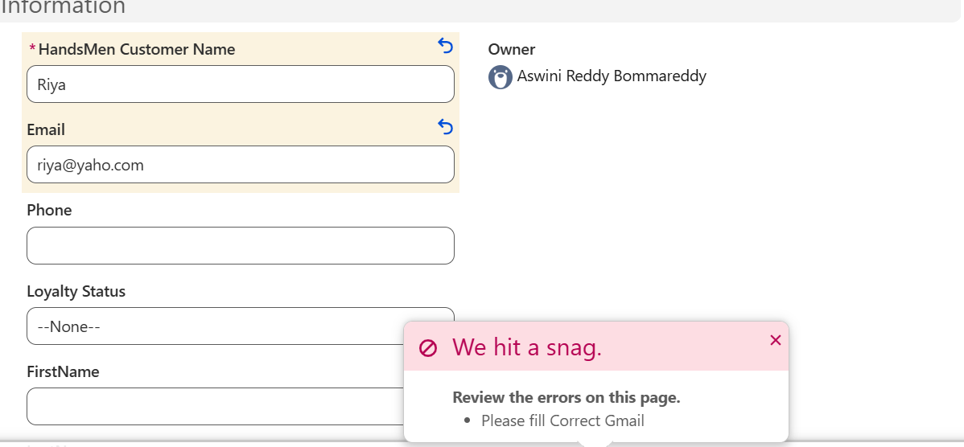
Figure – Validation Rule configuration evidence.

14. Security Configuration

14.1 Platform 1 Profile
Platform 1 was created by cloning the Standard User profile. Access was configured for HandsMen Product and Inventory.
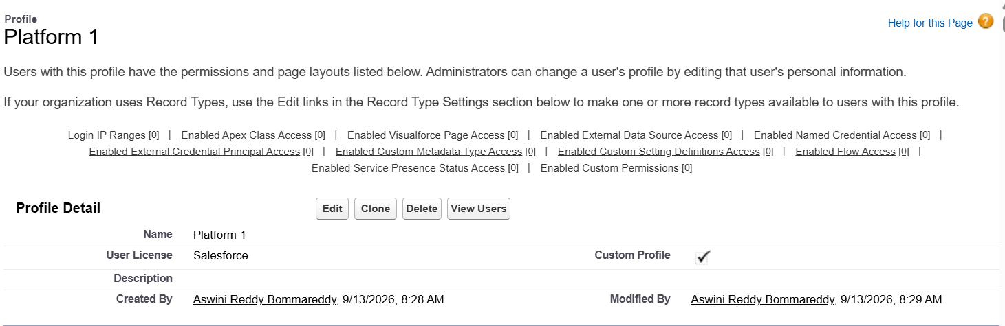
Figure – Platform 1 Profile.

14.2 Roles and Role Hierarchy
CEO → Sales, Inventory, Marketing
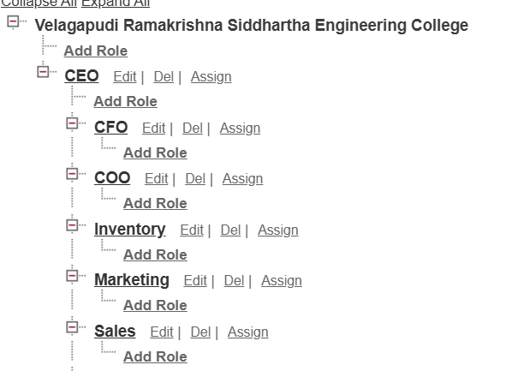
Figure – Role Hierarchy.

14.3 Users
User | Role | User License | Profile
Niklaus Mikaelson | Sales | Salesforce | Platform 1
Kol Mikaelson | Inventory | Salesforce | Platform 1
Daniel Mikaelson | Marketing | Salesforce | Platform 1
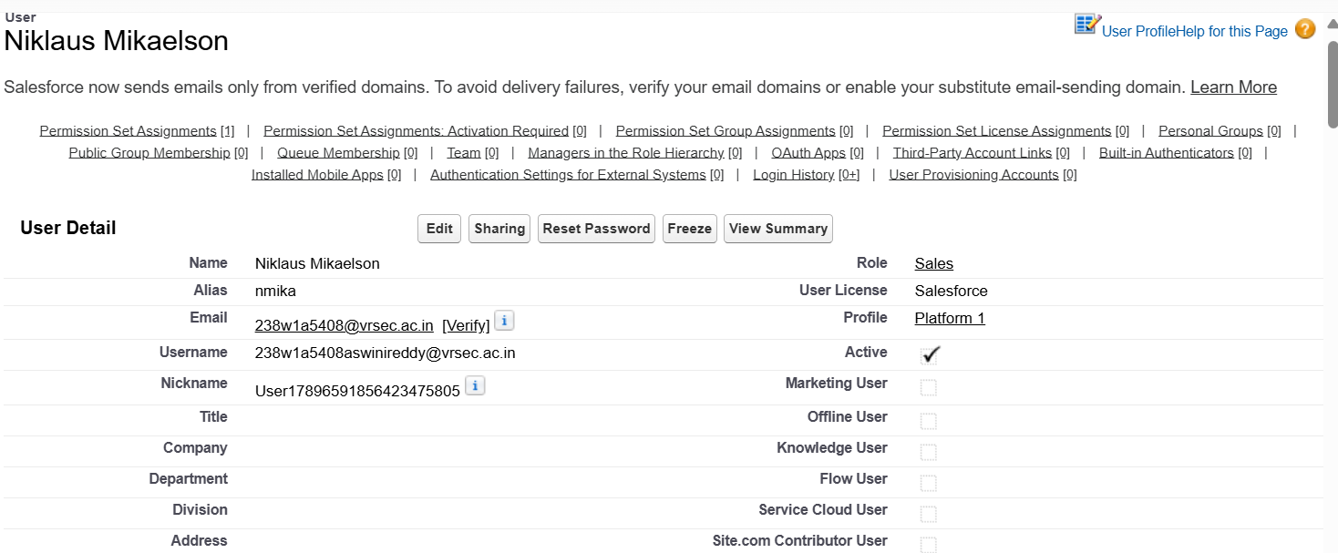
Figure – User configuration.

14.4 Permission Set
Permission_Platform_1 was created and assigned to all three users.
Object | Permissions
HandsMen Customer | Read, Create, Edit, Delete
HandsMen Order | Read, Create, Edit, Delete
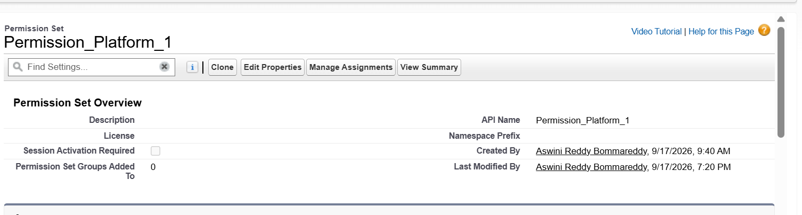
Figure – Permission Set and assignment.

15. Email Communication
Email Template | Purpose
Order_Confirmation_Email | Order confirmation
Low_Stock_Alert | Low stock notification
Loyalty_Program_Email | Loyalty program update
Email Alert | Purpose
Order Confirmation Email Alert | Order confirmation
Low Stock Alert | Low stock notification
Loyalty Program Email | Loyalty program update
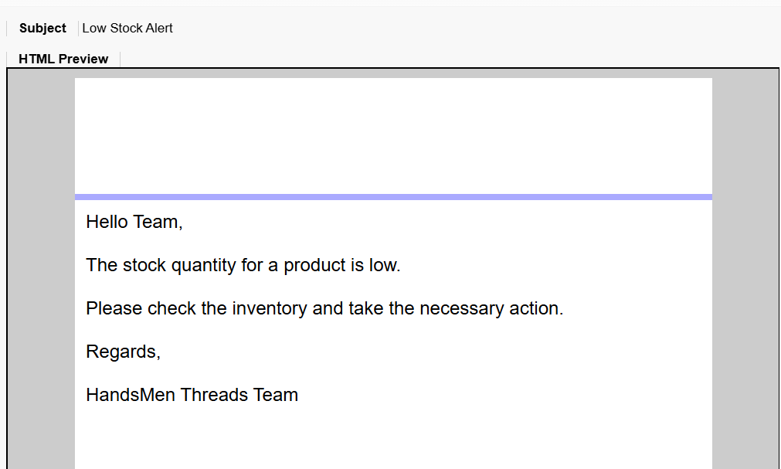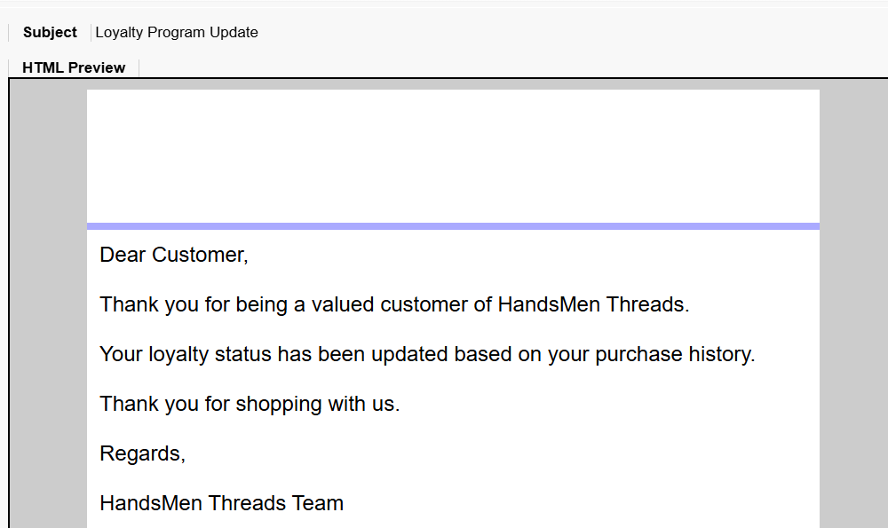
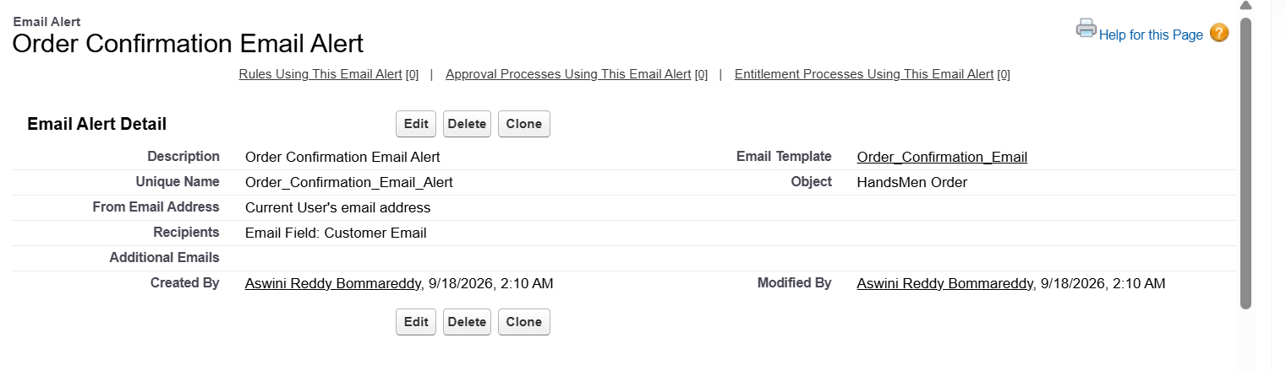
Figure – Email Templates and Email Alerts.

16. Process Automation – Flows

16.1 Order Confirmation Flow
Item | Configuration
Object | HandsMen Order
Trigger | Record updated to Confirmed
Action | Send Order Confirmation Email
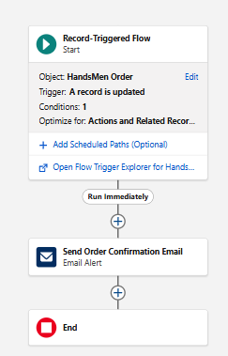
Figure – Order Confirmation Flow.

16.2 Stock Alert Flow
Item | Configuration
Object | Inventory
Trigger | Record created or updated
Condition | Stock Quantity < 5
Action | Send Low Stock Alert
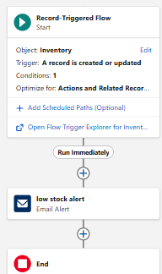
Figure – Stock Alert Flow.

16.3 Loyalty Status Update Flow
Item | Configuration
Type | Schedule-Triggered Flow
Frequency | Daily
Gold | Total Purchases > 1000
Bronze | Total Purchases < 500
Silver | Default outcome
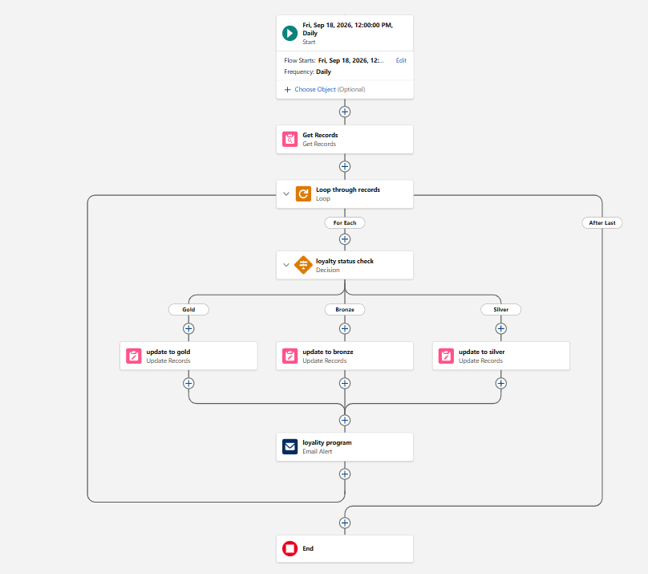
Figure – Loyalty Status Update Flow.

17. Apex Development

17.1 Apex Class – OrderTriggerHandler
OrderTriggerHandler validates order quantity according to status.
Status | Requirement
Confirmed | More than 500
Pending | More than 200
Rejection | Exactly 0
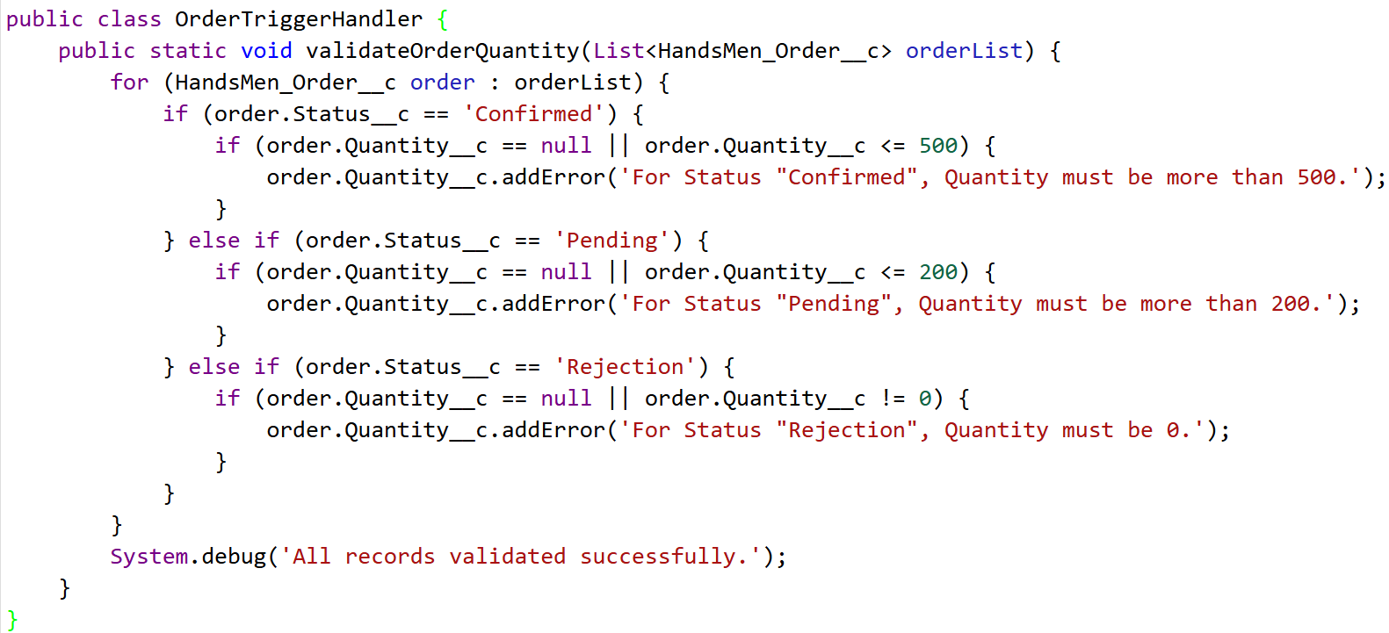
Figure – OrderTriggerHandler in Developer Console.

17.2 Apex Trigger – OrderTrigger
OrderTrigger is configured on HandsMen_Order__c for before insert and before update events and calls OrderTriggerHandler.validateOrderQuantity(Trigger.new).
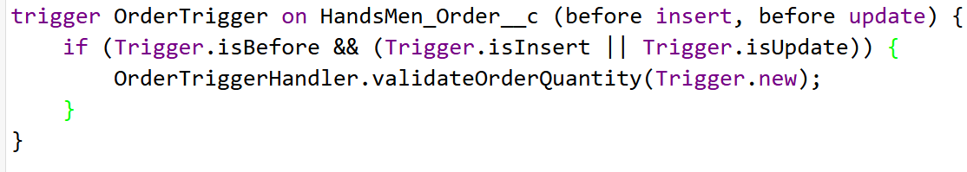
Figure – OrderTrigger in Developer Console.

18. Batch Apex & Scheduled Processing

18.1 InventoryBatchJob
InventoryBatchJob implements Database.Batchable<SObject> and Schedulable. The configured process identifies low-stock products and applies the configured restocking logic. Restock logic: increase stock quantity by 50. Batch size: 200.
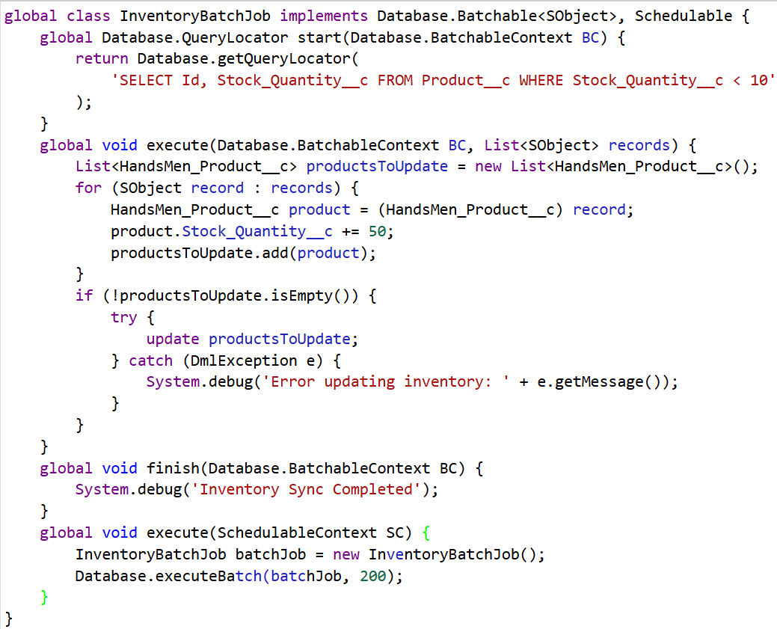
Figure – InventoryBatchJob in Developer Console.

18.2 Daily Inventory Sync
The InventoryBatchJob is scheduled as Daily Inventory Sync using the configured midnight schedule.
System.schedule('Daily Inventory Sync', '0 0 0 * * ?', new InventoryBatchJob());
Figure – Scheduled Jobs / Daily Inventory Sync.

20. Maintenance
- Review customer, order, product and inventory records.
- Monitor Flow execution and errors.
- Review Apex Jobs and Scheduled Jobs.
- Maintain user roles and permission assignments.
- Update email templates when required.
- Review validation and automation rules when requirements change.

21. Future Enhancements
- AI-based customer recommendations.
- Chatbot integration for customer support.
- Automated product recommendations.
- Advanced inventory forecasting.
- AI-based demand prediction.
- Enhanced dashboards and analytics.
- Integration with external business systems.
- Mobile-oriented CRM enhancements.

22. Conclusion
The HandsMen Threads Salesforce CRM project establishes a centralized Salesforce environment for customer, product, order, inventory and marketing management. The implementation combines custom objects, fields, relationships, formulas, validation rules, security configuration, email communication, Flow automation, Apex, triggers, Batch Apex and Scheduled Apex.
The configured solution demonstrates the use of Salesforce declarative and programmatic capabilities for business data management, data quality, automated communication, inventory processing and controlled user access.

