**44-599: Introduction to Data Visualization**

**Worksheet**

**Worksheet for Treemap using Qlik Sense and Voronoi Tessellations using RAWGraphs.**

**Objective:** The main objective of this worksheet is to generate **Treemap** using **Qlik Sense** and **Voronoi Tessellations** using **RAW Graphs**.

In this worksheet, we have two different datasets.

1. The impaired driving death rate in the United States by age and gender during the year 2012 and 2014.
2. It is a sample data created by using words as a series of connection between alphabets.

**Worksheet for Treemap using Qlik Sense:**

**Goal 1**: What is the age group that is most prone to driving related death?

Implementing goal 1 with the help of qlik sense using tree map.

Steps to be followed:

1. Download and install Qlik Sense.
2. Go to the following link <http://www.qlik.com/us/try-or-buy/download-qlik-sense> and register to download Qlik Sense Desktop.
3. Run the file to install the Qlik Sense on your desktop. After the installation is finished you will see an icon on your desktop. When you open the application if you find an error like this “**Could not Reach http://localhost:4848/hub with error (-102).”** Right click on the icon and select run as administrator.
4. Download the below excel sheet containing the modified data of impaired driving death rate in the United States by age and gender during the year 2012 and 2014.



1. Now select create a new app on the top right and give a name to the new app like “DrivingDeathRate” and select create. After the app is created then open the app.

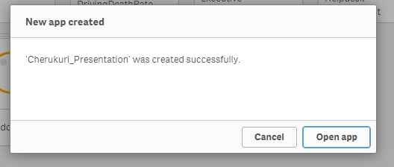

1. Select **Add data** and now select connect my data and also the excel files. Go to the location of the excel file on your desktop and double click on the file. Here we see the data on our excel file and select **load and finish**. It will prepare and load the data. Once the data is loaded you will receive a pop-up as Data is loaded successfully.

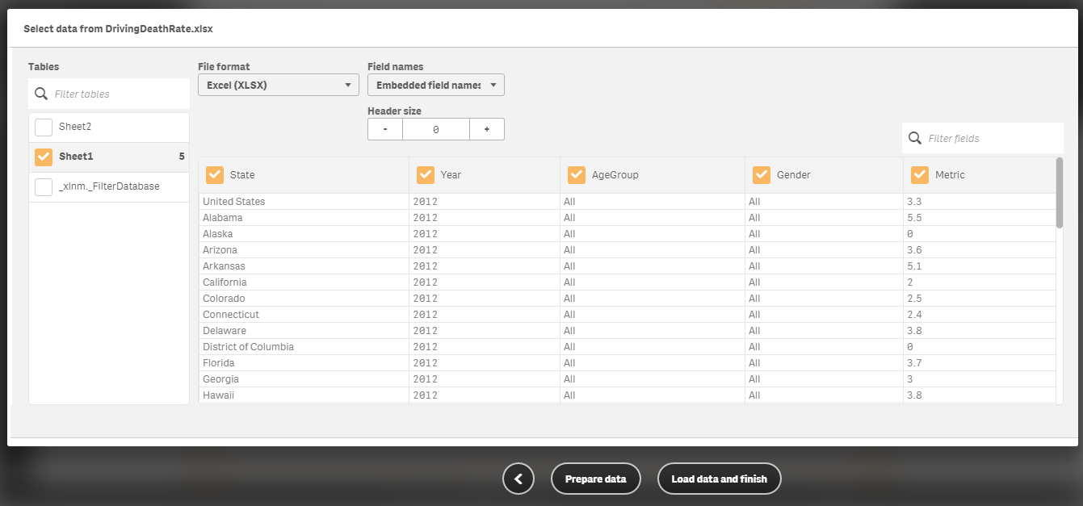

1. Now select the created new sheet or my new sheet on the app overview.
2. On the top right corner of the sheet click on edit to create the visualization.
3. On the left corner, you will see four icons. Now select the first icon. Hover the icon you will find the name as charts. Click on it. You will all the available charts.

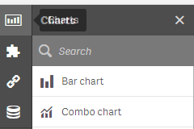

1. Now drag and drop the tree map present at the bottom of the screen.
2. It will ask you to all dimension and measure. Click on Add dimension and select the **Age Group**. Click on Add measure and select the **Metric** and aggregation as **average**.
3. Now you will see a map that is not answerable. We need to customize it. Fit the treemap to screen space. Go to the right corner you will see **Data**.

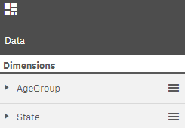

1. Under data, you will see dimensions. Now click on Add and select **State** as a dimension.
2. Again go to charts tab and select filter pane. Drag and Drop the filter pane and adjust the screen.
3. Select filter pane and select the dimension as Year. Rename the title as “Select Year”.
4. Now select or click on the treemap. Again go to the right side you will see Add-ons, click it and then open the data handling.
5. Now enter this expression in the calculation condition. “**GetSelectedCount(Year) =1**” and under the display message as “**Please select one year.**”
6. Again go to charts tab and select #1 KPI. Drag and Drop the #1 KPI and adjust the screen.
7. Select #1 KPI and click on data on the right side. Select the measure as metric and select aggregation as average. Now select the Avg(metric). Under the expression modify the condition like this “**Avg( {$<AgeGroup={'All'},State={'United States'},Gender={'All'}>} Metric )**”. Enter the label as the “Overall death rate”. You click on formatting and select from the drop down as a number and modify the display format as single digit after the decimal.

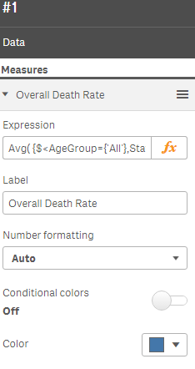

1. Again go to charts tab and select Table. Drag and Drop Table and adjust the screen.
2. Select Table and click on data on the right side. Select the add column and select dimension as Age Group and select again add column and select measure as metric and select aggregation as average.
3. Now select AgeGroup and unlink it using the icon under dimension. After that add the field as “**=IF(AgeGroup<>'All',AgeGroup)**” and label as “**Age Group**”.

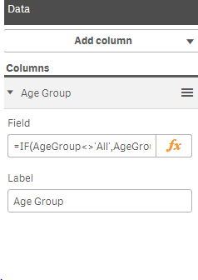

1. Now select Avg(metric). Under the expression modify the condition like this “**Avg(** **{$<AgeGroup={*}-{'All'}>} Metric )**”. Enter the label as the “Death rate”. You click on formatting and select from the drop down as a number and modify the display format as single digit after the decimal.
2. Now go to appearance and under general tab off the show titles button.
3. Now click on the treemap. Now select Avg(metric) under a measure in the data tab on the right side. Under the expression modify the condition like this “**IF(ISNULL(Metric)=0,Avg(Metric))**”. Enter the label as the “Driving Death rate”.

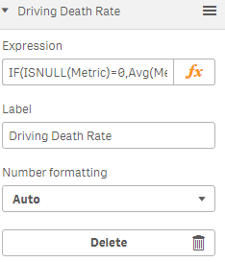

1. Now go to appearance and under general tab off the show titles button and turn on show details button.
2. Now go to presentation tab under general tab off the headers and labels and headers and turn on overlay, leaf and value labels.
3. Now go to colors and legend tab under general tab off the colors and drop down by measure and select the **Metric** and aggregation as **average**. Rename the label as **“Driving Death Rate”.** Colors schema as a diverging gradient**.** Turn on the show legend and select to display legend at the bottom.

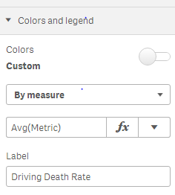

1. Now click on the new sheet and rename the title with the goal. What is the age group that is most prone to driving related death? And adjust the screens. After that click on done on the top and save.

Output screen will look as below if you select year as 2012.

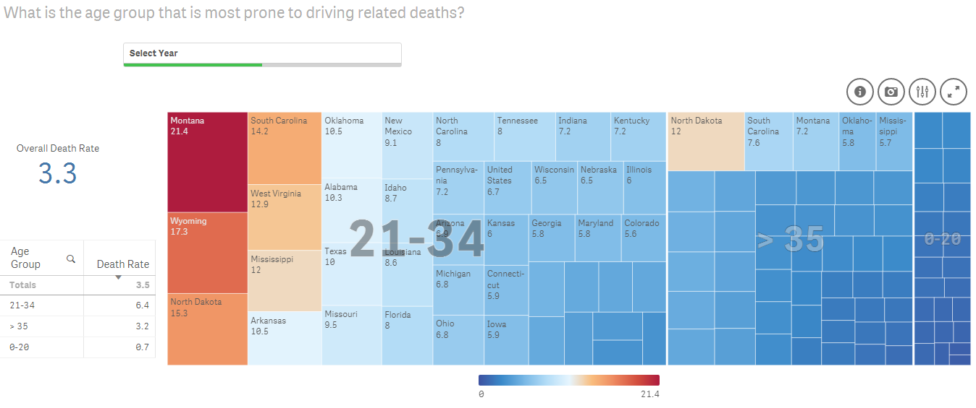

Output screen will look as below if you select year as 2014.

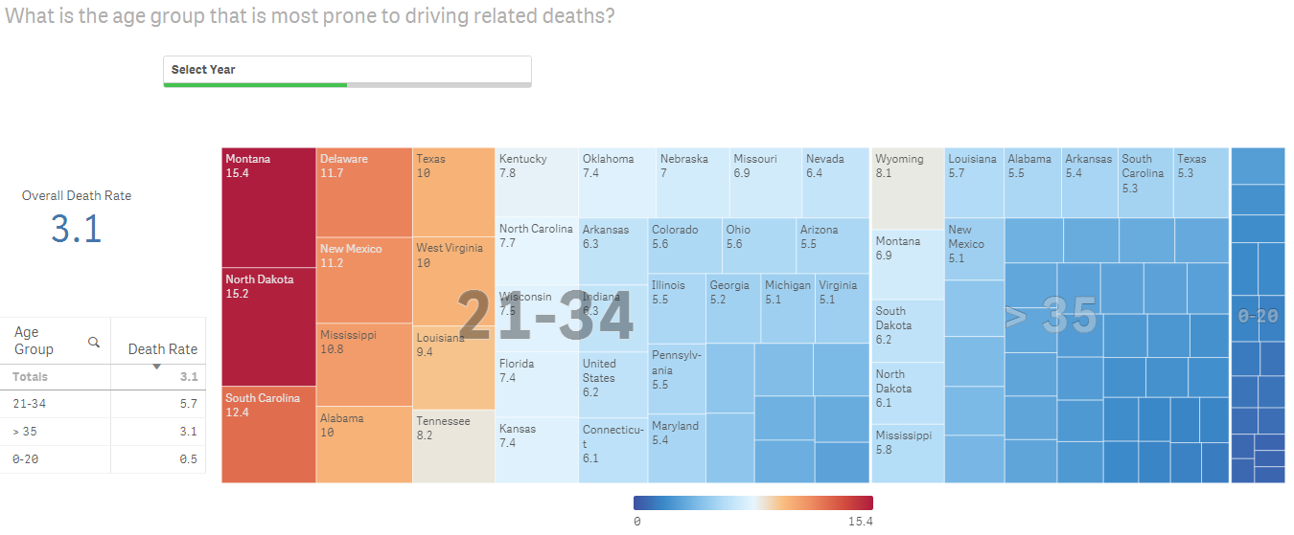

**Worksheet for Voronoi Tessellations using RAWGraphs**

**Goal 2**: Who are the nearest neighbors for the alphabets?

Implementing goal 2 with the help of Voronoi Tessellations using RAW Graphs.

Steps to be followed:

1. Download the below excel sheet



1. Go to the following link <http://app.rawgraphs.io/>.
2. Select upload a file on the left and select the downloaded excel sheet.

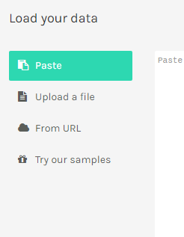

1. Go down and select choose a chart as Voronoi Tessellation.
2. Go down to map your dimensions. Under x-axis drag series 1, under y-axis drag series 2 and under color drag alphabet.

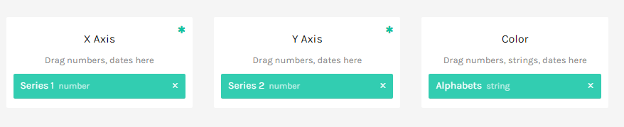

1. Now you will see the voronoi tessellations.

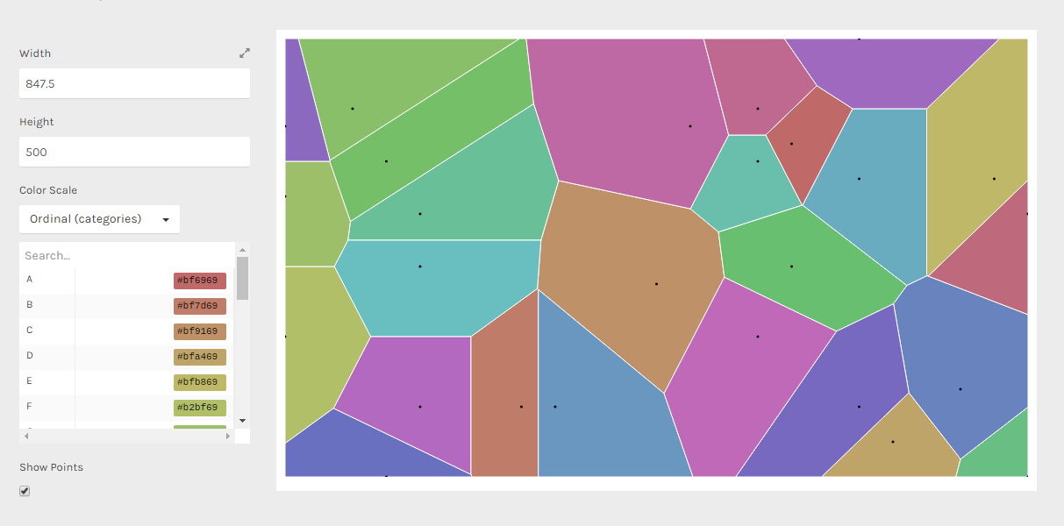

1. You can customize the color as you like on the left.
2. You can also download the visualization in the image format.

Output screen will look as below

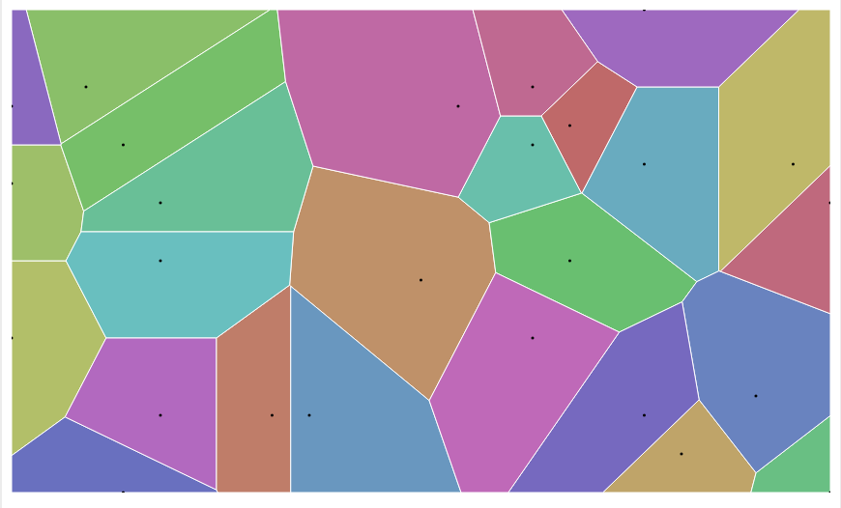

**Conclusion:**

By the end of this worksheet you will able to draw and analyze treemap using qlik sense and voronoi tessellations using RAWGraphs.

Link to GitHub repository: <https://github.com/aswinich/DatavisualizationPresentation.git>