Function

It have two rows. They are single row and multiple row.

- Single Row:
A single row is one horizontal line of data, objects, or items arranged side by side.

- Multiple Row:
, Multiple rows means two or more horizontal lines of data, objects, or items arranged one below another.

MULTI-ROW OR AGGREGATE FUNCTION:

Type:
* COUNT()
*SUM()
*AVG()
*MAX()
*MIN()
1.Count():
Counts tha number of rows.

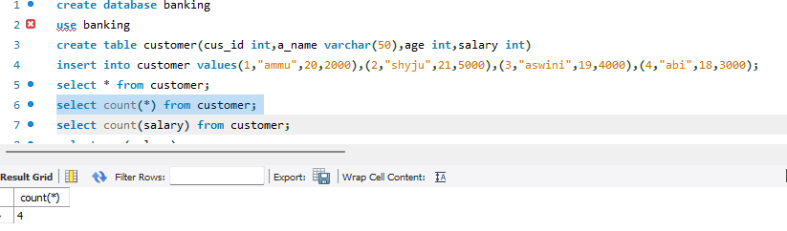

Count level:

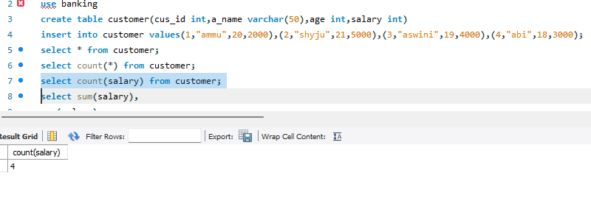
2. SUM():
In SQL, SUM() is an aggregate function that calculates the total of values in a numeric column.

3.AVG():
#.In SQL, AVG() is an aggregate function that calculates the average (arithmetic mean) of values in a numeric column.
#.AVG() returns the average of all non-NULL values in a specified numeric column.
4.MAX():
In SQL, MAX() is an aggregate function that returns the highest value in a column.
MAX() returns the maximum (largest) value from a specified column, ignoring NULL values.
- MIN():
In SQL, MIN() is an aggregate function that returns the lowest value in a column.

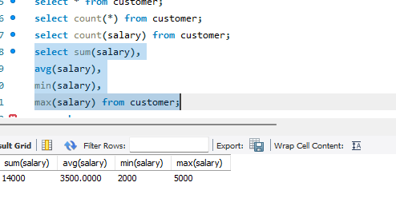
- GROUP BY():
The GROUP BY clause is used to group rows that have the same values in specified columns and perform aggregate functions (SUM(), AVG(), COUNT(), MAX(), MIN()) on each group.

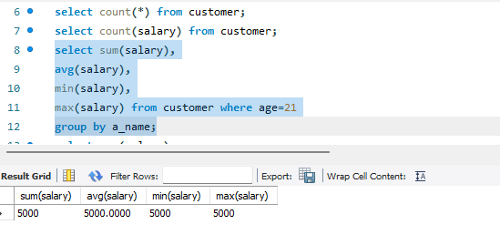

- HAVING():
The HAVING clause is used to filter groups of rows after the GROUP BY clause has been applied. It is often used with aggregate functions such as SUM(), COUNT(), AVG(), MAX(), and MIN().

