JOINS

- UNION:

UNION in SQL is an operator used to combine the results of two or more SELECT queries into a single result set.

UNION returns all distinct rows from the combined queries. Duplicate rows are automatically removed.

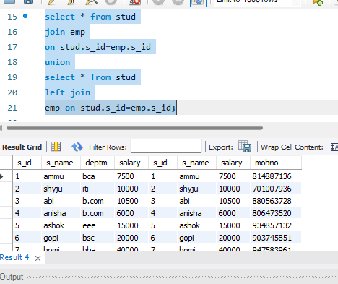

- UNION ALL:

UNION ALL in SQL combines the results of two or more SELECT statements without removing duplicate rows
Unlike UNION, which returns only distinct records, UNION ALL returns every row from all queries, including duplicates.

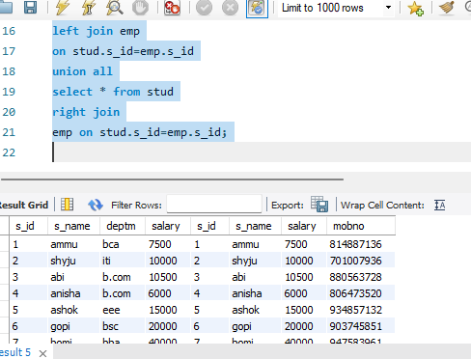

- CROSS JOIN:

A CROSS JOIN returns the Cartesian product of two tables. It combines every row from the first table with every row from the second table.

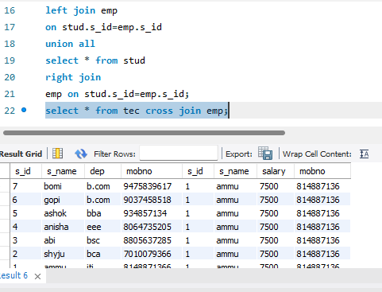

- SELF JOIN:

A SELF JOIN is a regular join where a table is joined with itself. It is useful when rows within the same table are related to each other.

A self join allows you to compare rows in the same table by using table aliases to treat the table as if it were two separate tables.

