JOINS

*“Join” means to connect, combine, or become part of something.
Tow ro more table based on a relates column.

TYPES OF JOINS

*Equi join
*Outer join
- Left outer join
- Right outer join
- Full outer join
*Inner or self join
*Cross join

- EQUI JOIN:

An equi join is a type of database join that combines rows from two or more tables by using an equality condition (=) between column.

.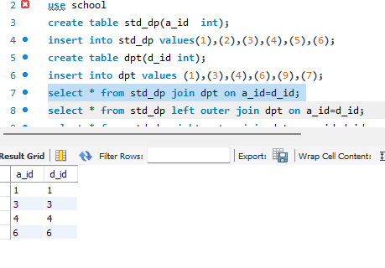

* OUTER JOIN:
1 Left outer join:

A Left Outer Join is a type of database join that returns all rows from the left table and the matching rows from the right table. If there is no match in the right table, the result shows NULL values for the right table’s columns.

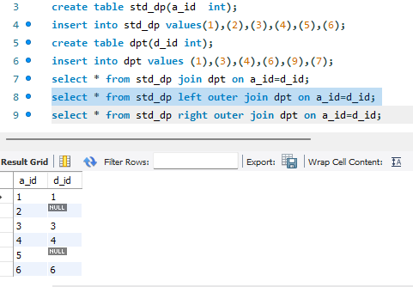

- Right outer join:

A Right Outer Join is a type of database join that returns all rows from the right table and the matching rows from the left table. If there is no match in the left table, the result shows NULL values for the left table’s columns.

