MindTrack Project:

Pre-Requisites:

* Git
* Docker Desktop for Windows
* Kubectl
* Eksctl
* AWS cli
* Node and npm to build react js application

Step 1: Clone the repo <https://github.com/Vennilavan12/Brain-Tasks-App.git> locally

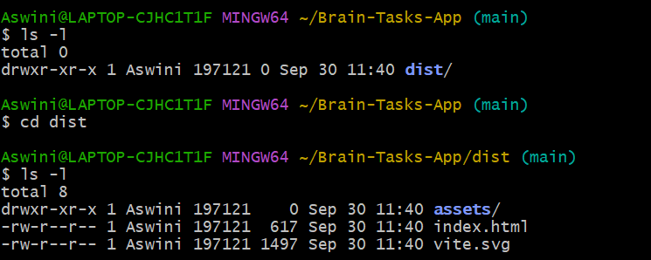

Step 2: run the application locally and see if it is serving

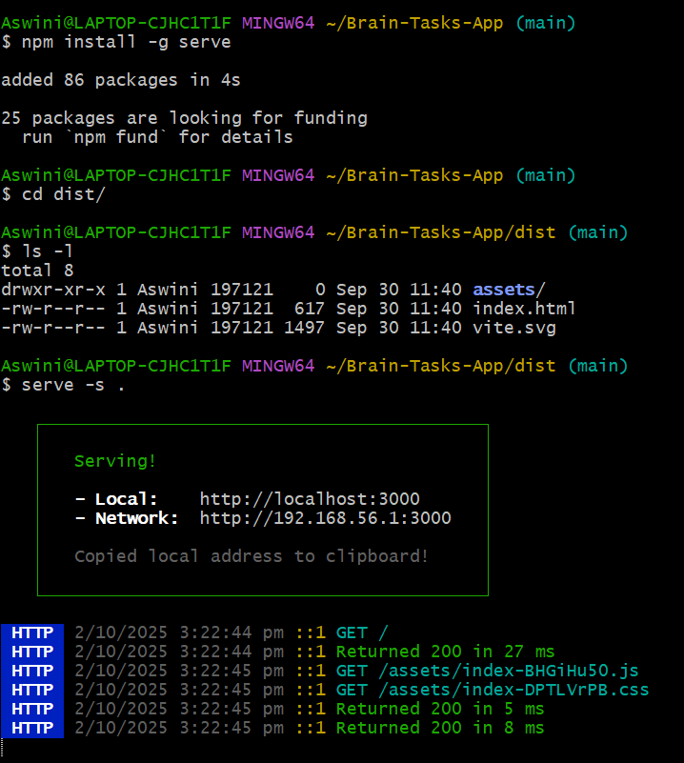

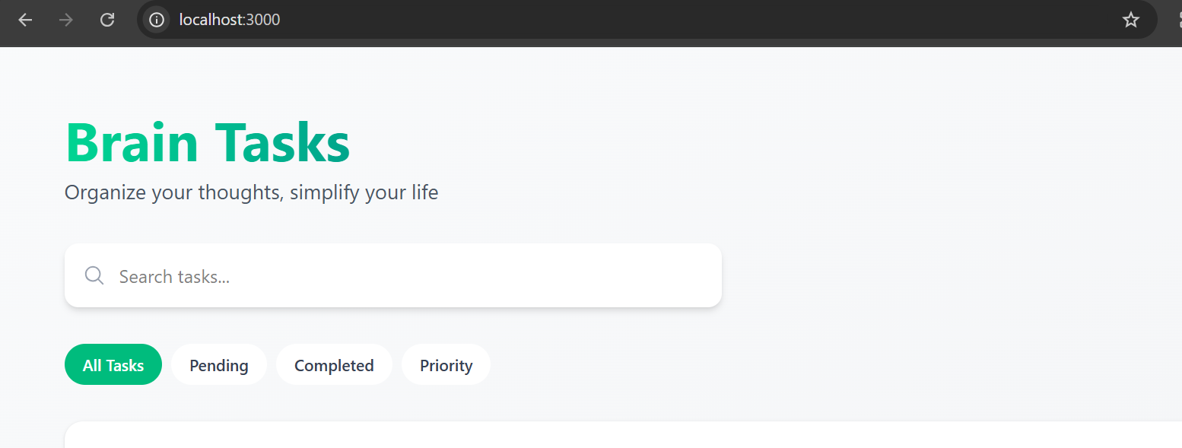

Step 3: Dockerize the application

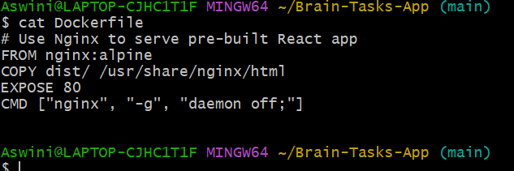

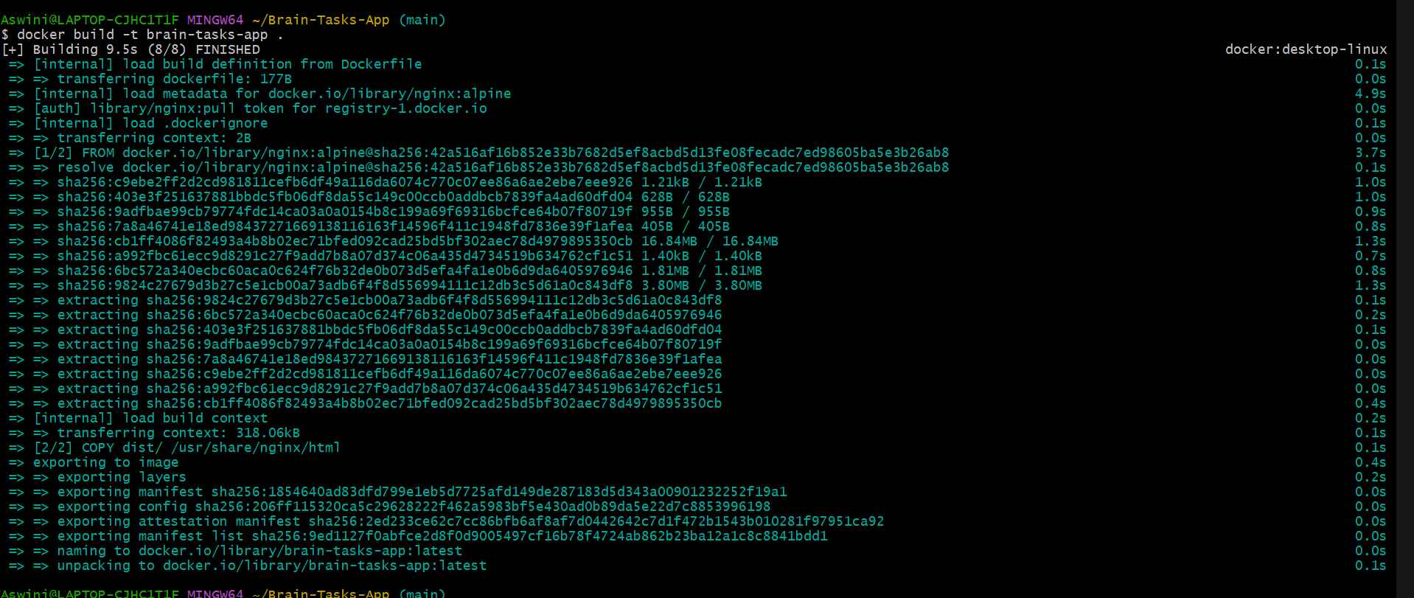

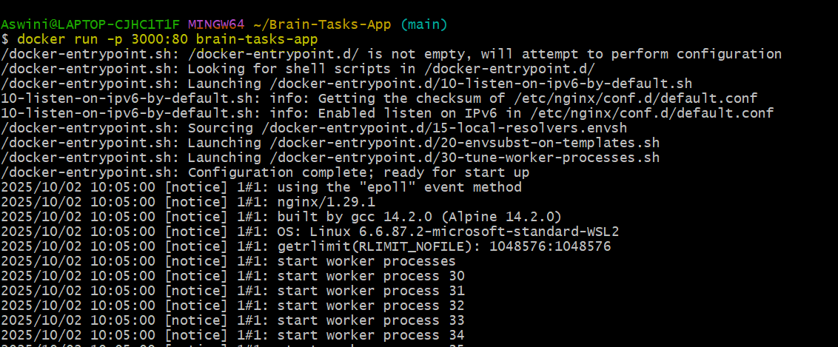

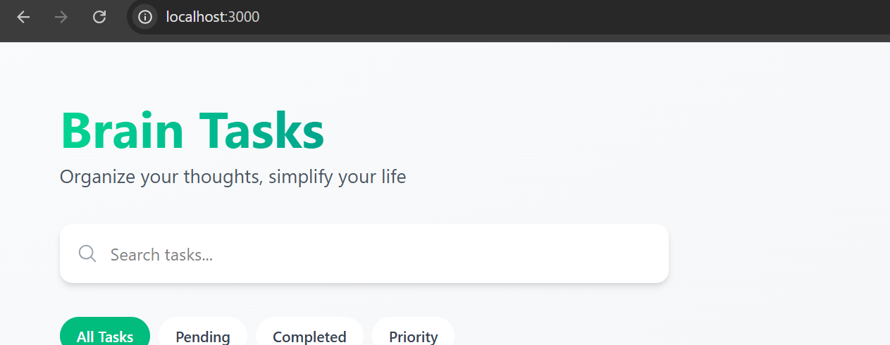

Step 4: Pushing the created docker image to ECR:

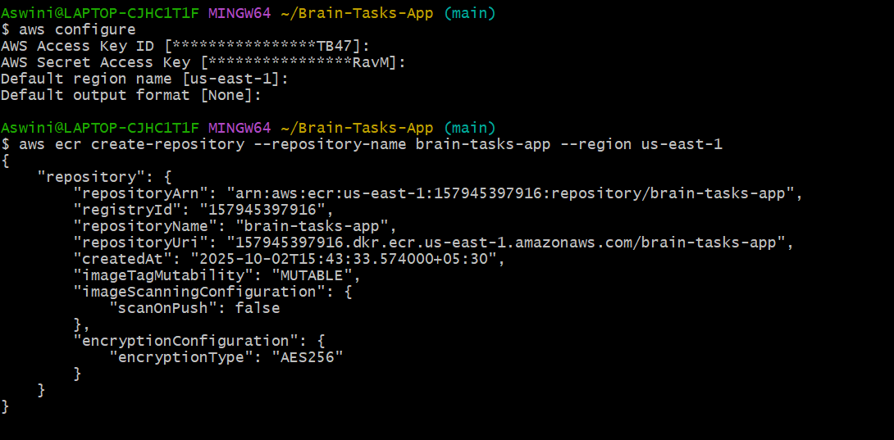

Step 5: Tag and push the image to ECR  
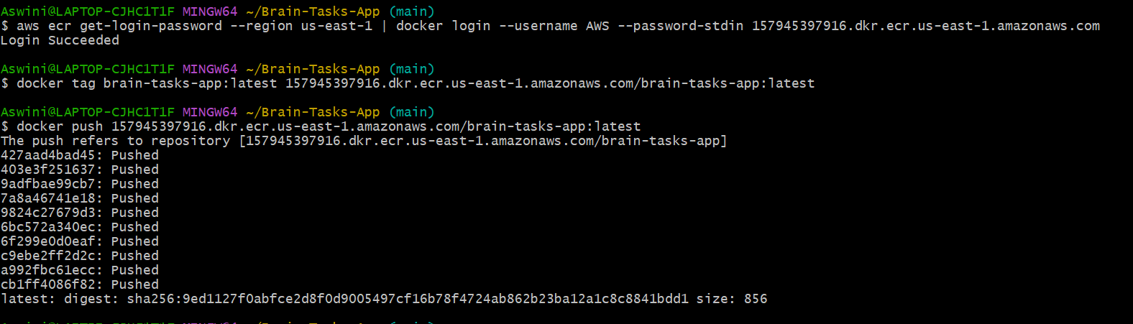

Step 6: Create EKS cluster and make sure the clusters are running

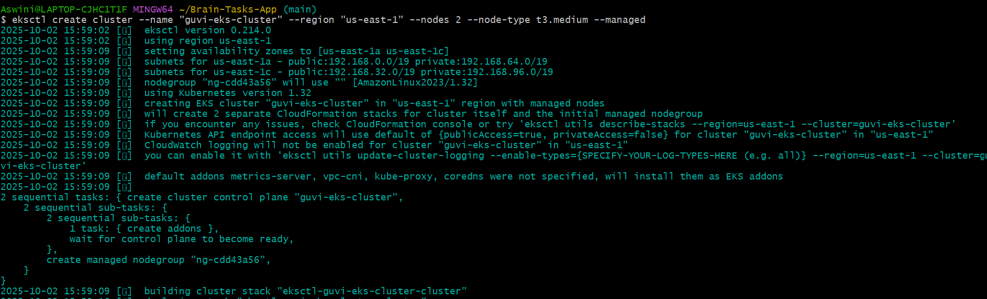

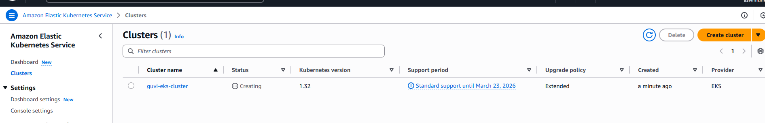



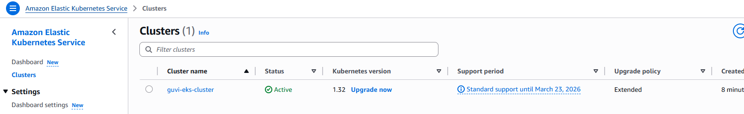

**Verifying if the clusters are up and running**

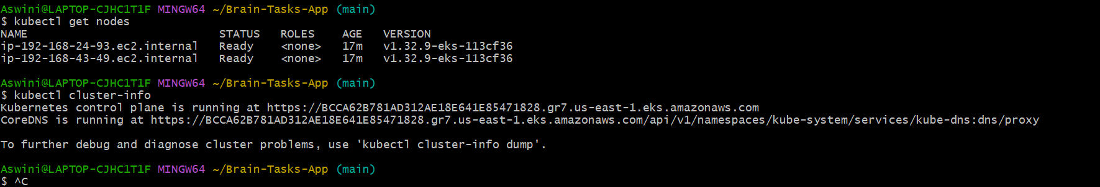

**Step 7: Create Deployment and service yaml files**

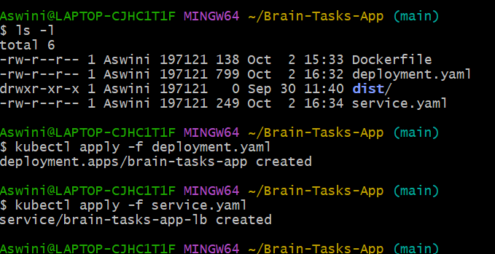

**Step8: Check the status of the cluster and get the Load balancer ARN**

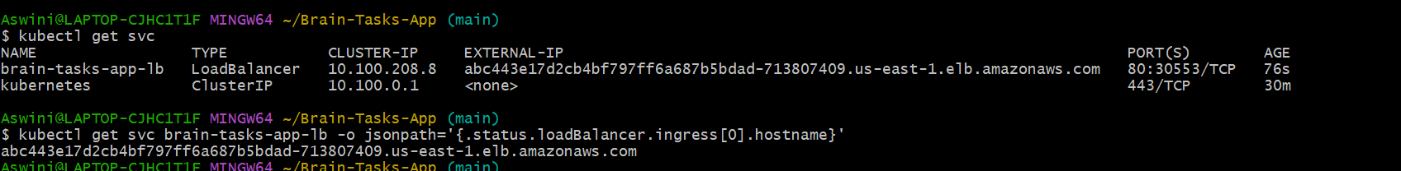

**STEP 9: Create the buildspec.yml file for the CodeBuild build stage**

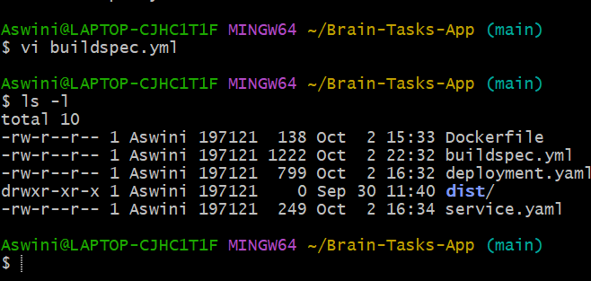

**Step 10: Create appspec.yml to specify the CodeDeploy instructions for Kubernetes**

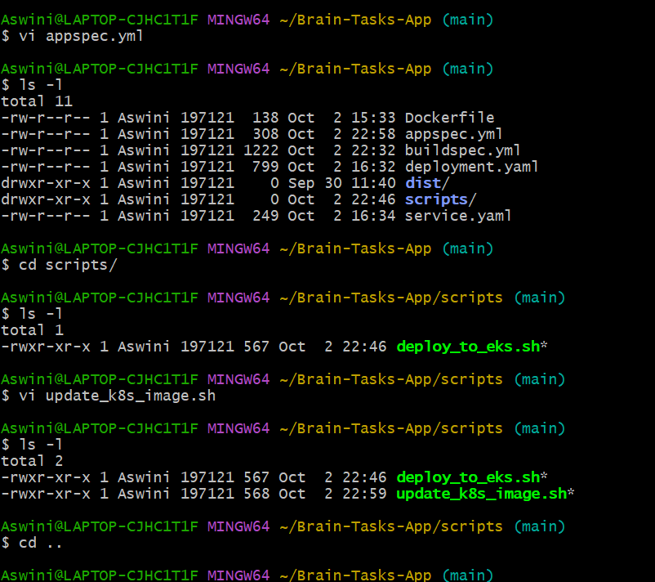

**Step 11: Push all the files to my git repo**

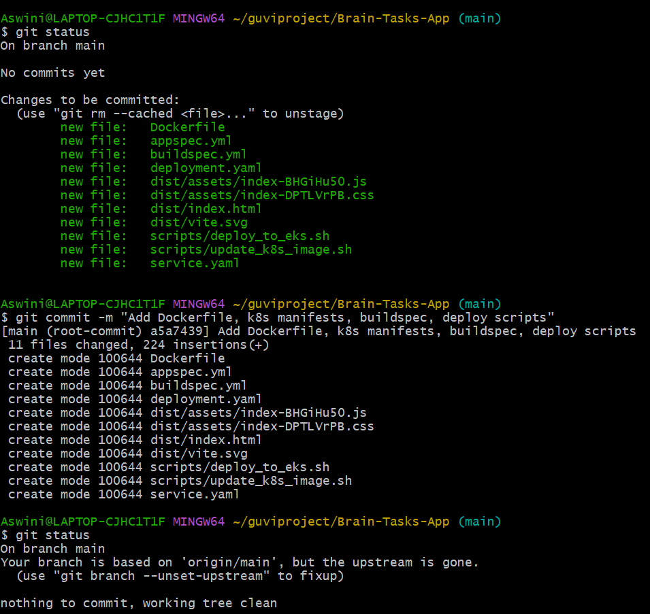

**Step 12: Creating a Code Pipeline**

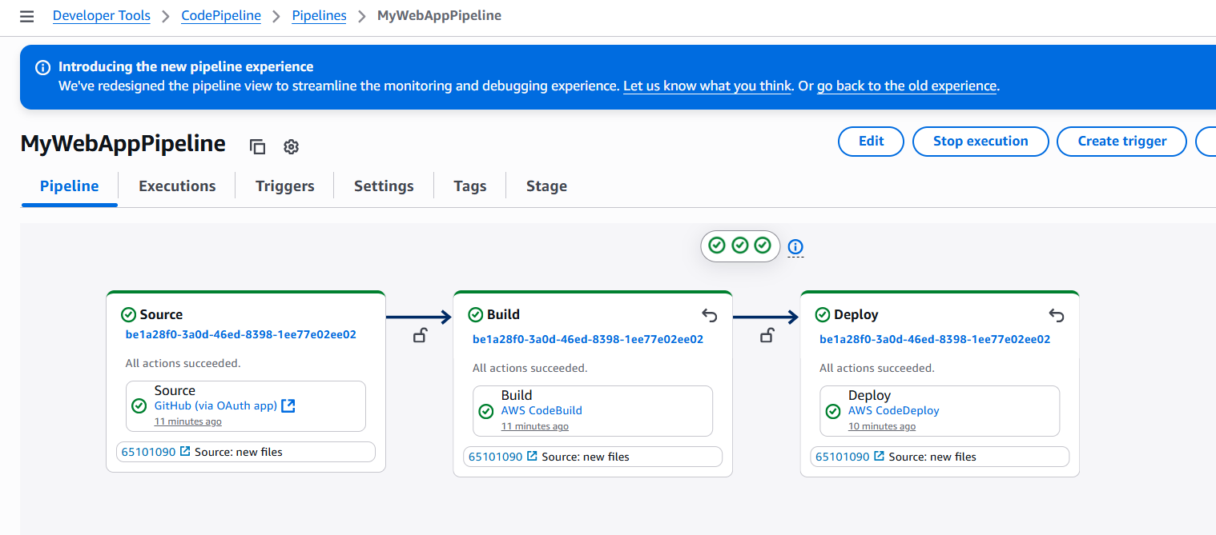

**Step 13: Deploying the code and testing it**

