**Persona 1:**

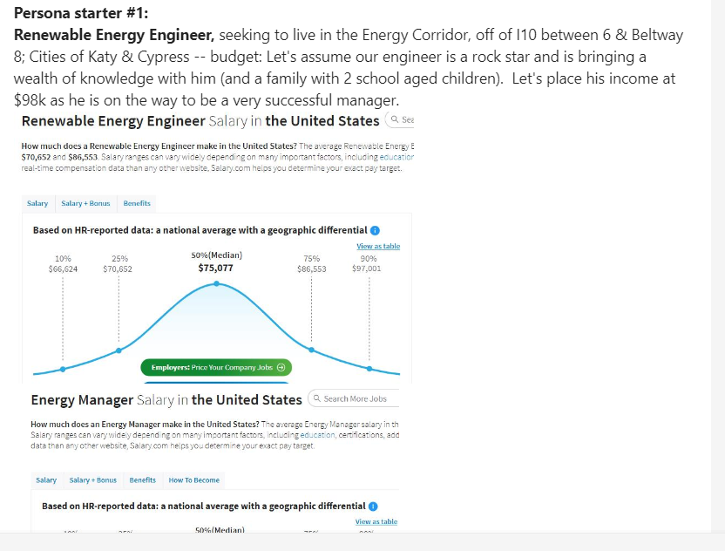

Children will start school at CALVIN NELMS HIGH SCHOOL and CALVIN NELMS MIDDLE SCHOOL (20625 Clay Rd, Katy TX, 77449  
(281) 398-803).

The family wants to live within a 20 minute drive of the school.

The family wants to get the best price/sqft as possible.

Due to high flood risk in the Energy Corridor, the family would like to compare property by zip code.

Use the attached map to suggest the best zip code for avoiding the floods.

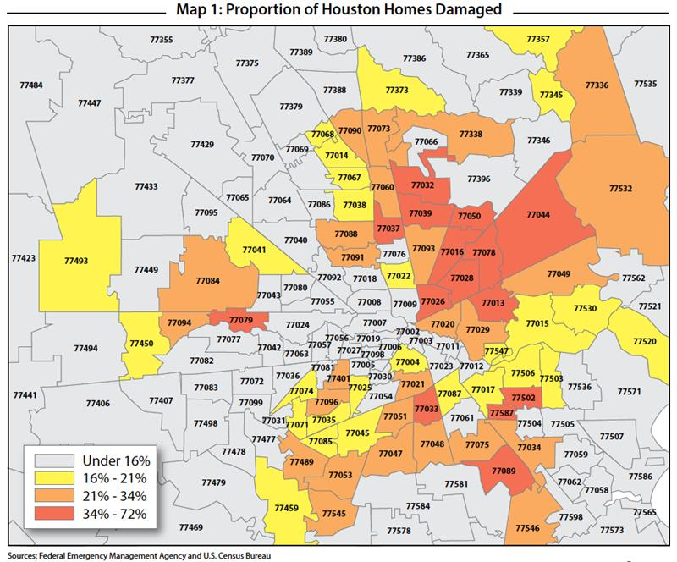

**Persona starter 2:**

Oncology Resident; looking for a condo near the S. Central Houston Medical Corridor; need to back into a budget of about 300k to make it a possible scenario

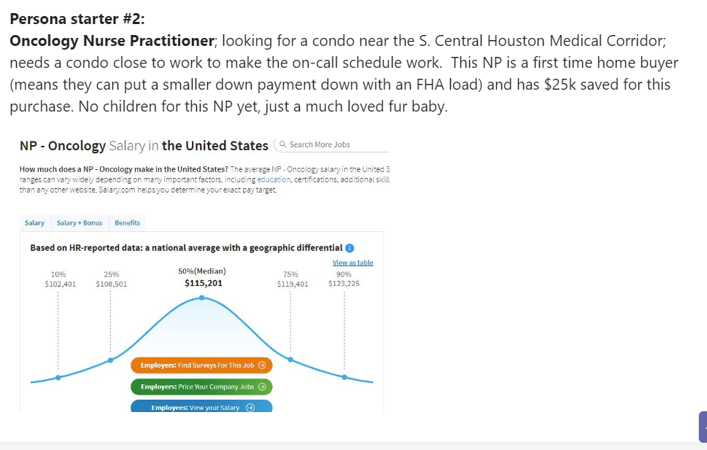

As a recent graduate she has chosen to save for a Condo before buying a car.

Due to this, she needs to be within a 30 minute walk of her job at Texas Oncology-Houston Medical Center. ([Address](https://www.google.com/search?rlz=1C1CHBF_en-GBGB935GB935&sxsrf=ALeKk00wXribc_xNc9HWoSp_yK9jHN8JYg:1629061845638&q=texas+oncology-houston+medical+center+address&ludocid=14909215024892209155&sa=X&ved=2ahUKEwiNle2k-LPyAhXBQTABHe58DGoQ6BMwBXoECAAQAg): 7515 Main St Suite 740, Houston, TX 77030)

Note: Average walking time per mile is 18 minutes.

**Persona 3:**

