1. **Description**

This system corresponds to the BLB model Ⅱ which was described in “Yang Li, You-Liang Zhu, Yan-Chun Li, Hu-Jun Qian and Chia-Chung Sun, Self-assembly of two-patch particles in solution: a Brownian dynamics simulation study, Molecular Simulation, 2014 Vol. 40, No. 6, 449–457”. The snapshot of the nano-particle is given in the following picture.



The formed structure will be the one shown in following picture.

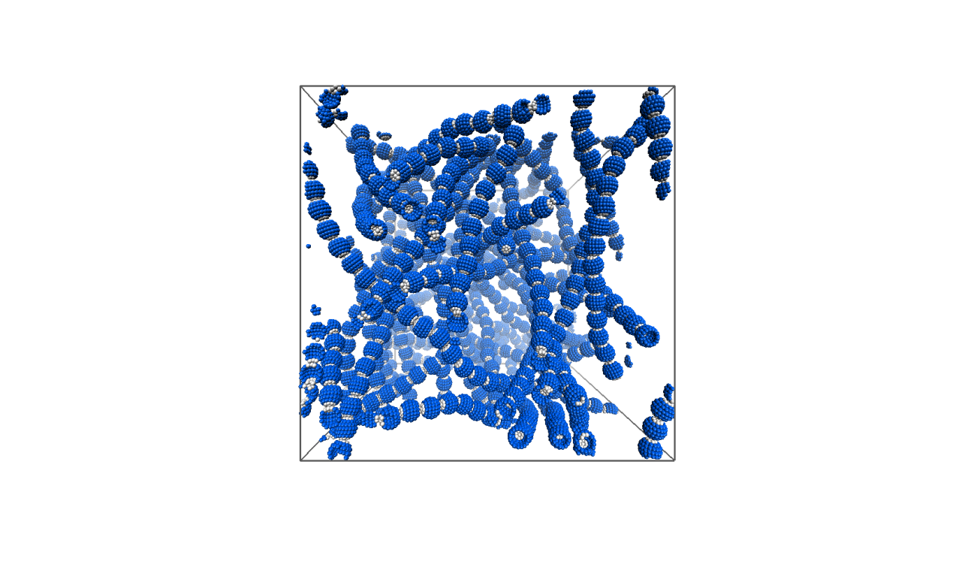

1. **Parameters**

Temperature: 

Number of nano-particle: 729

Number of particles in one nano-particle: 90

Thermostat: Brownian dynamics

Ensemble: NVT

Potentials: LJ and WCA

1. **Commands**
2. Run the simulation by:

chmod +x nanoparticle.gala

./ nanoparticle.gala --gpu=0 >a.log&

1. You can see the configuration by

vmd –hoomd filename.xml